Supplementary Tables
Supplementary Table 1. Nucleotide sequences of primers used in quantitative reverse transcription PCR (RT-qPCR) analysis.
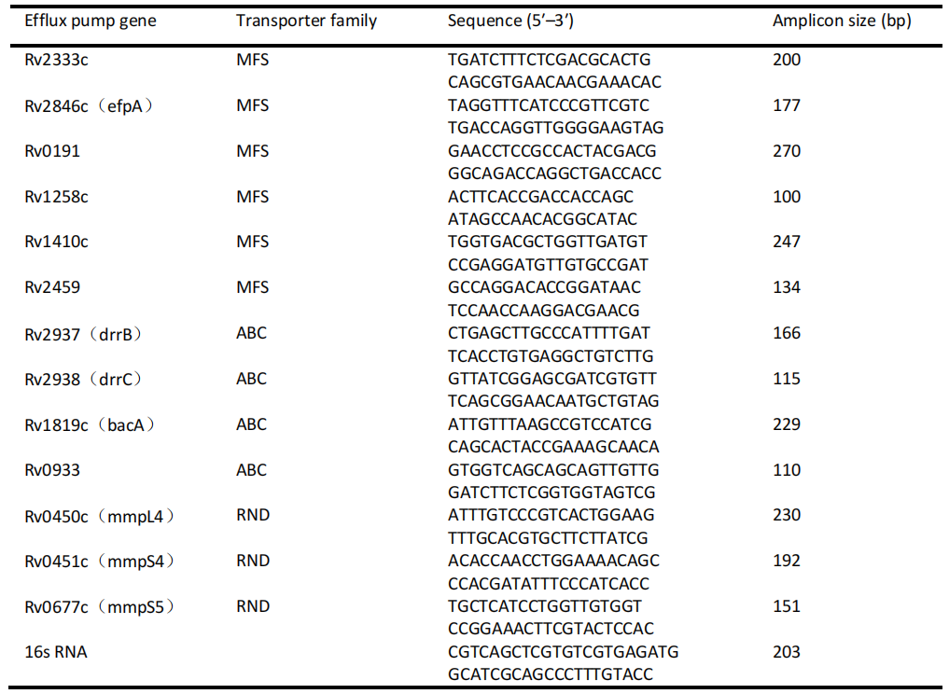

Supplementary Table 2. Efflux pump gene expression levels in drug-resistant Mtb isolates under conditions of RIF or RIF+VP treatment.
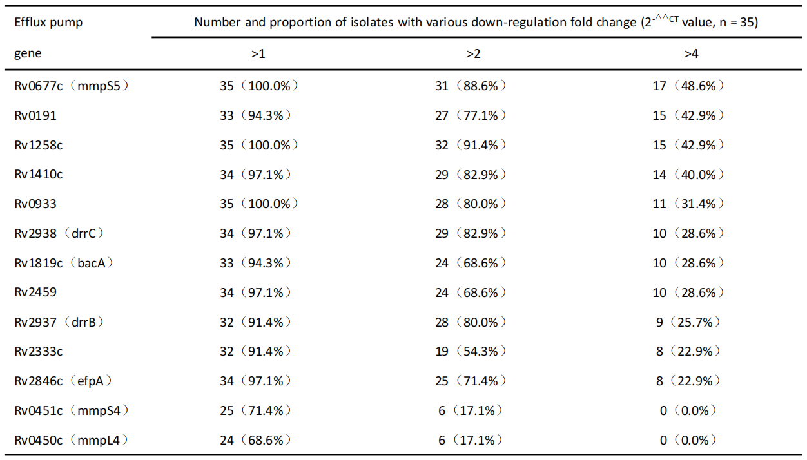
Relative mRNA expression was analyzed with the 2^{- △△CT} method, comparing samples to the control sample. The gene expression ratio for clinical isolates exposed to RIF and RIF+VP is presented as fold-change downregulation.

Supplementary Figures

Supplementary Figure 1. a-b. Data are shown for Rv0677c (mmpS5) (a) and Rv0191 (b). The 35 isolates included in this study were classified into 4 groups based on their MIC values in order to compare relative Rv0677c (mmpS5) and Rv0191 expression levels following exposure to RIF (1/2 MIC) for 10 days. Values represent normalized expression levels for the indicated genes relative to the control group, as analyzed via the 2^{- △△CT} method. No significant differences in Rv0677c (mmpS5) or Rv0191 overexpression were observed among groups.

