Supplementary Table 1 Primer used in our study.
Primer | Sequence 5’-3’
rpoB F | CAGAAGAGAAGAACAAGTTAT
rpoB R | CGTGAAGAAGCATTAGTAG
adeB F | GGAATAAGGCACCACAACAAT
adeB R | CGAAGTTAGGAATACCAGCAATAC
adeS F | TTGCTGGTTCTCTACTAAG
adeS R | ACGCCTATAACGATATTACA
adeJ F | CGTTGCACGCCAGTTTTGTA
adeJ R | AGAACTCGCAAGTTGCCGTA
tet（X1）F | CGAAAAATGTTGCTTGGCAGCTT
tet（X1）R | AGTTGTTGAACGAATTAACTCC
tet（X2）F | CGGGATGTCCAAGGTAAGAAAA
tet（X2）R | TGACAACGTCGTATGAATCAA
tet（X3）F | GACACTTGATCTGCACAGGGATT
tet（X3）R | CCCTACAAAAGATGATGTCAAAC
tet（X4）F | CTGATTCGTGTGACATCATCTTTTG
tet（X4）R | GTTAAATTTCCCATTGGTCAGATTA
tet（X5）F | GGTATCAACATTTCAATGCTTG
tet（X5）R | CGATTCGTCCTGCGTATCTTTTG

Supplementary Table 2 Distribution of isolate samples
specimen type | 2021 |  |  | 2022 |  |  | 2023 |  |  | 2024
specimen type | (n=357) |  |  | (n=398) |  |  | (n=675 |  |  | (n=713)
specimen type | No. of strain | % |  | No. of strain | % |  | No. of strain | % |  | No. of strain | %
Sputum | 285 | 79.83% |  | 312 | 78.39% |  | 535 | 79.26% |  | 575 | 80.65%
Bronchoalveolar lavage | 19 | 5.32% |  | 37 | 9.30% |  | 48 | 7.11% |  | 58 | 8.13%
Urine | 21 | 5.88% |  | 23 | 5.78% |  | 34 | 5.04% |  | 26 | 3.65%
Sterile fluid sample | 16 | 4.48% |  | 16 | 4.02% |  | 37 | 5.48% |  | 39 | 5.47%
Tissue specimen | 12 | 3.36% |  | 3 | 0.75% |  | 5 | 0.74% |  | 6 | 0.84%
Other | 4 | 1.12% |  | 7 | 1.76% |  | 16 | 2.37% |  | 9 | 1.26%
%: Proportion;

Supplementary Table 3 Department distribution of isolates
Clinical Department | 2021 |  |  | 2022 |  |  | 2023 |  |  | 2024
Clinical Department | No. of strain | % |  | No. of strain | % |  | No. of strain | % |  | No. of strain | %
Intensive Care Unit | 98 | 27.5% |  | 121 | 30.4% |  | 281 | 41.6% |  | 318 | 44.6%
Respiratory Medicine Department | 96 | 26.9% |  | 116 | 29.1% |  | 156 | 23.1% |  | 169 | 23.7%
Medical Department | 72 | 20.2% |  | 57 | 14.3% |  | 112 | 16.6% |  | 110 | 15.4%
Surgical Department | 61 | 17.1% |  | 63 | 15.8% |  | 83 | 12.3% |  | 68 | 9.5%
Pediatric Department | 18 | 5.0% |  | 19 | 4.8% |  | 11 | 1.6% |  | 8 | 1.1%
Emergency Department | 12 | 3.4% |  | 11 | 2.8% |  | 9 | 1.3% |  | 22 | 3.1%
Organ Transplant Department | - | - |  | 7 | 1.8% |  | 16 | 2.4% |  | 15 | 2.1%
Department of Oncology | - | - |  | 4 | 1.0% |  | 7 | 1.0% |  | 3 | 0.4%
%: Proportion; -: No data available;

Supplementary Table 4 Gene of Acinetobacter baumannii resistance to Antimicrobials.
Antimicrobials | AMR Gene Family | Element Name and Symbol | CARD Short Name | Percentage
Aminoglycoside antibiotic | AAC(3) | Aminoglycoside N-acetyltransferase AAC(3)-Ia | aac(3)-Ia | 6.97%(3/43)
Aminoglycoside antibiotic | ANT(3'') | Aminoglycoside nucleotidyltransferase ANT(3’’)-IIa | ant(3'')-IIa | 100%(43/43)
Aminoglycoside antibiotic | 16S rRNA methyltransferase (G1405) | ArmA family 16S rRNA (guanine(1405)-N(7))-methyltransferase | armA | 97.67%(42/43)
Aminoglycoside antibiotic | APH(3'') | Aminoglycoside O-phosphotransferase APH(3’’)-Ib | aph(3'')-Ib | 97.67%(42/43)
Aminoglycoside antibiotic | APH(3') | Aminoglycoside O-phosphotransferase APH(3’)-Ia | aph(3')-Ia | 79.06%(34/43)
Aminoglycoside antibiotic | APH(3') | aminoglycoside O-phosphotransferase APH(3')-IIc | aph(3')-IIc | 4.65%(2/43)
Aminoglycoside antibiotic | AAC(6) | Aminoglycoside O-phosphotransferase APH(6) | aph(6) | 4.65%(2/43)
Aminoglycoside antibiotic | APH(6) | Aminoglycoside O-phosphotransferase APH(6)-Id | aph(6)-Id | 97.67%(42/43)
Aminoglycoside antibiotic | ANT(3'') | Aminoglycoside nucleotidyltransferase AadA1 | aadA1 | 58.13%(25/43)
Cephalosporin antibiotic | ADC beta-lactamase without carbapenemase activity | Extended-spectrum class C beta-lactamase ADC-30 | bla_{ADC-30} | 53.49%(23/43)
Cephalosporin antibiotic | ADC beta-lactamase without carbapenemase activity | Extended-spectrum class C beta-lactamase ADC-73 | bla_{ADC-73} | 44.19%(19/43)
Cephalosporin antibiotic | ADC beta-lactamase without carbapenemase activity | Extended-spectrum class C beta-lactamase ADC-99 | bla_{ADC-99} | 2.33%(1/43)
Cephalosporin antibiotic | L1 family beta-lactamase | L1 family subclass B3 metallo-beta-lactamase gene family | bla_{L1} | 4.65%(2/43)
Cephalosporin antibiotic | OXA beta-lactamase | OXA-23 family carbapenem-hydrolyzing class D beta-lactamase OXA-23 | bla_{OXA-23} | 97.67%(42/43)
Cephalosporin antibiotic | OXA beta-lactamase | OXA-51 family carbapenem-hydrolyzing class D beta-lactamase OXA-66 | bla_{OXA-66} | 95.35%(41/43)
Cephalosporin antibiotic | OXA beta-lactamase | OXA-51 family carbapenem-hydrolyzing class D beta-lactamase OXA-80 | bla_{OXA-80} | 2.33%(1/43)
Cephalosporin antibiotic | TEM beta-lactamase | broad-spectrum class A beta-lactamase TEM-1 | bla_{TEM-1} | 93.02%(40/43)
Aminoglycoside antibiotic | AAC(6') | Aminoglycoside N-acetyltransferase AAC(6’)-Ib’ | aac(6')-Ib' | 58.14%(25/43)
Aminoglycoside antibiotic | AAC(6') | Aminoglycoside N-acetyltransferase AAC(6')-Iz | aac(6')-Iz | 4.65%(2/43)
Sulfonamide antibiotic | sulfonamide resistant sul | Sulfonamide resistance protein (sul1) gene | sul1 | 58.14%(25/43)
Sulfonamide antibiotic | sulfonamide resistant sul | Sulfonamide resistance protein (sul2) gene | sul2 | 25.58%(11/43)
Streptogramin antibiotic | msr-type ABC-F protein | Msr-type ABC-F protein | msr(E) | 95.34%(41/43)
Tetracycline antibiotic | major facilitator superfamily (MFS) antibiotic efflux pump | Tetracycline efflux MFS transporter Tet(B) gene family | tet(B) | 97.67%(42/43)
Chloramphenicol antibiotic | chloramphenicol acetyltransferase (CAT) | Type B-3 chloramphenicol O-acetyltransferase CatB8 gene family | catB8 | 58.14%(25/43)
Macrolide antibiotic | macrolide phosphotransferase (MPH) | Mph(E) family macrolide 2'-phosphotransferase gene family | mph(E) | 95.35%(41/43)
AMR= Anti-microbial Resistance;
CARD= the Comprehensive Antibiotic Research Database
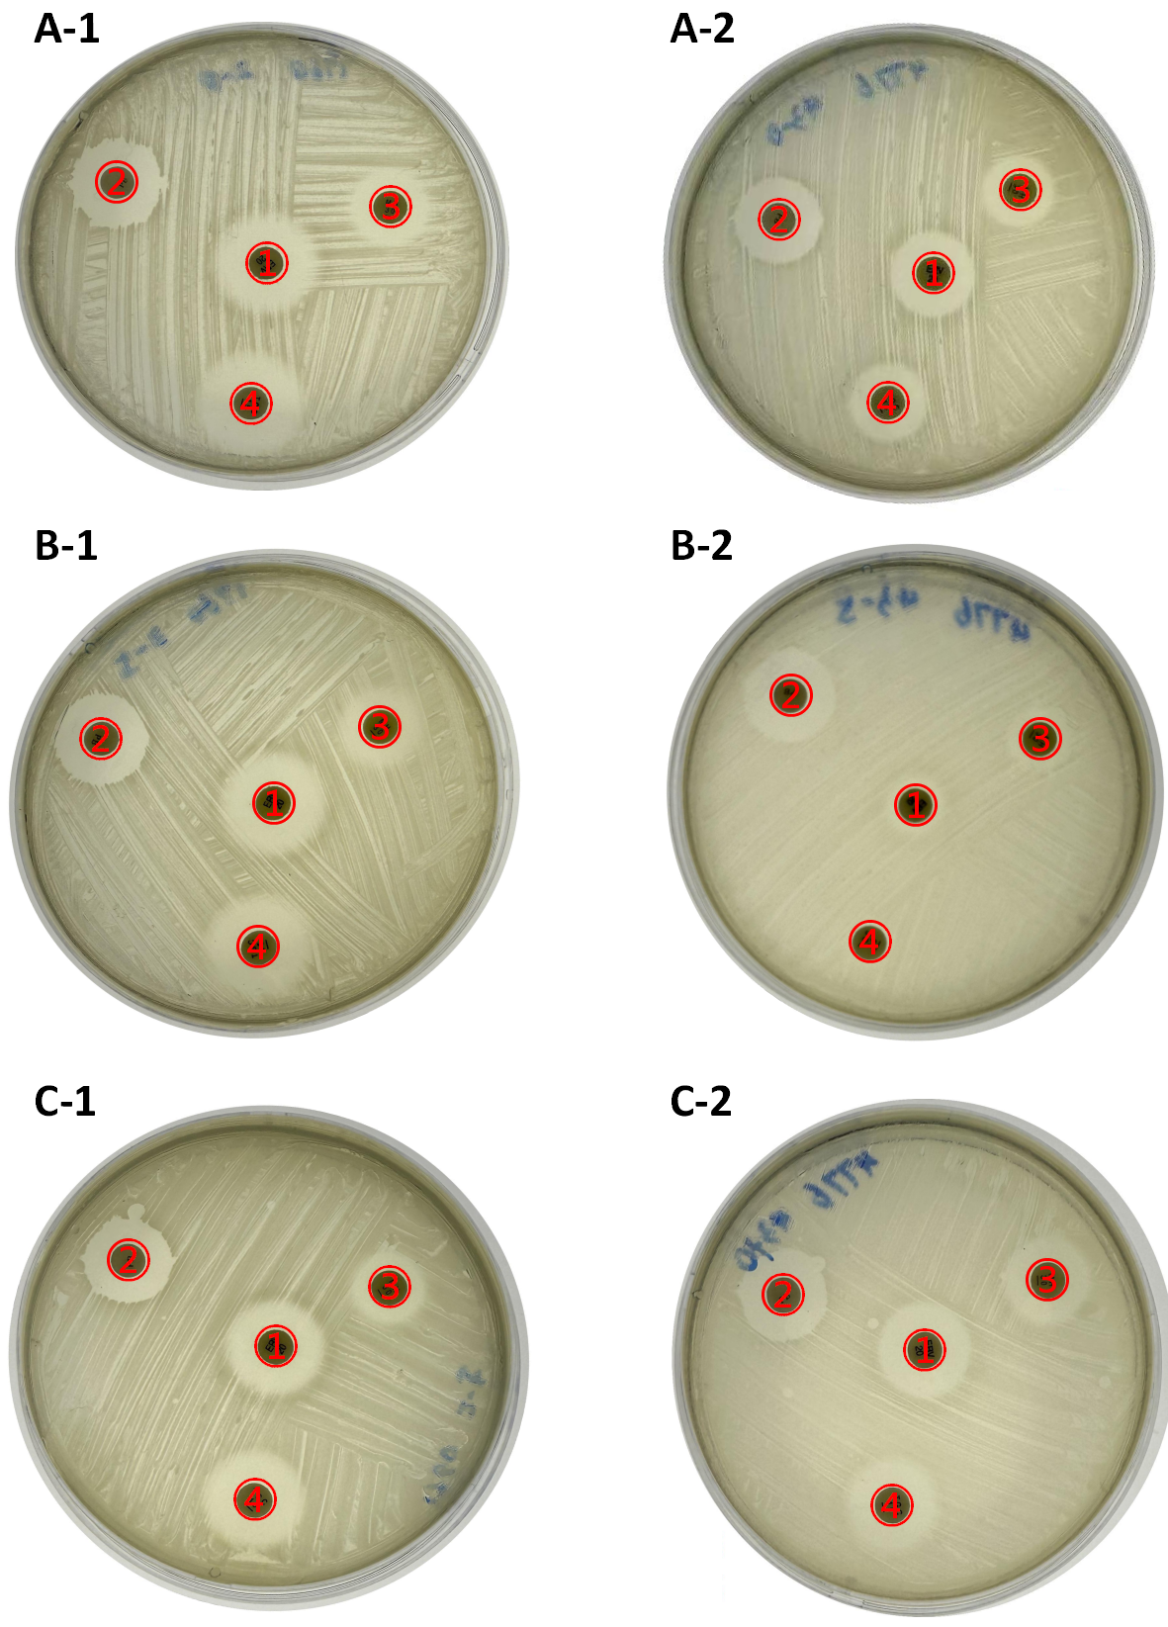Supplementary Figure. Antimicrobial agents interactions before and after eravacycline induction. The antimicrobial agents interactions between strains before and after Eravacycline induction were detected using the disk diffusion method. No additive or subtractive effects were detected between the four antimicrobial agents.
- Eravacycline; ②Polymyxin B; ③Minocycline; ④Tigecycline;
A: group A; B: group B; C: group C;

