Additional File 1

Detailed classification of relevant health and aging studies
Table S1: Mobility indicators from a selected set of exemplary studies classified according to the characteristic aspects of the mobility indicator classification framework (cf. Figure 2 in the main paper).
Study | # | Mobility indicator | Characteristic aspects
 |  |  | Space |  |  | Time |  |  | Mvt. sc. |  |  | Attribute
 |  |  | Count | Extent | Shape/distr. | Duration | Timing | Temp. distr. | Stop | Move | Trajectory | Out of home | Transport mode | Further attribute
Harada et al. (1,2) | 1 | Time out of home (TOH)
Kaspar et al. (3) | 2 | TOH
Kaspar et al. (3) | 2 | Distance walking
Wahl et al. (4) | 2 | TOH
Wahl et al. (4) | 2 | Number of locations
Blamoutier et al. (5) | 3 | Time in vehicle
Blamoutier et al. (5) | 3 | Time on foot
Blamoutier et al. (5) | 3 | Minimum span ellipse area
Cuignet et al. (8) | 3 | Area of standard deviational (SD) ellipse
Cuignet et al. (8) | 3 | Time spent in trips
Cuignet et al. (8) | 3 | Number of trips
Giannouli et al. (6,7) | 4 | Area of convex hull
Giannouli et al. (6,7) | 4 | Mean/max distance from home
Giannouli et al. (6,7) | 4 | Total distance
Tung et al. (9) | 4 | Area of convex hull
Tung et al. (9) | 4 | Perimeter of convex hull
Tung et al. (9) | 4 | TOH
Tung et al. (9) | 4 | Mean distance from home
Cornwell and Cagney (10) | 5 | Mean distance from home
Cornwell and Cagney (10) | 5 | Area of SD ellipse
Cornwell and Cagney (10) | 5 | Number GPS points outside residential tracts
Cornwell and Cagney (10) | 5 | Number of tracts visited
Cornwell and Cagney (10) | 5 | Number of tracts for at least 10 min
Takemoto et al. (11) | 6 | Number of trips on foot / in vehicle
Takemoto et al. (11) | 6 | Distance on foot / in vehicle
Takemoto et al. (11) | 6 | Time on foot / in vehicle
Wettstein et al. (12, 13, 14*, 15**) | 5, 7*, 8** | TOH
Wettstein et al. (12, 13, 14*, 15**) | 5, 7*, 8** | Number of locations
Wettstein et al. (12, 13, 14*, 15**) | 5, 7*, 8** | Distance on foot
Wettstein et al. (12, 13, 14*, 15**) | 5, 7*, 8** | Time on foot
Wettstein et al. (12, 13, 14*, 15**) | 5, 7*, 8** | Walking speed
Wettstein et al. (12, 13, 14*, 15**) | 5, 7*, 8** | Walking duration per track*
Wettstein et al. (12, 13, 14*, 15**) | 5, 7*, 8** | Number of walking tracks*/**
Wettstein et al. (12, 13, 14*, 15**) | 5, 7*, 8** | Mean/max distance from home**
Boissy et al. (16) | 10 | Time at home
Boissy et al. (16) | 10 | Number of trips
Boissy et al. (16) | 10 | Number of locations
Boissy et al. (16) | 10 | Maximum distance from home
Boissy et al. (16) | 10 | Distance in vehicle
Boissy et al. (16) | 10 | Time in vehicle
Boissy et al. (16) | 10 | Time on foot
Boissy et al. (16) | 10 | Distance on foot
Boissy et al. (16) | 10 | Minimum span ellipse major axis length
Boissy et al. (16) | 10 | Minimum span ellipse area
Saeb et al. (17,18) | 11 | Location variance
Saeb et al. (17,18) | 11 | Circadian movement
Saeb et al. (17,18) | 11 | Speed mean
Saeb et al. (17,18) | 11 | Speed variance
Saeb et al. (17,18) | 11 | Distance
Saeb et al. (17,18) | 11 | Number of locations
Saeb et al. (17,18) | 11 | Entropy
Saeb et al. (17,18) | 11 | Normalized entropy
Saeb et al. (17,18) | 11 | Raw entropy
Saeb et al. (17,18) | 11 | Time at home
Saeb et al. (17,18) | 11 | Percentage time traveling
Isaacson et al. (19) | 11 | TOH
Isaacson et al. (19) | 11 | Number of locations
Isaacson et al. (19) | 11 | Duration on foot
Isaacson et al. (19) | 11 | Number of trips on foot
Isaacson et al. (19) | 11 | Time in trips
Isaacson et al. (19) | 11 | Number of trips in vehicle
Isaacson et al. (19) | 11 | Average time per trip in vehicle
Isaacson et al. (19) | 11 | Average time per trip on foot
Isaacson et al. (19) | 11 | Average distance per trip on foot
Isaacson et al. (19) | 11 | Driving speed
Isaacson et al. (19) | 11 | Walking speed
Sanchez et al. (20) | 25 | Percentage time spent in 50/100/400/800/1600 m residential buffers
Sanchez et al. (20) | 25 | Percentage time spent in village boundaries
Sanchez et al. (20) | 25 | Percentage time spent at home
Sanchez et al. (20) | 25 | Percentage time spent at OH locations
Sanchez et al. (20) | 25 | Percentage time spent in trips
Sanchez et al. (20) | 25 | Number OH locations
Sanchez et al. (20) | 25 | Percentage of locations inside village boundaries
Sanchez et al. (20) | 25 | Percentage of locations inside SD ellipse
Sanchez et al. (20) | 25 | Average distance from home to locations
Sanchez et al. (20) | 25 | Perimeter/surface of convex hull / SD ellipse
Sanchez et al. (20) | 25 | Compactness of convex hull / SD ellipse
Sanchez et al. (20) | 25 | Distance from home to centroid of convex hull / SD ellipse
Sanchez et al. (20) | 25 | Mean/median distance from home
Note. ‘Mvt. sc.’ is abbreviated for ‘Movement scope’. ‘#’ refers to the number of GPS-based mobility indicators used in the study. Multiple studies published by the same first author involving a similar set of mobility indicators are counted as one study. The underlined reference is the one we used for the other tables building on this one (i.e., Table 1 and Table 2 in the main paper). The studies are ordered by increasing number of included GPS-based mobility indicators.

Optimal number of factors for exploratory factor analyses across all runs

Figure S1: Optimal number of factors according to the 4 statistical tests (Kaiser Rule, Parallel Analysis, Optimal Coordinates, Acceleration Factor) across the 10 runs of all the 5 input data conditions, adding up to 2000 suggested factor number solutions.

Summary matrices for exploratory factor analyses for different inclusion criteria
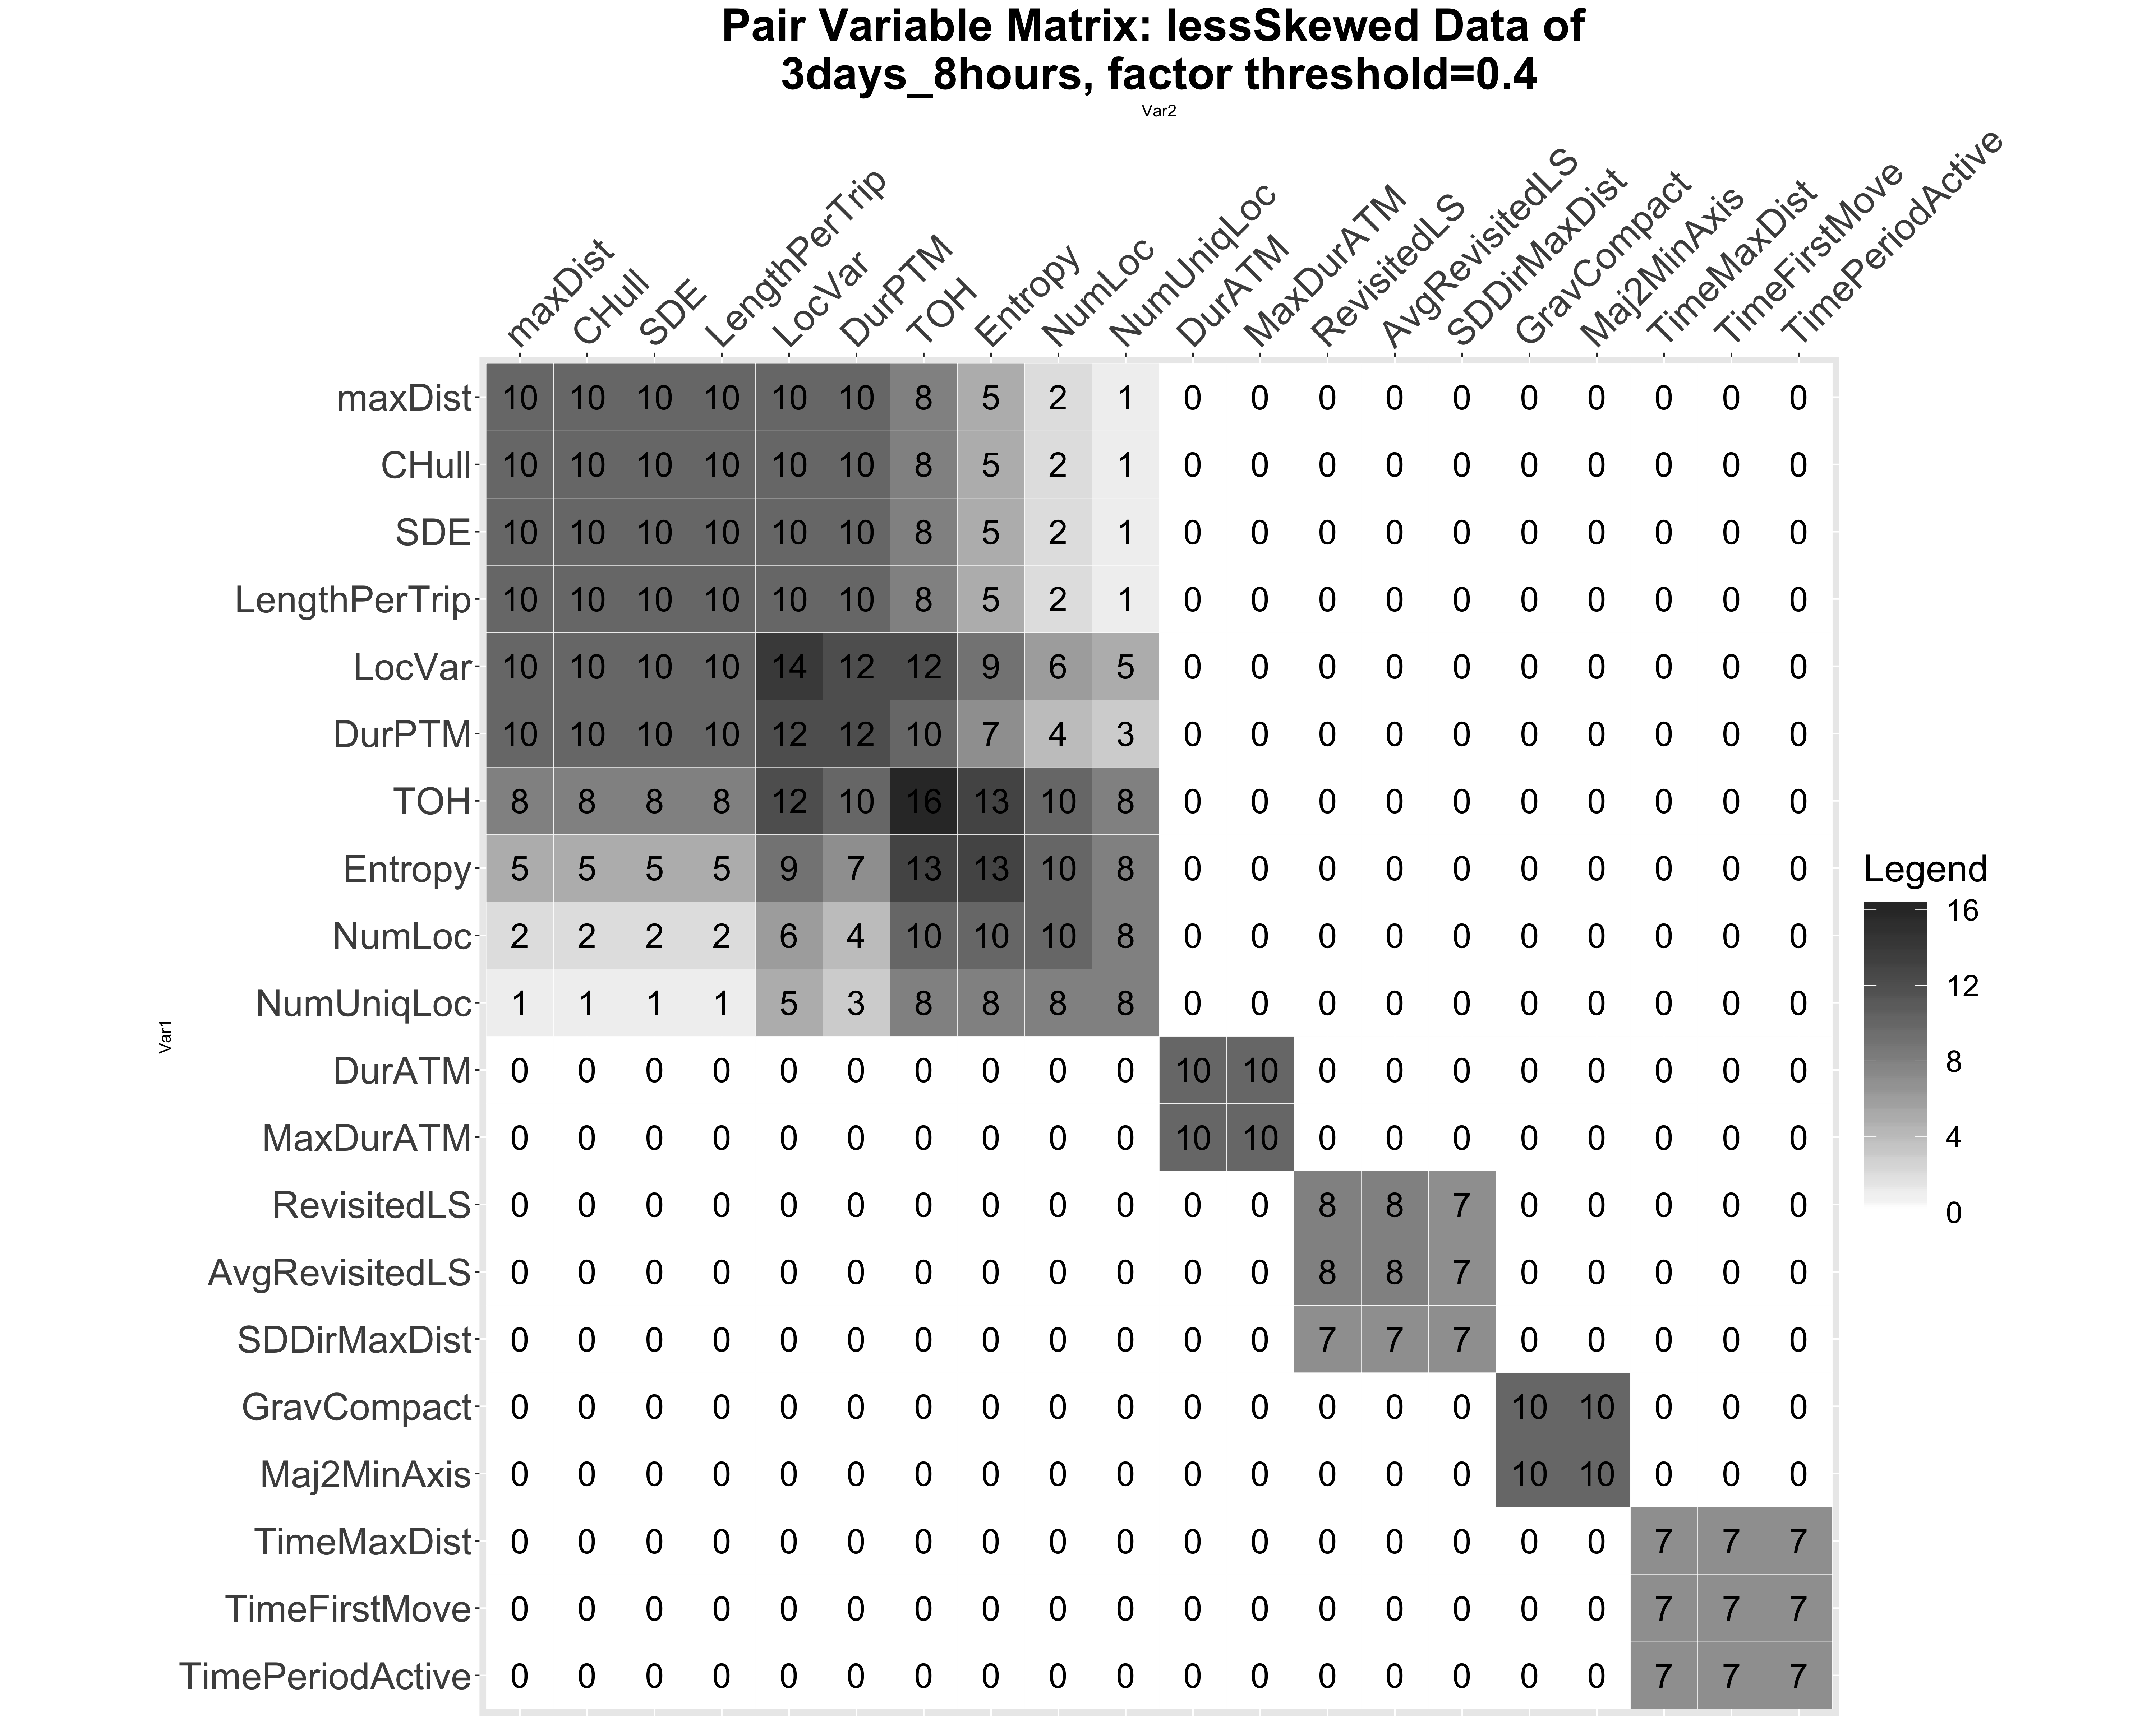
Figure S2: Exploratory factor analysis (EFA) summary matrix for the 10 runs of random day selection, with the inclusion criteria 3 days of at least 8 hours per participant.

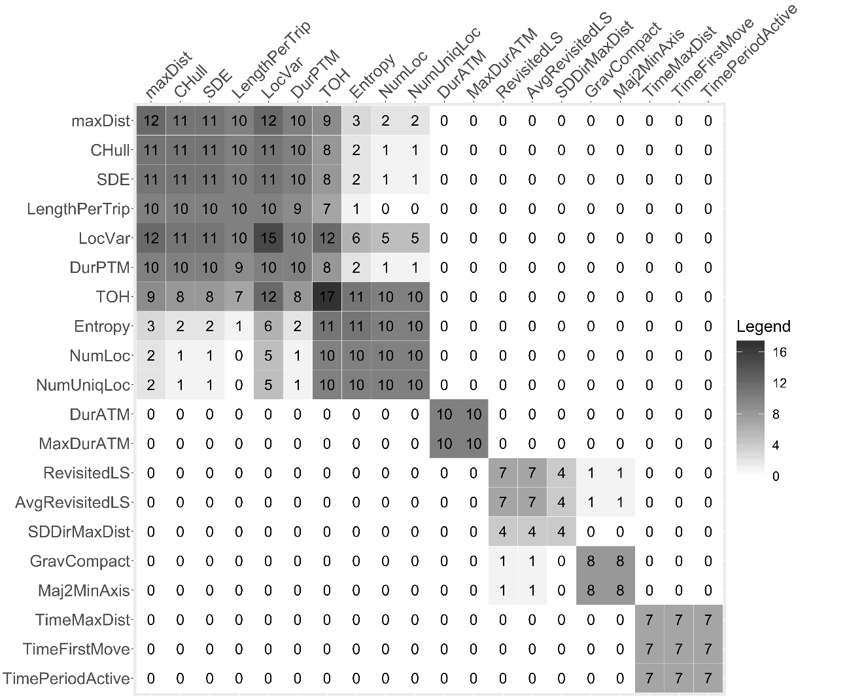
Figure S3: EFA summary matrix for the 10 runs of random day selection, with the inclusion criteria 4 days of at least 8 hours per participant.
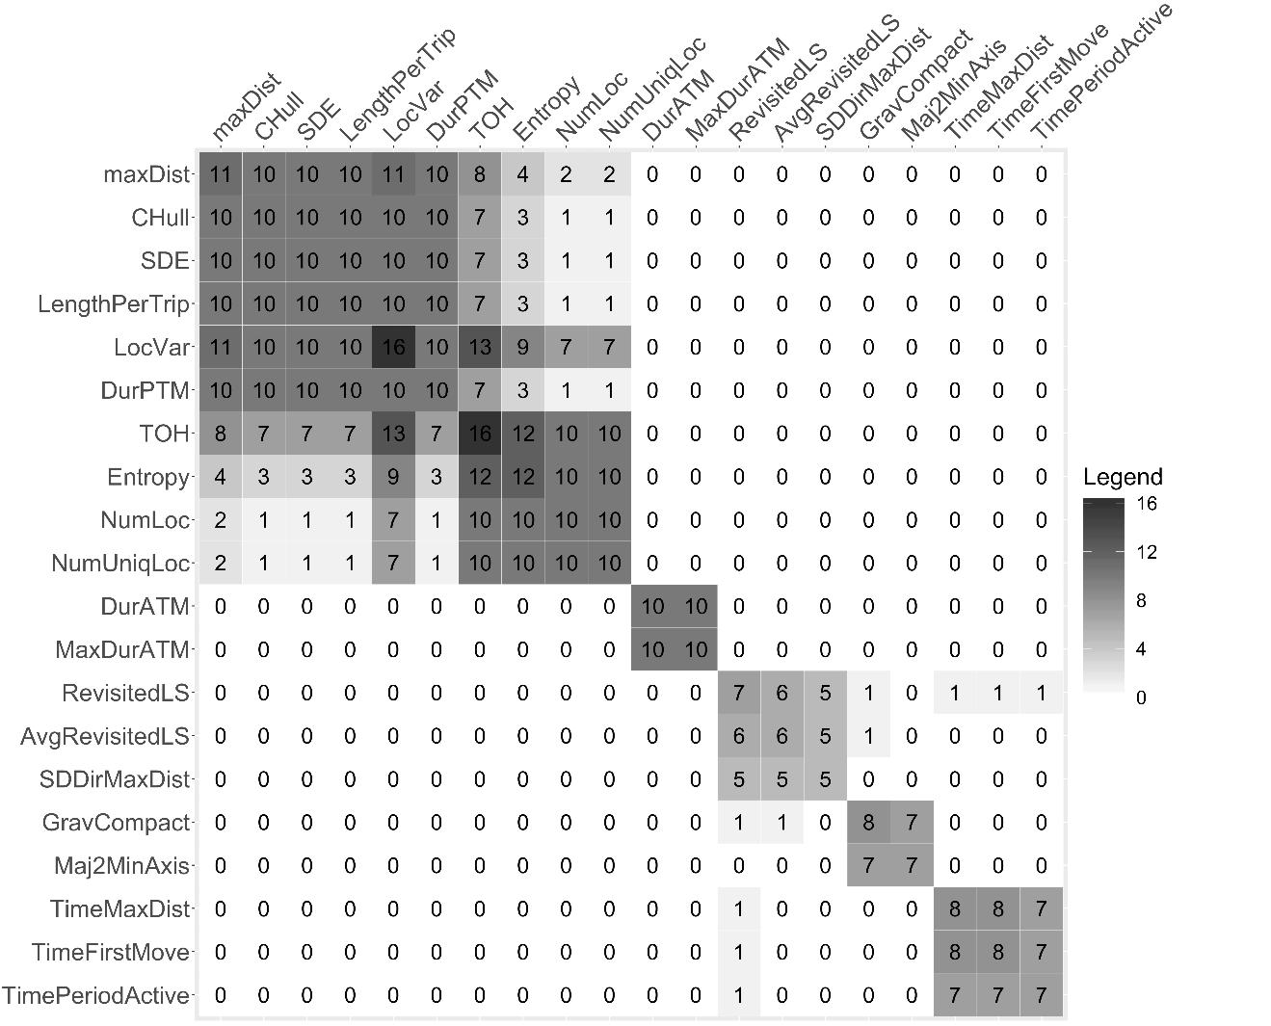
Figure S4: EFA summary matrix for the 10 runs of random day selection, with the inclusion criteria 4 days of at least 9 hours per participant.
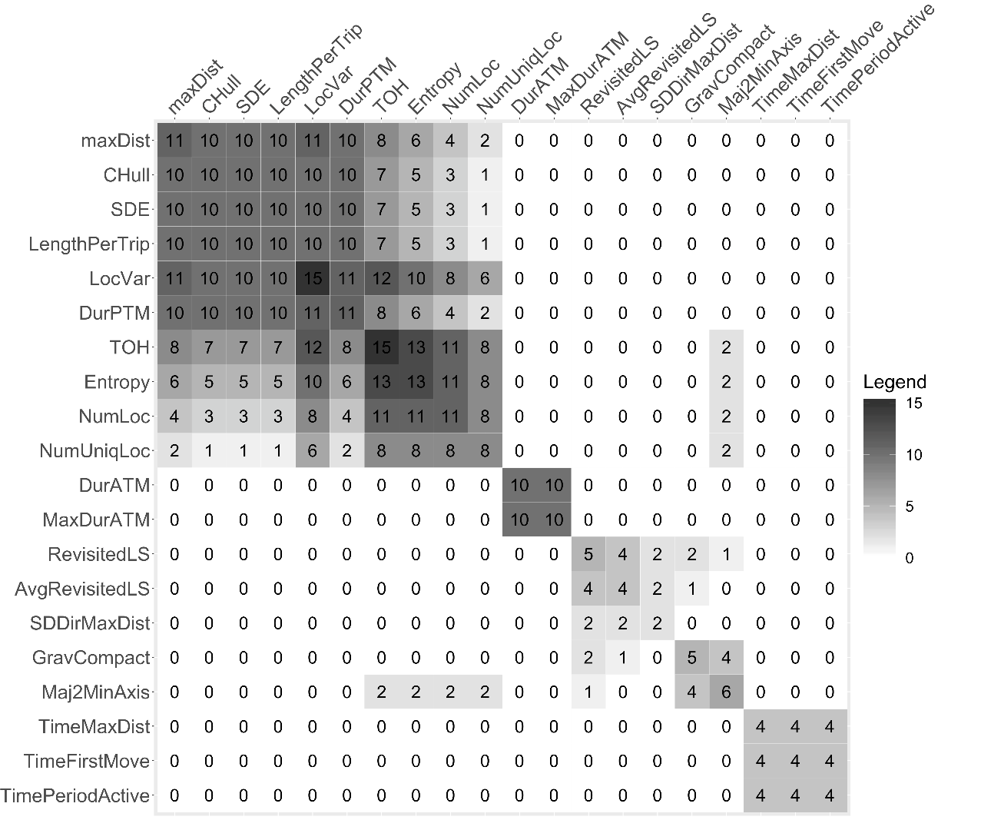
Figure S5: EFA summary matrix for the 10 runs of random day selection, with the inclusion criteria of 4 days with at least 10 hours per participant.

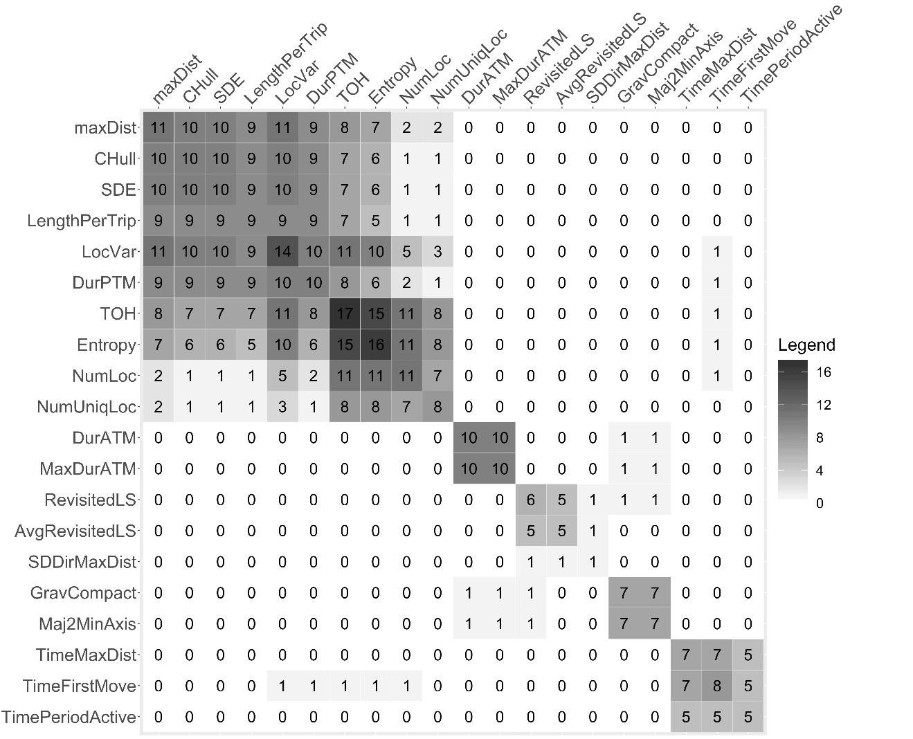
Figure S6: EFA summary matrix for the 10 runs of random day selection, with the inclusion criteria 5 days with at least 10 hours per participant.

References for Additional File 1
1. Harada K, Lee S, Lee S, Bae S, Harada K, Suzuki T, et al. Objectively-measured outdoor time and physical and psychological function among older adults. Geriatrics and Gerontology International. 2017;17(10):1455–62.
2. Harada K, Lee S, Lee S, Bae S, Harada K, Shimada H. Changes in objectively measured outdoor time and physical, psychological, and cognitive function among older adults with cognitive impairments. Archives of Gerontology and Geriatrics [Internet]. 2018 Sep 1 [cited 2019 Jan 24];78:190–5. Available from: https://www.sciencedirect.com/science/article/pii/S0167494318301171
3. Kaspar R, Oswald F, Wahl H-W, Voss E, Wettstein M. Daily mood and out-of-home mobility in older adults: does cognitive impairment matter? Journal of Applied Gerontology [Internet]. 2015 Feb;34(1):26–47. Available from: http://jag.sagepub.com/cgi/doi/10.1177/0733464812466290
4. Wahl H-W, Wettstein M, Shoval N, Oswald F, Kaspar R, Issacson M, et al. Interplay of cognitive and motivational resources for out-of-home behavior in a sample of cognitively heterogeneous older adults: findings of the SenTra project. Journals of Gerontology Series B: Psychological Sciences and Social Sciences. 2013;68(5):691–702.
5. Blamoutier M, Boissy P, Brière S, Faucher G, Lauzé M, Duval C. Is a decrease of grip strength associated with community mobility restriction in dynapenic older women? JCSM Clinical Reports [Internet]. 2018;3(1):1–9. Available from: https://jcsm-clinical-reports.info/index.php/jcsm-cr/article/view/42
6. Giannouli E, Bock O, Mellone S, Zijlstra W. Mobility in old age: capacity is not performance. BioMed Research International [Internet]. 2016;(February):1–8. Available from: http://www.hindawi.com/journals/bmri/2016/3261567/
7. Giannouli E, Bock O, Zijlstra W. Cognitive functioning is more closely related to real-life mobility than to laboratory-based mobility parameters. European Journal of Ageing. 2018;1–9.
8. Cuignet T, Perchoux C, Caruso G, Klein O, Klein S, Chaix B, et al. Mobility among older adults: deconstructing the effects of motility and movement on wellbeing. Urban Studies [Internet]. 2019; Available from: https://journals.sagepub.com/doi/pdf/10.1177/0042098019852033
9. Tung JY, Rose RV, Gammada E, Lam I, Roy EA, Black SE, et al. Measuring life space in older adults with mild-to-moderate Alzheimer’s disease using mobile phone GPS. Gerontology. 2014;60:154–62.
10. Cornwell EY, Cagney KA. Aging in activity space: results from smartphone-based GPS-tracking of urban seniors. Journals of Gerontology: Social Sciences. 2017;72(5):864–75.
11. Takemoto M, Carlson JA, Moran K, Godbole S, Crist K, Kerr J. Relationship between objectively measured transportation behaviors and health characteristics in older adults. International Journal of Environmental Research and Public Health. 2015;12(11):13923–37.
12. Wettstein M, Wahl HW, Diehl MK. A multidimensional view of out-of-home behaviors in cognitively unimpaired older adults: examining differential effects of socio-demographic, cognitive, and health-related predictors. European Journal of Ageing. 2014;11(2):141–53.
13. Wettstein M, Wahl H-W, Shoval N, Oswald F, Voss E, Seidl U, et al. Out-of-home behavior and cognitive impairment in older adults: findings of the SenTra project. Journal of Applied Gerontology [Internet]. 2015;34(1):3–25. Available from: http://jag.sagepub.com/cgi/doi/10.1177/0733464812459373
14. Wettstein M, Wahl HW, Shoval N, Auslander G, Oswald F, Heinik J. Identifying mobility types in cognitively heterogeneous older adults based on GPS-tracking: what discriminates best? Journal of Applied Gerontology. 2015;34(8):1001–27.
15. Wettstein M, Wahl HW, Shoval N, Auslander G, Oswald F, Heinik J. Cognitive status moderates the relationship between out-of-home behavior (OOHB), environmental mastery and affect. Archives of Gerontology and Geriatrics [Internet]. 2014;59(1):113–21. Available from: http://dx.doi.org/10.1016/j.archger.2014.03.015
16. Boissy P, Blamoutier M, Brière S, Duval C. Quantification of free-living community mobility in healthy older adults using wearable sensors. Frontiers in Public Health [Internet]. 2018;6:1–13. Available from: https://www.frontiersin.org/article/10.3389/fpubh.2018.00216/full
17. Saeb S, Lattie EG, Schueller SM, Kording KP, Mohr DC. The relationship between mobile phone location sensor data and depressive symptom severity. PeerJ. 2016;4:e2537.
18. Saeb S, Zhang M, Karr CJ, Schueller SM, Corden ME, Kording KP, et al. Mobile phone sensor correlates of depressive symptom severity in daily-life behavior: an exploratory study. Journal of Medical Internet Research [Internet]. 2015 Jul 15;17(7):e175. Available from: http://www.jmir.org/2015/7/e175/
19. Isaacson M, Wahl H, Shoval N, Oswald F, Auslander G. The relationship between spatial activity and wellbeing-related data among healthy older adults: an exploratory geographic and psychological analysis. In: Samanta T, editor. Cross-Cultural and Cross-Disciplinary Perspectives in Social Gerontology [Internet]. Singapore: Springer Singapore; 2017. p. 203–19. Available from: http://link.springer.com/10.1007/978-981-10-1654-7
20. Sanchez M, Ambros A, Salmon M, Bhogadi S, Wilson RT, Kinra S, et al. Predictors of daily mobility of adults in peri-urban south India. International Journal of Environmental Research and Public Health. 2017;14(7):1–16.

