Additional file
Table S1. Correlation Between Variables.
 | Poverty | Limited Lang. | NDVI | Smoking Prev. | Depression Prev. | Obesity Prev. | PM_{2.5} | Uninsured | Minority | Temperature | O₃ | Asthma Prev.
Poverty | 1.00 | -0.01 | -0.19 | 0.62 | 0.37 | 0.56 | 0.17 | 0.46 | 0.35 | 0.40 | -0.22 | 0.64
Limited Lang. | -0.01 | 1.00 | -0.31 | -0.43 | -0.36 | -0.16 | 0.13 | 0.30 | 0.58 | 0.26 | 0.15 | -0.26
NDVI | -0.19 | -0.31 | 1.00 | 0.14 | 0.10 | 0.02 | 0.02 | -0.49 | -0.50 | -0.45 | -0.03 | 0.08
Smoking Prev. | 0.62 | -0.43 | 0.14 | 1.00 | 0.65 | 0.65 | 0.12 | 0.22 | -0.16 | 0.22 | -0.31 | 0.68
Depression Prev. | 0.37 | -0.36 | 0.10 | 0.65 | 1.00 | 0.27 | 0.20 | 0.06 | -0.30 | 0.11 | -0.21 | 0.65
Obesity Prev. | 0.56 | -0.16 | 0.02 | 0.65 | 0.27 | 1.00 | 0.21 | 0.31 | 0.18 | 0.37 | -0.25 | 0.43
PM_{2.5} | 0.17 | 0.13 | 0.02 | 0.12 | 0.20 | 0.21 | 1.00 | 0.05 | 0.21 | 0.45 | -0.20 | 0.12
Uninsured | 0.46 | 0.30 | -0.49 | 0.22 | 0.06 | 0.31 | 0.05 | 1.00 | 0.49 | 0.50 | -0.08 | 0.17
Minority | 0.35 | 0.58 | -0.50 | -0.16 | -0.30 | 0.18 | 0.21 | 0.49 | 1.00 | 0.55 | -0.02 | 0.04
Temperature | 0.40 | 0.26 | -0.45 | 0.22 | 0.11 | 0.37 | 0.45 | 0.50 | 0.55 | 1.00 | -0.30 | 0.10
O₃ | -0.22 | 0.15 | -0.03 | -0.31 | -0.21 | -0.25 | -0.20 | -0.08 | -0.02 | -0.30 | 1.00 | -0.09
Asthma  Prev. | 0.64 | -0.26 | 0.08 | 0.68 | 0.65 | 0.43 | 0.12 | 0.17 | 0.04 | 0.10 | -0.09 | 1.00

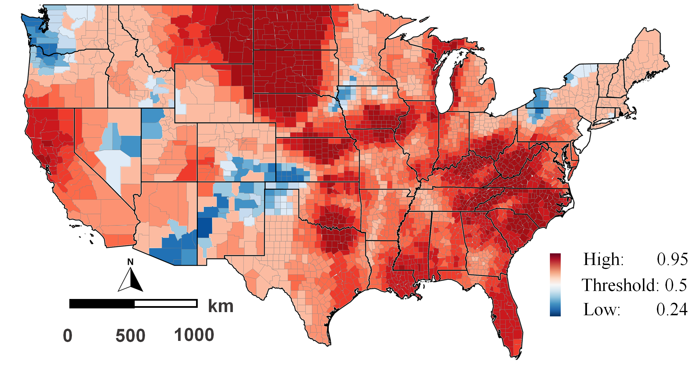 | 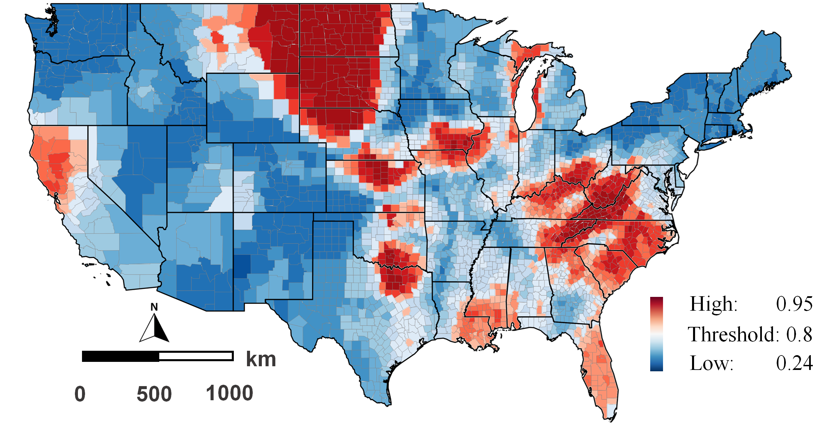

Fig S1. Local Determinant (OUT-OF-BAG R²) of GWRF Model: a. red areas explaining OUT-OF-BAG R² (> 0.5), b. red areas explaining OUT-OF-BAG R² (>0.8).

Additional file Text
Survey design weights are sometimes used to adjust a possible sample imbalance. The BRFSS employs iterative proportional fitting, or "raking," to account for demographic disparities between the sampled individuals and the population they represent. As a result, the weighting approach is divided into design weight and raking.
The design weights are calculated using the weight of each geographic stratum (STRWT), the number of landline phones within a household (NUMPHON2), and the number of adults who use those phones (NUMADULT). For cell phone respondents, both NUMPHON2 and NUMADULT are set to 1. The formula for the design weight is as follows:
Design Weight = STRWT * (1/NUMPHON2) * NUMADULT
The stratum weight (STRWT) accounts for differences in the probability of selection among strata (subsets of area code/prefix combinations). It is the inverse of the sampling fraction of each stratum.
Then to calculate final weight, BRFSS rakes the design weight to eight margins (gender by age group, race/ethnicity, education, marital status, tenure, gender by race/ethnicity, age group by race/ethnicity, and phone ownership). In addition, BRFSS uses weight trimming to increase the value of extremely low weights and decrease the value of extremely high weights. The objective of weight trimming is to reduce errors in the outcome estimates caused by unusually high or low weights in some categories [50].

