Additional file 1
Image S1. A visual represenation of the different greenness measures for Luxembourg City at study wave 1.
Luxembourg City
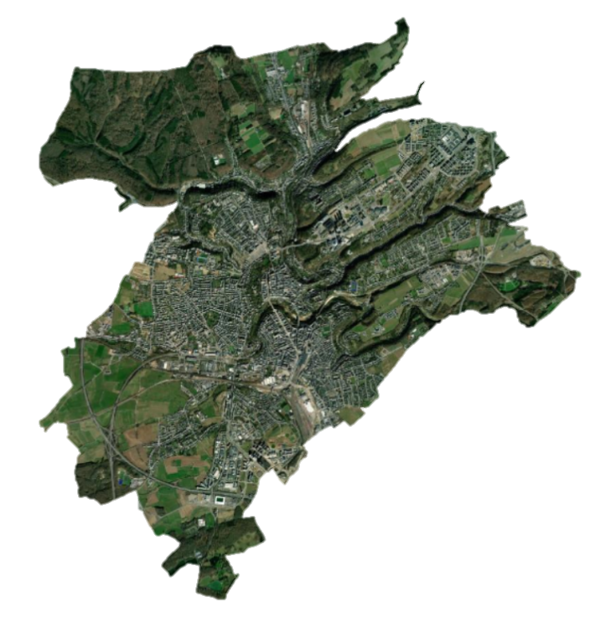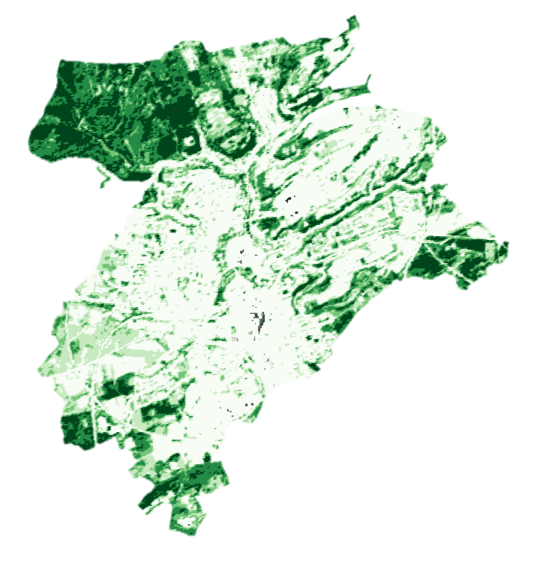
a) Hybrid photo b) Soil-adjusted vegetation index (SAVI)
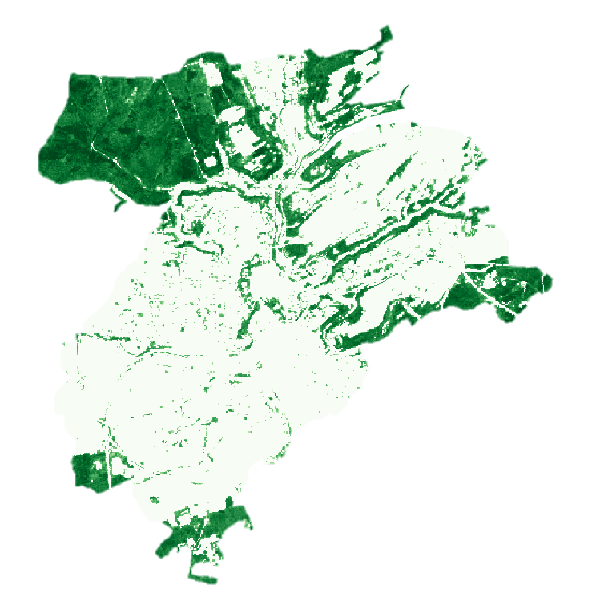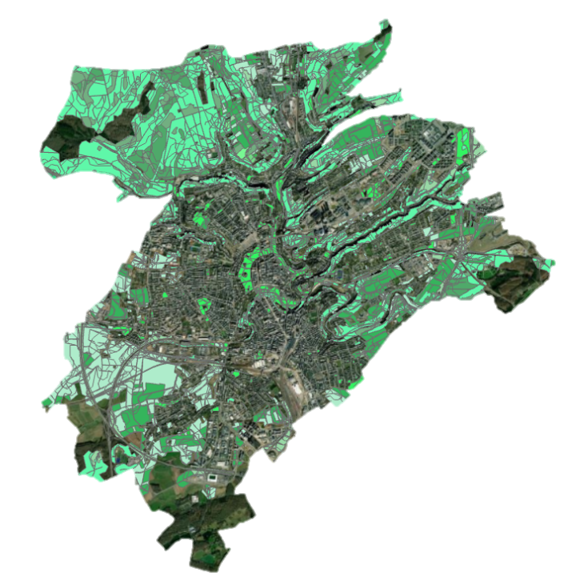
c) Tree cover density (TCD) d) Green land use mix (GLUM)
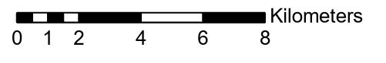
Image S2. A visual represenation of street network buffers and built environment characteristics at study wave 1.
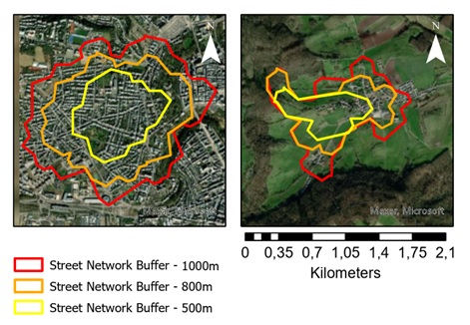
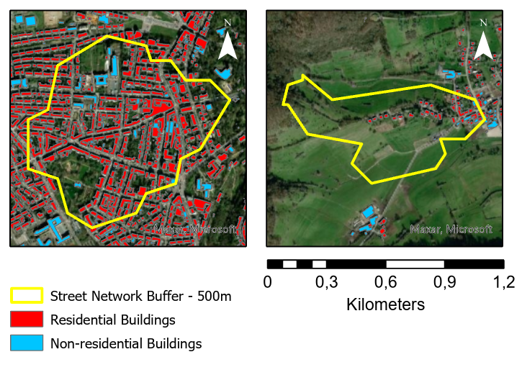
Above: the three different street network buffer sizes for participants living in an urban (left) and rural (right) area, below: built environment characteristics for participants living in an urban (left) and rural (right) area.

Table S1. Spearman correlation matrix of the three outcome measures and environmental covariates for the main buffer (1000m).

 | TCD | SAVI | GLUM | Residential Building Density | Nonresidential Building Density | Housing Price
TCD | 1,0000
SAVI | 0,3362 | 1,0000
GLUM | 0,3982 | 0,7095 | 1,0000
Residential Building Density | -0,0528 | -0,7318 | -0,7311 | 1,0000
Nonresidential Building Density | -0,2287 | -0,7279 | -0,6658 | 0,6145 | 1,0000
Housing Price | -0,1756 | -0,3889 | -0,1973 | 0,2453 | 0,2042 | 1,0000
TCD = tree cover density, SAVI = soil adjusted vegetation index, and GLUM = green land use mix
Table S2. Summary of BDLTC building classification for both data collection periods
 | BDLTC 2008 |  |  | BDLTC 2018
1 | 4.5 BATIMENT | bâtiment autre que ceux distingués par la suite |  | 4.1 BATIMENT
2 | 4.6 BATI_INDUS | bâtiment d'activité industrielle ou artisanale |  | attribut | Nature | commentaire
3 | 4.7 BATI_AGRI | bâtiment d'activité agricole | 1 | NULL | Bâtiment ordinaire | Bâtiment ordinaire, habitation, et construction à l’architecture ordinaire (toit en tuile ou en ardoise) ainsi que les bâtiments en construction.
4 | 4.8 BATI_COMME | bâtiment d'activité commerciale | 2 | 10000 | Bâtiment industriel | Bâtiment d’activité industrielle ou artisanale. Regroupe les hangars, ateliers, usines.
 | 4.9 BATI_PUB | bâtiment à caractère public ou administratif | 3 | 10001 | Centre de recyclage | Centre de recyclage
5 | 0 | Non codé | 4 | 10002 | Station d’épuration | Station d’épuration
6 | 1 | Hotel de ville | 5 | 20000 | Bâtiment agricole | bâtiment ayant une fonction de production agricole : élevage, laiterie, silo. Les fermes sont à traiter en bâtiment ordinaire.
7 | 2 | Mairie | 6 | 30000 | Bâtiment commercial | bâtiments commerciaux à l’architecture caractéristique (toit en tôle ou fibrociment). Un commerce de surface inférieure à 500 m² donc l’architecture est ordinaire est traité en bâtiment ordinaire.
8 | 3 | Gendarmerie | 7 | 40000 | Bâtiment publique | Bâtiment publique ne répondant pas aux cas listés cidessous.
9 | 4 | Police | 8 | 40101 | Gendarmerie | Gendarmerie
10 | 5 | Ministère | 9 | 40102 | Police | Bâtiment de gendarmerie accueillant le public
11 | 6 | Administration | 10 | 40103 | Douane | Centre douanier.
12 | 7 | Etablissement public | 11 | 40201 | Palais de justice | Palais de justice
13 | 8 | Centre de télécommunications | 12 | 40202 | Centre pénitentiaire | Centre pénitentiaire
14 | 9 | Bureau de Poste | 13 | 40301 | Hôtel de ville | Hôtel de ville
15 | 10 | Centre d'intervention | 14 | 40302 | Mairie | Mairie
16 | 11 | Centre douanier | 15 | 40303 | Ministère | Ministère
17 | 12 | Institutions européennes | 16 | 40304 | Institution européenne | Institution européenne
18 | 13 | Palais Grand-Ducal | 17 | 40305 | Autre administration | Autre administration accueillant du public.
19 | 14 | Palais de justice | 18 | 40401 | Bureau de poste | Bureau de poste
20 | 15 | Etablissement pénitentiaire | 19 | 40402 | Établissement publique | Établissement publique accueillant du public.
21 | 16 | Enceinte militaire | 20 | 40501 | Bâtiment militaire | Bâtiment situé dans une enceinte militaire.
22 | 17 | Stand de tir militaire | 21 | 40502 | Stand de tir militaire | Stand de tir militaire
23 | 18 | Aérogare | 22 | 40503 | Centre d’instruction militaire | Centre d’instruction militaire
24 | 19 | Ecole | 23 | 40601 | Centre d’intervention | Bâtiment principal de centre de secours, caserne de pompiers.
 | 20 |  | 24 | 40701 | École, collège, lycée, université | École, collège, lycée, université
 | 21 |  | 25 | 40702 | Maison d’enfants | Maison d’enfants
25 | 22 | Maison d'enfants | 26 | 40703 | Centre d’éducation différenciée | Centre d’éducation différenciée
26 | 23 | Centre d'education differenciee | 27 | 40704 | Conservatoire de musique | Conservatoire de musique
27 | 24 | Conservatoire de musique | 28 | 40705 | Garderie | Garderie
28 | 25 | Centre culturel | 29 | 40706 | Centre socio-éducatif | Centre socio-éducatif
29 | 26 | Théatre | 30 | 40801 | Gare | Gare ferroviaire, bâtiment accueillant le publique  (renseignement, vente de billet, …)
30 | 27 | Musée | 31 | 40802 | Aérogare | Bâtiment accueillant le public, vente, embarquement, débarquement, …
31 | 28 | Bibliothèque | 32 | 40803 | Centre de contrôle technique automobile | Centre de contrôle technique automobile
32 | 29 | Hôpital | 33 | 40901 | Bâtiment de camping | Accueil, sanitaires, …
33 | 30 | Maison de soins | 34 | 40902 | Auberge de jeunesse | Auberge de jeunesse
34 | 31 | Maison de retraite | 35 | 41001 | Théâtre | Théâtre
35 | 32 | Maison des aveugles | 36 | 41002 | Musée | Musée
36 | 33 | Sanatorium | 37 | 41003 | bibliothèque | bibliothèque
37 | 34 | Foyer | 38 | 41004 | Site historique | Site historique
38 | 35 | Croix-Rouge | 39 | 41005 | Casemate | Casemate
39 | 36 | Etablissement thermal | 40 | 41006 | Centre d’activités culturelles | Centre d’activités culturelles
40 | 37 | Auberge de jeunesse | 41 | 41101 | Bâtiment de parc public | Bâtiment de parc public accueillant du public
41 | 38 | Parc public | 42 | 41102 | Foire | Bâtiments accueillant du public dans une foire ou un centre d’exposition
42 | 39 | Camping | 43 | 41103 | Centre de loisir | Bâtiments accueillant du public inclus dans un centre de loisir
43 | 40 | Contrôle technique des automobiles | 44 | 41201 | Hôpital | Hôpital
44 | 41 | Foire | 45 | 41202 | Maison de soin | Maison de soin
45 | 42 | Centre de loisirs | 46 | 41203 | Sanatorium | Sanatorium
46 | 43 | Site historique | 47 | 41204 | Établissement thermal | Établissement thermal
47 | 44 | Casemate | 48 | 41205 | Croix rouge | Croix rouge
48 | 45 | Garderie | 49 | 41206 | Foyer | Foyer
 | 46 |  | 50 | 41207 | Maison de retraite | Maison de retraite
 | 47 |  | 51 | 41208 | Maison des aveugles | Maison des aveugles
 | 48 |  | 52 | 41301 | Usage mixte | Bâtiment accueillant du public répondant à plusieurs des critères énumérés.
 | 49 |  | 53 | 41302 | Kiosque | Kiosque
49 | 50 | Usage mixte | 54 | 41303 | Lavoir | Lavoir
50 | 4.10 SERRE | bâtiment vitré destiné à l'horticulture | 55 | 41304 | Centre de télécommunication | Centre de télécommunication
51 | 4.11 CONS_LEGER | bâtiment vitré destiné à l'horticulture | 56 | 41305 | Palais grand-ducal | Palais grand-ducal
52 | 4.13 BATI_REMAR | bâtiment remarquable dans le paysage | 57 | 50001 | Cathédrale | Cathédrale
 | 4.17 BATI_RELIG |  | 58 | 50002 | Église | Église
53 | 0 | Non codé | 59 | 50003 | Temple protestant | Temple protestant
54 | 1 | Cathédrale | 60 | 50004 | Église orthodoxe russe | Église orthodoxe russe
55 | 2 | Eglise | 61 | 50005 | Chapelle | Chapelle
56 | 3 | Eglise protestante | 62 | 50006 | Oratoire | Oratoire
57 | 4 | Eglise orthodoxe russe | 63 | 50007 | Couvent | Couvent
58 | 5 | Chapelle | 64 | 50008 | Abbaye | Abbaye
59 | 6 | Oratoire | 65 | 50009 | Grotte à caractère religieux | Grotte à caractère religieux
60 | 7 | Couvent | 66 | 50010 | Séminaire | Séminaire
61 | 8 | Abbaye | 67 | 50011 | Synagogue | Synagogue
62 | 9 | Grotte | 68 | 50012 | Morgue | Morgue
63 | 10 | Séminaire | 69 | 60000 | Bâtiment remarquable | bâtiment ayant une architecture qui les distingue (moulin, tour, donjon, château, …)
64 | 11 | Synagogue | 70 | 70001 | Piscine | Piscine
65 | 12 | Morgue | 71 | 70002 | Centre omnisport | Centre omnisport
 | 4.22 CENT_SPORT |  | 72 | 80000 | Serre | Serre de construction pérenne avec armature maçonnée et vitres
66 | 0 | Omnisport | 73 | 90000 | Construction légère | Cabane, baraque, abris permanent
67 | 1 | Piscine | 74 | 100000 | Bâtiment parking | Immeuble de parking réservé uniquement à cet usage.
68 | 2.2 GARE |  | 75 | 110000 | Bâtiment tertiaire | Bâtiment à usage tertiaire signalé par l’ACT.
 |  |  | 76 | 50000 | Batiment religieus | Non codé

Data imputation method specification
Two full ORISCAV datasets were used for data imputations (1432 respondents in Wave 1, 1558 respondents in Wave 2). At the first stage, data cleaning and variable reformatting were performed. Namely, the following cleaning steps were conducted:
- Vegetable and fruit consumption was summarised as variables tot_vegfr_1 (Wave 1) and tot_vegfr_2 (Wave 2)
- Variable ALCOOL_J_V2 was categorised into ALCOOL_S_V2 (Wave 2)
- IPAQ time variables were summarised as APINTHE_T, APMODHE_T, APMARHE_T, APASSH_T (Wave 1) and APINTHE_T_V2, APMODHE_T_V2, APMARHE_T_V2, APASSH_T_V2 (Wave 2)
- Faulty IPAQ data was either set to NA or truncated, in accordance with the “IPAQ – Short form” data cleaning guide
- Sedentary behaviour time variables were combined into TVSEMH_T, TVREPH_T, ORDSEMH_T, ORDREPH_T (Wave 1) and TVSEMH_T_V2, TVREPH_T_V2, ORDSEMH_T_V2, ORDREPH_T_V2 (Wave 2)
- Faulty Sedentary Behaviour data, exceeding the total limit of 16h per day was set to NAs
- ecran_travail, ecran_repos were excluded from the dataset, as they were equal to TVSEMH_T+ORDSEMH_T and TVREPH_T+ORDREPH_T correspondingly
- ECRAN_TRAVAIL_V2, ECRAN_REPOS_V2 were excluded from the dataset, as they were equal to TVSEMH_T_V2 and TVREPH_T_V2 correspondingly
The proportions of complete cases of IPAQ Wave 1, Sedentary Behaviour Wave 1, IPAQ Wave 2, and Sedentary Behaviour Wave 2 were 94%, 97%, 56%, and 44% correspondingly. Therefore, the largest proportion of missing data among all the parts was 56%. Thereof, the number of copies of the imputed datasets was set to 60 (>56).
The following list of variables was tested for correlation/association with IPAQ variables, Sedentary Behaviour variables and APASSH_T variable in Wave 1: SM_obesity_ATP3, Tryg_ATP3, HDL_ATP3, BP_ATP3, diabete_ATP3, SM_ATP3, Plasma, gluc, hemgl, insu, choltot, hdl, ldl, trig, crea, crp, apoa, apob, aciur, got, gpt, gamm, PAS, PAD, bmi, NRJ, tot_vegfr_1, Q59, pratsport, sexe, age, European_country, marital_status, dip_c3, Activite_cat, work_status, revenu_equivalent_adulte, nbe, distribfumeurs,alcohol_consumption, sante_c, antper1, antper2,antper3, antper4, antper5, antper6, antper7, antper8, antper9, antper10, antper11, antper12,antper13, antper14, dorm, alim, poids, soci, stress, actiphy, fumee, HOMA_IR, creauri, leuco, eryth, plaq, hemo, hema, pdsv, taiv, ttaiv, thanv, Ressource_perception, score_morbidite,
The following list of variables was tested for correlation/association with IPAQ variables, Sedentary Behaviour variables and APASSH_T_V2 variable in Wave 2: SM_OBESITY_ATP3_V2, TRYG_ATP3_V2, HDL_ATP3_V2, BP_ATP3_V2, DIABETE_ATP3_V2, SM_ATP3_V2, HOMA_IR_V2, PLASMA_V2, GLUC_N_V2, HEMGL_N_V2, INSU_N_V2, CHOLTOT_N_V2, HDL_N_V2, LDL_N_V2, TRIG_N_V2, CREA_N_V2, CREAURI_N_V2, CRP_N_V2, APOA_N_V2, APOB_N_V2, ACIUR_N_V2, GOT_N_V2, GPT_N_V2, GAMM_N_V2, PAS_V2, PAD_V2, WBC_N_V2, RBC_N_V2, PLAQ_N_V2, HGB_N_V2, HCT_N_V2, IMC_V2, POIDS_V2, TAIV_V2, TTAIV_V2, THANV_V2, NRJ_V2, tot_vegfr_2, Q59_V2, PRATSPOR_V2, SEXE_V2, AGE_V2, EUROPEAN_COUNTRY_V2, MARITAL_STATUS_V2, DIP_C3_V2, ACTIVITE_CAT_V2, WORK_STATUS_V2, RESSOURCE_PERCEPTION_V2, REVENU_EQUIVALENT_ADULTE_V2, NBE_V2, DISTRIBFUMEURS_V2, ALCOOL_J_V2, SANTE_PERCU_V2, SCORE_MORBIDITE_V2, INS_CARDIAQUE_V2, TROUBLE_RYTHME_V2, ANGINE_POIT_V2, INFARCTUS_V2, VALVES_V2, AVC_V2, HYPERTENSION_V2, ARTERITE_V2, VARICES_V2, ULCERE_V2, DOULEUR_POIT_V2, DIABETE_1_V2, DIABETE_2_V2, DYSLIPID_V2, DORM_V2, ALIM_V2, POIDS_QOL_V2, SOCIALE_V2, STRESS_V2, ACTIPHY_V2, FUMEE_V2, RATIO_TAILLE_HANCHE_V2, AD_ig_gradient_ENMO_0.24hr, AD_mean_ENMO_mg_0.24hr, AD_M2_ENMO_mg_0.24hr, AD_M0.5_ENMO_mg_0.24hr, AD_M0.25_ENMO_mg_0.24hr, dur_day_MVPA_bts_10_min_pla, dur_day_IN_bts_30_min_pla, dur_day_total_IN_min_pla, dur_day_total_LIG_min_pla, dur_day_total_MOD_min_pla, dur_day_total_VIG_min_pla, dur_day_total_MVPA_min_pla, power_law_exponent_alpha_SED, median_bout_length_s_SED, gini_index_SED.
A continuous variable was included in an imputation model if its Pearson correlation coefficient with the imputed section of the questionnaire was > 0.15 for Wave 2 (>0.4 for Wave 1), its Biserial correlation coefficient was >0.3 (for dichotomous variables) or its square root of Eta-square was >0.2 (for nominal variables). If two auxiliary variables that have demonstrated multi-collinearity, the one in the pair of such variables that had lower correlation/association with the imputed variable, was not included in an imputation model.
The following variables satisfied one of the conditions above and were used as auxiliary variables for imputations:
Imputed section | Auxiliary variables
IPAQ 1 | -
APASSH_T | dip_c3, Activite_cat, European_country
Sedentary Behaviour | Activite_cat
IPAQ 2 | EUROPEAN_COUNTRY_V2, ACTIVITE_CAT_V2, AGE_V2, PAS_V2, dur_day_MVPA_bts_10_min_pla, dur_day_total_MVPA_min_pla, AD_mean_ENMO_mg_0.24hr
APASSH_T_V2 | IP_C3_V2, ACTIVITE_CAT_V2, AGE_V2, TAIV_V2, REVENU_EQUIVALENT_ADULTE_V2, dur_day_total_LIG_min_pla, dur_day_IN_bts_30_min_pla, dur_day_total_IN_min_pla
Sedentary Behaviour 2 | CREAURI_N_V2, dur_day_total_LIG_min_pla, AD_mean_ENMO_mg_0.24hr, dur_day_IN_bts_30_min_pla, dur_day_total_IN_min_pla

All other potential auxiliary variables had very low association/correlation with the imputed sections, and were not used in imputation models, as their inclusion would not have benefitted in terms of estimates accuracy or bias reduction.
After applying MICE (alternatively named Fully Conditional Specification), there were 60 imputed datasets. The method used for every variable was PMM (Predictive Mean Matching).
Output files:
*the variable .imp represents to which data set each row belongs (0 – original dataset, 1-60 – imputed datasets)
**all newly created and imputed variables are located at the end of the data frames
Wave 1: imp_w1_tot_apr – 60 imputed datasets, plus the initial dataset in the beginning (top) of the data frame (in SPSS format ready for analyses) – 1432 observations per dataset
If first 1432 rows are deleted, then the data frame is in same format as in SAS, prepared for analyses and pooling.
Wave 2: imp_w2_tot_apr – 60 imputed datasets, with the initial dataset in the beginning (top) of the data frame (in SPSS format ready for analyses) – 1438 observations per dataset
If first 1558 rows are deleted, then the data frame is in same format as in SAS.
Wave1 + Wave 2: imp_tot_IPAQ_apr – 60 imputed datasets, with the initial dataset in the beginning (top) of the data frame (in SPSS format ready for analyses) – 633 observations per dataset, only MET’HOOD patients
If first 633 rows are deleted, then the data frame is in same format as in SAS.

