Supplementary File. Ecological Epidemiology Insights into Clonorchiosis Endemicity in Guangxi, China and Vietnam: A Comprehensive Machine Learning Analysis

1. Method- Environmental, Climatic, and Socio-Cultural Data Processing

1). Water Distance (m):
This variable represents the Euclidean (straight-line) distance from each spatial unit (5×5 km grid cell) to the nearest freshwater body (including rivers, lakes, and reservoirs), based on the Geomorphological Research Group data: http://gis.ess.washington.edu/data/vector/. This was computed using the distance() function in the R raster package, which calculates distance from each pixel to the closest “water” cell within a binary raster layer. Ocean coastlines were excluded because: Clonorchis sinensis is transmitted via freshwater fish and requires freshwater snail and fish intermediate hosts; transmission does not occur in brackish or marine environments.

2). Elevation and Slope:
Elevation data were obtained from the WorldClim v2.1 database at a spatial resolution of 5 × 5 km, which is derived from the Shuttle Radar Topography Mission (SRTM) digital elevation model (https://www.worldclim.org/data/worldclim21.html). Slope data were calculated from the same SRTM source using terrain processing tools, based on datasets provided by NASA and CGIAR-CSI (https://srtm.csi.cgiar.org/), and similarly resampled to a 5 × 5 km grid to maintain consistency across all environmental variables.

3). NDVI (Normalized Difference Vegetation Index):
NDVI values were extracted from MODIS MOD13Q1 satellite composites, averaged across 2000–2020 to capture long-term vegetation coverage. Values range from –1 to 1 and were resampled to a 5 km resolution to match other variables. NDVI data, representing vegetation cover and primary productivity, were obtained from the Moderate Resolution Imaging Spectroradiometer (MODIS) satellite dataset provided by the U.S. National Aeronautics and Space Administration (NASA). Specifically, we used long-term averaged NDVI composites spanning 2000 to 2020 at a spatial resolution of 5 × 5 km, consistent with the resolution of other environmental covariates. The NDVI dataset was accessed via the CGIAR-CSI SRTM portal (https://srtm.csi.cgiar.org/), which aggregates MODIS-derived vegetation indices for global applications.
To extract NDVI values at each Clonorchis sinensis occurrence site, we used the raster package in R. First, NDVI raster layers were projected and clipped to match the spatial extent of the study area. Georeferenced occurrence points were then used to extract pixel-level NDVI values using the extract() function. For each point, the NDVI value of the corresponding raster cell was assigned, allowing integration of vegetation information into the spatial database for downstream modeling.

4). Land Cover:
Land cover data were derived from the Moderate Resolution Imaging Spectroradiometer (MODIS) MCD12Q1 product, a global land cover dataset produced annually at a native resolution of 500 meters and distributed by the NASA Land Processes Distributed Active Archive Center (LP DAAC) (https://lpdaac.usgs.gov/products/mcd12c1v006/). For this study, we used the University of Maryland (UMD) land cover classification scheme, which categorizes land surface into 15 distinct classes (e.g., cropland, forest, urban, wetland, and grassland). The MCD12Q1 data were aggregated and reprojected to match a 5 × 5 km spatial resolution to ensure consistency with other environmental covariates used in the model.
To extract land cover values at each georeferenced Clonorchis sinensis occurrence and pseudo-absence location, we first resampled and clipped the land cover raster to the extent of the Guangxi–Vietnam study region. Using the raster package in R, the extract() function was applied to assign the dominant land cover class for each point. These categorical values were then included in the modeling framework to evaluate the potential role of landscape features in shaping C. sinensis transmission dynamics.

5) . Human Influence and Human Footprint Indices:
To account for anthropogenic pressure on the environment, we included two spatial datasets: the Human Influence Index (HII) and the Human Footprint (HFP). The HII quantifies direct human influence on terrestrial ecosystems by integrating eight variables: population density, land use/land cover, built-up areas, roads, railways, navigable rivers, coastlines, and nighttime lights. It is expressed on a 0–64 scale, where 0 represents no human impact and 64 denotes the highest cumulative human pressure. The dataset was compiled by the Wildlife Conservation Society (WCS) and the Center for International Earth Science Information Network (CIESIN), and accessed from the SEDAC data repository (https://sedac.ciesin.columbia.edu/downloads/metadata/wildareas-v2-human-influence-index-geographic.html).
To integrate these indices into our modeling framework, raster layers for HII and HFP were clipped to the extent of the study region (Guangxi, China, and Vietnam) and resampled to a spatial resolution of 5 × 5 km to match other environmental covariates. Using the raster package in R, values of both HII and HFP were extracted for each georeferenced Clonorchis sinensis presence point and pseudo-absence location using the extract() function. This enabled spatially explicit incorporation of human disturbance into the ecological risk modeling of liver fluke transmission.

6) . Bioclimatic Variables (BIO1–BIO19):
Nineteen bioclimatic variables representing temperature and precipitation trends, seasonality, and extremes were obtained from the WorldClim v2.1 database (https://www.worldclim.org/data/bioclim.html), which provides interpolated global climate surfaces derived from weather station data and remote sensing observations. These variables, widely used in ecological modeling, capture biologically meaningful aspects of climate that influence species distribution. The datasets used in this study were based on long-term averages over the period 1970–2000, at a spatial resolution of 5 × 5 km, consistent with the scale of other environmental layers.
To integrate these variables with Clonorchis sinensis occurrence data, we used the raster package in R. All 19 bioclimatic rasters (BIO1–BIO19) were spatially cropped to the study region encompassing Guangxi, China, and Vietnam, and aligned to a common coordinate reference system. Using the extract() function, we extracted the values of each bioclimatic variable at every georeferenced presence location of C. sinensis and corresponding pseudo-absence points.

2. LASSO Regression for Feature Selection in Risk Modeling
To identify the most relevant predictors associated with Clonorchis sinensis infection risk, we employed Least Absolute Shrinkage and Selection Operator (LASSO) regression, a regularization method that performs both variable selection and coefficient shrinkage to enhance model interpretability and prevent overfitting. This method is particularly suitable for high-dimensional ecological and epidemiological datasets with potentially collinear predictors.
LASSO regression was implemented using the glmnet package in R. The model fitting procedure used 10-fold cross-validation to identify the optimal value of the regularization parameter (λ), selected as the value that minimized the binomial deviance within one standard error (the “1-SE rule”). The model was trained on 70% of the data, with the remaining 30% reserved for independent testing.
The predictive performance of the LASSO-based model was assessed by computing the Area Under the Receiver Operating Characteristic Curve (AUC) for both the training and test datasets. ROC curves were plotted to compare sensitivity and specificity across different thresholds. The performance of the LASSO-reduced model was then compared with that of the full-variable logistic regression model to evaluate the trade-off between model simplicity and predictive power.

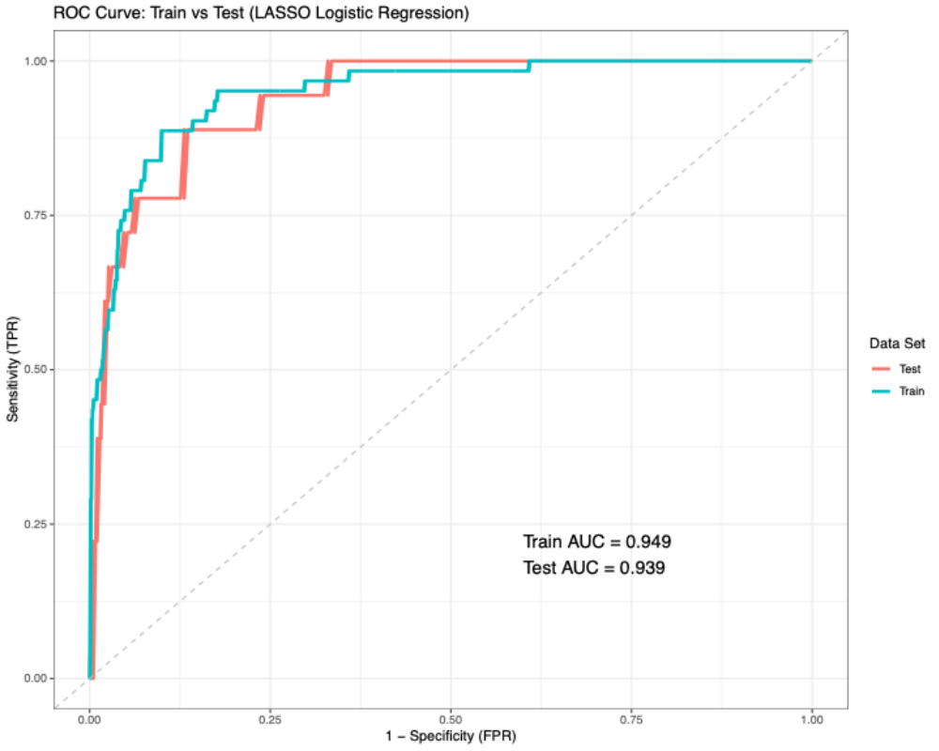
Figure S1: Receiver Operating Characteristic (ROC) curves for LASSO logistic regression model performance in training and test datasets. This figure illustrates the predictive performance of the LASSO-regularized logistic regression model in distinguishing Clonorchis sinensis infection risk based on selected environmental and socio-cultural predictors. The ROC curves are shown separately for the training set (blue) and test set (red). The area under the curve (AUC) for the training set is 0.949, and for the test set is 0.939, indicating high model discriminative ability with minimal overfitting. The dotted diagonal line represents the no-discrimination baseline (AUC = 0.5). Despite strong performance, this reduced-variable model was slightly inferior to the full model and was not selected for final prediction mapping.

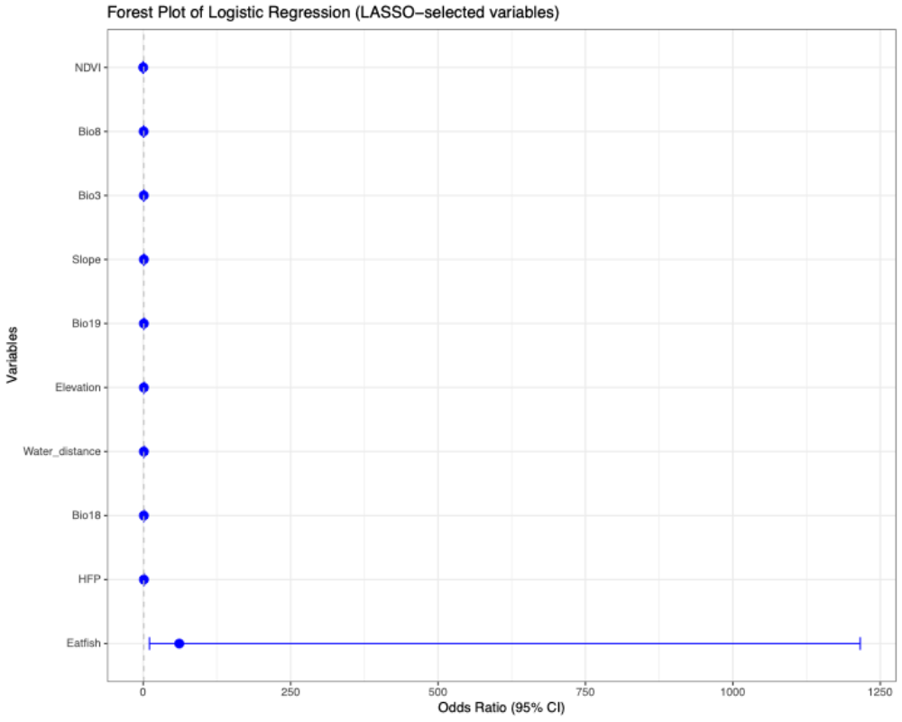
Figure S1: Forest plot of logistic regression using LASSO-selected variables. This figure displays the odds ratios (ORs) and 95% confidence intervals (CIs) for the predictor variables retained in the final logistic regression model following LASSO-based variable selection. A total of 10 variables were selected, including NDVI, multiple bioclimatic indicators (Bio3, Bio8, Bio18, Bio19), topographic features Slope, Water distance), land use/cover type, human footprint index (HFP), and the key socio-cultural factor—raw freshwater fish consumption (Eatfish). The horizontal axis represents the odds ratio on a continuous scale, with the vertical dotted line indicating the null effect (OR = 1).

The LASSO-regularized logistic regression model identified 10 key predictors associated with Clonorchis sinensis infection risk. The strongest predictor was raw freshwater fish consumption (Eatfish), which showed a markedly elevated odds ratio (OR = 61.11, 95% CI: 10.58–1215.89, p < 0.001), reinforcing its critical role in the transmission pathway. Human environmental disturbance, measured via the Human Footprint Index (HFP), was also positively associated with infection risk (OR = 1.09, 95% CI: 1.05–1.14, p < 0.001). Among the climatic predictors, precipitation of the warmest quarter (Bio18) and precipitation of the coldest quarter (Bio19) were significantly associated with infection, although Bio19 showed a modest inverse effect (OR = 0.99, p = 0.051). Vegetation cover, as represented by NDVI, had a strong protective association (OR = 0.0019, 95% CI: 0.00004–0.078, p = 0.001). Other environmental features such as elevation, slope, distance to water bodies, and temperature-related bioclimatic variables (Bio3, Bio8) showed smaller or borderline significant effects.
