Additional File 3: Spatial distribution of the socio-economic disadvantage in South-East Queensland (SEQ)
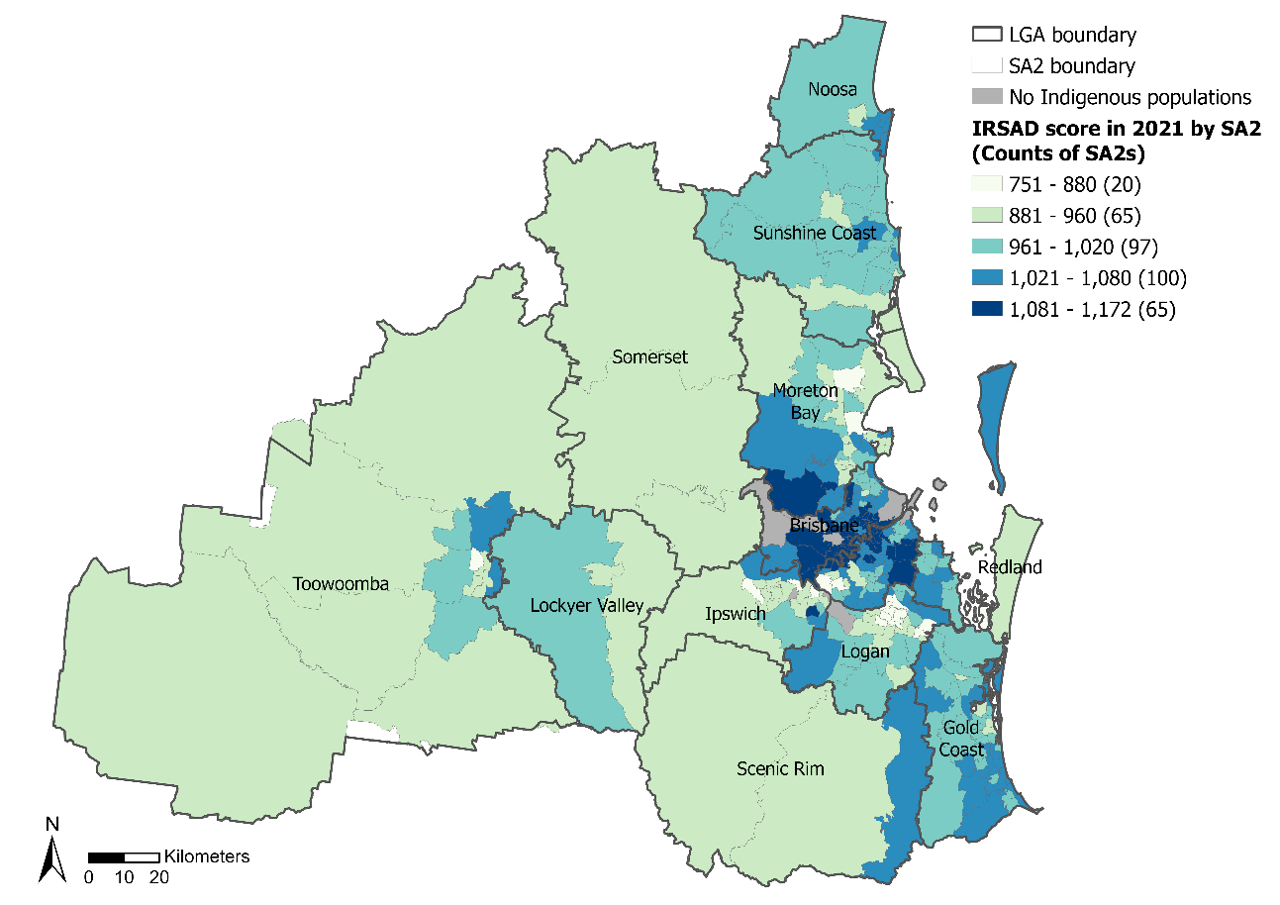
Fig. A. Distribution of the Index of Relative Socio-economic Advantage and Disadvantage (IRSAD) in 2021 across SEQ (Classification method: Natural Breaks (Jenks))
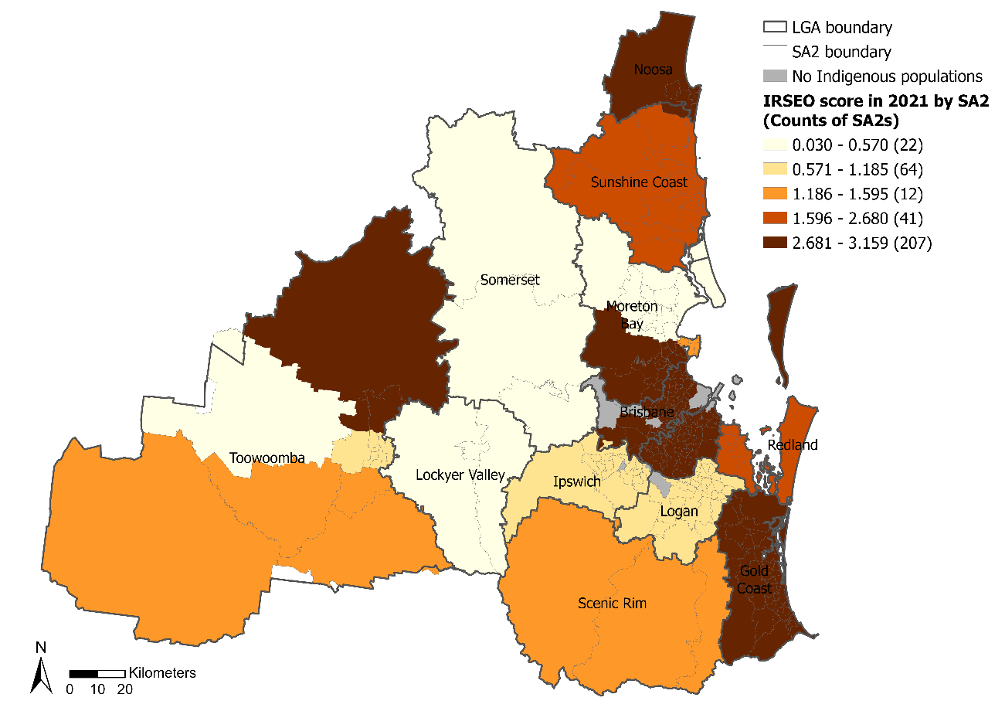
Fig. B. Distribution of the Indigenous Relative Socio-Economic Outcomes (IRSEO) scores in 2021 across SEQ (Classification method: Natural Breaks (Jenks))

