Supplemental Materials

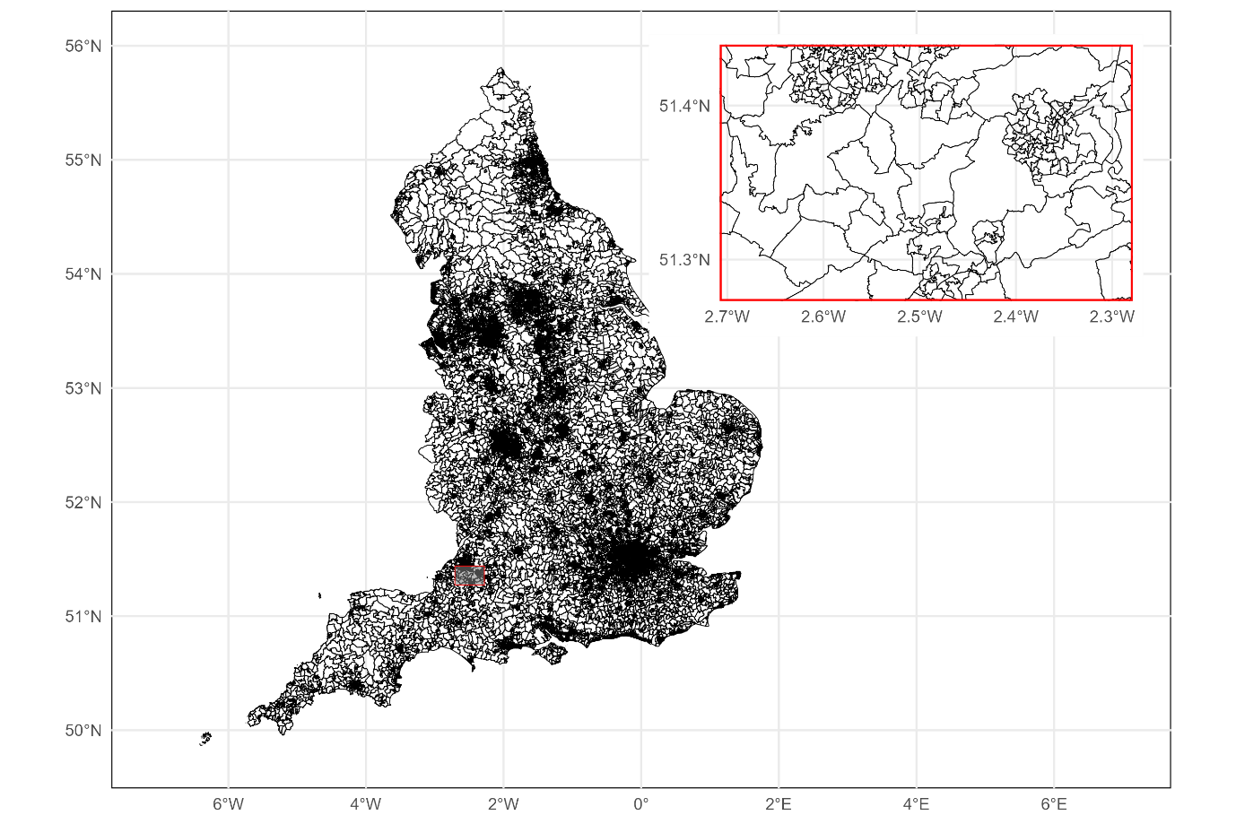
Figure 1 LSOAs with inset map showing Bath area and the differences in sizes between LSOAs
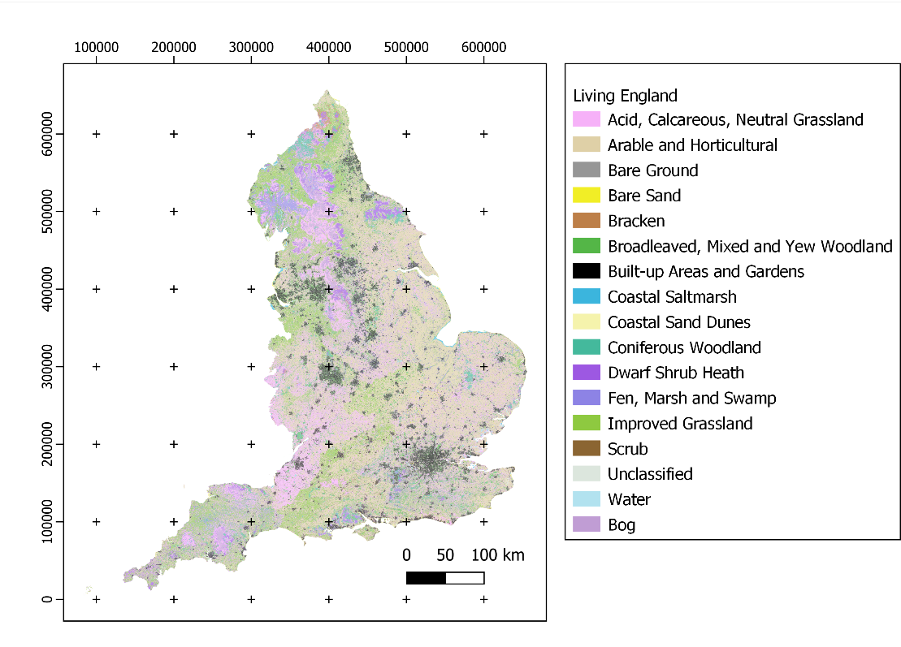
Figure 2 Living England Habitat map (Natural England 2022)
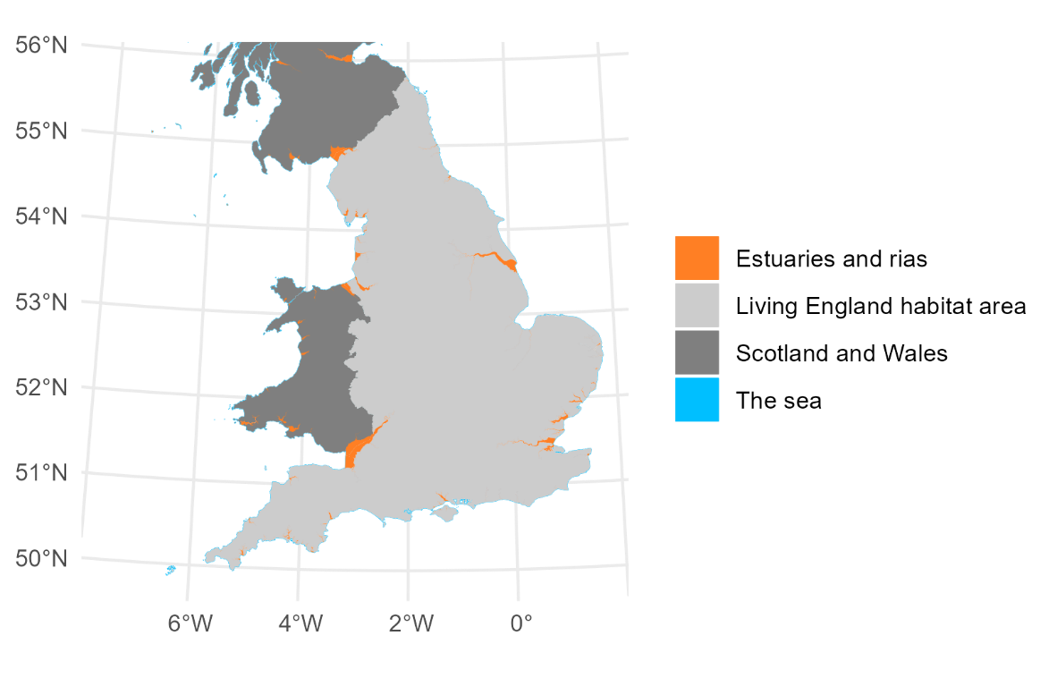
Figure 3 Additional data including estuaries and rias (Joint Nature Conservation Committee 2018a; Joint Nature Conservation Committee 2018b); Wales and Scotland boundaries (Ordnance survey 2022)

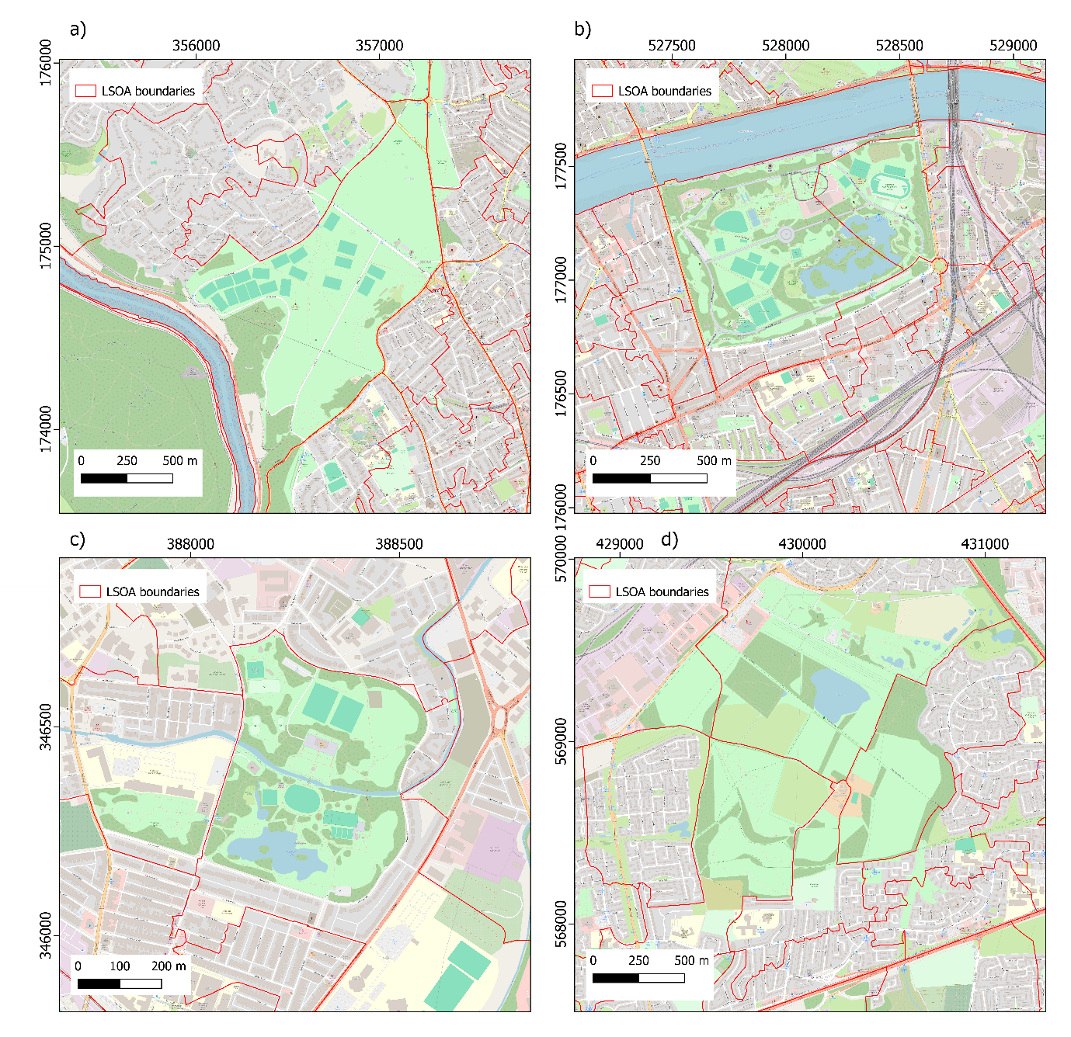
Figure 4 Example LSOA boundaries in a) Bristol, surrounding Clifton Downs; b) London, surrounding Battersea Park; c) Stoke-On-Trent surrounding Hanley Park; and d) Newcastle Upon Tyne, surrounding the Rising Sun Country Park

