Supplemental information
Table S1.- Spearman correlation among contextual neighbourhood variables.

 | Variable | 1 | 2 | 3 | 4 | 5 | 6 | 7 | 8 | 9
1 | Socioeconomic strata | 1.00 | -0.60 | 0.02 | 0.53 | 0.54 | -0.54 | 0.29 | -0.78 | -0.52
2 | Unmet basic needs index | -0.60 | 1.00 | 0.12 | -0.62 | -0.57 | 0.51 | -0.40 | 0.54 | 0.80
3 | % Subjects aged 20 to 59 | 0.02 | 0.12 | 1.00 | -0.38 | -0.35 | 0.08 | -0.09 | -0.22 | 0.20
4 | % Subjects aged 70 to 79 | 0.53 | -0.62 | -0.38 | 1.00 | 0.85 | -0.57 | 0.38 | -0.34 | -0.60
5 | % Subjects aged 80+ | 0.54 | -0.57 | -0.35 | 0.85 | 1.00 | -0.56 | 0.34 | -0.31 | -0.59
6 | % of Afro-Colombians | -0.54 | 0.51 | 0.08 | -0.57 | -0.56 | 1.00 | -0.53 | 0.35 | 0.55
7 | % Subjects aged 60+ in single-person households | 0.29 | -0.40 | -0.09 | 0.38 | 0.34 | -0.53 | 1.00 | -0.14 | -0.51
8 | % Households with overcrowded bedrooms | -0.78 | 0.54 | -0.22 | -0.34 | -0.31 | 0.35 | -0.14 | 1.00 | 0.33
9 | Block’s population density | -0.52 | 0.80 | 0.20 | -0.60 | -0.59 | 0.55 | -0.51 | 0.33 | 1.00

Table S2.- Results of the estimation of the first part of the model for vaccination and death outcomes.

Variable | Category | Only one dose OR (95%CrI) | Full schedule OR (95%CrI) | Booster OR (95%CrI) | Death OR (95%CrI)
Sex | Female | 1.03 (1.01-1.06)** | 1.05 (1.03-1.07)** | 1.06 (1.03-1.09)** | 1.06 (1.04-1.08)**
Age | 25-34 | 0.85 (0.78-0.92)** | 0.96 (0.92-0.99)** | 0.95 (0.91-0.99)** | 0.92 (0.88-0.96)**
Age | 35-44 | 0.80 (0.75-0.85)** | 0.94 (0.91-0.97)** | 0.91 (0.88-0.94)** | 0.89 (0.81-0.97)**
Age | 45-54 | 0.80 (0.70-0.90)** | 0.99 (0.89-1.09) | 0.97 (0.95-0.99)** | 0.94 (0.90-0.98)**
Age | 55-64 | 0.83 (0.69-0.97)** | 1.07 (1.01-1.13)** | 1.04 (1.01-1.07)** | 1.00 (0.95-1.05)
Age | 65-74 | 0.87 (0.85-0.89)** | 0.92 (0.87-0.97)** | 0.94 (0.90-0.98)** | 0.95 (0.92-0.98)**
Age | 75 or more | 0.87 (0.83-0.91)** | 0.87 (0.82-0-92)** | 0.87 (0.81-0.93)** | 0.89 (0.80-0.98)**
Diabetes | Yes | 2.40 (2.20-2.60)** | 2.19 (2.07-2.31)** | 2.10 (1.99-2.21)** | 2.19 (1.94-2.44)**
Asthma | Yes | 1.92 (1.64-2.20)** | 1.71 (1.64-1.78)** | 1.62 (1.42-1.82)** | 1.74 (1.52-1.96)**
Cardiovascular disease | Yes | 2.21 (1.59-2.83)** | 3.10 (2.83-3.37)** | 2.49 (2.16-2.82)** | 2.35 (2.00-2.70)**
COPD | Yes | 2.48 (1.93-3.03)** | 3.08 (2.92-3.24)** | 2.50 (2.06-3.02)** | 2.40 (1.96-2.84)**
Cancer | Yes | 2.67 (1.57-3.77)** | 3.85 (3.67-4.03)** | 3.09 (2.60-3.58)** | 2.75 (2.24-3.26)**
Kidney failure | Yes | 1.39 (1.05-1.73)** | 1.53 (1.23-1.83)** | 1.70 (1.21-2.19)** | 1.50 (1.22-1.78)**
Obesity | Yes | 3.22 (2.75-3.69)** | 2.95 (2.75-3.15)** | 2.67 (2.30-3.04)** | 2.87 (2.45-3.29)**
Hypertension | Yes | 3.62 (3.47-3.77)** | 3.45 (3.23-3.67)** | 3.46 (3.12-3.80)** | 3.55 (3.16-3.94)**
Hypothyroidism | Yes | 3.39 (3.18-3.60)** | 3.50 (3.40-3.60)** | 3.38 (3.17-3.59)** | 3.44 (2.87-4.03)**
Smoker | Yes | 1.88 (1.75-2.01)** | 1.98 (1.68-2.22)** | 1.72 (1.49-1.95)** | 1.80 (1.51-2.09)**
Occupation | Professionals | 2.11 (1.97-2.24)** | 1.98 (1.86-2.10)** | 1.95 (1.85-2.05)** | 2.07 (1.93-2.21)**
Occupation | Administrative Assistant | 2.03 (1.91-0.12)** | 1.95 (1.81-2.09)** | 1.92 (1.78-2.06)** | 2.00 (1.83-2.17)**
Occupation | Service And Sales Workers | 2.70 (2.45-2.95)** | 2.62 (2.45-2.79)** | 2.39 (2.25-2.53)** | 2.52 (2.30-2.74)**
Occupation | Technicians And Associated Professionals | 2.24 (2.05-2.43)** | 2.16 (2.05-2.27)** | 1.99 (1.88-2.10)** | 2.11 (1.95-2.28)**
Occupation | Manual Workers | 2.10 (1.86-2.34)** | 2.15 (1.89-2.41)** | 2.15 (1.90-2.40)** | 2.11 (1.90-2.32)**
Occupation | Student | 3.83 (2.73-4.93)** | 4.21 (3.31-5.11)** | 3.96 (3.47-4.45)** | 3.89 (3.28-4.50)**
Occupation | Armed Forces, Police, Security, Protection | 3.56 (3.39-3.73)** | 3.58 (2.77-4.39)** | 3.25 (2.78-3.72)** | 3.31 (2.79-3.83)**
Occupation | Retired | 3.38 (2.98-3.78)** | 2.77 (2.40-3.14)** | 2.76 (2.41-3.11)** | 2.99 (2.58-3.40)**
Occupation | Unemployed | 4.22 (3.57-4.87)** | 3.88 (3.08-4.67)** | 4.21 (3.39-5.03)** | 4.13 (3.53-4.73)**
Ethnicity | Afro-Colombian | 1.99 (1.78-2.20)** | 2.11 (1.82-2.40)** | 1.98 (1.76-2.20)** | 1.95 (1.77-2.13)**
Ethnicity | Raizal, Indigenous or Gypsy | 2.36 (1.34-3.38)** | 3.17 (2.56-3.78)** | 2.82 (2.06-3.58)** | 2.48 (2.37-2.59)**

OR: Odds ratio
95%CrI : 95% credible interval

** The credible interval at 95% did not contain the unity.
* The credible interval at 90% did not contain the unity.

Figure S1.- Unmet basic needs (UBN) index quartiles against strata.

Own construction based on data from DANE^{[11]}

Figure S2.- Daily effective reproduction number and daily COVID-19 vaccines applied before and during the study period.

Own construction based on data from SIVIGILA^{[7]}

Figure S3a. Residual analysis of the models

First part
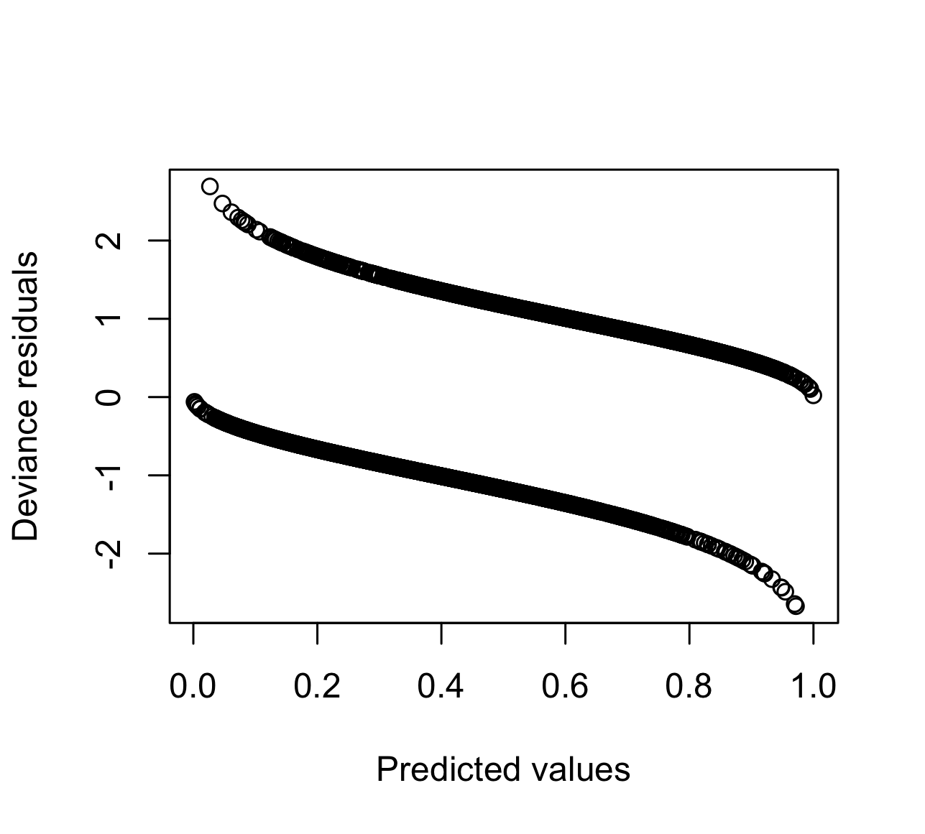 | 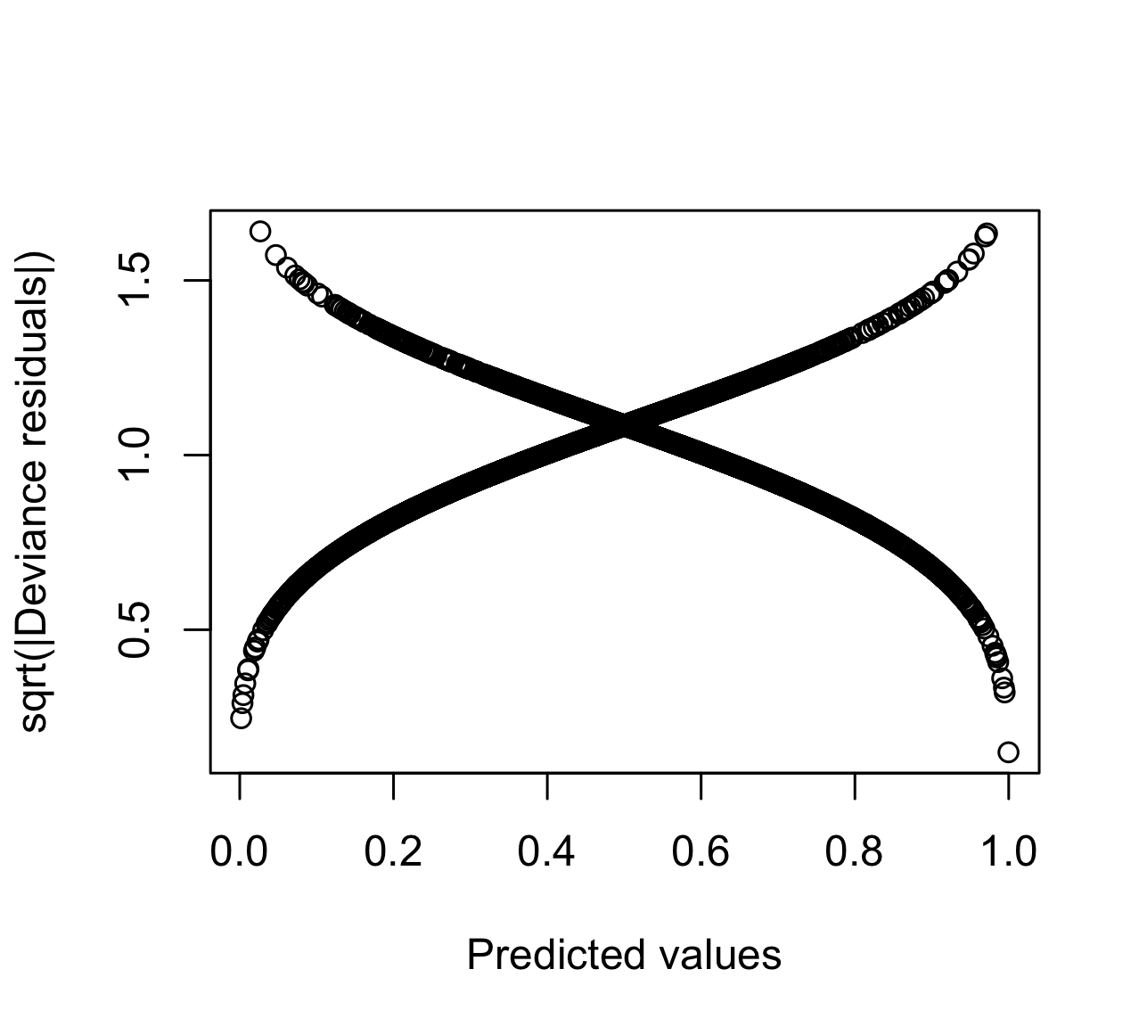
Outcome variable: Death
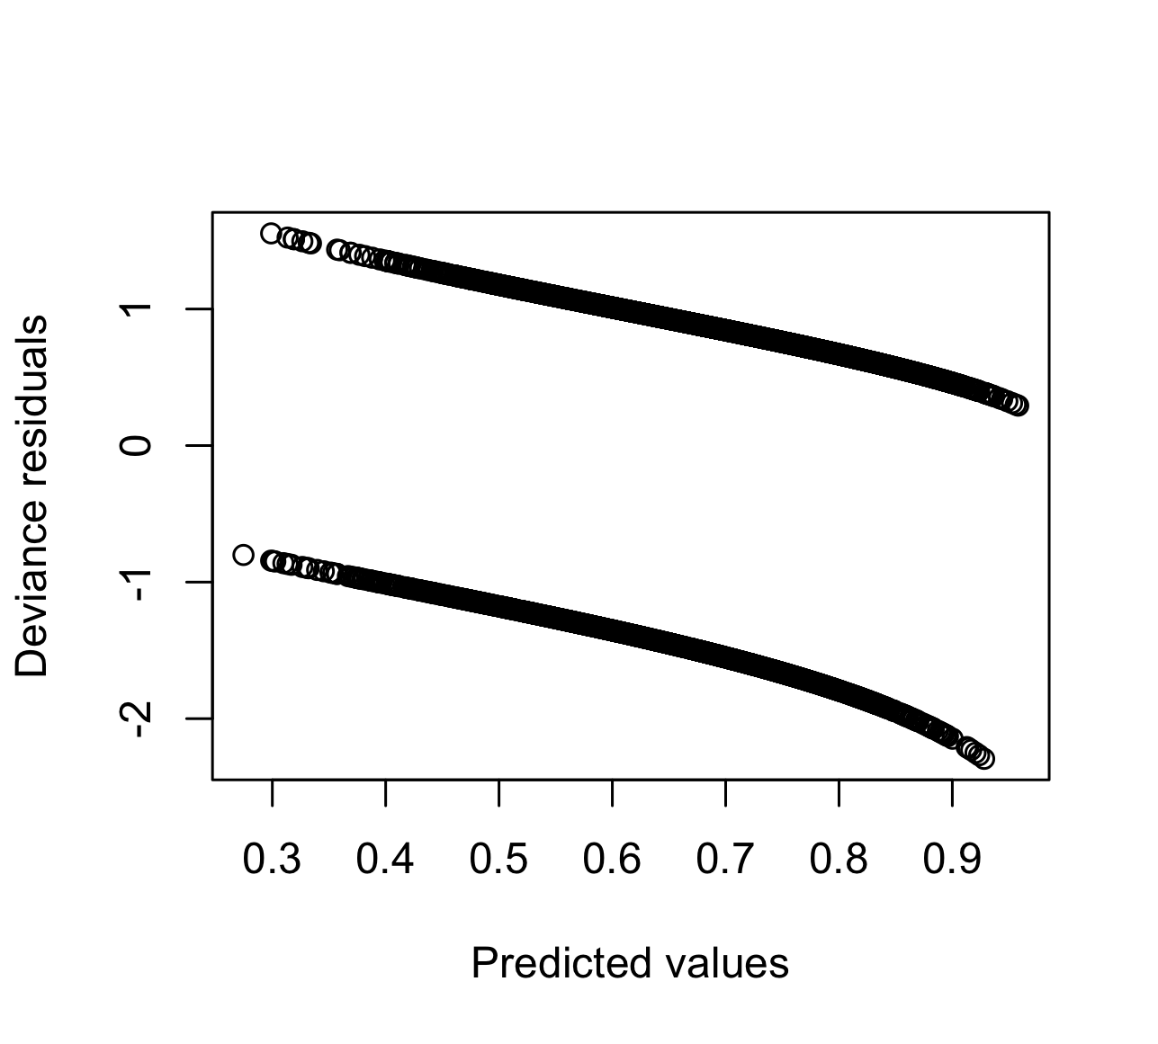 | 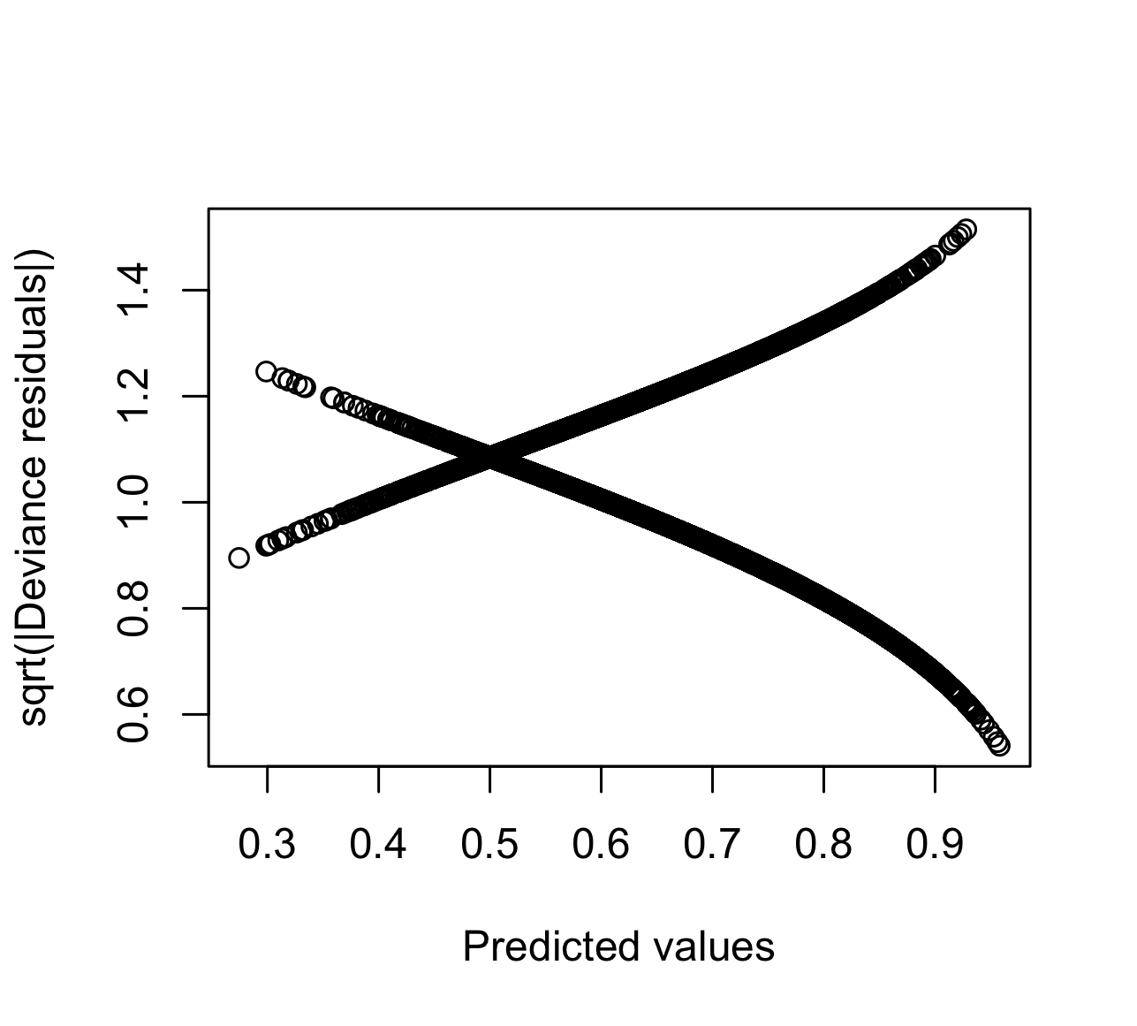

Figure S3b. Residual analysis of the models

Outcome variable: One only dose
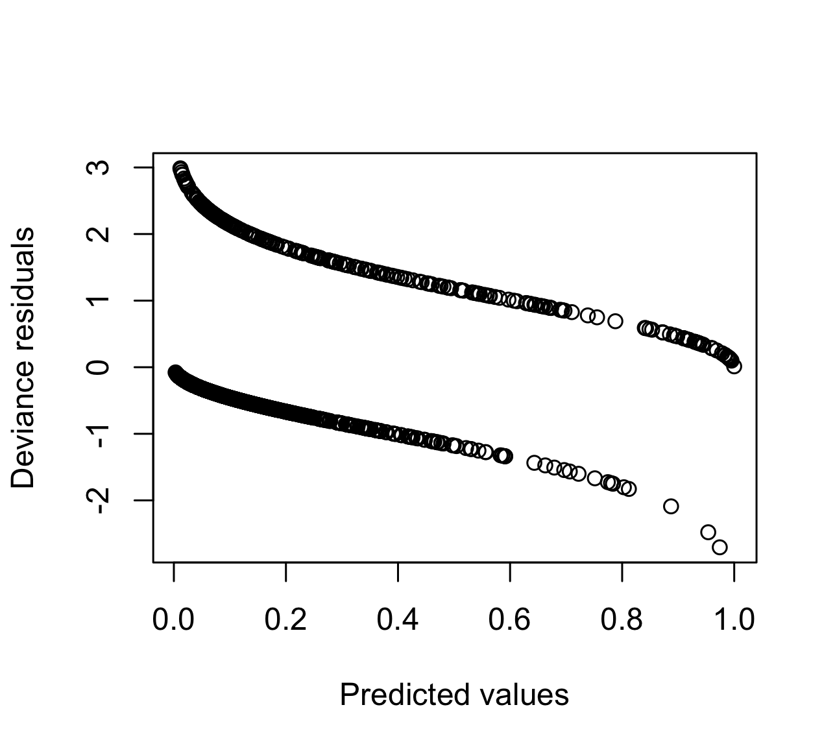 |  | 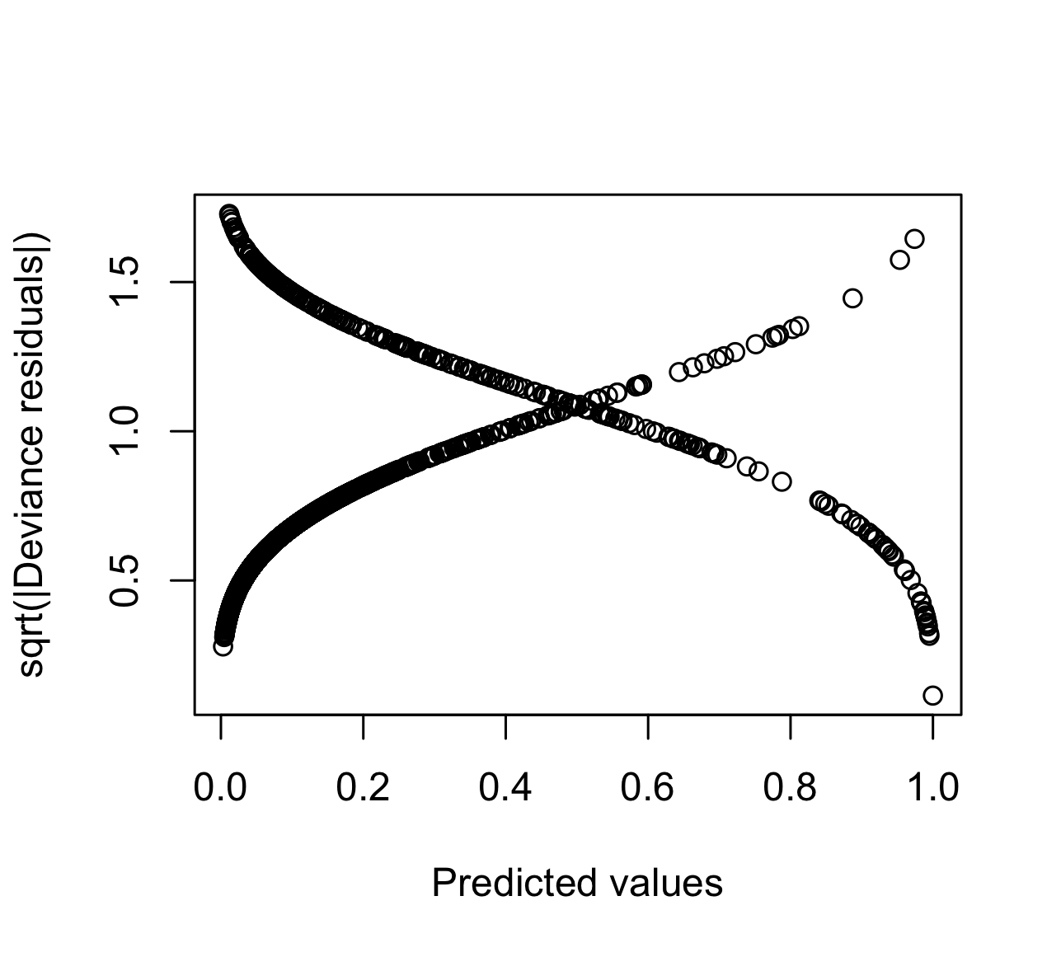
Outcome variable: Full schedule
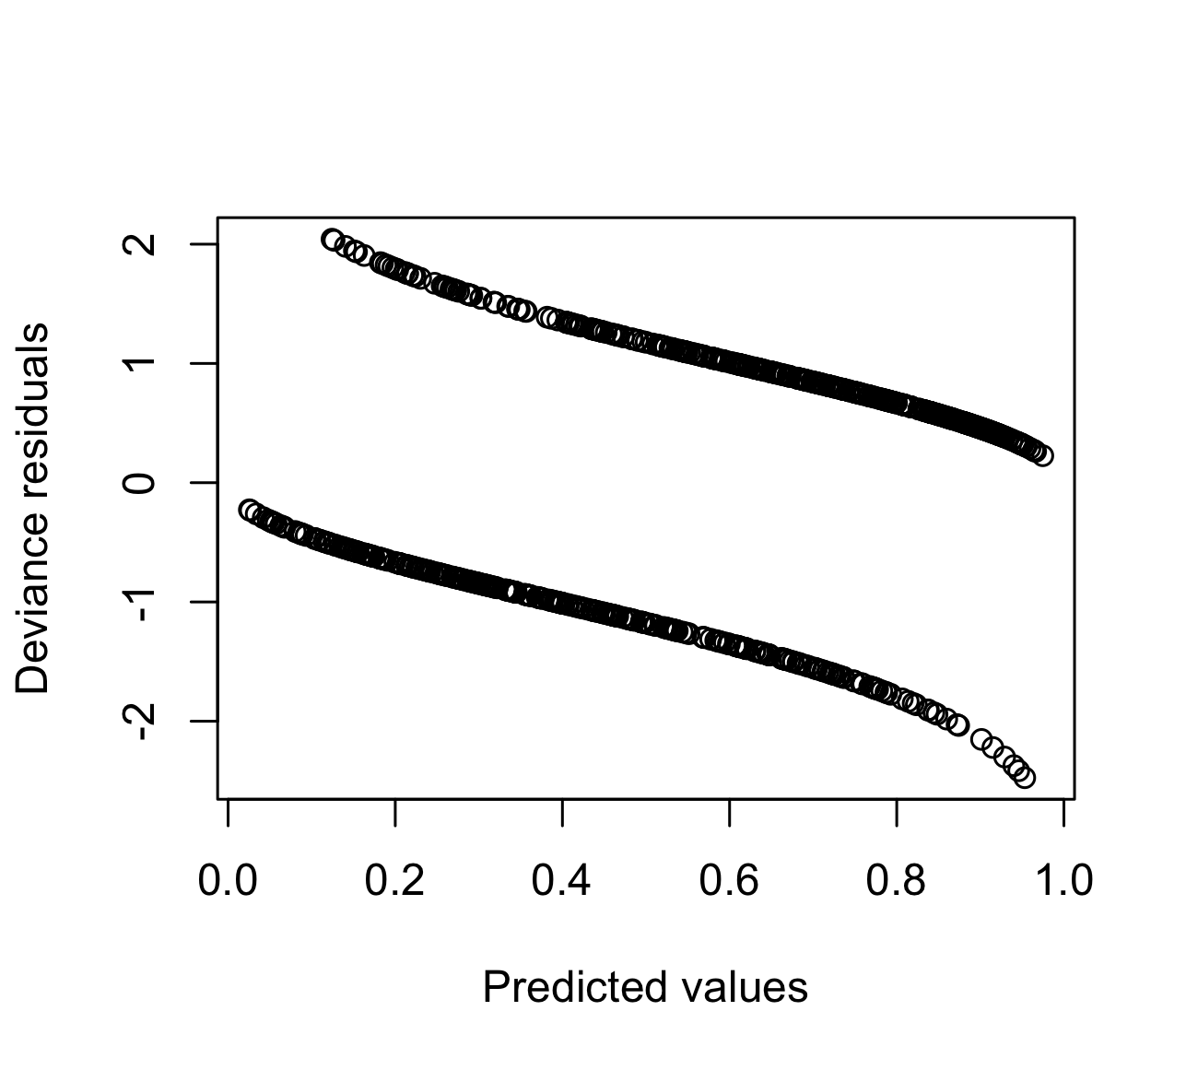 | 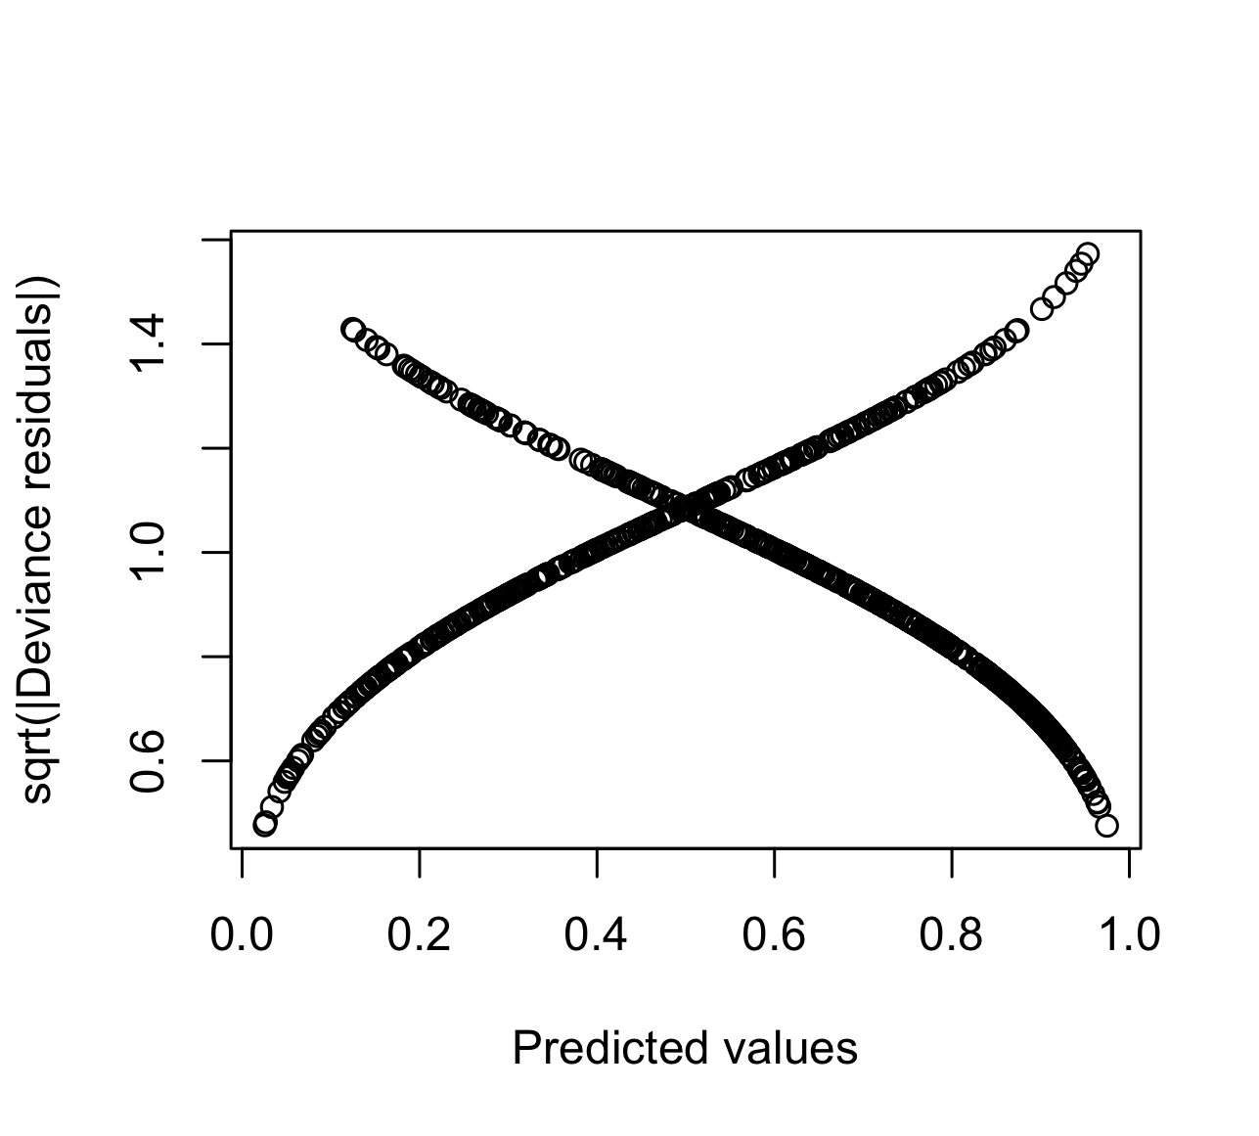
Outcome variable: Booster
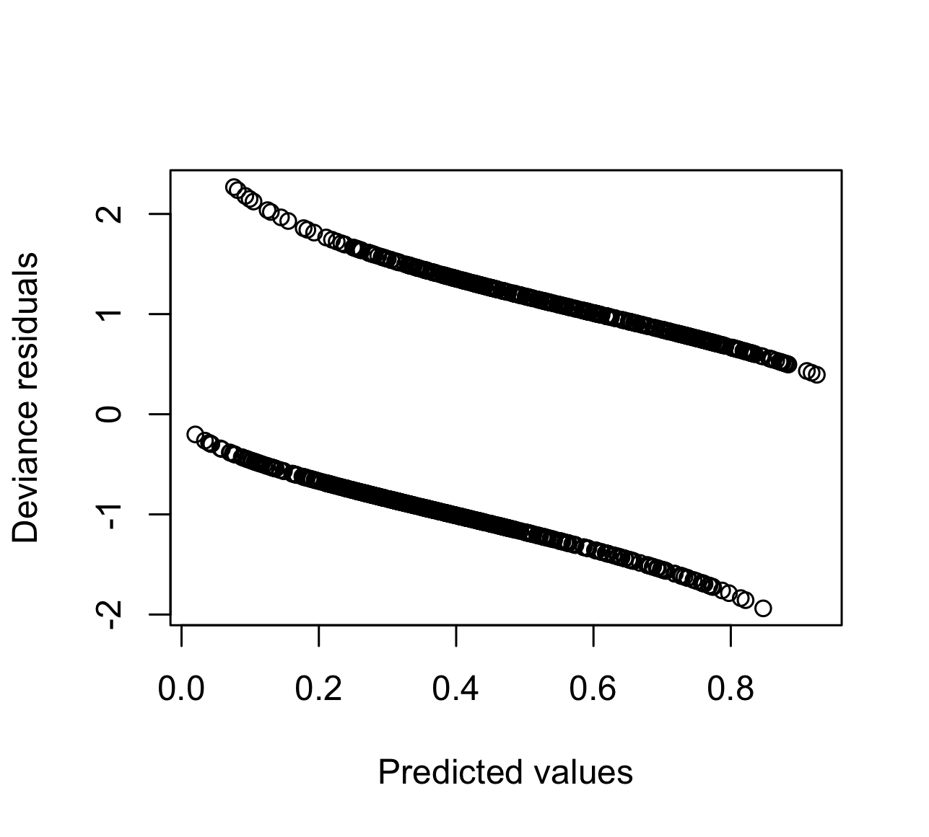 | 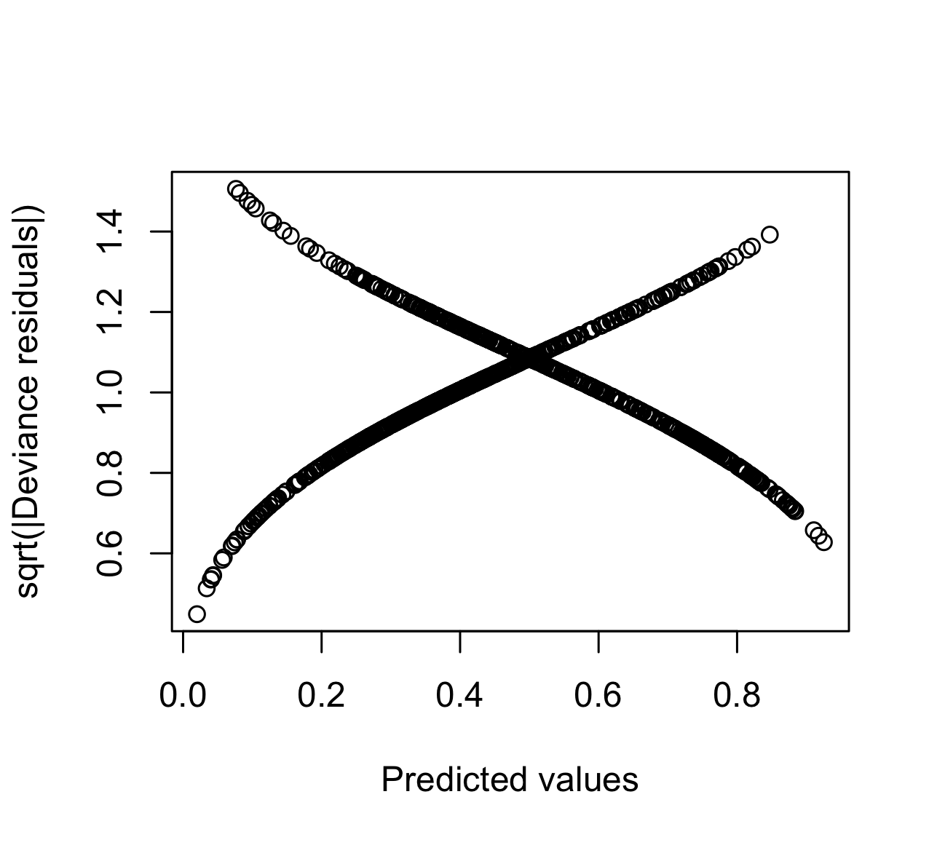

Code

#Working directory
setwd("/Users/marcsaez/Documentos/Treballs varis/COVID-19/Francisco")

#Data
library(foreign)
datos1=read.spss("Data_Cali final.sav",to.data.frame=TRUE, use.value.labels=F)

names(datos1)

missings=is.na(datos1$muerte)
datos1Nous=datos1[missings=='FALSE',]
datos2=datos1Nous[datos1Nous$y==1,]

datos1Nous$id=1:dim(datos1Nous)[1]

# Construction of the final data frame

n=dim(datos1Nous)[1]
N=n+dim(datos2)[1]

Y = matrix(NA, N, 2)
Y[1:n, 1] = datos1Nous$y
Y[(n+1):dim(Y)[1], 2] = datos2$muerte

#For vaccination, replace 'muerte' (death) with 'vacunado', 'solo_una_dosis',
#'solo_pauta_completa', or 'booster'.

id.first <- c(datos1Nous$id, datos2$id)
id.second <- c(datos1Nous$id,datos2$id)

#Construction of the matrices of the covariables

Sexo_first= numeric(N)
Sexo_first[1:n] = datos1Nous$sexo
Sexo_first[(n+1):dim(Y)[1]] = NA

Sexo_second= numeric(N)
Sexo_second[1:n] = NA
Sexo_second[(n+1):dim(Y)[1]] = datos2$sexo

Edad_first= numeric(N)
Edad_first[1:n] = datos1Nous$edad_cat
Edad_first[(n+1):dim(Y)[1]] = NA

Edad_second= numeric(N)
Edad_second[1:n] = NA
Edad_second[(n+1):dim(Y)[1]] = datos2$edad_cat

Diabetes_first= numeric(N)
Diabetes_first[1:n] = datos1Nous$diabetes
Diabetes_first[(n+1):dim(Y)[1]] = NA

Diabetes_second= numeric(N)
Diabetes_second[1:n] = NA
Diabetes_second[(n+1):dim(Y)[1]] = datos2$diabetes

Asma_first= numeric(N)
Asma_first[1:n] = datos1Nous$asma
Asma_first[(n+1):dim(Y)[1]] = NA

Asma_second= numeric(N)
Asma_second[1:n] = NA
Asma_second[(n+1):dim(Y)[1]] = datos2$asma

Cardiovascular_first= numeric(N)
Cardiovascular_first[1:n] = datos1Nous$cardiovascular
Cardiovascular_first[(n+1):dim(Y)[1]] = NA

Cardiovascular_second= numeric(N)
Cardiovascular_second[1:n] = NA
Cardiovascular_second[(n+1):dim(Y)[1]] = datos2$cardiovascular

EPOC_first= numeric(N)
EPOC_first[1:n] = datos1Nous$epoc
EPOC_first[(n+1):dim(Y)[1]] = NA

EPOC_second= numeric(N)
EPOC_second[1:n] = NA
EPOC_second[(n+1):dim(Y)[1]] = datos2$epoc

Cancer_first= numeric(N)
Cancer_first[1:n] = datos1Nous$cancer
Cancer_first[(n+1):dim(Y)[1]] = NA

Cancer_second= numeric(N)
Cancer_second[1:n] = NA
Cancer_second[(n+1):dim(Y)[1]] = datos2$cancer

Ins_renal_first= numeric(N)
Ins_renal_first[1:n] = datos1Nous$ins_renal
Ins_renal_first[(n+1):dim(Y)[1]] = NA

Ins_renal_second= numeric(N)
Ins_renal_second[1:n] = NA
Ins_renal_second[(n+1):dim(Y)[1]] = datos2$ins_renal

Obesidad_first= numeric(N)
Obesidad_first[1:n] = datos1Nous$obesidad
Obesidad_first[(n+1):dim(Y)[1]] = NA

Obesidad_second= numeric(N)
Obesidad_second[1:n] = NA
Obesidad_second[(n+1):dim(Y)[1]] = datos2$obesidad

hta_first= numeric(N)
hta_first[1:n] = datos1Nous$HTA
hta_first[(n+1):dim(Y)[1]] = NA

hta_second= numeric(N)
hta_second[1:n] = NA
hta_second[(n+1):dim(Y)[1]] = datos2$HTA

hipotiroidismo_first= numeric(N)
hipotiroidismo_first[1:n] = datos1Nous$Hipotiroidismo
hipotiroidismo_first[(n+1):dim(Y)[1]] = NA

hipotiroidismo_second= numeric(N)
hipotiroidismo_second[1:n] = NA
hipotiroidismo_second[(n+1):dim(Y)[1]] = datos2$Hipotiroidismo
Fumador_first= numeric(N)
Fumador_first[1:n] = datos1Nous$fumador
Fumador_first[(n+1):dim(Y)[1]] = NA

Fumador_second= numeric(N)
Fumador_second[1:n] = NA
Fumador_second[(n+1):dim(Y)[1]] = datos2$fumador

Ocupacion_first= numeric(N)
Ocupacion_first[1:n] = datos1Nous$ocupacion
Ocupacion_first[(n+1):dim(Y)[1]] = NA

Ocupacion_second= numeric(N)
Ocupacion_second[1:n] = NA
Ocupacion_second[(n+1):dim(Y)[1]] = datos2$ocupacion

Etnia_first= numeric(N)
Etnia_first[1:n] = datos1Nous$etnia_original
Etnia_first[(n+1):dim(Y)[1]] = NA

Etnia_second= numeric(N)
Etnia_second[1:n] = NA
Etnia_second[(n+1):dim(Y)[1]] = datos2$etnia_original

Estrato_second= numeric(N)
Estrato_second[1:n] = NA
Estrato_second[(n+1):dim(Y)[1]] = datos2$estrato

qporcentaje_20_59_second= numeric(N)
qporcentaje_20_59_second[1:n] = NA
qporcentaje_20_59_second[(n+1):dim(Y)[1]] = datos2$Qporcentaje_20_59

qporcentaje_60_unipersonales_second= numeric(N)
qporcentaje_60_unipersonales_second[1:n] = NA
qporcentaje_60_unipersonales_second[(n+1):dim(Y)[1]] = datos2$Qporcentaje_60_unipersonales

qporcentaje_60_unipersonales_second= numeric(N)
qporcentaje_60_unipersonales_second[1:n] = NA
qporcentaje_60_unipersonales_second[(n+1):dim(Y)[1]] = datos2$Qporcentaje_60_unipersonales

Ultima_dosis_second= numeric(N)
Ultima_dosis_second[1:n] = NA
Ultima_dosis_second[(n+1):dim(Y)[1]] = datos2$ultima_dosis

#Temporal Dependence

Temporal= numeric(N)
Temporal[1:n] = NA
Temporal[(n+1):dim(Y)[1]] = datos2$year_month_muerte

#Spatial Dependence
library(INLA)
inla.setOption(inla.mode="experimental")

mesh = inla.mesh.2d(cbind(datos2$utm_x_barrio/1000,datos2$utm_y_barrio/1000),
max.edge=c(20,20), offset=c(3,3), cutoff=0.3)

#Build the SPDE model on the mesh
spde = inla.spde2.pcmatern(mesh, constr=TRUE, prior.range=c(0.01,0.01), prior.sigma=c(100,0.1))

Field=numeric(N)
Field[1:n]=NA
Field[(n+1):dim(Y)[1]]= field=mesh$idx$loc
#Construction of the link matrix
link = rep(NA, N)
link[1:n] = 1
link[(n+1):dim(Y)[1]] = 2

#Construction of the data frame
datos<- data.frame(id.first,id.second,Field,Temporal, Y, link)

#Model formula

# Without explanatory variables

# Model formula

formula = Y~
f(id.second,copy="id.first")+
f(id.first, model="iid",
hyper= list( prec= list( prior="pc.prec", param=c(0.5, 0.01)))) +
f(Field, model=spde)+
f(Temporal, model= "rw1", scale.model=T,
hyper = list(theta = list(prior="pc.prec", param=c(0.5,0.01))))

# Call INLA

ptm <- proc.time()

result= inla(formula, data=datos, family= c("binomial","binomial"),
control.compute = list(dic=T,waic=T),
control.predictor=list(link=link,compute=TRUE),
control.fixed = list(expand.factor.strategy='inla', prec = 0.01, prec.intercept = 0.01))

proc.time() - ptm

summary(result)

matriz=matrix(NA, length(names(result$marginals.fixed)),1)
for(i in 1: length(names(result$marginals.fixed))){
matriz[i,]=ifelse(result$summary.fixed[i,1]>0,1-inla.pmarginal(0,result$marginals.fixed[[i]]), inla.pmarginal(0,result$marginals.fixed[[i]]))}

prob.coef.dif.zero=matriz[,1]
data.frame(OR=exp(result$summary.fixed[,1]), exp(result$summary.fixed[,c(3,5)]), prob.coef.dif.zero)

# Computation of the RR and the PRP

temporal=datos$Field[(n+1):dim(Y)[1]]

# RR

csi=inla.spde.result(result,"Field",spde)$marginals.values[temporal]

RR=as.numeric(lapply(csi, function(x) inla.emarginal(exp, x)))

PRP =as.numeric(lapply(csi,function(x) {1-inla.pmarginal(0,x)}))

library(haven)
Datos=data.frame(datos2$Documento,RR,PRP)
write_sav(Datos,"RR_PRP.sav")

# With explanatory variables

#Data frame
datos<- data.frame(id.first,id.second,Field,Temporal, Y, link,
Sexo_first, Sexo_second,Edad_first, Edad_second, Diabetes_first, Diabetes_second,
Asma_first, Asma_second, Cardiovascular_first, Cardiovascular_second, EPOC_first, EPOC_second,
Cancer_first, Cancer_second, Ins_renal_first, Ins_renal_second,Obesidad_first, Obesidad_second,
hta_first, hta_second, hipotiroidismo_first, hipotiroidismo_second,
Fumador_first, Fumador_second, Ocupacion_first, Ocupacion_second, Etnia_first, Etnia_second,
Estrato_second, qporcentaje_20_59_second, qporcentaje_60_unipersonales_second,
Ultima_dosis_second)

# Model formula

formula = Y~ factor(Ultima_dosis_second)+
Sexo_first + factor(Edad_first) + Diabetes_first + Asma_first + Cardiovascular_first +
EPOC_first + Cancer_first + Ins_renal_first + Obesidad_first + hta_first + hipotiroidismo_first +
Fumador_first + factor(Ocupacion_first) + factor(Etnia_first) +
Sexo_second + factor(Edad_second) + Diabetes_second + Asma_second + Cardiovascular_second +
EPOC_second + Cancer_second + Ins_renal_second + Obesidad_second + hta_second + hipotiroidismo_second +
Fumador_second + factor(Ocupacion_second) + factor(Etnia_second) + factor(-Estrato_second) +
factor(qporcentaje_20_59_second)+ factor(qporcentaje_60_unipersonales_second) +
f(id.second,copy="id.first")+
f(id.first, model="iid",
hyper= list( prec= list( prior="pc.prec", param=c(0.5, 0.01)))) +
f(Field, model=spde)+
f(Temporal, model= "rw1", scale.model=T,
hyper = list(theta = list(prior="pc.prec", param=c(0.5,0.01))))

# Call INLA

ptm <- proc.time()

result= inla(formula, data=datos, family= c("binomial","binomial"),
control.compute = list(dic=T,waic=T),
control.predictor=list(link=link,compute=TRUE),
control.fixed = list(expand.factor.strategy='inla', prec = 0.01, prec.intercept = 0.01))

proc.time() - ptm

summary(result)

matriz=matrix(NA, length(names(result$marginals.fixed)),1)
for(i in 1: length(names(result$marginals.fixed))){
matriz[i,]=ifelse(result$summary.fixed[i,1]>0,1-inla.pmarginal(0,result$marginals.fixed[[i]]), inla.pmarginal(0,result$marginals.fixed[[i]]))}

prob.coef.dif.zero=matriz[,1]
data.frame(OR=exp(result$summary.fixed[,1]), exp(result$summary.fixed[,c(3,5)]), prob.coef.dif.zero)

