Table S1 The exclusion criteria and corresponding countries or regions
Exclusion Criteria | List of Countries or Regions
After eliminating US Domestic Provinces or Regions (228) | AFG, ALB, DZA, ASM, AGO, AIA, ATG, ARG, ARM, ABW, AUS, AUT, AZE, BHS, BHR, BGD, BRB, BLR, BEL, BLZ, BEN, BMU, BTN, BOL, BES, BIH, BWA, BRA, BRN, BGR, BFA, BDI, KHM, CMR, CAN, CPV, CYM, CAF, TCD, CHL, CHN, TWN, CXR, CCK, COL, COM, COG, COD, COK, CRI, CIV, HRV, CUB, CUW, CYP, CZE, DNK, DJI, DMA, DOM, ECU, EGY, SLV, GNQ, ERI, EST, SWZ, ETH, FLK, FRO, FJI, FIN, FRA, GUF, PYF, GAB, GMB, GEO, DEU, GHA, GIB, GRC, GRL, GRD, GLP, GUM, GTM, GIN, GNB, GUY, HTI, HND, HKG, HUN, ISL, IND, IDN, IRN, IRQ, IRL, ISR, ITA, JAM, JPN, JOR, KAZ, KEN, KIR, PRK, KOR, KWT, KGZ, LAO, LVA, LBN, LSO, LBR, LBY, LTU, LUX, MAC, MKD, MDG, MWI, MYS, MDV, MLI, MLT, MHL, MTQ, MRT, MUS, MYT, MEX, FSM, MDA, MCO, MNG, MNE, MSR, MAR, MOZ, MMR, NAM, NRU, NPL, NLD, NCL, NZL, NIC, NER, NGA, NIU, NFK, MNP, NOR, OMN, PAK, PLW, PAN, PNG, PRY, PER, PHL, POL, PRT, PRI, QAT, REU, ROU, RUS, RWA, BLM, SHN, KNA, LCA, MAF, SPM, WSM, STP, SAU, SEN, SRB, SYC, SLE, SGP, SVK, SVN, SLB, SOM, ZAF, SSD, ESP, LKA, VCT, SDN, SUR, SWE, CHE, SYR, TJK, TZA, THA, TLS, TGO, TON, TTO, TUN, TUR, TKM, TCA, TUV, USA, UGA, UKR, ARE, GBR, URY, UZB, VUT, VEN, VNM, VGB, VIR, WLF, YEM, ZMB, ZWE
No socioeconomics  (74) | AFG, AND, AIA, ATG, ABW, BMU, BES, VGB, CYM, CUW, COD, DJI, DMA, GNQ, ERI, FRO, FLK, GUF, GAB, GHA, GIB, GRL, GRD, GLP, GGY, GIN, GUY, IRQ, IMN, JEY, RKS, LAO, LBR, LBY, LIE, MWI, MTQ, MRT, MYT, MCO, MSR, NCL, MNP, PNG, REU, KNA, BLM, LCA, VCT, SMR, STP, SYC, SXM, SOM, SSD, SDN, SUR, TWN, TTO, TCA, VAT, VEN, SHN, TJK, ALA, SPM, COK, NIU, NFK, PRK, PLW, TUV, WLF, YEM
No Social Network Indicators  (82) | AFG, AND, AIA, ATG, ARM, ABW, BMU, BES, VGB, CYM, COM, CUW, COD, DJI, DMA, GNQ, ERI, FRO, FLK, GUF, PYF, GAB, GHA, GIB, GRL, GRD, GLP, GGY, GIN, GNB, GUY, IRQ, IMN, JEY, RKS, LAO, LBR, LBY, LIE, MWI, MDV, MTQ, MRT, MYT, MCO, MNE, MSR, NCL, MKD, MNP, PSE, PNG, REU, KNA, BLM, LCA, VCT, SMR, STP, SYC, SXM, SOM, SSD, SDN, SUR, TWN, TTO, TCA, VAT, VEN, SHN, TJK, ALA, SPM, COK, NIU, NFK, PRK, PLW, TUV, WLF, YEM
No International Travel Restriction  (44) | AIA, ATG, ARM, BES, VGB, CYM, CUW, GNQ, FLK, GUF, PYF, GIB, GLP, GGY, GNB, IMN, JEY, MDV, MTQ, MYT, MNE, MSR, NCL, MKD, MNP, REU, KNA, BLM, LCA, VCT, STP, SXM, TCA, VAT, SHN, ALA, SPM, COK, NIU, NFK, PRK, PLW, TUV, WLF
No SE or SNI or ITR  (82) | ABW, AFG, AIA, ALA, AND, ARM, ATG, BES, BLM, BMU, COD, COK, COM, CUW, CYM, DJI, DMA, ERI, FLK, FRO, GAB, GGY, GHA, GIB, GIN, GLP, GNB, GNQ, GRD, GRL, GUF, GUY, IMN, IRQ, JEY, KNA, LAO, LBR, LBY, LCA, LIE, MCO, MDV, MKD, MNE, MNP, MRT, MSR, MTQ, MWI, MYT, NCL, NFK, NIU, PLW, PNG, PRK, PSE, PYF, REU, RKS, SDN, SHN, SMR, SOM, SPM, SSD, STP, SUR, SXM, SYC, TCA, TJK, TTO, TUV, TWN, VAT, VCT, VEN, VGB, WLF, YEM

Table S2 Workflow of missing data processing
Number of countries or regions left | Filter conditions
271 | The original aviation network data includes some U.S. states.
228 | After merging the data for the contiguous U.S. states (excluding Alaska and Hawaii) and filtering out flight records with zero passengers.
228 | With social network indicator data
199 | With socioeconomic data
185 | With international travel restriction data
147 | With T2A data

Table S3 The top 20 countries of spatial transmission potential
Index | ISO Code | Spatial Transmission Potential | Spatial Spreader Potential | Spatial Receiver Potential | T2A | SEPZ | Temporal  Infection Cluster
1 | USA | 0.115 | 0.055 | 0.061 | 13 | 3 | 1
2 | CHN | 0.111 | 0.056 | 0.055 | 0 | 2 | 1
3 | GBR | 0.105 | 0.053 | 0.052 | 31 | 1 | 1
4 | JPN | 0.087 | 0.043 | 0.044 | 16 | 2 | 1
5 | DEU | 0.083 | 0.042 | 0.042 | 27 | 1 | 1
6 | ESP | 0.078 | 0.039 | 0.039 | 31 | 1 | 1
7 | KOR | 0.073 | 0.037 | 0.037 | 20 | 2 | 1
8 | THA | 0.063 | 0.031 | 0.032 | 8 | 2 | 1
9 | ITA | 0.061 | 0.030 | 0.031 | 31 | 1 | 1
10 | FRA | 0.059 | 0.030 | 0.030 | 24 | 1 | 1
11 | CAN | 0.057 | 0.029 | 0.028 | 25 | 3 | 1
12 | MEX | 0.052 | 0.027 | 0.025 | 59 | 3 | 2
13 | HKG | 0.051 | 0.026 | 0.026 | 23 | 2 | 1
14 | ARE | 0.047 | 0.024 | 0.023 | 29 | 4 | 1
15 | NLD | 0.041 | 0.020 | 0.020 | 58 | 1 | 2
16 | SGP | 0.039 | 0.019 | 0.020 | 23 | 2 | 1
17 | CHE | 0.034 | 0.017 | 0.017 | 56 | 1 | 2
18 | VNM | 0.033 | 0.016 | 0.017 | 23 | 2 | 1
19 | IND | 0.032 | 0.016 | 0.016 | 30 | 4 | 1
20 | TUR | 0.030 | 0.015 | 0.015 | 71 | 1 | 3
Spatial transmission potential: the summation of hub and authority from HITS algorithm of each country; spatial spreader potential: the hub value from HITS algorithm of each country; spatial receiver potential: the authority value from HITS algorithm of each country; T2A: the arrival date difference between the first case in the world and the first imported case of the specific country; SEPZ: spatial epidemic prevention zone based on Infomap community detection; temporal infection cluster: the groups with a similar T2A by the k-means clustering.

Table S4 The country lists of four spatial transmission potential levels in each spatial epidemic prevention zone
 | Q1 | Q2 | Q3 | Q4
SEPZ-1 | GBR, DEU, ESP, FRA, ITA, TUR, NLD, CHE, RUS, POL, PRT, AUT, BEL, IRL, DNK, SWE, MAR | NOR, ISR, FIN, UKR, ROU, GRC, HUN, CZE, DZA, BGR, MLT, ISL | CYP, SRB, LVA, TUN, LTU, KAZ, UZB, BLR, LUX, GEO, AZE, ALB, SEN, HRV, EST, MDA, CPV, SVK | KGZ, CIV, BIH, SVN, MLI, BFA, GMB, NER, SLE
SEPZ-2 | CHN, JPN, THA, KOR, SGP, HKG, MYS, AUS, IDN, VNM, PHL | NZL, KHM, MAC, MMR | GUM, BRN, FJI, MNG | VUT, TLS, TON, SLB
SEPZ-3 | USA, CAN, MEX, BRA, PRI | PAN, COL, ARG, DOM, PER, CHL, CRI, CUB, JAM, SLV, BHS | ECU, GTM, HND, VIR, BRB, NIC, HTI, BLZ | URY, BOL, PRY
SEPZ-4 | ARE, IND, SAU, QAT | EGY, KWT, OMN, PAK, BHR, LKA, BGD | JOR, IRN, LBN, NPL | SYR, BTN
SEPZ-5 | (No country) | ZAF, ETH | KEN, NGA, MUS | TZA, UGA, AGO, RWA, ZWE, NAM, ZMB, CMR, MOZ, TGO, MDG, BWA, BEN, COG, BDI, TCD, CAF, LSO, SWZ

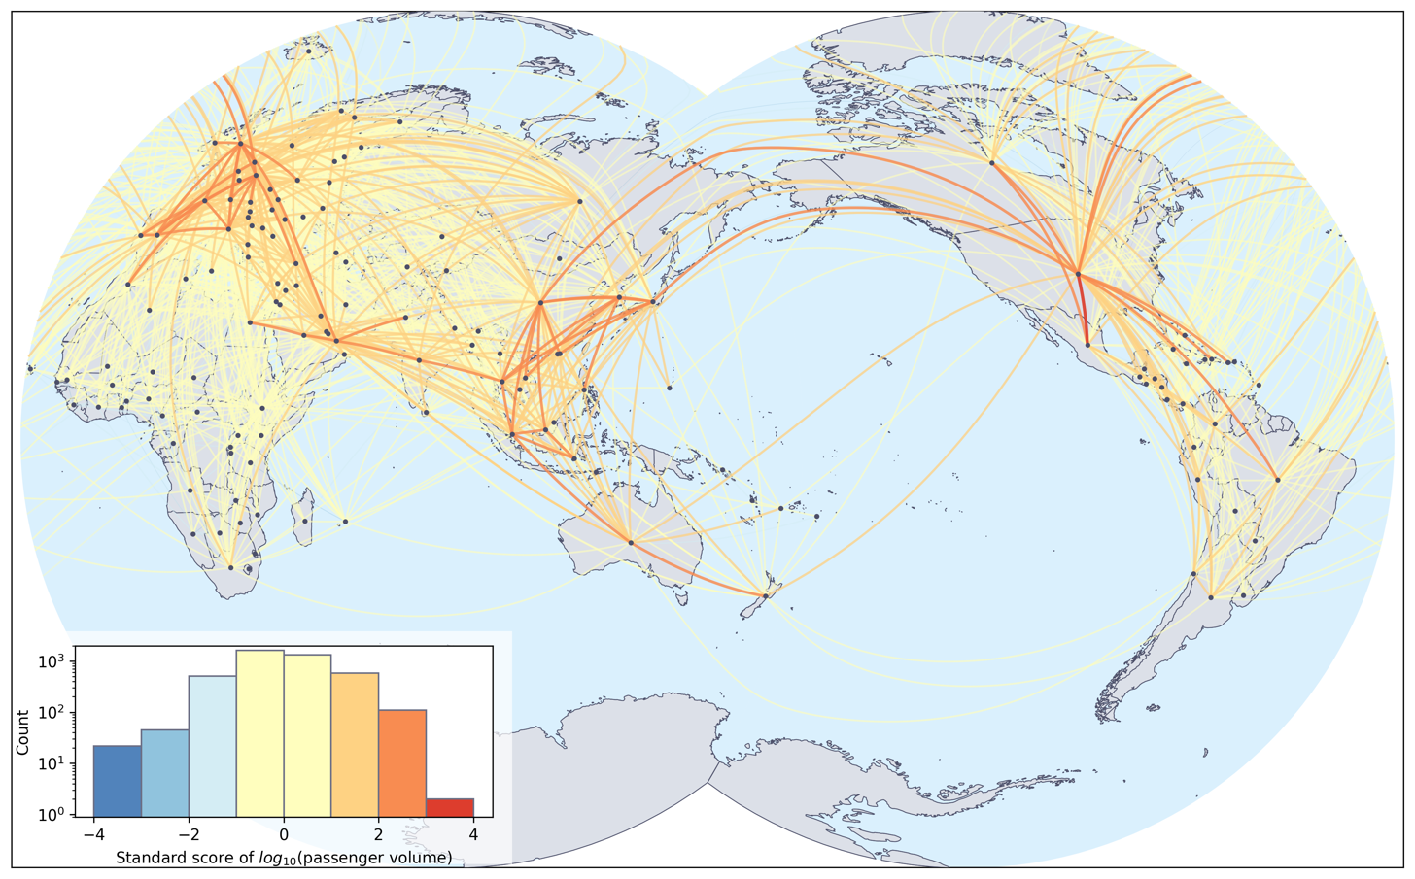
Figure S1 The global country network. Nodes represent countries and regions, and edges represent the great circle line between countries and regions. Colors are assigned based on the standard score of the logarithmic passenger volume (see the inset for the frequency distribution), with orange and red indicating volumes greater than the mean and blue indicating volumes less than the mean.

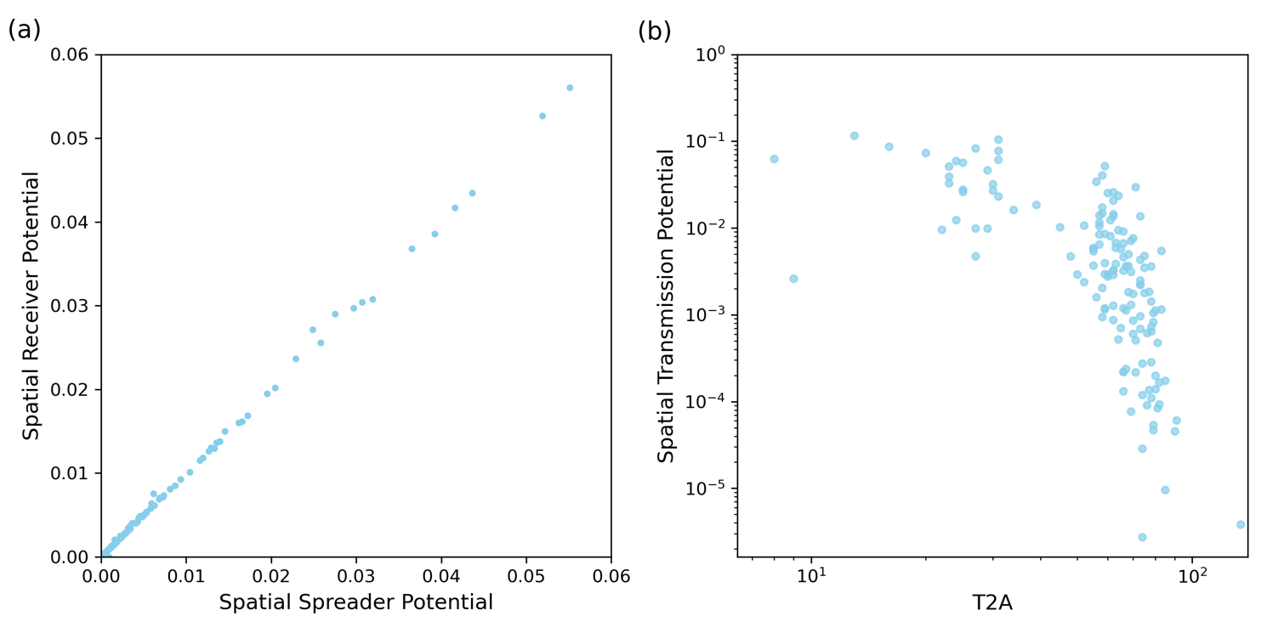
Figure S2 The relationship between spatial spreader potential, spatial receiver potential, spatial transmission potential, and T2A. (a) Spatial spreader potential versus spatial receiver potential; (b) T2A versus spatial transmission potential

