Table S1: Phenotypic classes assigned in the Multiparametric screen.
Class | Principle Phenotype  (in comparison with class C) | 3D Surface Reconstruction | Projected 3D Binary Mask
Class A | Reduced Proliferation, reduced invasion, reduced polarity. Included the dasatinib positive control | 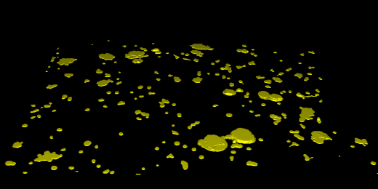 | 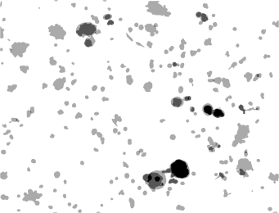
Class B | Reduced invasion, increased polarity.  Typified by a high incidence of organoids lacking protrusions and by the presence of lumens. | 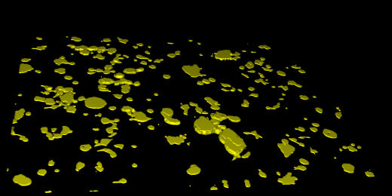 | 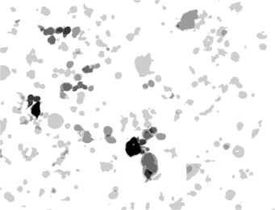
Class C | Phenotype of untreated organoids, including buffer control and non-targeting control antibodies | 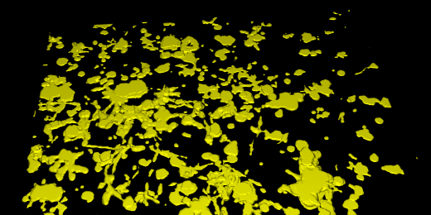 | 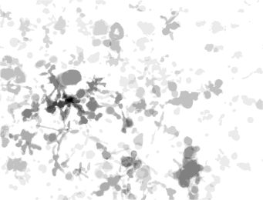
Class D | Increased proliferation and invasion | 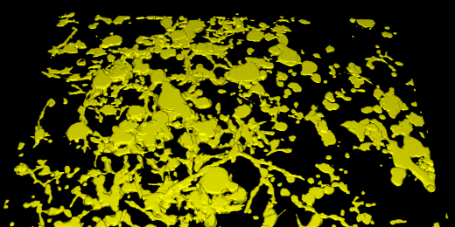 | 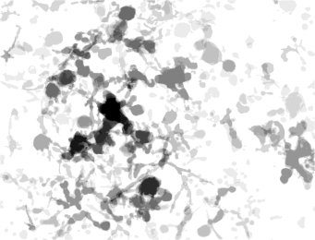
Class E | Increased proliferation and invasion; decreased polarity | 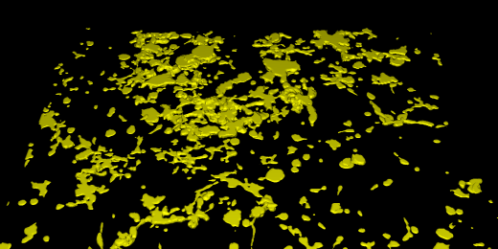 | 