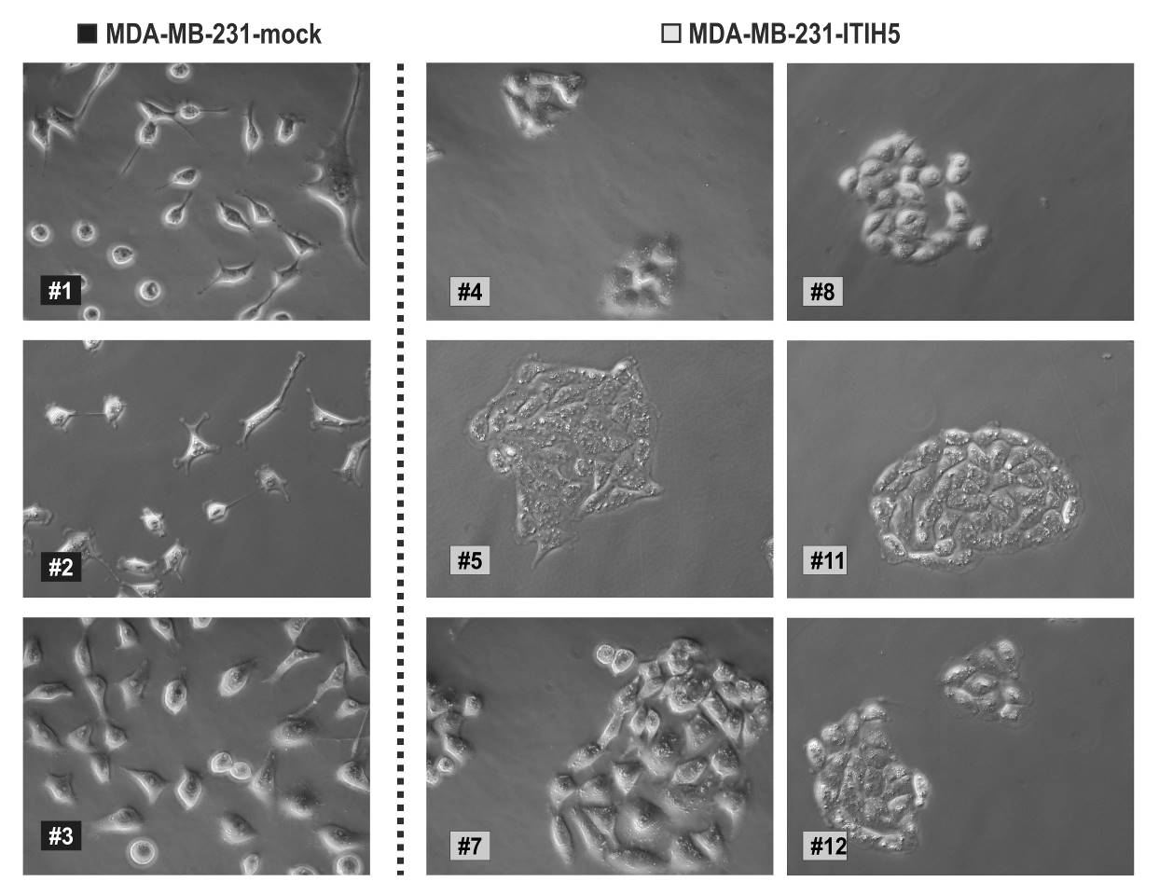
Additional file 1: Morphological characteristics of independent MDA-MB-231 single-cell clones (ΔpBK-mock n=3; and ΔpBK-ITIH5 n=6) using phase-contrast microscopy (original magnification x200).

