Additional file

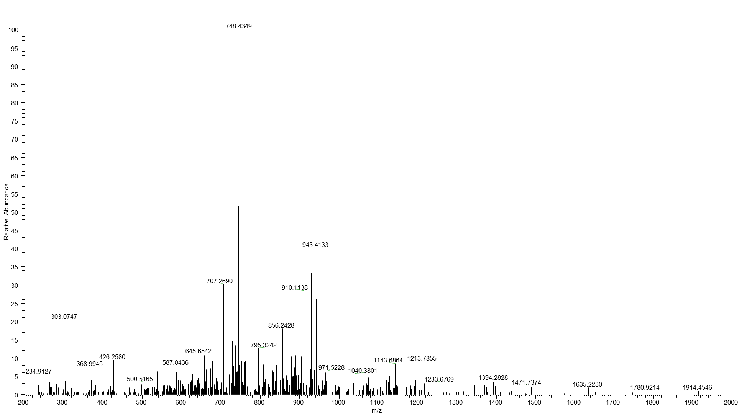

Figure S1: The spectrum obtained from MS analysis of Phospheptide of BMI1 (DFYAAHPSADAANGS#NEDRGEVADEDKR)

Figure S2: Association between BMI1+ CK2α (categorized into “high BMI1 + high CK2α” vs “others”) and patient survival (PFS).
Expression of CK2α and BMI1 in the ovarian cancer patient samples (N=20) were determined by immunoblotting, quantified by densitometry analysis as described in the “methods section” and grouped as high BMI1/high CK2α expressers versus all others. While PFS was worse in the high BMI1 + high CK2α group, the result was not statistically significant (P=0.4), possible due to small sample size.

