Supplemental Materials
Supplemental Data
Table S1. Primer sequences in the study
H19 | Forward (5’-3’) | GCACCTTGGACATCTGGAGT
H19 | Reverse (5’-3’) | TTCTTTCCAGCCCTAGCTCA
SNHG16 | Forward (5’-3’) | ACAGGATGCCGTCTTGTGTT
SNHG16 | Reverse (5’-3’) | GGTGGCAACCCATTAGCAGA
TUG1 | Forward (5’-3’) | CTGAAGAAAGGCAACATC
TUG1 | Reverse (5’-3’) | GTAGGCTACTACAGGATTTG
UBC1 | Forward (5’-3’) | CCTGCTTGGAAACTAATGACC
UBC1 | Reverse (5’-3’) | AGGCTCAACTTCCCAGACTCA
UCA1 | Forward (5’-3’) | TTAAGGTGTCCACGCAGTCC
UCA1 | Reverse (5’-3’) | TGGGGATTACTGGGGTAGGG
MALAT1 | Forward (5’-3’) | GTGAGCAAACTGTGTTGGCGTG
MALAT1 | Reverse (5’-3’) | CATCGAGGTGAGGGGTGAAGGG
MEG3 | Forward (5’-3’) | GGGCATTAAGCCCTGACCTT
MEG3 | Reverse (5’-3’) | CCTTGGGGAGGGAAACACTC
GAS5 | Forward (5’-3’) | CACUCUGAGUGGGACAAGCUCUUCA
GAS5 | Reverse (5’-3’) | UGAAGAGCUUGUCCCACUCAGAGUG
ANRIL | Forward (5’-3’) | TGCTCTATCCGCCAATCAGG
ANRIL | Reverse (5’-3’) | GGGCCTCAGTGGCACATACC
HOTAIR | Forward (5’-3’) | GGTAGAAAAAGCAACCACGAAGC
HOTAIR | Reverse (5’-3’) | ACATAAACCTCTGTCTGTGAGTGCC
Kcnq1ot1 | Forward (5’-3’) | CCAGCATAGCCTTATGGA
Kcnq1ot1 | Reverse (5’-3’) | GCTGTCCGGGCCTCTGATCTCCGAT
PTENP1 | Forward (5’-3’) | TCTCTCATCTCCCTCGCCTGA
PTENP1 | Reverse (5’-3’) | AGCCGTGATGGAAGTTTGAATG
PTEN | Forward (5’-3’) | AATGTTCAGTGGCGGAACTTGC
PTEN | Reverse (5’-3’) | AACTTGTCTTCCCGTCGTGTGG
GAPDH | Forward (5’-3’) | CCGGGAAACTGTGGCGTGATGG
GAPDH | Reverse (5’-3’) | AGGTGGAGGAGTGGGTGTCGCTGTT
U6 | Forward (5’-3’) | CTCGCTTCGGCAGCACA
U6 | Reverse (5’-3’) | AACGCTTCACGAATTTGCGT

Table S2. Clinical characteristics of paired bladder cancer tissue samples
No. | Age (years) | Sex | Smoking status | Tumor grade | Tumor stage
1 | 86 | Male | No | High grade | Non-muscle invasive
2 | 67 | Female | No | Low grade | Invasive
3 | 68 | Male | No | High grade | Non-muscle invasive
4 | 81 | Female | No | Low grade | Non-muscle invasive
5 | 72 | Male | Yes | High grade | Non-muscle invasive
6 | 55 | Female | No | Low grade | Non-muscle invasive
7 | 67 | Male | No | Low grade | Non-muscle invasive
8 | 73 | Male | Yes | High grade | Non-muscle invasive
9 | 80 | Male | No | Low grade | Non-muscle invasive
10 | 76 | Male | Yes | High grade | Non-muscle invasive
11 | 79 | Female | No | Low grade | Invasive
12 | 63 | Male | Yes | High grade | Non-muscle invasive
13 | 86 | Male | No | High grade | Non-muscle invasive
14 | 79 | Male | No | High grade | Non-muscle invasive
15 | 71 | Male | Yes | High grade | Non-muscle invasive
16 | 79 | Female | No | Low grade | Invasive
17 | 79 | Male | No | High grade | Non-muscle invasive
18 | 62 | Female | No | Low grade | Invasive
19 | 72 | Male | No | High grade | Non-muscle invasive
20 | 48 | Male | No | High grade | Non-muscle invasive

Table S3. The characteristics of candidate lncRNAs until December 2016
IncRNA | Dysregulation | Location | Cancer | Bladder Cancer
H19 | UP | 11:2016406..  2019065 | bladder, gastric, cervical | Reported
SNHG16 | UP | 17:74553846..  74561430 | bladder, colorectal | Reported
TUG1 | UP | 22: 31365634..  31375381 | bladder, breast, pancreas, endometrial | Reported
UBC1 | UP | 4: 39699664..  39784412 | bladder, colorectal, gastric | Reported
UCA1 | UP | 19:15939757..  15947131 | bladder, tongue squamous cell carcinomas | Reported
MALAT1 | UP | 11: 65265224..  65273940 | bladder, ovarian, breast,  thyroid, gastric,  esophageal | Reported
MEG3 | Down | 14:101292445..  101327363 | bladder, lung | Reported
GAS5 | Down | 1: 173833039..  173837125 | bladder, prostate, thyroid | Reported
ANRIL | UP | 9: 21994790..  22121096 | bladder, lung, ovarian, hepatocellular carcinoma | Reported
HOTAIR | UP | 12: 54356092..  54368740 | bladder, ovarian, gastric,  colorectal, glioma, lung,  cervical, urothelial, breast, carcinoma, pancreas | Reported
Kcnq1ot1 | UP | 11: 2629558..  2721228 | Nephroblastoma, hepatoblastoma | Not Reported
PTENP1 | Down | 9:33673502..  33677418 | prostate,  endometrial melanoma | Not Reported

Table S4. The relative expression of 12 candidate lncRNAs in paired bladder cancer tissues
lncRNA | Expression level (mean ± SD) |  | Pª
lncRNA | Cancer | Normal | Pª
H19 | 0.34±0.62 | 0.06±0.09 | 0.050
SNHG16 | 0.13±0.15 | 0.05±0.04 | 0.048
UCA1 | 0.44±0.70 | 0.12±0.11 | 0.032
PTENP1 | 0.03±0.03 | 0.05±0.03 | 0.015
MEG3 | 0.03±0.08 | 0.18±0.31 | 0.037
MALAT1 | 5.81±8.85 | 2.94±3.09 | 0.179
ANRIL | 0.02±0.02 | 0.03±0.02 | 0.087
TUG1 | 0.04±0.04 | 0.04±0.04 | 0.963
GAS5 | 0.34±0.50 | 0.41±0.58 | 0.682
HOTAIR | 0.05±0.08 | 0.07±0.07 | 0.222
Kcnq1ot1 | 0.01±0.01 | 0.02±0.01 | 0.166
UBC1 | 0.07±0.14 | 0.08±0.10 | 0.906
ª Student’s t-test for relative expression of lncRNA between cancer and normal tissues.

Figure Legend
Figure S1. Determination of candidate lncRNAs between bladder cancer tissues and paired normal tissues. qRT-PCR detection of the relative expression of 12 candidate lncRNAs in paired BC tissues (n=20). The data are presented as a fold-change in the tumor tissue relative to the normal tissue. Results are presented as mean ± SD. *P < 0.05.

Figure S2, related to Figure 1. Expression of plasma exosomal PTENP1 in patients with bladder cancer. Plasma Exosomes (Exos), exos isolated from the plasma of cases and controls. A. qRT-PCR detection of the relative expression of 5 candidate lncRNAs in plasma exos. B. qRT-PCR detection of the relative expression of PTENP1 in patients of different tumor grade, tumor stage and clinical grade. Results are presented as mean ± SD. *P < 0.05.

Figure S3, related to Figure 3. Exosomal PTENP1 serve as a mediator in intercellular communication. Exosomes (Exos) isolated from the medium of 293A, J82 and EJ cells, namely 293A exos, J82 exos and EJ exos, respectively. A. qRT-PCR detection of the relative expression of PTENP1 in the medium of 293A, J82 and EJ cells treated with RNase (2 μg/ml) alone or combined with Triton X-100 (0.1%) for 20 min. B. qRT-PCR detection of the relative expression of PTENP1 in cell lines. C. qRT-PCR detection of the relative expression of PTENP1 in 293A exos, J82 exos and EJ exos. Results are presented as mean ± SD. *P < 0.05. All of the experiments were performed in triplicate.

Figure S4, related to Figure 2 and Figure 4. Effect of PTENP1/ exosomal PTENP1 on bladder cancer cellular phenotype. Totally 4.0 × 10³ EJ and J82 cells were transfected with PTENP1-expressing plasmid or NC vector, namely PTENP1 vector and NC, respectively. Exosomes (Exos) were isolated from 293A cells transfected with PTENP1-expressing plasmid or NC vector, namely PTENP1-Exos or NC-Exos, respectively. The 60 μg/ml of PTENP1-Exos and NC-Exos were extracted and added to the EJ and J82 cells for 24h. The viability ratios of NC and NC-Exos were used to establish the 100% level. A. CCk8 detection of the cell viability in EJ and J82 cells between PTENP1 vector and their corresponding NC, related to Figure 2B. B. CCk8 detection of the cell viability in EJ and J82 cells between PTENP1-Exos and their corresponding NC-Exos, related to Figure 4A. Results are presented as mean ± SD. *P < 0.05. All of the experiments were performed in triplicate.

Figure S5, related to Figure 6. Exosomal PTENP1 regulates PTEN expression via miR-17. U6 and GAPDH were used as a nucleus marker or cytoplasm marker, respectively. A. qRT-PCR detection of the expression PTENP1 in nucleus or cytoplasm of EJ and J82 cells were treated with PTENP1-Exos. B. qRT-PCR detection of the expression PTENP1 in cell nucleus or cytoplasm. Results are presented as mean ± SD. All of the experiments were performed in triplicate.

Figure S1.
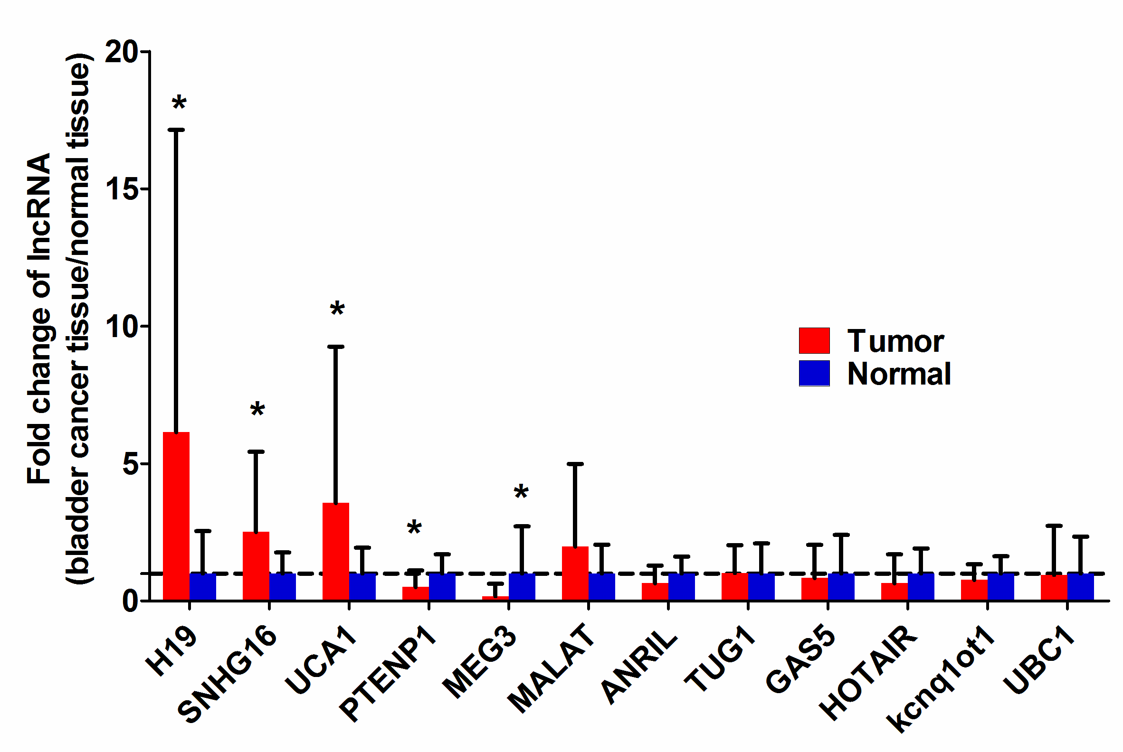

Figure S2.
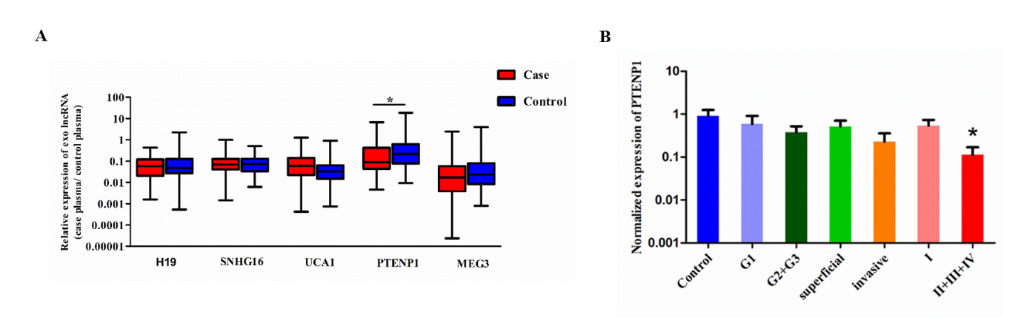

Figure S3.

Figure S4.
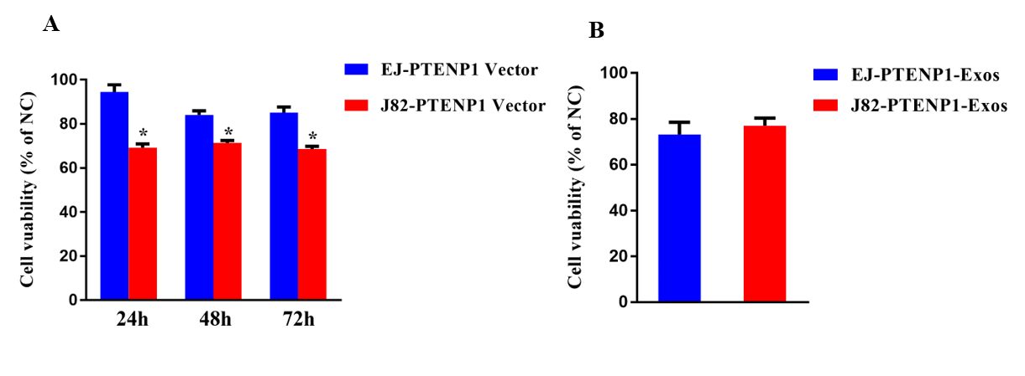

Figure S5.
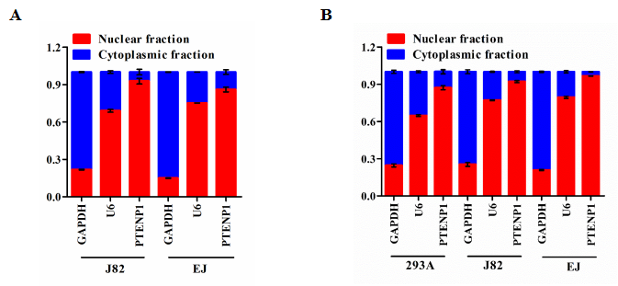

Supplemental experimental procedures
Exosome isolation
The plasma and culture medium were collected and centrifuged at 3000 g for 15 min to remove cells and cellular debris. Then, we filtered the supernatant through a 0.22- μm PVDF filter (Millipore). In the case of filtered plasma, an appropriate volume of Thrombin was added to the plasma and centrifuged at 10,000 rpm, 5 minutes to make them compatible with ExoQuick exosome precipitation. Then, we added the appropriate volume of ExoQuick exosome precipitation solution (System Biosciences) to the Thrombin-treated plasma and filtered culture medium. After refrigeration for 24 h, the ExoQuick/biofluid mixture was centrifuged at 1500 g for 30 min, and the supernatant was removed. The exosomes appear as a beige or white pellet at the bottom of the vessel.

Exosome labeling
Exosomes from 1.5 × 10⁶ cells were suspended in 100 μl of PBS with 1 ml of Diluent C. Then, the 4ul of PKH67 (Sigma, in Diluent C) and 1ml of Diluent C were mixed and added to the exosomes. After 4 min of incubation at room temperature, 2 ml of 0.5% bovine serum albumin (BSA) was added to terminate exosomes labeling, and dyed exosomes were isolated by using Exoquick exosome precipitation solution. Exosomes were suspended in 9.6 ml of basal medium, and 250 μl was added to sub-confluent layer of EJ and J82 cells. After incubation for 3 h at 37 °C, cells were washed twice with PBS, and incubated with 1 ml of 4 % paraformaldehyde for 30 min at room temperature. Then, cells were washed three times with PBST (3.5 g of Na₂HPO₄.12H₂O, 0.25 g of NaH₂PO₄.2H₂O, 4.5 g of NaCl, and 0.25 ml of TWEEN dissolved in 500 ml of double distilled water). To stain the nuclei, the 4’,6-diamidino-2-phenylindole (DAPI, Sigma) was added for 10 min, and stained cells were observed on a fluorescence microscope (Zeiss, LSM700B, Germany).

Cell proliferation assay
Approximately 4.0 × 10³ EJ and J82 cells that were transfected with PTENP1 overexpression/NC vectors or incubated with exosomes were plated in 96-well plates. Cell proliferation was performed by using the Cell Counting Kit-8 (Dojindo Laboratories, Kumamoto, Japan) according to manufacturer’s protocol. The absorbance was evaluated at 450 nm by the Infinite M200 spectrophotometer (Tecan, Switzerland). We performed all experiments in triplicate.

Colony formation assays
A total of 24 h after transfection or exosomes incubation, about 200 cells were placed onto the 6-well plate and maintained in RPMI-1640 with 10% FBS, replacing the medium every 4 days. After 2 weeks, the colonies were fixed using 95% methanol and stained with 0.1% crystal violet. We performed all experiments in triplicate.

Cell invasion assay
To investigate the effect of PTENP1 and exosomal PTENP1 on EJ or J82 cell invasion. The day before cells seeded on the upper chamber of the trans-well (8-μm pore size, Corning, MA, USA), Matrigel (Becton Dickinson Labware, Bedford, MA) was added to the upper chamber. Twenty-four hours after transfection or exosomes incubation, a total of 4.0 × 10⁴ EJ or 5.0× 10⁴ J82 cells suspended in 100 μl of serum-free medium were seeded into the upper chamber of the trans-well. RPMI-1640 with 10% FBS was added to the lower chamber. After 24 h of culture at 37˚C, the cells of upper chamber were removed, and the cells on the lower chamber were fixed in 95% methanol for 30 min and stained with 0.1% crystal violet for 20 min. The stained cells were counted at five fields per membrane under microscopic inspection. We performed all experiments in triplicate.

Cell migration assay
Similar to invasion assay, migration assay was also performed by trans-well filters.
About 2.0 × 10⁴ EJ or 3.0× 10⁴ J82 cells were suspended in 100 μl of serum-free medium and seed into upper chamber. The following process is consistent with cell invasion assay. We performed all experiments in triplicate.

Flow-cytometric analysis for apoptosis and cell cycle
For apoptosis assay, the PTENP1 overexpression/NC vectors or exosomes was cultured in 6-well plate for 24 h, and then stained with Annexin V (FITC-conjugated) (BD Biosciences, Erembodegem, Belgium) and 7-amino-actinomycin (7-AAD; BD Biosciences). Apoptosis assay was evaluated by flow cytometry. For cell cycle assay, cells were collected and fixed using 70% ethanol at -20 ˚C for 18 h, and stained with 500 ul of propidium iodide (PI) for 15 min.

