Figure S1
Figure S1. CircFGFR1 expression in the NSCLC cells. a circFGFR1 expression in several NSCLC cell lines was measured using RT-qPCR analysis. b circFGFR1 expression in the A549 and HCC827 cells was modified by transfection of shRNA to cause interference. c FGFR1 mRNA expression in circFGFR1-knockdown NSCLC cells. d circFGFR1 expression in the NCI-H358 and NCI-H1299 cells was modified by cDNA transfection. The data are presented as the mean ± SD, n=3. *P < 0.05; **P < 0.01; NS, not significant.
Figure S2
Figure S2. Effects of decreased circFGFR1 expression on the progression of the NSCLC cells. a and b Proliferation in NSCLC cells with decreased expression of circFGFR1 was assessed by CCK-8 assay (a) and clonal formation assay (b). c and d Migration and invasion of the NSCLC cells with decreased circFGFR1 expression were assessed by wound healing assay (c) and Matrigel Transwell assay (d). The data are presented as the mean ± SD, *P < 0.05, **P < 0.01.

Figure S3
Figure S3. The relationship between circFGFR1 and miR-381-3p expression in the NSCLC cells. a miR-381-3p expression in the A549 and HCC827 cells was modified by cDNA transfection. b circFGFR1 expression in the miR-381-3p-overexpressing NSCLC cells. c miR-381-3p expression in the A549 and HCC827 cells was modified by shRNA transfection. d circFGFR1 expression in the miR-381-3p-knockdown NSCLC cells. The data are presented as the mean ± SD, n=3. **P < 0.01; ***P < 0.001; NS, not significant.
Figure S4
Figure S4. The predicted target mRNAs of miR-381-3p were identified in vivo. a The luciferase activity of wild-type LUC-CXCR4/FGF7/FGFR2/FGFR1/IGF2BP1/UBE2C or mutant LUC-CXCR4/FGF7/FGFR2/FGFR1/IGF2BP1/UBE2C in the HEK-293T cells cotransfected with miR-191 or the negative control (NC). b FGF7, FGFR2, FGFR1, IGF2BP1, and UBE2C mRNA expression in the A549 cells was changed by miR-381-3p siRNA transfection. The data are presented as the mean ± SD, n=3. *P < 0.05; NS, not significant.

Figure S5
Figure S5. miR-381-3p inhibited CXCR4 expression in the NSCLC cells. a and b CXCR4 mRNA and protein expression in miR-381-3p-overexpressing NSCLC cells. c and d CXCR4 mRNA and protein expression in miR-381-3p-knockdown NSCLC cells. The data are presented as the mean ± SD, n=3. **P < 0.01; ***P < 0.001.
Figure S6
Figure S6. The levels of CXCR4 and miR-381-3p in the NSCLC tissues and prognostic significance. a and b Prognostic analysis of CXCR4 expression in 210 NSCLC patient tissues. c and d Prognostic analysis of miR-381-3p expression in 210 NSCLC patient tissues.
Figure S7
Figure S7. Knocking out CXCR4 in NSCLC cells via CRISPR/Cas9 technology. a CXCR4 expression in the NSCLC cell lines was examined using western blotting analysis. b circFGFR1 expression in the NCI-H358-CKO and NCI-H1299-CKO cells was modified by cDNA transfection. c CXCR4 protein expression in the circFGFR1-overexpressing NSCLC-CKO cells. The data are presented as the mean ± SD, n=3. **P < 0.01. CKO: CXCR4 knockout.

Figure S8
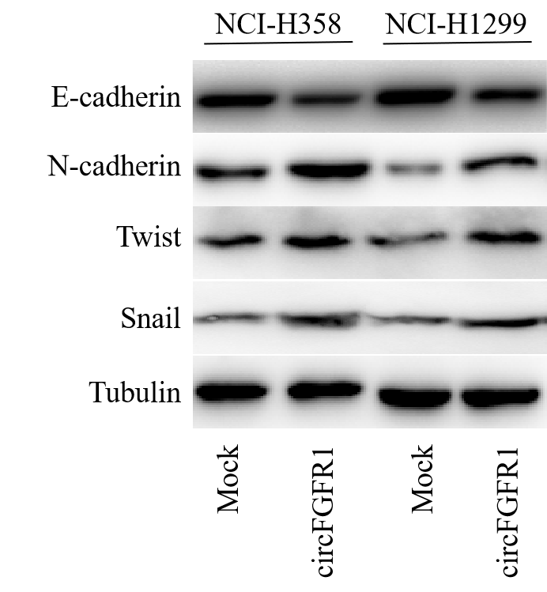
Figure S8. E-cadherin, N-cadherin, Twist, and Snail protein expression levels in the NCI-H358 and NCI-H1299 cells was modified by circFGFR1 transfection.

Figure S9
Figure S9. CXCR4 binds to miR-381-3p in the mouse NSCLC cells. a Putative binding sites of miR-381-3p with respect to mouse CXCR4 were predicated via StarBase v3.0. b The luciferase activity of pLG3-mouse CXCR4 in the HEK-293T cells cotransfected with miR-381-3p. c Level of circFGFR1 expression in the mouse LLC cells was modified by cDNA transfection. d and e The levels of mouse CXCR4 mRNA and protein expression were measured using RT-qPCR or western blotting in the NSCLC transfected with circFGFR1 or the control. The data are presented as the mean ± SD, n=3. **P < 0.01; ***P < 0.001; NS, not significant.

Figure S10
Figure S10. Effects of forced circFGFR1 expression on the immune inhibition of NSCLC cells. a The levels of PD-L1 was detected in LLC cells after transfection with circFGFR1 or the control using Western blotting. b PD-1 positive cells in the LLC-circFGFR1 or LLC-Mock cells derived tissues were analyzed by IHC. c PD-L1 positive cells in the LLC-circFGFR1 or LLC-Mock cells derived tissues were analyzed by IHC. The data are represented as the mean ± SD, n=6. *P < 0.05; NS, no significant.

