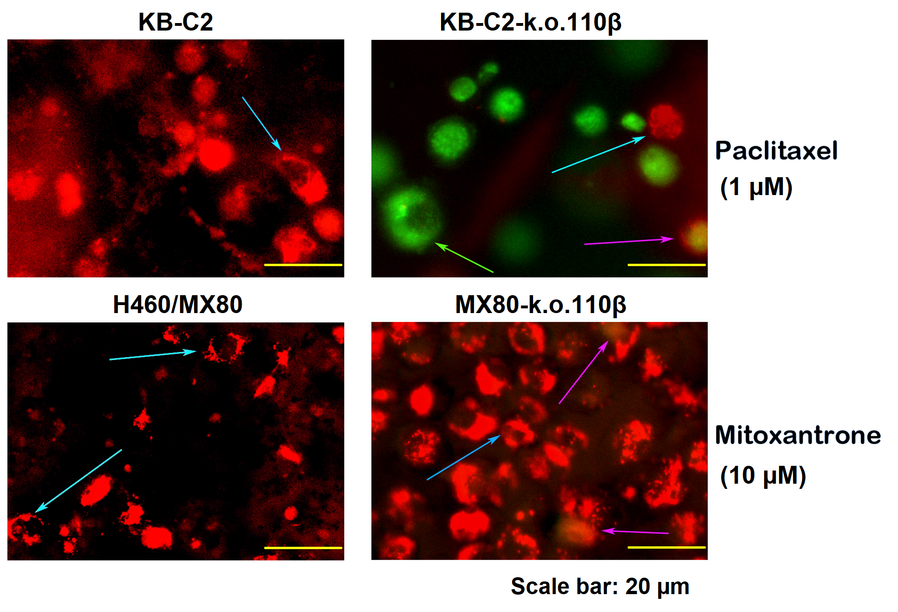
Figure S5 JC-1 analysis of the apoptosis of KB-C2 and H460/MX80 cells and the derivative cells with deficiency of P110β. JC-1 staining indicating mitochondrial membrane potential showed severe depolarization of the mitochondrial membrane as a result of severe apoptosis of 110β subunit-k.o. KB-C2 cells (namely KB-C2-k.o. 110 β), as depicted by the green arrows. KB-C2 and H460/MX80 cells without apoptosis are depicted by arrows in slight blue. Slightly apoptotic 110β subunit-k.o. H460/MX80 (namely MX80-k.o.110β) cells are depicted by arrows in pink. The KB-C2 and H460/MX80 cells were seeded into 96-well plates (5×10³ cells per well) and cultured for 8 h, followed by treatment with 1 µM of paclitaxel and 10 µM of mitoxantrone, respectively. JC-1 (2 µg mL⁻¹) was then used for cell staining for 30 min. The cells were washed with PBS and observed with fluorescent microscope. The experiments were independently repeated three times.

