Supplementary Figure S7
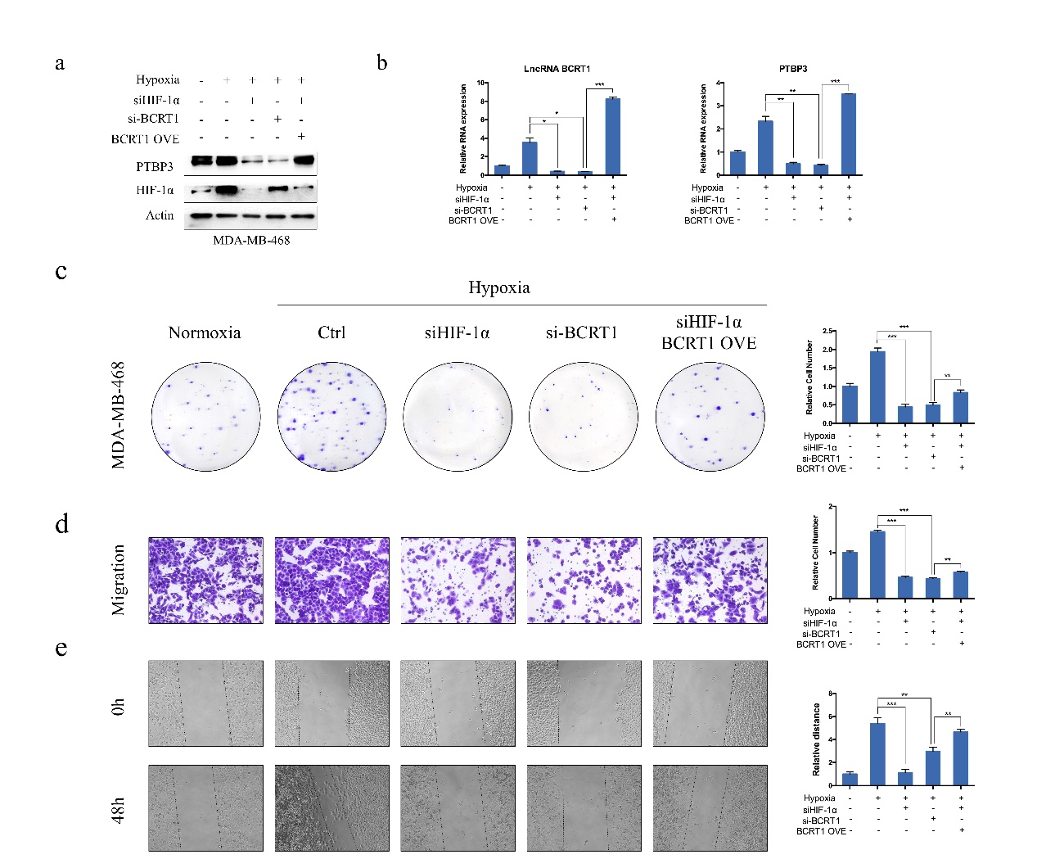
Figure S7. LncRNA BCRT1 is essential for HIF-1α-mediated hypoxia-induced malignant properties. MDA-MB-468 cells were treated with normoxia, hypoxia, a combination of siHIF-1α and hypoxia, a combination of si-BCRT1 and hypoxia, or hypoxia further and cotransfection with siHIF-1α and the pcDNA3.1-BCRT1 plasmid. a The expression of HIF-1α and PTBP3 was evaluated by western blot. b RT-PCR was used to detect the expression of lncRNA BCRT1 and PTBP3. c Proliferation of MDA-MB-468 cells was assessed by colony formation assay. d-e Transwell assay and wound healing assay were applied to analyze the migration ability of MDA-MB-468 cells. (*P < 0.05, **P < 0.01, and ***P < 0.001).

