Supplementary Figure S2

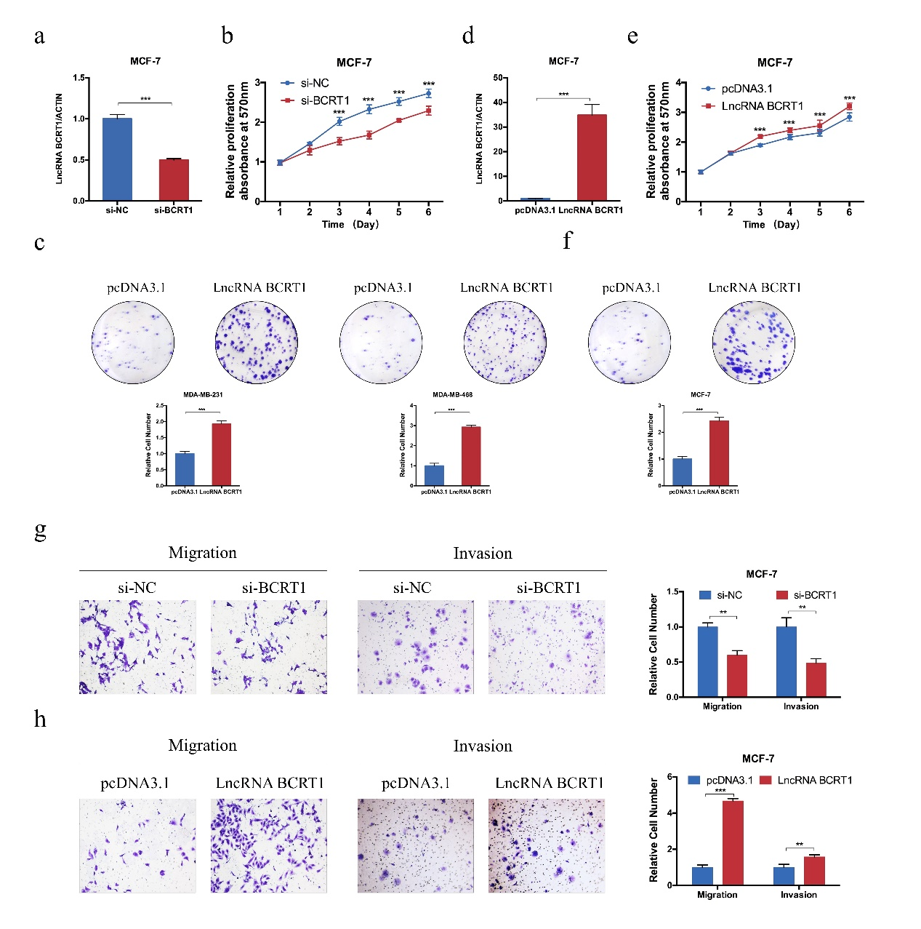

Figure S2. LncRNA BCRT1 regulates proliferation and migration of breast cancer cells in vitro. a The efficiency of lncRNA BCRT1 knockdown in MCF-7 cells was validated with RT-PCR. b MTT assays showed the reduced proliferation of MCF-7 cells transfected with si-BCRT1. c Colony formation assay showed the decreased proliferation of MDA-MB-231 and MDA-MB-468 cells after lncRNA BCRT1 knockdown. d The proliferation rate of MCF-7 cells was evaluated after lncRNA BCRT1 overexpression. e-f MTT assay and colony formation assay were used to evaluate proliferation rate after lncRNA BCRT1 overexpression in MCF-7 cells. g-h Transwell assays demonstrated that lncRNA BCRT1 knockdown inhibited whereas lncRNA BCRT1 overexpression promoted cell migration and invasion abilities in MCF-7 cells. (**P<0.01, ***P<0.001, Student’s t test).

