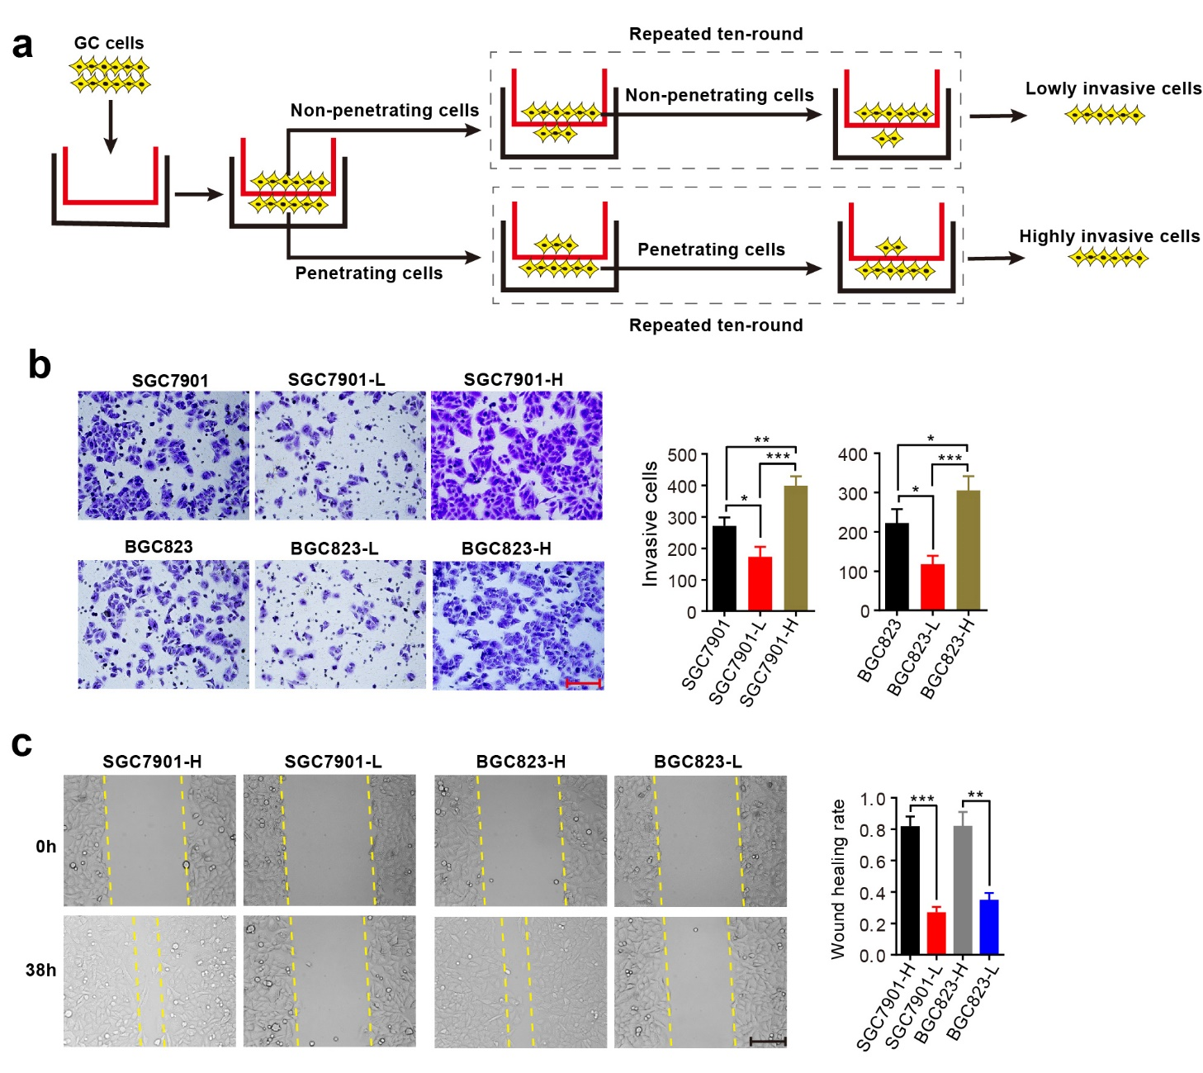
Figure S1. Establishment of highly and lowly invasive GC cell sublines. a General scheme of the establishment of highly invasive and lowly invasive cell sublines from SGC7901 and BGC823 cell lines. b Cell invasive abilities of parental, highly invasive and lowly invasive GC cell sublines. c Cell migratory abilities of highly and lowly invasive GC cell sublines. b-c Scale bars, 150 μm. Error bars indicate SD from 3 independent experiments. * P < 0.05; ** P < 0.01; ***P < 0.001.
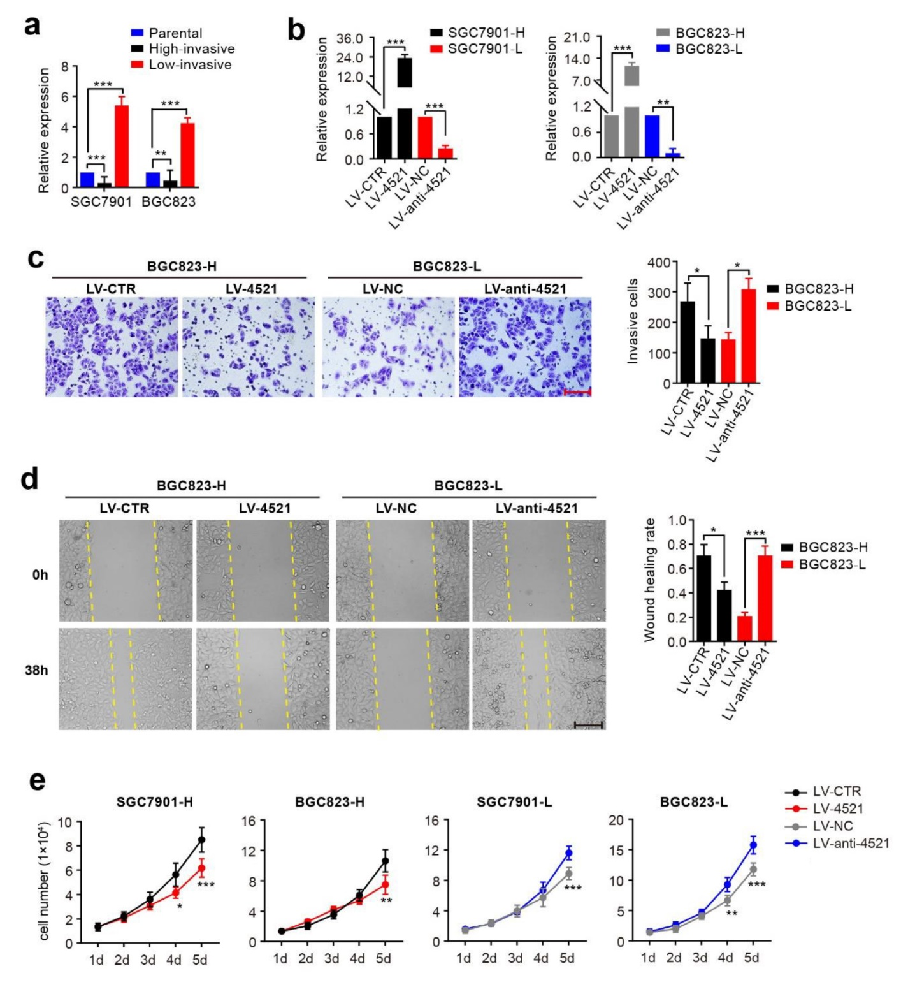
Figure S2. miR-4521 inhibits GC cell invasion, migration and growth. a qRT-PCR analysis of miR-4521 expression in parental, highly invasive and lowly invasive GC cell sublines. b qRT-PCR analysis was used to confirm the level of miR-4521 in cells with stable overexpression or knockdown of miR-4521. c-d Cell invasion and migration in BGC823-H cells stably expressing miR-4521, BGC823-L cells stably silencing miR-4521 and the respective control cells were examined by transwell and wound healing assays. Scale bars, 150 μm. e Cell proliferation assay in highly invasive cells stably expressing miR-4521, lowly invasive cells stably silencing miR-4521 and the control cells. a-e Error bars, SD from three independent experiments performed in triplicate. *P < 0.05; **P < 0.01; ***P < 0.001.
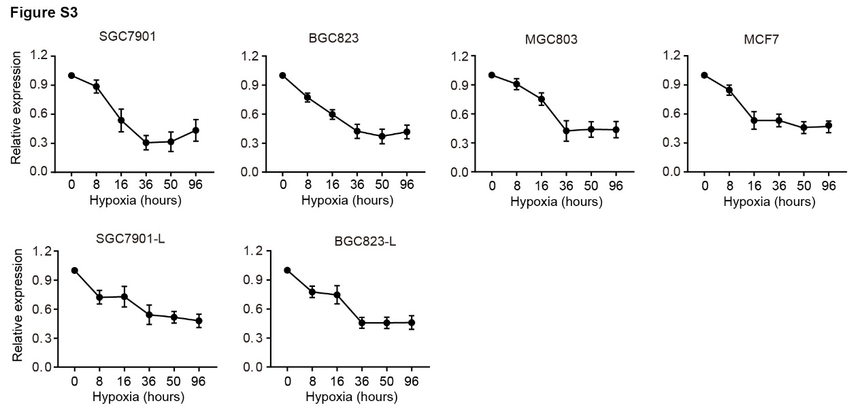
Figure S3. miR-4521 expression levels under hypoxic conditions for multiple cancer cell lines at different time points.

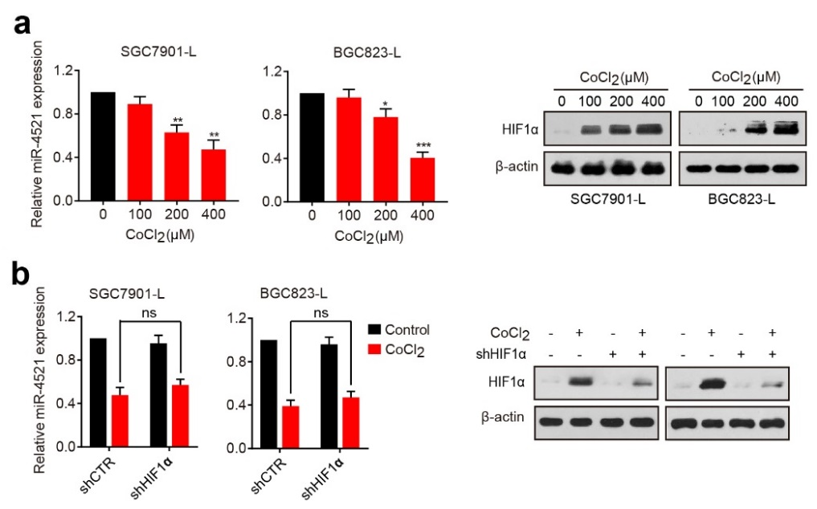
Figure S4. CoCl₂ treatment represses miR-4521 expression in a HIF1α-independent manner. a qRT-PCR analysis of miR-4521 expression levels in SGC7901-L and BGC823-L cells incubated with different concentrations of CoCl₂ for 16 h. Meanwhile, Western blotting was performed to detect HIF1α protein levels. b miR-4521 expression in HIF1α-silenced cells incubated with CoCl₂ (400μM) for 16 h. Meanwhile, Western blotting analysis was performed to assess the inhibition efficiency. Error bars represent SD. *P <0.05; **P < 0.01; ***P <0.001; ns, not significant.

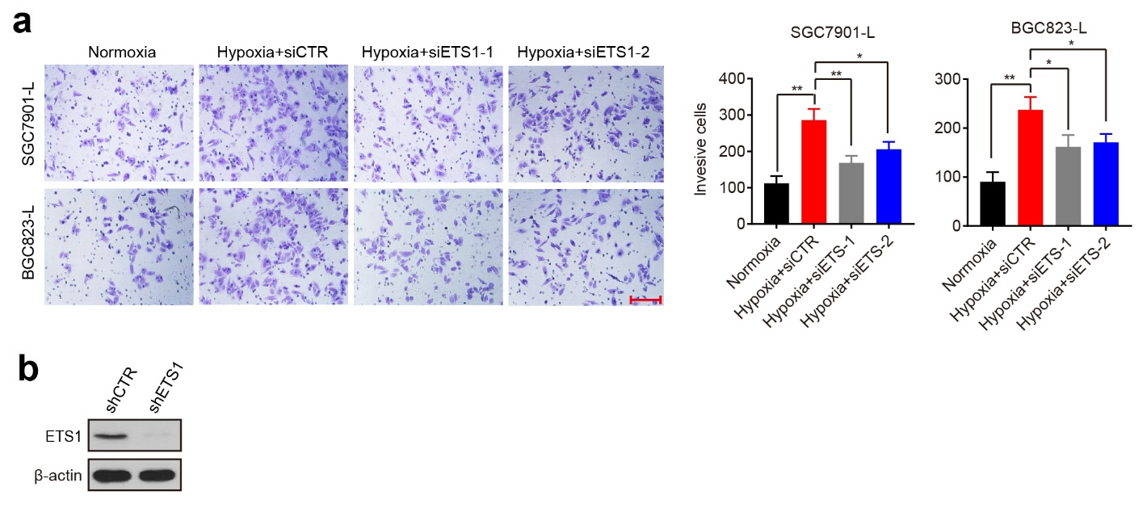
Figure S5. Knockdown of ETS1 suppresses invasive ability of hypoxia-exposed cells. a Cell invasion assays of SGC7901-L and BGC-L cells transfected with ETS1 siRNAs during hypoxia. Scale bar, 150 μm. Error bars indicate SD. *P <0.05; **P < 0.01. b The inhibition efficiency was examined in SGC7901-H cells stably expressing ETS1 shRNA by Western blotting.

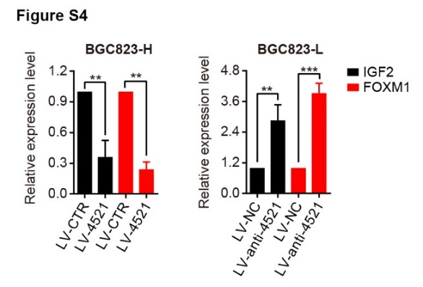
Figure S6. miR-4521 downregulates IGF2 and FOXM1 mRNA levels. Error bars denote SD. **P < 0.01; ***P < 0.001.

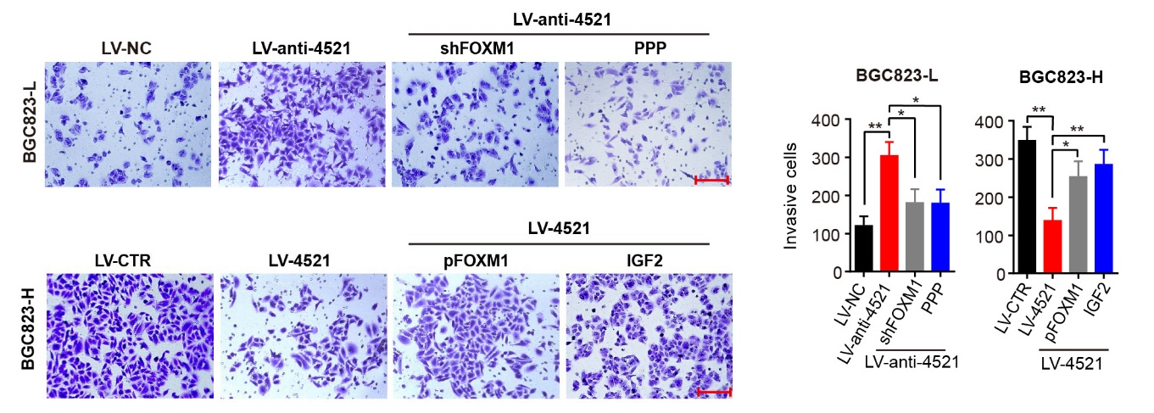
Figure S7. IGF2 and FOXM1 offset the effect of miR-4521 on cell invasion. miR-4521-silenced BGC823-L cells were transfected with FOXM1 siRNA or treated with the IGF1R inhibitor PPP (10 nM) for 48 hours, while BGC823-H cells overexpressing miR-4521 were transfected with a plasmid encoding FOXM1 or treated with 100 ng/ml IGF2 for 48 hours. The invasion ability of these cells was evaluated by transwell assay. Scale bars, 150 μm. Error bars denote SD. *P < 0.05; **P < 0.01.

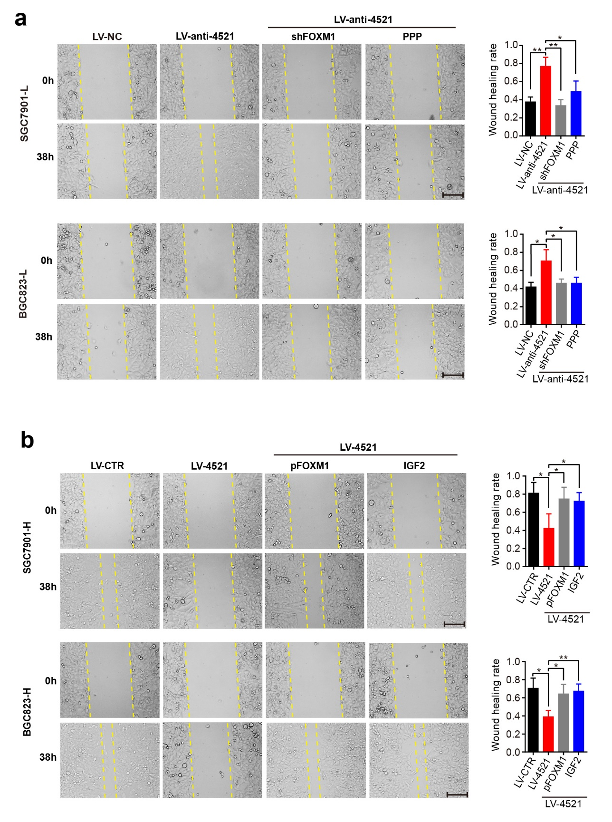
Figure S8. IGF2 and FOXM1 abrogate the effect of miR-4521 on GC migration. a-b miR-4521-silenced cells were transfected with FOXM1 shRNA or treated with the IGF1R inhibitor PPP (10 nM) for 38 hours (a), while miR-4521-expressing cells were transfected with a plasmid encoding FOXM1 or treated with 100 ng/ml IGF2 for 38 hours (b). The migratory ability of these cells was evaluated by transwell assay. Scale bars, 150 μm. Experiments were repeated three times, and error bars represent SD. *P < 0.05; **P < 0.01.

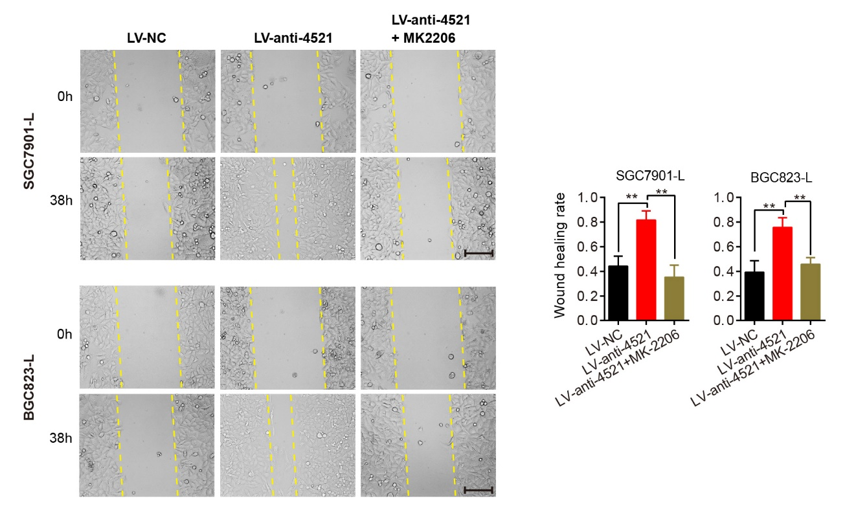
Figure S9. Blocking the AKT pathway abrogates the effect of miR-4521 knockdown on cancer cell migration. Cell migration was assessed in miR-4521-silenced cells treated with the AKT inhibitor MK2206. Scale bars, 150 μm. Error bars, SD from three independent experiments performed in triplicate. **P < 0.01.

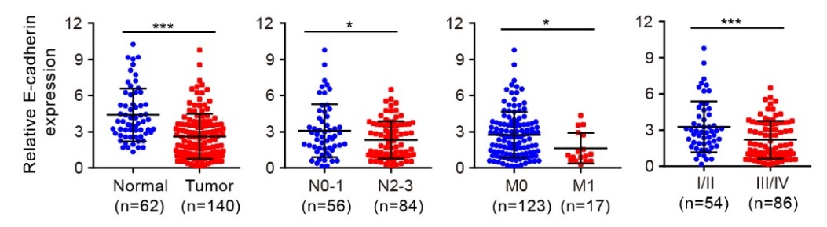
Figure S10. E-cadherin mRNA levels in normal gastric tissues and GC tumors (cohort A). Error bars represent SD. *P < 0.05; ***P < 0.001.

