Additional file 2
Supplementary Figure 2
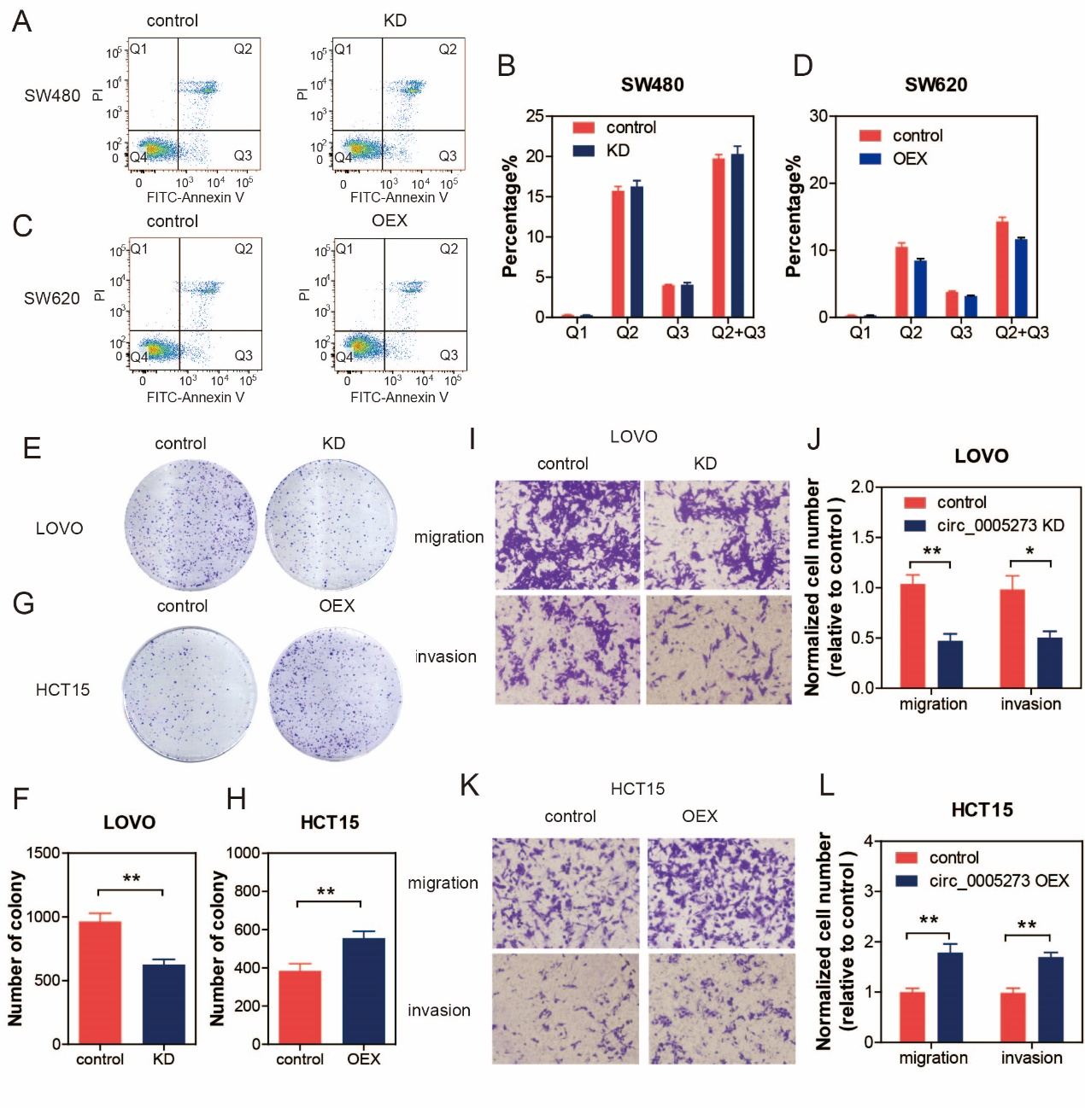
Supplementary Figure 2. CircPTK2 promoted aggressive phenotypes of CRC cells in vitro. Cells were transfected with circPTK2 siRNA or circPTK2-overexpressing plasmid for 48 hours. Then cells were harvested for annexin-V and PI staining. Cell apoptosis was detected with flow cytometry analysis. The cells were stained by crystal violet to evaluate cell proliferation, migration, and invasion capability. (A, B) The effect of circPTK2 knockdown on SW480 apoptosis. (C, D) The effect of circPTK2 overexpression on SW620 apoptosis. (E-H) Representative images and quantification results of the colony formation of cells. (I-L) Representative images and quantification results of the migration and invasion of cells. The data are the mean ± SEM. *P＜0.05, **P＜0.01, ***P＜0.001. P values were calculated by one-way ANOVA.

