Supplemental materials and methods
Tissue-elevated lncRNAs across tissues
Long noncoding RNAs (LncRNAs) play important roles in maintaining morphology and function of tissues, whose regulatory effectiveness is closely associated with spatial expression. All the tissue-elevated lncRNAs (TE lncRNAs) were downloaded from LncSpA resource (http://bio-bigdata.hrbmu.edu.cn/LncSpA), which is a comprehensive spatial atlas of expression for lncRNAs [1]. In total, 71,131 and 12,007 TE lncRNAs were identified across 38 normal and 33 adult cancer tissues.
Expression of protein-coding genes across tissues
Four widely available transcriptome datasets were collected, including the Genotype-Tissue Expression (GTEx) consortium [2], Human BodyMap 2.0 (HBM2.0) [3], Human Protein Atlas (HPA) [4] and FANTOM5 project [5]. The gene expression profiles across 33 representing cancer types were generated by TCGA (http://cancergenome.nih.gov/), covering 11,093 samples. The clinical data of these cancer patients were also downloaded [6].
m⁶A modification across tissues
N6-methyladenosine (m⁶A) is the most abundant internal mRNA modification. We downloaded the m⁶A methylome across human tissues from one recent study, which included 43 human tissues [7]. The chromosome coordinates of m⁶A methylome peaks were downloaded from the supplemental files of this study.
Identification of m⁶A regulated lncRNAs
The chromosome coordinates of human lncRNAs were downloaded from GENCODE [8]. First, we manually mapped the tissues between m⁶A peaks and LncSpA. We next overlapped the lncRNA coordinates with m⁶A peaks. If an m⁶A peak was included in an lncRNA region, we defined this lncRNA was regulated by m⁶A modification. This process was performed by BEDTools [9].
Tissue similarity based on m⁶A regulated lncRNAs
To evaluate the similarity between tissues among different data resource, we calculated Simpson index between tissues based on lncRNAs with m⁶A modification. The similarity between tissue i and j was calculated as following:
$$S\left(i,j\right)=\frac{L_{i}∩L_{j}}{min⁡(L_{i},L_{j})}$$
where $L_{i}$ and $L_{j}$ were the m⁶A-related lncRNA sets in tissue i and j. The circular layout plot was plotted with R package circlize [10].
Expression correlation between lncRNAs and m⁶A regulators
We first collected the m⁶A regulators from one recent study [11]. Next, the gene expression correlation was calculated between the m⁶A regulators and TE lncRNAs. Pearson correlation coefficient (PCC) was calculated based on gene expression of m⁶A regulators and TE lncRNAs across tissues in different data resources. The m⁶A regulator-TE lncRNA pairs with p-value<0.05 were identified in each data resource.
Differential expression of lncRNAs
First, we select the cancer types with at least five adjacent tissues and also with m⁶A modified-TE lncRNA. Ten cancer types were identified for the following analysis. T-test and fold-change were calculated based on the lncRNA expression in cancer and normal samples of these cancers. LncRNAs with fold-change>2 or <0.5 and p-value<0.05 were considered as differentially expressed lncRNAs. Finally, we overlapped the differentially expressed lncRNAs and m⁶A modified-TE lncRNAs of the same cancer.
Survival analysis based on lncRNA expression
To identify the survival-related m⁶A-TE lncRNAs in cancer, we performed cox regression analysis and log-rank test for the cancer types with m⁶A modified-TE lncRNA. In total, 9 cancer types were screened. The univariate cox regression analysis was used to evaluate the association between survival and expression level of each m⁶A-TE lncRNA. In addition, all the patients were ranked based on the lncRNA expression. The top 20% and bottom 20% patients were defined as lncRNA high- or low-expressed groups. The differences in survival between the two groups were evaluated by the Kaplan–Meier method. Log-rank test was used to evaluate the survival significance. LncRNAs with p-values of log-rank test <0.05 were identified as survival-related lncRNAs. If patients with high expression of lncRNA were with significantly better survival, this lncRNA was defined as protective lncRNA. If patients with high expression of lncRNA were with significantly worse survival, this lncRNA was defined as risky lncRNA.
Prediction of functions of lncRNAs
To predict the function of m⁶A modified lncRNAs, we performed Gene Set Enrichment Analysis (GSEA) [12, 13]. First, we calculated the Pearson Correlation Coefficient (PCC) between the expressions of all protein coding genes with lncRNA of interest. The genes were ranked by the PCCs and subjected into pre-ranked GSEA. Here, we considered the functional sets associated with cancer hallmarks. Functional sets with p-adjusted<0.05 were considered as significant pathways.
References
1. Lv D, Xu K, Jin X, Li J, Shi Y, Zhang M, Jin X, Li Y, Xu J, Li X: LncSpA: LncRNA Spatial Atlas of Expression across Normal and Cancer Tissues. Cancer Res 2020, 80:2067-2071.
2. Mele M, Ferreira PG, Reverter F, DeLuca DS, Monlong J, Sammeth M, Young TR, Goldmann JM, Pervouchine DD, Sullivan TJ, et al: Human genomics. The human transcriptome across tissues and individuals. Science 2015, 348:660-665.
3. Klijn C, Durinck S, Stawiski EW, Haverty PM, Jiang Z, Liu H, Degenhardt J, Mayba O, Gnad F, Liu J, et al: A comprehensive transcriptional portrait of human cancer cell lines. Nat Biotechnol 2015, 33:306-312.
4. Uhlen M, Oksvold P, Fagerberg L, Lundberg E, Jonasson K, Forsberg M, Zwahlen M, Kampf C, Wester K, Hober S, et al: Towards a knowledge-based Human Protein Atlas. Nat Biotechnol 2010, 28:1248-1250.
5. Uhlen M, Hallstrom BM, Lindskog C, Mardinoglu A, Ponten F, Nielsen J: Transcriptomics resources of human tissues and organs. Mol Syst Biol 2016, 12:862.
6. Hoadley KA, Yau C, Hinoue T, Wolf DM, Lazar AJ, Drill E, Shen R, Taylor AM, Cherniack AD, Thorsson V, et al: Cell-of-Origin Patterns Dominate the Molecular Classification of 10,000 Tumors from 33 Types of Cancer. Cell 2018, 173:291-304 e296.
7. Liu J, Li K, Cai J, Zhang M, Zhang X, Xiong X, Meng H, Xu X, Huang Z, Peng J, et al: Landscape and Regulation of m(6)A and m(6)Am Methylome across Human and Mouse Tissues. Mol Cell 2020, 77:426-440 e426.
8. Frankish A, Diekhans M, Ferreira AM, Johnson R, Jungreis I, Loveland J, Mudge JM, Sisu C, Wright J, Armstrong J, et al: GENCODE reference annotation for the human and mouse genomes. Nucleic Acids Res 2019, 47:D766-D773.
9. Quinlan AR, Hall IM: BEDTools: a flexible suite of utilities for comparing genomic features. Bioinformatics 2010, 26:841-842.
10. Gu Z, Gu L, Eils R, Schlesner M, Brors B: circlize Implements and enhances circular visualization in R. Bioinformatics 2014, 30:2811-2812.
11. Li Y, Xiao J, Bai J, Tian Y, Qu Y, Chen X, Wang Q, Li X, Zhang Y, Xu J: Molecular characterization and clinical relevance of m(6)A regulators across 33 cancer types. Mol Cancer 2019, 18:137.
12. Mootha VK, Lindgren CM, Eriksson KF, Subramanian A, Sihag S, Lehar J, Puigserver P, Carlsson E, Ridderstrale M, Laurila E, et al: PGC-1alpha-responsive genes involved in oxidative phosphorylation are coordinately downregulated in human diabetes. Nat Genet 2003, 34:267-273.
13. Subramanian A, Tamayo P, Mootha VK, Mukherjee S, Ebert BL, Gillette MA, Paulovich A, Pomeroy SL, Golub TR, Lander ES, Mesirov JP: Gene set enrichment analysis: a knowledge-based approach for interpreting genome-wide expression profiles. Proc Natl Acad Sci U S A 2005, 102:15545-15550.

Supplemental figures

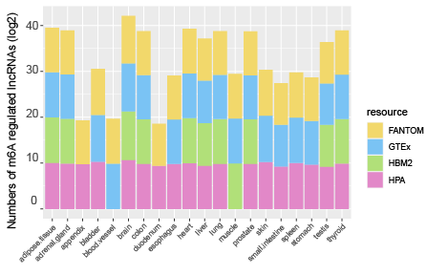
Figure S1. Numbers of m⁶A-regulated lncRNAs across tissues.

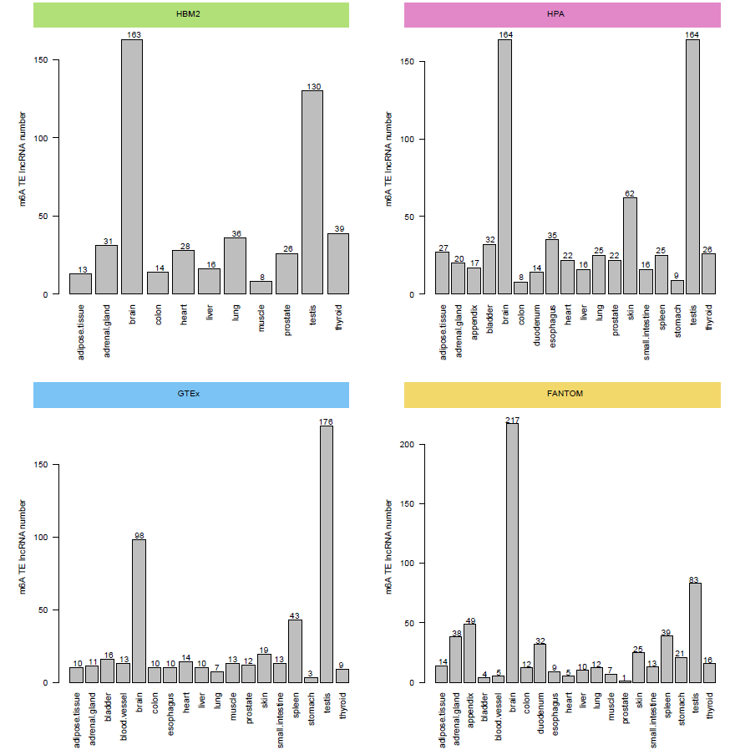
Figure S2. Numbers of m⁶A-regulated TE lncRNAs across tissues in four data resources.

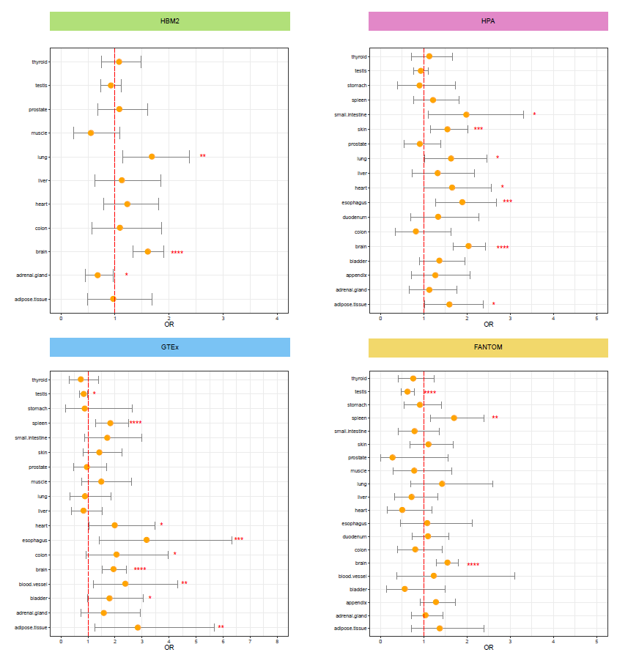
Figure S3. Distribution of odds ratios for comparison between TE lncRNAs and non-TE lncRNAs across tissues in four data resources.

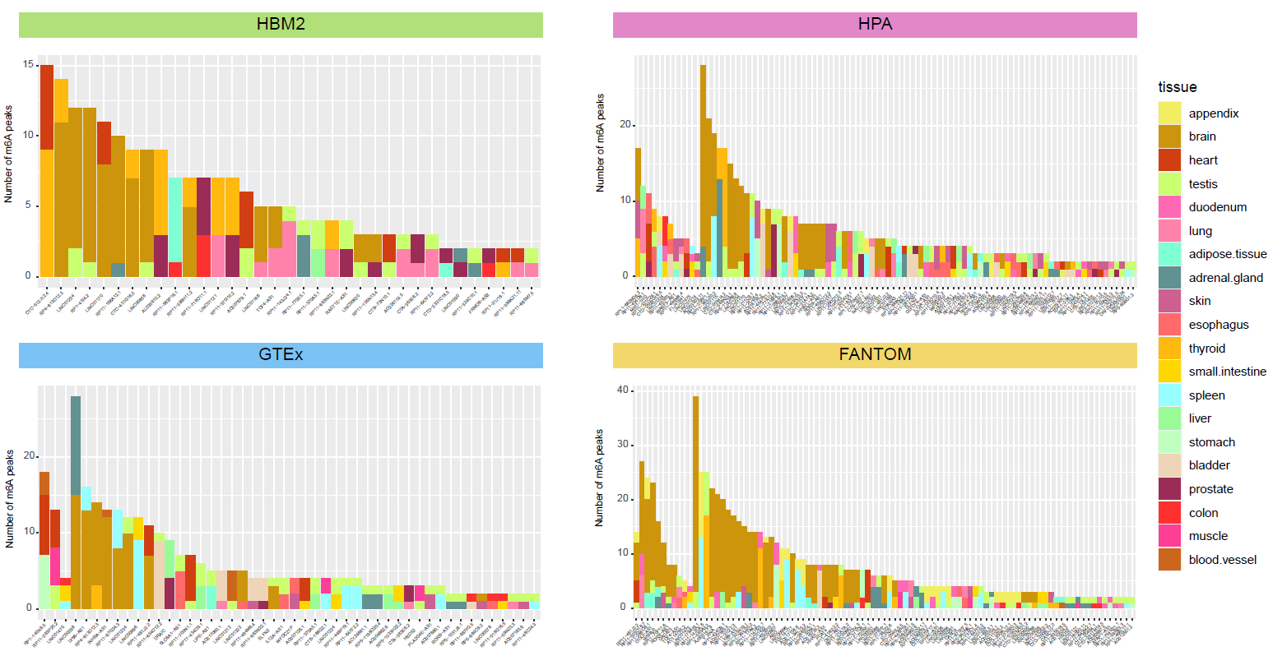
Figure S4. Number of m⁶A peaks correlated with TE lncRNAs in four resources.
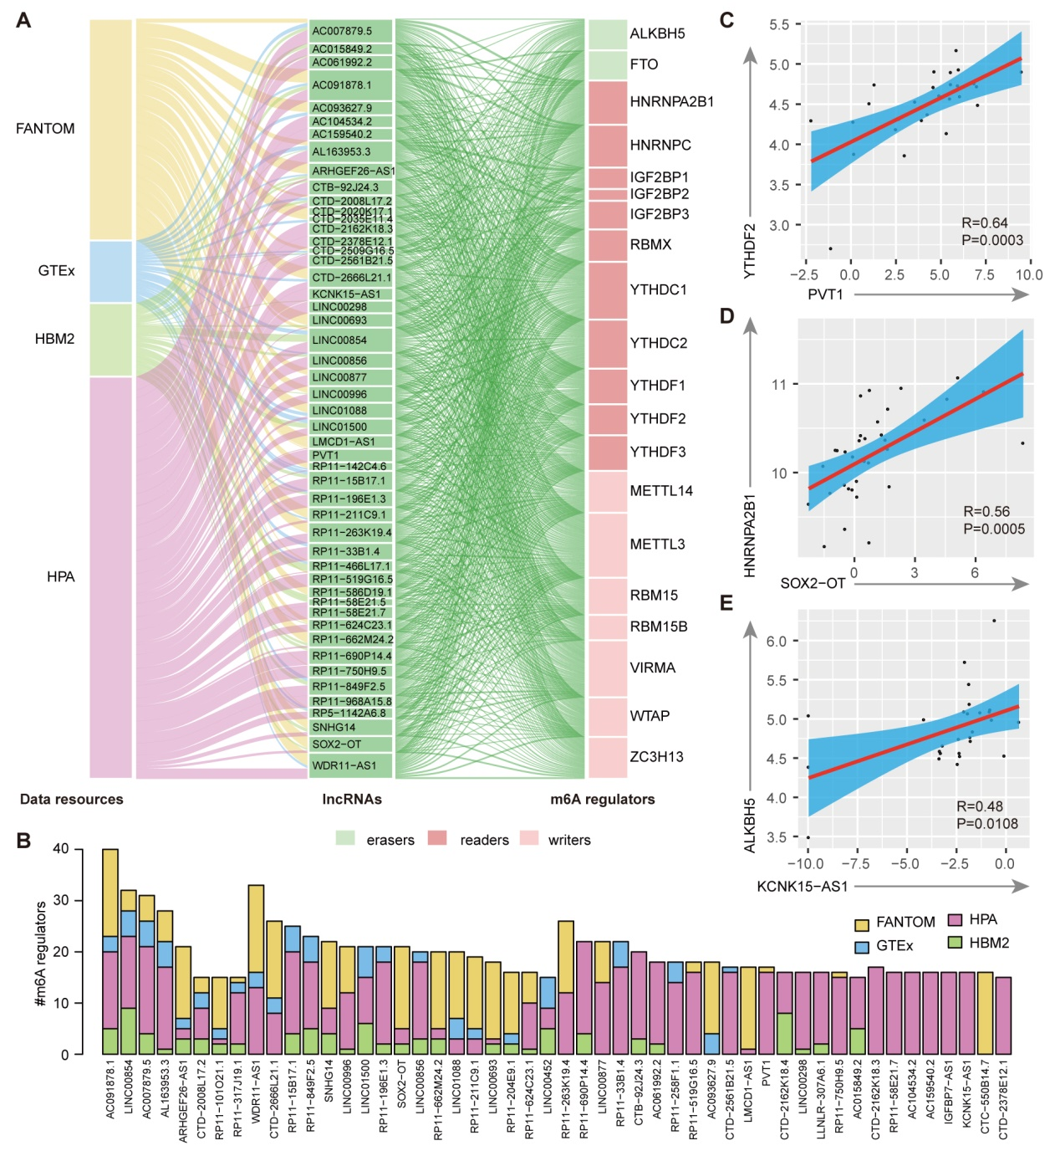
Figure S5. Co-expression between m⁶A regulators and m⁶A-modified TE lncRNAs. A, River plot showing the expression correlation between m⁶A-modified TE lncRNAs and m⁶A regulators. B, Bar plots showing the number of m⁶A regulators correlated with each m⁶A-modified TE lncRNA. Color indicated the different data resources. C-E, Scatter plots showing the correlation between the expression of lncRNAs and m⁶A regulators. C for PVT1 and YTHDF2; D for SOX2-OT and HNRNPA2B1; E for KCNK15-AS1 and ALKBH5.

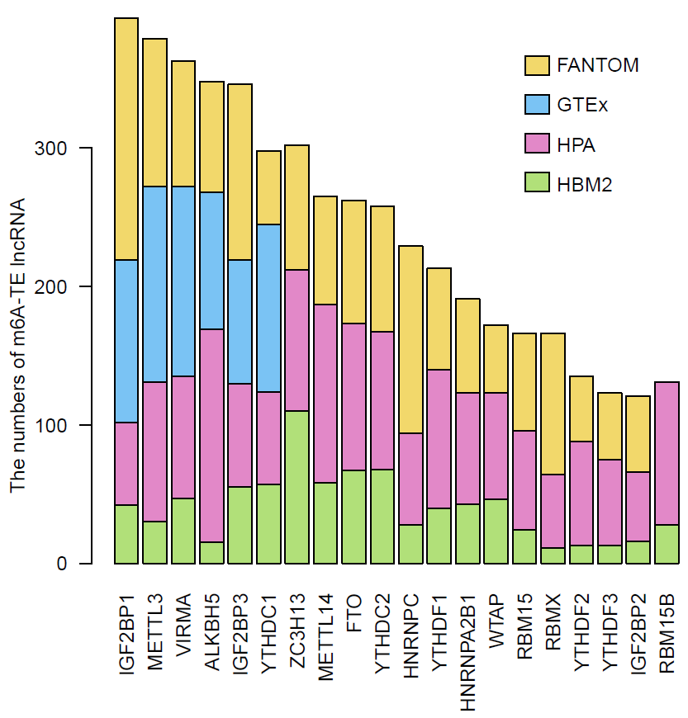
Figure S6. Numbers of TE lncRNAs correlated with m⁶A regulators.

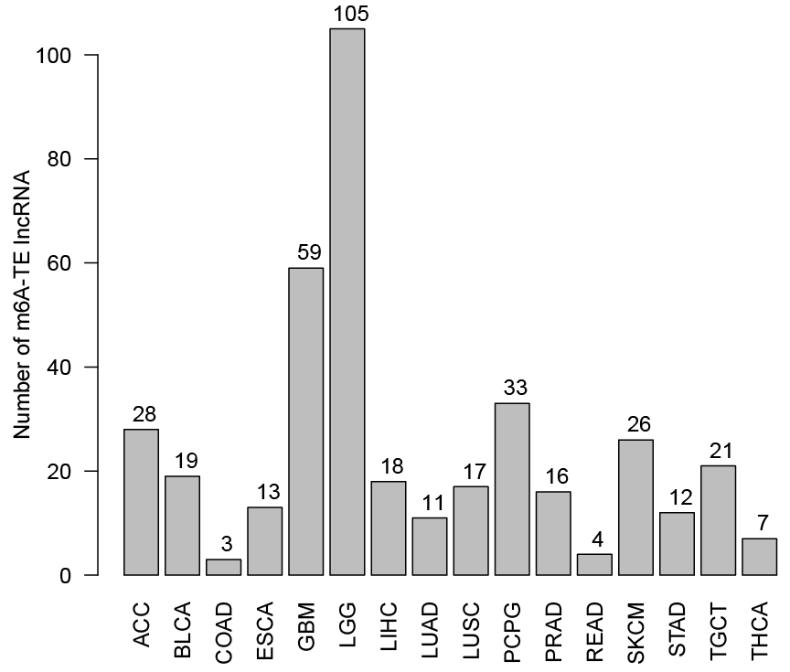
Figure S7. Number of m⁶A-modified TE lncRNAs across cancer types.
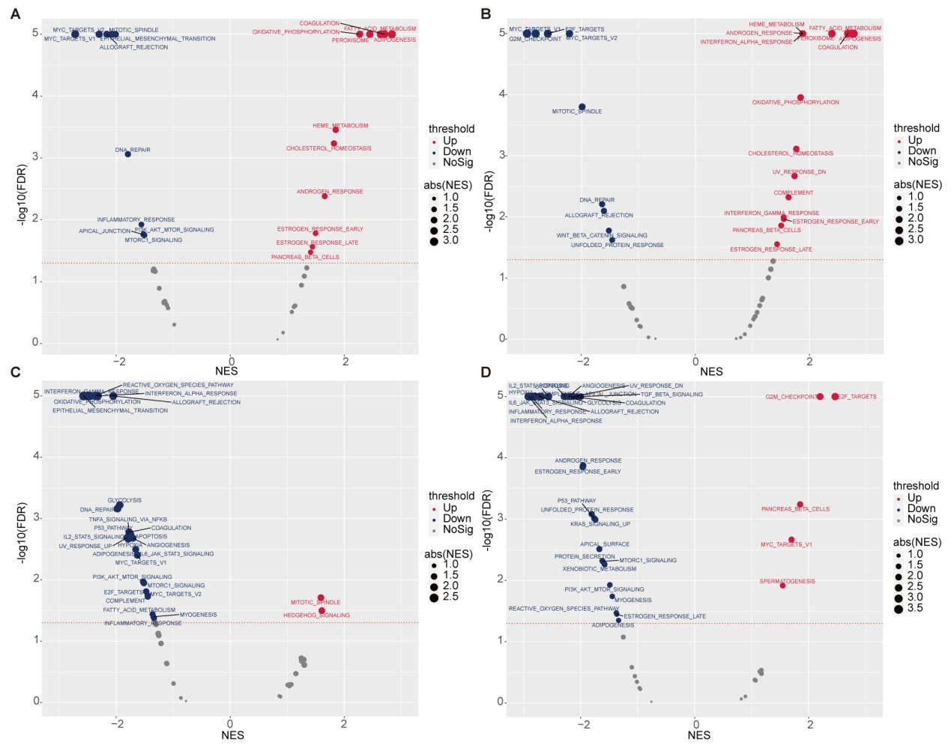
Figure S8. GSEA for m⁶A-modified lncRNAs in HCC, LGG and GBM.
A, F11-AS1 in HCC; B, LINC01018 in HCC; C, MIR325HG in LGG, D, MIR325HG in GBM.

Figure S9. GSEA figures for m⁶A-modified lncRNAs in HCC, LGG and GBM.
A, F11-AS1 enriched in DNA repair pathway in HCC; B, LINC01018 enriched in DNA repair pathway in HCC; C, MIR325HG enriched in EMT pathway in LGG, D, MIR325HG enriched in EMT pathway in GBM.

