γH2AX of CDDP-treated group in Fig. 2j
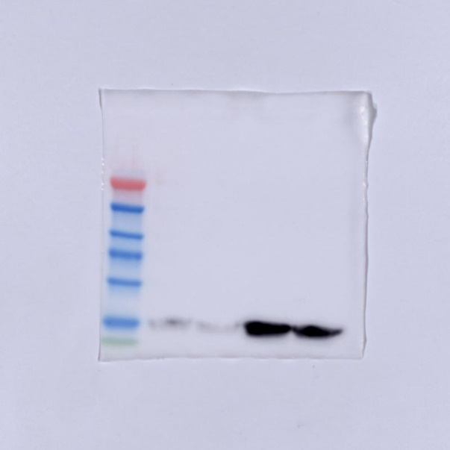

caspase-3 of CDDP-treated group in Fig. 2j
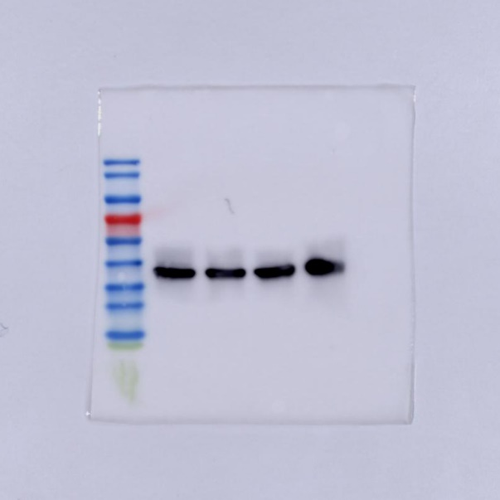

cleaved caspase-3 of CDDP-treated group in Fig. 2j
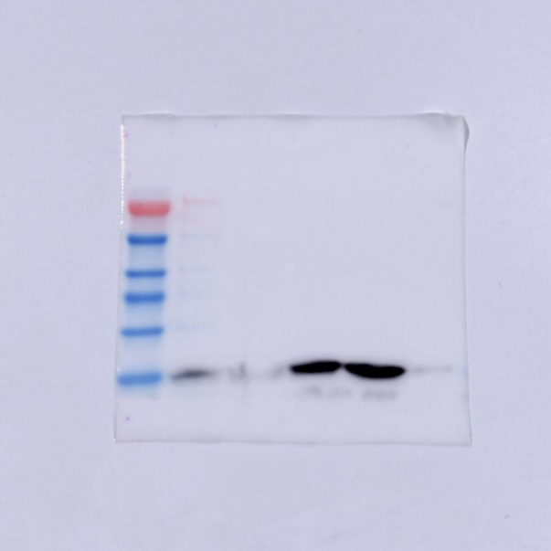

GAPDH of CDDP-treated group in Fig. 2j
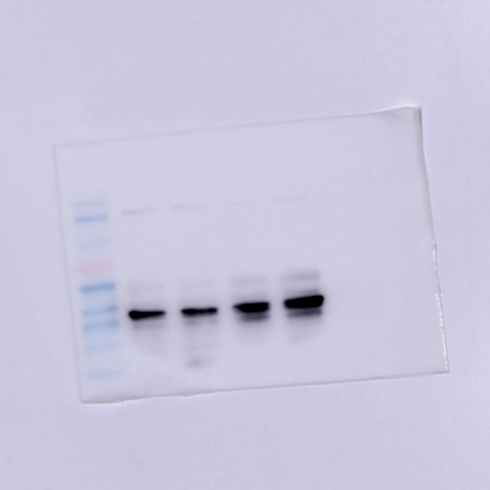

γH2AX of PBS-treated group in Fig. 2j
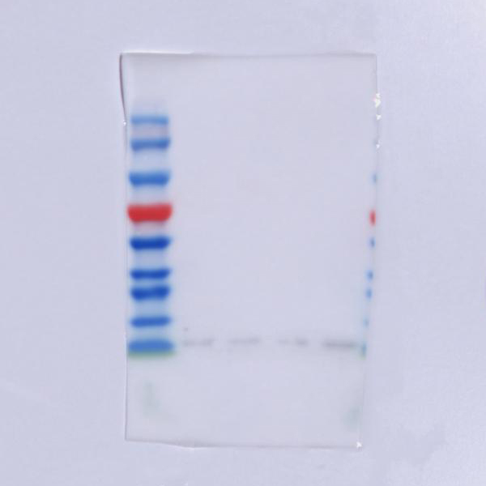

caspase-3 of PBS-treated group in Fig. 2j
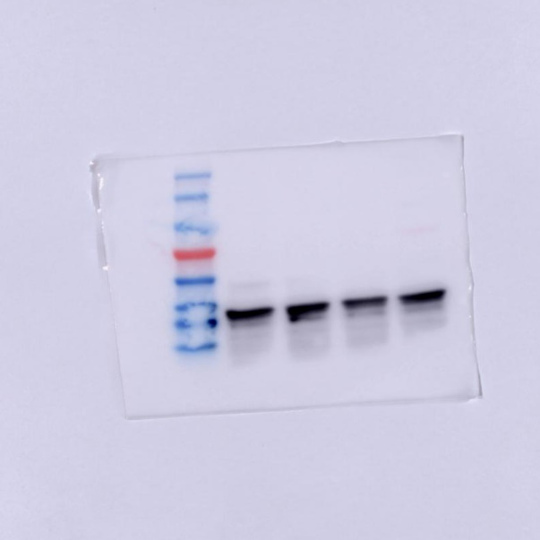

cleaved caspase-3 of PBS-treated group in Fig. 2j
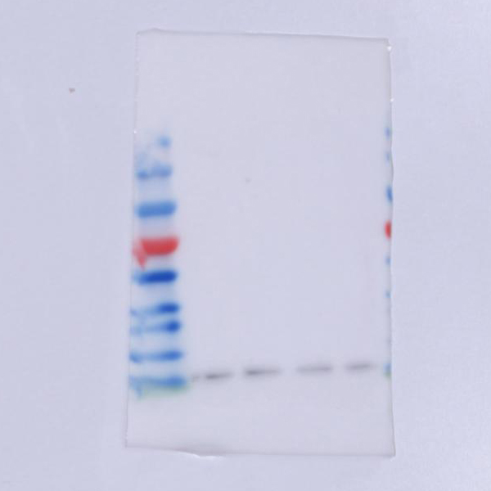

GAPDH of PBS-treated group in Fig. 2j
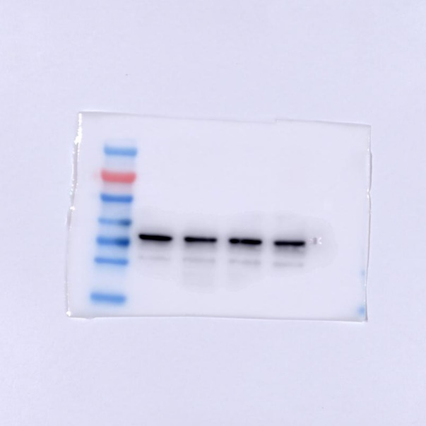

γH2AX of CDDP-treated group in Fig. 2k
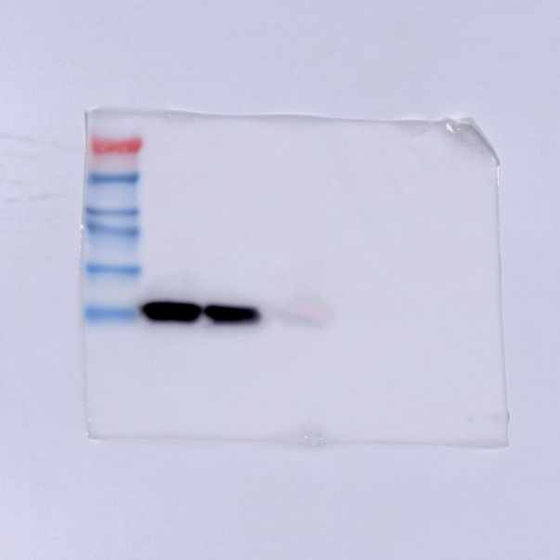

caspase-3 of CDDP-treated group in Fig. 2k (left 3 lanes) and Fig. S4i (right 3 lanes)
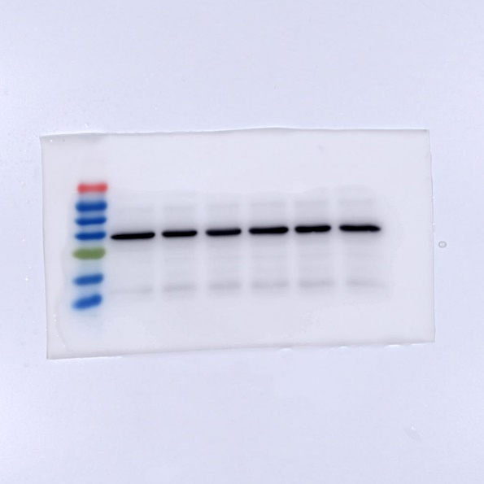

cleaved caspase-3 of CDDP-treated group in Fig. 2k
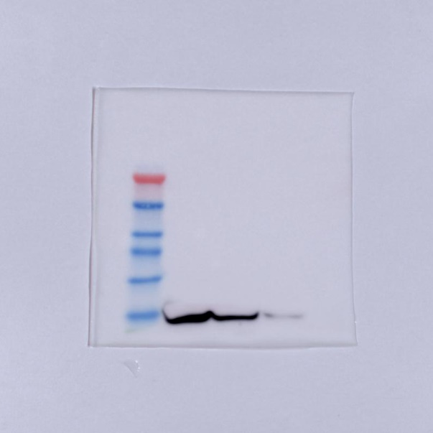

GAPDH of CDDP-treated group in Fig. 2k (left 3 lanes) and Fig. S4i (right 3 lanes)
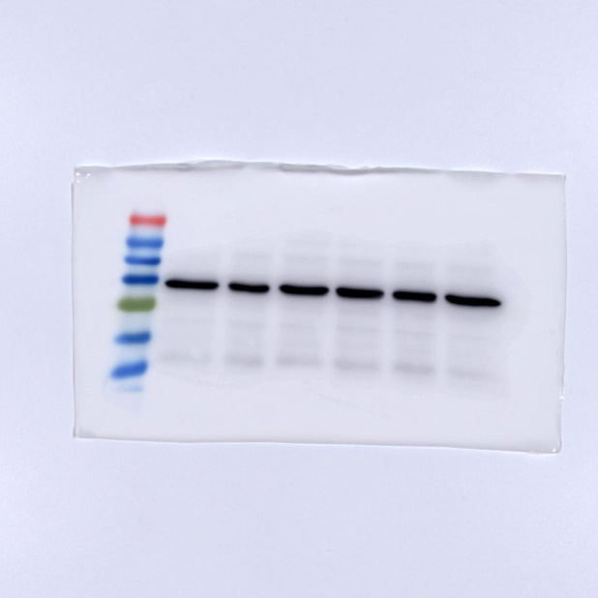

MTDH in Fig. 4d (left 2 lanes represent KYSE30/CDDP-R and KYSE30, right 2 lanes represent TE1/CDDP-R and TE1)
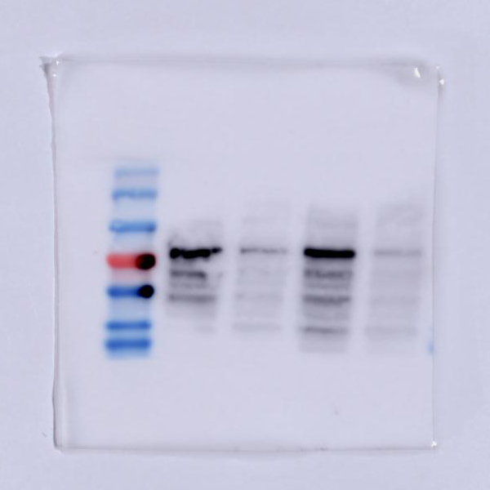

GAPDH of KYSE30/CDDP-R and KYSE30 in Fig. 4d
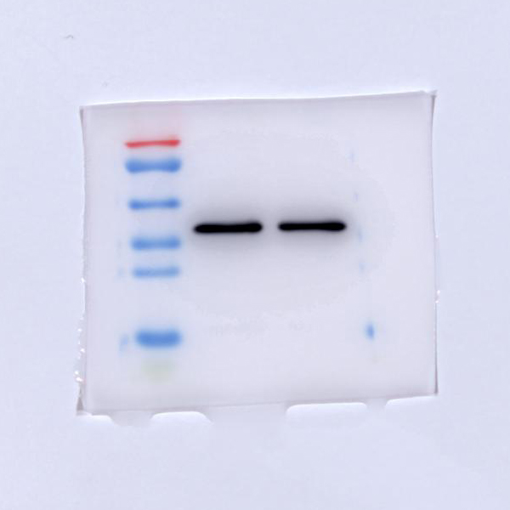

GAPDH of TE1/CDDP-R and TE1 in Fig. 4d
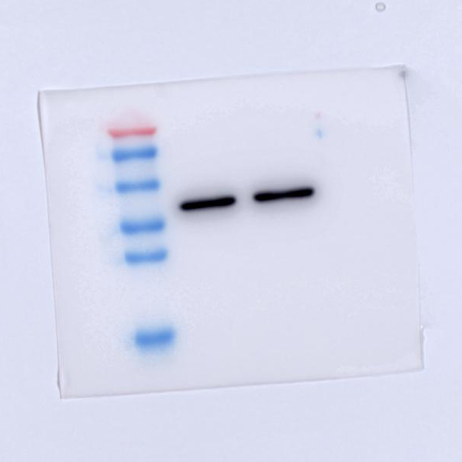

MTDH in Fig. 4g
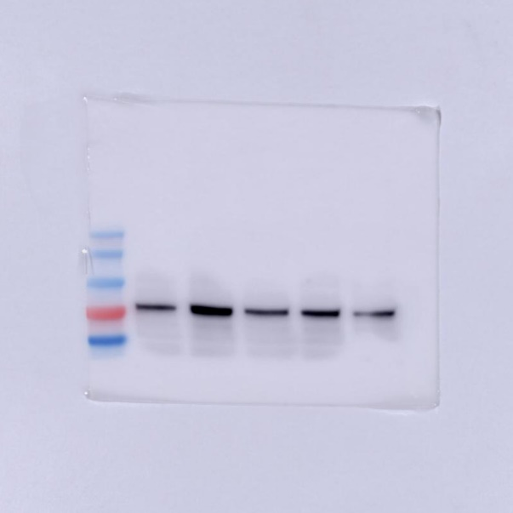

GAPDH in Fig. 4g
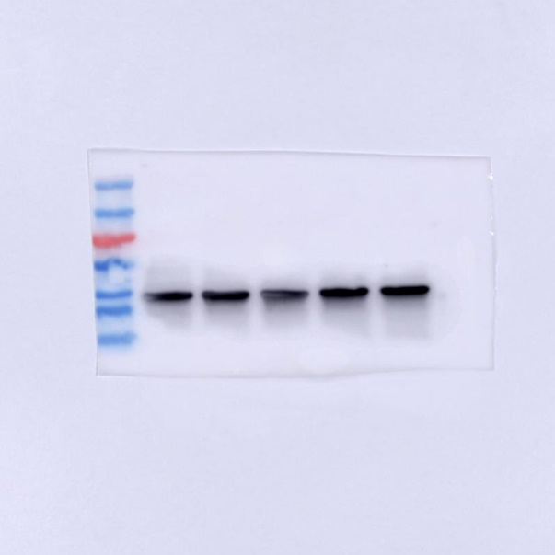

MTDH in Fig. 4h
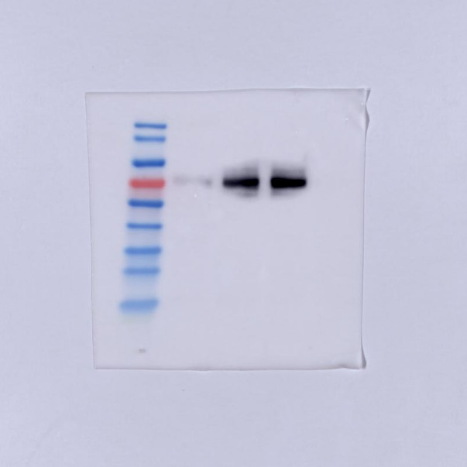

GAPDH in Fig. 4h and Fig. 5e
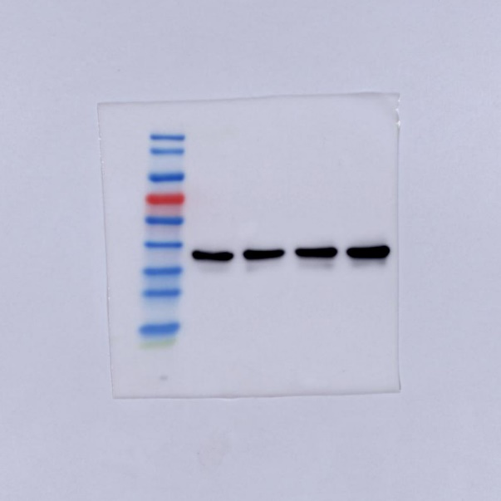

MTDH in Fig. 4i
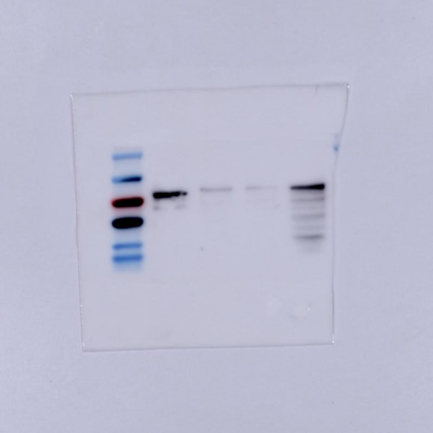

GAPDH in Fig. 4i
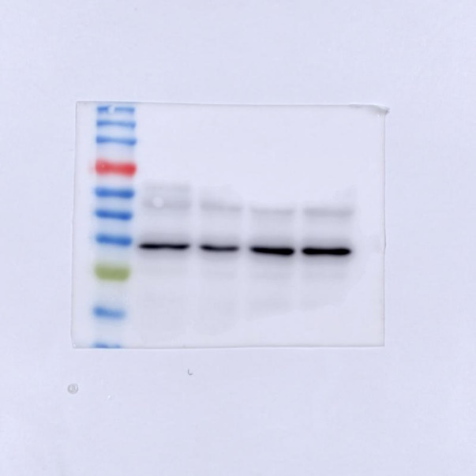

MTDH in Fig. 5e
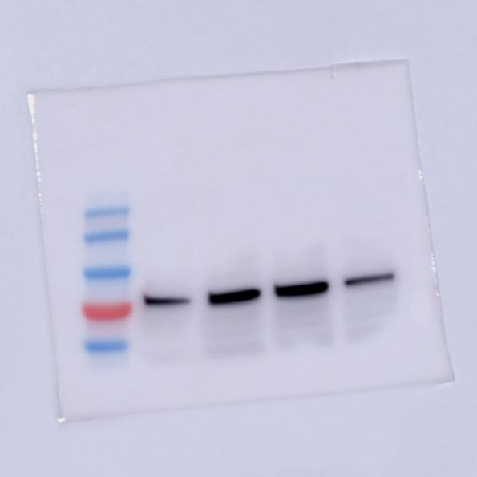

p38 MAPK in Fig. 5e
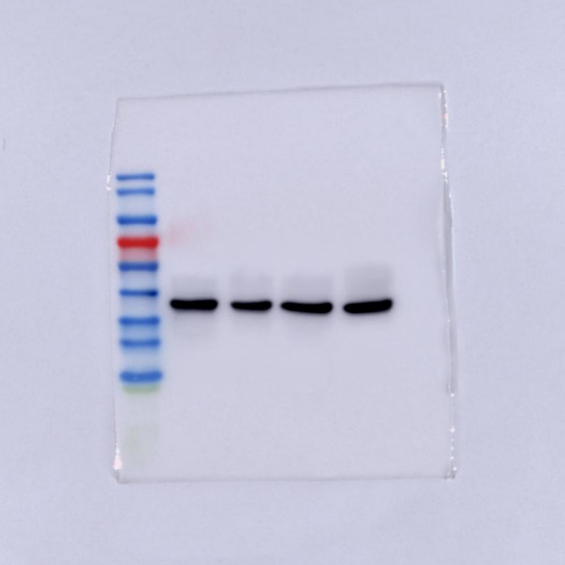

phospho-p38 MAPK in Fig. 5e
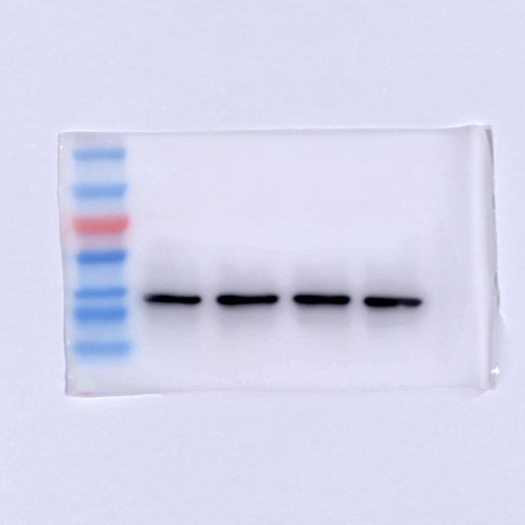

AKT in Fig. 5e
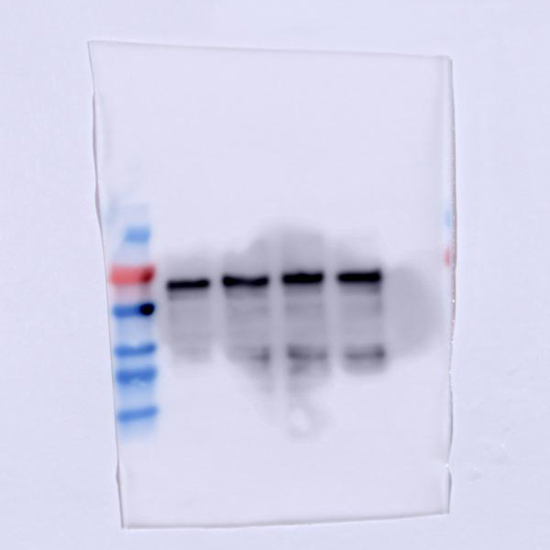

phospho-AKT in Fig. 5e
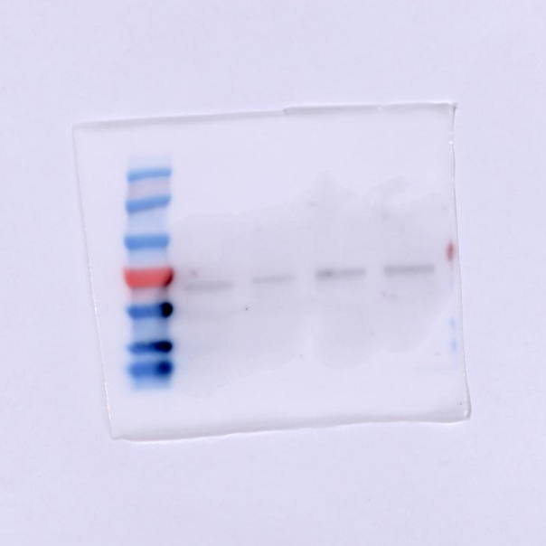

NF-κB in Fig. 5e
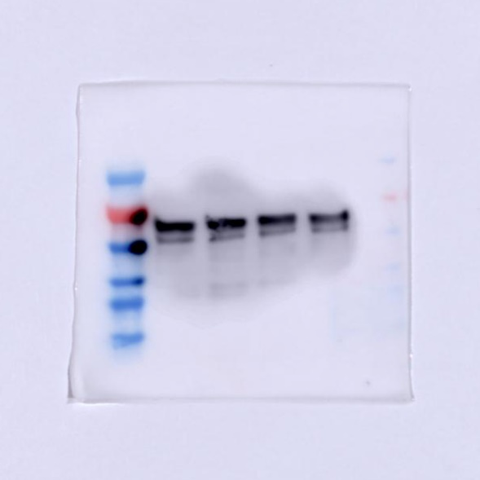

phospho- NF-κB in Fig. 5e
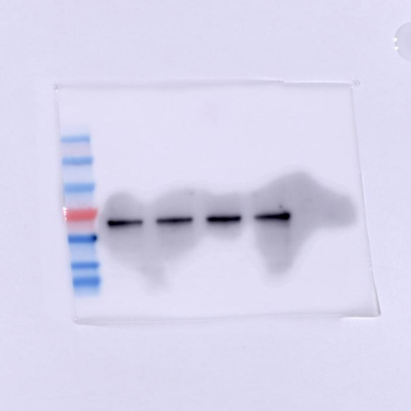

β-catenin in Fig. 5e
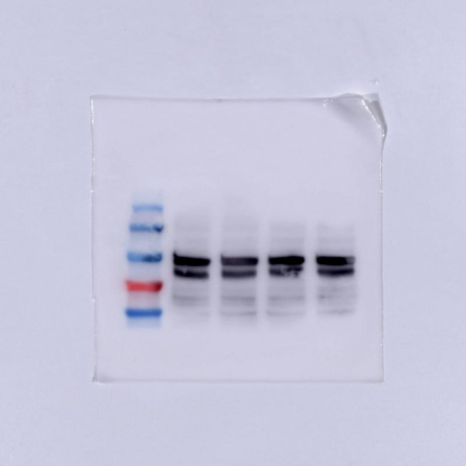

phospho-β-catenin in Fig. 5e
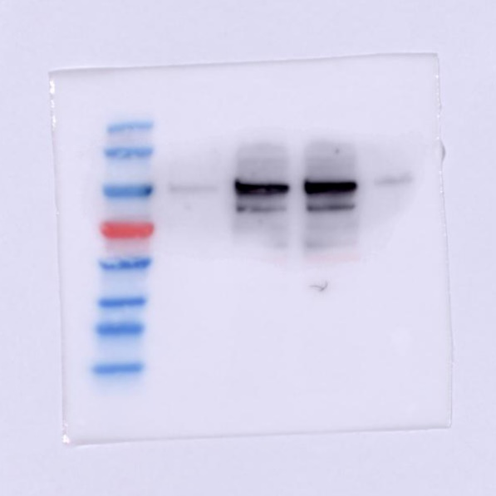

GAPDH in Fig. 5e
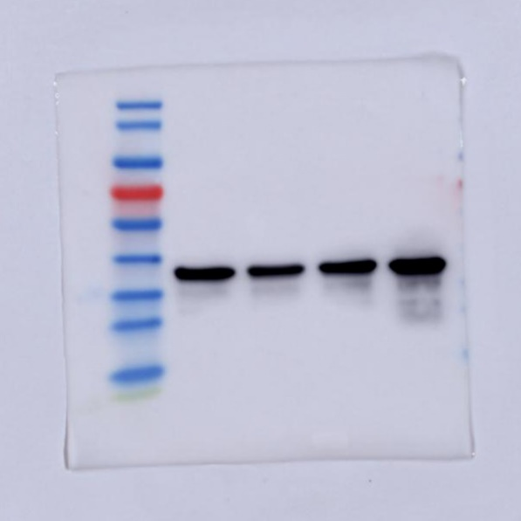

β-catenin in Fig. 5f
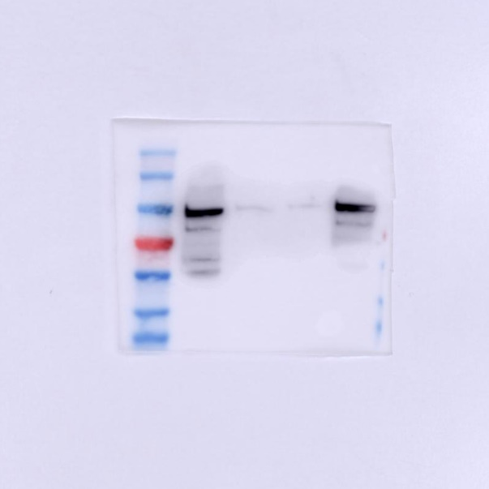

GAPDH in Fig. 5f
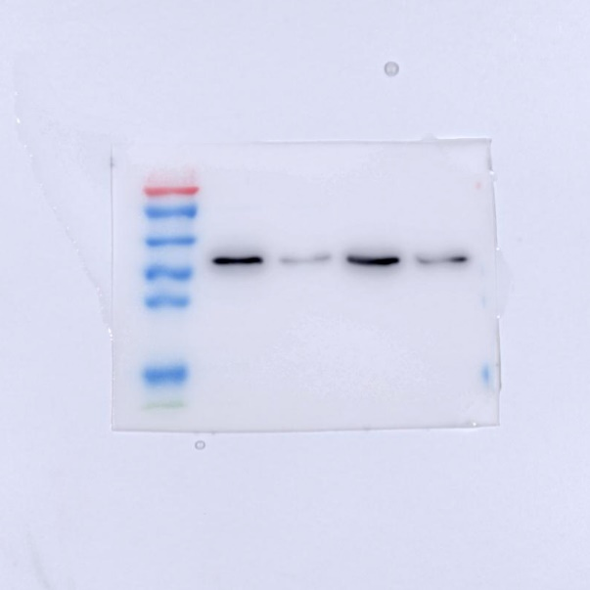

Histone H3 in Fig. 5f
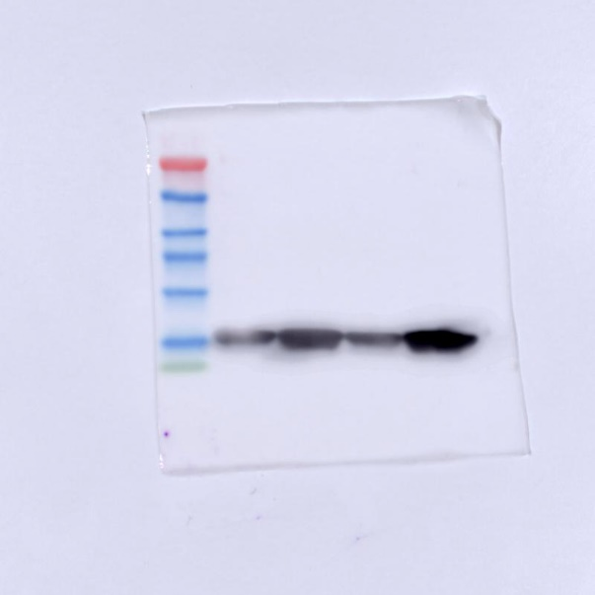

E-cadherin in KYSE30/CDDP-R in Fig. 6c
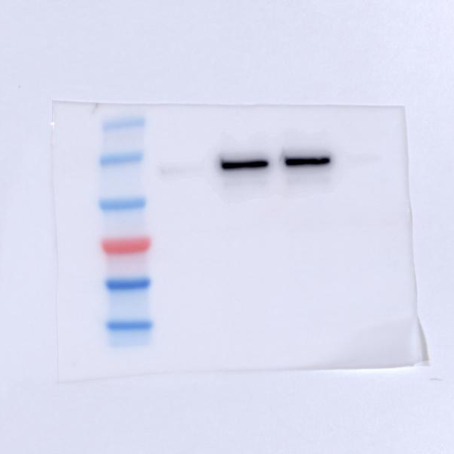

N-cadherin in KYSE30/CDDP-R in Fig. 6c
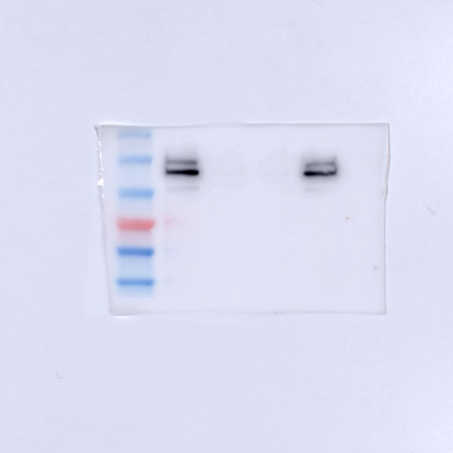

MMP9 in KYSE30/CDDP-R in Fig. 6c
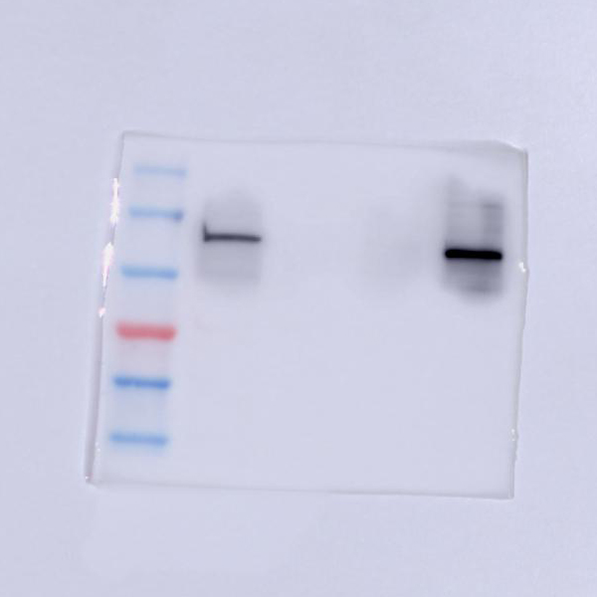

GAPDH in KYSE30/CDDP-R in Fig. 6c
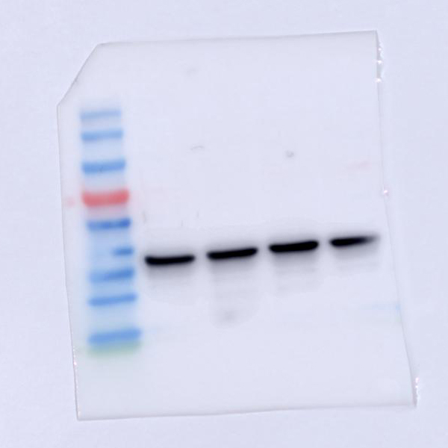

E-cadherin in KYSE30 in Fig. 6c
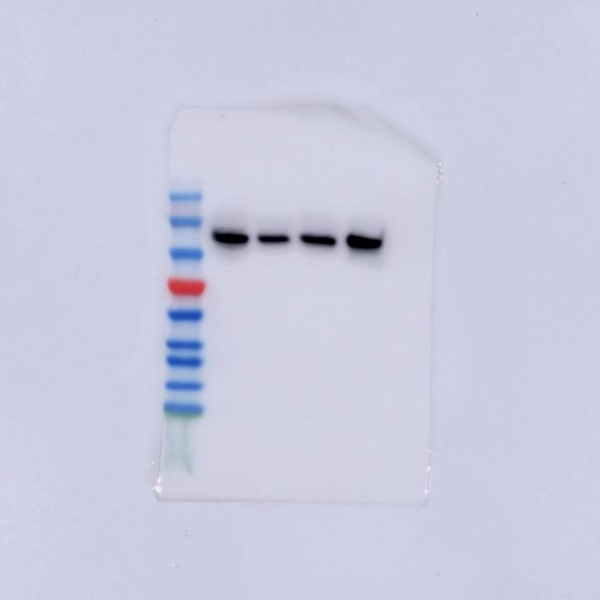

N-cadherin in KYSE30 in Fig. 6c
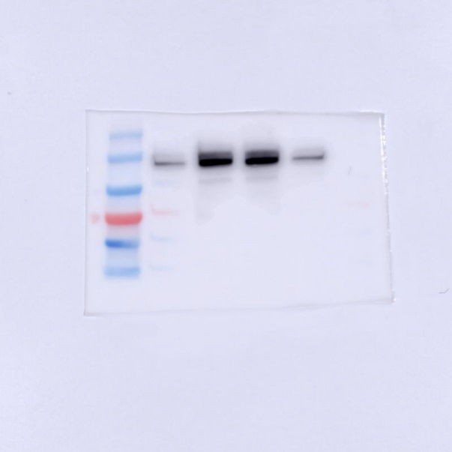

MMP9 in KYSE30 in Fig. 6c
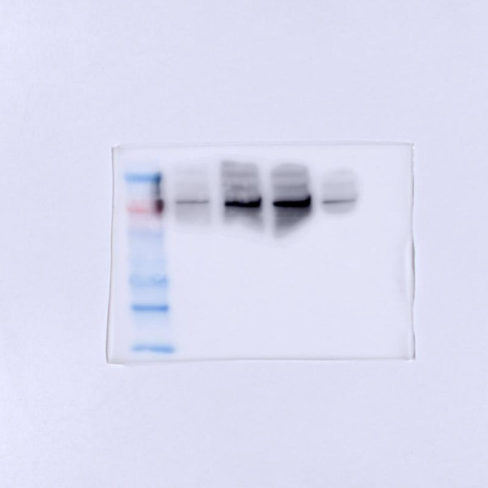

GAPDH in KYSE30 in Fig. 6c
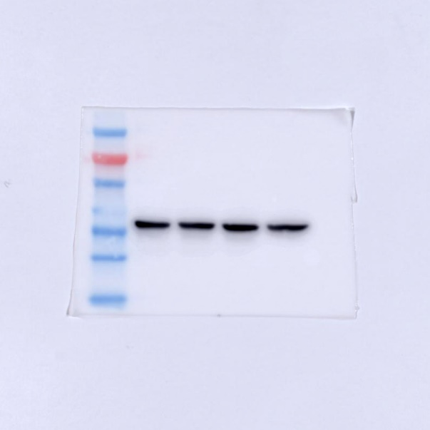

γH2AX of CDDP-treated group in Fig. S4h
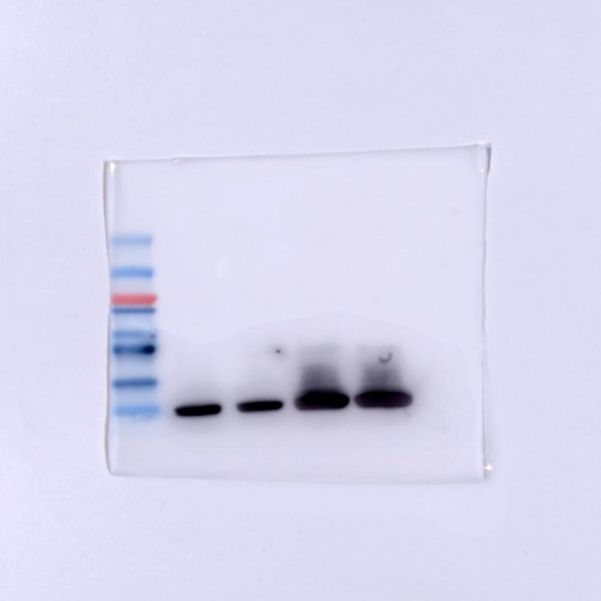

caspase-3 of CDDP-treated group in Fig. S4h
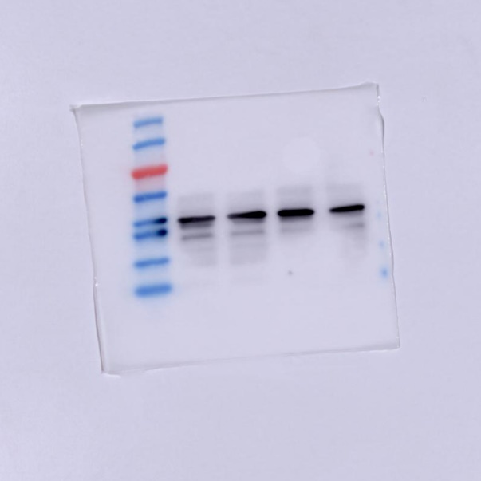

cleaved caspase-3 of CDDP-treated group in Fig. S4h
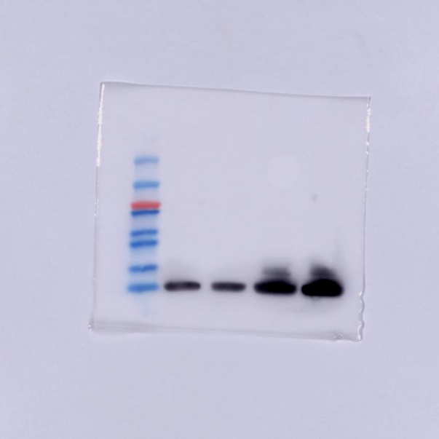

GAPDH of CDDP-treated group in Fig. S4h
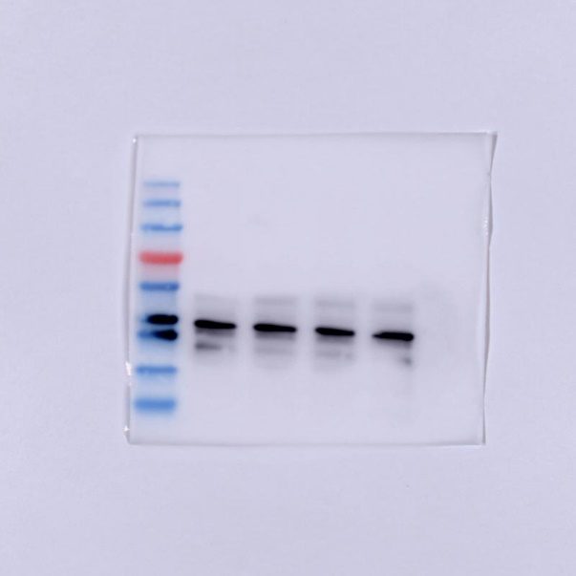

γH2AX of PBS-treated group in Fig. S4h
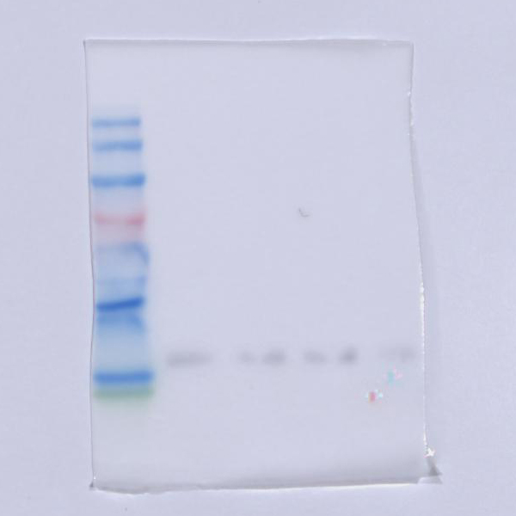

caspase-3 of PBS-treated group in Fig. S4h
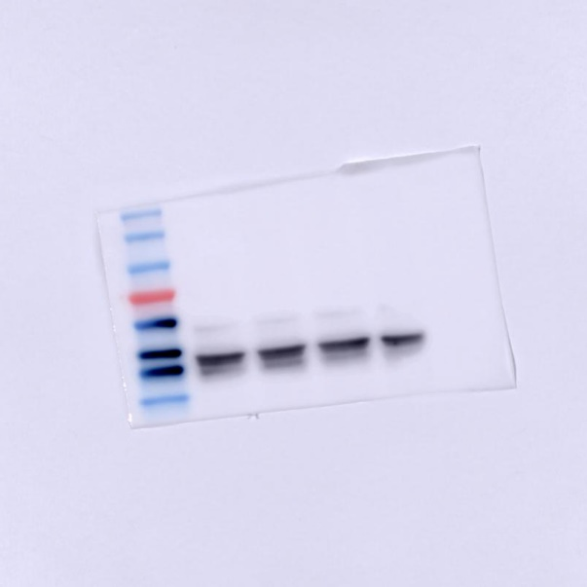

cleaved caspase-3 of PBS-treated group in Fig. S4h
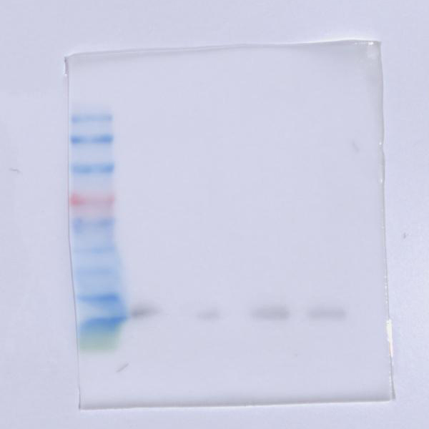

GAPDH of PBS-treated group in Fig. S4h
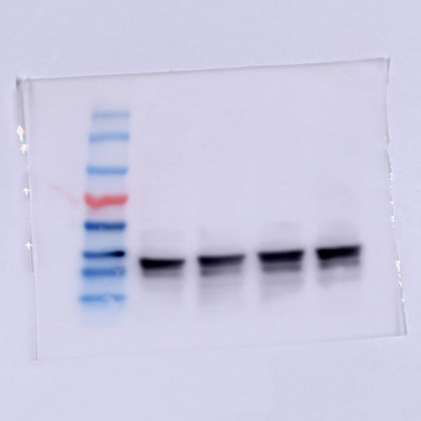

γH2AX of CDDP-treated group in Fig. S4i
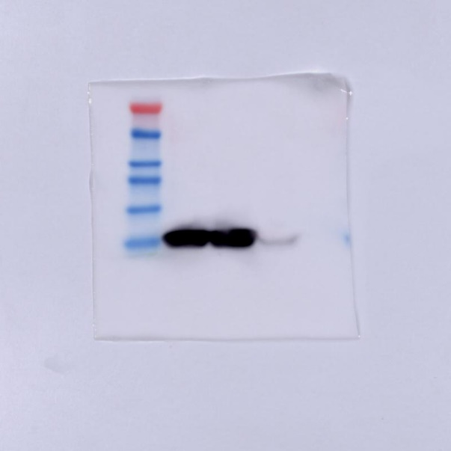

cleaved caspase-3 of CDDP-treated group in Fig. S4i
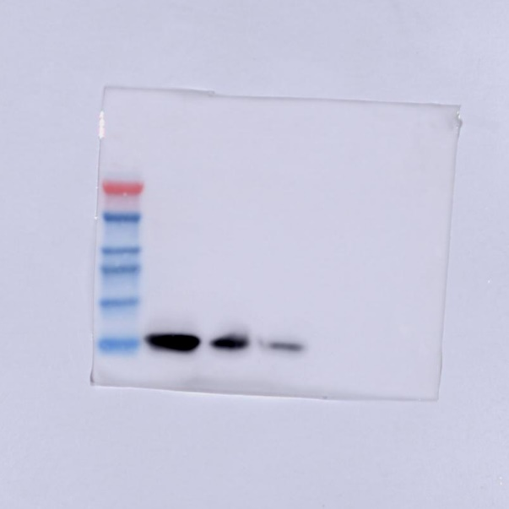

MTDH in Fig. S5e
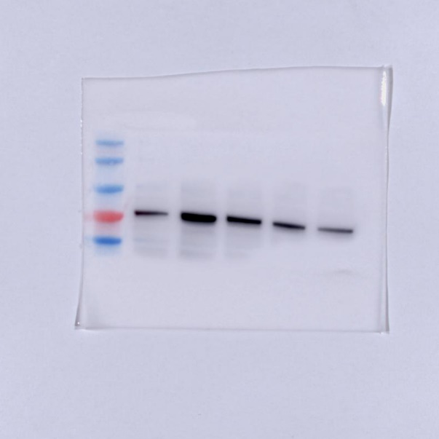

GAPDH in Fig. S5e
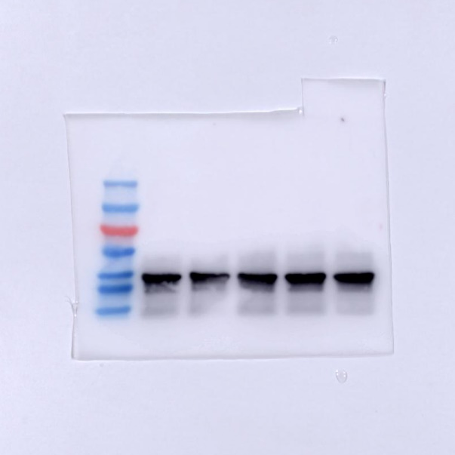

MTDH in Fig. S5f
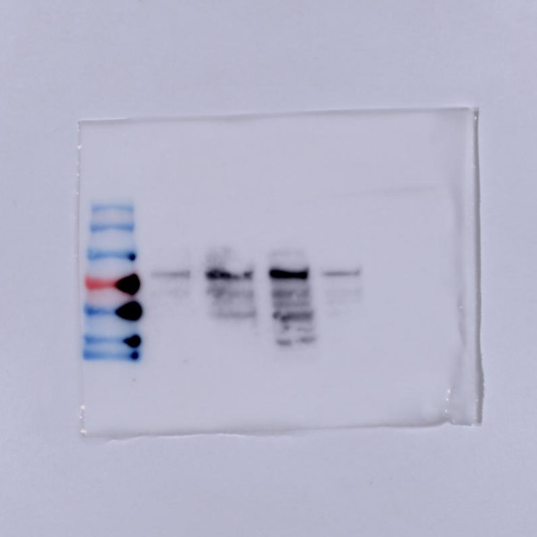

GAPDH in Fig. S5f

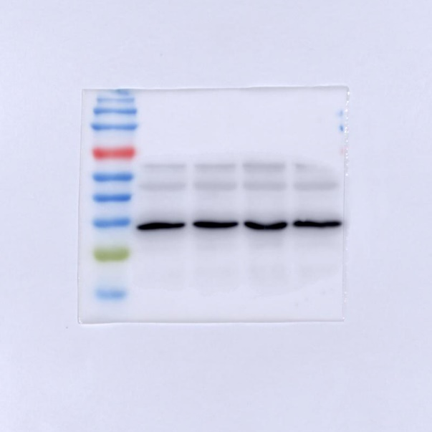

MTDH in Fig. S5g
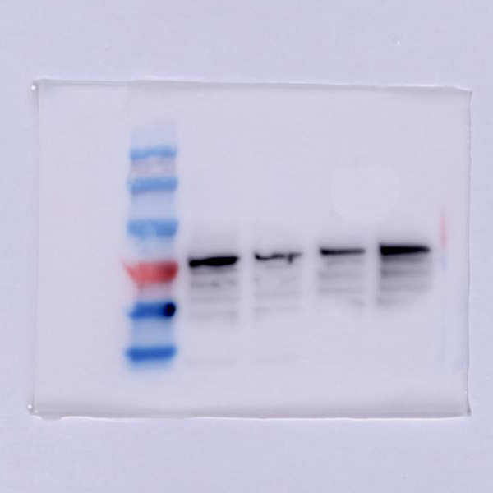

GAPDH in Fig. S5g
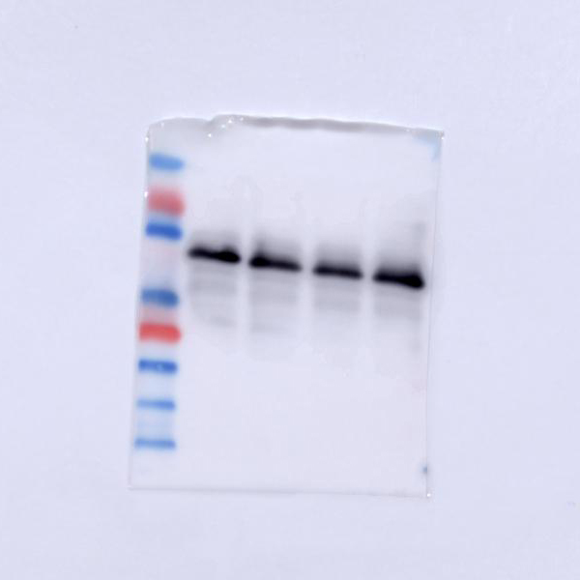

MTDH in Fig. S7e
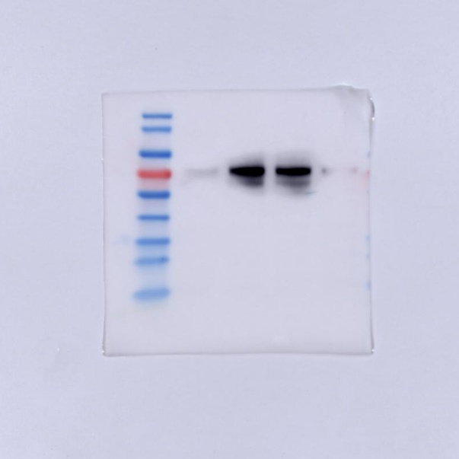

p38-MAPK in Fig. S7e
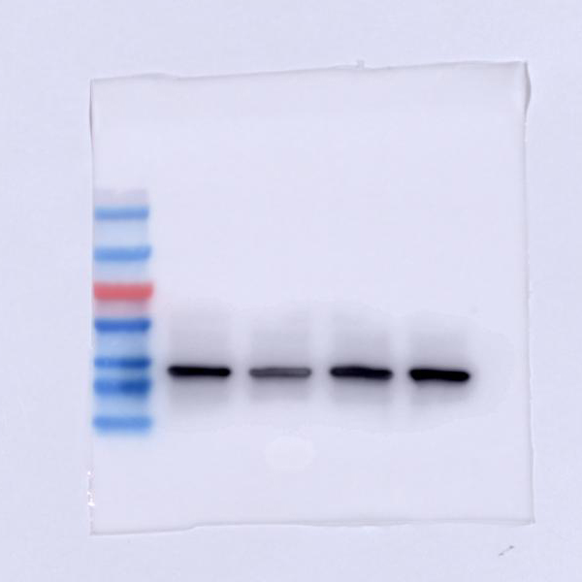

phospho-p38-MAPK in Fig. S7e
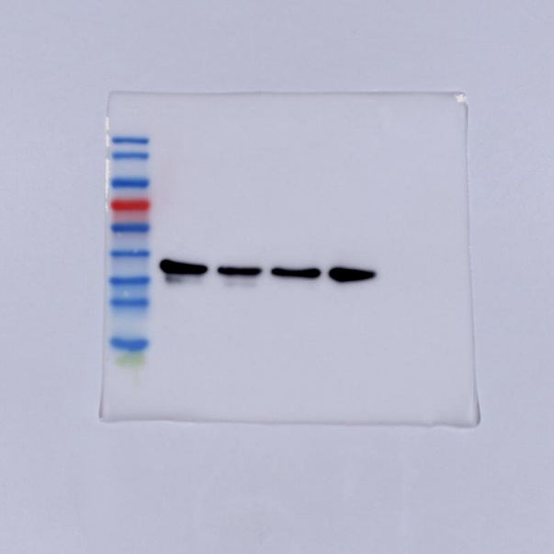

AKT in Fig. S7e
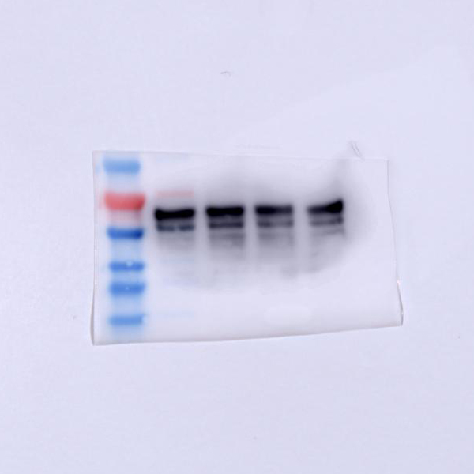

phospho-AKT in Fig. S7e
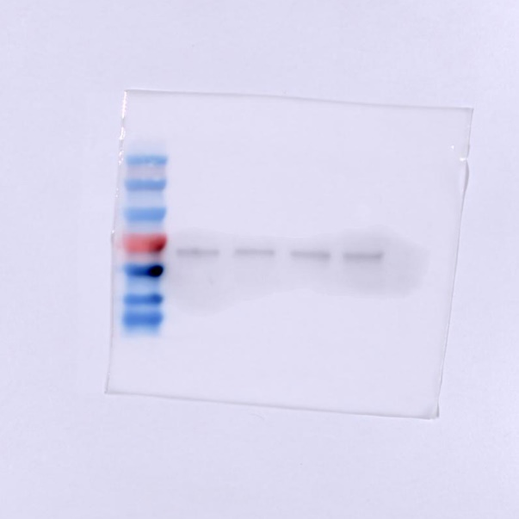

NF-κB in Fig. S7e
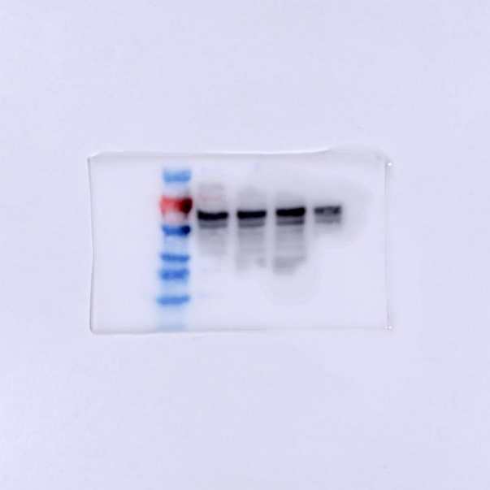

phospho- NF-κB in Fig. S7e
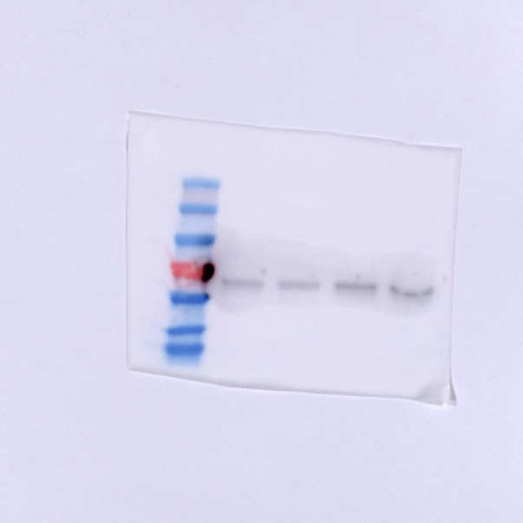

β-catenin in Fig. S7e
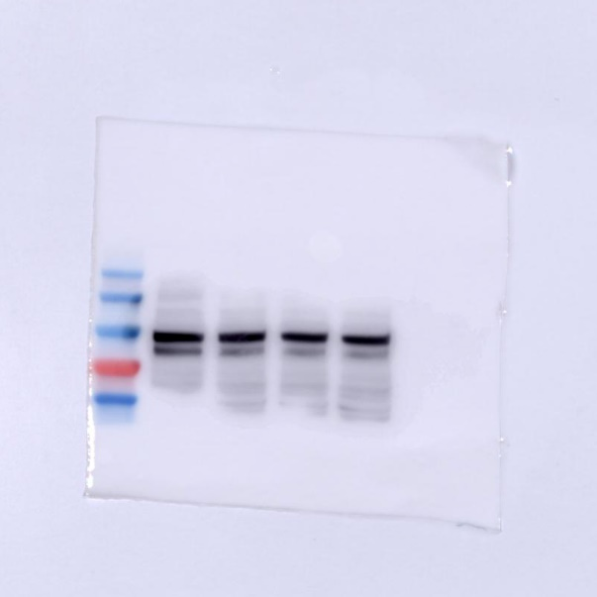

phospho-β-catenin in Fig. S7e
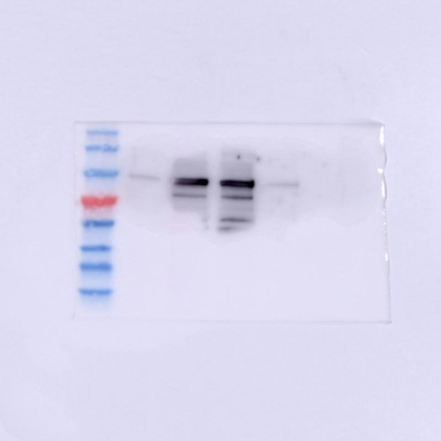

GAPDH in Fig. S7e
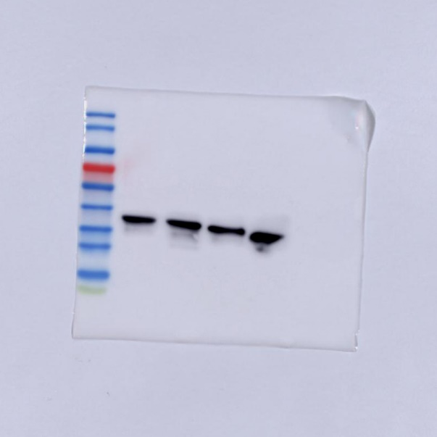

β-catenin in Fig. S7f
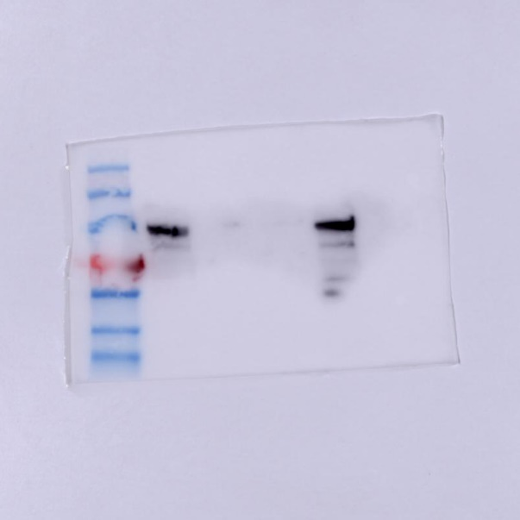

GADPH in Fig. S7f
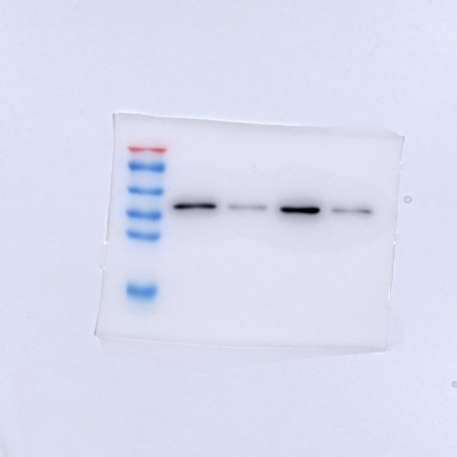

Histone H3 in Fig. S7f
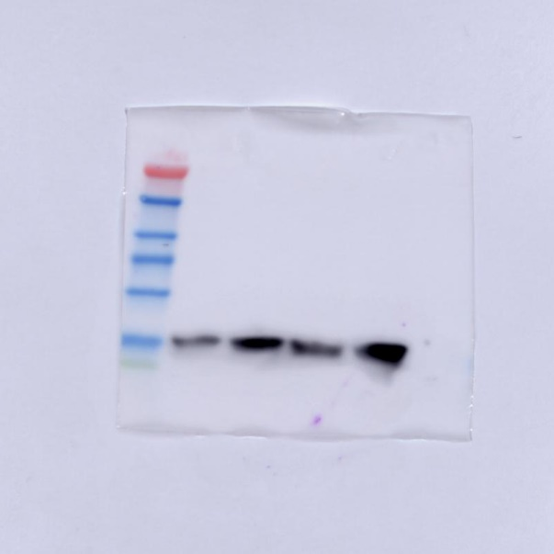

E-cadherin in TE1/CDDP-R in Fig. S8c
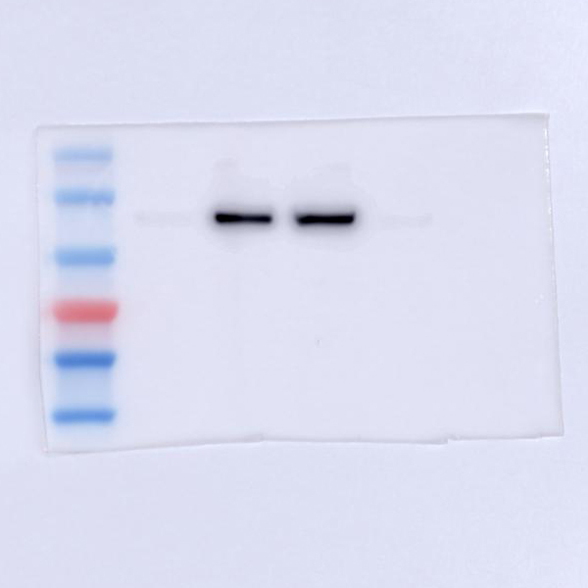

N-cadherin in TE1/CDDP-R in Fig. S8c
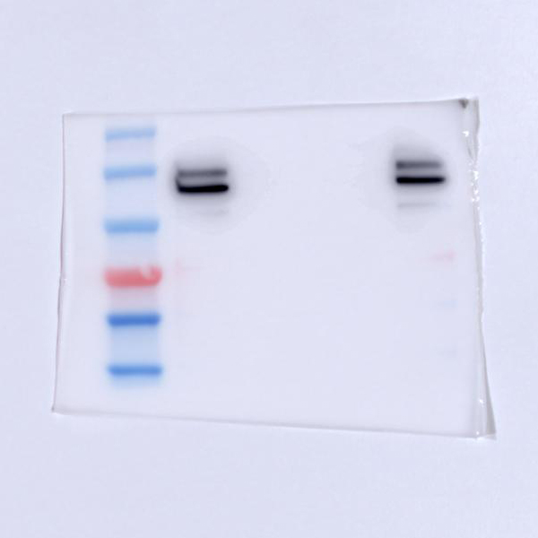

MMP9 in TE1/CDDP-R in Fig. S8c
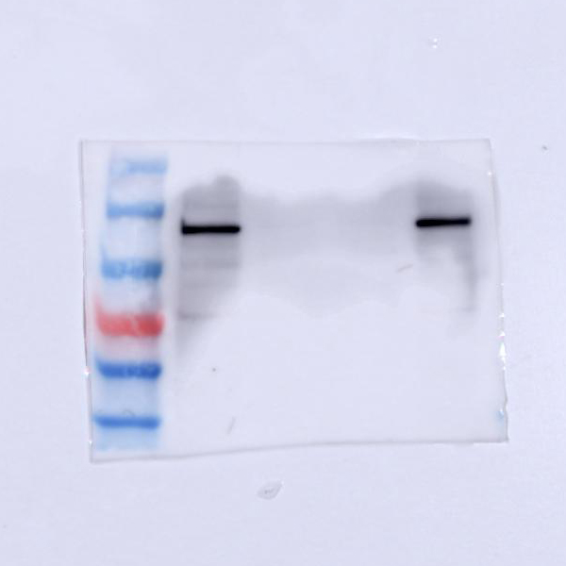

GAPDH in TE1/CDDP-R in Fig. S8c
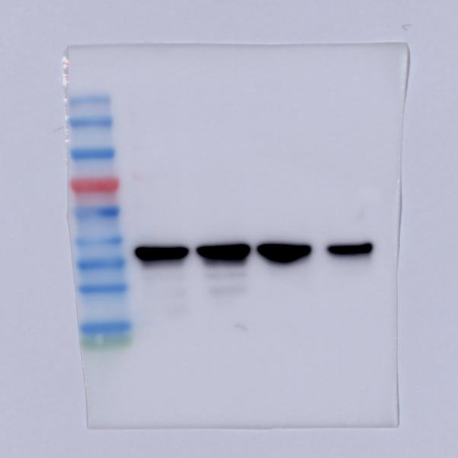

E-cadherin in TE1 in Fig. S8c
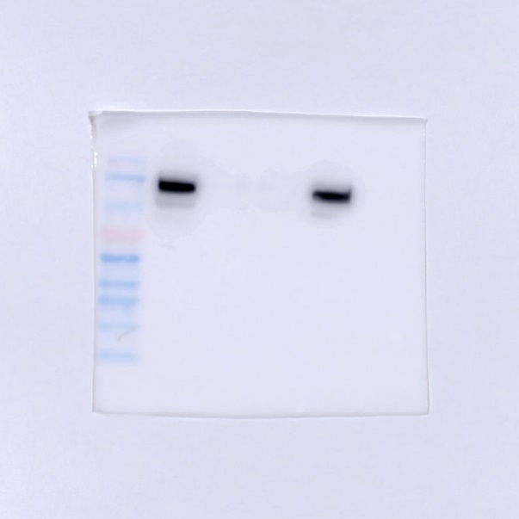

N-cadherin in TE1 in Fig. S8c
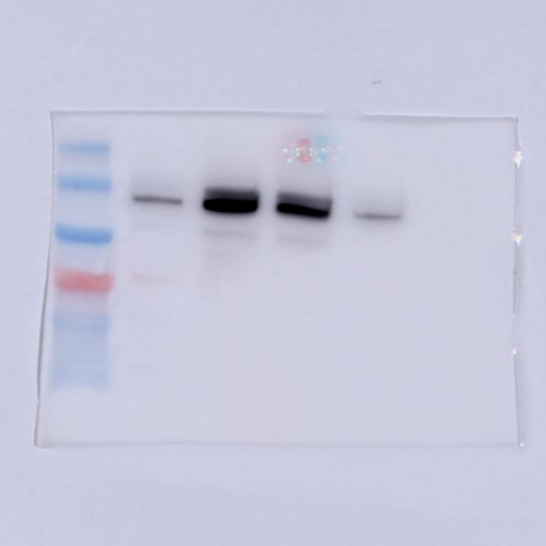

MMP9 in TE1 in Fig. S8c
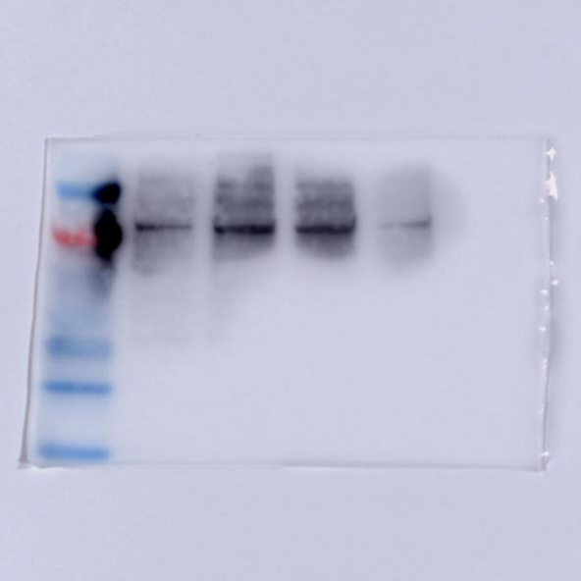

GAPDH in TE1 in Fig. S8c
