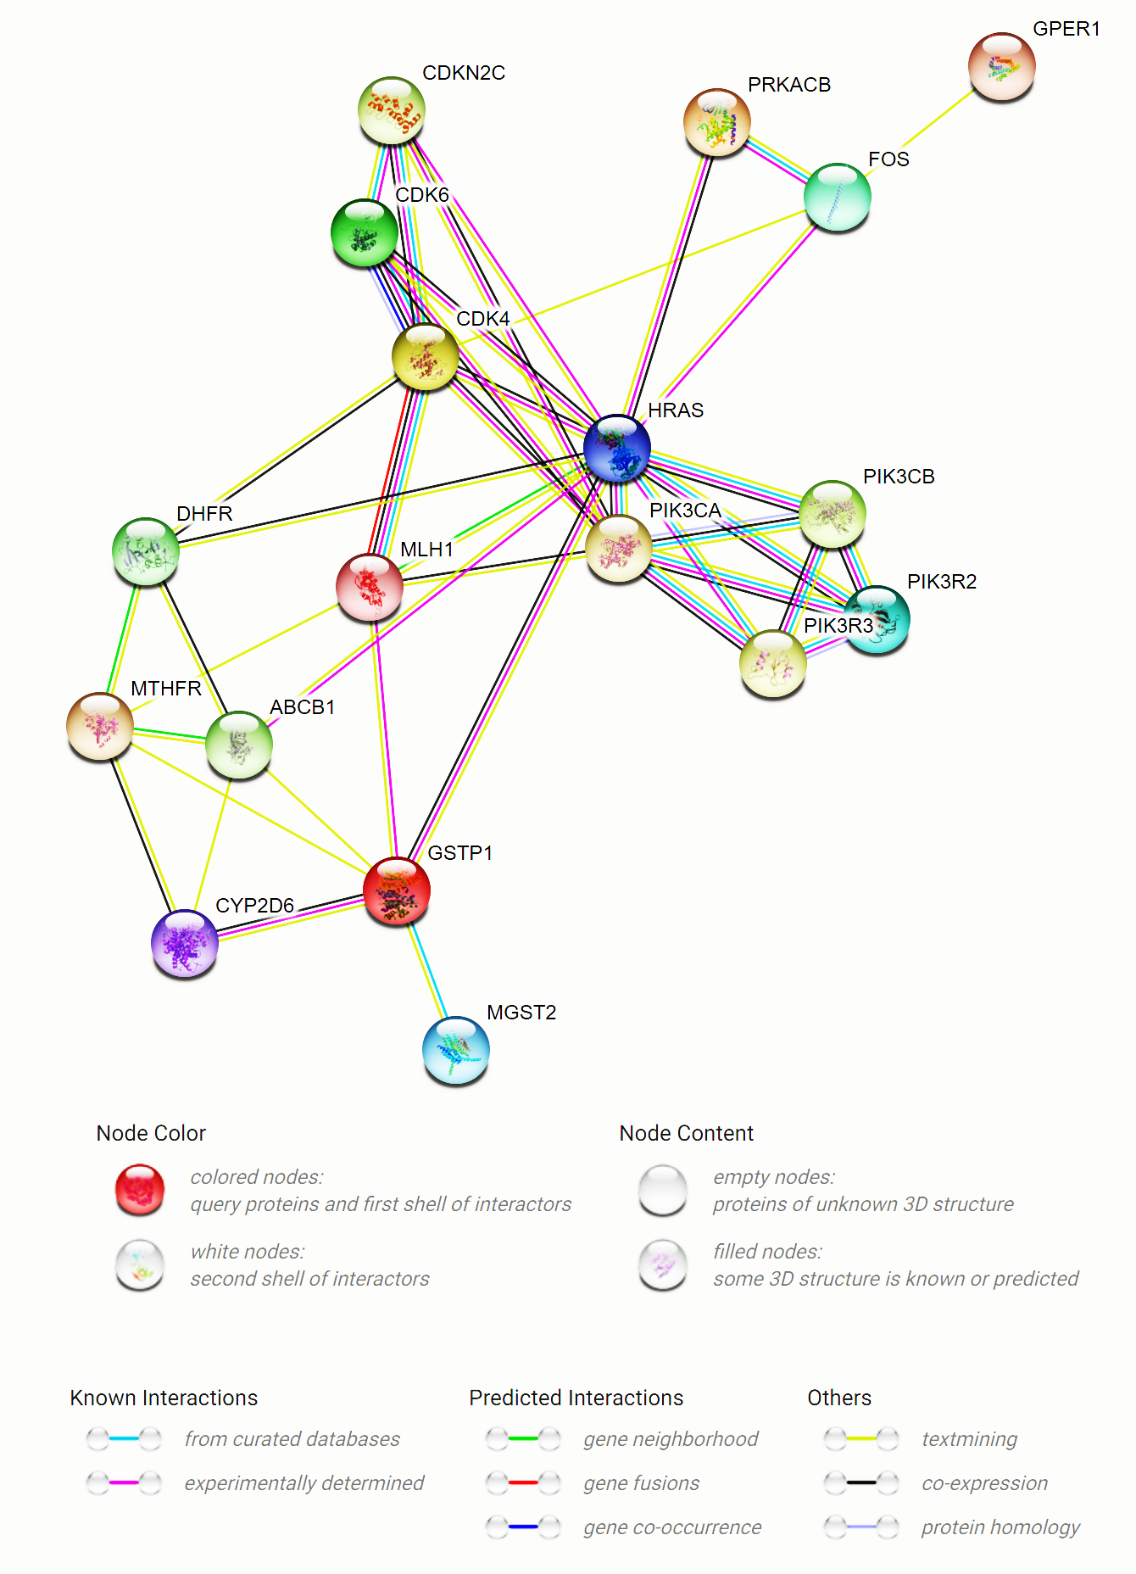
Fig. S2 Protein-protein interaction of the proteins which are most correlated with endocrine resistance.

