Table S1. Differential expression of CDK6, ABCB1, CDK4, PIK3CA, PIK3CB and GAPDH genes in KB-C2 and KB-C2-k.o.cdk6
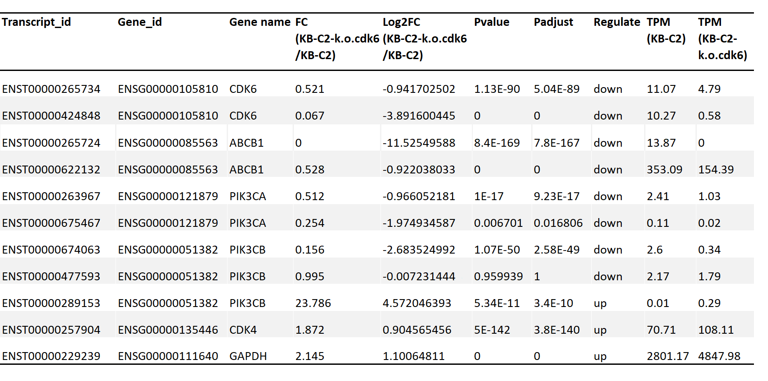
Identical amounts of total RNA from KB-C2 and KB-C2-k.o.cdk6 cells were analyzed for transcriptome sequences and differential gene expression. The transcripts encoding full or effective length of proteins are listed.

