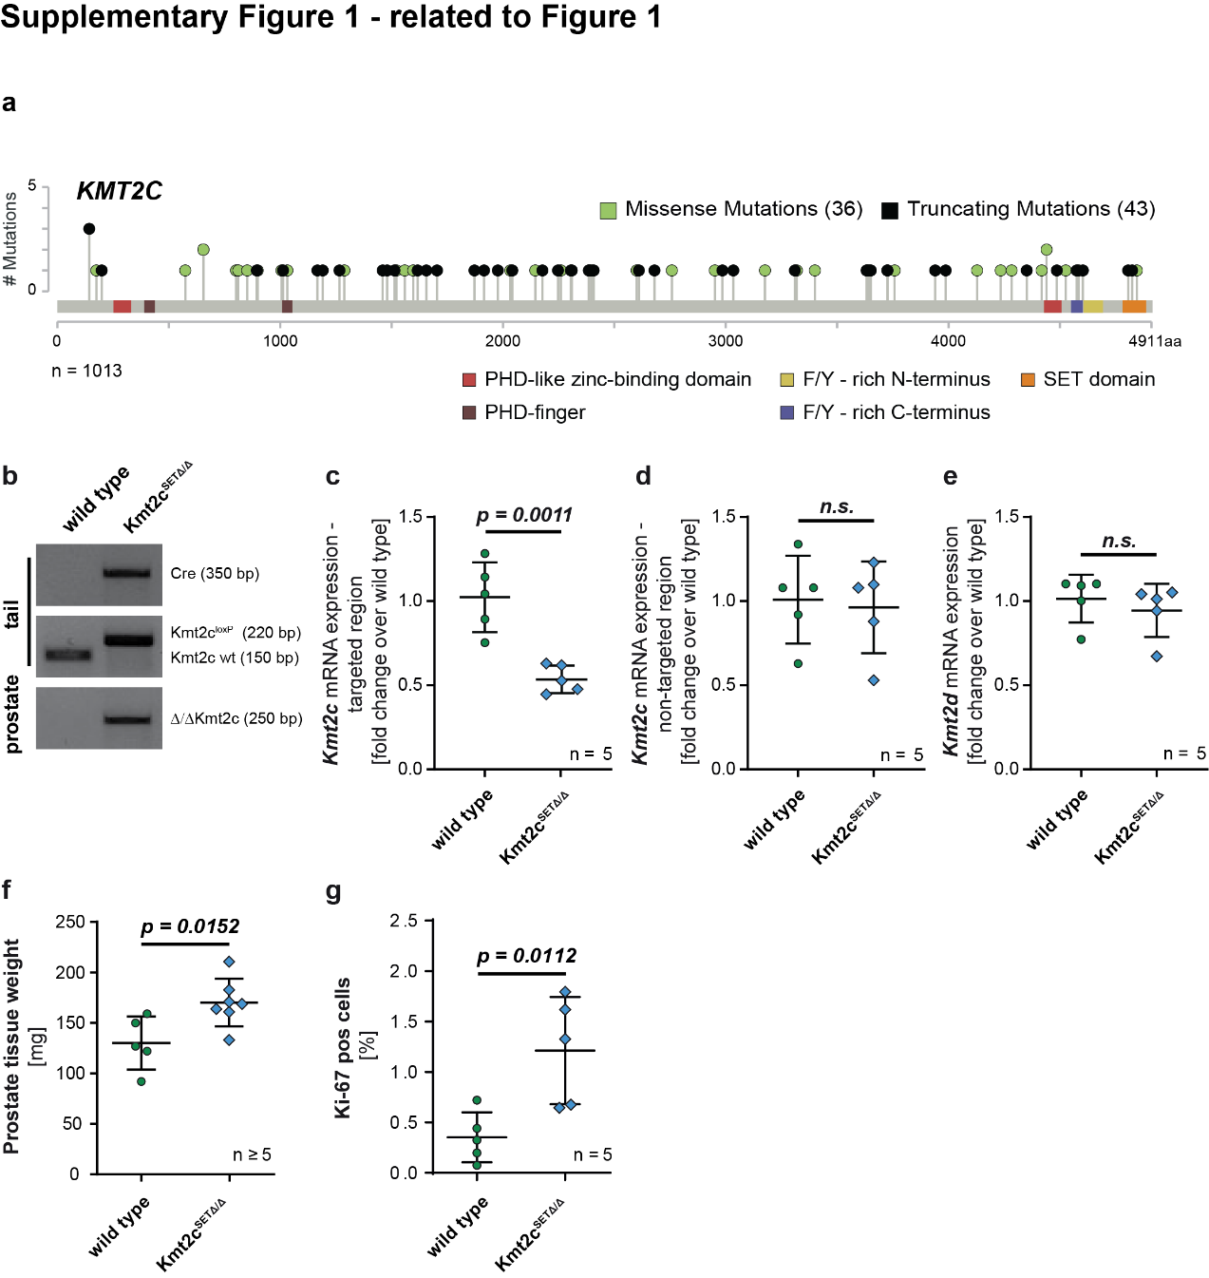
Suppl. Figure 1. related to Figure 1. a, Diagram of the KMT2C gene with indications for mutations identified in the MSKCC/DFCI cohort (n = 1013). b, PCR-based analysis of the Cre transgene and the Kmt2c gene locus in a wild type and a Kmt2c^{SET∆/∆} sample. Depicted are results for Cre and the non-recombined Kmt2c alleles (without loxP sites: wt; with loxP sites: loxP/loxP) from tail DNA as well as the recombined (∆/∆) Kmt2c locus from purified genomic DNA of prostates after Cre expression. c, d, e, RT-qPCR based quantification of mRNA transcripts normalized to geometric mean of Actb and Ppia and depicted as fold change over wild type of a targeted (C) and non-targeted (D) Kmt2c gene region and mRNA transcripts of Kmt2d (E). f, Prostate weight of wild type and Kmt2c^{SET∆/∆} mice at 90 weeks p.p. g, Quantification of cells positive for Ki-67 in prostates of 90-week-old mice using QuPath software. c-g, Individual biological replicates are shown. Data are mean ± SD, and P values were determined by unpaired two-tailed Student’s t-tests.

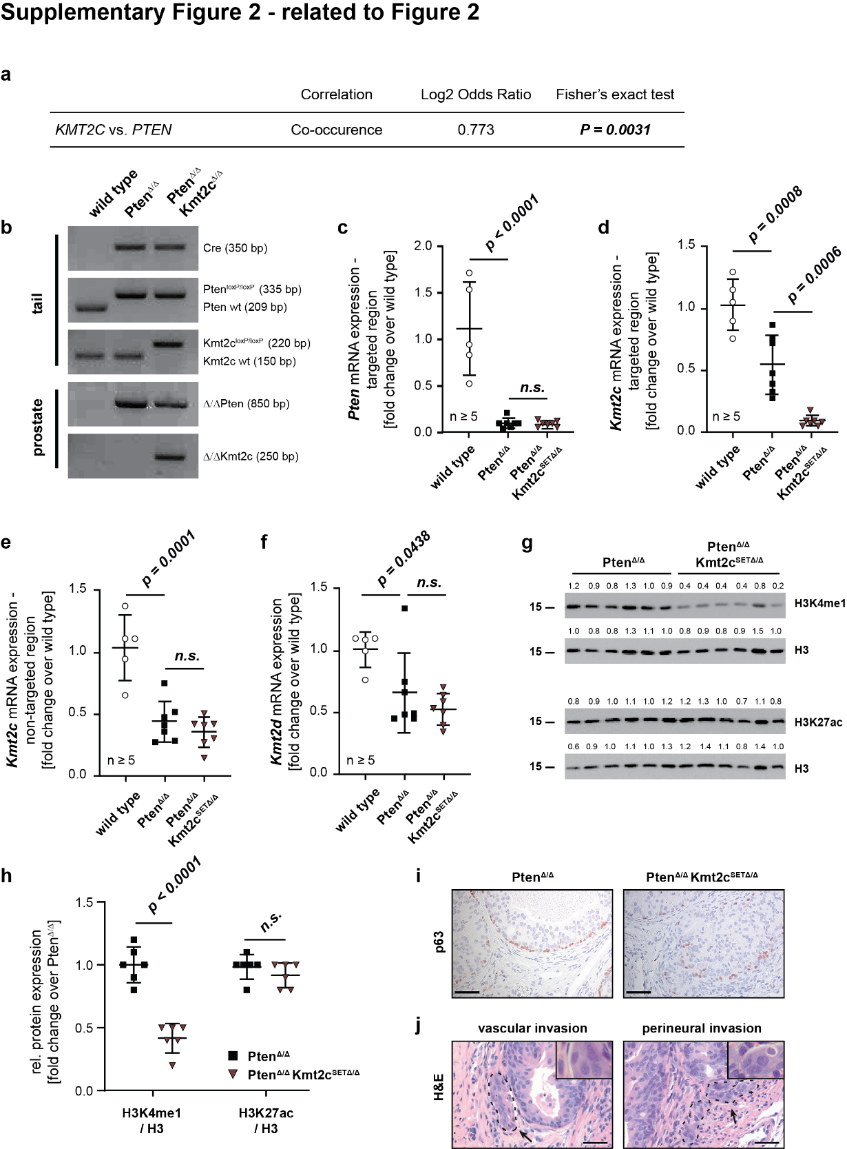
Suppl. Figure 2. related to Figure 2. a, Fisher’s exact-test analysing co-occurrence of KMT2C and PTEN mutations in the MSKCC/DFCI PCa patient cohort (n = 1013). b, PCR-based analysis of the Cre transgene and the Kmt2c and Pten gene locus in wild type, Pten∆/∆ and Pten∆/∆Kmt2c^{SET∆/∆} mice. Depicted are results for Cre and the non-recombined Kmt2c and Pten alleles (without loxP sites: wt; with loxP sites: loxP/loxP) from tail DNA as well as the recombined (∆/∆) Kmt2c and Pten loci from purified genomic DNA of prostates after Cre expression. c-f, RT-qPCR based quantification of mRNA transcripts normalized to geometric mean of Actb and Ppia and depicted as fold change over wild type of Pten (c), a targeted (d) and non-targeted (e) Kmt2c gene region and Kmt2d (f). Individual biological replicates are shown. Data are plotted as mean ± standard deviation, and P values were determined by ordinary one-way ANOVA with Tukey’s multiple comparisons test. g, Histone Blot analysis showing levels of H3K4me1 and H3K27ac for Pten∆/∆ and Pten∆/∆Kmt2c^{SET∆/∆} prostate lysates (n = 6). H3 served as loading control. The number above the band depicts the fold change over the average expression level detected in Pten∆/∆ samples. h, Quantification of Histone Blots shown in Fig. S2g. Individual biological replicates are shown. Data are plotted as mean ± standard deviation, and P values were determined by unpaired two-tailed Student’s t-test i, Representative pictures of p63 IHC stainings of Pten∆/∆ and Pten∆/∆Kmt2c^{SET∆/∆} mouse prostates at 19 weeks p.p. depicting focal disruption of basal cell layer in Pten∆/∆Kmt2c^{SET∆/∆} samples. Scale bars: 50 µm. j, Examples of vascular (left) and perineural (right) invasion of tumour cells in Pten∆/∆Kmt2c^{SET∆/∆} mouse prostates at 19 weeks p.p. Scale bars: 50 µm.

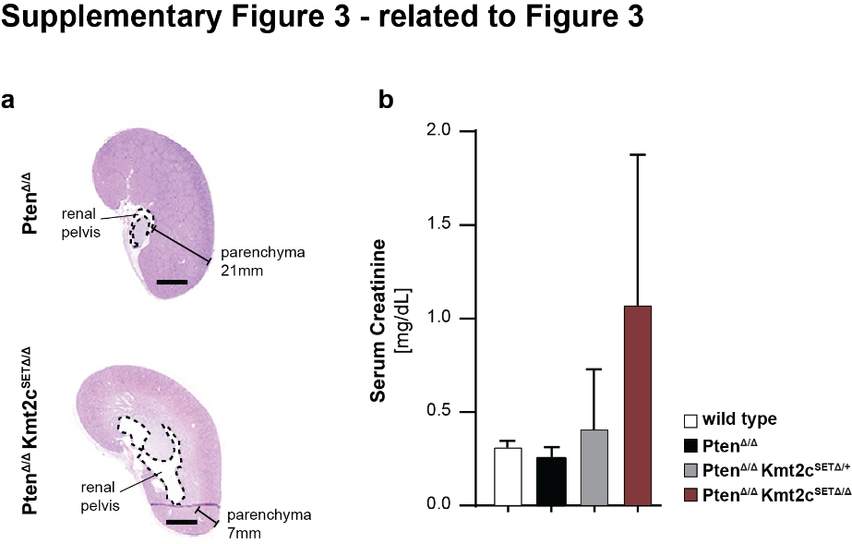
Suppl. Figure 3. related to Figure 3. a, Whole slide H&E images of massive parenchymal loss and renal pelvic expansion due to hydronephrosis following urinary tract obstruction occurring in a late stage Pten∆/∆Kmt2c^{SET∆/∆} mouse and a healthy kidney of an age matched Pten∆/∆ control animal. Parenchyma width estimations are shown. Scale bars: 200µm. b, Serum creatinine levels of wild type, Pten∆/∆, Pten∆/∆Kmt2c^{SET∆/+} and Pten∆/∆Kmt2c^{SET∆/∆} mice. Serum of wild type animals was collected at 38 weeks p.p. for comparison. Serum of tumour-bearing animals was collected at moribundity. Pten∆/∆, mean age: 84 weeks p.p.; Pten∆/∆Kmt2c^{SET∆/+}, mean age 48 weeks p.p., Pten∆/∆Kmt2c^{SET∆/∆}, mean age 37 weeks p.p.

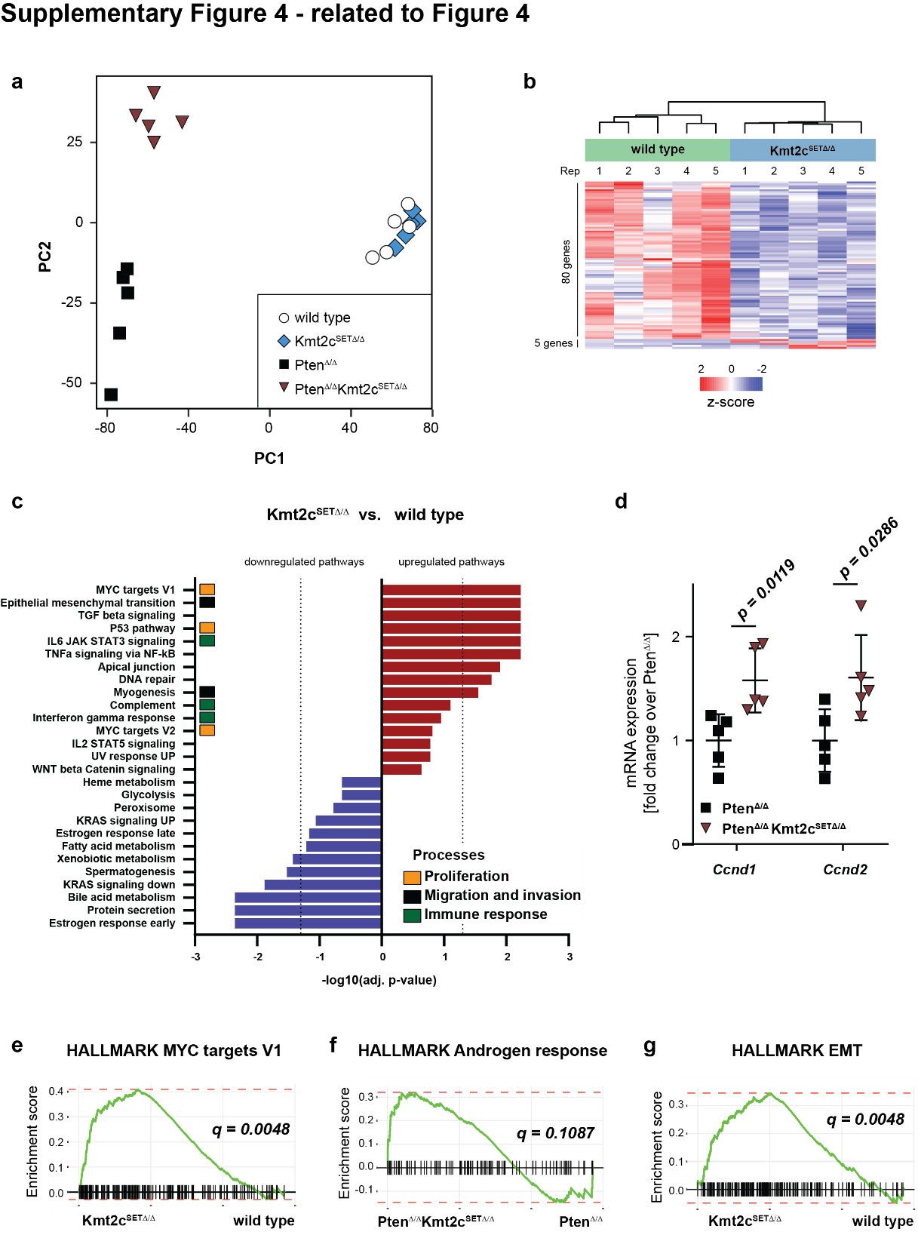
Suppl. Figure 4. related to Figure 4. a, Principal component analysis (PCA) of mRNA samples of prostate epithelial cells derived from 19-week-old mice. 5 individual biological replicates are shown. b, Unsupervised hierarchical clustering and heatmap of significantly differentially expressed genes between wild type and Kmt2c^{SET∆/∆} prostate epithelial cells. Number of genes deregulated at q-value < 0.05 and log₂FC ≥ 1 / ≤ -1 are shown on the left. c, HALLMARK gene sets enriched in Kmt2c^{SET∆/∆} versus wild type groups at an FDR < 0.25. Dotted lines: adj. P value = -log10(0.05). d, Gene expression levels of Ccnd1 and Ccnd2 based on normalized counts from RNA-Seq analysis of Pten∆/∆ and Pten∆/∆Kmt2c^{SET∆/∆} prostate epithelial cells. Individual biological replicates are shown. Data are plotted as mean ± standard deviation, and P values were determined by unpaired two-tailed Student’s t-tests. e, f, g, fGSEA plots of Kmt2c^{SET∆/∆} versus wild type groups (e, g) and Pten∆/∆Kmt2c^{SET∆/∆} versus Pten∆/∆ groups (F) showing an enrichment of MYC target genes (HALLMARK_MYC_TARGETS_V1) (e), androgen response genes (HALLMARK_ANDROGEN_RESPONSE) (f) and genes involved in EMT (HALLMARK_EPITHELIAL_MESENCHYMAL_TRANSITION) (g).

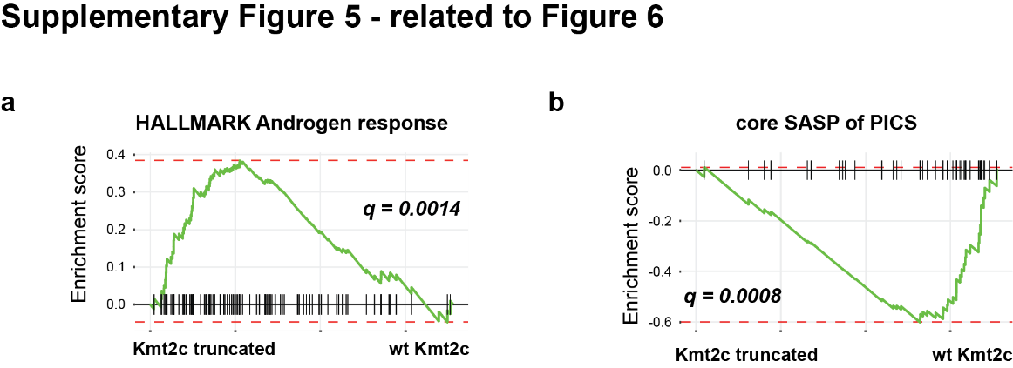
Suppl. Figure 5. related to Figure 6. a, b, fGSEA plots of KMT2C truncated versus KMT2C wild type (wt) prostate cancer patient samples showing an enrichment of androgen response genes (HALLMARK_ANDROGEN_RESPONSE) (a) and a depletion of the “core SASP of PICS” gene signature (Core SASP of PICS, see also Supplementary Materials and Methods) (b) in KMT2C truncated samples.

