Supplementary tables and figures
Table S1 Primer pairs designed for ZNRD1-AS1 segmental amplification
Segment | Primer_F | Primer_R
Seg1 | CGGAATTCCGCGAACCGTGTCTCGGGAG | CGGGATCCCGCTAAATGGTTTGTTCTTAAATTCTCC
Seg2 | CGGAATTCCGACAAGTACTACAACCCCCCA | CGGGATCCCGAGAACGAGCATTTGAAAAAAAAAAGG
Seg3 | CGGAATTCCGTCCAGGGTTCAGTGAATA | CGGGATCCCGTATTCACCTTCAGTAACTAACAT
Seg4 | CGGAATTCCGAAGAGAAGTCTCTGCCCTTG | GCTCTAGAGCCAACTTAAGCATAATATTCCTGAGGG
Seg5 | CGGAATTCCGTGATAATTCTGATGCCCACC | CGGGATCCCGAAATTCCAGAACTAGCAAAGAG
Seg6 | CGGAATTCCGCCAGGATGCACATCAAAA | CGGGATCCCGTAAGCAACTGTTAGGGATAC

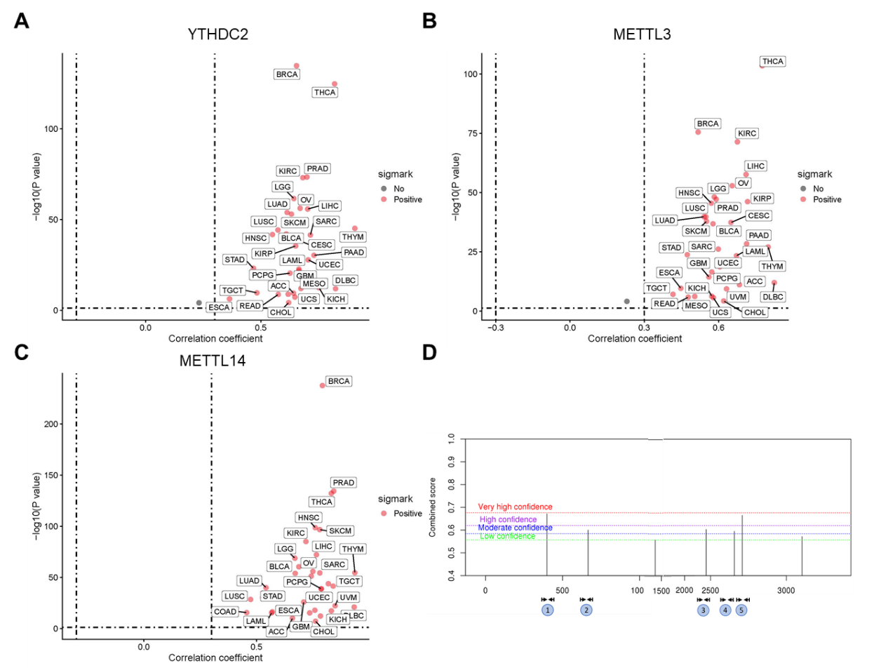
Figure S1 ZNRD1-AS1 is predicted to be regulated via m⁶A modification. Scatter plots presenting the correlation analysis between ZNRD1-AS1 and the m⁶A ‘reader’ (A) YTHDC2 as well as m⁶A ‘writers’ (B) METTL3 and (C) METTL14 via pan-cancer analysis. (D) m⁶A sites in ZNRD1-AS1, which were predicted using the SRAMP online tool.

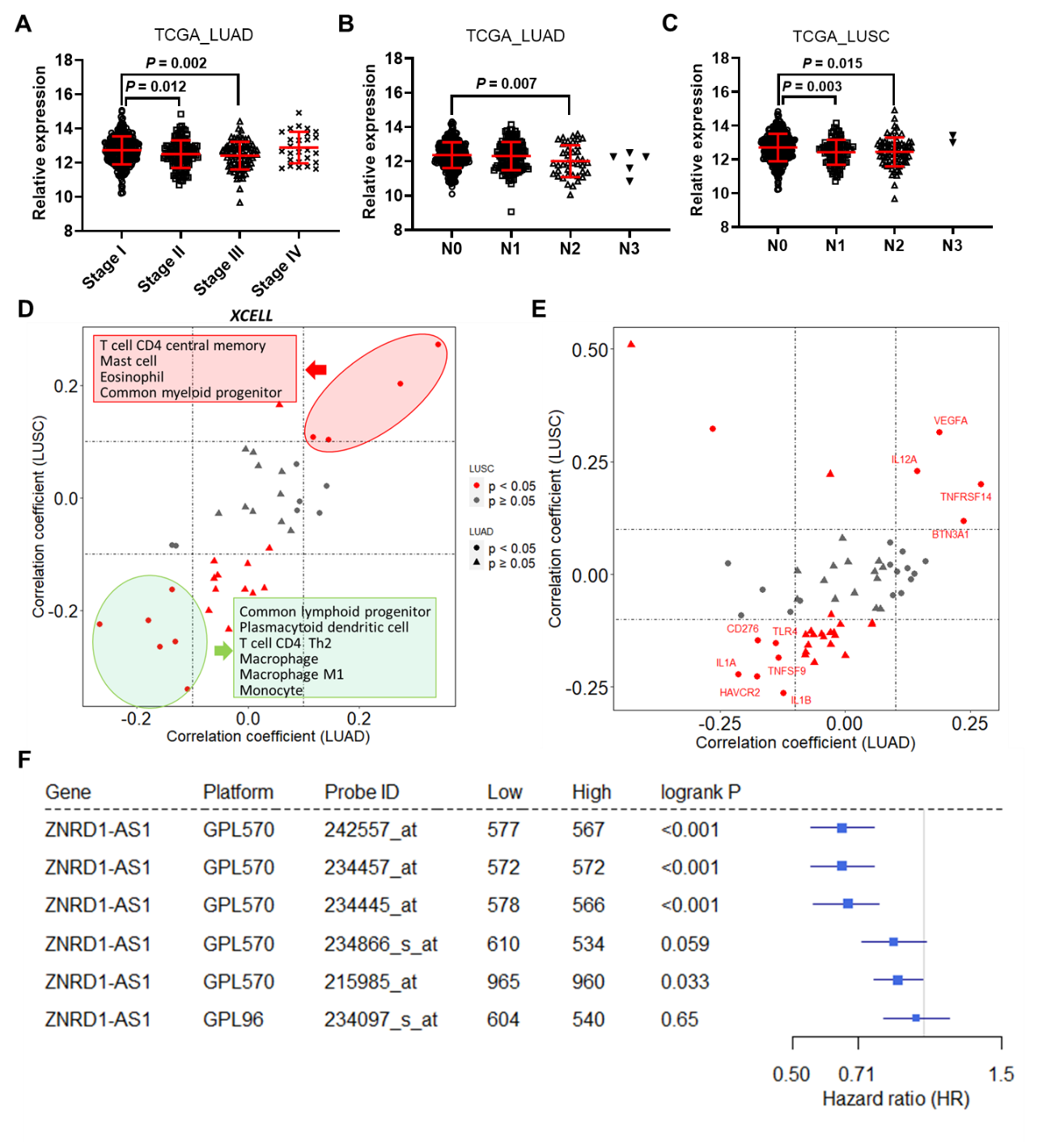
Figure S2 Clinical significance of ZNRD1-AS1 in lung cancer. Relative expression levels of ZNRD1-AS1 in LUAD tissues at (A) different pathological stages and in (B) lymph node metastasis based on TCGA database. (C) Relative expression levels of ZNRD1-AS1 in LUSC tissues with different lymph node metastasis based on the TCGA database. (D) Spearman correlation analysis between ZNRD1-AS1 and immune cell infiltration levels based on the XCELL algorithm in LUAD and LUSC datasets. (E) Spearman correlation analysis between the expression levels of ZNRD1-AS1 and immune checkpoint genes in LUAD and LUSC datasets. (F) Probability of overall survival in patients with lung cancer expressing high or low ZNRD1-AS1 levels according to KMplotter online tool.

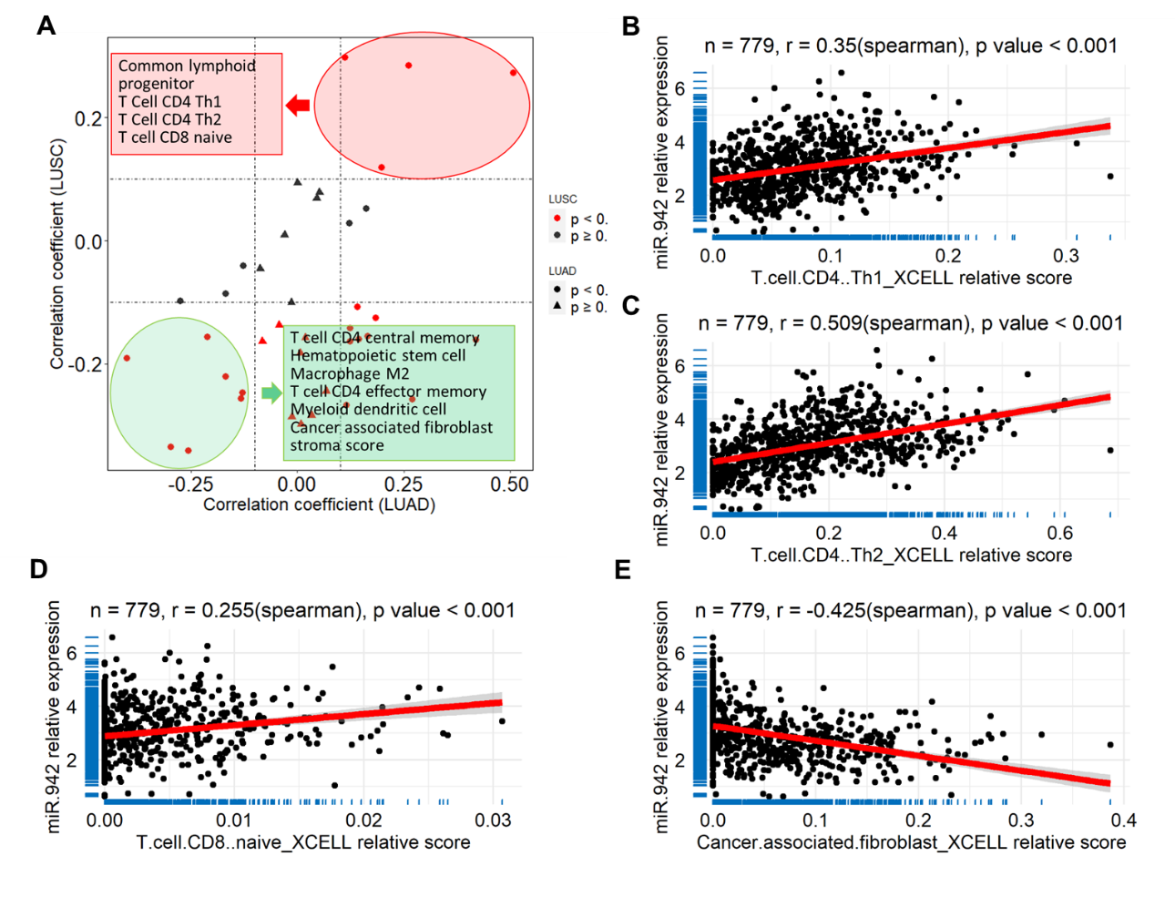
Figure S3 miR-942 association with immune cell infiltration in lung cancer. (A) Scatter plot presenting the correlation analysis between miR-942 expression and immune cell infiltration score using the XCELL algorithm in LUSC and LUAD datasets. Scatter plots presenting the association between miR-942 expression levels and (B) CD4+ T helper 1 cells, (C) CD4+ T helper 2 cells and (D) T cell CD8+ naïve cells, as well as (E) cancer associated fibroblasts in lung cancer.

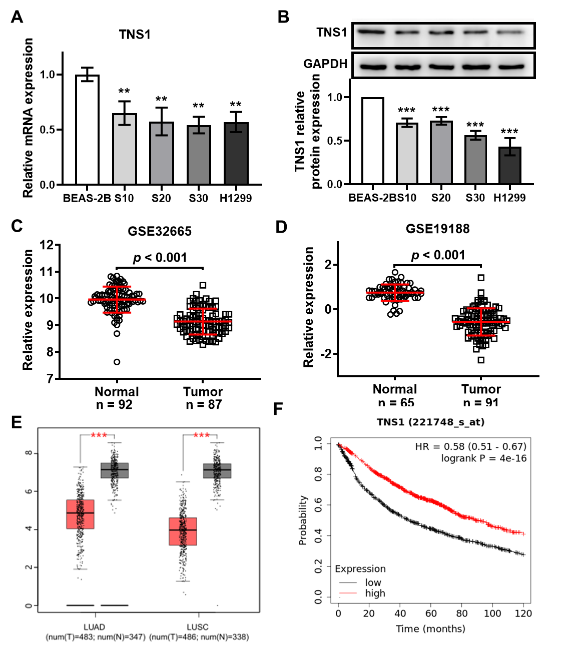
Figure S4 TNS1 was downregulated in CS-exposed cells and lung cancer tissues. Relative TNS1 (A) mRNA and (B) protein expression in CS-exposed cells. ** P < 0.01 and *** P < 0.001 vs. BEAS-2B cells. TNS1 was demonstrated to be downregulated in lung cancer based on the (C) GSE32665 and (D) GSE19188 datasets from the GEO database, as well as in (E) LUAD and LUSC datasets from the TCGA database. *** P < 0.001 vs. normal. (F) Probability of overall survival in patients with lung cancer expressing high or low TNS1 expression levels using the KMplotter online tool.

