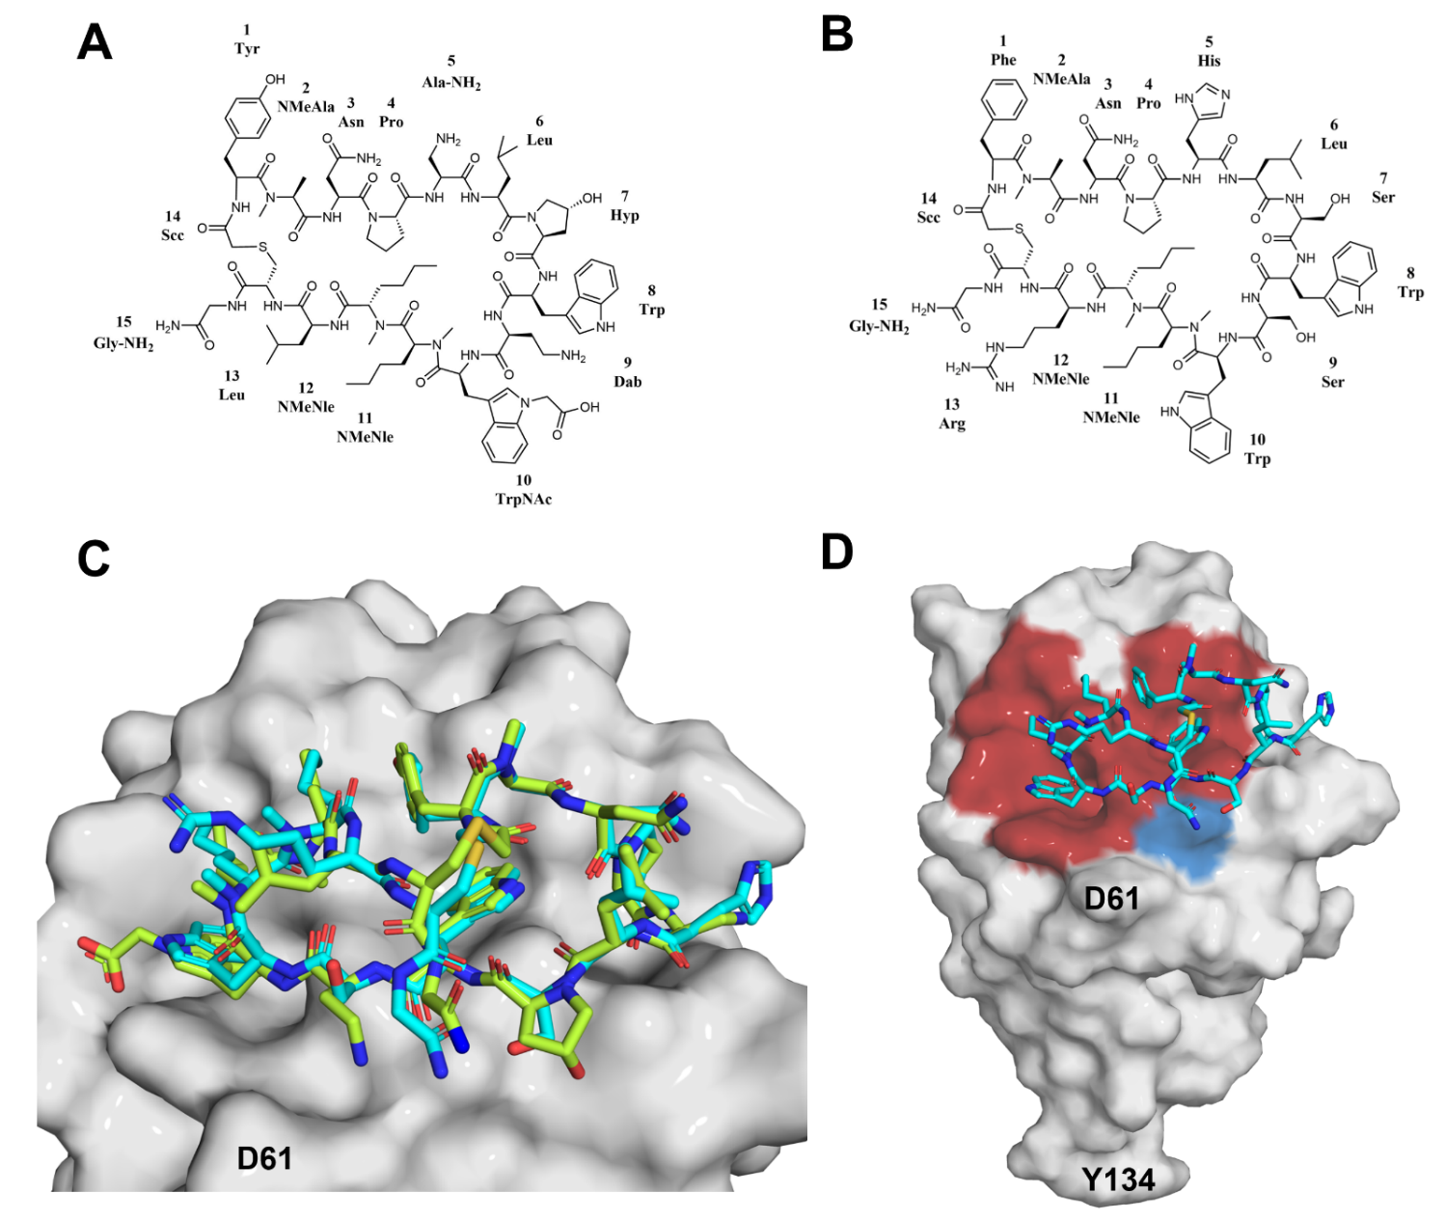
Figure S8. Chemical structures and binding mode of macrocyclic peptides at the surface of PD-L1. A) Chemical structure of the pAC65 peptide. B) Chemical structure of the p57 peptide. C) Superposition of the PD-L1/pAC65 (PDB: 8ALX) and PD-L1/p57 (PDB: 5O4Y) complexes (PD-L1 from PD-L1/p57 complex is not shown for clarity). D) PD-L1/p57 (PDB: 5O4Y) binding interface, hydrophobic interactions are shown in red and hydrophilic in blue.

