SUPPLEMENTARY TABLES

Supplementary Table 1: Number of patients presenting at least one adverse effect related to Cyclophosphamide and/or JX-594 and/or avelumab by AE term, SOC and grade in Arm 2 (n=14)
Maximum intensity
Grade 1/2 |  |  | Grade 3 |  | Grade 4
N |  | % | N | % | N | %
Anemia | 5 | 33.3 | . | . | . | .
Hyperthyroidism | 2 | 13.3 | . | . | . | .
Abdominal Pain | 3 | 20.0 | . | . | . | .
Diarrhea | 2 | 13.3 | . | . | . | .
Mucositis oral | 5 | 33.3 | . | . | . | .
Nausea | 9 | 60.0 | . | . | . | .
Vomiting | 7 | 46.6 | . | . | . | .
Chills | 11 | 73.3 | . | . | . | .
Fatigue | 12 | 80.0 | 3 | 60.0 | . | .
Fever | 14 | 90.3 | 2 | 40.0 | . | .
Rash pustular | 8 | 53.3 | . | . | . | .
Infusion related reaction | 3 | 20 | 1 | 6.7
Alanine aminotransferase increased | 1 | 6.7 | . | . | . | .
Alkaline phosphatase increased | 1 | 6.7 | 1 | 6.7 | . | .
Lymphopenia | 1 | 6.7 | 1 | 6.7 | . | .
Headache | 4 | 26.7 | . | . | . | .
Hypertension | 3 | 20 | 1 | 6.7 | .
Hypotension | 6 | 40 | 2 | 13.3
Pruritus | 2 | 13.3 | . | . | . | .
Dry skin | 2 | 13.3 | . | . | . | .

SUPPLEMENTARY FIGURES
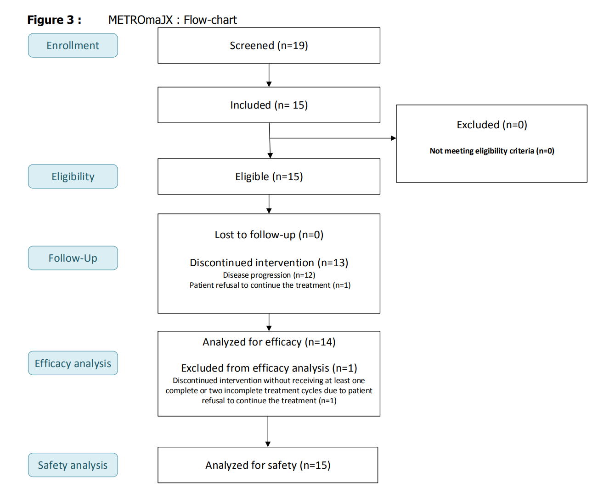
Supplementary Figure 1. Flow chart of the METROMAJX study

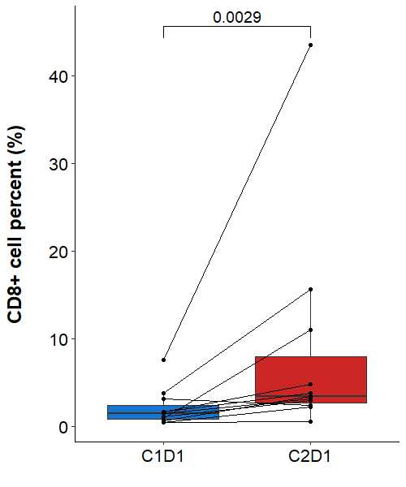
Supplementary Figure 2. CD8+ TIL percentage as a measure of pharmacodynamic activity in the METROMAJX study (n=11)
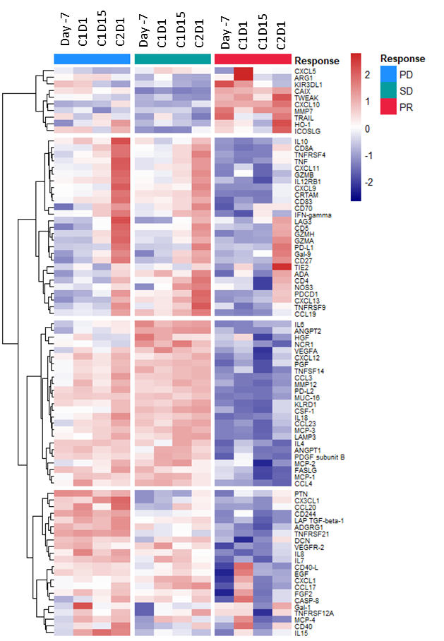
Supplementary Figure 3. Evolution of the plasma proteome as a measure of pharmacodynamic activity in the METROMAJX study (n=11).

