Fig.3L
FASN
FASN
SW480
HCT116
ACC1
ACC1
SW480
HCT116
SW480
HCT116
SCD1
SCD1
CD36
CD36
SW480
HCT116
CPT1A
CPT1A
SW480
HCT116
β-actin
β-actin
SW480
HCT116
Fig.3N
ACC1
FASN
CD36
SCD1
β-actin
CPT1A
Fig.4D
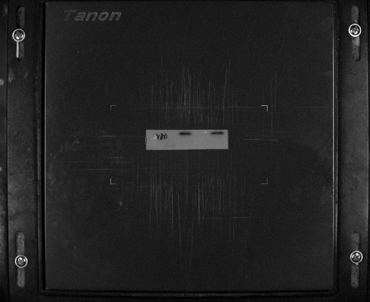
YBX1
Fig.4I
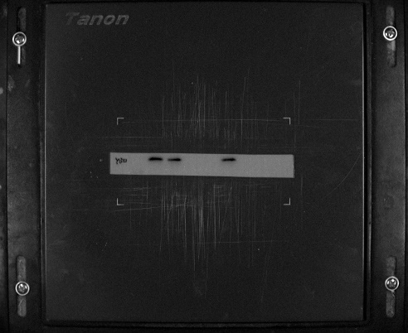
YBX1
Fig.4K
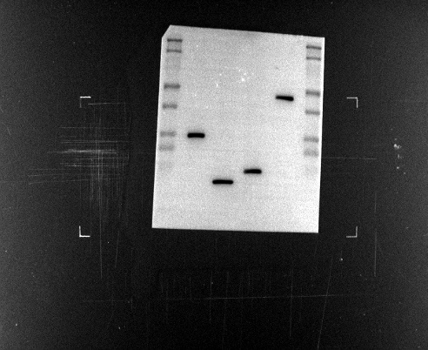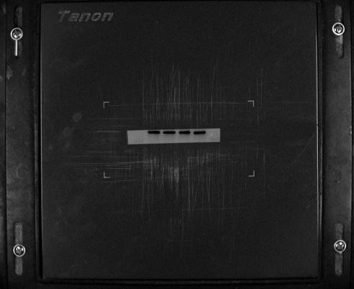
β-actin
Flag

Fig.5B
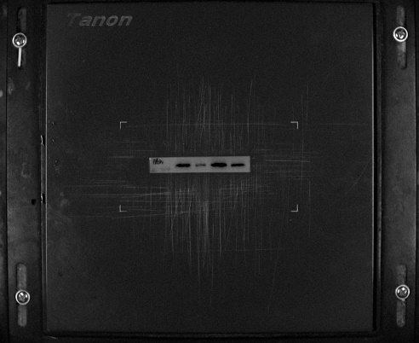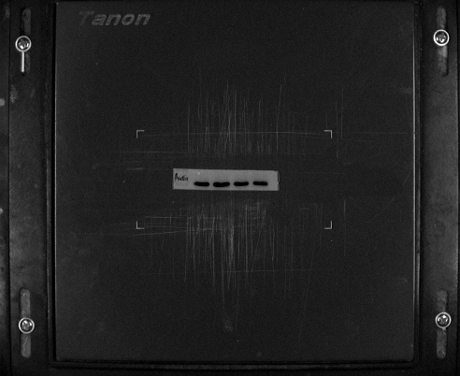
HCT116
β-actin
FASN
HCT116
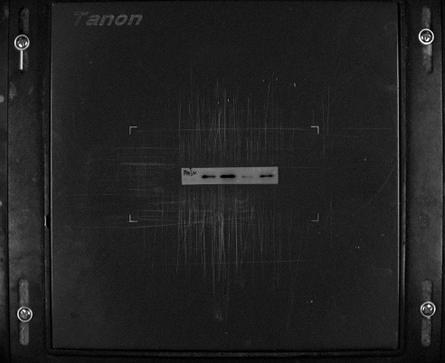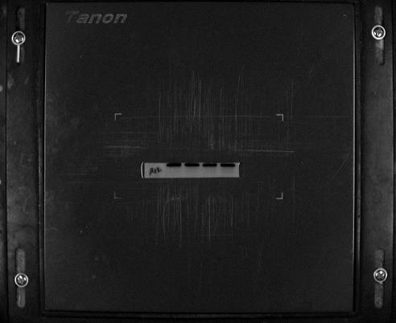
SW480
SW480
β-actin
FASN
Fig.S3G
β-actin
YBX1
Fig.S4G
FASN
β-actin

Fig.S4O
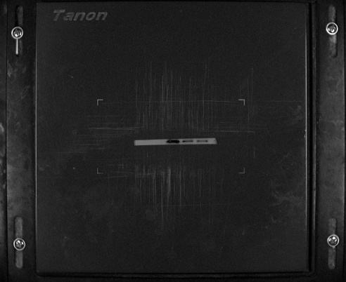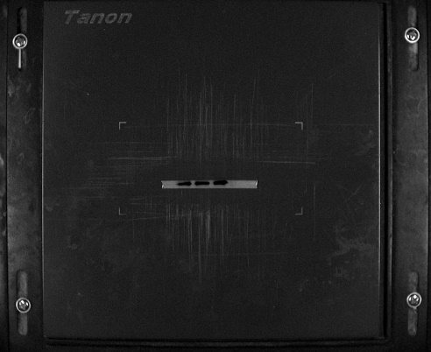
β-actin
METTL3
Fig.S4P
METTL3
β-actin

