SUPPLEMENTARY FIGURES
Supplementary Fig. 1: Overall survival and progression-free survival outcomes based on RAF1i and RAF2i therapies.
RAF1i = First RAF inhibitor; RAF2i = Second RAF inhibitor
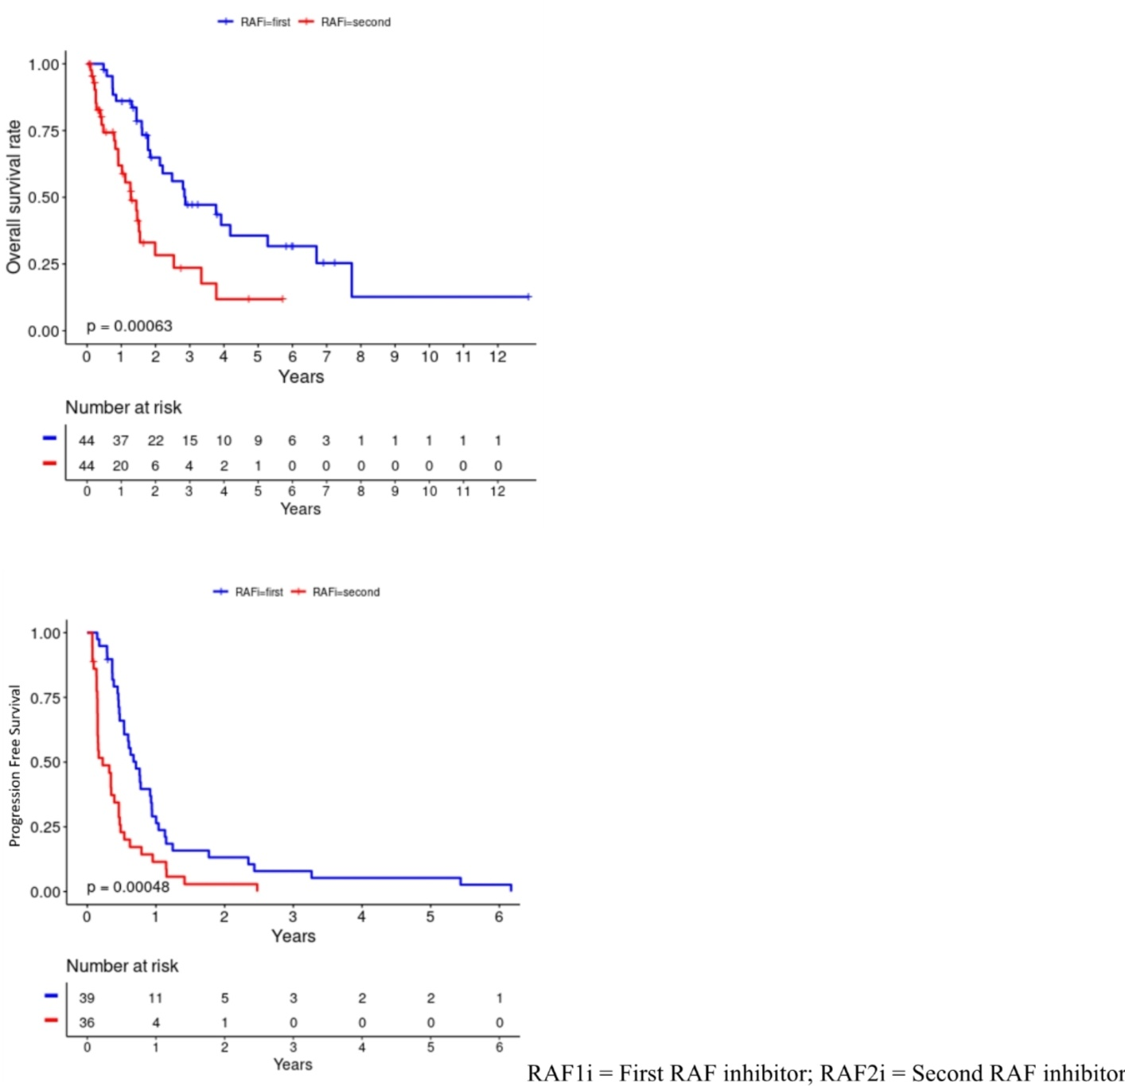
Supplementary Fig. 2 (A; B; C): Prognostic impact of metastatic burden, gender, ECOG on OS and PFS.
2A. Impact of metastatic burden of disease (0–2 lesions versus 3–5 lesions) at presentation with first RAF inhibitor and second RAF inhibitor
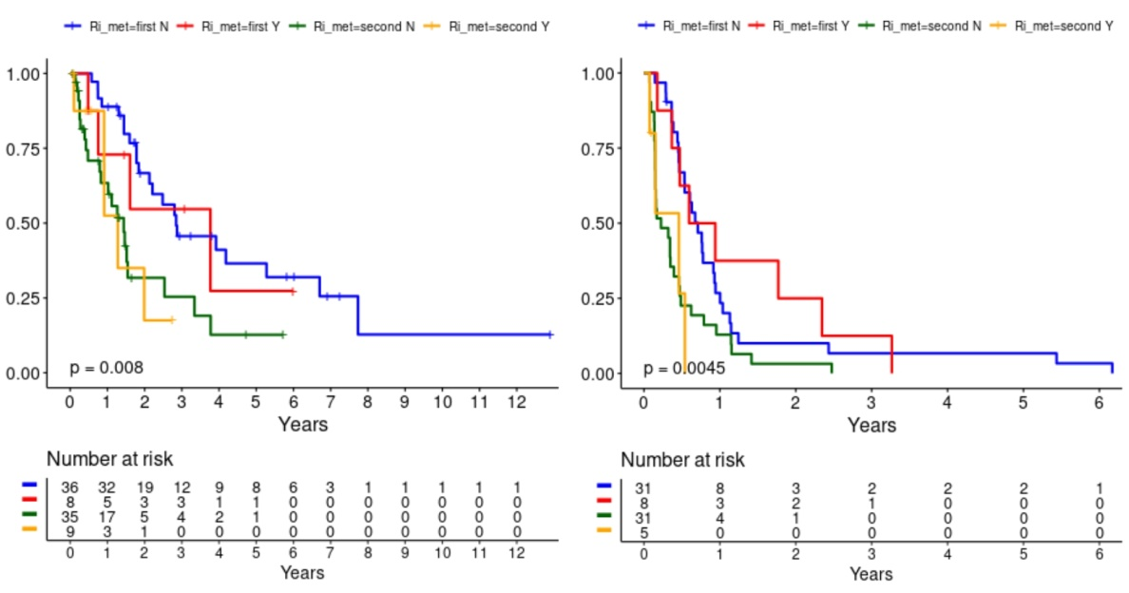
Overall Survival Progression Free Survival
2B. Impact of gender at presentation with first RAF inhibitor and second RAF inhibitor
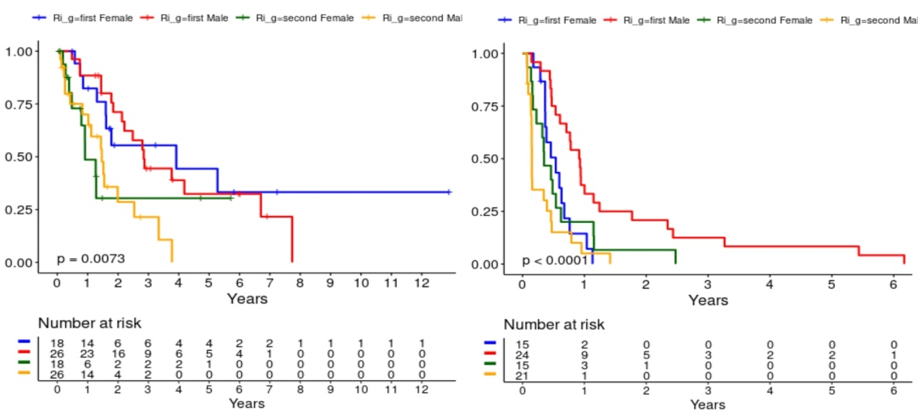
Overall Survival Progression Free Survival
2C. Impact of Performance Status with first RAF inhibitor and second RAF inhibitor
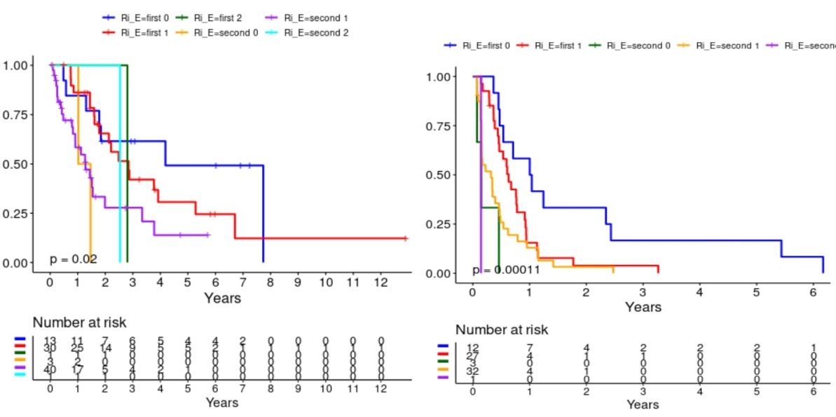
Overall Survival Progression Free Survival
Supplementary Fig. 3: Intervening therapies between RAF1i and RAF2i and impact on OS and PFS
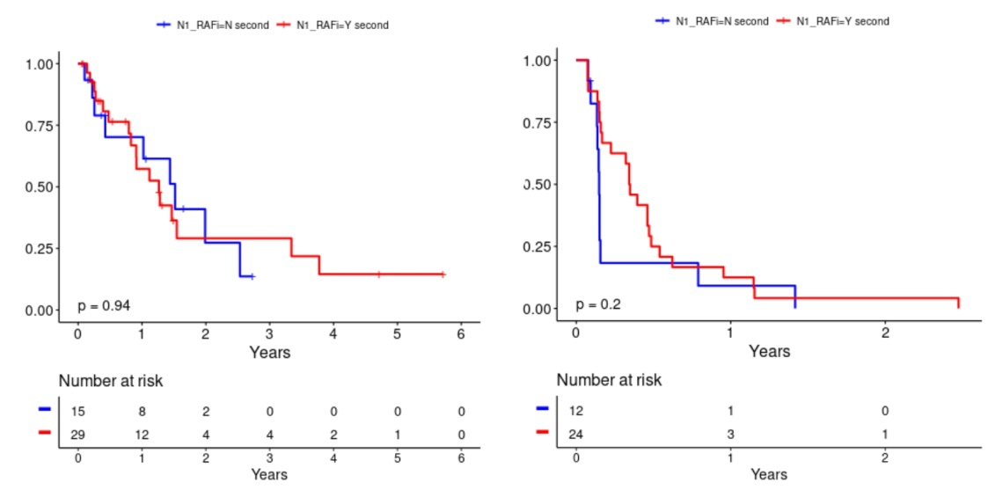
Overall Survival Progression Free Survival
Supplementary Fig. 4: RAF1i and RAF2i with combinations and impact on OS and PFS
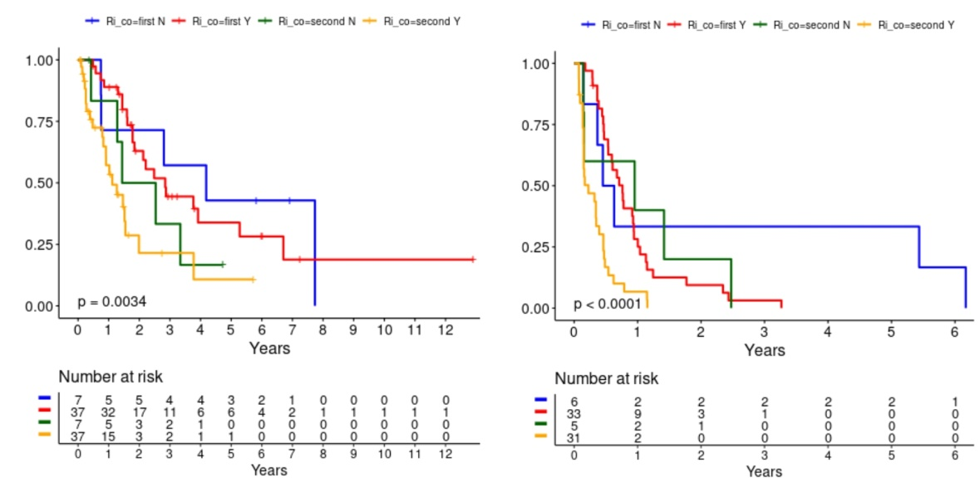
Overall Survival Progression Free Survival
Supplementary Fig. 5: RAF1i and RAF2i as standard of care or investigational therapies and impact on OS and PFS
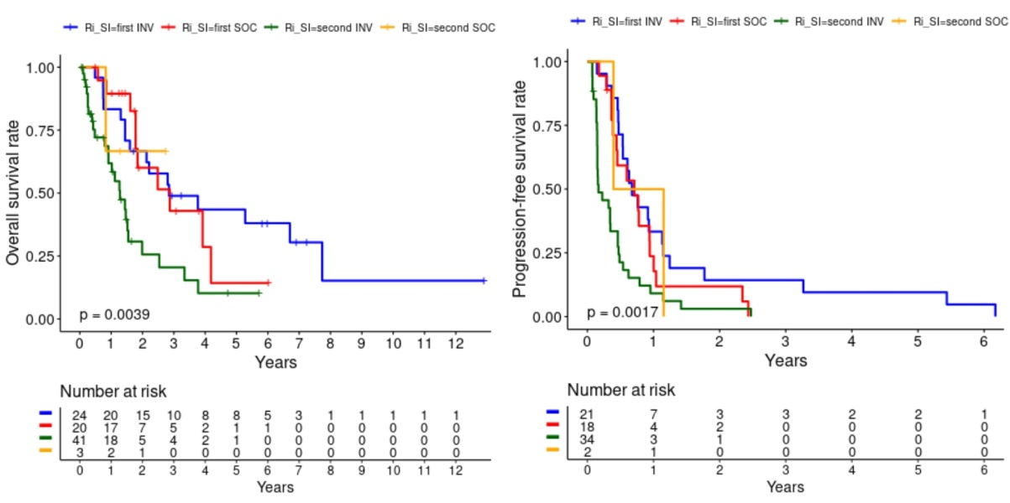
Overall Survival Progression Free Survival
SUPPLEMENTARY TABLES
Supplementary Table S1. Baseline Characteristics
DEMOGRAPHICS |  | ALL PATIENTS  (n = 44)
Age (Median Range) |  | 54.5 (25–76)
Gender, n (%)
Male |  | 26 (59%)
Female |  | 18 (41%)
Race, n (%)
Caucasian |  | 36 (82%)
Hispanic |  | 6 (14%)
Black |  | 1 (2%)
Asian |  | 1 (2%)
Primary tumor, n (%)
Cutaneous Melanoma |  | 16 (36%)
Colorectal Adenocarcinoma |  | 10 (23%)
Thyroid | Papillary Thyroid Carcinoma | 3 (7%)
Thyroid | Anaplastic Thyroid Cancer | 1 (2%)
Brain | Glioblastoma | 2 (5%)
Brain | Pleomorphic Xanthoastrocytoma | 1 (2%)
Brain | Anaplastic Astrocytoma | 1 (2%)
Cholangiocarcinoma |  | 3 (7%)
Pancreatic Adenocarcinoma |  | 2 (5%)
Ovarian Serous Carcinoma |  | 2 (5%)
Lung Adenocarcinoma |  | 1 (2%)
Triple Negative Breast Cancer |  | 1 (2%)
Neuroendocrine Carcinoma |  | 1 (2%)
Therapies: First RAF inhibitor
Dabrafenib |  | 21
Vemurafenib |  | 10
Encorafenib |  | 10
Investigational Agents |  | 3
Therapies: Second RAF inhibitor
Investigational Agents |  | 31
Dabrafenib |  | 1
Vemurafenib |  | 7
Encorafenib |  | 5
Prior lines of systemic therapies, n (%)
0–1 |  | 22 (%)
2–3 |  | 16 (%)
4–5 |  | 6 (%)
Survival Status
Alive |  | 18 (%)
Dead |  | 26 (%)
RAF = Rapidly Accelerated Fibrosarcoma; n = Number
Supplementary Table S2. Overall Responses with First RAFi and Rechallenge with Second RAFi
OVERALL RESPONSES | RAF1 INHIBITOR (n = 44) | RAF2 INHIBITOR (n = 44)
CR | 3 (7%) | 0 (0%)
PR | 13 (29.5%) | 8 (18.1%)
ORR | 16 (36%) | 8 (18.1%)
SD | 24 (54.5%) | 16 (36.3%)
PD | 4 (9%) | 20 (45.4%)
DCR (CR + PR + SD ≥ 6 months) | 27 (61.3%) | 8 (18.1%)
CBR = PR + SD | 37 (84%) | 24 (54.5%)
CR = Complete Response; PR = Partial Response; ORR = Overall Response Rate; SD = Stable Disease; PD = Progressive Disease.
DCR = Disease Control Rate; CBR = Clinical Benefit Rate; RAFi = Rapidly Accelerated Fibrosarcoma Inhibitor
Supplementary Table S3. Univariate Analysis of Patient Characteristics and Survival Outcomes
CHARACTERISTIC |  | OS HR (95% CI) | P VALUE | PFS HR (95% CI) | P VALUE
Age |  | 0.993 (0.965–1.02) | 0.615 | 0.982 (0.960-1.00) | 0.0976
Gender: Male |  | 3.05 (1.32–7.04) | 0.00894 | 0.442 (0.218–0.897) | 0.0238
Tumor type  Skin  Brain & CNS  Breast  Cecum  Cholangiocarcinoma  Colon  Gallbladder  NSCLC  Ovarian  Pancreatic  Rectal  Thyroid  Unknown Primary |  | Reference  1.62 (0.315–8.35)  4.35E-08 (0-Inf)  18.6 (1.73-201.107)  2.85 (0.320-25.418)  6.25 (1.49–26.3)  4.90 (0.894–26.9)  0.470 (0.0539-4.09)  0.427 (0.0504-3.62)  58.9 (6.34–548)  1.96 (0.374–10.3)  0.238 (0.0286-1.98)  0.890 (0.180–4.41) | 0.564  0.998  0.0161  0.348  0.0124  0.0672  0.494  0.435  0.000339  0.426  0.184  0.886 | Reference  0.32 (0.0710–1.44)  1 (1–1)  2.41 (0.315–18.5)  0.691 (0.0921-5.19)  1.25 (0.532–2.92)  1.03 (0.240–4.43)  5.56E-17 (0-Inf)  2.41 (0.553–10.5)  6.54 (1.42-30.0)  1.37 (0.319–5.88)  2.97E-09 (0-Inf)  14.5 (1.502-139) | 0.138  NA  0.397  0.719  0.611  0.967  0.995  0.241  0.0157  0.672  0.995  0.0208
ECOG: 0–1 |  | 3.529 (1.46–8.54) | 0.00514 | 3.510 (1.69–7.30) | 0.000779
Ethnicity | White | Reference
Ethnicity | Asian | 1.26E-08 (0-Inf) | 0.998 | 0.259 (0.0334-2.01) | 0.196
Ethnicity | Black | 1.43 (0.188–10.8) | 0.731 | 1.637 (0.216–12.41) | 0.634
Ethnicity | Hispanic | 0.701 (0.207–2.38) | 0.568 | 0.893 (0.339–2.35) | 0.819
Ethnicity | Native American | N/A
Metastatic sites (0–2 lesions) |  | Reference
Metastatic sites (3–5 lesions) |  | 1.64 (0.722–3.72) | 0.238 | 2.75 (1.24–6.11) | 0.0127
RAF1i vs RAF2i |  | 2.62 (1.48–4.63) | 0.000961 | 2.29 (1.42–3.68) | 0.000631
SOC vs INV therapies |  | 2.916 (1.48–5.73) | 0.0019 | 2.88 (1.61–5.15) | 0.000384
RAFi combination vs monotherapy |  | 3.57 (1.27-10.0) | 0.0159 | 6.24 (2.02–19.2) | 0.00145
Presence of brain metastases |  | 1.22 (0.417–3.59) | 0.713 | 0.838 (0.3776–1.858) | 0.663
Combination with IO |  | 1.05 (0.391–2.84) | 0.919 | 1.09 (0.488–2.44) | 0.833
Combination with TT |  | 2.34 (0.790–6.92) | 0.125 | 2.33 (0.882–6.13) | 0.088
Combination with CT |  | 3.82 (1.16–12.5) | 0.0274 | 1.38 (0.561–3.37) | 0.486
OS = Overall Survival; PFS = Progression Free Survival; HR = Hazard Ratio; CI = Confidence Interval; inf = infimum; CNS = Central Nervous System; NA = Not Available; NSCLC = Non-Small Cell Lung Cancer; ECOG = Eastern Cooperative Oncology Group; RAF1i = First RAF inhibitor; RAF2i = Second RAF inhibitor; SOC = Standard of Care; INV = Investigational; IO = Immunotherapy; TT = Targeted Therapy; CT = Chemotherapy

