Supplemental Figures and legends
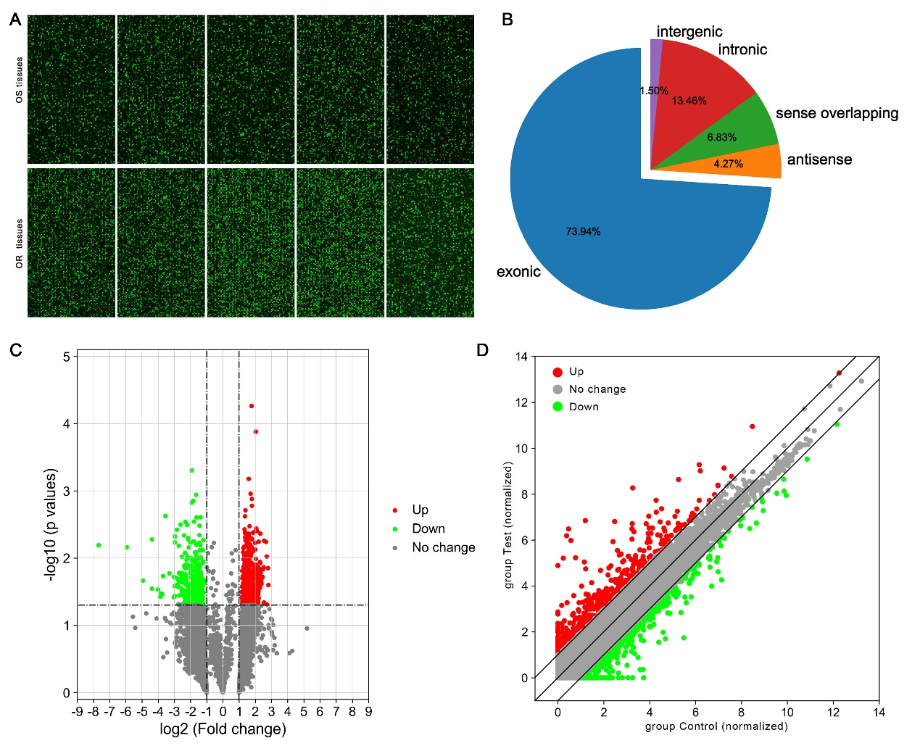
Supplemental Figure 1. Differential expression of circRNAs in OR and OS tissues. (A) circRNA microarray hybridization signal diagram; (B) Distribution of differentially expressed circRNAs; (C) circRNAs Volcano plots. The red dot represents the up-regulated circRNAs, and the green dot represents the down-regulated circRNAs; (D) circRNAs Scatter plot. The X-axis and Y-axis are the standardized signals. OS: Osimertinib Sensitive; OR: Osimertinib Resistance.

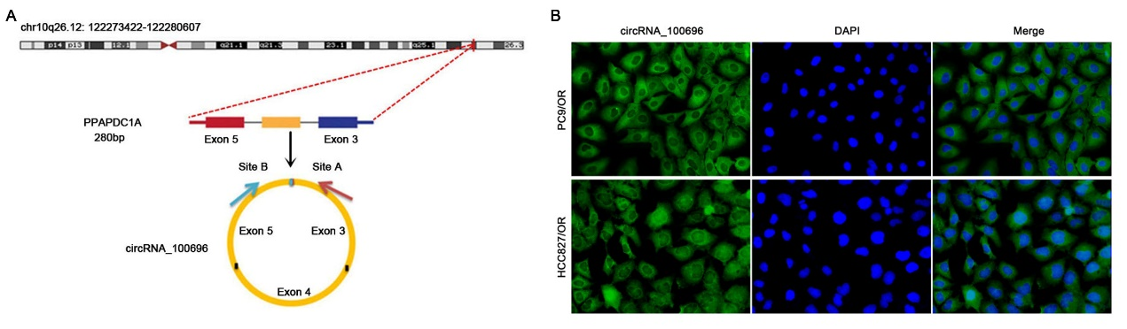
Supplemental Figure 2. (A) Chromosome location, exon splicing site and pattern map of circRNA_100696. circ_100696 was located on chromosome 10 at position q26.12: 122273422-122280607 and formed by the splicing of the 3rd, 4th, and 5th exons of the PPAPDC1A gene. (B) Fluorescence in situ hybridization assay revealed that circ_100696 is widely present in PC9/OR and HCC827/OR cells, with the primary localization being enriched in the cytoplasm. OS: Osimertinib Sensitive; OR: Osimertinib Resistance. circ_100696: circ_PPAPDC1A.

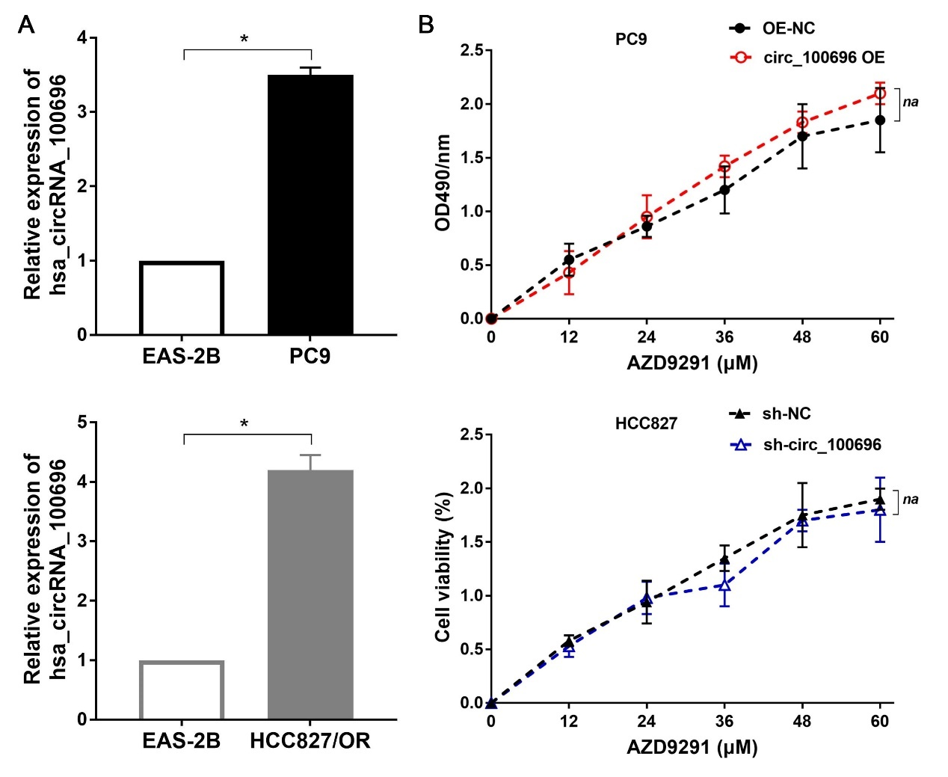
Supplemental Figure 3. (A) circ_PPAPDC1A exhibits significantly lower expression in human normal lung epithelial cells EAS-2B compared to PC9 and HCC827 cells. (B) CCK-8 assay showed that circ_PPAPDC1A has no significant effect on the cell proliferation of PC9 and HCC827 cells. n=3. *P<0.05, na: no statistical significance. Osimertinib Sensitive; OR: Osimertinib Resistance. RT-qPCR, reverse transcription- quantitative PCR. circ_100696: circ_PPAPDC1A. OE: OverExpression.

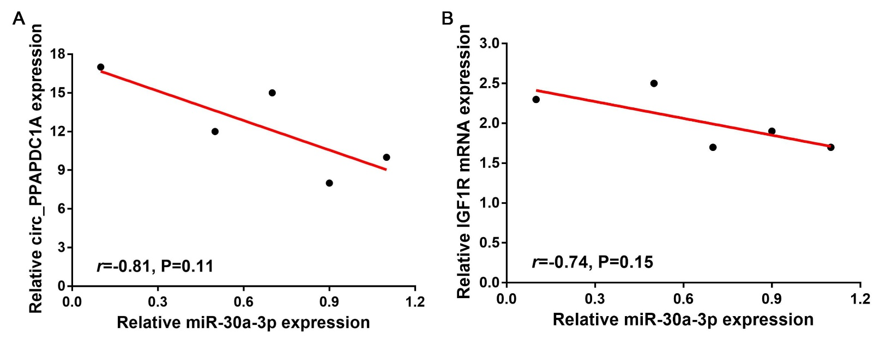
Supplemental Figure 4. Pearson's correlation analysis. (A) Pearson's correlation analysis highlighted a negative correlation trend between circ_PPAPDC1A and miR-30a-3p expression (n=5; r=-0.81, P=0.11). (B) Pearson's correlation analysis highlighted a negative correlation trend between IGF1R mRNA and miR-30a-3p expression in Osimertinib resistance tissues (n=5; r=-0.74, P=0.15; Supplemental Figure 3B). Although there was no statistical significance due to the small sample size.

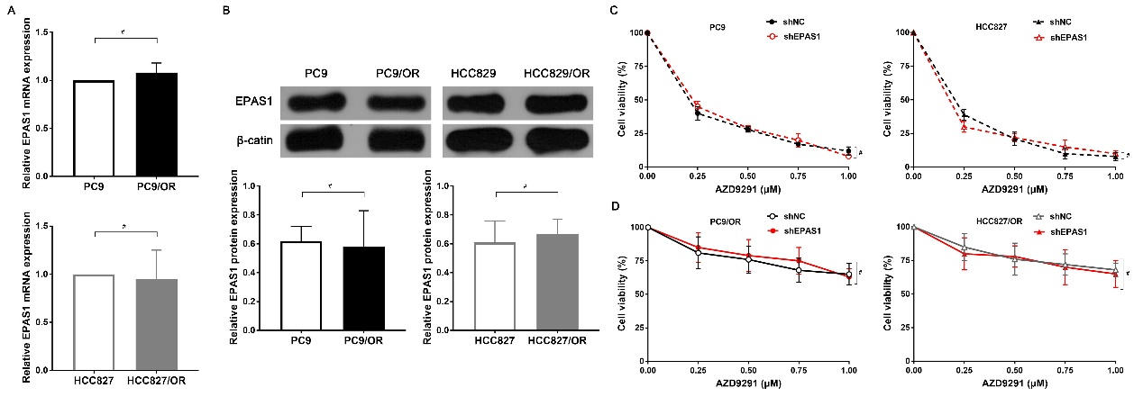
Supplemental Figure 5. The role of EPAS1 in Osimertinib resistance of NSCLC. (A) EPAS1 mRNA expression in NSCLC Osimertinib sensitive and resistance cells was assessed by RT-qPCR. (B) EPAS1 protein expression in NSCLC Osimertinib sensitive and resistance cells was assessed by Western Blot. (C-D) Cell counting kit-8 (CCK8) assay was conducted to determine the sensitivity of PC9, HCC829, PC9/OR, and HCC829/OR cells to Osimertinib. n=3. #: no statistical significance. Osimertinib Sensitive; OR: Osimertinib Resistance. RT-qPCR, reverse transcription-quantitative PCR.

