Supplementary figures
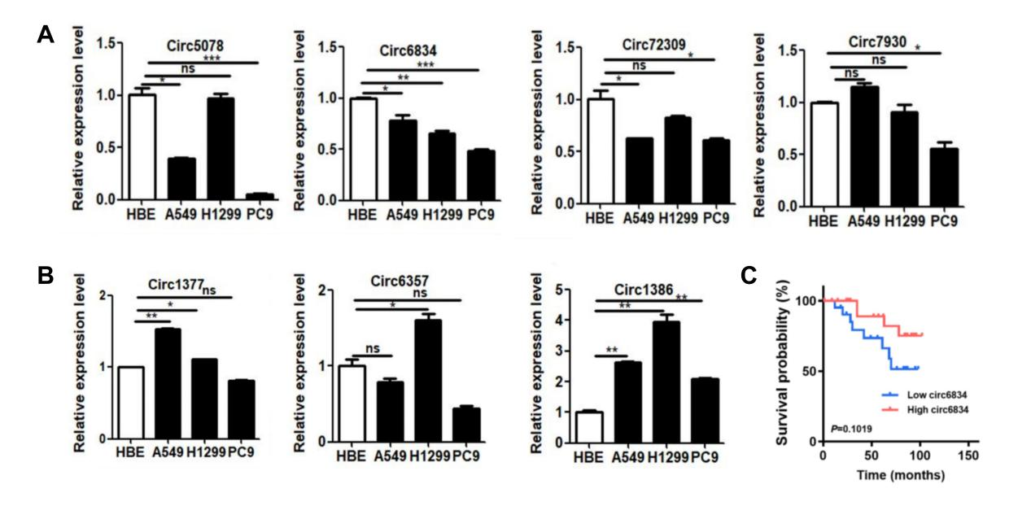
Supplementary Fig. 1 Expression and prognosis of circRNAs in NSCLC. A The expression of downregulated circRNAs (circ5078, circ6834, circ72309, circ7930) in NSCLC cells by qRT-PCR. B The expression of upregulated circRNAs (circ1377, circ6357, circ1386) in NSCLC cells by qRT-PCR. C Kaplan-Meier analysis of the OS rate in NSCLC patients with high or low circ6834 expression.

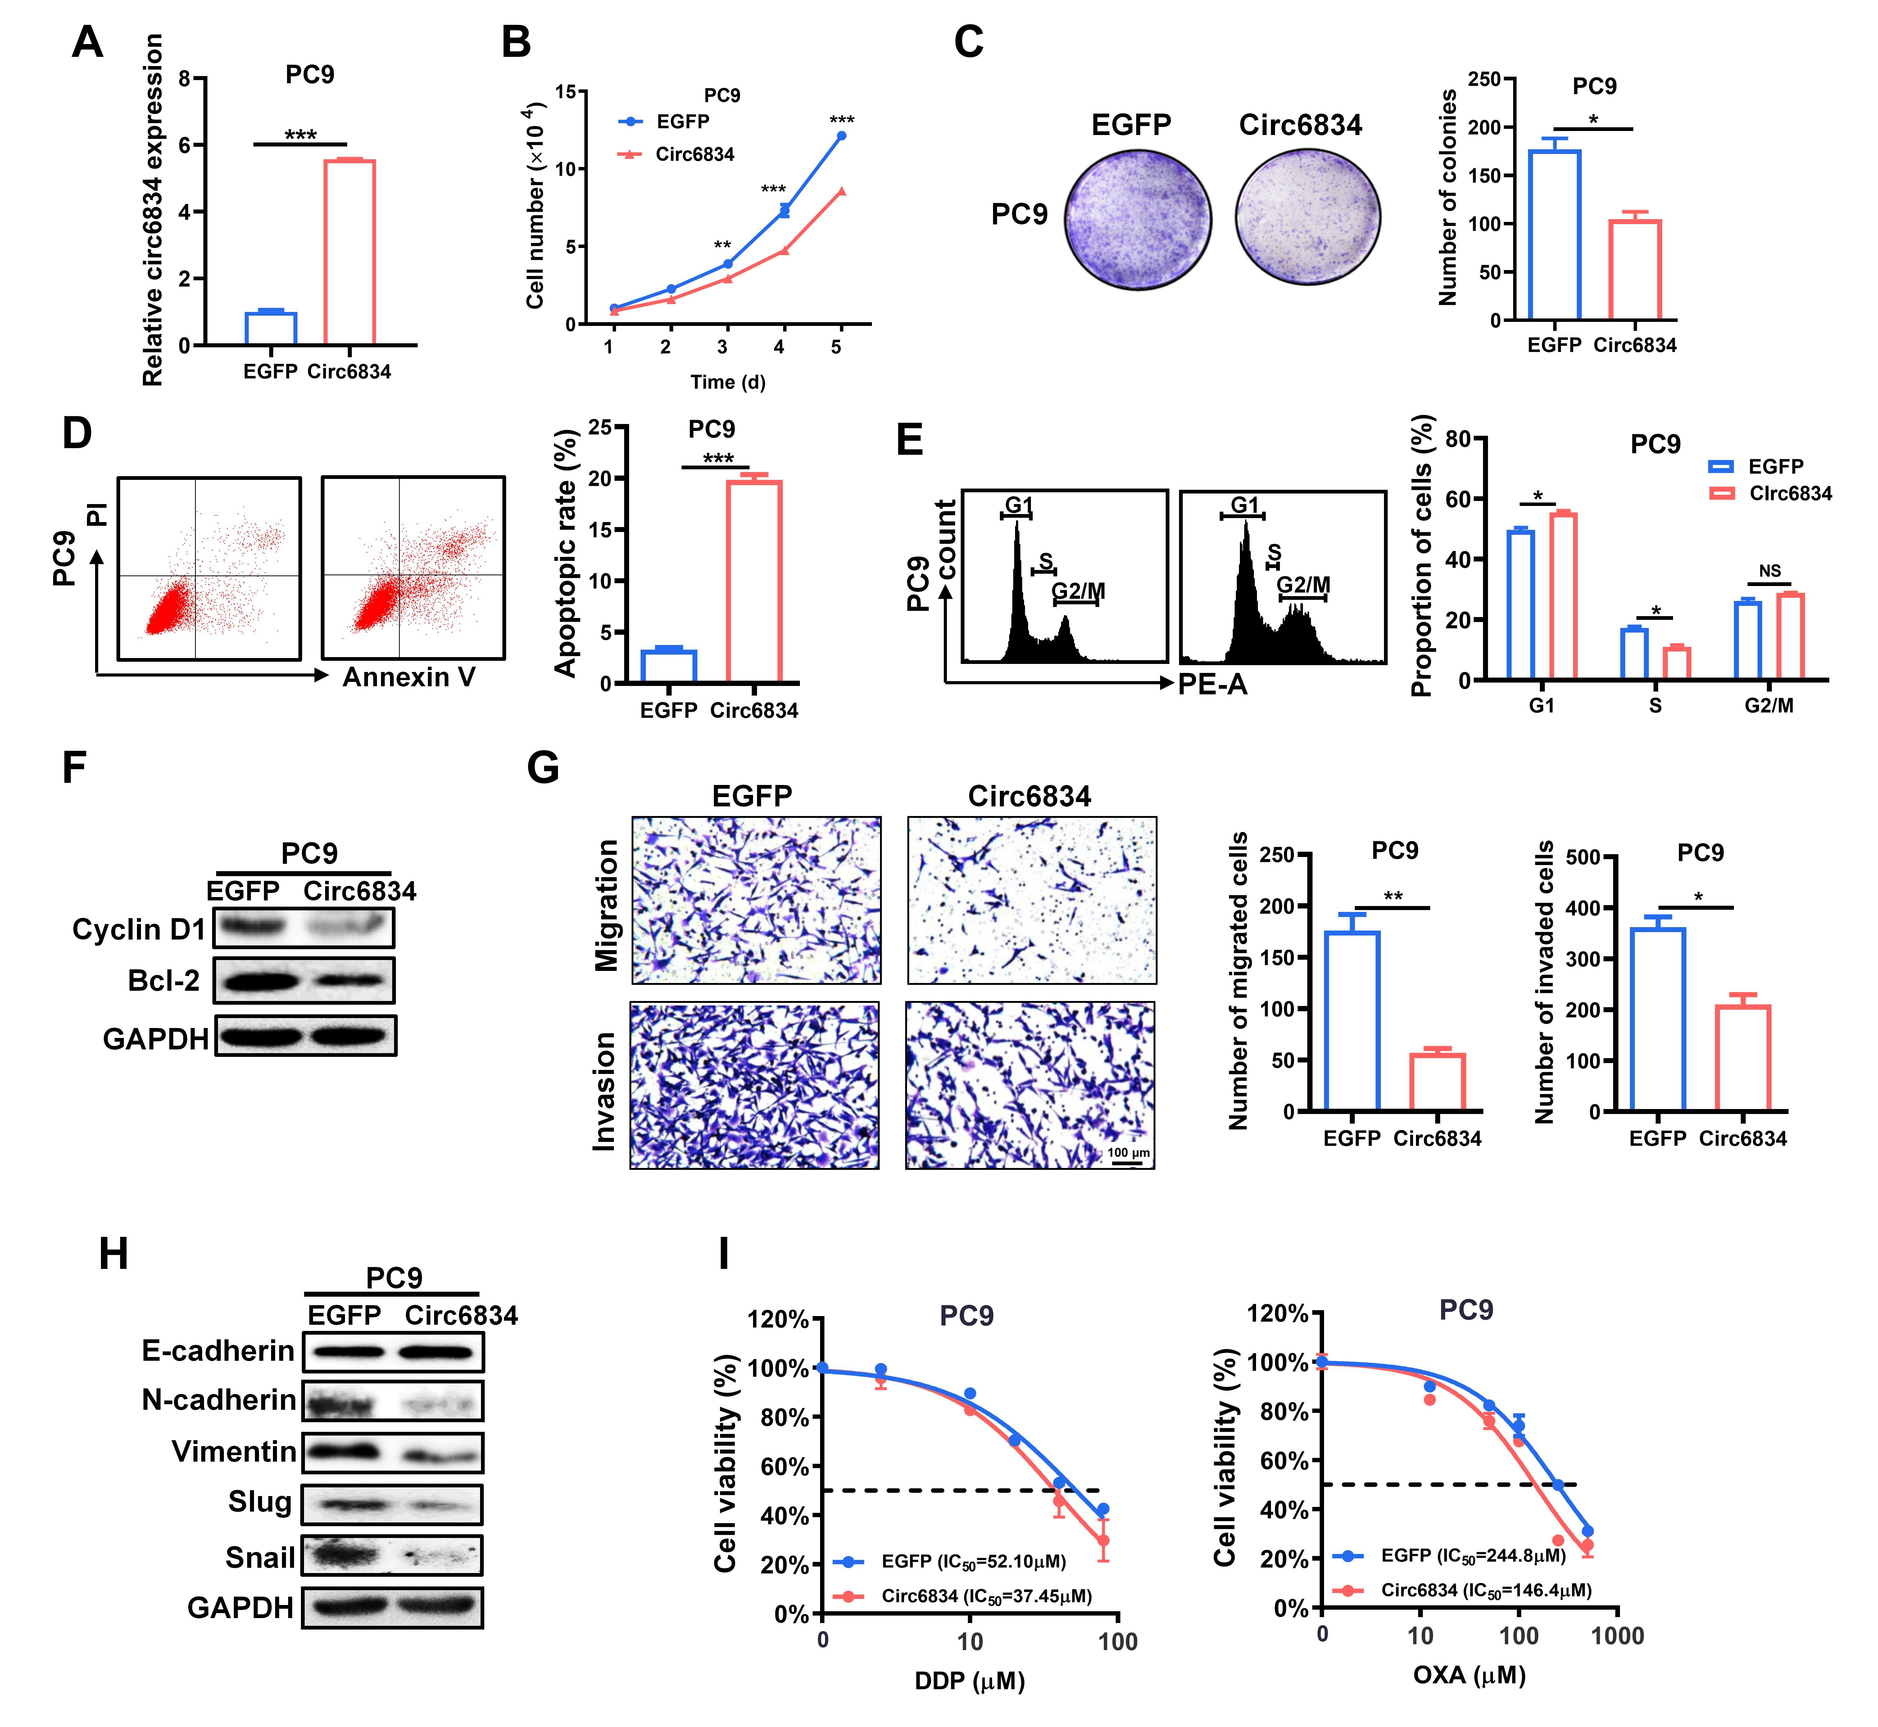
Supplementary Fig. 2 Circ6834 overexpression inhibits NSCLC malignant biological function. A The efficiency of circ6834 overexpression in PC9 cells. B-E, G Cell growth curves (B), colony formation assays (C), flow cytometric analyses of cell apoptosis (D) and cell cycle (E), and Transwell migration and Matrigel invasion assays (G) for EGFP and circ6834-overexpressing PC9 cells. F, H Western blot analyses for the expression of Cyclin D1, Bcl-2 (F), and EMT markers (H) in EGFP and circ6834-overexpressing PC9 cells. I The effects of circ6834 overexpression on the sensitivity of PC9 cells to DDP and OXA treatment.
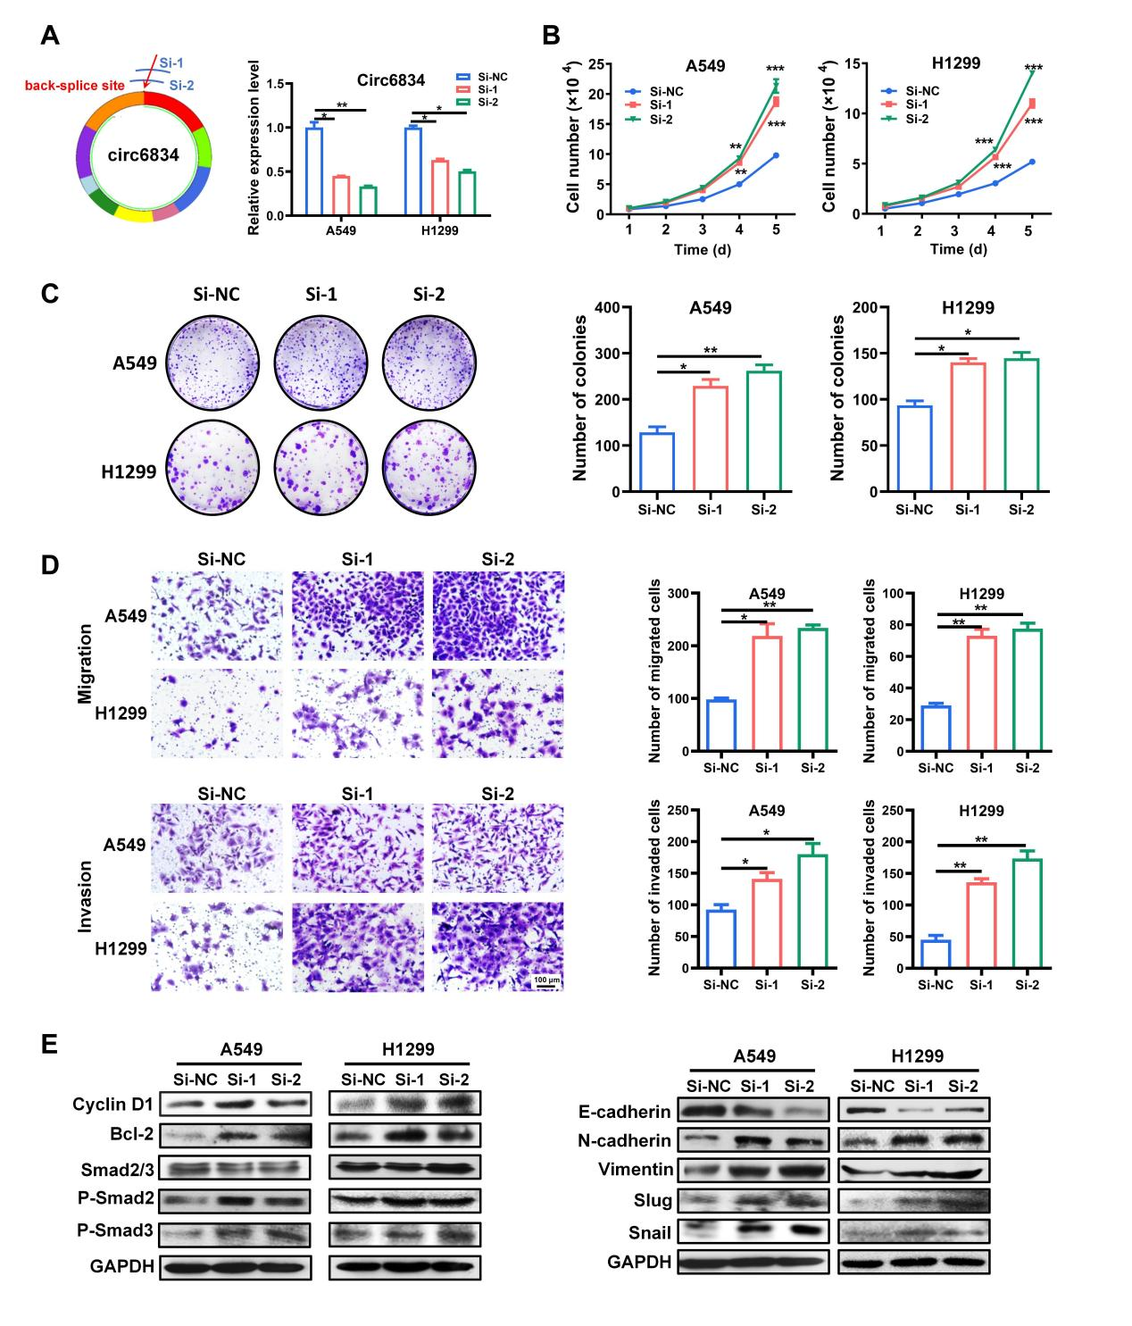
Supplementary Fig. 3 Circ6834 knockdown promotes NSCLC cell proliferation, migration, and invasion. A Schematic diagram and efficiency of circ6834 knockdown via an RNAi technique. B-D Cell growth curves (B), colony formation (C), and Transwell migration and Matrigel invasion assays (D) for Si-NC and circ6834 knockdown NSCLC cells. E Western blot analyses for the expression of Cyclin D1, Bcl-2, EMT markers and phospho-Smad2/3 in Si-NC and circ6834 knockdown NSCLC cells.

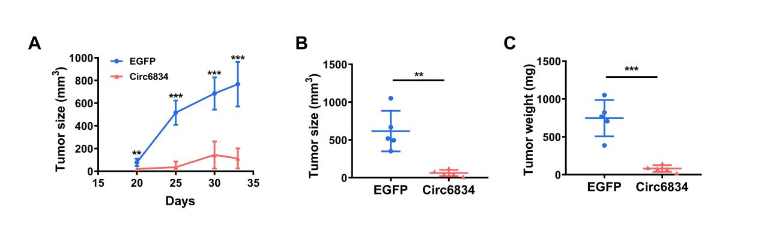
Supplementary Fig. 4 Circ6834 overexpression suppresses NSCLC growth in vivo. A-C Growth curves (A), volumes (B), and weights (C) of tumors from mice in the EGFP and circ6834-overexpressing groups.
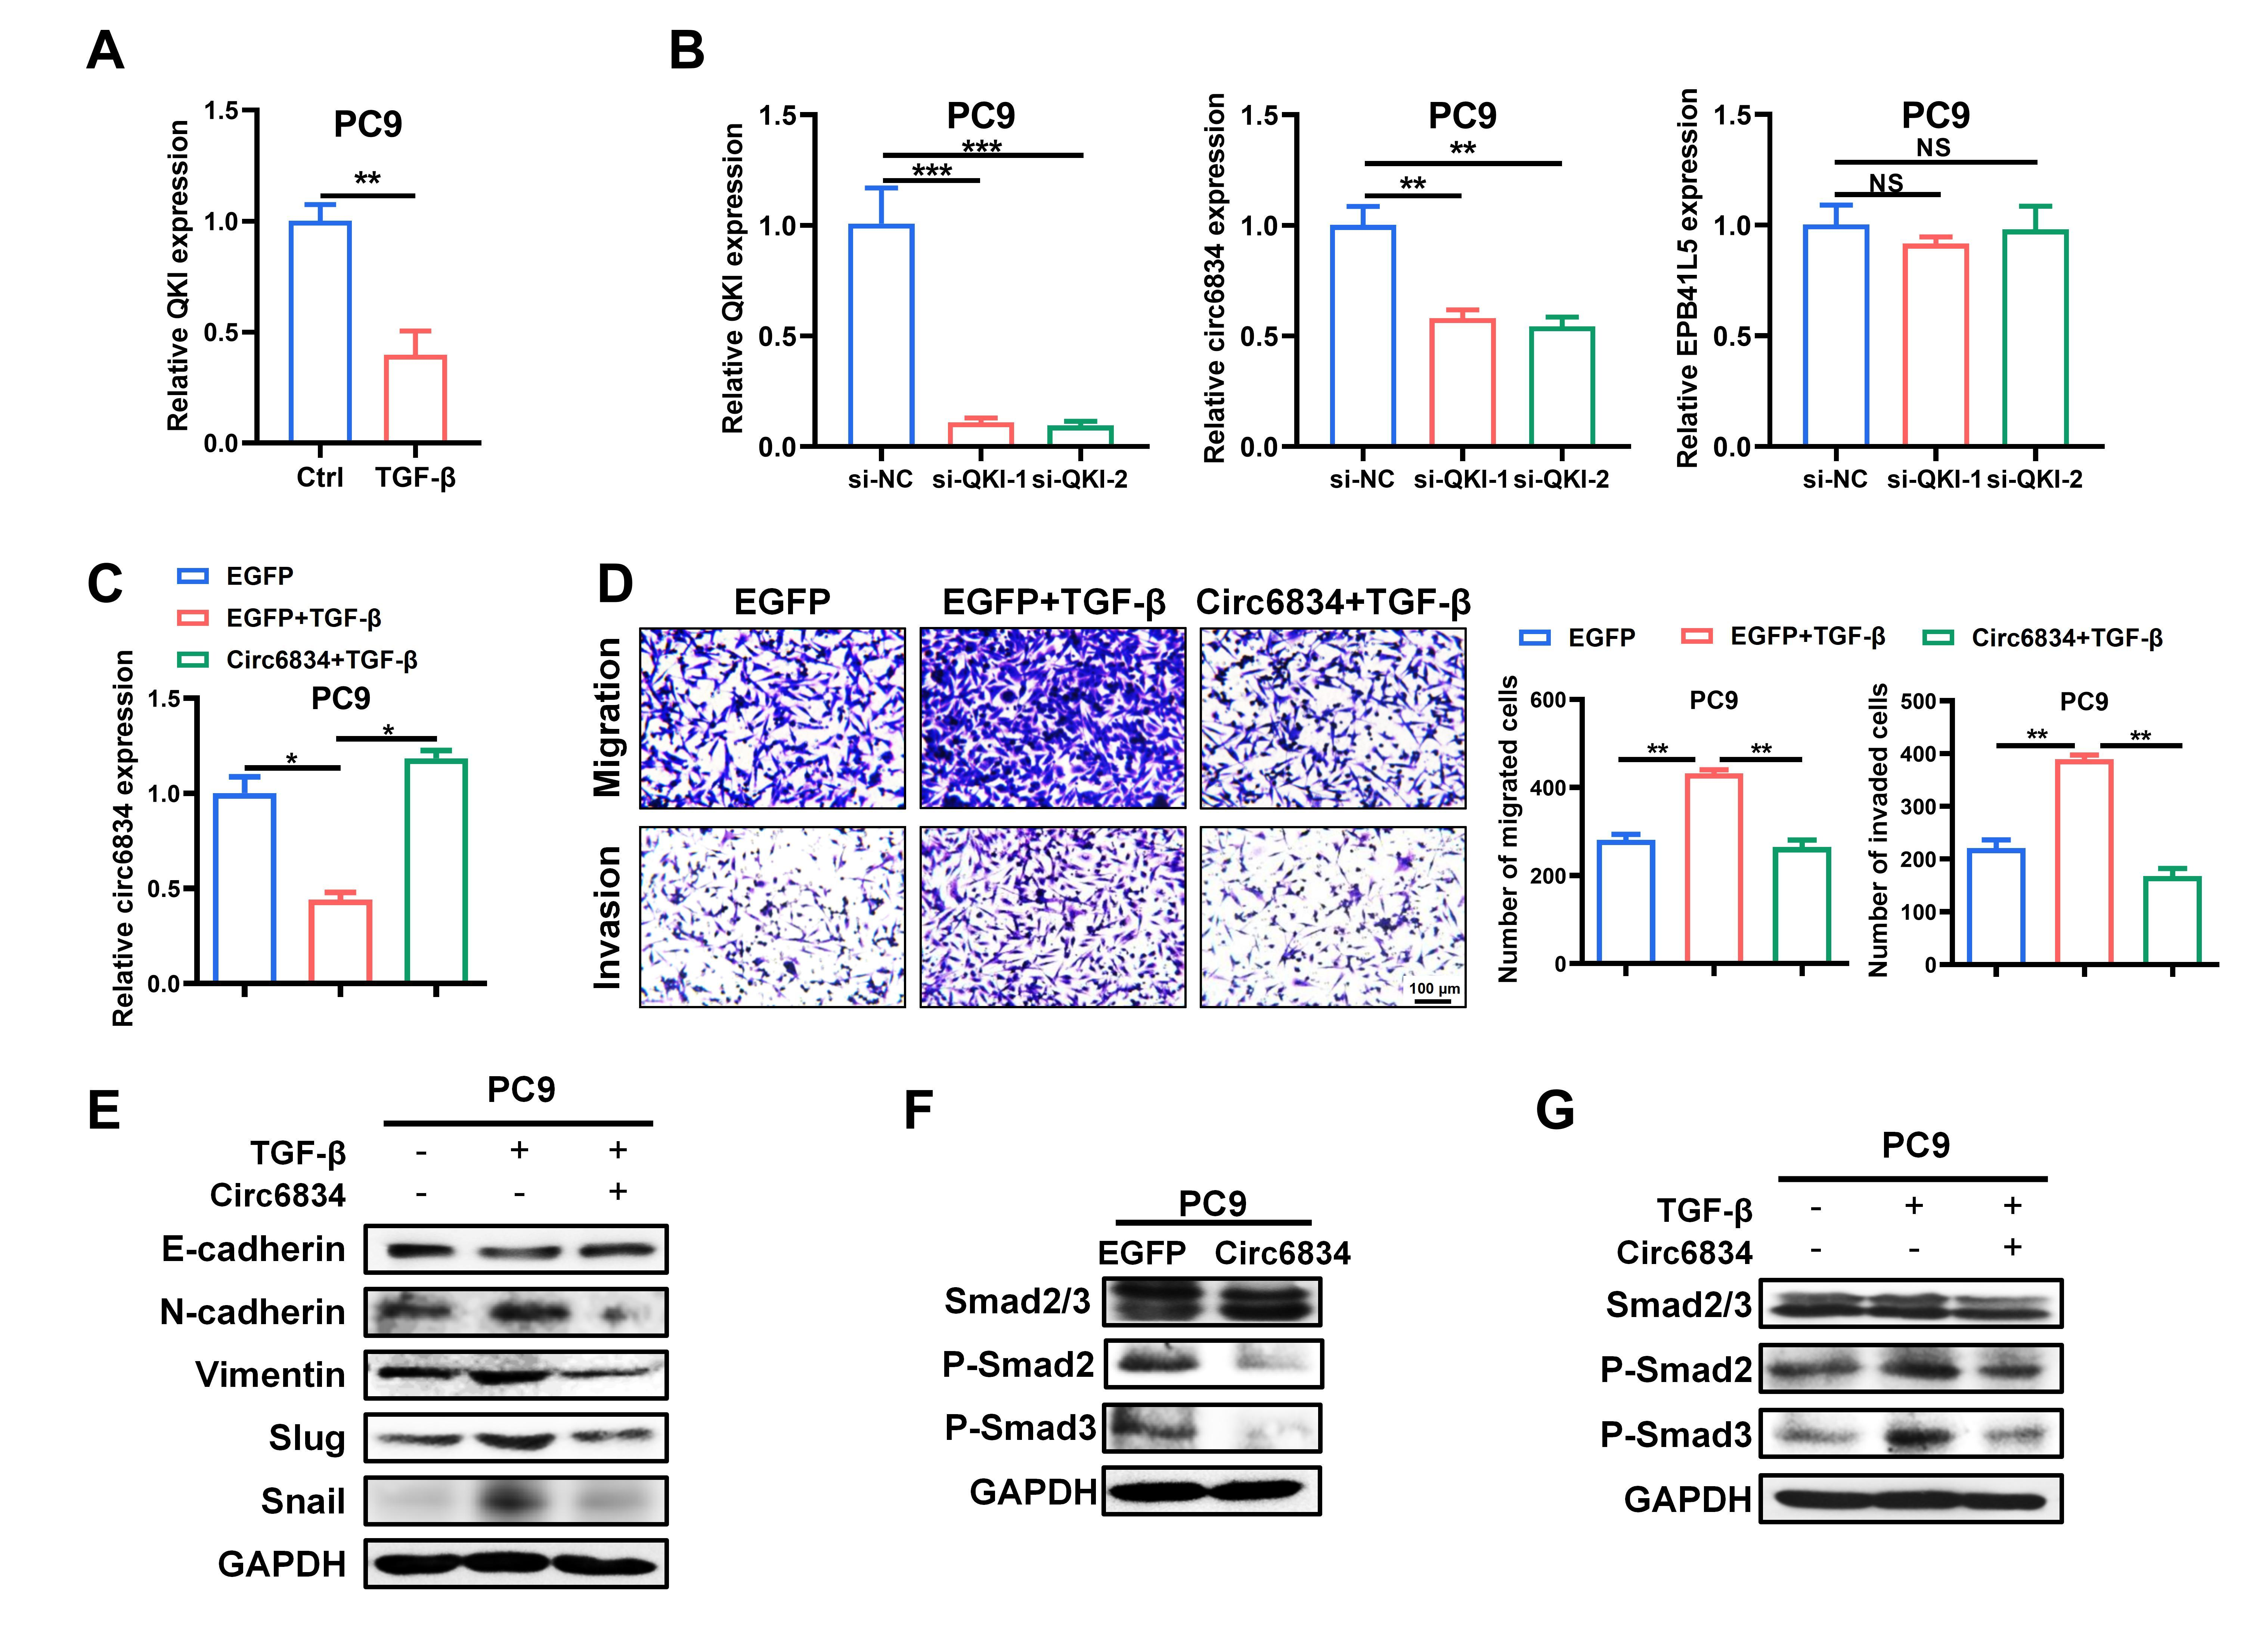
Supplementary Fig. 5 Circ6834 responds to TGF-β stimulus and inhibits TGF-β/SMAD pathway in PC9 cells. A Relative QKI expression in PC9 cells after TGF-β treatment detected by qRT-PCR. B QRT-PCR for QKI, circ6834, and EPB41L5 expression in QKI knockdown PC9 cells. C-D QRT-PCR for circ6834 (C), and Transwell migration and Matrigel invasion assays (D) in PC9 cells overexpressing circ6834 treated with TGF-β. E-G Western blot for EMT markers (E), and p-SMAD2/3 expression (F, G) in PC9 cells with different treatments.

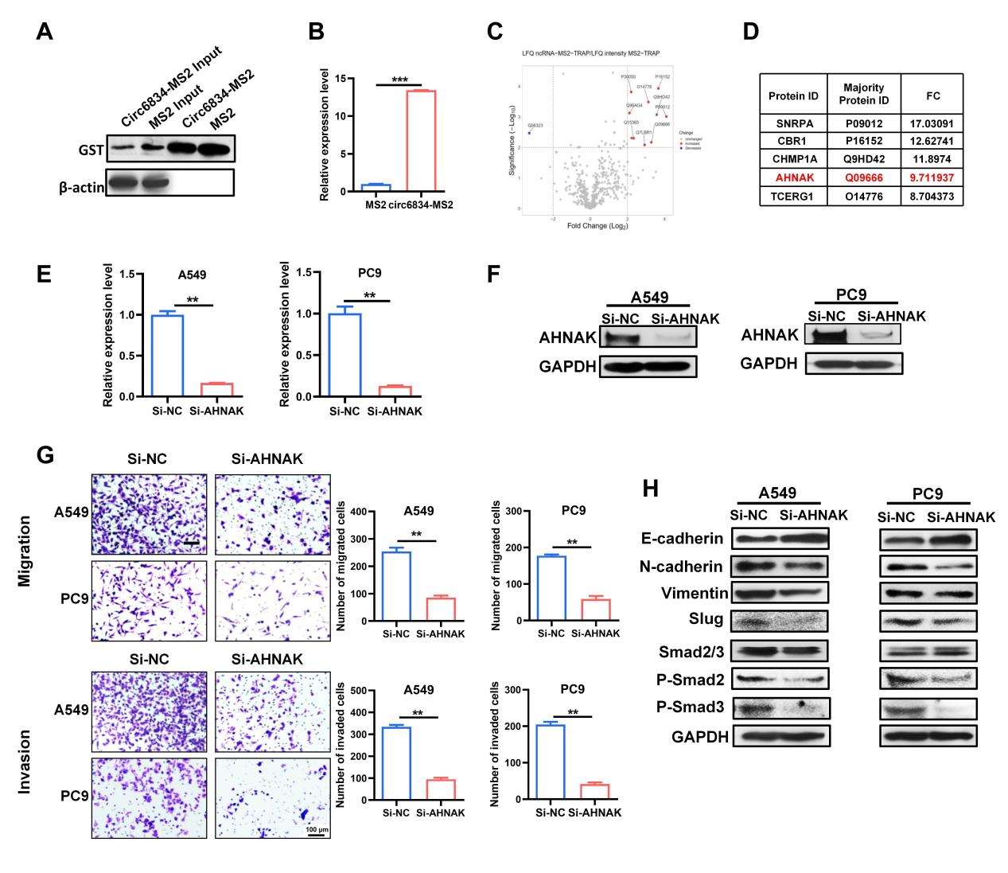
Supplementary Fig. 6 AHNAK knockdown inhibits NSCLC cell metastasis. A GST protein expression was detected by western blot. B QRT-PCR was conducted to detect circ6834 expression in MS2 and circ6834-MS2 group. C-D The volcano plot (C) and list (D) of circ6834 binding proteins analyzed by LC-MS/MS. E-F The RNA (E) and protein (F) level of AHNAK in knockown NSCLC cells. G Transwell migration and Matrigel invasion assays of AHNAK knockown NSCLC cells. H Western blot analyses for the expression of EMT markers and P-Smad2/3 in AHNAK knockown NSCLC cells.
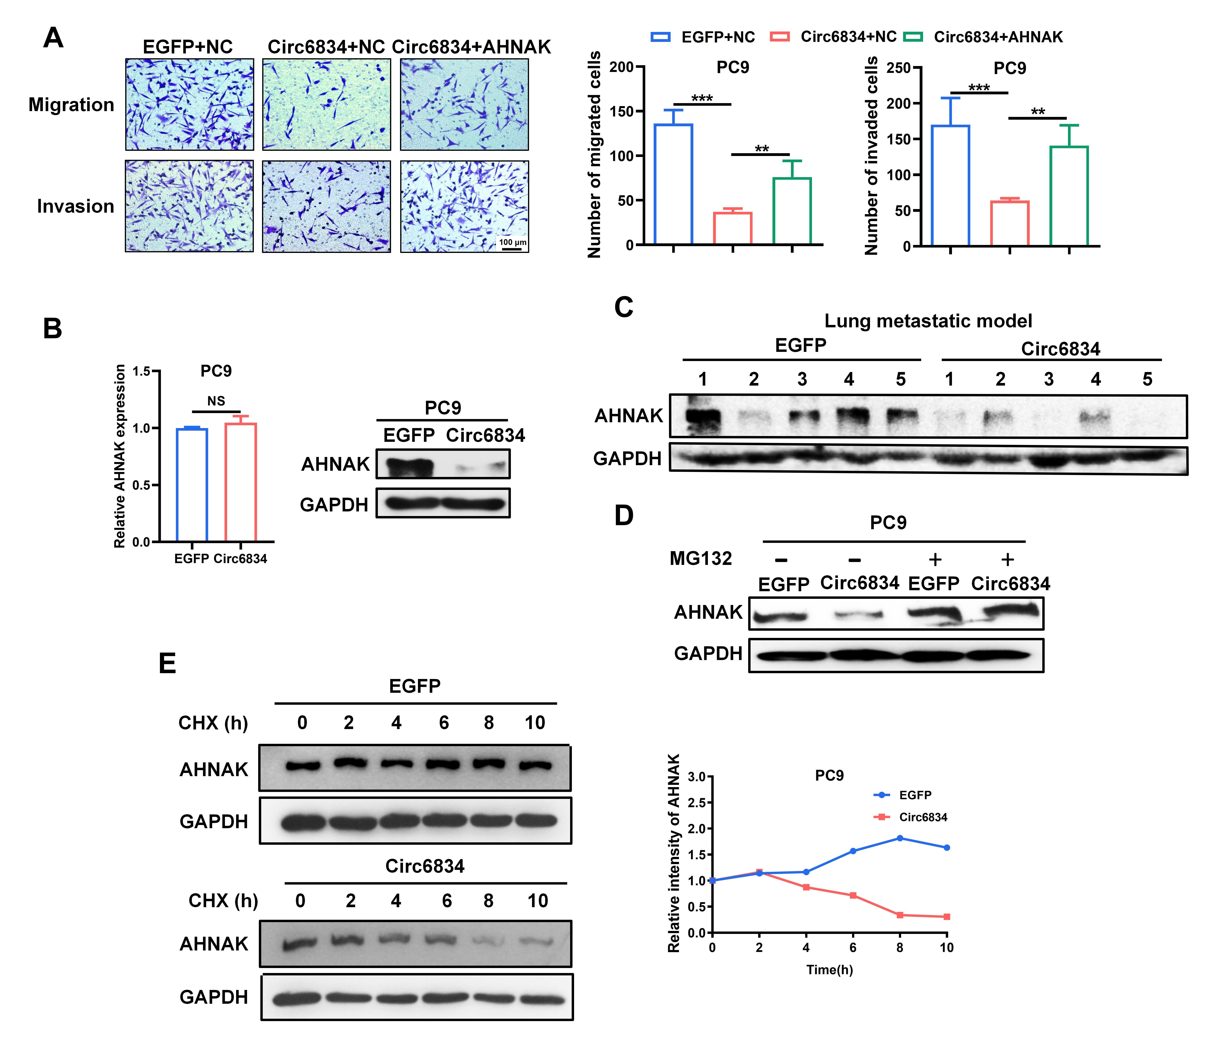
Supplementary Fig. 7 Circ6834 promotes AHNAK ubiquitination. A Transwell migration and Matrigel invasion assays for PC9 cells cotransfected with circ6834 and AHNAK. B AHNAK mRNA and protein levels in PC9 cells overexpressing circ6834. C Western blot for AHNAK expression in lung metastasis tissues. D MG132 (40 μM, 6 h) experiment for AHNAK expression in PC9 cells overexpressing circ6834. E CHX assay for determining the half-life of AHNAK protein in PC9 cells overexpressing circ6834.
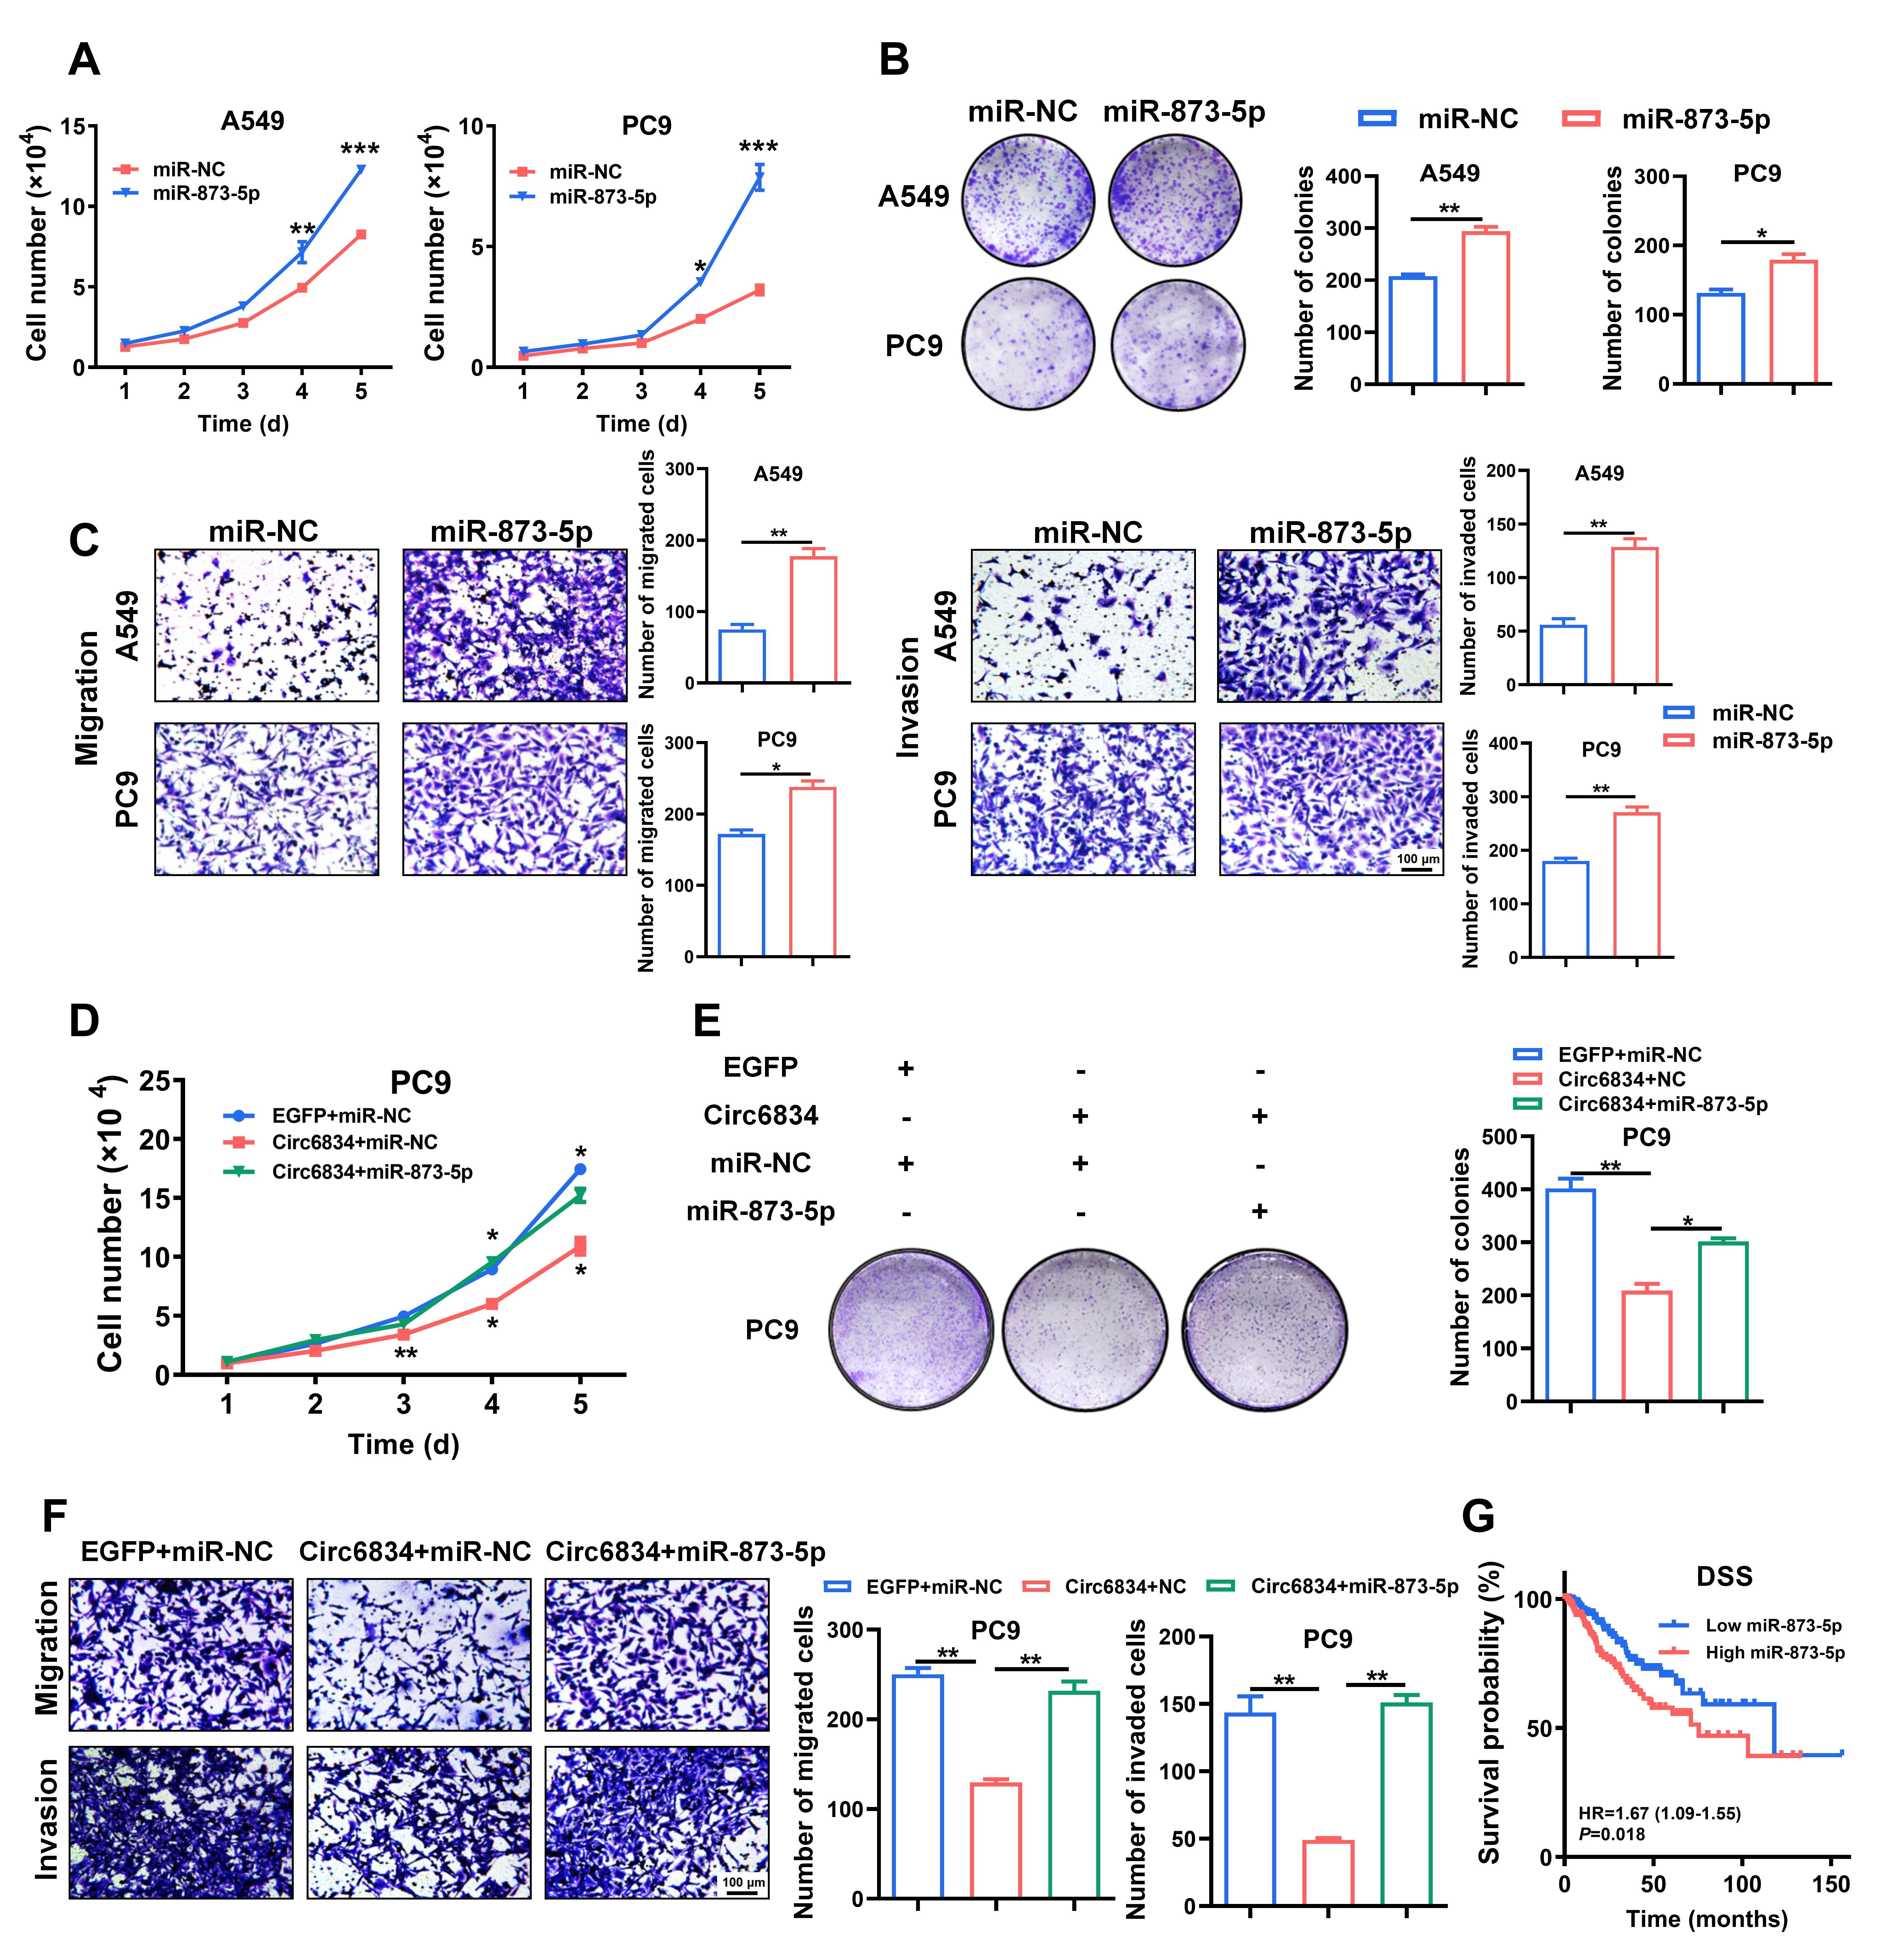
Supplementary Fig. 8 Circ6834 reverses the cancer-promoting effects of miR-873-5p. A-C Cell growth curves (A), colony formation assays (B), and Transwell migration and Matrigel invasion assays (C) for miR-873-5p mimics in NSCLC cells. D-F Cell growth curves (D), colony formation assays (E), and Transwell migration and Matrigel invasion assays (F) for circ6834 and miR-873-5p overexpression in PC9 cells. G TCGA databsse analysis for disease-specific survival time of lung cancer patients with different miR-873-5p expression.
Supplementary Fig. 9 Circ6834 regulates miR-873-5p/TXNIP axis in NSCLC. A-B QRT-PCR (A) and western blot (B) were performed to detect the expression of TXNIP in PC9 cells with circ6834 or miR-873-5p overexpression. C A549 cells were transfected with TXNIP WT or Mut plasmids and miR-873-5p mimics as indicated. Relative luciferase activity was detected and normalized to the control. D-F Cell growth curves (D), colony formation assays (E), and Transwell migration and Matrigel invasion assays (F) of circ6834 overexpressing and TXNIP knockdown A549 cells. G-I Cell growth curves (G), colony formation assays (H), and Transwell migration and Matrigel invasion assays (I) of A549 cells cotransfected with miR-873-5p mimics and TXNIP plasmid.
Supplementary tables

Supplementary table. 1 The sequences of primers
Gene | Forward primers | Reverse primers
β-actin | CACGAAACTACCTTCAACTCC | CATACTCCTGCTTGCTGATC
Circ6834 | TGTTGGATTCAGGAGCTTGT | GCTTGGGATGTTTCCATAGT
TRIM25 | AAAGCCACCAGCTCACATCCGA | GCGGTGTTGTAGTCCAGGATGA
TXNIP | GGTCTTTAACGACCCTGAAAAGG | ACACGAGTAACTTCACACACCT
AHNAK | GTGGGTGCCACCATCTACTT | GGTGGAGACTGAAACTGCCC
EPB41L5 | TGTACCACCTGGACCTGATTGA | ACCATCCAACCAATGTGCTACT
QKI | TAAATCACCAACAGCCCAGG | GTTCCGTTTGGCATGACAGC

Supplementary table. 2 The sequences of siRNAs and miRNA mimics
Gene | Sense | Antisense
Negative control | UUCUCCGAACGUGUCACGUTT | ACGUGACACGUUCGGAGAATT
Si-circ6834-1 | CAUCAUCGGACUUGUAAGATT | UCUUACAAGUCCGAUGAUGTT
Si-circ6834-2 | CAUCGGACUUGUAAGACUUTT | AAGUCUUACAAGUCCGAUGTT
Si-TXNIP-1 | GGAUCUGGUGGAUGUCAAUTT | AUUGACAUCCACCAGAUCCTT
Si-TXNIP-2 | GCCACACUUACCUUGCCAATT | UUGGCAAGGUAAGUGUGGCTT
Si-AHNAK | GCCCUGAAUUCAAGAUCAATT | UUGAUCUUGAAUUCAGGGCTT
Si-QKI-1 | GGGACCUAUUGUUCAGUUATT | UAACUGAACAAUAGGUCCCTT
Si-QKI-2 | GGAGCAUCUAAAUGAAGAUTT | AUCUUCAUUUAGAUGCUCCTT
miR-873-5p mimics | GCAGGAACUUGUGAGUCUCCU | AGGAGACUCACAAGUUCCUGC

