Supplementary Figures

BRCA1 secondary splice-site mutations drive exon-skipping and PARP inhibitor resistance
Nesic et al., 2023

Figure S1
A.
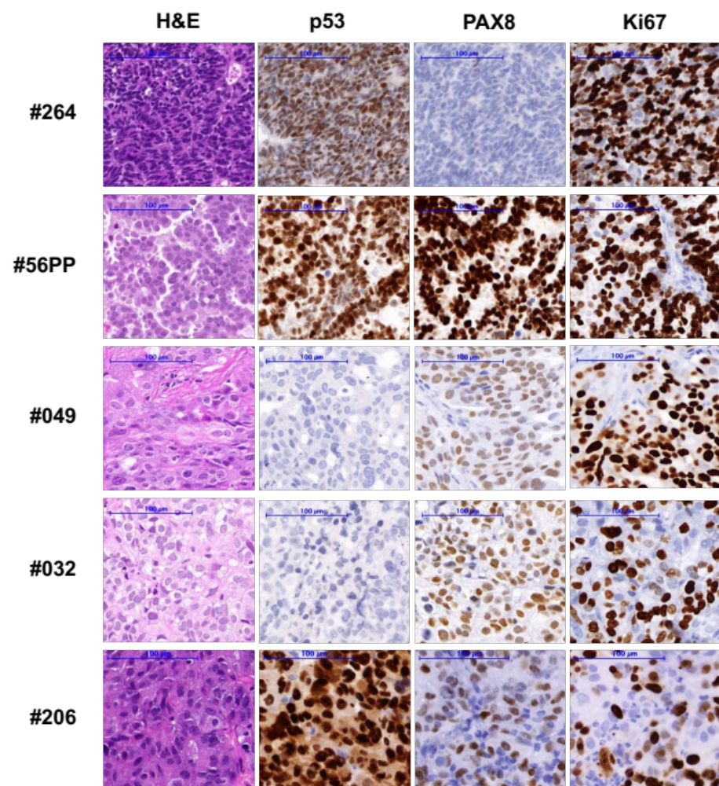

B.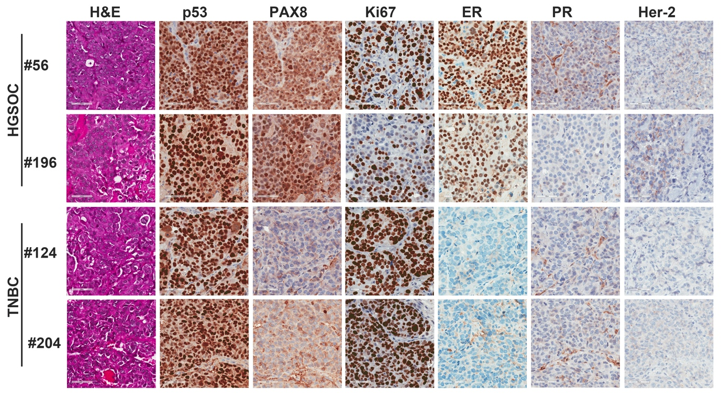
Supplementary Figure S1. Histology of each PDX model.
Immunohistochemistry (IHC) staining was used to assess PDX tumour morphology and histology. A. Histology of WEHI PDX. Hematoxylin and eosin (H&E) staining confirmed morphology consistent with HGSOC for models #56PP, #049, #032 and #206, and OCS for PDX model #264. PDX #56PP harbors a TP53:c.963delA (p.K321fs) mutation, but still had p53 staining possibly as this mutation occurs later in the protein and may not lead to nonsense-mediated decay. PDX #206 harbours a TP53:c.451C>T mutation (p.P151S) and had high p53 staining, while PDX #049 was found to have a frameshift TP53:c.428_429insCA (E144Sfs*27) mutation, leading to a pre-mature stop codon early in the protein and absent p53 staining. OCS PDX #264 had a TP53: c.1006G>T (p.E336X) mutation but still had p53 staining by IHC, possibly for the same reason as #56PP. High PAX8 was observed in HGSOC models #56PP, #049 #032 and #206, but none in OCS PDX model #264. Scale bars are 100μm. B. FCCC PDX models #56 and #196 were confirmed to have HGSOC histology, and PDX #124 and #204 were confirmed to have TNBC histology. Scale bar represents 50um.

Figure S2
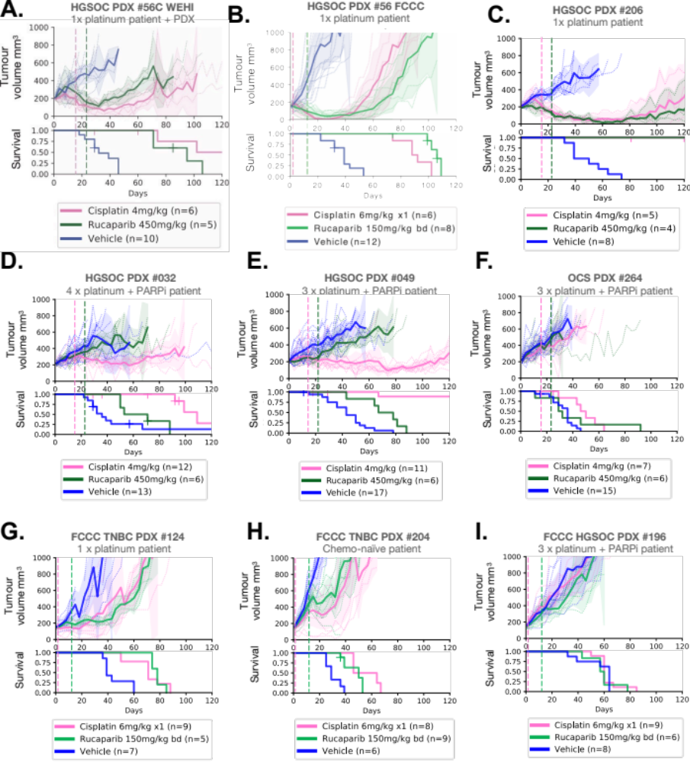
Supplementary Figure S2. In vivo PARP and platinum responses of WEHI and FCCC PDX models.
HGSOC, OCS and TNBC PDX models with BRCA1 exon 11 mutations were treated with cisplatin or the PARPi rucaparib (treatment interval indicated by hashed vertical lines), and tumor volume assessed twice weekly. Mean tumor volume (mm³) ± 95% CI (hashed lines are individual mice) and corresponding Kaplan–Meier survival analysis. Censored events are represented by crosses on Kaplan–Meier plot; n = individual mice. Detailed patient clinical data can be found in Supplementary Table 1. Details of time to harvest, time to progression and Log-Rank test P values for each PDX can be found in Supplementary Table 2. A. A new lineage of HGSOC PDX #56 (#56C) was derived from a mouse that had been treated with 4 mg/kg cisplatin, and this lineage was found to still be responsive to both rucaparib 450 mg/kg and cisplatin 4 mg/kg (P <0.001 for both compared with vehicle). B. The FCCC derivative of PDX #56 was also classified as sensitive to cisplatin and rucaparib, correlating with responses observed for the original lineage treated at WEHI (Figure 1B and Table S2). C. HGSOC PDX #206 had a complete response to both cisplatin (P <0.001) and rucaparib (P = 0.002). D. HGSOC PDX #032 had progressive disease on rucaparib (P = 0.395) and stable disease on cisplatin (P = 0.093). E. HGSOC PDX #049 had a partial response to cisplatin (P <0.001) and stable disease following rucaparib (P = 0.005). F. OCS PDX #264 had progressive disease on cisplatin (P = 0.004) and rucaparib (P = 0.502). G. TNBC PDX #124 (one line platinum in patient) was classified as sensitive to cisplatin (P <0.001) and rucaparib (P <0.001), H. as was TNBC PDX #204 (P <0.001 and P <0.001, respectively; chemo-naïve patient). I. HGSOC PDX #196 (3 prior lines of platinum, and PARPi, in patient) was resistant to both cisplatin (P = 0.793) and rucaparib (P = 0.629).

Figure S3
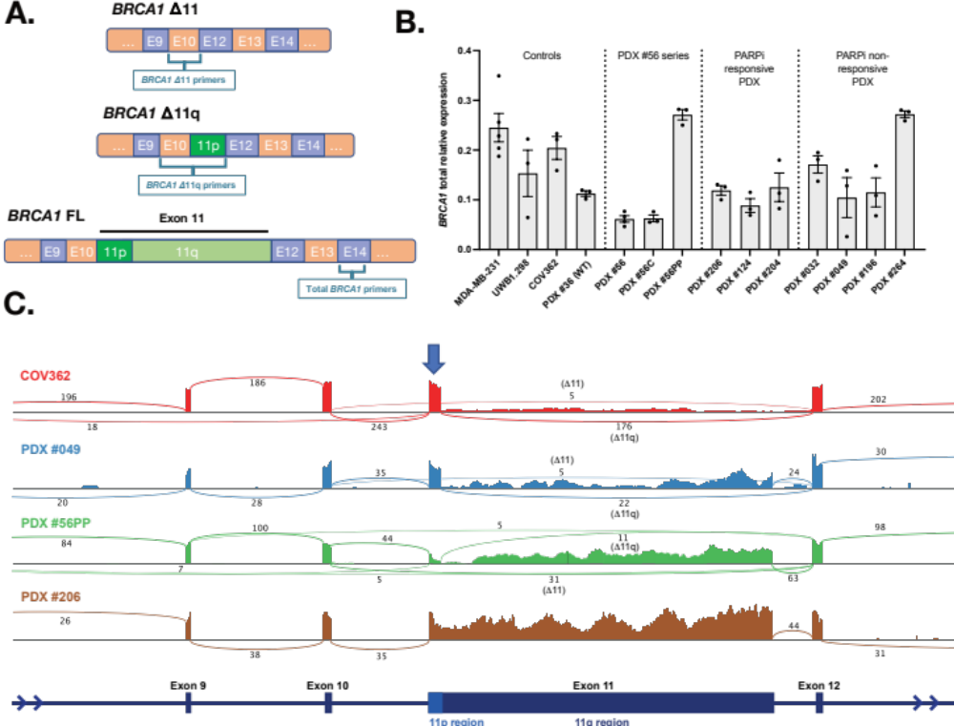
Figure S3. High BRCA1 Δ11q/Δ11 isoform expression observed in PARPi-resistant PDX models.
A. Schematic for design of quantitative two-step PCR (qRT-PCR) assays used in this Figure part B, and main Figure 1D-E. B. Relative total BRCA1 expression for each PDX (mean ± SD). Δ11q-high cell line MDA-MB-231 (1) was included as a technical control on each qRT-PCR plate, while UWB1.289 and COV362 were included as additional cell line controls. PDX #36 was included as a Δ11q-high PDX control. C. RNA sequencing results for a subset of models with either high Δ11q (cell line COV362, PDX #049), high Δ11 (PDX #56PP) or low Δ11/ Δ11q (#206) and presented as sashimi plots. BRCA1 exon regions are displayed at bottom of plot, and sequencing read coverage across each exon is represented as a histogram above. The lines connecting exons represent splicing events detected, and the numbers indicate the number of reads assigned to a given event. The blue arrow indicates the exon 11p region, which is retained in the Δ11q isoform.

Figure S4
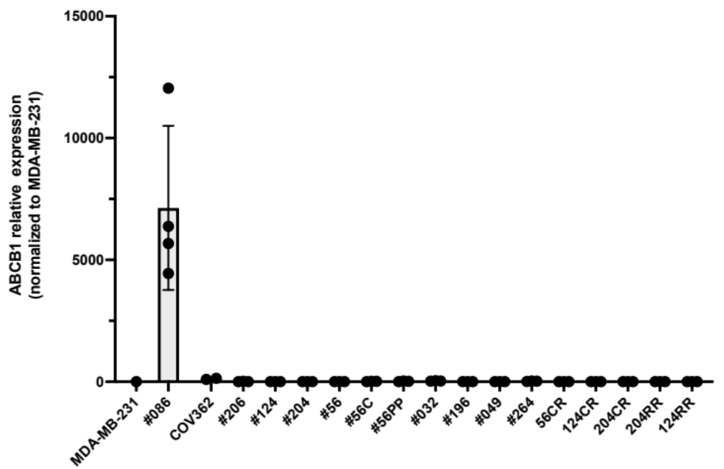

Supplementary Figure S4. ABCB1 gene expression in each PDX and cell line model.
Expression of the drug efflux gene ABCB1 was assessed by two-step RT-qPCR for each model in our study to exclude this as a mechanism of PARP inhibitor resistance. None of the models in our study had high ABCB1 expression relative to the ABCB1-high control PDX #086. Data presented is fold-change relative to cell line MDA-MB-231. Each point represents an independent PDX or cell line passage, with mean ± standard deviation presented.

Figure S5
A.
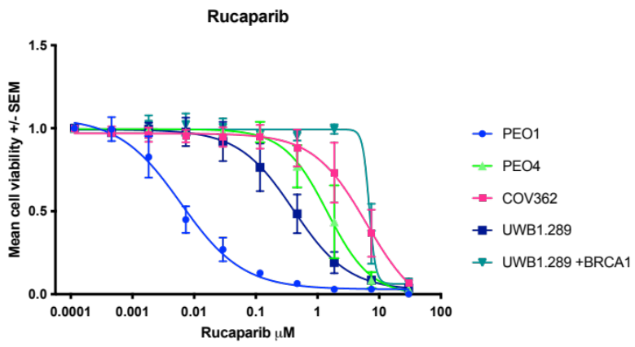
B.
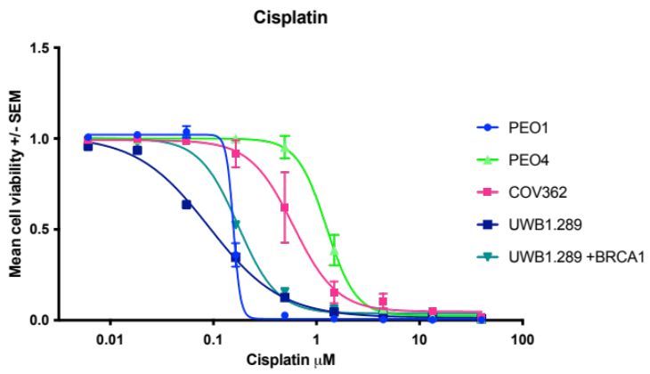
Supplementary Figure S5. COV362 cell line is resistant to PARPi and platinum.
The CTG cell viability assays demonstrated that Δ11q-high cell line COV362 is resistant to A. PARPi rucaparib and B. platinum treatment relative to the sensitive control cell line PEO1 (BRCA2-mutant), and resistant control cell lines PEO4 (BRCA2 reversion mutation, HR competent), UWB1.289 (Δ11q-high) and UWB1.289+BRCA1 (UWB1.289 harbouring a BRCA1 expression vector – additional resistance to PARPi compared to the parental line). While COV362 has been described as both PARPi or platinum responsive (2,3) or resistant in the literature (4,5), our derivative, obtained from CellBank Australia (#07071910) at passage 36, is PARPi and platinum resistant. Data presented is mean +/- SEM from n=3 independent experiments.

Figure S6
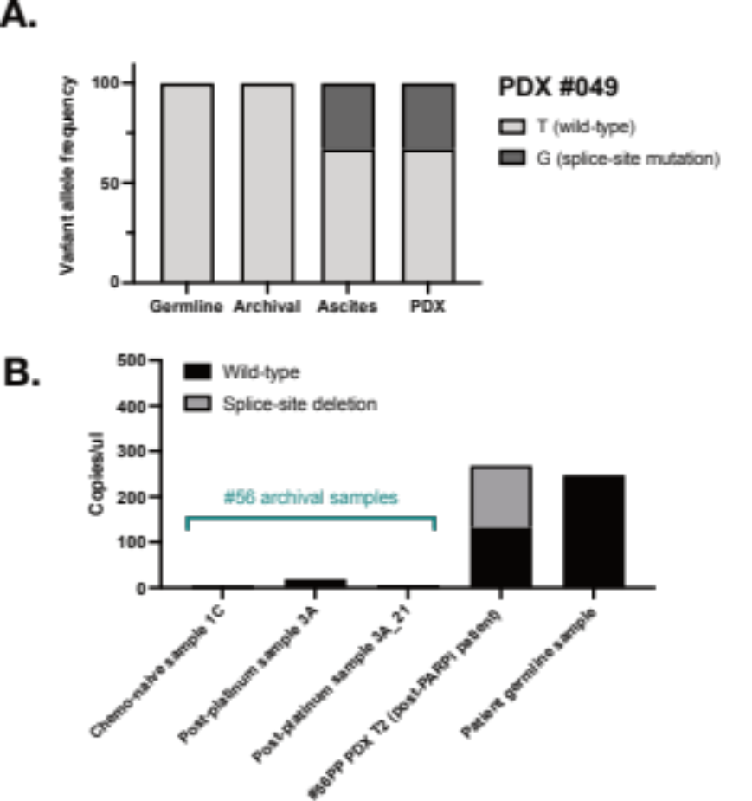
Figure S6. SSMs from PDX #049 and #56PP not detected in archival samples from corresponding patients.
We aimed to determine whether these mutations were detectable in archival HGSOC samples from corresponding patients that were collected prior to chemotherapy (indicating whether this mechanism was pre-existing or acquired). A. Targeted sequencing confirmed the presence of the c.4096+3A>C mutation in the patient ascites sample used to generate PDX #049 (post chemotherapy and PARPi sample), but this mutation was not detected in a pre-PARPi, but post-neoadjuvant chemotherapy, archival surgical #049 sample. This sample was 20% tumor purity (based on TP53 mutation sequencing) and was sequenced to a depth of 68,400x. B. The larger secondary splice site deletion in PDX #56PP was measurable by digital droplet PCR and detected with 50% frequency, consistent with a heterozygous state at a BRCA1 copy number of 2 (copy number from SNP array data). This deletion was not detected in the matched chemo-naïve PDX #56, the patient’s archival FFPE chemo-naïve tumor (sample 1C), nor in a tumor collected five years after 1st line platinum therapy (prior to PARPi) (sample 3A). Whilst the deletion was not detected in either of these pre-PARPi FFPE samples, the DNA samples generated from FFPE appeared to be poor quality, with limited droplet amplification of these samples compared to PDX and germline DNA. These data suggest that the secondary SSMs in PDX #56PP and #049 were acquired following treatment of patients with chemotherapy/PARPi, although the poor quality of archival FFPE samples (leading to poor droplet amplification) limits our assessment. While no deletion was detected in archival samples, in these samples limits interpretation. T2 = transplant/passage 2 PDX aliquot.

Figure S7
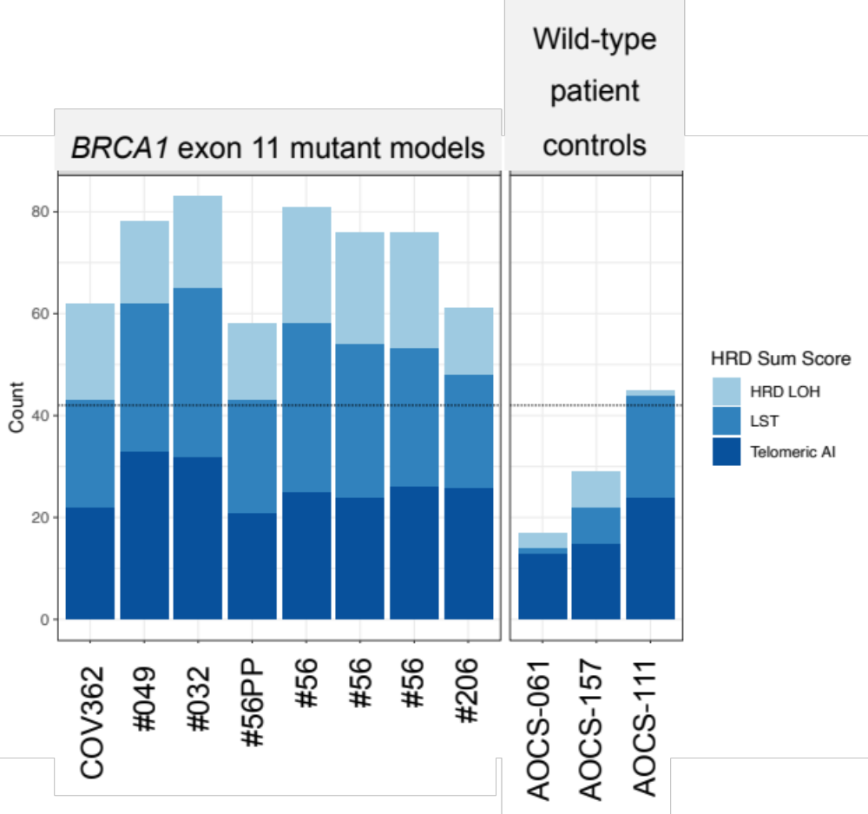
Supplementary Figure S7. SNP array HRD scores for PDX and cell line COV362.
All Δ11/Δ11q-high models (PDX and cell line COV362) that were tested SNP arrays in this study were found to have high combined HRD scores, indicating either current or historical HRD in the tumour. This may support an acquired mode of resistance in these initially therapy-responsive patients, although the effects of Δ11 and Δ11q isoforms alone on genomic signatures is not established. Dashed line indicates previously defined threshold (6-8). SNP arrays of AOCS were performed previously in the ICGC-Ovarian Cancer Project (9) and were re-analysed as controls for this study.

Figure S8
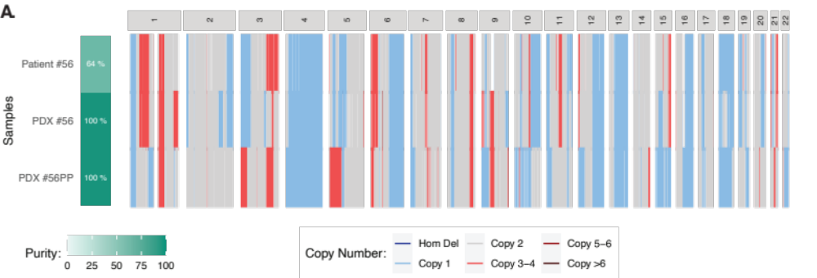

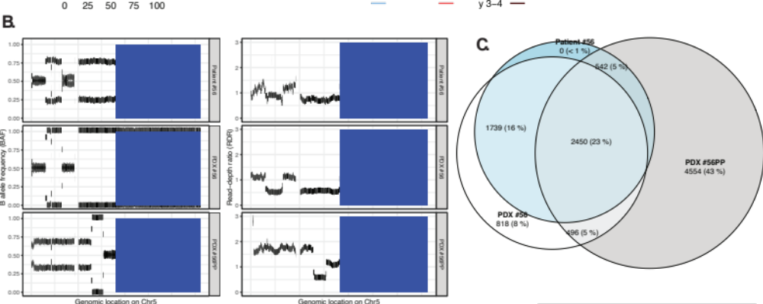

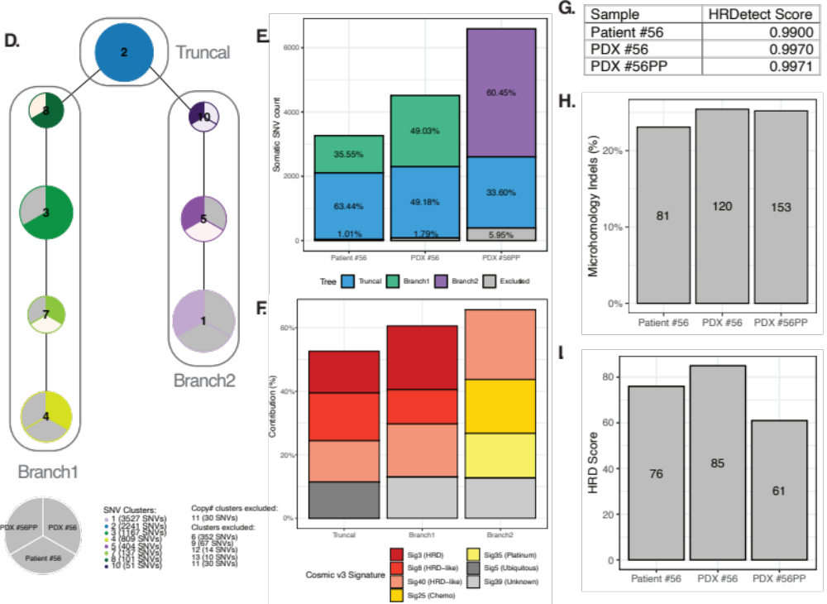

Supplementary Figure S8. Genomic clonality analysis of the longitudinal #56 samples.
Whole-genome sequencing of matched #56 and #56PP patient and PDX samples suggested an early clonal divergence of the #56PP clone, and expansion shortly after the HR reversion event in the patient. We interrogated the timing of the secondary mutation and restoration of HR in PDX#56PP using whole-genome sequencing of the chemo-naïve PDX #56, matched chemo-naïve patient tumor and PDX #56PP samples. We observed a high degree of heterogeneity and early (i.e. pre-treatment) clonal divergence between chemo-naïve and post-treatment PDX #56PP sample. These data an early clonal divergence of the #56PP clone, and expansion shortly after the HR reversion event in the patient. A. Somatic genome-wide levels of copy number alterations (CNA) determined using ascatNGS across the whole-genome sequencing (WGS) analysed samples. B. B allele frequency (BAF) and read-depth ratio (RDR) of chromosome 5 across the analysed samples using HATCHet. The region with loss of heterozygosity (LOH) on chr5q in treatment naïve samples (PDX #56 and Patient #56) is highlighted using purple shading, and suggests that the timing of this LOH was after clonal divergence but before treatment. C. Overlap of the somatic single nucleotide variants (SNV) across the analysed samples. Only 23% of somatic single nucleotide variants were shared by all three samples, with 16% of variants being distinct to pre-treatment samples. D. The clonal evolution tree of the SNV clusters (and three major branches – truncal, branch 1 and branch 2) identified using CONIPHER. Individual pies represent each SNV cluster with shading indicating the level of contribution from each corresponding sample – darker shade indicates higher level of contribution, while grey indicates no contribution. Upper left: PDX #56PP, upper right: PDX #56, bottom: Patient #56. E. The absolute count of clonal events across the major somatic SNV branches. The proportion of clonal events for each sample is shown in text. The expansion of the mutational clone observed in the PDX #56PP sample also likely happened shortly after HR reversion, based on a large contribution of chemo-associated signatures (SBS25 and SBS35) and an absence of SBS3 signature in PDX #56PP private mutations, which is in contrast to the pre-treatment private mutations. F. The proportion of Cosmic V3 Signature contribution for the major somatic SNV branches. G. The HRDetect scores across the three analysed samples. H. The proportion of somatic microhomology insertions and deletions (indels) relative to all somatic indels detected in each analysed sample. The absolute count of microhomology indels in shown in text. I. The HRD scores across the three analysed samples estimated using WGS. Given neither the HRD sum score nor the number or proportion of microhomology indels was increased in the post-treatment sample, this indicates no additional accumulation of HRD scarring.

Figure S9
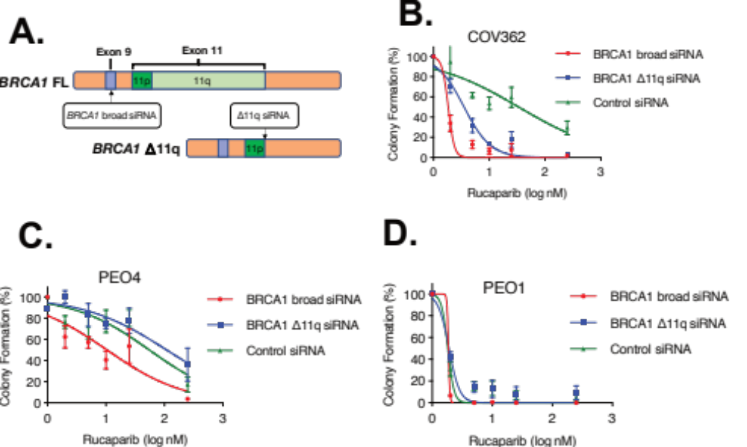
Figure S9. BRCA1 Δ11q isoform expression drives PARPi resistance in cell line and PDX
The PARPi-resistant COV362 cell line was also confirmed to harbor a BRCA1 SSM, and had extremely high Δ11q isoform expression. COV362 was derived from a pleural effusion of a patient with ovarian endometrioid carcinoma (10), although molecular profiling studies support COV362 falling within the HGSOC subtype (11,12). It is unclear whether this patient had received prior chemotherapy (10), and whether the SSM was present in the original carcinoma sample. A-D. Interestingly, COV362 was sensitised to PARPi rucaparib following siRNA knockdown of either Δ11q specifically, or broad knockdown BRCA1, with schematic of siRNA design shown in A. Mean ± SEM are shown for three independent colony formation experiments, data is normalized to rucaparib-untreated controls. Knockdown was confirmed by qRT-PCR (Supplementary Figure S8). Controls are PEO1 (HR deficient) and PEO4 (HR proficient).

Figure S10
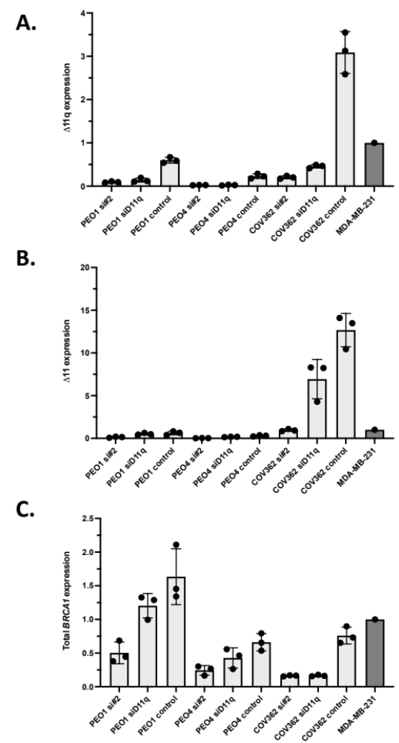
Supplementary Figure S10. BRCA1 isoform expression following siRNA treatment.
Following siRNA treatment targeting either most BRCA1 isoforms (si#2), Δ11q isoform specifically (siD11q) or a non-specific control, the expression of the A. Δ11q isoform, B. Δ11 isoform or C. total BRCA1 expression was assessed using two-step RT-qPCR. Data presented is fold-change relative to cell line MDA-MB-231. Each point represents an independent experiment, with mean ± standard deviation presented.

Figure S11
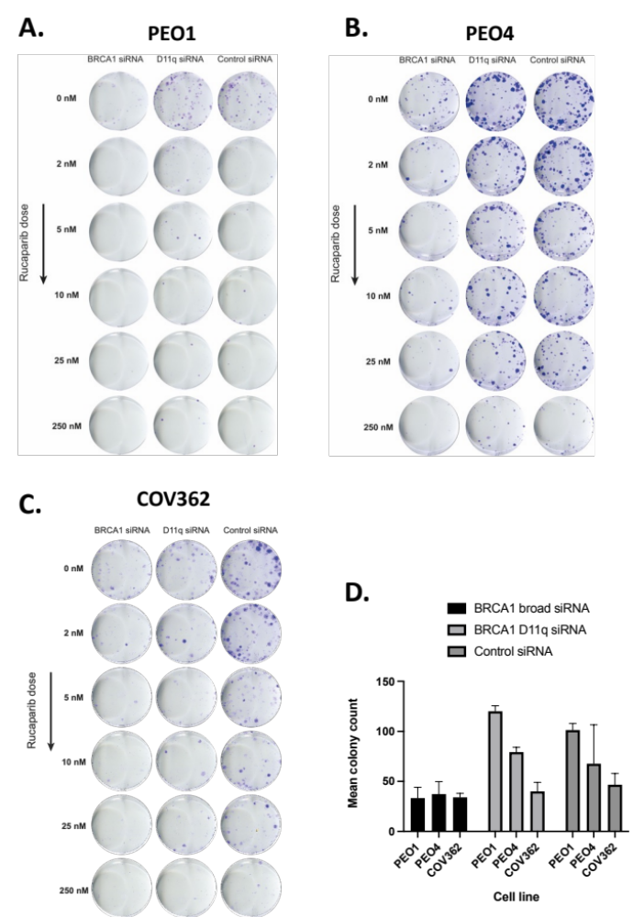

Supplementary Figure S11. Colony formation of COV362 following siRNA and PARPi treatments.
Representative images showing colony formation of A. HR deficient control cell line PEO1, B. HR competent control cell line PEO4 and C. Δ11q-high cell line COV362 following siRNA knockdown of most BRCA1 isoforms (BRCA1 siRNA), Δ11q specifically or control siRNA treatment and various doses of rucaparib. D. Mean colony count for rucaparib- untreated wells (± standard deviation) shows that broad BRCA1 siRNA treatment alone reduces colony-forming capacity in PEO1 and PEO4. COV362 colony counts were not significantly affected based on CFU.ai software analysis, however COV362 colonies produced following BRCA1 and BRCA1 Δ11q siRNA were smaller and more diffuse compared to the untreated control.

Figure S12
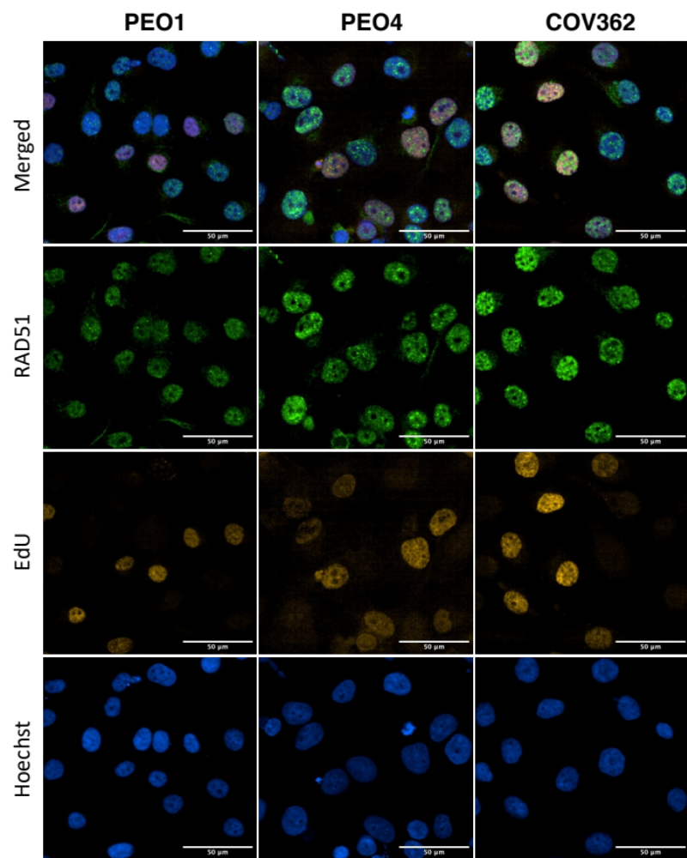

Supplementary Figure S12. RAD51 foci formation in cell line COV362.
Representative images showing RAD51 foci formation 1 hour post 10Gy γ-irradiation in cell lines COV362, HR deficient control PEO1 and HR competent control PEO4. Scale bar is 50μm.

Figure S13
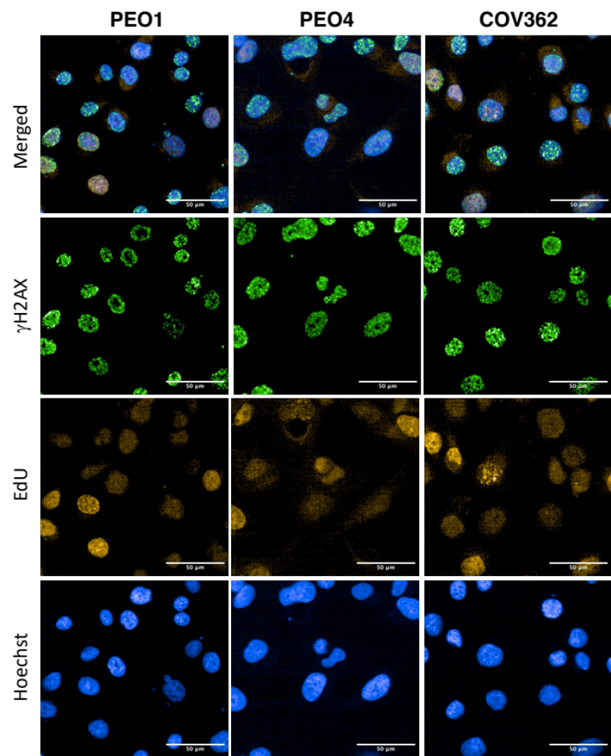

Supplementary Figure S13. γH2AX foci formation in cell line COV362.
Representative images showing γH2AX foci formation 1 hour post 10Gy γ-irradiation in cell lines COV362, HR deficient control PEO1 and HR competent control PEO4. Scale bar is 50μm.

Supp Figure S14
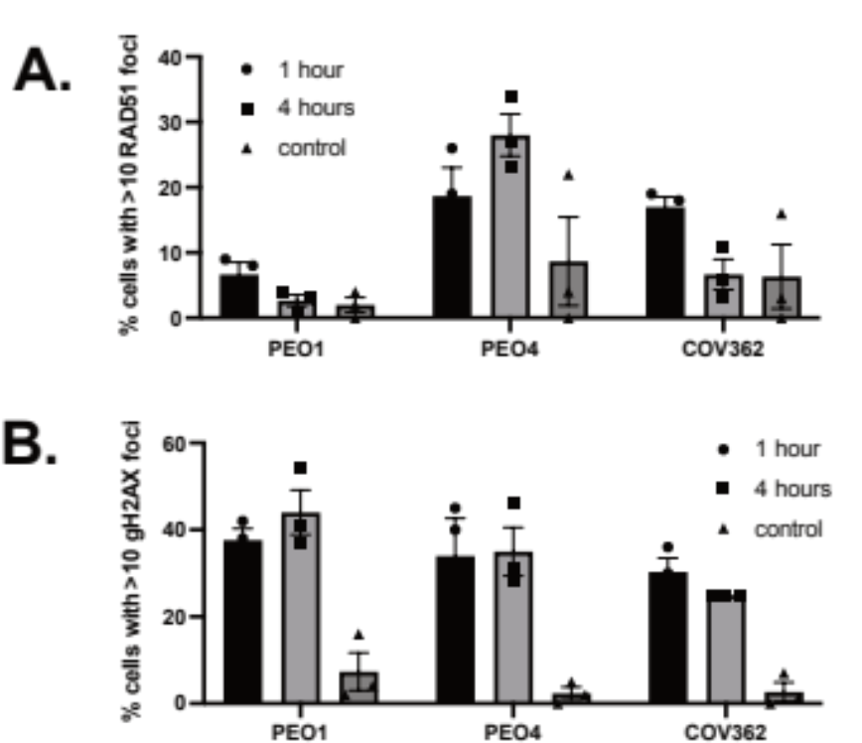

Supplementary Figure S14. Quantification of RAD51 and γH2AX foci formation in cell line COV362.
The BRCA1-Δ11q protein is hypomorphic and its expression does not restore HR to the same extent as expression of full-length BRCA1 (1). A. COV362 demonstrated some capacity to form RAD51 foci relative to control 1 hour after DNA damage (10 Gy irradiation; not significant; P value = 0.153). B. DNA damage following irradiation was confirmed by gH2AX foci (mean ± SEM percent of geminin positive cells with ≥10 RAD51 or gH2AX foci).
Figure S15
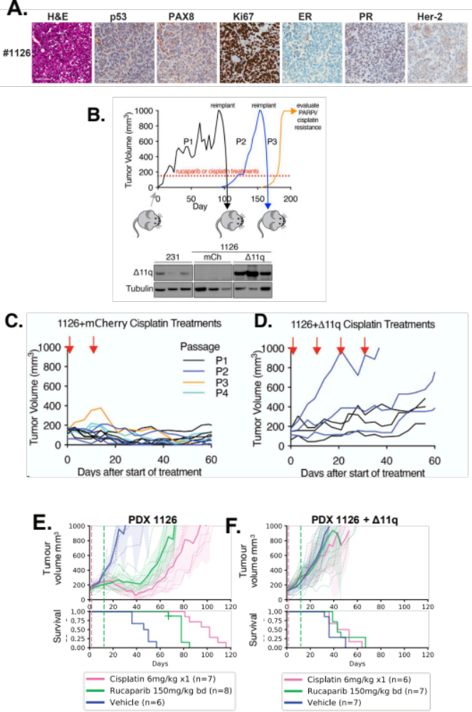

Supplementary Figure S15. Generation of cisplatin and rucaparib resistant FCCC PDX 1126 lineage.
We investigated whether therapeutic selection pressure could drive the formation of SSMs and PARPi resistance in PDX using in vivo cisplatin or PARPi re-treatments. We carried out serial cisplatin or PARPi re-treatments to HGSOC #56, TNBC #204 and TNBC #124, and developed derivatives that were PARPi (RR) and cisplatin resistant (CR). Elevated Δ11q protein was observed in some resistant tumors derived from PDX #56 and #204, but not resistant PDX #124 tumors. Of note, #56CR, unlike PDX #56PP, had elevated Δ11q without a secondary mutation. Therefore, additional mechanisms can drive Δ11q protein expression beyond SSMs, such as increased protein stability (13), or transcription (1). A. IHC confirmed that PDX #1126 has a TNBC histology. B. PDX #1126 (BRCA1 exon 13 mutation) tumors expressing either mCherry or BRCA1-Δ11q were treated with cisplatin or rucaparib. Treated tumors were transplanted into recipient mice for further treatment. BRCA1-Δ11q protein expression was assessed in PDX #1126 infected with BRCA1-Δ11q or mCherry encoded lentivirus following in vivo selection with cisplatin. MDA-MB-231 (231) lysate was included as a control. C-D. Cisplatin resistance was selected for in PDX #1126 tumors infected with lentivirus encoding BRCA1-Δ11q as described for the mCherry control in B. Unlike the mCherry control, resistant tumors emerged after the second passage for tumors expressing BRCA1-Δ11q. Cisplatin, rucaparib and vehicle responses were assessed in PDX E. #1126 or F. PDX #1126 tumors with ectopic BRCA1-Δ11q expression following in vivo selection for cisplatin resistance. Treatment end = vertical hashed lines. Mean tumor volume (mm³) ± 95% CI (hashed lines are individual mice) and corresponding Kaplan–Meier survival analysis. Censored events = crosses on Kaplan–Meier plot; n = individual mice.

Figure S16
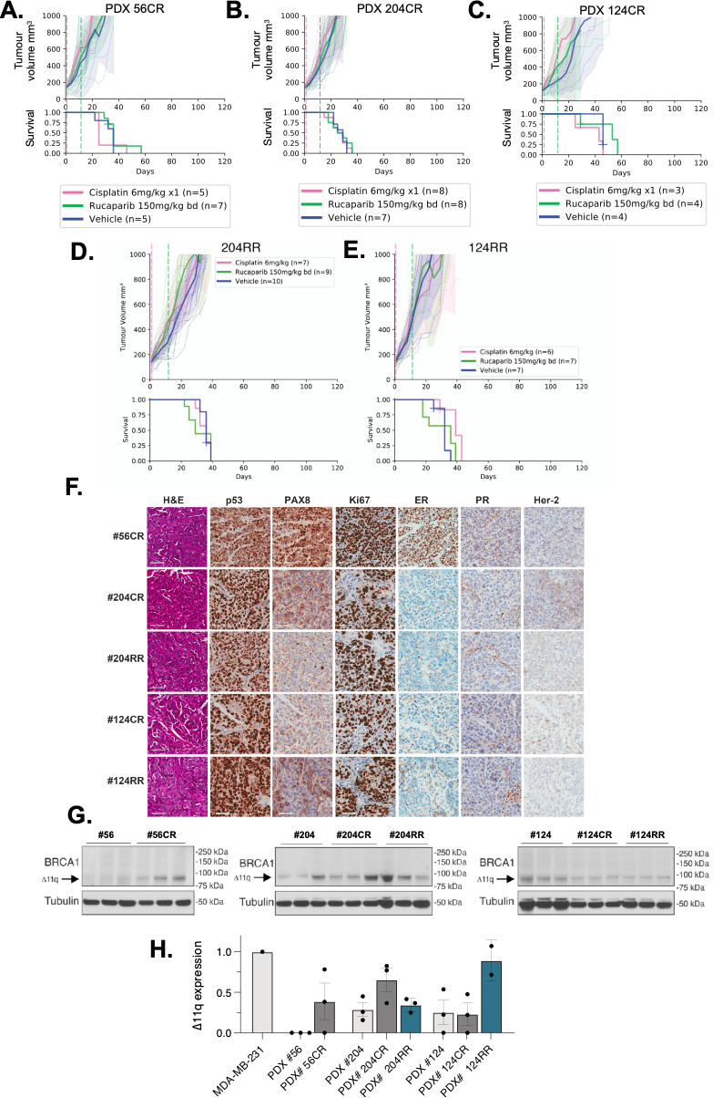
Supplementary Figure S16. Generation of cisplatin and rucaparib resistant FCCC PDX lineages.
A. PDX #56 was subjected to in vivo selection for cisplatin resistance as described in Supp Figure S10 for PDX #1126. Cisplatin and rucaparib responses following 3 passages of cisplatin re-treatment of PDX #56 (PDX #56CR). B. Cisplatin and rucaparib resistant PDX #204 (PDX #204CR) were obtained following 3 passages of cisplatin re-treatments of PDX #204. C. Cisplatin resistant PDX #124 (PDX #124CR) was obtained following 4 passages of cisplatin re-treatment. D. Rucaparib resistant PDX #204 (PDX #204RR) were obtained after four passages of rucaparib treatments using the scheme described in Supp Figure S14. The resultant resistant derivative was assessed for response to rucaparib and cisplatin using a single dose of 6 mg/kg cisplatin or 150 mg/kg bid rucaparib for 10 days. Unlike parental PDX #204 tumors, PDX #204RR and PDX #204CR, tumors rapidly grew through both cisplatin and rucaparib treatments. E. Rucaparib resistant PDX #124 (PDX #124RR) were obtained after six passages of rucaparib treatments. Similar to PDX #124CR, PDX #124RR lacked response to cisplatin or rucaparib while the parental PDX #124 was responsive to both therapies. F. PDX lineages #56CR, #204CR, #204RR, #124CR and #124RR all matched their corresponding parental PDX histology. G. Three independent tumors per PDX lineage were probed for BRCA1 expression by immunoblotting. Bands at the anticipated sizes for full length (FL) BRCA1 and the Δ11/Δ11q isoforms are marked. Tubulin immunoblotting is included as a loading control. H. BRCA1 Δ11q qPCR of the resulting CR and RR PDX lineages reveals increased Δ11q mRNA expression in #56CR, #204CR and #124RR, however these difference were not found to be statistically significant when compared to the parental lineage (Mean ± SEM shown; Welch two-tailed t test). Results for #56CR are concordant with western blot results, but not so for other PDX lineages. This may be due to differences in cellular mRNA processing between lineages, or due to tumour heterogeneity.

Figure S17
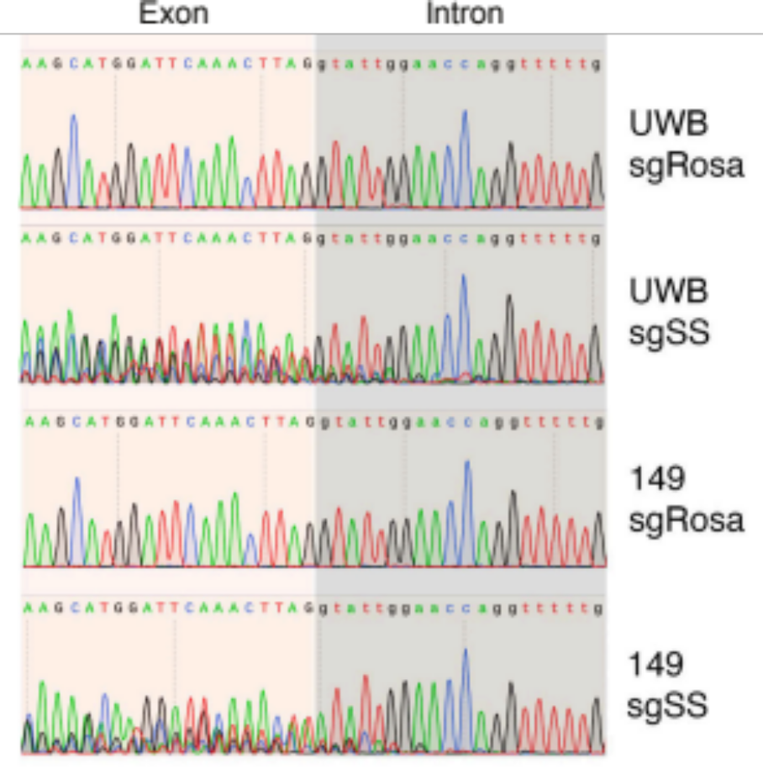
Figure S17. Sanger sequencing confirmation of CRISPR SSM disruption.
Sanger sequencing traces of the BRCA1 exon 11 donor splice site show CRISPR-based disruption of this region in UWB1.289 (UWB) or SUM149 (149) cells exposed to single guide RNAs (sgRNA) targeting the BRCA1 exon 11 donor splice site (sgSS), or Rosa locus (sgRosa) as a control.

Figure S18
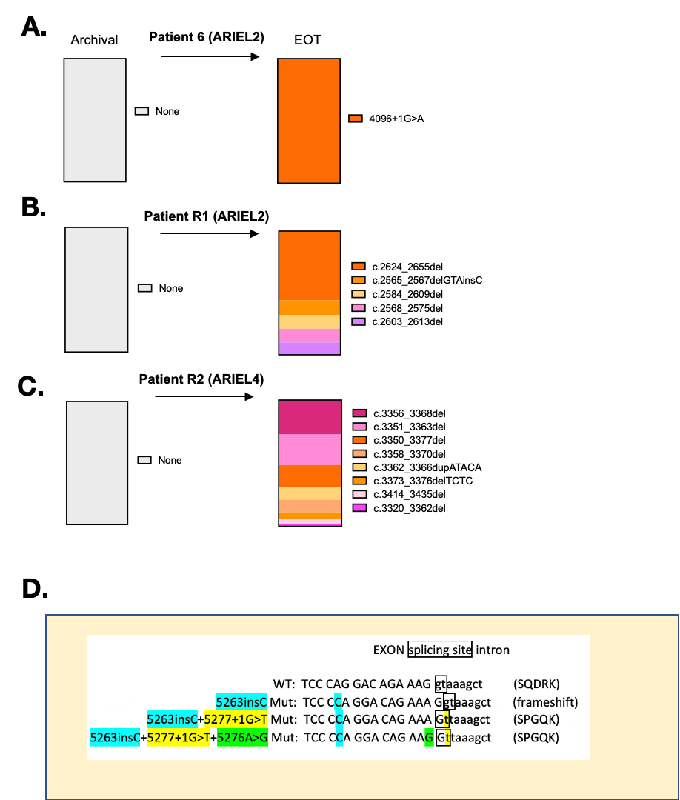
E.
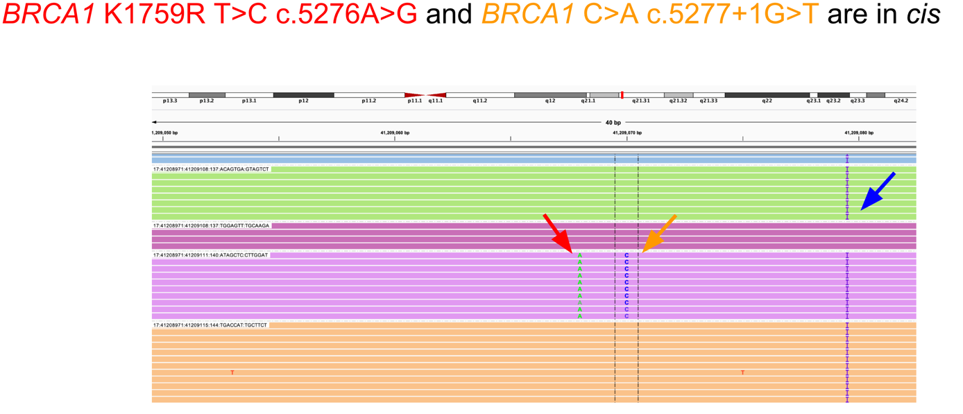
Supplementary Figure S18. Interpreting BRCA1 secondary mutations found in ARIEL2 and ARIEL4 clinical trial patient samples.
A. Patient 6 was platinum sensitive (2 prior lines of platinum) and had a partial response to rucaparib on the ARIEL2 clinical trial. The BRCA1 exon 11 splice site mutation 4096+1G>A was detected in post-treatment tissue sample by FMI, but not in an archival sample. Deleterious germline mutation was c.2042_2043insT, in exon 11. B. and C. show examples of patients that had multiple non-splicing secondary mutations arise in their plasma samples following rucaparib treatment, showing that this number of reversion events is not unique to patients with secondary BRCA1 splice-site mutations (e.g. patients 3 and 4). D. Four cases were found to have the same primary germline BRCA1 exon 20 pathogenic variant: c.5266dupC (Q1756fs; Supp Table 8). Interestingly, three of the four individuals had the same SSM, BRCA1 c.5277+1G>T (in yellow), accompanied by a nearby c.5276A>G variant (in green), reported previously in another study (14). The additional c.5276A>G variant may be required to re-establish the boundary sequence adjacent to the splice site to enable proper splicing. c.5276A>G was confirmed not to be an artefact, thus it is possible that c.5277+1G>T generates a new GT splice site that is shifted 1 bp from the original position into the exon, effectively creating an additional frameshift (exon loses 1 bp, intron gains 1 bp) and restoring the reading frame. The 5276A>G mutation may be required to re-establish the boundary sequence adjacent to the splice site to enable proper splicing. Note - the secondary mutation found in patient 7 (the fourth patient) was reported as an SSM by Guardant Health, however in silico splicing predictions did not suggest altered splicing (Supp Table S9). E. Example IGV alignment data from one of the cases with a BRCA1 primary c.5266dupC mutation and co-occurring c.5276A>G and c.5277+1G>T secondary mutations, showing that these were mutations occurred in cis with one another. This linkage was observed for all patients with these mutations. Primary pathogenic mutation highlighted with blue arrow.
Figure S19
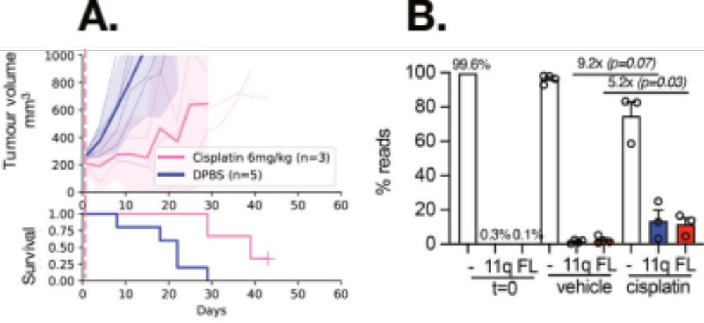
Supplementary Figure S19. Reversion and splice site mutation in vivo competition experiments.
Since SSM’s and reversion mutations were found in the same samples for some patients, we wanted to examine if either the Δ11q or full length BRCA1 proteins provided a selective advantage, so we performed an in vivo competition experiment. We tested the concept that cells containing either a frame-reverting mutation or a splice site secondary mutation might both be subject to positive selection during therapy. SUM149 is a TNBC cell line with a BRCA1 exon 11 frameshift variant (c.2288delT) that shows high levels of Δ11q expression. We previously made derivatives where Δ11q was knocked-out (null) or a frame-correcting reversion mutation was introduced (1). In the current study, we mixed equal amounts (0.1% each) of Δ11q-high parent cells and “FL” (full length BRCA1) cells harboring a secondary mutation, with BRCA1-null (-) SUM149 cells (99.8%). These cell mixtures were then injected into mice and treated with vehicle or 6 mg/kg cisplatin. A. SUM149 cells expressing BRCA1-Δ11q (11q) or full length BRCA1 (FL) were mixed equally (0.1%) with a BRCA1-null (-) SUM149 derivative cell line (99.8%) (1). These cell mixtures were injected into mice and treated with vehicle (DPBS) or 6mg/kg cisplatin. Mean tumor volume (mm³) ± 95% CI (hashed lines are individual mice) and corresponding Kaplan–Meier survival analysis. Censored events = crosses on Kaplan–Meier plot; n = individual mice. B. Targeted sequencing was used to measure the representation of each SUM149 derivative in tumors from (J) and from the cell mixture prior to implantation (t= 0). 11q representation increased 9.2-fold (P = 0.07) while FL representation increased 5.2-fold (P= 0.03) in cisplatin treated tumors compared to vehicle treated tumors. Sequencing thus revealed that cells with secondary mutations (FL) or only Δ11q expression (11q) were selected for equally with platinum pressure, providing a potential rationale for why both reversion and SSM were detected in the same therapy-resistant patient samples. Each datapoint indicates read percentage for independent tumors and P value shown from unpaired t-tests for the indicated comparisons.

Figure S20
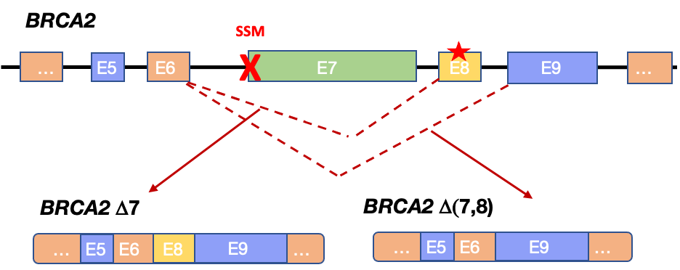

Supplementary Figure S20. Schematics of additional secondary splice site mutations found in BRCA2 in an ARIEL2 clinical trial patient.
The end of treatment sample for patient 12 contained two secondary mutations, both predicted in silico to disrupt the exon 7 acceptor splice site (indicated by a red X). One of these, c.517G>T, has been shown to cause skipping of both exon 7 and 8 within an in vitro BRCA2 minigene system (15). This would cause skipping of the pathogenic primary mutation in exon 8 (indicated by the red star) found in this case, and potential restoration of the reading frame and DNA repair capacity of BRCA2. The c.517G>T SSM was not observed in the pre-treatment (PARPi) ctDNA sample, suggesting that it was selected for during PARPi treatment.
References
1. Wang Y, Bernhardy AJ, Cruz C, Krais JJ, Nacson J, Nicolas E, et al. The BRCA1-Delta11q Alternative Splice Isoform Bypasses Germline Mutations and Promotes Therapeutic Resistance to PARP Inhibition and Cisplatin. Cancer Res 2016;76(9):2778-90 doi 10.1158/0008-5472.CAN-16-0186.
2. Hurley RM, Wahner Hendrickson AE, Visscher DW, Ansell P, Harrell MI, Wagner JM, et al. 53BP1 as a potential predictor of response in PARP inhibitor-treated homologous recombination-deficient ovarian cancer. Gynecol Oncol 2019;153(1):127-34 doi 10.1016/j.ygyno.2019.01.015.
3. Pettitt SJ, Krastev DB, Brandsma I, Drean A, Song F, Aleksandrov R, et al. Genome-wide and high-density CRISPR-Cas9 screens identify point mutations in PARP1 causing PARP inhibitor resistance. Nat Commun 2018;9(1):1849 doi 10.1038/s41467-018-03917-2.
4. Haley J, Tomar S, Pulliam N, Xiong S, Perkins SM, Karpf AR, et al. Functional characterization of a panel of high-grade serous ovarian cancer cell lines as representative experimental models of the disease. Oncotarget 2016;7(22):32810-20 doi 10.18632/oncotarget.9053.
5. Fedier A, Maggi N, Tozzi A, Disler M, Coelho R, Jacob F, et al. Exposure to escalating olaparib does not induce acquired resistance to PARPi and to other chemotherapeutic compounds in ovarian cancer cell lines. Int J Oncol 2022;61(1) doi 10.3892/ijo.2022.5379.
6. Mills GB, Timms KM, Reid JE, Gutin AS, Krivak TC, Hennessy B, et al. Homologous recombination deficiency score shows superior association with outcome compared with its individual score components in platinum-treated serous ovarian cancer. Gynecologic Oncology 2016;141:2-3 doi 10.1016/j.ygyno.2016.04.034.
7. Telli ML, Timms KM, Reid J, Hennessy B, Mills GB, Jensen KC, et al. Homologous Recombination Deficiency (HRD) Score Predicts Response to Platinum-Containing Neoadjuvant Chemotherapy in Patients with Triple-Negative Breast Cancer. Clin Cancer Res 2016;22(15):3764-73 doi 10.1158/1078-0432.CCR-15-2477.
8. Sztupinszki Z, Diossy M, Krzystanek M, Reiniger L, Csabai I, Favero F, et al. Migrating the SNP array-based homologous recombination deficiency measures to next generation sequencing data of breast cancer. npj Breast Cancer 2018;4(1):16 doi 10.1038/s41523-018-0066-6.
9. Patch AM, Christie EL, Etemadmoghadam D, Garsed DW, George J, Fereday S, et al. Whole-genome characterization of chemoresistant ovarian cancer. Nature 2015;521(7553):489-94 doi 10.1038/nature14410.
10. van den Berg-Bakker CA, Hagemeijer A, Franken-Postma EM, Smit VT, Kuppen PJ, van Ravenswaay Claasen HH, et al. Establishment and characterization of 7 ovarian carcinoma cell lines and one granulosa tumor cell line: growth features and cytogenetics. Int J Cancer 1993;53(4):613-20 doi 10.1002/ijc.2910530415.
11. Domcke S, Sinha R, Levine DA, Sander C, Schultz N. Evaluating cell lines as tumour models by comparison of genomic profiles. Nat Commun 2013;4:2126 doi 10.1038/ncomms3126.
12. Barnes BM, Nelson L, Tighe A, Morgan RD, McGrail J, Taylor SS. Classification of ovarian cancer cell lines using transcriptional profiles defines the five major pathological subtypes. bioRxiv 2020:2020.07.14.202457 doi 10.1101/2020.07.14.202457.
13. Pettitt SJ, Shao N, Zatreanu D, Frankum J, Bajrami I, Brough R, et al. A HUWE1 defect causes PARP inhibitor resistance by modulating the BRCA1-∆11q splice variant. Oncogene 2023;42(36):2701-9 doi 10.1038/s41388-023-02782-8.
14. Patel JN, Braicu I, Timms KM, Solimeno C, Tshiaba P, Reid J, et al. Characterisation of homologous recombination deficiency in paired primary and recurrent high-grade serous ovarian cancer. Br J Cancer 2018;119(9):1060-6 doi 10.1038/s41416-018-0268-6.
15. Fraile-Bethencourt E, Valenzuela-Palomo A, Díez-Gómez B, Goina E, Acedo A, Buratti E, et al. Mis-splicing in breast cancer: identification of pathogenic BRCA2 variants by systematic minigene assays. J Pathol 2019;248(4):409-20 doi 10.1002/path.5268.

