Supplementary Figures3
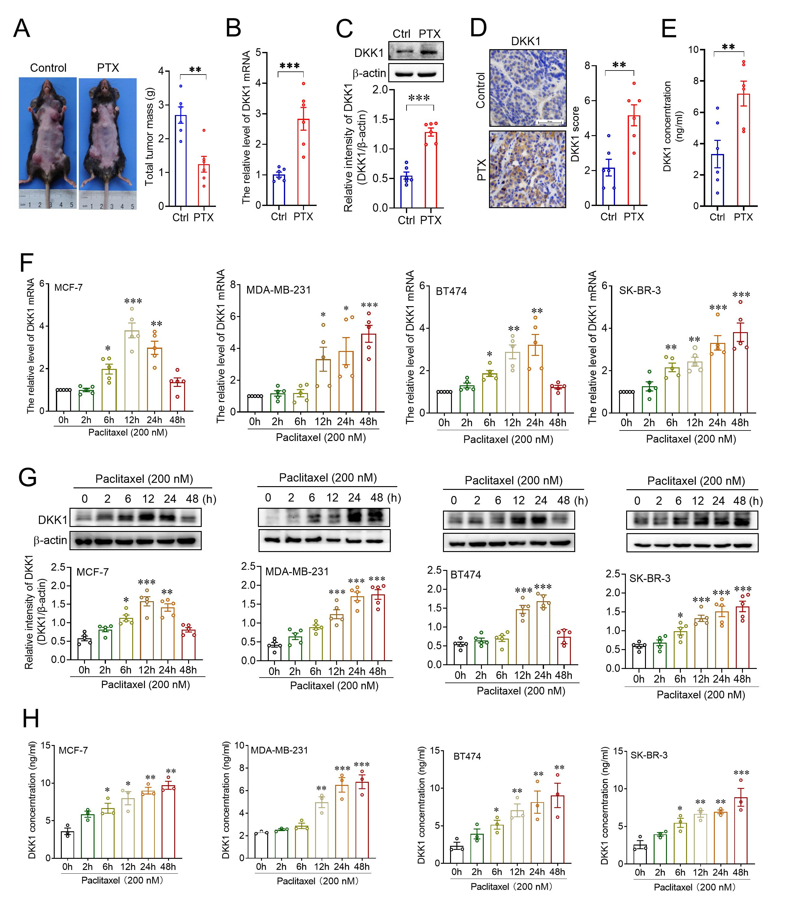Figure S1. Paclitaxel promoted DKK1 expression and secretion in breast cancer cells. (A) Effects of paclitaxel on tumor growth in MMTV-PyMT mice. **p<0.01, a two-tailed unpaired t test, n = 6. (B-D) Effects of paclitaxel on DKK1 mRNA and protein expression in spontaneous breast tumors. B, Real-time analysis of DKK1 mRNA expression; C, Western blot of DKK1 protein expression; D, IHC staining analysis of DKK1 protein expression. Scale bar, 50 µm. **p<0.01, ***p<0.001, a two-tailed unpaired t test, n = 6. (E) Effects of paclitaxel on the serum DKK1 content in MMTV-PyMT mice. **p<0.01, a two-tailed unpaired t test, n = 6. (F, G) Effects of paclitaxel on DKK1 mRNA (F) and protein (G) expression in MCF-7, MDA-MB-231, BT474, and SK-BR-3 cells. *p<0.05, **p<0.01, ***p<0.001, one-way ANOVA, n=5. (H) Effects of paclitaxel on the amount of DKK1 in the cell culture medium from MCF-7, MDA-MB-231, BT474, and SK-BR-3 cells. *p<0.05, **p<0.01, ***p<0.001, one-way ANOVA, n=3.
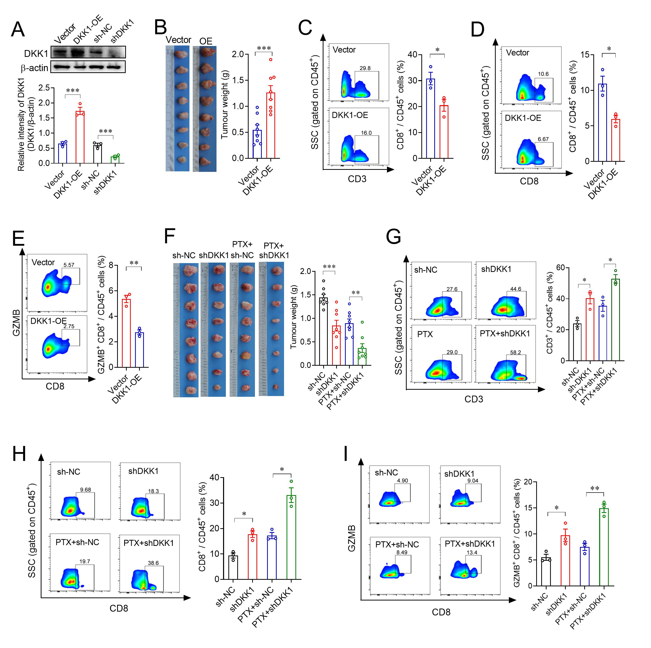
Figure S2. DKK1 attenuated the antitumor activity of paclitaxel by affecting CD8⁺ T cells in breast cancer. (A) Western blot of the construction efficiency of DKK1-overexpressing and DKK1-knockdown 4T1 cells. ***p<0.001, one-way ANOVA, n=3. (B) Analysis of DKK1 overexpression on tumor growth in a mouse xenograft model. ***p<0.001, a two-tailed unpaired t test, n = 8. (C-E) Flow cytometry of tumoral CD3⁺ (C), CD8⁺ (D), and GZMB⁺CD8⁺ (E) CD45⁺ cells from DKK1-overexpressing or CTRL xenografts and quantification. *p<0.05, **p<0.01, a two-tailed unpaired t test, n = 3. (F) Effects of DKK1 knockdown on the antitumor activity of paclitaxel in a mouse xenograft model. sh-NC: Vector, shDKK1: DKK1 knockdown, sh-NC+PTX: Vector plus paclitaxel, shDKK1+PTX: shDKK1 plus paclitaxel. ***p<0.001, one-way ANOVA, n = 8. (G-I) Flow cytometry of tumoral CD3⁺ (G), CD8⁺ (H), and GZMB⁺CD8⁺ (I) CD45⁺ cells from the sh-NC, shDKK1, sh-NC+PTX, and shDKK1+PTX groups and quantification. *p<0.05, **p<0.01, one-way ANOVA, n = 3.
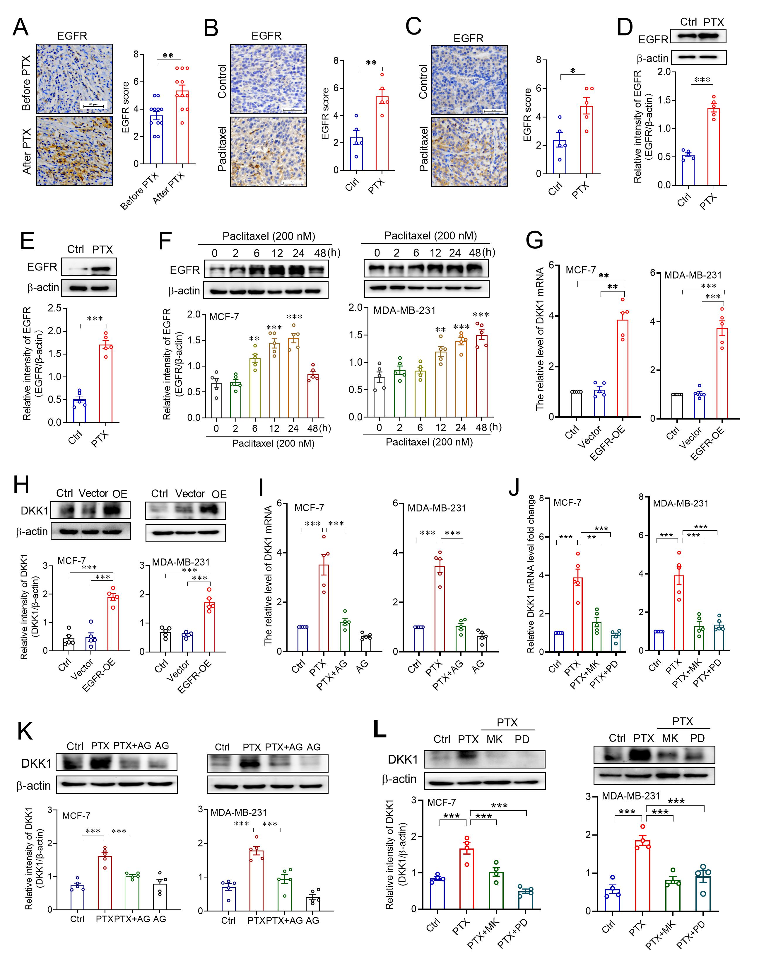Figure S3. Paclitaxel promoted DKK1 expression by activating the EGFR signaling pathway in breast cancer. (A) IHC staining of EGFR in breast cancer tissues before and after neoadjuvant chemotherapy including paclitaxel. ***p<0.001, a two-tailed unpaired t test, n = 11. Scale bar, 50 µm. (B, C) IHC staining of tumoral EGFR expression from xenograft mice (B) and MMTV-PyMT mice (C) treated with vehicle (Ctrl) or paclitaxel (PTX). *p<0.05, **p<0.01, a two-tailed unpaired t test, n = 5. (D, E) Western blot of tumoral EGFR expression from xenograft mice (D) and MMTV-PyMT mice (E) treated with vehicle or paclitaxel. ***p<0.001, a two-tailed unpaired t test, n = 5. (F) Western blot of EGFR expression in MCF-7 and MDA-MB-231 cells treated with paclitaxel. **p<0.01, ***p<0.001, one-way ANOVA, n = 5. (G, H) Effects of EGFR overexpression on the mRNA (G) and protein (H) expression of DKK1 in MCF-7 and MDA-MB-231 cells. **p<0.01, ***p<0.001, one-way ANOVA, n = 5. (I, J) Effects of pretreatment with EGFR inhibitor AG1478 (20µM; AG), Akt inhibitor MK2206 (20 µM; “MK”), and MEK inhibitor PD98059 (20 µM; “PD”) on paclitaxel (PTX)-induced DKK1 mRNA expression in MCF-7 and MDA-MB-231 cells. **p<0.01, ***p<0.001, one-way ANOVA, n = 5. (K, L) Effects of pretreatment with AG1478 (20µM; AG), MK2206 (20 µM; “MK”), and PD98059 (20 µM; “PD”) on paclitaxel-induced DKK1 protein expression in MCF-7 and MDA-MB-231 cells. ***p<0.001, one-way ANOVA, n = 4 or 5.

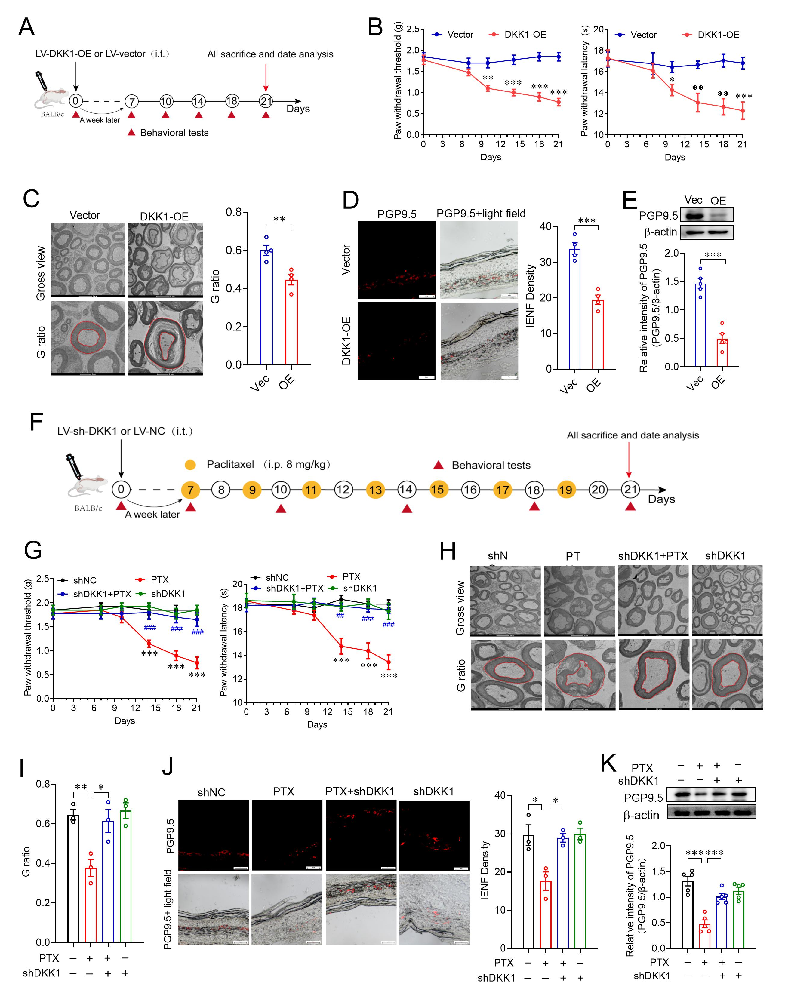
Figure S4. DKK1 was involved in paclitaxel-induced peripheral neuropathy. (A) Schematic diagram of DKK1 overexpression in DRGs by intrathecally injecting lentivirus-packed DKK1 and behavioral tests in normal mice. (B) Effects of DKK1 overexpression on mechanical allodynia (left) and thermal hyperalgesia (right) in normal mice. **p<0.01, ***p<0.001, two-way ANOVA, n = 8. (C) Transmission electron micrographs of the sciatic nerves and quantification of the G-ratio in mouse sciatic nerves from mice transfected with vector or DKK1. **p<0.01, a two-tailed unpaired t test, n = 4. (D) Immunofluorescence staining of PGP9.5 in the mouse hind paw intraplantar skin and quantification analysis of intraepidermal nerve fibers (IENF). ***p<0.001, a two-tailed unpaired t test, n = 4. (E) Western blot of PGP9.5 in the mouse hind paw intraplantar skin from vector or DKK1 group. ***p<0.001, a two-tailed unpaired t test, n = 5. (F) Schematic diagram of DKK1 knockdown in DRGs by intrathecally injecting lentivirus-packed DKK1 shRNA, paclitaxel (PTX) administration, and behavioral tests in normal mice. (G) Effects of DKK1 knockdown on paclitaxel-induced mechanical allodynia (left) and thermal hyperalgesia (right) in normal mice. **p<0.01, ***p<0.001 compared with shNC group; ##p<0.01, ###p<0.001 compared with PTX group; two-way ANOVA, n = 8. (H, I) Transmission electron micrographs of the sciatic nerves (H) and quantification of the G-ratio (I) in mouse sciatic nerves from shNC, shDKK1, shNC+PTX, and shDKK1+PTX group. *p<0.05, **p<0.01, one-way ANOVA, n = 3. (J) Immunofluorescence staining of PGP9.5 in the mouse hind paw intraplantar skin and quantification analysis of intraepidermal nerve fibers (IENF). *p<0.05, a two-tailed unpaired t test, n = 3. (K) Western blot of PGP9.5 in the mouse hind paw intraplantar skin from shNC, shDKK1, shNC+PTX, and shDKK1+PTX group. ***p<0.001, one-way ANOVA, n = 5.

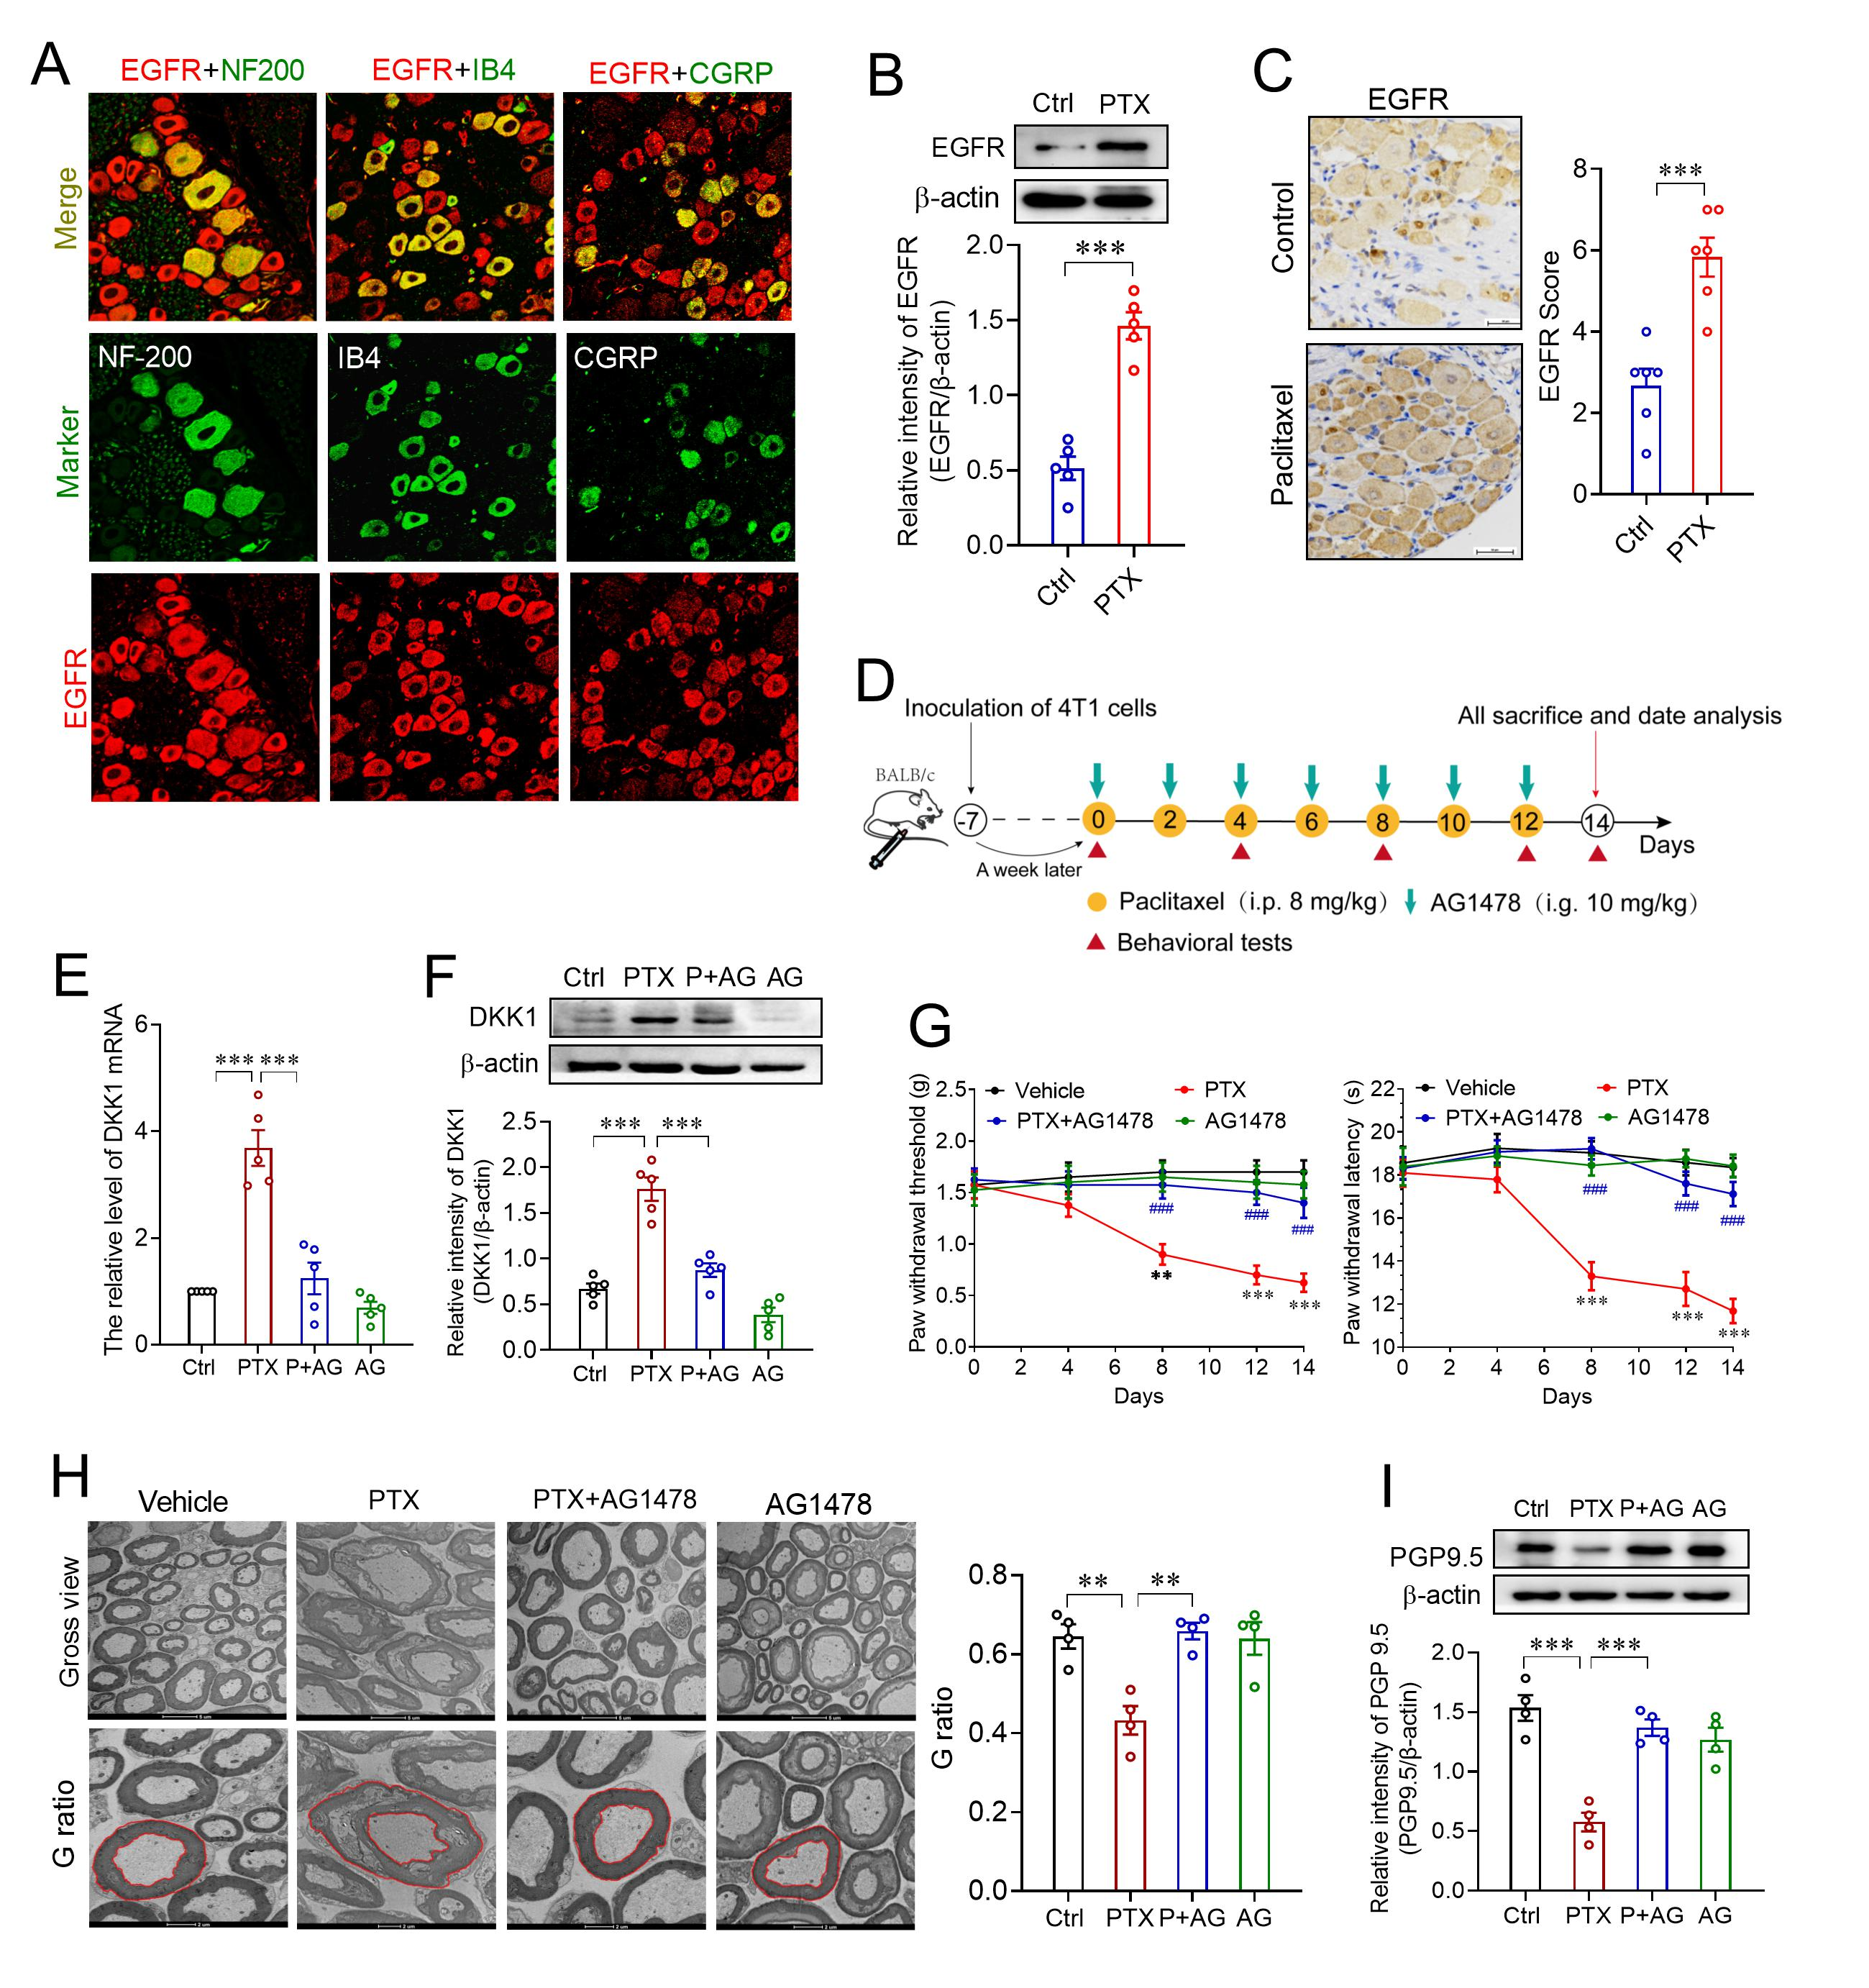
Figure S5. EGFR signaling contributed to paclitaxel-induced DKK1 expression in DRGs and peripheral neuropathy. (A) Analysis of EGFR expression in L4-L5 DRGs in paclitaxel-treated xenograft mice, n=3. (B) Western blot of EGFR expression in L4-L5 DRGs from vehicle or paclitaxel-treated xenograft mice. ***p<0.001, a two-tailed unpaired t test, n = 5. (C) IHC staining of EGFR expression in L4-L5 DRGs from xenograft mice treated with vehicle (Ctrl) or paclitaxel (PTX). **p<0.01, a two-tailed unpaired t test, n = 6. (D) Schematic diagram of drug injection and behavioral tests in tumor-bearing mice. (E, F) Effects of EGFR inhibitor AG1478 on paclitaxel-induced the upregulation of DKK1 mRNA (E) and protein (F) expression. ***p<0.001, one-way ANOVA, n = 5. (G) Effects of EGFR inhibitor AG1478 on paclitaxel-induced mechanical allodynia (left) and thermal hyperalgesia (right) in xenograft mice. **p<0.01, ***p<0.001 (PTX group) compared with vehicle group; ###p<0.001 compared with PTX group; two-way ANOVA, n = 8. (H) Transmission electron micrographs of the sciatic nerves and quantification of the G-ratio in mouse sciatic nerves from xenograft mice treated with vehicle, PTX, PTX plus AG1478, or AG1478. *p<0.05, one-way ANOVA, n = 4. (I) Western blot of PGP9.5 in the hind paw intraplantar skin from xenograft mice treated with vehicle, PTX, PTX plus AG1478, or AG1478. **p<0.01, ***p<0.001, one-way ANOVA, n = 4.

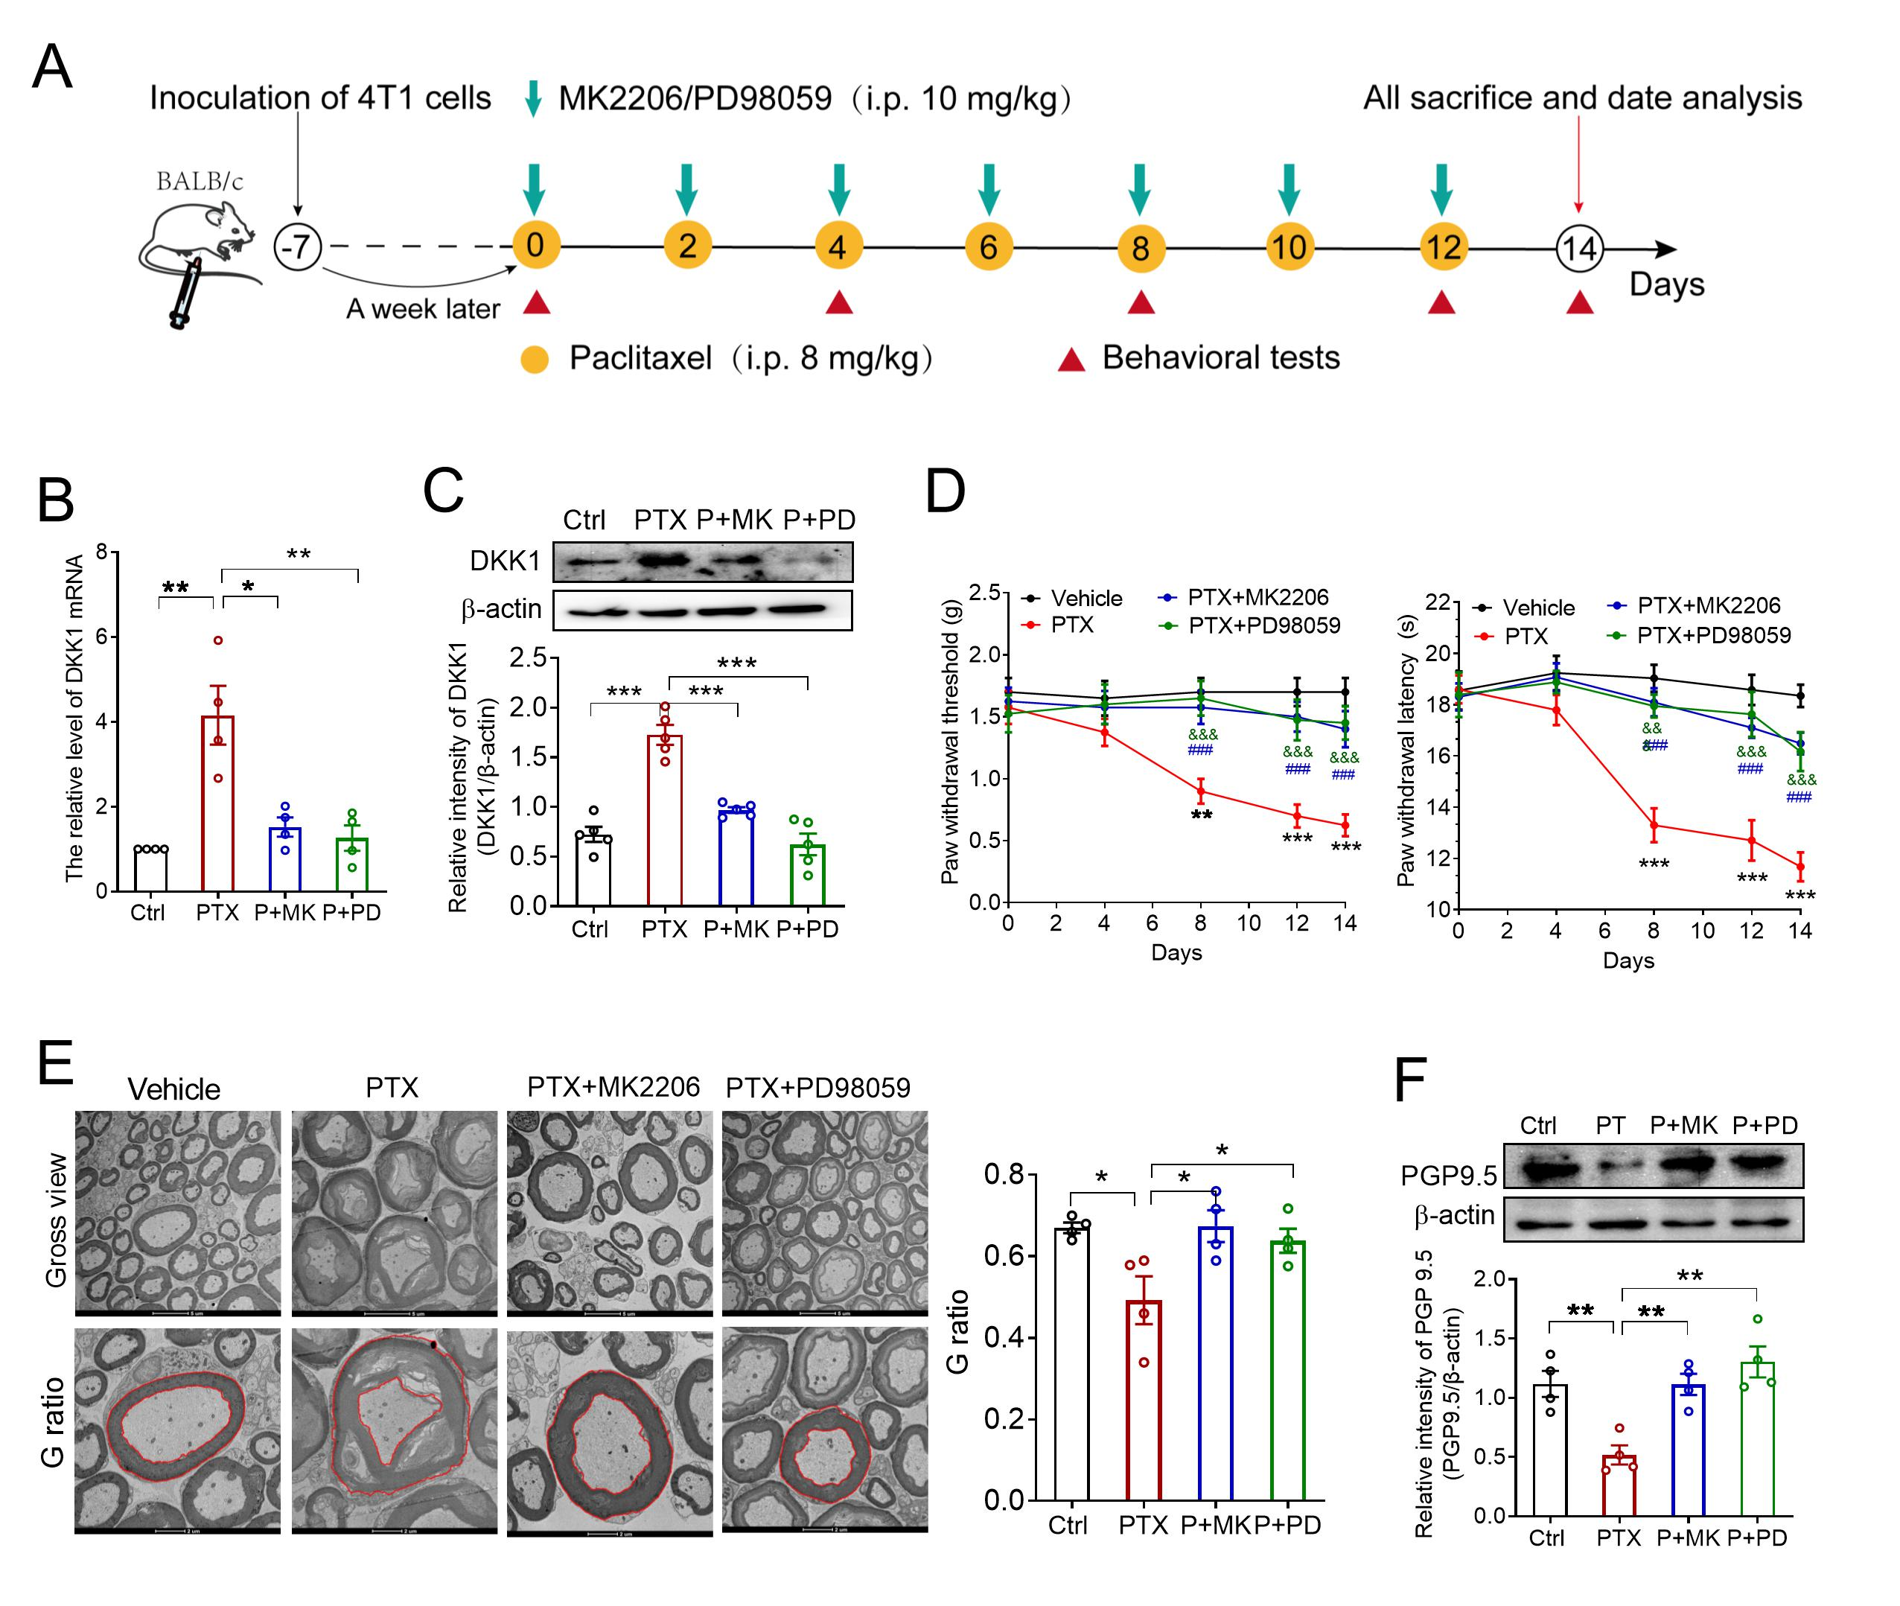
Figure S6. Inhibition of PI3K/Akt and MEK/ERK signaling attenuated paclitaxel-induced DKK1 expression in DRGs and peripheral neuropathy. (A) Schematic diagram of drug injection and behavioral tests in tumor-bearing mice. (B, C) Effects of Akt inhibitor MK2206 and MEK inhibitor PD98059 on paclitaxel-induced the upregulation of DKK1 mRNA (B) and protein (C) expression, **p<0.01, ***p<0.001, one-way ANOVA, n = 5. (D) Effects of Akt inhibitor MK2206 and MEK inhibitor PD98059 on paclitaxel-induced mechanical allodynia (left) and thermal hyperalgesia (right) in xenograft mice. **p<0.01, ***p<0.001 (PTX group) compared with vehicle group; ###p<0.001 (PTX+MK2206 group) compared with PTX group; &&&p<0.001 (PTX+PD98059 group) compared with PTX group, two-way ANOVA, n = 8. (E) Transmission electron micrographs of the sciatic nerves and quantification of the G-ratio in mouse sciatic nerves from xenograft mice treated with vehicle, PTX, PTX plus MK2206, PTX plus PD98059. *p<0.05, one-way ANOVA, n = 5. (F) Western blot of PGP9.5 in the hind paw intraplantar skin from xenograft mice treated with vehicle, PTX, PTX plus MK2206, PTX plus PD98059. **p<0.01, one-way ANOVA, n = 5.

