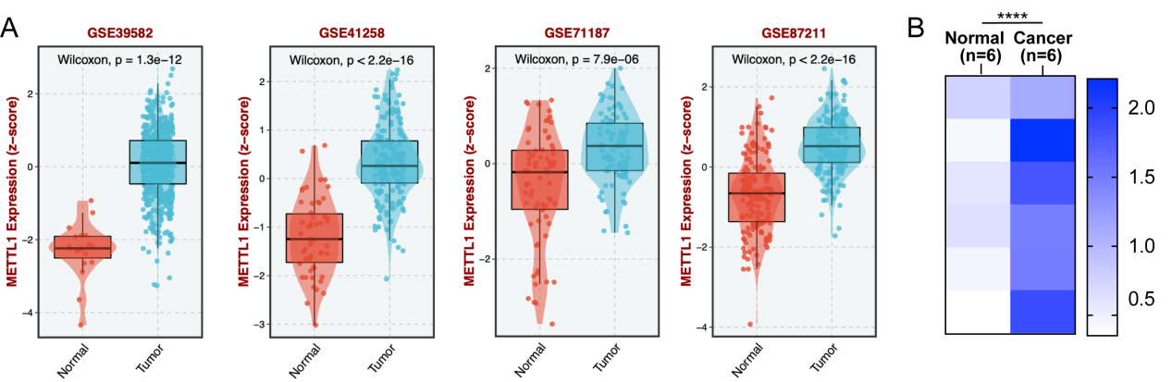
Figure S1 A. GEO database data analysis of METTL1 expression in colon cancer; B. METTL1 expression in 6 pairs of CRC tissues. Wilcoxon, *P < 0.05, 0.001 < **P < 0.01, ***P < 0.001

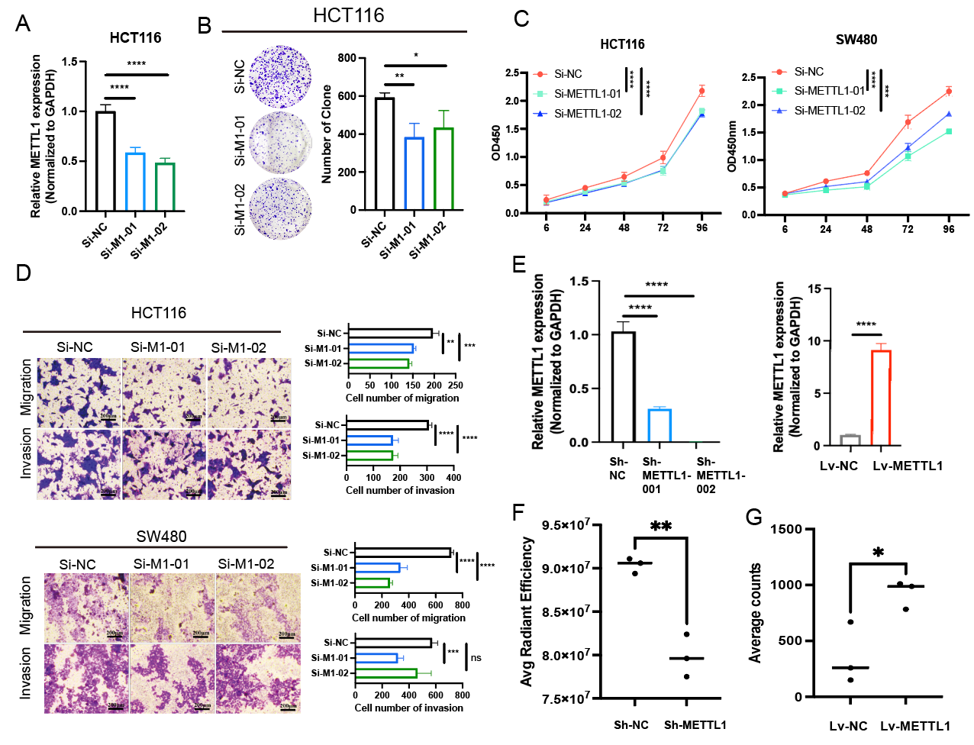
Figure S2 A. The interference efficiency of siMETTL1; B. Effect of SIMETTL on CC cell clone formation; C. The effect of SIMETTL on CC cell proliferation; D. the effect of SIMETTL on CC cell invasion and migration; E. The stable transfection efficiency of siMETTL1 and LVMETTL1.
- Average Radiant Efficiency statistics of lung nodules in sh-NC and sh-METTL1 groups of mice (n=3, [p/s/cm²/sr] / [µW/cm²]); G. Average Counts statistics of lung nodules in lv-NC and lv-METTL1 groups of mice (n=3). Mean ± SD. Student's t-test, *P < 0.05, 0.001 < **P < 0.01, ***P < 0.001

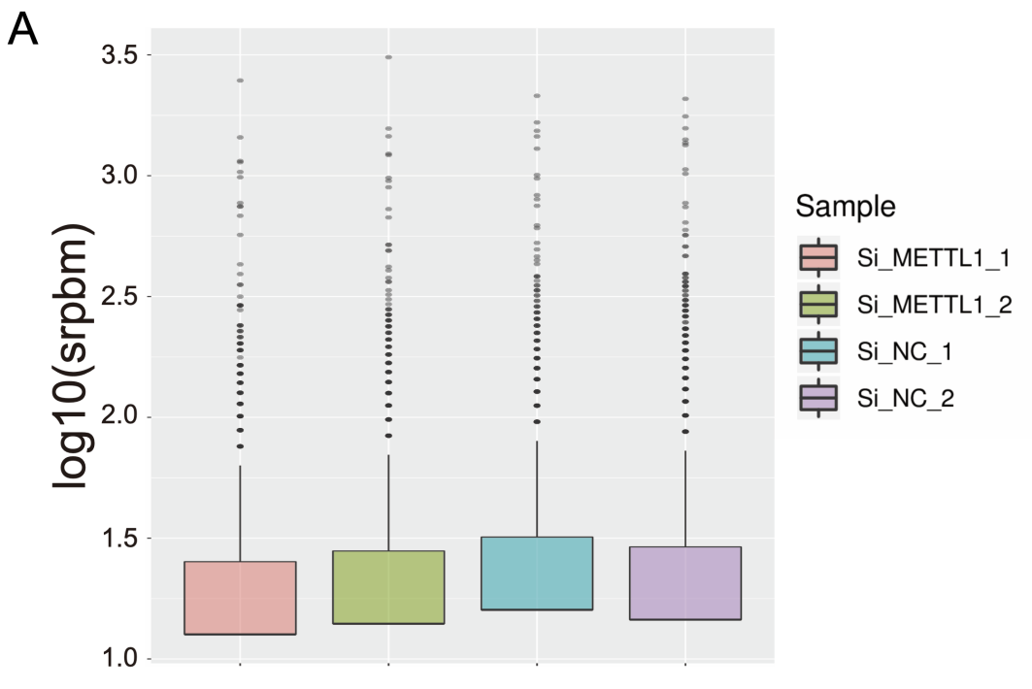
Figure S3 A.Effects of interfering with METTL1 on overall circRNA expression. srpbm:spliced reads per billion mapping
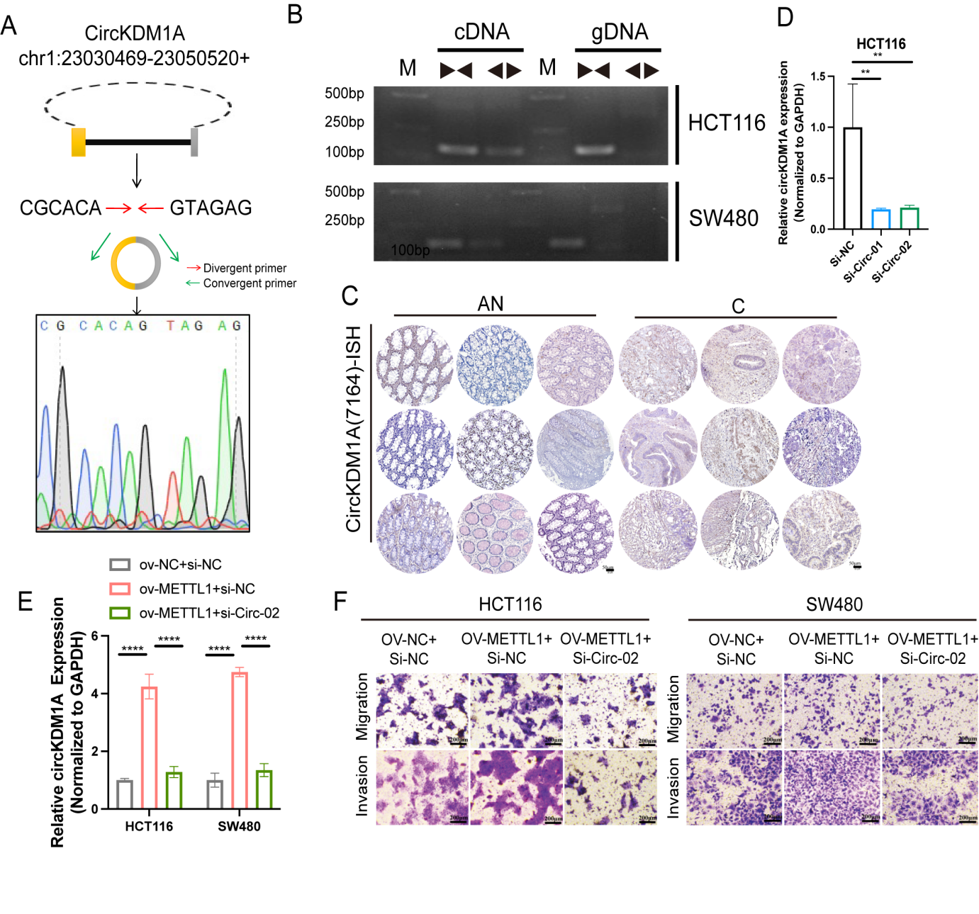

Figure S4 A. The Sanger sequencing of circKDM1A; B. Use the divergent primer and convergent primer of circKDM1A to detect QPCR products from cDNA and gDNA; C. ISH analysis of circKDM1A in CC tissues (C) and adjacent normal tissues (AN); D. Interference efficiency of circKDM1A in CC cells; E. qPCR detection of circKDM1A expression levels; F. Transwell assay analysis the migration and invasion of overexpressed METTL1 cell by silencing circKDM1A. Mean ± SD. Student's t-test, *P < 0.05, 0.001 < **P < 0.01, ***P < 0.001

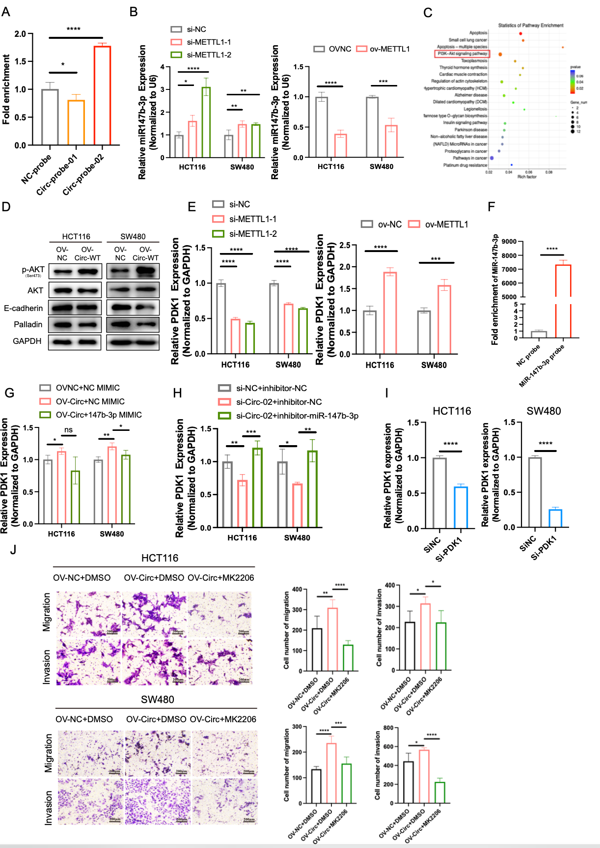

Figure S5 A. The extraction efficiency of circKDM1A probe; B. QPCR detection of miR-147b-3p expression after knocked down or overexpressed METTL1; C. The enrichment of the KEGG pathway after interfering with METTL1; D. The effect of overexpression of circKDM1A on pAKT and tumor suppressor molecules; E. QPCR detection of PDK1 expression after knocked down or overexpressed METTL1; F. The extraction efficiency of miR-147-3p biotin probe; G. QPCR detection of PDK1 expression in overexpressed circKDMA1 after adding miR-147b-3p mimic; H. QPCR detection of PDK1 expression in knocked down circKDMA1 and adding miR-147b-3p inhibitor; I. The efficiency of interfering PDK1 in CC cells; J. Transwell detection of the effect of overexpressing circKDM1A and adding MK2206 on cell invasion and migration. Mean ± SD. Student's t-test, *P < 0.05, 0.001 < **P < 0.01, ***P < 0.001

Figure S6 A. Effect of GG mutation of circKDM1A on the expression of miR-147b-3p in CRC cells; B. Effect of GG mutation of circKDM1A on the expression of PDK1 in CRC cells; C. Correlation analysis of circKDM1A and METTL1 in CRC clinical samples (n=46); D. Correlation analysis of circKDM1A and miR-147b-3p in CRC clinical samples (n=46); E. Correlation analysis of circKDM1A and PDK1 in CRC clinical samples (n=46); F. Correlation analysis of circKDM1A and p-AKT in CRC clinical samples (n=46); G. Correlation analysis of METTL1 and miR-147b-3p in CRC clinical samples (n=46); H. Correlation analysis of METTL1 and PDK1 in CRC clinical samples (n=46); I. Correlation analysis of METTL1 and p-AKT in CRC clinical samples (n=46); J. Correlation analysis of miR-147b-3p and PDK1 in CRC clinical samples (n=46); K. Co-localization positive area of METTL1 and circKDM1A in mouse pulmonary metastatic nodules (n=4); L. Mean fluorescence intensity of circKDM1A in mouse pulmonary metastatic nodules (n=4); M. Mean fluorescence intensity of PDK1 in mouse pulmonary metastatic nodules (n=4).
Mean ± SD. Student's t-test, *P < 0.05, 0.001 < **P < 0.01, ***P < 0.001,****P < 0.0001.

Table S1 The sequence of siRNA and probe
siRNA | Sequence(5'→3')
Si-METTL1-01 | GATGGACTGGTCTGAGCTA
Si-METTL1-02 | GGATGTGCACTCATTTCGA
Si-CircKDM1A-01 | CCGCACAGTAGAGTACAGA
Si-CircKDM1A-02 | AGAAACCGCACAGTAGAGT
CircKDM1A-FISH | 5'Cy3-CTCTGTAC+TCTACTG+TGCGGT+TTCT
CircKDM1A-ISH | 5'DIG-ATCTCTCTGTACTCTACTGTGCGGTTTCTAATGAA
CircKDM1A-PD-1 | 5'Biotin-TCTAC+TGTGCGGT+TTCTAA+TGAAAA
CircKDM1A-PD-2 | 5'Biotin-TGTAC+TCTACTG+TGCGGT+TTCTAAT
miR-147b-3-probe | 5'Biotin-GTGTGCGGAAATGCTTCTGCT
miRNA-NC probe | 5'Biotin-AGCAGAAGCATTTCCGCACAC

Table S2 The sequence of primer
Primer | Sequence(5'→3')
METTL1-F | CCCAAAGGATAAGAAAGAAAAG
METTL1-R | ATCTCCAGACCCAGAATAAGTG
CircKDM1A-F | CAAGAAGCAGCCTGTTTTCCAG
CircKDM1A-R | TACTCATCTTCTGAGAGGTTGGC
CircKDM1A-Mut-F | ACCACAACAGACCCAGAAGG
CircKDM1A-Mut-R | ATTAATAAGGTGGGGCTTGAGGG
CircSEMA4B-F | AGGCGATGATGACAAGATCTACTT
CircSEMA4B-R | GAATCTGAGGAATGGCCGCT
CircANKRD11-F | CCTCGTCAGCACTGACTTTCA
CircANKRD11-R | TAAGAAGAAAGAGCTCTAGGCCA
KDM1A-F | 5′-ATACAGCAGTGCGACAGGTTC-3′
KDM1A-R | 5′-TGCAGATGTTTTCCACTCAGG-3′
SEMA4B-F | CAAGACCCAGCTTTTGTGGC
SEMA4B-R | GTGAAGACACAGACGGCAGA
ANKRD11-F | GGGCCCCTGGAAAATAGCTT
ANKRD11-R | TCACCATCTGCGGCATCTTT
PDK1-F | CTGTGATACGGATCAGAAACCG
PDK1-R | TCCACCAAACAATAAAGAGTGCT
GAPDH | AACGGATTTGGTCGTATTGG
GAPDH | TTGATTTTGGAGGGATCTCG
has-miR-147b-3p | GTGTGCGGAAATGCTTCTGC
hsa-miR-526b-5p | CTCTTGAGGGAAGCACTTTCTGT
hsa-miR-625-5p | CGAGGGGGAAAGTTCTATAGTCC

Table S3 The participant’s baseline characteristics (1)
 |  | CircKDM1A expression
Characteristic | Overall, N = 60 ¹ | Low, N = 28 (46.67%)¹ | High, N = 32 (53.33%)¹ | P Value²
Gender |  |  |  | 0.769
female | 28 (46.67%) | 12 (42.86%) | 16 (50.00%)
male | 32 (53.33%) | 16 (57.14%) | 16 (50.00%)
Age |  |  |  | 0.323
≥65 | 27 (45.00%) | 15 (53.57%) | 12 (37.50%)
＜65 | 33 (55.00%) | 13 (46.43%) | 20(62.50%)
Histological_grade |  |  |  | 0.737
I-II | 50 (83.33%) | 24 (85.71%) | 26 (81.25%)
III-IV | 10 (16.67%) | 4 (14.29%) | 6 (18.75%)
Tumor_depth |  |  |  | 0.088
T1-T2 | 6 (10.00%) | 5 (17.86%) | 1 (3.13%)
T3-T4 | 54 (90.00%) | 23 (82.14%) | 31 (96.88%)
Lymph_node_metastasis |  |  |  | 0.058
No | 34 (56.67%) | 20 (71.43%) | 14 (43.75%)
Yes | 26 (43.33%) | 8 (28.57%) | 18 (56.25%)
Clinical_stage |  |  |  | 0.033
1-2 | 33 (55.00%) | 20 (71.43%) | 13 (40.63%)
3-4 | 27 (45.00%) | 8 (28.57%) | 19 (59.38%)

¹n (%)
²Pearson’s Chi-squared test; Fisher’s exact test

Table S4 The participant’s baseline characteristics (2)
 |  | CircKDM1A expression
Characteristic | Overall, N = 46 ¹ | Low, N = 23 (50.00%)¹ | High, N = 23 (50.00%)¹ | P Value²
Gender |  |  |  | 1
female | 22 (47.82%) | 11 (47.83%) | 11 (47.83%)
male | 24 (52.18%) | 12 (52.17%) | 12 (52.17%)
Age |  |  |  | 0.529
≥65 | 15 (32.61%) | 9 (39.13%) | 6 (26.09%)
＜65 | 31 (63.39%) | 14 (60.87%) | 17 (73.91%)
Nerve invasion |  |  |  | 0.222
No | 29(63.04%) | 17 (73.91%) | 12 (52.17%)
Yes | 17 (36.96%) | 6 (26.09%) | 11 (47.83%)
Vascular invasion |  |  |  | 0.023
No | 34 (73.91%) | 21(91.30%) | 13 (56.52%)
Yes | 12 (26.09%) | 2 (8.70%) | 10 (43.48%)
Tumor depth |  |  |  | 0.131
T1-T2 | 18 (39.13%) | 12 (52.17%) | 6 (26.09%)
T3-T4 | 28 (60.87%) | 11 (47.83%) | 17 (73.91%)
Lymph node metastasis |  |  |  | 0.018
No | 25 (54.35%) | 17 (73.91%) | 8 (34.78%)
Yes | 21 (45.65%) | 6 (26.09%) | 15 (65.22%)
Distant metastasis |  |  |  | 0.232
No | 43 (93.48%) | 23 (100.0%) | 20 (86.96%)
Yes | 3 (6.52%) | 0 (0.00%) | 3 (13.04%)

¹n (%)
²Pearson’s Chi-squared test; Fisher’s exact test

