supplementary file
Fig.1

Fig.1H(786-O)

Fig.1H(Caki-1)
Fig.3

Fig.3A
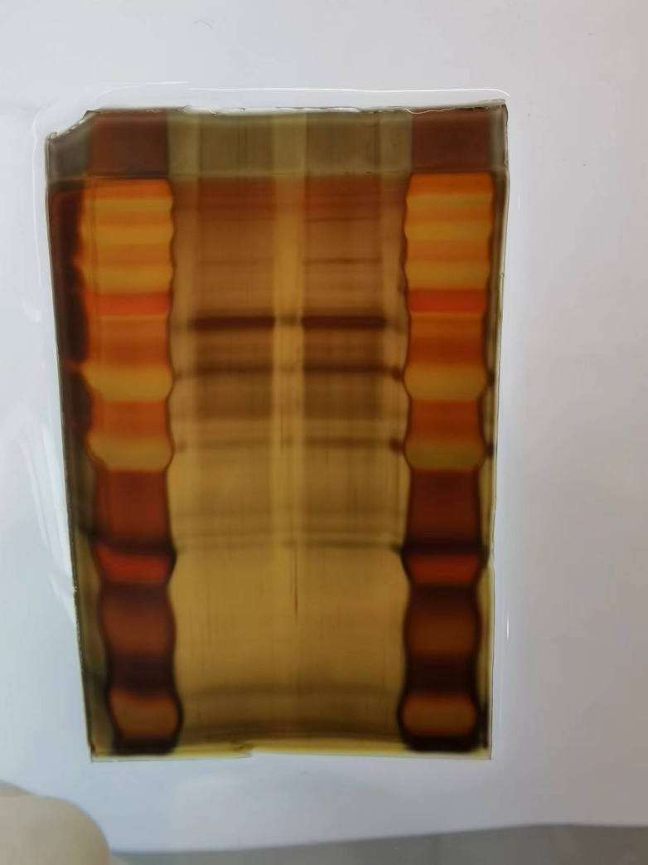

Fig.3E
Fig.3F(Input)
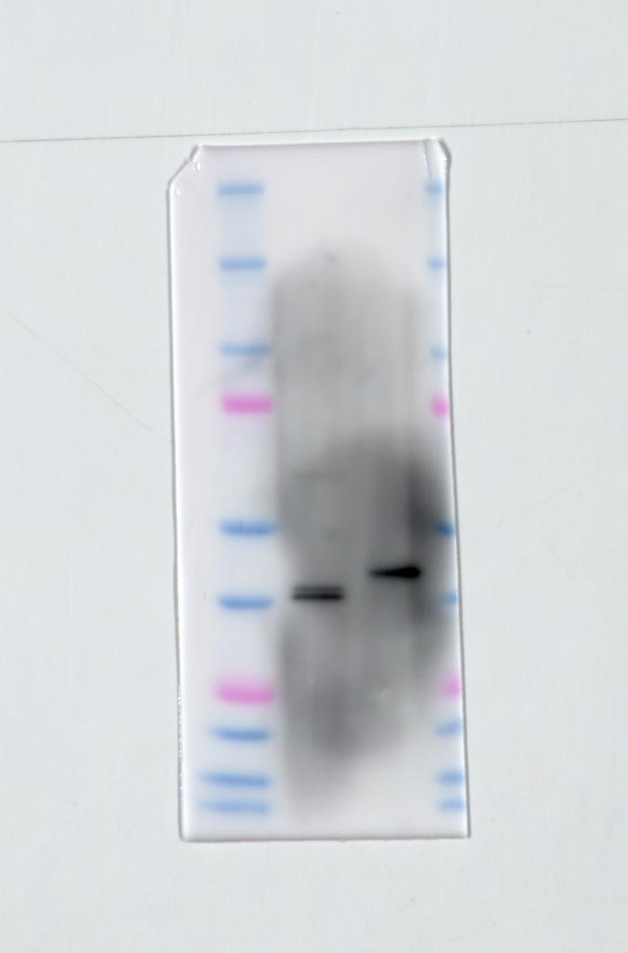

Fig.3F(RIP)
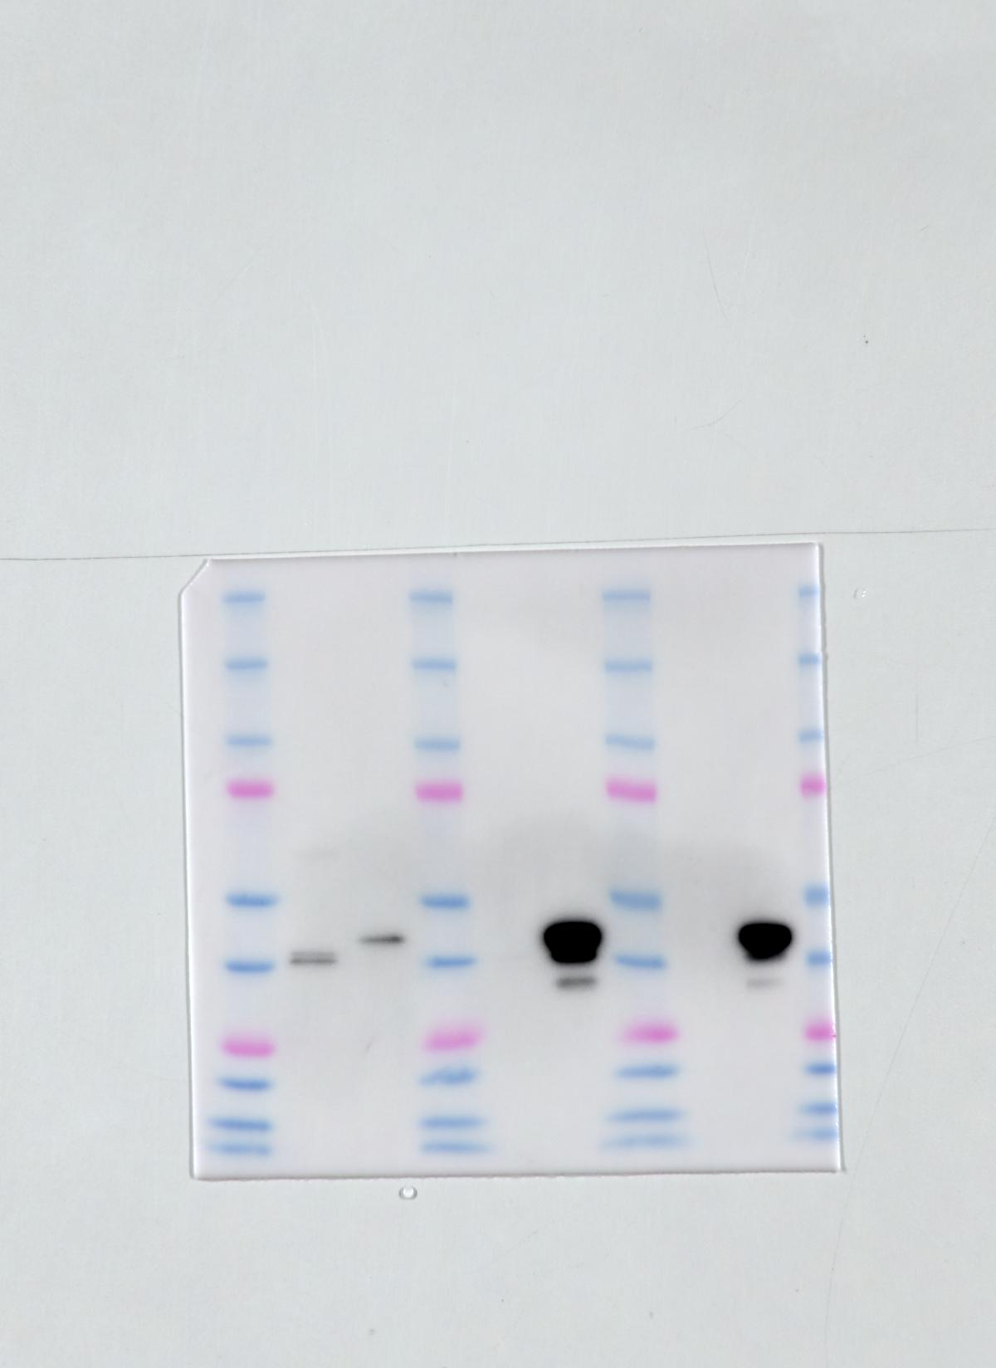

Fig.3J(Input)
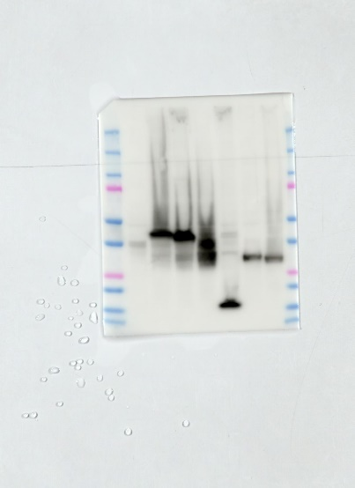

Fig.3J(RIP)
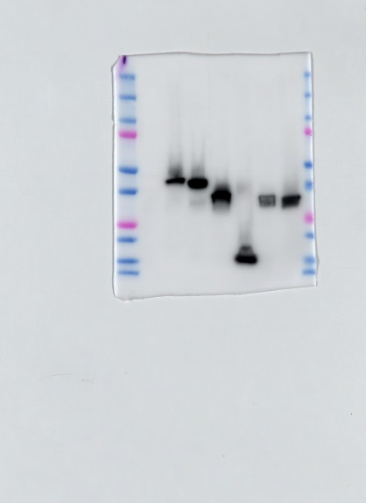

Fig.3L

Fig.4

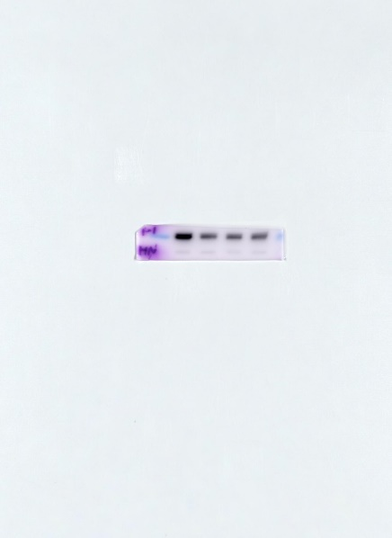
Fig.4A HNRNPC (786-Onc-si1-si2-si3)

Fig.4A HNRNPC (Caki-1nc-si1-si2-si3)
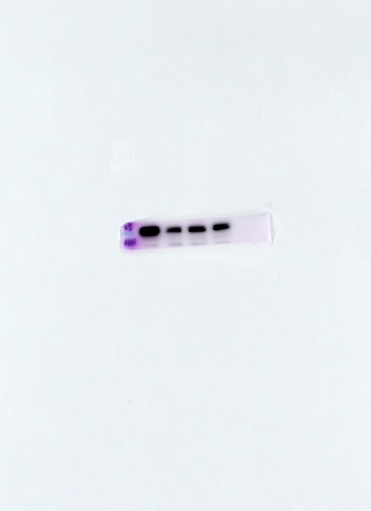

Fig.4A Tubulin (786-Onc-si1-si2-si3)
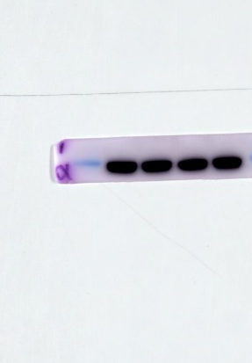
Fig.4A Tubulin (Caki-1nc-si1-si2-si3)
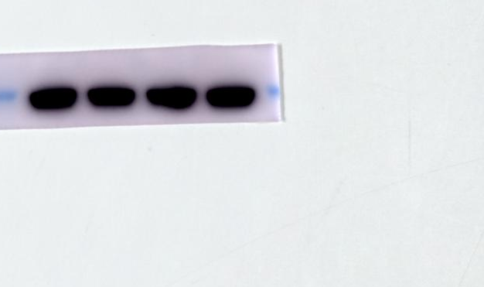

Fig.4D HNRNPC (786-O-nc)
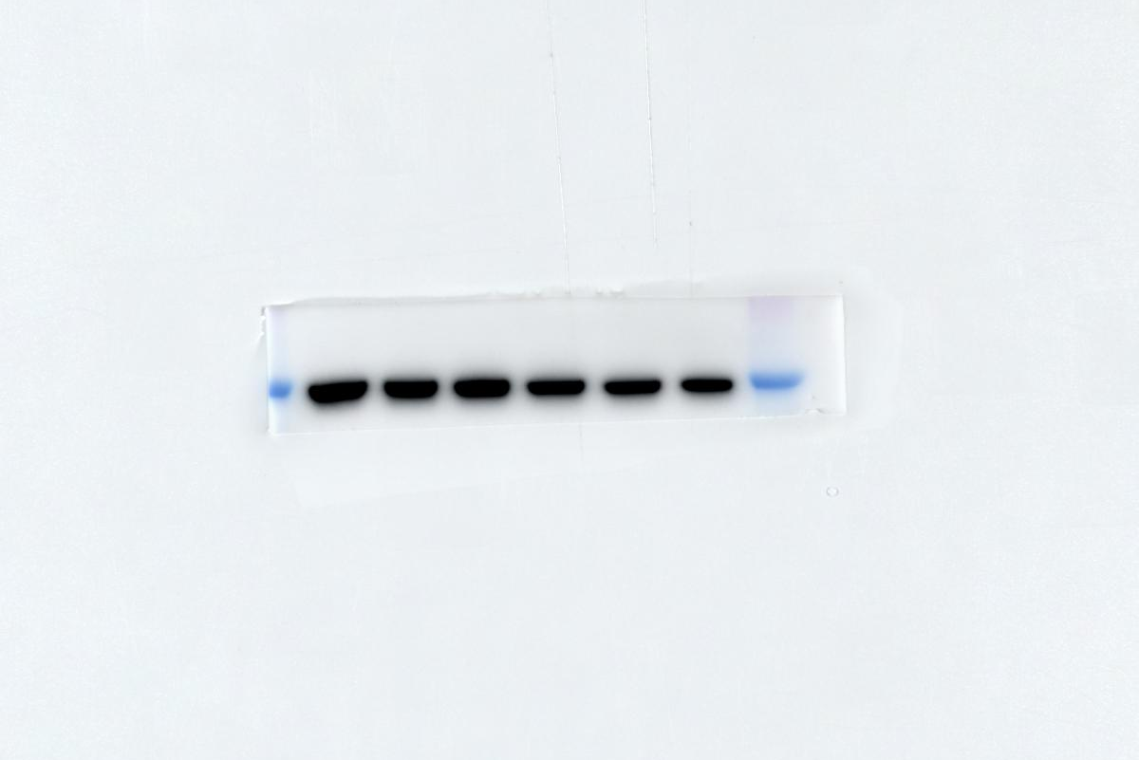

Fig.4D HNRNPC (786-O-si1)
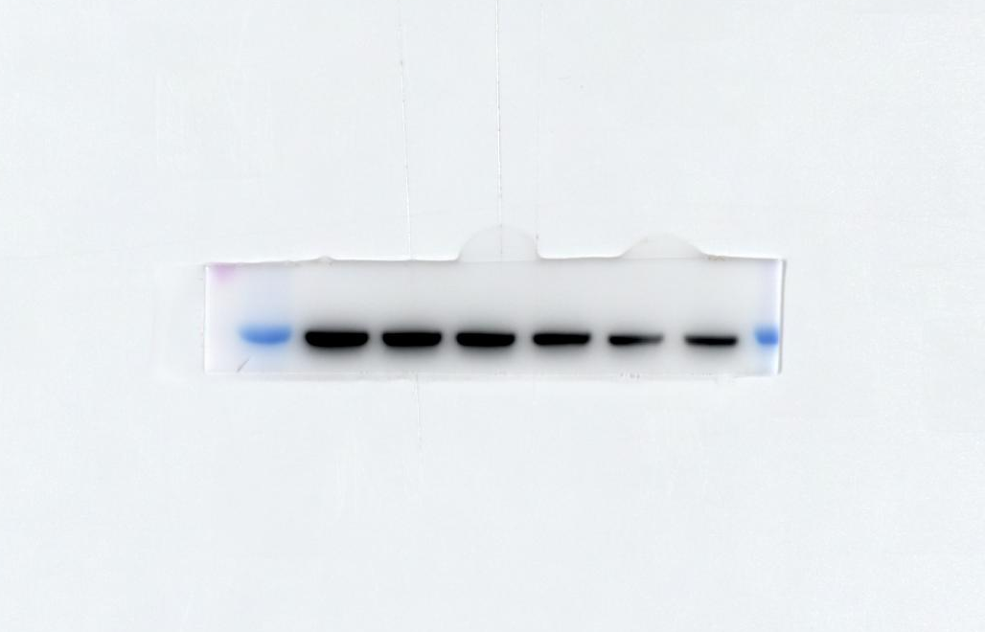

Fig.4D HNRNPC (786-O-si2)
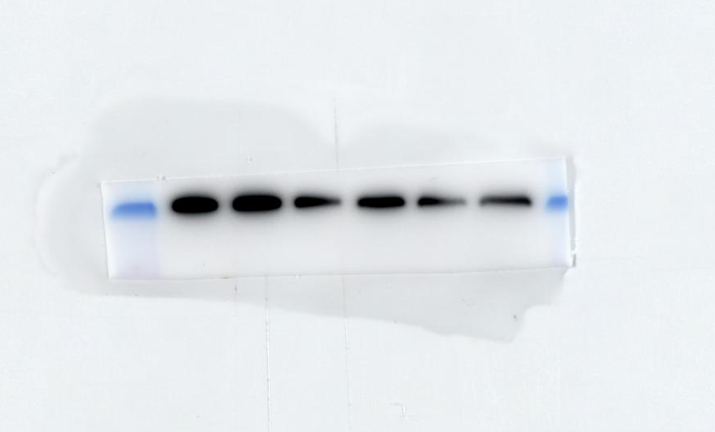
Fig.4D Tubulin (786-O-nc)
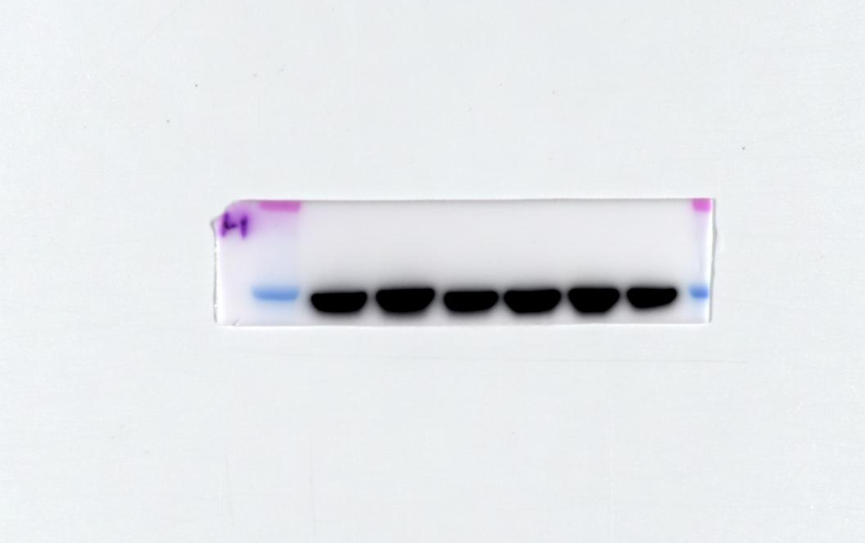

Fig.4D Tubulin (786-O-si1)
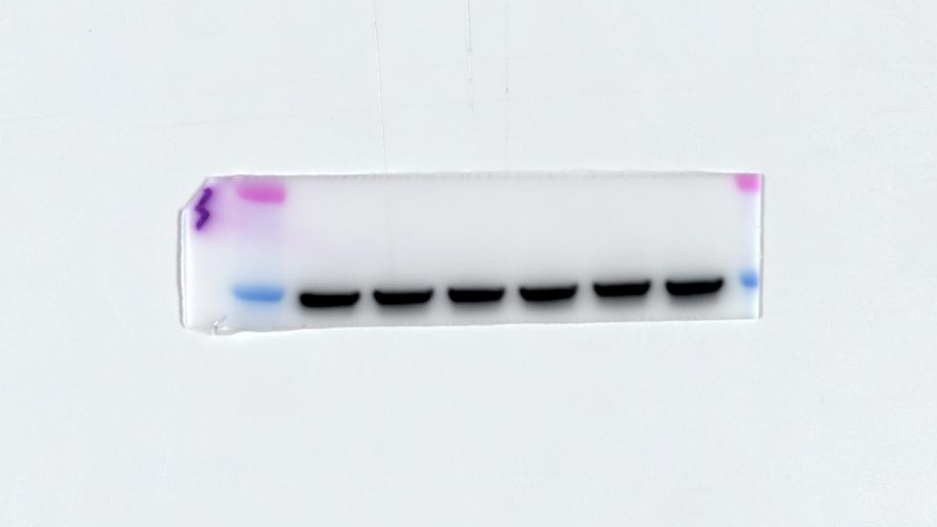

Fig.4D Tubulin (786-O-si2)
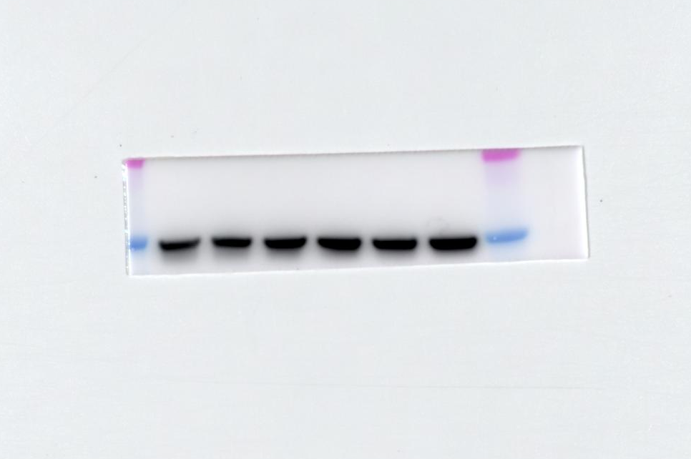

Fig.4D HNRNPC (Caki-1 -nc)
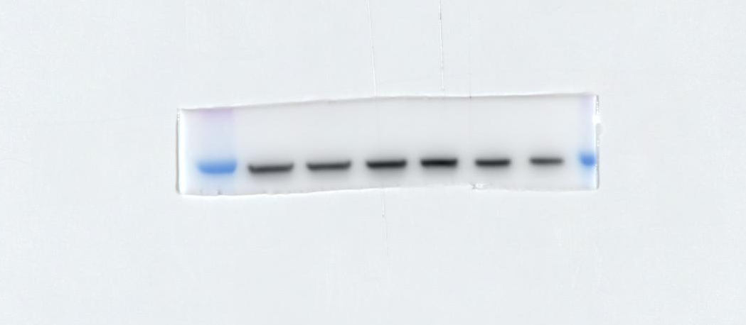

Fig.4D HNRNPC (Caki-1 -si1)
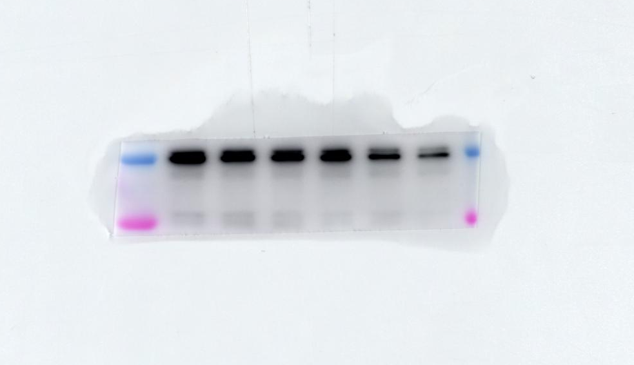

Fig.4D HNRNPC (Caki-1 -si2)
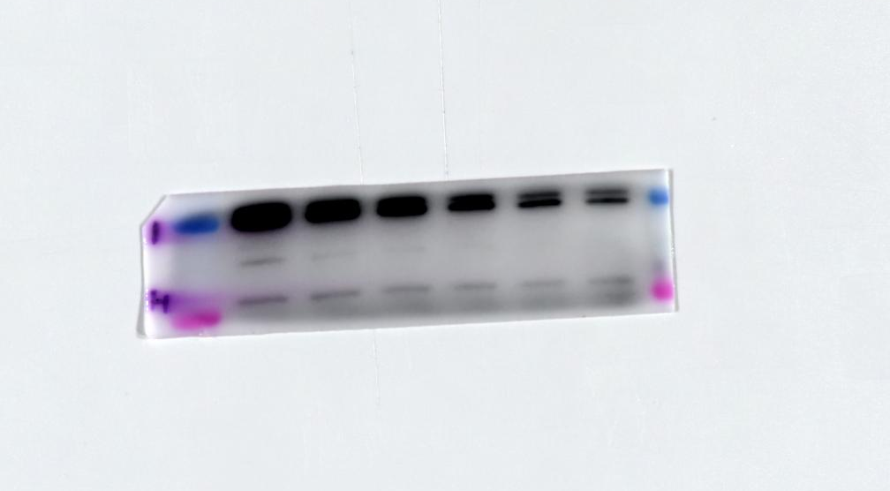

Fig.4D Tubulin (Caki-1 -nc)
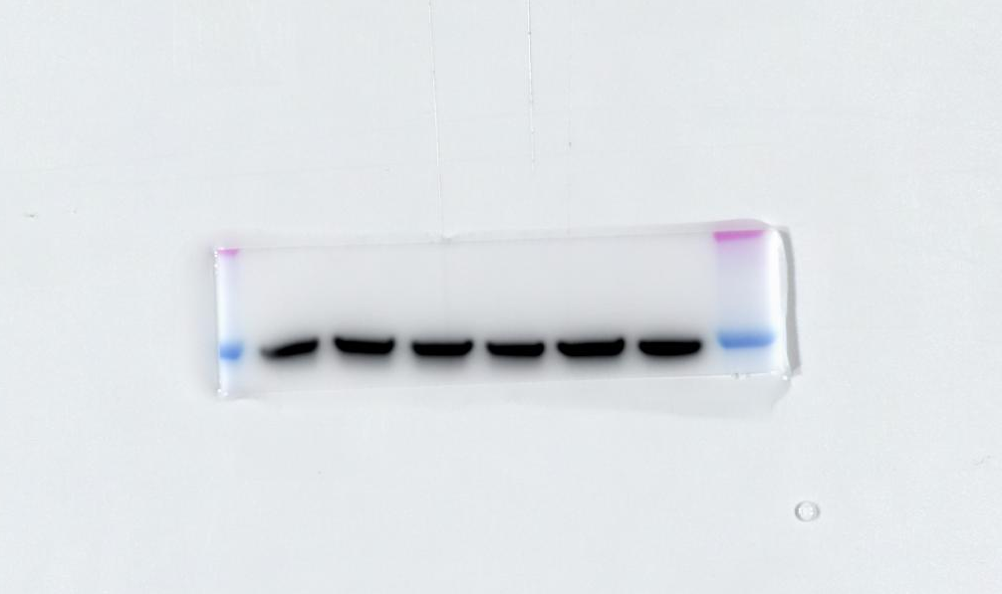

Fig.4D Tubulin (Caki-1 -si1)

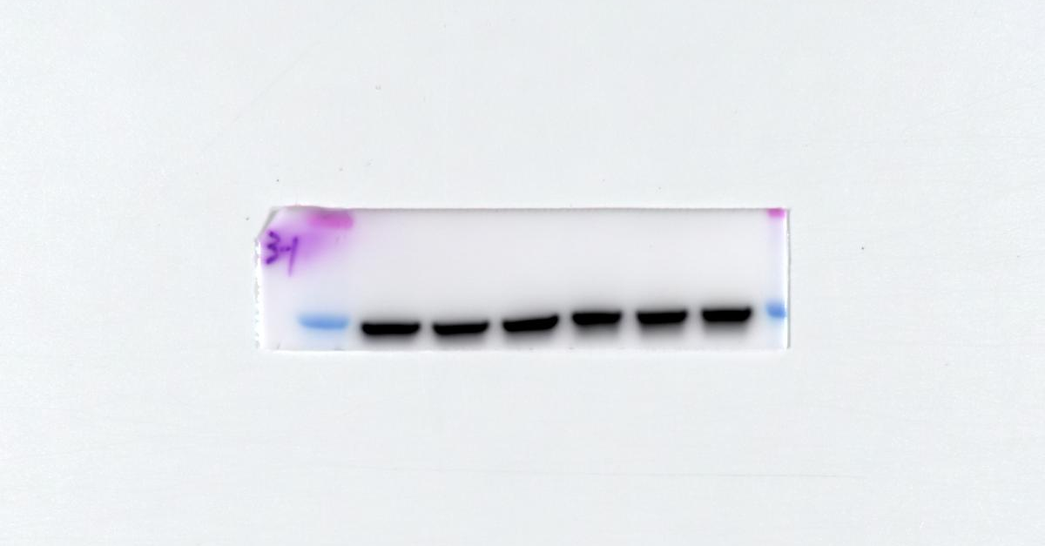

Fig.4D Tubulin (Caki-1 -si2)
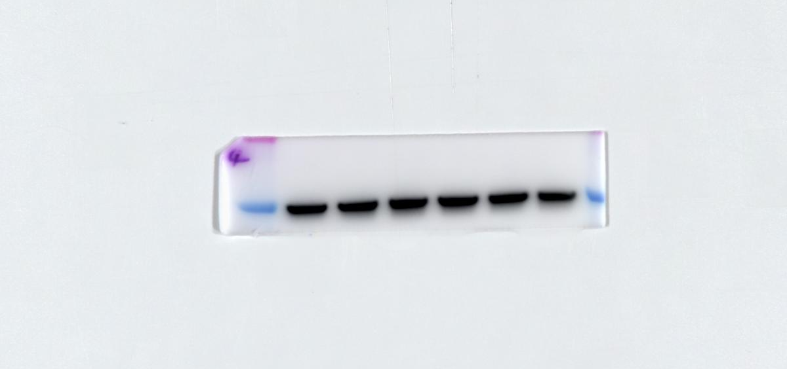

Fig.4E 786-O-Caki-1---hnrnpc

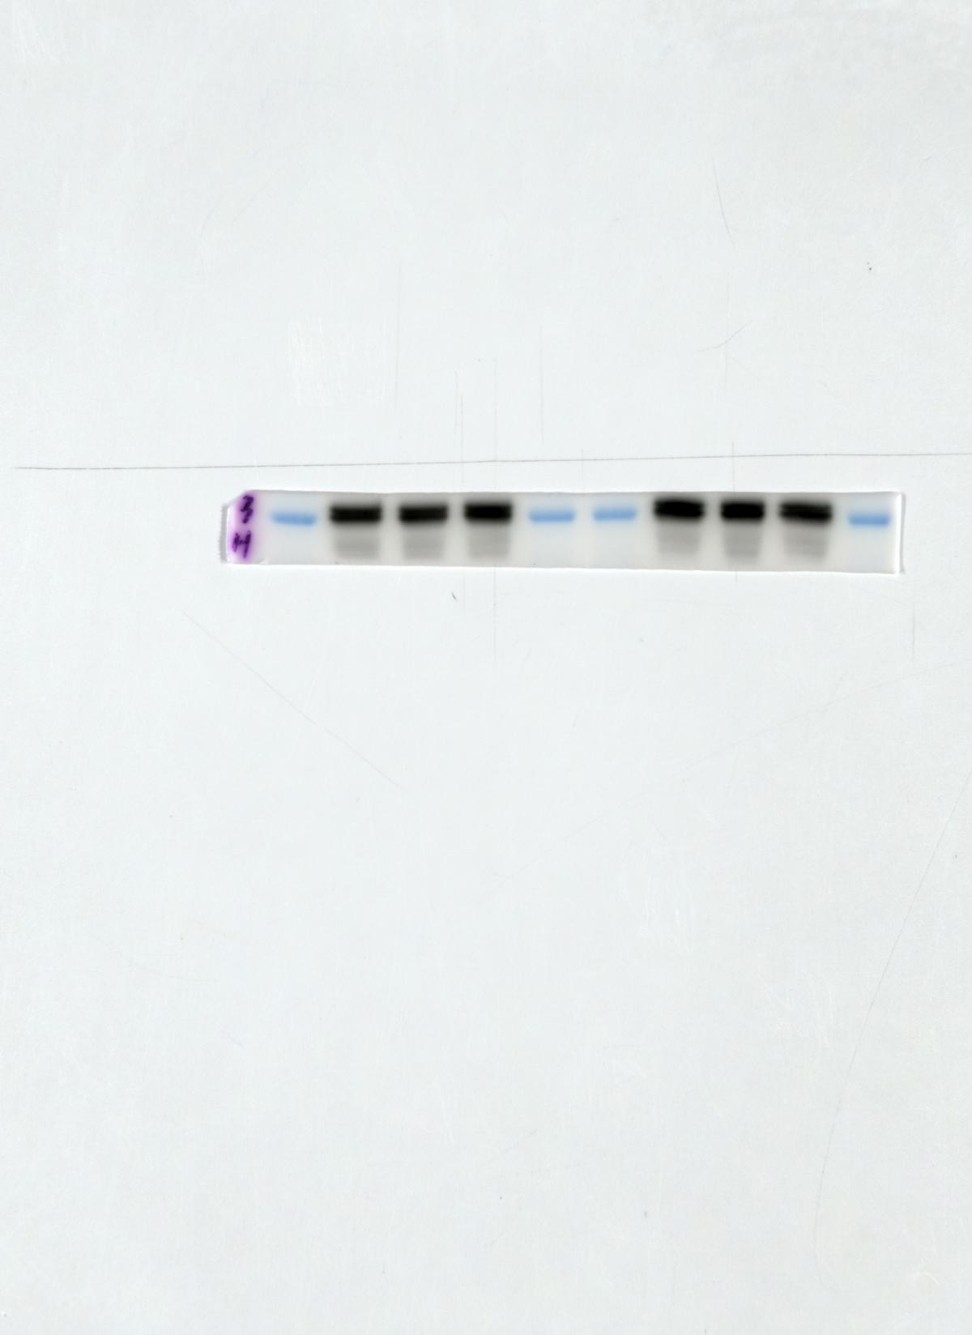

Fig.4E 786-O-Caki-1---Tubulin
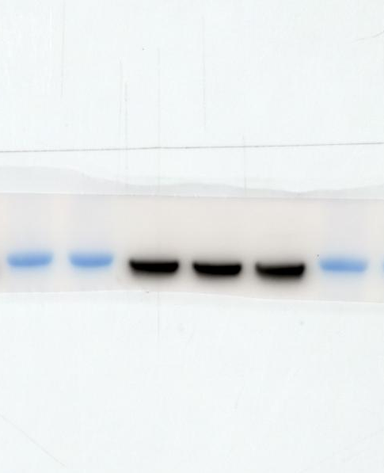

Fig.4F
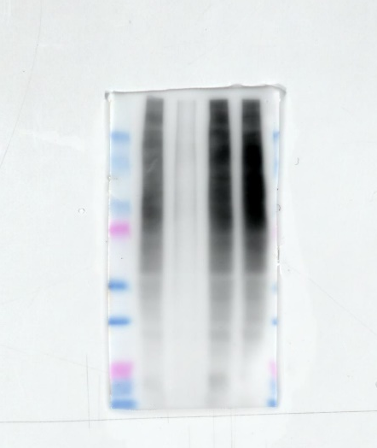
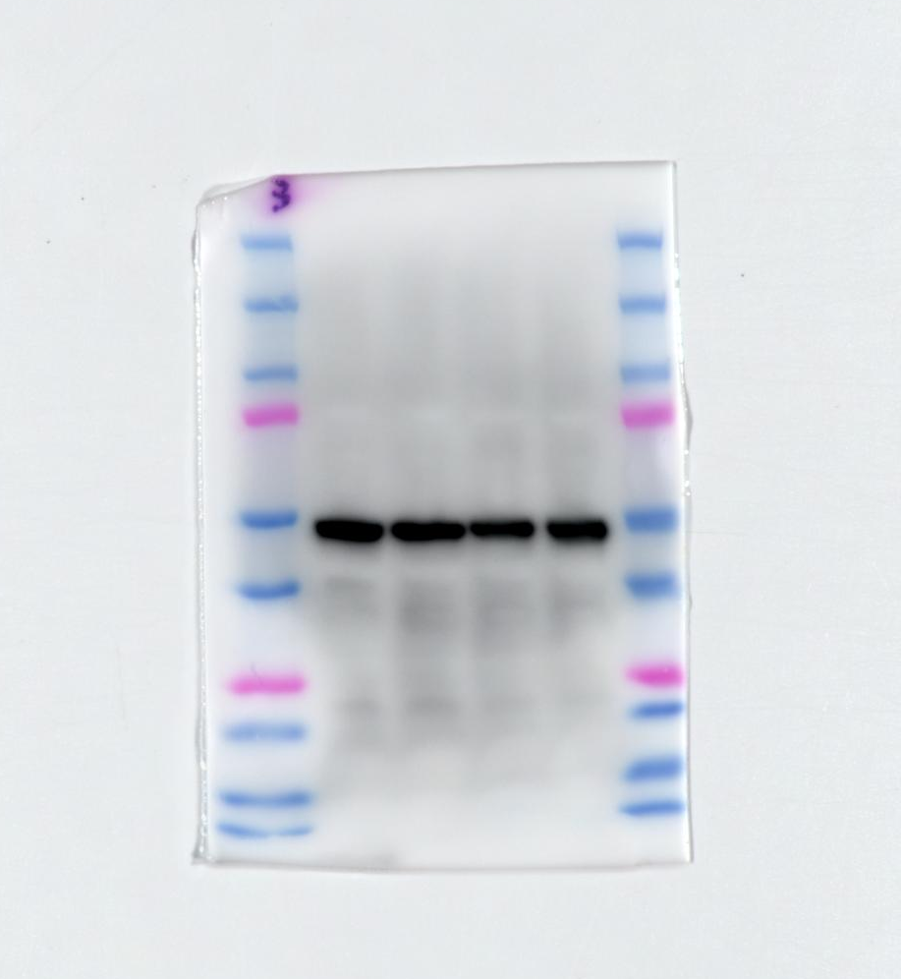

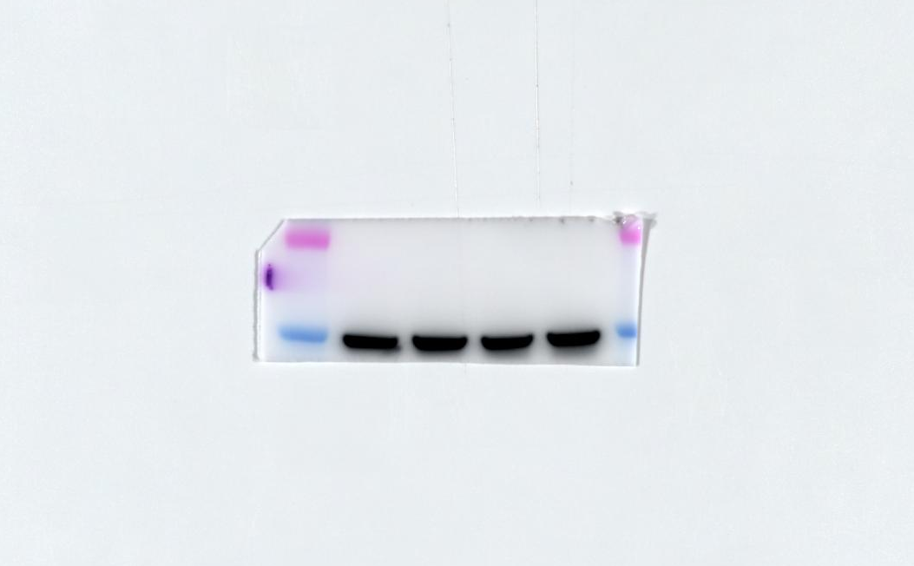

Fig.4G
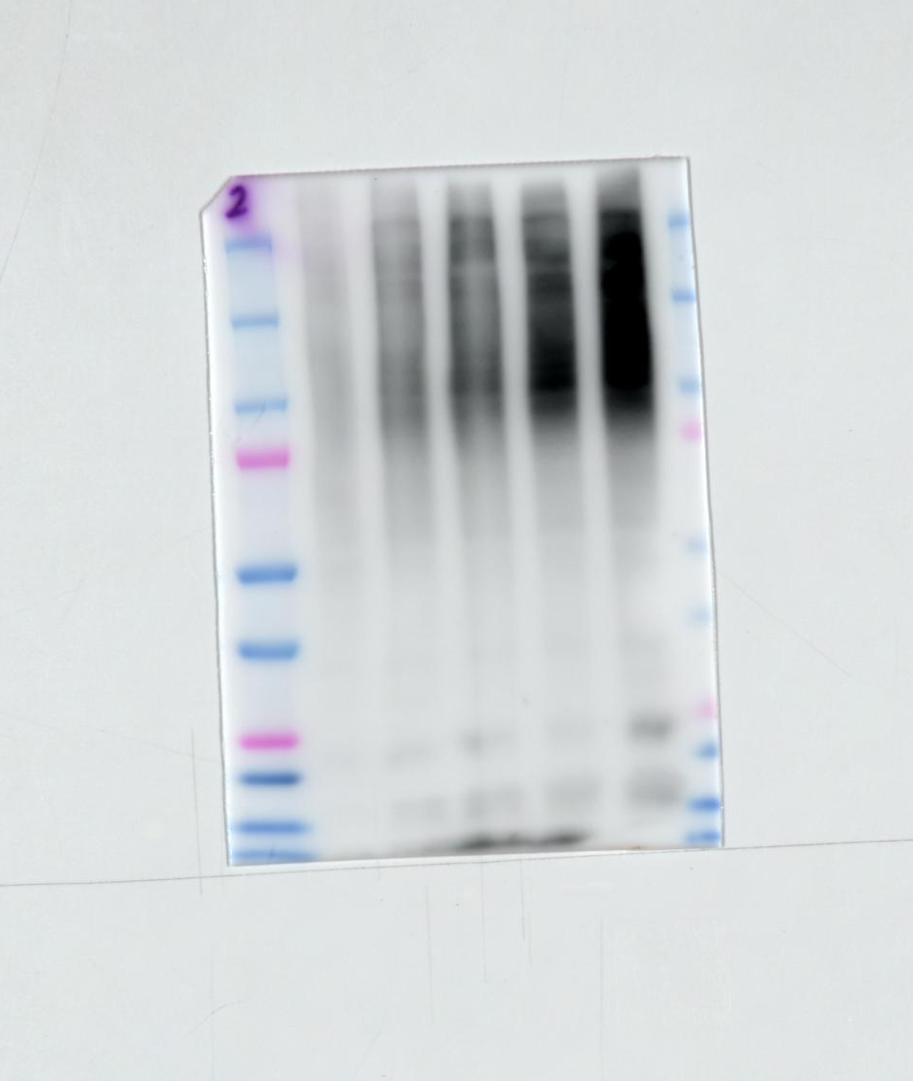

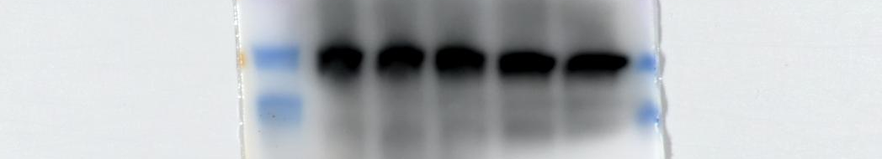

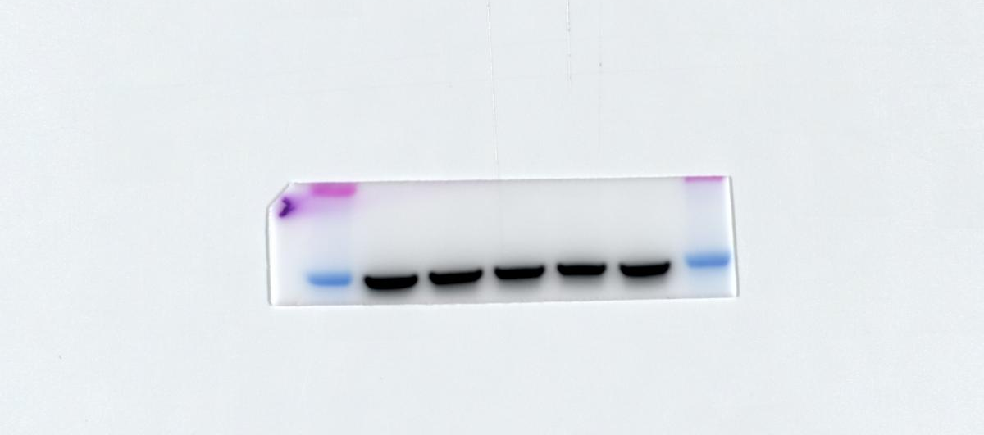

Fig.5

Fig.5B SLC7A11
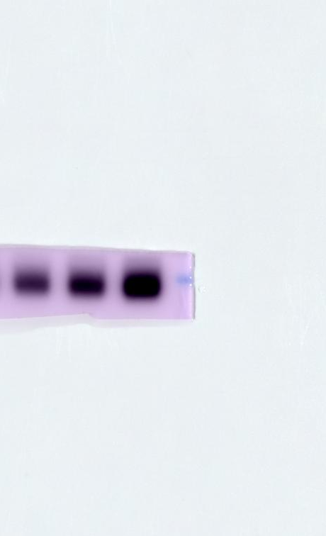

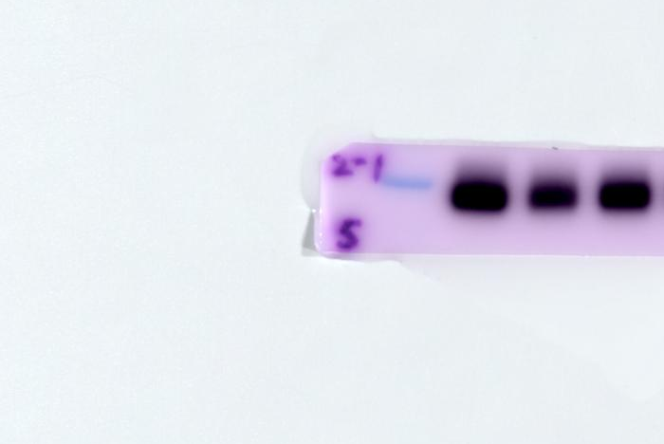

Fig.5B ACSL4
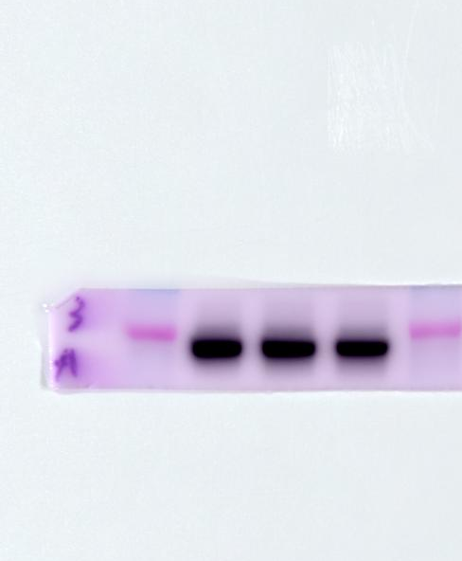

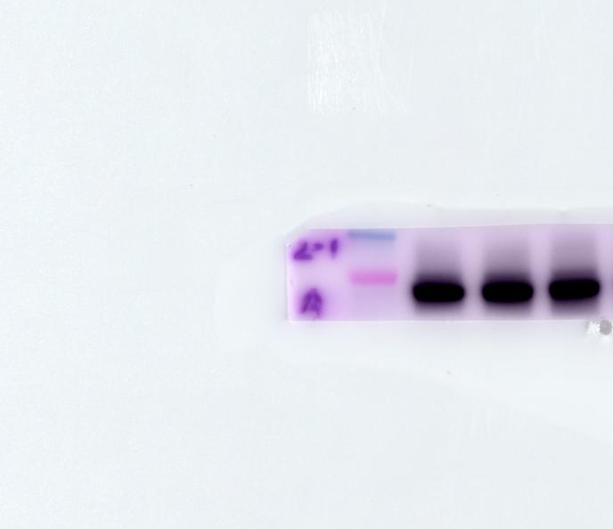

Fig.5B GPX4
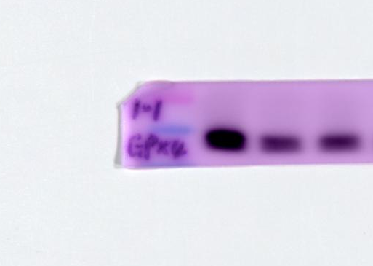
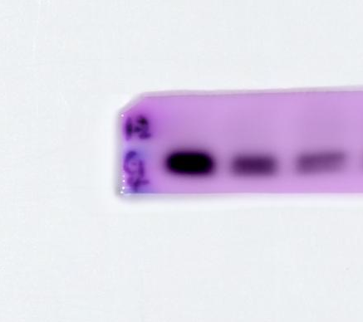

Fig.5B FTH1
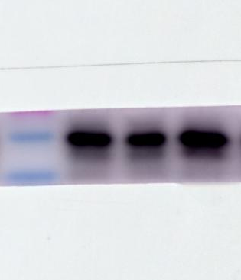
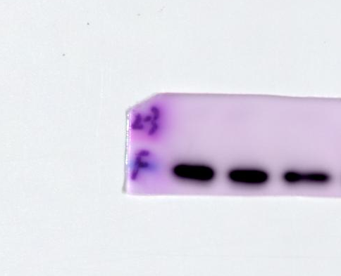

Fig.5B Tubulin
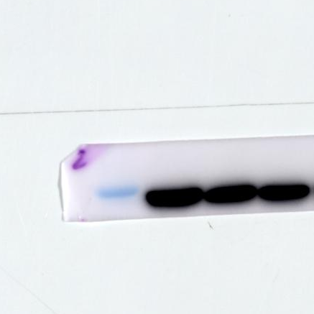
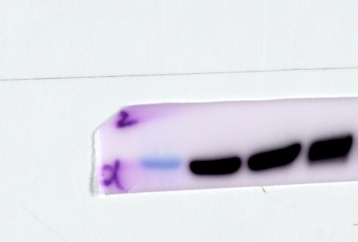

Fig.5C 786-O-HNRNPC
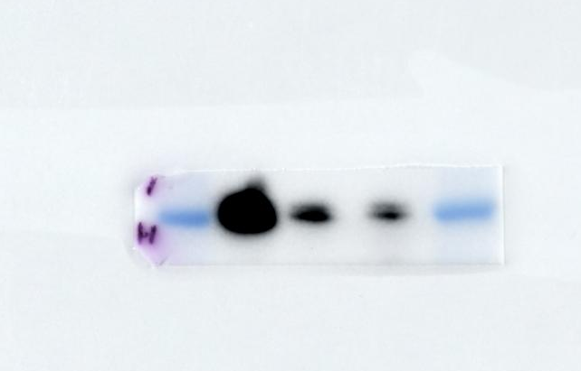
Fig.5C 786-O-GPX4
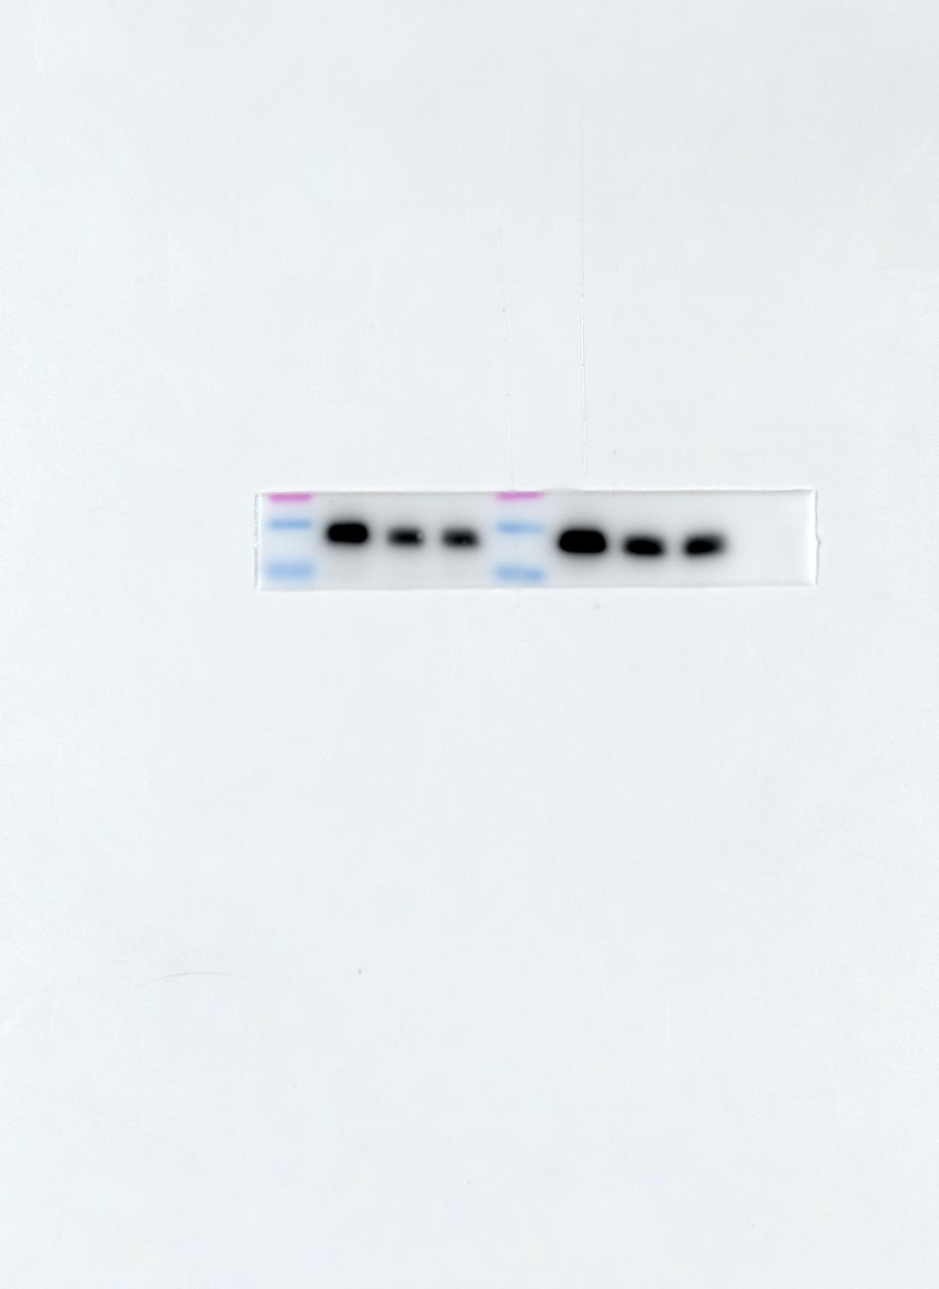
Fig.5C 786-O-Tubulin
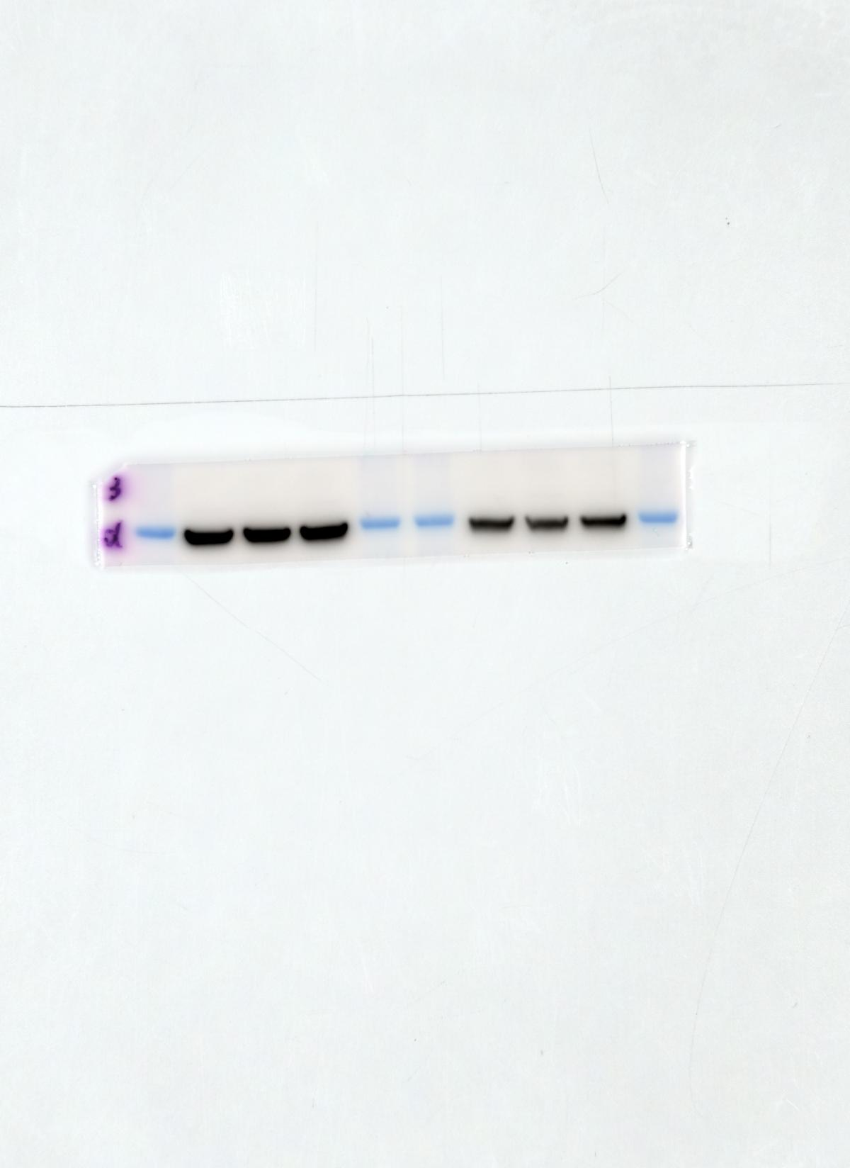
Fig.5C Caki-1-HNRNPC
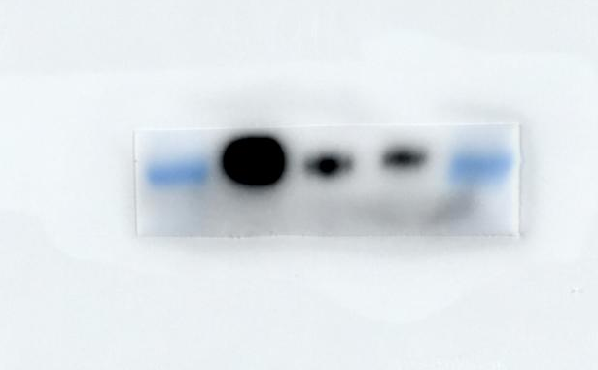
Fig.5C Caki-1-GPX4

Fig.5C Caki-1-Tubulin

Fig.5D 786-O-HNRNPC
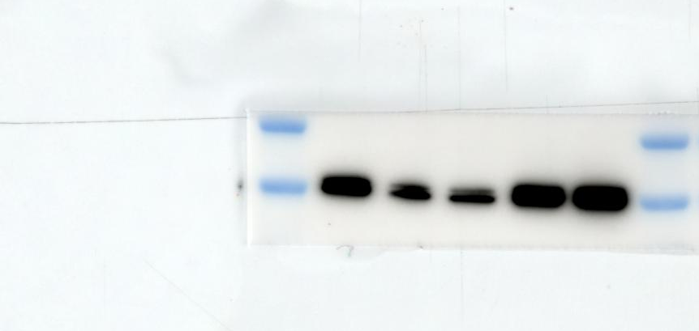

Fig.5D 786-O-GPX4
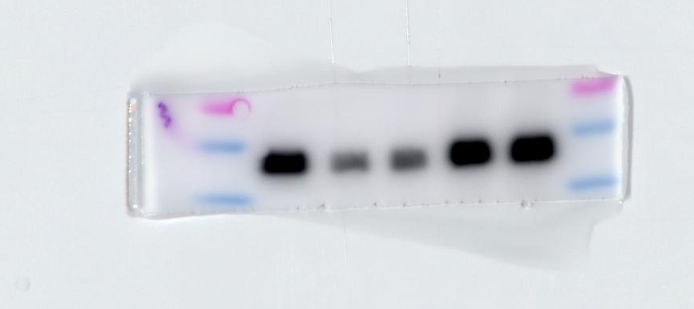

Fig.5D 786-O-Tubulin
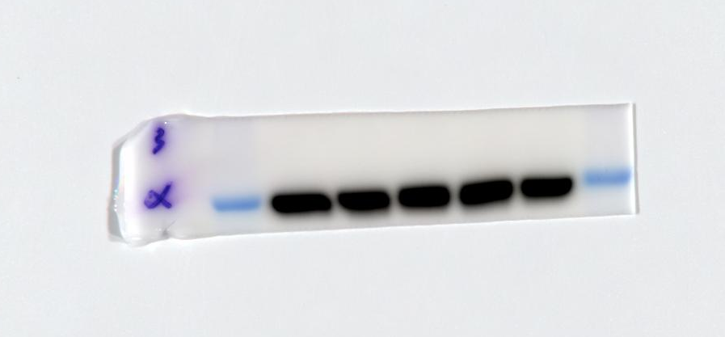

Fig.5D Caki-1-HNRNPC
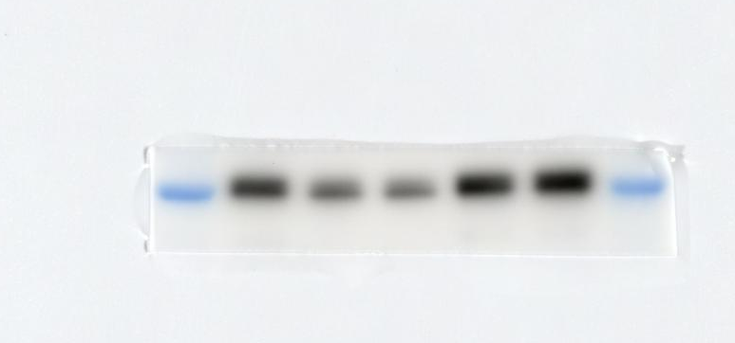

Fig.5D Caki-1-GPX4
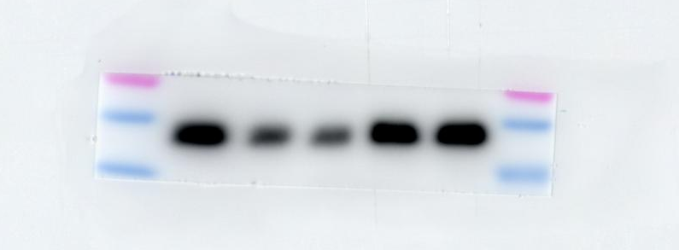

Fig.5D Caki-1-Tubulin
