Charting the metabolic biogeography of the colorectum in cancer: challenging the right sided versus left sided classification

Abhishek Jainª, Montana T. Morris^{b}, Domenica Berardiª, Trisha Arora^{c}, Xavier Domingo-Almenara^{c}, Philip B. Paty^{d}, Nicholas J. W. Rattray^{e}, Daniel Kerekes^{b}, Lingeng Lu^{f}, Sajid A. Khan^{*,b}, Caroline H. Johnson^{*,a}

ª Department of Environmental Health Sciences, Yale School of Public Health, 60 College Street, New Haven, CT, 06510, USA
^{b}Department of Surgery/Surgical Oncology, Yale School of Medicine, 333 Cedar Street, New Haven, CT, 06510, USA
^{c}EURECAT - Technology Centre of Catalonia, Omics Sciences Unit, Avda. Universitat 1, 43204
Reus, Catalonia, Spain.
^{d}Department of Surgery, Memorial Sloan Kettering Cancer Center, 1275 York Ave, New York, NY, 10065, USA.
^{e}Strathclyde Institute of Pharmacy and Biomedical Sciences, University of Strathclyde, Glasgow, UK
^{f}Department of Chronic Disease Epidemiology, Yale School of Public Health, 60 College Street, New Haven, CT06510, USA

* Corresponding Author: caroline.johnson@yale.edu , sajid.khan@yale.edu

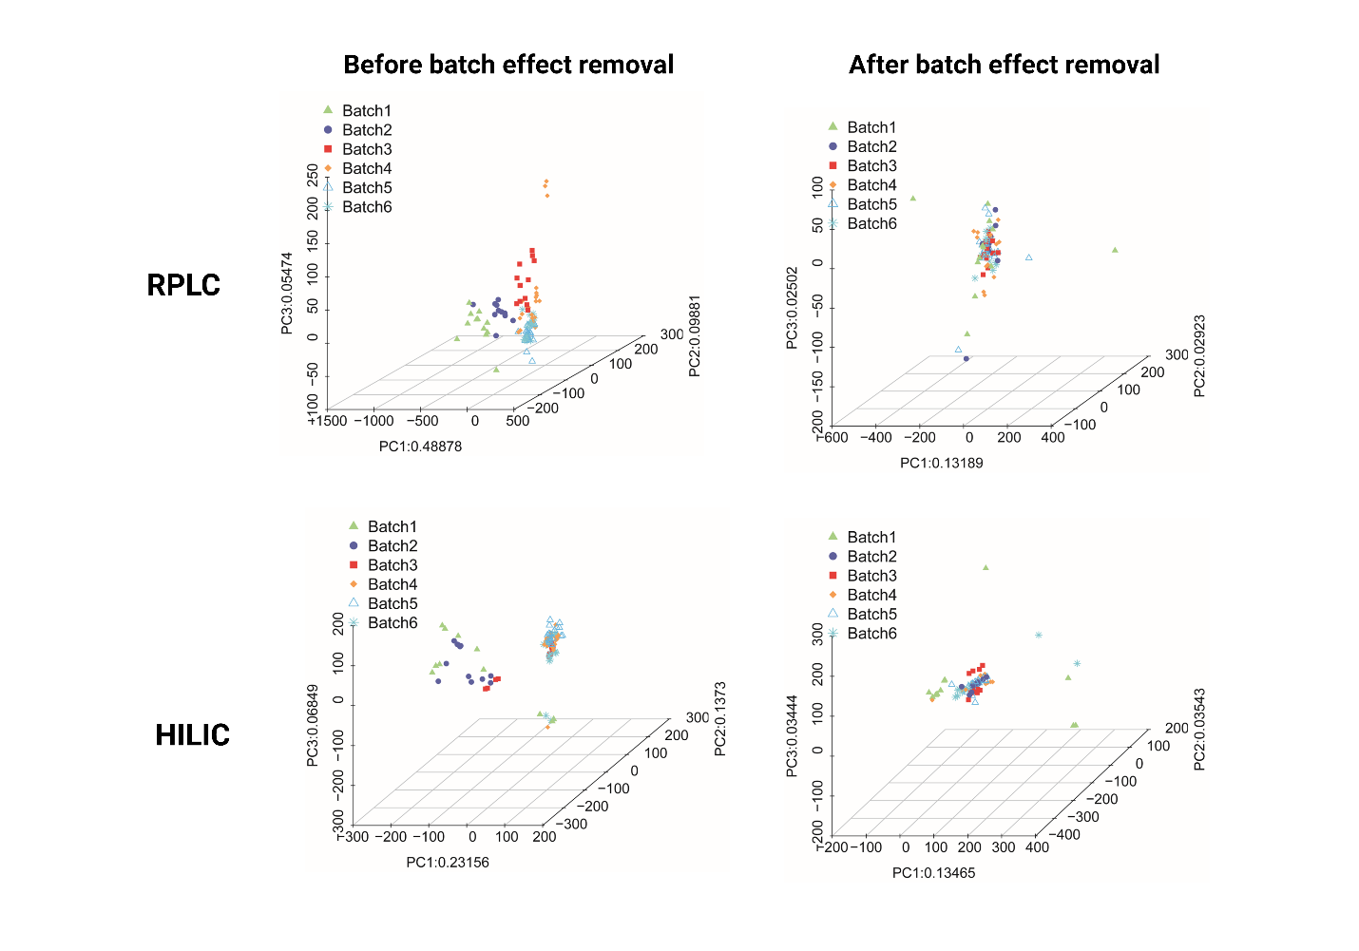
Figure S1: Principal component analysis scores plots of quality control samples from six different batches are shown before and after batch effect removal.

Table S1: List of metabolites annotated at level 1 and level 2 using analytical standards.

Name | ID Level | Mode | M-H | RT (sec)
1,2-Dipalmitoyl-sn-glycero-3-phosphoethanolamine | 1 | HILIC (-) | 690.5067 | 142.1
2-Aminoisobutyric acid | 1 | HILIC (-) | 102.0554 | 312.3
2-Deoxy-D-glucose | 1 | HILIC (-) | 163.0601 | 286.6
2-Deoxyguanosine | 1 | HILIC (-) | 266.0889 | 219.3
2'-Deoxyinosine | 1 | HILIC (-) | 251.0777 | 174.3
2-Ketobutyric acid | 1 | HILIC (-) | 101.0238 | 247.6
4-Hydroxy-3-methoxyphenylacetic acid | 1 | HILIC (-) | 181.0496 | 174.3
4-Hydroxyproline | 1 | HILIC (-) | 130.0504 | 329.9
5-Aminovaleric acid | 1 | HILIC (-) | 116.0707 | 361.4
Adenosine 5'-diphosphate | 1 | HILIC (-) | 426.0215 | 436.6
Adenosine 5'-triphosphate | 1 | HILIC (-) | 505.9878 | 466.3
Alanylglutamic acid | 1 | HILIC (-) | 217.0821 | 394.7
Alany-L-glutamine | 1 | HILIC (-) | 216.0978 | 329.7
Alanyl-Histidine | 1 | HILIC (-) | 225.0979 | 348.7
Alanyl-L-phenylalanine | 1 | HILIC (-) | 235.1077 | 197.0
Alanylmethionine | 1 | HILIC (-) | 219.0770 | 269.1
Aminoadipic acid | 1 | HILIC (-) | 160.0607 | 388.0
Arginine | 1 | HILIC (-) | 173.1036 | 489.7
Argininosuccinic acid | 1 | HILIC (-) | 289.1148 | 446.4
Aspartate | 1 | HILIC (-) | 132.0294 | 382.5
Citramalic acid | 1 | HILIC (-) | 147.0292 | 372.5
Cysteic acid | 1 | HILIC (-) | 167.9961 | 347.8
dAMP | 1 | HILIC (-) | 330.0602 | 394.1
Dodecanedioic acid | 1 | HILIC (-) | 229.1434 | 267.2
Dopamine sulfate | 1 | HILIC (-) | 232.0276 | 134.5
Epsilon-(gamma-Glutamyl)lysine | 1 | HILIC (-) | 274.1401 | 467.5
Estradiol-17-glucuronide | 1 | HILIC (-) | 447.1909 | 225.7
Ethyl laurate | 1 | HILIC (-) | 227.2007 | 42.1
Flavin Adenine Dinucleotide | 1 | HILIC (-) | 784.1488 | 377.2
Formylmethionine | 1 | HILIC (-) | 176.0376 | 182.7
Glucosamine 6-phosphate | 1 | HILIC (-) | 258.0378 | 446.5
Glucose-6-phosphate | 1 | HILIC (-) | 259.0228 | 448.2
Glutamic acid | 1 | HILIC (-) | 146.0453 | 377.1
Glutathione oxidized | 1 | HILIC (-) | 611.1435 | 471.3
Glycoursodeoxycholic acid | 1 | HILIC (-) | 448.3055 | 194.6
Glycyl-glycyl-glycine | 1 | HILIC (-) | 188.0662 | 364.1
Glycyl-L-glutamine | 1 | HILIC (-) | 202.0822 | 350.2
Glycylproline | 1 | HILIC (-) | 171.0762 | 349.9
Glycyl-Serine | 1 | HILIC (-) | 161.0548 | 352.3
Glycyl-L-phenylalanine | 1 | HILIC (-) | 221.0915 | 257.6
Guanosine | 1 | HILIC (-) | 282.0842 | 253.3
Hexadecanoic acid | 1 | HILIC (-) | 255.2328 | 40.5
Hippuric acid | 1 | HILIC (-) | 178.0501 | 177.5
Homoserine | 1 | HILIC (-) | 118.0503 | 341.4
Hydrocinnamic acid | 1 | HILIC (-) | 149.0595 | 74.9
Inosine | 1 | HILIC (-) | 267.0733 | 205.7
Isoleucine | 1 | HILIC (-) | 130.0875 | 263.6
Isoleucyl-Leucine | 1 | HILIC (-) | 243.1705 | 176.5
Isovalerylglycine | 1 | HILIC (-) | 158.0811 | 179.2
Linolenic Acid | 1 | HILIC (-) | 277.2173 | 40.5
Lysine | 1 | HILIC (-) | 145.0971 | 494.4
Maltotriose | 1 | HILIC (-) | 503.1748 | 445.8
N2-Acetylornithine | 1 | HILIC (-) | 173.0920 | 378.0
N4-Acetylcytidine | 1 | HILIC (-) | 284.0881 | 161.7
N6-Acetyl-L-lysine | 1 | HILIC (-) | 187.1073 | 333.7
N-Acetylaspartylglutamic acid | 1 | HILIC (-) | 303.0838 | 418.6
N-Acetylglycine | 1 | HILIC (-) | 116.0347 | 262.4
N-Acetyl-L-aspartic acid | 1 | HILIC (-) | 174.0406 | 375.7
N-Acetyl-L-cysteine | 1 | HILIC (-) | 162.0220 | 191.7
N-Acetylleucine | 1 | HILIC (-) | 172.0969 | 181.4
N-Acetyl-L-methionine | 1 | HILIC (-) | 190.0532 | 186.9
N-Acetylneuraminic acid | 1 | HILIC (-) | 308.0980 | 355.7
N-Acetylthreonine | 1 | HILIC (-) | 160.0611 | 259.9
NADH | 1 | HILIC (-) | 664.1166 | 381.1
O-Acetyl-L-serine | 1 | HILIC (-) | 146.0453 | 288.7
O-Phospho-L-tyrosine | 1 | HILIC (-) | 260.0255 | 448.7
Palmitoleic acid | 1 | HILIC (-) | 253.2169 | 41.1
Phenylalanyl-L-proline | 1 | HILIC (-) | 261.1235 | 226.4
Phosphoenolpyruvate | 1 | HILIC (-) | 166.9751 | 433.6
Proline | 1 | HILIC (-) | 114.0561 | 298.9
p-Toluenesulfonic acid | 1 | HILIC (-) | 171.0117 | 37.7
Pyroglutamic acid | 1 | HILIC (-) | 128.0340 | 290.7
Sertraline | 1 | HILIC (-) | 304.0663 | 25.6
S-Lactoylglutathione | 1 | HILIC (-) | 378.0968 | 402.5
sn-Glycerol-3-phosphate | 1 | HILIC (-) | 171.0050 | 405.9
Suberic acid | 1 | HILIC (-) | 173.0770 | 358.0
Succinate | 1 | HILIC (-) | 117.0182 | 371.4
Threoninyl-Leucine | 1 | HILIC (-) | 231.1339 | 227.1
Tricarballylic acid | 1 | HILIC (-) | 175.0246 | 421.3
Turanose | 1 | HILIC (-) | 341.1082 | 356.3
Uracil | 1 | HILIC (-) | 111.0198 | 157.6
Uridine 5'-diphosphate | 1 | HILIC (-) | 402.9939 | 451.2
Vaccenic acid | 1 | HILIC (-) | 281.2474 | 42.0
Valine | 1 | HILIC (-) | 116.0708 | 290.6
Valyl-Methionine | 1 | HILIC (-) | 247.1123 | 193.6
Valyl-Serine | 1 | HILIC (-) | 203.1028 | 284.1
Phenylalanine | 1 | HILIC (-) | 164.0713 | 259.5
Xanthine | 1 | HILIC (-) | 151.0256 | 199.9
Xanthosine | 1 | HILIC (-) | 283.0675 | 299.1
3-Nitro-L-tyrosine | 2 | HILIC (-) | 225.0508 | 301.2
Methylguanosine | 2 | HILIC (-) | 296.0997 | 191.9
Cholesterol sulfate | 2 | HILIC (-) | 465.2980 | 45.9
Folinic acid | 2 | HILIC (-) | 472.1675 | 388.5
GDP-glucose | 2 | HILIC (-) | 604.0699 | 447.4
Glycerol Triheptanoate | 2 | HILIC (-) | 427.2991 | 46.7
Glycerol Tripentadecanoate | 2 | HILIC (-) | 763.7031 | 41.7
Indirubin | 2 | HILIC (-) | 261.0607 | 43.3
Methyl tetradecanoate | 2 | HILIC (-) | 241.2169 | 41.4
Mevalonate | 2 | HILIC (-) | 147.0655 | 353.9
N-Acetyl-L-alanine | 2 | HILIC (-) | 130.0504 | 240.2
NADP+ | 2 | HILIC (-) | 742.0673 | 468.1
Nervonic acid | 2 | HILIC (-) | 365.3419 | 38.1
Phenylacetylglycine | 2 | HILIC (-) | 192.0653 | 165.3
Phenylacetylglutamine | 2 | HILIC (-) | 263.1022 | 205.9
Retinyl acetate | 2 | HILIC (-) | 327.2320 | 39.7
S-Methyl-L-cysteine sulfoxide | 2 | HILIC (-) | 150.0220 | 331.9
Thiamine pyrophosphate | 2 | HILIC (-) | 424.0365 | 459.4
Name | ID Level | Mode | M+H | RT (sec)
2-Deoxycytidine | 1 | RPLC (+) | 228.0973 | 35.8
4-Methoxymandelic acid | 1 | RPLC (+) | 183.0630 | 155.9
4-methyl-2-oxovalerate | 1 | RPLC (+) | 131.0695 | 157.7
S-Adenosyl-methionine | 1 | RPLC (+) | 400.1428 | 33.6
5-Hydroxyindole-3-acetic acid | 1 | RPLC (+) | 192.0647 | 170.1
Adenosine cyclophosphate | 1 | RPLC (+) | 330.0579 | 124.1
Alanine | 1 | RPLC (+) | 90.0547 | 32.6
Alanyl-Alanine | 1 | RPLC (+) | 161.0932 | 32.8
Alanyl-Leucine | 1 | RPLC (+) | 203.1380 | 144.7
Alpha NAAG | 1 | RPLC (+) | 305.0965 | 80.5
Amino valeric acid | 1 | RPLC (+) | 118.0862 | 33.7
Arachidonoyl carnitine | 1 | RPLC (+) | 449.3443 | 389.8
Arginyl phenylalanine | 1 | RPLC (+) | 322.1887 | 134.5
Butyrylcarnitine | 1 | RPLC (+) | 232.1546 | 150.4
Citicoline | 1 | RPLC (+) | 490.1171 | 32.5
CMP sialic acid | 1 | RPLC (+) | 615.1579 | 38.9
Creatine | 1 | RPLC (+) | 132.0776 | 33.2
Creatinine | 1 | RPLC (+) | 114.0659 | 32.2
Cysteinylglycine | 1 | RPLC (+) | 179.0476 | 39.6
Cystine glutathione disulfide | 1 | RPLC (+) | 427.0936 | 33.2
Cytidine | 1 | RPLC (+) | 244.0912 | 37.9
Cytidine 5' monophosphate | 1 | RPLC (+) | 324.0576 | 38.3
Cytosine | 1 | RPLC (+) | 112.0499 | 39.1
Decanoylcarnitine | 1 | RPLC (+) | 316.2472 | 298.4
Diacetylspermine | 1 | RPLC (+) | 287.2435 | 33.2
Doxylamine succinate | 1 | RPLC (+) | 271.1749 | 169.4
Epsilon-gamma-glutamyllysine | 1 | RPLC (+) | 276.1585 | 31.9
Ergothioneine | 1 | RPLC (+) | 230.0954 | 33.9
FAD | 1 | RPLC (+) | 786.1628 | 157.1
Gamma-glutamylglutamate | 1 | RPLC (+) | 277.1014 | 37.6
Glucose-6-phosphate | 1 | RPLC (+) | 261.0374 | 34.7
Glutamine | 1 | RPLC (+) | 147.0761 | 32.1
Oxidized glutathione | 1 | RPLC (+) | 613.1597 | 90.4
Glycocholic acid | 1 | RPLC (+) | 466.3154 | 284.3
Glycodeoxycholic acid | 1 | RPLC (+) | 450.3197 | 327.0
Glycyl leucine | 1 | RPLC (+) | 189.1233 | 39.0
Hexanoylcarnitine | 1 | RPLC (+) | 261.1880 | 207.2
Homocarnosine | 1 | RPLC (+) | 241.1357 | 137.1
Isovalerylcarnitine | 1 | RPLC (+) | 246.1691 | 174.2
Kynurenic acid | 1 | RPLC (+) | 190.0500 | 143.1
Kynurenine | 1 | RPLC (+) | 209.0915 | 132.5
Lauroylcarnitine | 1 | RPLC (+) | 345.2817 | 338.0
Leucyl proline | 1 | RPLC (+) | 229.1526 | 154.6
Methionine | 1 | RPLC (+) | 150.0576 | 48.8
Methylaspartic acid | 1 | RPLC (+) | 148.0600 | 34.6
Myoinositol-1-phosphate | 1 | RPLC (+) | 261.0374 | 34.7
Myristoylcarnitine | 1 | RPLC (+) | 372.3089 | 373.8
N2-gamma-glutamylglutamine | 1 | RPLC (+) | 276.1173 | 37.5
N-acetylserine | 1 | RPLC (+) | 148.0603 | 146.4
NAD | 1 | RPLC (+) | 664.1147 | 38.9
Norvaline | 1 | RPLC (+) | 118.0862 | 33.7
Octanoylcarnitine(deuterated) | 1 | RPLC (+) | 289.2184 | 256.5
Oleic acid | 1 | RPLC (+) | 283.2633 | 516.5
Oleoylcarnitine | 1 | RPLC (+) | 427.3601 | 413.9
Pantothenate | 1 | RPLC (+) | 220.1171 | 142.4
Phenylalanyl proline | 1 | RPLC (+) | 263.1376 | 168.4
Phosphocholine | 1 | RPLC (+) | 185.0761 | 31.8
Riboflavin | 1 | RPLC (+) | 377.1440 | 176.0
sn-glycero-3-phosphocholine | 1 | RPLC (+) | 258.1093 | 32.6
Stearoylcarnitine | 1 | RPLC (+) | 429.3763 | 434.2
Styrene | 1 | RPLC (+) | 105.0676 | 134.7
Synephrine | 1 | RPLC (+) | 168.1010 | 38.9
Theoromine | 1 | RPLC (+) | 181.0707 | 152.2
Threonine | 1 | RPLC (+) | 120.0647 | 33.7
trans-Urocanic acid | 1 | RPLC (+) | 139.0489 | 39.9
Trigonelline | 1 | RPLC (+) | 138.0567 | 32.9
Tryptophan | 1 | RPLC (+) | 205.0956 | 157.7
Tryptophanamide | 1 | RPLC (+) | 204.1108 | 142.7
Tyrosine | 1 | RPLC (+) | 182.0813 | 71.6
Uric acid | 1 | RPLC (+) | 169.0356 | 45.9
Uridine 5 phosphoric acid | 1 | RPLC (+) | 325.0438 | 39.2
Uridine 5-diphosphate | 1 | RPLC (+) | 405.0165 | 39.5
Valerylcarnitine | 1 | RPLC (+) | 247.1716 | 172.9
Vitamin A | 1 | RPLC (+) | 287.2357 | 483.5
Xanthosine | 1 | RPLC (+) | 285.0819 | 128.6
LysoPE (18:2) | 1 | RPLC (+) | 478.2921 | 386.5
LysoPC (16:1) | 1 | RPLC (+) | 494.3256 | 379.6
LysoPC (18:1) | 1 | RPLC (+) | 522.3441 | 390.9
LysoPE (16:0) | 1 | RPLC (+) | 454.2933 | 408.6
LysoPE (16:1) | 1 | RPLC (+) | 452.2760 | 376.3
LysoPE (18:1) | 1 | RPLC (+) | 480.3079 | 419.1
LysoPE (18:0) | 1 | RPLC (+) | 482.3253 | 458.0
Bilirubin | 1 | RPLC (+) | 585.2707 | 284.0
Arachidonic acid | 1 | RPLC (+) | 305.2458 | 483.5
Prostaglandin E2 | 1 | RPLC (+) | 353.2288 | 279.6
Ethyl-4-aminobenzoate | 1 | RPLC (+) | 166.0885 | 264.2
N-Acetyl Lysine | 1 | RPLC (+) | 189.1233 | 39.0
3,3-Diiodothyronine | 2 | RPLC (+) | 525.9128 | 228.5
8-Hydroxy-2'-deoxyguanosine | 2 | RPLC (+) | 284.0975 | 119.4
Aldosterone Sulfate | 2 | RPLC (+) | 441.1636 | 246.5
Inosine 5 triphosphate | 2 | RPLC (+) | 508.9988 | 31.9
Kyotorphin | 2 | RPLC (+) | 338.1813 | 38.7
N-Acetyl-glutamine | 2 | RPLC (+) | 189.0857 | 34.4
Prolylglycine | 2 | RPLC (+) | 173.0906 | 38.9
Serine | 2 | RPLC (+) | 106.0485 | 39.3
Silyin | 2 | RPLC (+) | 483.1227 | 262.4
Taurocholic acid sulfate | 2 | RPLC (+) | 596.2519 | 247.9
Thymidine | 2 | RPLC (+) | 243.1031 | 142.1
3-Hexenedioic acid | 2 | RPLC (+) | 145.0487 | 39.8
Valyl aspartate | 2 | RPLC (+) | 233.1133 | 38.9
LysoPC (14:0) | 2 | RPLC (+) | 468.3084 | 365.5
LysoPC (18:3) | 2 | RPLC (+) | 518.3235 | 367.4
LysoPC (20:3) | 2 | RPLC (+) | 546.3549 | 459.4
LysoPC (20:4) | 2 | RPLC (+) | 544.3385 | 388.2
LysoPC (22:6) | 2 | RPLC (+) | 568.3382 | 387.5
LysoPE (20:4) | 2 | RPLC (+) | 502.2927 | 382.6
LysoPE (P18:0) | 2 | RPLC (+) | 466.3320 | 470.6
LysoPE (22:5) | 2 | RPLC (+) | 528.3184 | 412.7

Table S2: List of metabolites annotated at level 3 through MS^{E} data using Progensis QI

Metaolite | m/z | RT(Sec) | Fragmentation similarity | Isotope similarity
Glutamylisoleucine | 241.1183 | 208.0 | 92.9 | 86.9
2-Amino-2-thiazoline-4-caroxylic acid | 127.0005 | 370.2 | 84.9 | 93.1
Leu-Arg-Asn-Arg | 538.3145 | 186.1 | 84.0 | 94.5
Hesperetin | 283.0676 | 206.6 | 79.2 | 92.8
Pyrazolopyrimidinone | 133.0145 | 164.1 | 74.3 | 94.6
Gly-Pro-Arg-Pro-Lys | 552.3290 | 221.6 | 72.8 | 94.2
Pregnanetriol 3a-O--D-glucuronide | 511.2862 | 227.3 | 71.4 | 85.0
Arginyl-prolyl-proline | 349.2007 | 47.0 | 64.8 | 95.7
Filipin II | 637.3934 | 165.2 | 64.4 | 80.7
((4-(4-Amidinophenoxy) utanoyl) aspartyl) valine | 417.1794 | 381.4 | 63.5 | 95.5
PE (20:0/LTE4) | 929.5621 | 189.6 | 63.1 | 66.8
PC(P-18:0/TX2) | 840.5758 | 134.6 | 63.1 | 85.9
dTDP-4-acetamido-4,6-dideoxy-D-galactose | 624.0653 | 285.0 | 62.3 | 92.0
PE (22:0/22:5(7Z,10Z,13Z,16Z,19Z)) | 830.5926 | 135.8 | 60.0 | 82.3
1-Stearoylglycerophosphoserine | 506.2877 | 217.5 | 59.7 | 98.5
PE(P-18:0/20:3(6,8,11)-OH (5)) | 750.5448 | 133.2 | 59.6 | 84.9
PE(PGF1alpha/P-18:0) | 802.5452 | 183.1 | 59.5 | 89.8
SM(d17:1/PGE1) | 785.5396 | 43.4 | 58.8 | 57.2
PA (20:0/PGE1) | 783.5317 | 42.8 | 57.8 | 85.5
Cucuritacin | 557.3082 | 240.4 | 57.2 | 84.6
Acetylstrophanthidin | 427.2162 | 28.2 | 56.2 | 93.1
PE(TX2/18:0) | 832.5296 | 38.3 | 55.6 | 66.7
PE(LTE4/18:0) | 901.5449 | 46.5 | 55.4 | 71.8
Cholylasparagine | 557.2866 | 143.6 | 55.2 | 87.9
Ganolucidic acid E | 465.3040 | 63.7 | 55.2 | 87.3
L-2-Aminoethyl seryl phosphate | 209.0311 | 175.5 | 55.1 | 92.3
PE (24:1(15Z)/PGE2) | 878.5935 | 130.6 | 54.7 | 83.1
Perindoprilat | 339.2000 | 27.1 | 54.0 | 93.8
PG(i-20:0/TX2) | 873.5703 | 180.0 | 51.2 | 84.1
Ganodermic acid TQ | 491.3131 | 220.4 | 49.8 | 86.2
Dihydrotestosterone diglucuronide | 641.2693 | 161.7 | 48.5 | 92.6
Calanolide A | 369.1756 | 28.2 | 48.2 | 81.1
PE (16:0/20:0) | 728.5546 | 131.8 | 47.9 | 60.4
PS (24:0/PGJ2) | 906.5819 | 135.4 | 47.1 | 85.9
PE (20:3(6,8,11)-OH(5)/P-16:0) | 722.5142 | 134.5 | 46.4 | 78.7
Pelargonidin 3-rhamnoside 5-glucoside | 614.1449 | 470.8 | 46.3 | 81.9
Colforsin daropate | 508.3032 | 216.1 | 46.3 | 82.2
LysoPA(P-16:0/0:0) | 375.2295 | 180.6 | 45.4 | 89.4
O-Desmethylquinidine | 309.1564 | 28.4 | 44.9 | 95.8
Lucyoroside | 734.4953 | 184.4 | 44.7 | 63.6
PE(24:0/PGJ2) | 880.6073 | 131.1 | 44.7 | 77.3
Erythrono-1,4-lactone | 152.9945 | 45.2 | 43.1 | 98.9
Remogliflozin A | 431.2282 | 26.3 | 43.1 | 92.9
Tyrosylhydroxyproline | 275.1028 | 198.3 | 42.5 | 88.2
Polyoxyethylene 40 monostearate | 309.2788 | 44.5 | 42.2 | 87.5
DG(21:0/PGJ2/0:0) | 751.5276 | 36.6 | 42.1 | 81.3
Humic acid | 208.0274 | 43.9 | 41.6 | 89.0
Hawkinsin | 272.0609 | 33.4 | 41.6 | 82.7
DG(15:0/PGF1alpha/0:0) | 689.4754 | 44.3 | 41.3 | 83.1
Dirithromycin | 833.5331 | 38.5 | 41.2 | 87.4
Rhizoxin | 624.3210 | 226.0 | 41.1 | 78.6
PI(20:0/20:3(6,8,11)-OH(5)) | 967.5701 | 168.6 | 40.6 | 83.0
Etalamate | 190.0165 | 197.4 | 39.7 | 96.4
MG(P-18:0/0:0/0:0) | 323.2946 | 38.1 | 37.7 | 69.5
DG(20:0/5-iso PGF2VI/0:0) | 675.5266 | 31.0 | 37.4 | 91.0
Geldanamycin | 541.2644 | 265.7 | 37.1 | 27.0
PI(6 keto-PGF1alpha/16:0) | 905.5186 | 175.3 | 37.1 | 60.0
(Z)-9-Cycloheptadecen-1-one | 231.2108 | 38.9 | 36.4 | 96.5
PC(14:0/5-iso PGF2VI) | 756.4887 | 179.9 | 35.9 | 62.0
PC(2:0/18:1(12Z)-2OH(9,10)) | 576.3291 | 220.9 | 35.6 | 86.5
Kamolonol | 379.1940 | 32.9 | 35.1 | 94.1
Physapuescin | 511.2713 | 31.4 | 35.1 | 78.7
Retinoyl-AZT | 548.2956 | 187.4 | 34.7 | 91.1
Clomazone | 274.0403 | 27.1 | 34.4 | 60.8
6|A-Hydroxy-7|A-(thiomethyl)spirolactone | 403.1981 | 26.7 | 34.3 | 90.3
PA(PGJ2/21:0) | 831.5028 | 45.6 | 33.1 | 72.0
DG(15:0/20:4(6E,8Z,11Z,14Z)-OH(5S)/0:0) | 653.4552 | 39.2 | 33.0 | 89.4
Ganoderic acid eta | 513.2760 | 46.0 | 32.7 | 85.2
Pentacosanoic acid | 381.3725 | 37.3 | 32.4 | 95.6
5-Nitroxystearic acid | 380.2192 | 190.6 | 32.2 | 80.8
Iganidipine | 507.2716 | 211.6 | 32.1 | 71.6
1-eicosanoyl-glycero-3-phosphate | 447.2864 | 45.4 | 32.0 | 95.9
Cadinol | 203.1796 | 39.4 | 31.4 | 91.0
3-Hydroxymugineic acid | 317.0992 | 473.3 | 30.4 | 91.5
Tangeraxanthin | 483.3232 | 43.2 | 30.1 | 87.3
Ethyl oleate | 309.2789 | 185.2 | 29.9 | 91.1
gamma-Tocopherol | 451.3416 | 32.4 | 29.8 | 97.1
gamma-Tocopheryl quinone | 413.3414 | 36.8 | 29.5 | 89.2
3-Oxo-5eta-cholanoic acid | 355.2628 | 37.9 | 28.6 | 96.2
DG(17:0/PGE2/0:0) | 677.5298 | 45.8 | 28.1 | 89.0
Deoxycholylvaline | 472.3451 | 35.2 | 27.8 | 90.3
(11E)-Octadec-11-enedioylcarnitine | 490.2923 | 46.5 | 27.0 | 58.2
Maioside D | 779.4675 | 188.5 | 45.9 | 65.0
Pristimerin | 463.2834 | 45.5 | 66.3 | 90.2
Crustacean Cardioactive Peptide | 990.3232 | 496.8 | 63.0 | 53.3
Deoxycholylphenylalanine | 520.3405 | 184.0 | 58.5 | 88.2
TG(14:0/18:4(6Z,9Z,12Z,15Z)/15:0) | 783.6367 | 166.9 | 51.3 | 79.1
(3'x,5'a,9'x,10')-O-(3-Hydroxy-6-oxo-7-drimen-11-yl)umelliferone | 395.1901 | 27.5 | 51.2 | 77.0
Heptacosanoic acid | 409.3923 | 43.9 | 46.8 | 85.5
Glycyl-prolyl-arginyl-valyl-valyl-glutamic acid | 636.3474 | 184.7 | 44.4 | 72.2
DG(18:2n6/0:0/20:4n6) | 653.5091 | 46.4 | 42.5 | 86.3
5-(Galactosylhydroxy)-L-Lysine | 359.1242 | 322.8 | 40.6 | 97.1
DG(10:0/TX2/0:0) | 633.3765 | 121.4 | 39.7 | 68.2
Glutamyllysine | 274.1401 | 467.5 | 38.2 | 86.6
6-Hydroxydopamine | 150.0560 | 29.8 | 37.7 | 98.1
14alpha-Hydroxyixocarpanolide | 469.2558 | 150.4 | 37.7 | 93.1
CPA(18:0/0:0) | 419.2599 | 45.2 | 36.8 | 83.1
PA(24:1(15Z)/20:4(8Z,11Z,14Z,17Z)-2OH(5S,6R)) | 873.5511 | 44.3 | 35.9 | 73.8
Methyl sulfate | 110.9745 | 34.5 | 34.7 | 93.9
PE(18:3(9Z,12Z,15Z)/22:2(13Z,16Z)) | 774.5364 | 182.5 | 34.7 | 82.6
9E-Heptadecenoic acid | 267.2323 | 42.0 | 32.9 | 97.5
Glyvenol | 513.2062 | 396.6 | 31.9 | 76.4
Auerganol | 239.2008 | 41.4 | 31.9 | 95.1
LysoPA(18:0/0:0) | 419.2564 | 181.2 | 31.7 | 83.3
Scillipheosidin 3-[glucosyl-(1->2)-rhamnoside] | 689.3219 | 27.4 | 31.3 | 90.0
Methionyl-Glutamate | 259.0747 | 218.7 | 31.2 | 91.1
N-(1-Deoxy-1-fructosyl)leucine | 328.1140 | 416.9 | 31.2 | 94.4
PC(22:2(13Z,16Z)/TX2) | 908.5733 | 134.3 | 30.3 | 86.0
Cucuritacin I 2-glucoside | 657.3311 | 28.0 | 30.2 | 91.7
5alpha-Androstane | 259.2433 | 39.2 | 28.6 | 98.7
PE(DiMe(13,5)/DiMe(13,5)) | 916.6518 | 39.9 | 38.1 | 67.8
PE(PGF1alpha/22:0) | 856.6307 | 41.8 | 72.3 | 75.7
DG(17:0/20:4(6Z,8E,10E,14Z)-2OH(5S,12R)/0:0) | 697.4798 | 175.5 | 63.6 | 82.0
DG(6 keto-PGF1alpha/17:0/0:0) | 731.4861 | 181.2 | 31.6 | 58.8
PE(20:1(11Z)/20:4(5Z,8Z,11Z,14Z)-OH(20)) | 808.5507 | 43.9 | 58.3 | 41.6
Lusitanicoside | 423.1608 | 259.3 | 31.0 | 89.5
TG(15:0/18:4(6Z,9Z,12Z,15Z)/18:4(6Z,9Z,12Z,15Z)) | 867.6387 | 32.3 | 38.8 | 75.9

Table S3: List of metabolites annotated at level 3 through data depedent acquisition using Progensis QI
Metabolite | m/z | RT(Sec) | Fragmentation similarity | Isotope similarity
N-[(3a,5,7a)-3-hydroxy-24-oxo-7-(sulfooxy)cholan-24-yl]-Glycine | 528.2630 | 218.3 | 83.5 | 97.0
[(2S,3R,4R,5R)-5-(2,4-Dioxopyrimidin-1-yl)-3,4-dihydroxyoxolan-2-yl]methyl dihydrogen phosphate | 305.0172 | 270.1 | 82.6 | 98.9
Maltohexaose | 989.3196 | 499.3 | 78.4 | 89.0
Nomilin | 495.2088 | 264.1 | 77.6 | 91.0
Methyl dihydrojasmonate | 261.1335 | 342.8 | 75.9 | 96.9
PE(22:5(7Z,10Z,13Z,16Z,19Z)/P-18:0) | 776.5494 | 138.5 | 74.6 | 80.0
Ethyl hydrogen sulfate | 124.9904 | 32.5 | 73.1 | 98.0
LysoPE(P-16:0/0:0) | 436.2857 | 183.7 | 73.0 | 97.0
PE(16:0/18:1(11Z)) | 698.5125 | 136.8 | 72.1 | 83.4
(5E)-7-{4,6-Dihydroxy-2-[(1E,5E)-3-hydroxyocta-1,5-dien-1-yl]oxan-3-yl}hept-5-enoylcarnitine | 546.2804 | 188.3 | 71.2 | 93.5
Cicaprost | 373.2081 | 253.8 | 69.7 | 91.1
Goshonoside F5 | 627.3489 | 228.8 | 69.7 | 93.8
DHAP(18:0) | 435.2501 | 225.8 | 69.7 | 78.1
3-Formyl-6-hydroxyindole | 160.0394 | 233.1 | 69.0 | 95.3
2,8-Dihydroxyadenine | 166.0359 | 242.1 | 68.6 | 98.9
Cilazapril | 416.2142 | 289.5 | 68.2 | 92.3
3'-DEOXY-3'-FLUOROTHYMIDINE | 279.0573 | 291.5 | 68.0 | 90.6
16,17-Dihydro-16alpha,17-dihydroxygierellin A4 17-glucoside | 563.1722 | 472.4 | 67.6 | 87.4
N-Lactoylvaline | 188.0916 | 180.4 | 67.2 | 99.2
Fructose lactate | 267.0728 | 166.3 | 66.3 | 96.8
N-di-Demethyl roxithromycin | 805.4858 | 185.0 | 65.5 | 87.7
N6-Galacturonyl-L-lysine | 357.1086 | 270.5 | 65.2 | 94.9
PA(18:1(11Z)/20:1(11Z)) | 727.5261 | 37.3 | 64.7 | 77.0
LysoPE(P-18:0/0:0) | 464.3153 | 179.2 | 64.7 | 90.3
(-)-Epigallocatechin 3-(3-methyl-gallate) | 453.0744 | 455.2 | 64.6 | 91.0
Voriconazole | 348.1021 | 164.9 | 64.1 | 96.2
3-O-Caffeoyl-1-O-methylquinic acid | 367.1065 | 290.1 | 64.1 | 96.4
Velagliflozin | 394.1604 | 225.2 | 64.0 | 94.5
Ganosporelactone | 495.2717 | 221.0 | 63.8 | 43.2
PE(18:1(11Z)/18:0) | 726.5435 | 134.7 | 61.6 | 51.6
3-(4-Hydroxyphenyl)-1-propanol | 133.0656 | 291.5 | 61.2 | 95.3
Oenanthoside A | 321.0943 | 159.7 | 61.1 | 95.4
Galactan | 351.1311 | 246.8 | 60.9 | 80.0
Ciprostene | 399.2287 | 43.5 | 59.3 | 95.4
Glucose pyruvate lactate | 335.0602 | 204.5 | 59.0 | 99.5
LysoPI(18:1(9Z)/0:0) | 633.2664 | 170.5 | 58.8 | 93.9
Deoxypyridinoline | 393.1836 | 277.7 | 57.3 | 93.0
Pectachol | 441.2345 | 226.9 | 56.8 | 91.5
Docosa-2,4,6,8-tetraenoic acid | 331.2631 | 38.5 | 55.8 | 94.9
N-Lactoylleucine | 202.1071 | 166.2 | 55.7 | 93.9
PE(22:0/PGE2) | 852.5803 | 132.9 | 55.2 | 83.3
LysoPC(18:0/0:0) | 522.3559 | 182.7 | 54.6 | 78.5
2-Methylglutaric acid | 145.0499 | 215.5 | 54.5 | 96.0
Postin | 531.2719 | 144.3 | 54.2 | 94.9
Indolepyruvate | 184.0444 | 323.0 | 53.8 | 91.6
2-[[(2S)-1-[(2S)-2-[[(2S)-1-[(2S)-2-Amino-3-(4-hydroxyphenyl)propanoyl]pyrrolidin-2-yl]methylamino]-3-phenylpropanoyl]pyrrolidine-2-caronyl]amino]acetic acid | 546.2810 | 224.5 | 53.6 | 86.6
Docosapentaenoic acid (22n-6) | 329.2472 | 39.2 | 53.5 | 94.7
Tetracosatetraenoic acid (24:4n-6) | 359.2951 | 37.7 | 53.5 | 95.1
Mycolactone | 723.4954 | 37.4 | 52.9 | 88.0
Norepinephrine sulfate | 230.0141 | 29.8 | 52.5 | 90.9
PA(17:0/18:1(12Z)-2OH | 719.4859 | 43.6 | 51.3 | 80.0
Valylisoleucine | 229.1548 | 190.5 | 51.1 | 96.1
11-Eicosatrienoic acid | 305.2481 | 41.9 | 50.5 | 95.1
4'-Thiothymidine | 293.0324 | 209.0 | 49.6 | 97.5
PA(18:0/18:2) | 699.4975 | 38.0 | 49.5 | 80.0
PE(22:1(13Z)/PGF1alpha) | 854.5919 | 131.7 | 48.8 | 76.4
PA(18:1(11Z)/18:0) | 701.5110 | 37.7 | 48.7 | 94.4
5,6-Dihydroxyprostaglandin F1a | 369.2278 | 192.0 | 47.6 | 96.8
PG(20:1(11Z)/TX2) | 871.5460 | 37.9 | 47.4 | 88.1
Lipofectin | 725.5119 | 37.3 | 47.2 | 83.1
alpha-Dimorphecolic acid | 295.2266 | 45.6 | 46.9 | 95.9
Eicosadienic acid | 307.2627 | 38.9 | 46.8 | 91.7
N-Palmitoyl Glutamic acid | 420.2484 | 32.7 | 44.5 | 95.2
PE-NMe(15:0/14:0) | 662.4759 | 145.2 | 43.9 | 89.4
PE(16:0/16:1(9Z)) | 688.4919 | 143.1 | 43.6 | 74.8
Cinnamic acid | 147.0441 | 247.8 | 43.4 | 98.7
DG(8:0/12:0/0:0) | 435.2873 | 46.1 | 43.0 | 94.9
PE(16:1(9Z)/18:1(11Z)) | 714.5082 | 142.2 | 42.9 | 88.2
N-Acetyl-9-O-acetylneuraminic acid | 350.1088 | 321.0 | 42.6 | 98.5
24-Methylenecholestanol ferulate | 611.3784 | 233.8 | 42.2 | 90.8
2-Oxo-4-hydroxy-4-caroxy-5-ureidoimidazoline | 183.0151 | 241.4 | 41.8 | 71.1
N-Arachidonoyl Phenylalanine | 450.2980 | 175.1 | 40.8 | 92.5
PG(16:0/18:1(11Z)) | 747.5184 | 45.3 | 38.6 | 81.8
Daphniphylline | 526.3496 | 188.1 | 36.9 | 89.5
PI(PGE2/18:2 | 911.5060 | 210.5 | 36.5 | 79.0
Aldosterone 18-glucuronide | 517.2009 | 246.2 | 36.2 | 90.7
PE(LTE4/P-18:0) | 867.5391 | 176.2 | 35.5 | 86.9
16eta-OH-Dhea sulfate | 383.1530 | 33.1 | 35.2 | 48.1
Lamivudine | 228.0458 | 377.0 | 33.4 | 85.5
Epigallocatechin 3-caffeate | 467.0844 | 460.8 | 33.3 | 89.4
LysoPA(0:0/18:2(9Z,12Z)) | 433.2353 | 183.6 | 33.2 | 96.4
Esculeogenin A | 446.3300 | 35.7 | 31.9 | 84.8
N-Arachidonoyl Glutamine | 431.2938 | 43.9 | 31.6 | 91.8
DG(17:0/20:3(8Z,11Z,14Z)-2OH(5,6)/0:0) | 663.5310 | 38.3 | 30.5 | 94.6
N-Lactoylphenylalanine | 236.0929 | 155.7 | 28.1 | 99.2

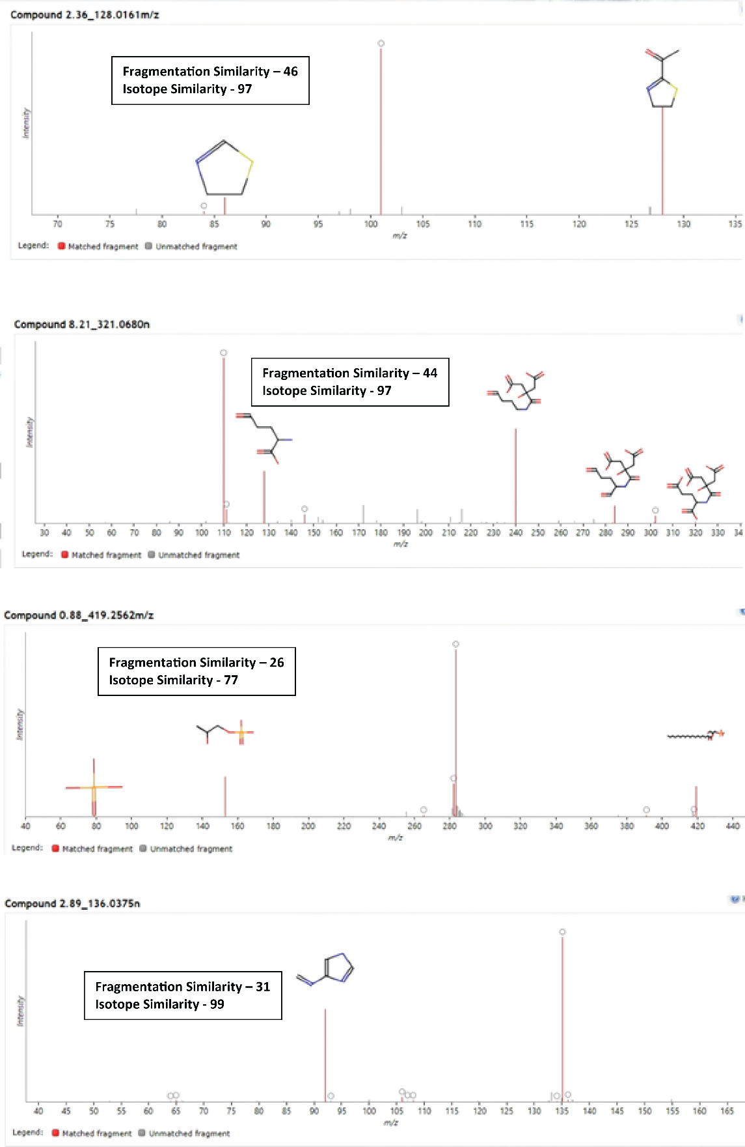
Figure S2: Representative examples showing spectra matching at different fragmentation similarity and isotope similarity scores.

Table S4: Clinicopathologic characteristics of the patients in each of the colorectum subsites

 | Cecum | Ascending | Transverse | Descending | Sigmoid | Rectosigmoid | Rectum | P-value
Sex | F: 28(44.5%)  M:35(55.5%) | F: 22(46.7%)  M:22(53.3%) | F: 14(50%)  M: 14 (50%) | F:14(43.75%)  M:18(56.25%) | F: 34(44.80%)  M: 42(55.26%) | F:1 8(47.37%)  M: 20(52.63%) | F: 43(46.74%)  M: 49(53.26%) | 0.997
Age | 67.44  (±13.06) | 66.17  (±13.54) | 67.00  (±10.74) | 61.37  (±15.07) | 64.84  .(±10.69) | 64.00(±11.66) | 61.90  (±12.49) | 0.073
I | 11 | 7 | 3 | 3 | 7 | 9 | 26 | 0.006
II | 18 | 14 | 10 | 5 | 19 | 11 | 23 | 0.006
III | 9 | 12 | 5 | 10 | 13 | 5 | 24 | 0.006
IV | 25 | 12 | 10 | 14 | 37 | 13 | 19 | 0.006

Table S5: Bonferroni posthoc analysis of stages between the colorectum subsites

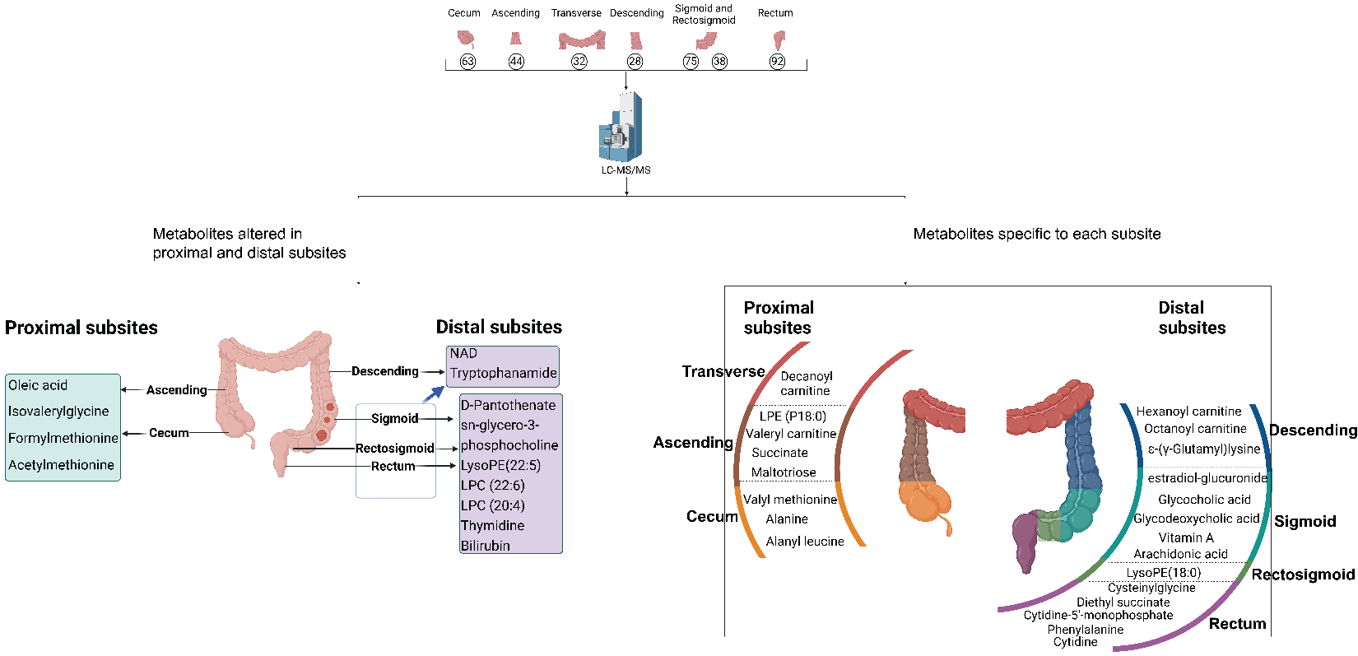
Figure S3: Unique metabolite changes in tumors compared to matched normal mucosa in each of the seven subsites of colorectum. Only the metabolites annotated with analytical standards are shown.

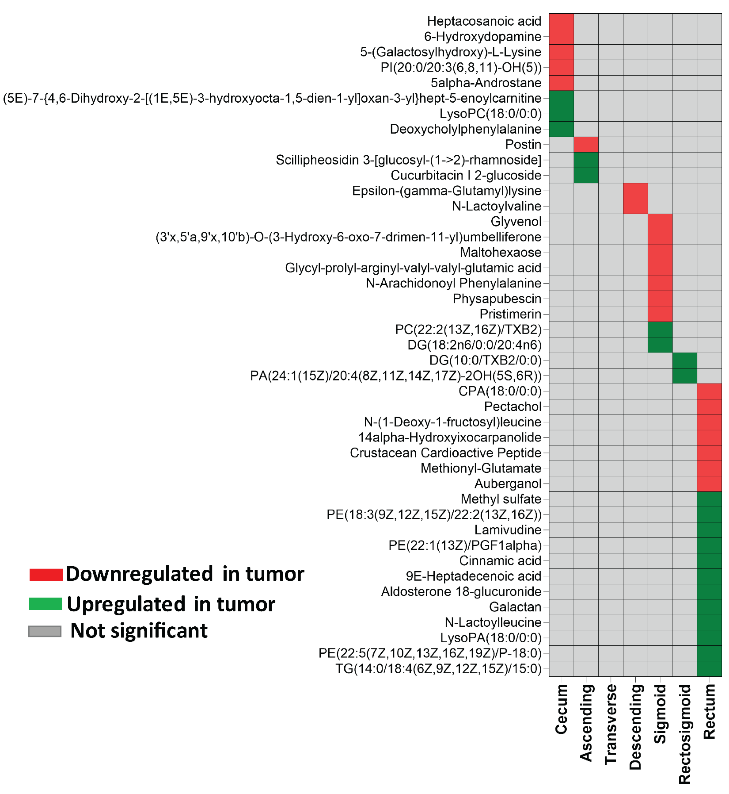
Figure S4: Unique metabolite changes in tumors compared to matched normal mucosa in each of the seven subsites of colorectum. The additional metabolites annotated with Progensis QI at level 3 are shown.

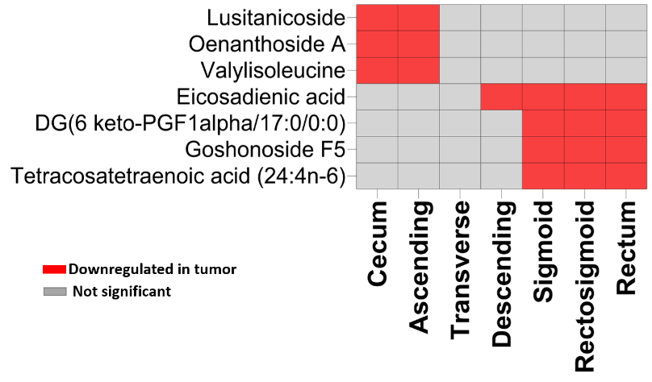
Figure S5: Unique metabolite changes in tumors compared to matched normal mucosa in only proximal subsites or distal subsites of colorectum. The additional metabolites annotated with Progensis QI at level 3 are shown.

Table S6: List of metabolites commonly altered across the different subsites of the colorectum and their association with CRC. FDR- False discovery rate, logFC- log fold change(tumor/normal), OR-Odds ratio

 |  | Cecum | Ascending | Transverse | Descending | Sigmoid | Rectosigmoid | Rectum
5-Hydroxyindoleacetic acid (HIAA) | FDR | 2.00E-03 | 1.00E-06 | 7.10E-05  7.10E-05 | 8.00E-06 | 1.00E-09  1.00E-09 | 2.00E-08 | 3.00E-13  3E-13
5-Hydroxyindoleacetic acid (HIAA) | LogFC | -1.77 | -2.37 | -2.21 | -2.66 | -2.22 | -2.71 | -2.36
5-Hydroxyindoleacetic acid (HIAA) | OR | 0.43 | 0.25 | 0.27 | 0.13 | 0.27 | 0.12 | 0.14
Uric acid | FDR | 6.00E-03 | 6.00E-03 | 4.00E-04 | 4.20E-02 | 3.00E-08 | 5.40E-04 | 8.00E-12
Uric acid | LogFC | -0.63 | -0.9 | -1.24 | -0.93 | -1.09 | -0.89 | -1.34
Uric acid | OR | 0.49 | 0.38 | 0.23 | 0.52 | 0.27 | 0.26 | 0.18
Gly-Phe | FDR | 3.00E-04 | 3.00E-04 | 7.00E-03 | 4.00E-03 | 3.38E-06 | 4.00E-05 | 5.00E-08
Gly-Phe | LogFC | 1.02 | 0.85 | 1.2 | 1.38 | 1.4 | 1.25 | 1.05
Gly-Phe | OR | 1.54 | 1.76 | 2.77 | 1.68 | 1.99 | 2.19 | 2.19
Butyrylcarnitine | FDR | 3.00E-04 | 7.00E-03 | 2.80E-03 | 9.00E-04 | 7.00E-04 | 3.00E-03 | 1.00E-04
Butyrylcarnitine | LogFC | 1.26 | 1.37 | 1.25 | 1.38 | 0.87 | 1.31 | 0.92
Butyrylcarnitine | OR | 1.40 | 1.72 | 1.61 | 2.32 | 1.45 | 1.88 | 1.51
Stearoylcarnitine | FDR | 3.00E-06 | 5.80E-03 | 5.00E-03 | 3.00E-03 | 6.4E-07 | 2.00E-05 | 2.00E-06
Stearoylcarnitine | LogFC | 1.37 | 0.76 | 1.38 | 1.83 | 1.36 | 2 | 1.24
Stearoylcarnitine | OR | 1.94 | 1.43 | 1.69 | 2.14 | 2.01 | 2.40 | 1.90
Lauroylcarnitine | FDR | 2.00E-05 | 1.40E-03 | 1.40E-03 | 5.00E-05 | 1.26E-06 | 3.00E-05 | 4.00E-10
Lauroylcarnitine | LogFC | 1.56 | 1.26 | 1.83 | 2.29 | 1.3 | 1.71 | 1.78
Lauroylcarnitine | OR | 2.13 | 2.00 | 2.21 | 2.92 | 1.60 | 2.12 | 2.34
Myristoylcarnitine | FDR | 4.00E-07 | 8.85E-06 | 3.00E-05 | 2.00E-05 | 2.00E-09 | 1.50E-06 | 4.00E-11
Myristoylcarnitine | LogFC | 1.96 | 1.61 | 2.41 | 2.16 | 1.79 | 2.09 | 1.91
Myristoylcarnitine | OR | 2.26 | 2.38 | 5.107 | 5.157 | 3.082 | 3.348 | 3.845
LysoPC (14:0) | FDR | 1.00E-03 | 4.00E-04 | 2.00E-04 | 1.40E-02 | 1.00E-05 | 1.00E-04 | 8.00E-09
LysoPC (14:0) | LogFC | 1.38 | 1.13 | 1.81 | 1.7 | 1.4 | 1.977 | 1.77
LysoPC (14:0) | OR | 1.42 | 1.35 | 1.40 | 1.55 | 1.51 | 1.65 | 1.79
Kynurenine | FDR | 1.00E-06 | 6.66E-06 | 7.00E-05 | 7.00E-04 | 3.52E-10 | 3.38E-07 | 3.53E-13
Kynurenine | LogFC | 1.41 | 1.39 | 1.51 | 1.43 | 1.59 | 1.87 | 1.63
Kynurenine | OR | 2.948 | 2.066 | 2.415 | 2.729 | 4.245 | 6.591 | 5.114
LysoPE(16:1) | FDR | 7.87E-07 | 3.00E-04 | 4.00E-04 | 5.00E-03 | 4.00E-05 | 4.96E-06 | 1.18E-07
LysoPE(16:1) | LogFC | 1.78 | 1.2 | 2.02 | 1.76 | 1.23 | 1.69 | 1.13
LysoPE(16:1) | OR | 2.36 | 1.52 | 1.82 | 1.64 | 1.7 | 1.83 | 1.59
Citicoline | FDR | 4.46E-07 | 9.07E-08 | 2.92E-05 | 7.00E-05 | 2.65E-10 | 1.10E-07 | 3.53E-13
Citicoline | LogFC | 2.45 | 2.64 | 2.46 | 2.88 | 2.73 | 2.76 | 2.88
Citicoline | OR | 2.407 | 2.859 | 3.357 | 2.514 | 2.973 | 2.353 | 2.467
Diacetylspermine | FDR | 4.00E-06 | 2.42E-07 | 1.50E-04 | 2.10E-05 | 1.69E-10 | 1.17E-08 | 9.74E-13
Diacetylspermine | LogFC | 2.78 | 3.46 | 2.9 | 3.38 | 3.39 | 3.753 | 2.87
Diacetylspermine | OR | 1.94 | 2.34 | 2.28 | 3.90 | 2.53 | 12.35 | 2.60
Linolenic Acid | FDR | 3.00E-04 | 1.70E-04 | 5.00E-03 | 1.90E-02 | 9.00E-08 | 5.80E-06 | 3.00E-10
Linolenic Acid | LogFC | -1.04 | -1.1 | -0.94 | -1.05 | -1.34 | -1.35 | -1.4
Linolenic Acid | OR | 0.57 | 0.42 | 0.58 | 0.51 | 0.37 | 0.35 | 0.37
1.2-Dipalmitoyl-sn-glycero-3-phosphoethanolamine | FDR | 2.00E-05 | 2.00E-05 | 2.00E-05 | 7.60E-04 | 1.00E-09 | 8.00E-06 | 6.00E-13
1.2-Dipalmitoyl-sn-glycero-3-phosphoethanolamine | LogFC | 1.09 | 1.29 | 1.71 | 1.78 | 1.69 | 1.41 | 1.76
1.2-Dipalmitoyl-sn-glycero-3-phosphoethanolamine | OR | 3.82 | 4.31 | 6.03 | 6.03 | 4.93 | 2.74 | 7.4
Hydroxyproline | FDR | 2.20E-06 | 4.50E-03 | 1.60E-03 | 7.00E-03 | 1.00E-08 | 1.00E-05 | 3.00E-05
Hydroxyproline | LogFC | 0.88 | 0.84 | 0.94 | 1.04 | 1.06 | 1.05 | 0.91
Hydroxyproline | OR | 2.35 | 2.02 | 2.39 | 2.24 | 5.03 | 4.12 | 1.94
Citramalic acid | FDR | 1.78E-04 | 1.10E-03 | 4.10E-02 | 2.40E-02 | 8.00E-04 | 9.00E-03 | 3.00E-05
Citramalic acid | LogFC | 1.27 | 1.35 | 1.09 | 1.57 | 1.04 | 0.83 | 0.89
Citramalic acid | OR | 1.78 | 1.75 | 2.20 | 1.79 | 1.69 | 1.47 | 1.56
Dopamine sulfate | FDR | 7.00E-03 | 2.00E-03 | 4.20E-02 | 1.00E-02 | 7.00E-05 | 3.00E-02 | 1.00E-05
Dopamine sulfate | LogFC | -0.59 | -0.84 | -0.76 | -0.85 | -0.93 | -0.59 | -0.75
Dopamine sulfate | OR | 0.53 | 0.34 | 0.53 | 0.35 | 0.35 | .52 | 0.37
Guanosine diphosphate (GDP)-glucose | FDR | 3.00E-03 | 7.00E-03 | 4.00E-04 | 6.00E-03 | 1.3E-08 | 1.70E-03 | 9E-08
Guanosine diphosphate (GDP)-glucose | LogFC | 1.38 | 1.23 | 2.002 | 2.25 | 1.93 | 1.54 | 1.98
Guanosine diphosphate (GDP)-glucose | OR | 1.40 | 1.59 | 1.82 | 1.53 | 1.73 | 1.47 | 1.57
Alanyl-phenylalanine | FDR | 6.10E-03 | 7.00E-05 | 2.00E-02 | 1.60E-02 | 3.00E-04 | 4.50E-02 | 8.00E-06
Alanyl-phenylalanine | LogFC | 1.05 | 1.17 | 0.88 | 1.27 | 1.26 | 1.01 | 1.16
Alanyl-phenylalanine | OR | 1.69 | 2.40 | 1.68 | 1.84 | 1.79 | 1.66 | 1.81
Glycyl-phenylalanine | FDR | 4.00E-06 | 9.00E-05 | 9.80E-04 | 2.00E-02 | 8.00E-03 | 1.60E-03 | 4.00E-07
Glycyl-phenylalanine | LogFC | 1.55 | 1.74 | 1.33 | 1.21 | 0.97 | 1.26 | 1.18
Glycyl-phenylalanine | OR | 1.98 | 2.85 | 1.91 | 1.55 | 1.52 | 1.917 | 1.93
L-Cysteic acid | FDR | 2.50E-04 | 3.00E-04 | 1.00E-03 | 1.50E-02 | 1.00E-05 | 5.00E-05 | 9.00E-10
L-Cysteic acid | LogFC | 0.75 | 1.06 | 1.2 | 0.93 | 0.9 | 1.16 | 1.16
L-Cysteic acid | OR | 2.46 | 3.29 | 4.71 | 3.56 | 2.87 | 3.24 | 4.48
N-Acetyl-L-cysteine | FDR | 6.20E-06 | 6.00E-06 | 1.60E-03 | 4.40E-02 | 5.00E-07 | 7.10E-04 | 5.00E-08
N-Acetyl-L-cysteine | LOGFC | 1.15 | 0.99 | 0.97 | 0.79 | 1.13 | 1.05 | 0.98
N-Acetyl-L-cysteine | OR | 3.75 | 7.30 | 3.90 | 2.40 | 3.07 | 2.81 | 3.27
Reduced nicotinamide adenine dinucleotide (NADH) | FDR | 2.00E-05 | 9.00E-04 | 3.60E-02 | 1.80E-02 | 5.00E-08 | 2.10E-05 | 8.00E-10
Reduced nicotinamide adenine dinucleotide (NADH) | LogFC | 1.17 | 1.11 | 0.76 | 1.17 | 1.11 | 1.38 | 1.43
Reduced nicotinamide adenine dinucleotide (NADH) | OR | 2.69 | 2.06 | 2.22 | 2.15 | 3.18 | 3.44 | 3.72
Nervonic acid | FDR | 9.20E-04 | 5.00E-04 | 4.00E-04 | 6.40E-03 | 8.00E-10 | 3.00E-07 | 1.30E-09
Nervonic acid | LogFC | 0.97 | 1.12 | 1.58 | 1.91 | 2.16 | 2.23 | 1.54
Nervonic acid | OR | 1.84 | 2.75 | 2.74 | 2.43 | 3.15 | 2.71 | 2.14
S-Lactoylglutathione | FDR | 1.60E-02 | 3.00E-03 | 4.20E-02 | 1.80E-02 | 7.00E-04 | 1.20E-03 | 1.00E-08
S-Lactoylglutathione | LogFC | 0.91 | 1.16 | 1.14 | 1.35 | 0.9 | 1.08 | 1.04
S-Lactoylglutathione | OR | 1.74 | 2.20 | 1.82 | 2.19 | 1.832 | 2.62 | 2.64
Uridine 5'-diphosphate (UDP) | FDR | 1.60E-02 | 6.00E-04 | 1.70E-02 | 5.00E-03 | 1.80E-04 | 1.00E-04 | 7.00E-07
Uridine 5'-diphosphate (UDP) | LogFC | 0.51 | 0.77 | 0.76 | 0.98 | 0.53 | 0.73 | 0.67
Uridine 5'-diphosphate (UDP) | OR | 1.57 | 1.40 | 1.41 | 1.63 | 1.46 | 1.48 | 1.73

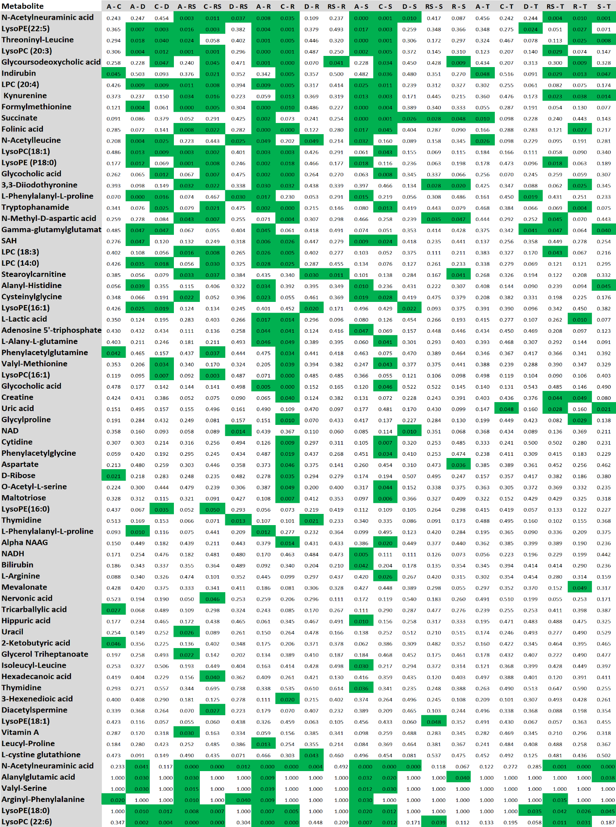
Table S7: Metabolic heterogeneity among normal tissues of seven colorectum subsites. Kruskal-Wallis ANOVA with Dunn’s post hoc test was applied and abundances for metabolites statistically significant (FDR<0.05) in at least one pairwise comparison between colorectum subsites are shown across seven colorectum subsites in normal mucosa (70 metabolites). Significant FDR-corrected p-values are highlighted in green. C-Cecum, A-Ascending, T-Transverse, D-Descending, S-Sigmoid, RS-Rectosigmoid, R-Rectum

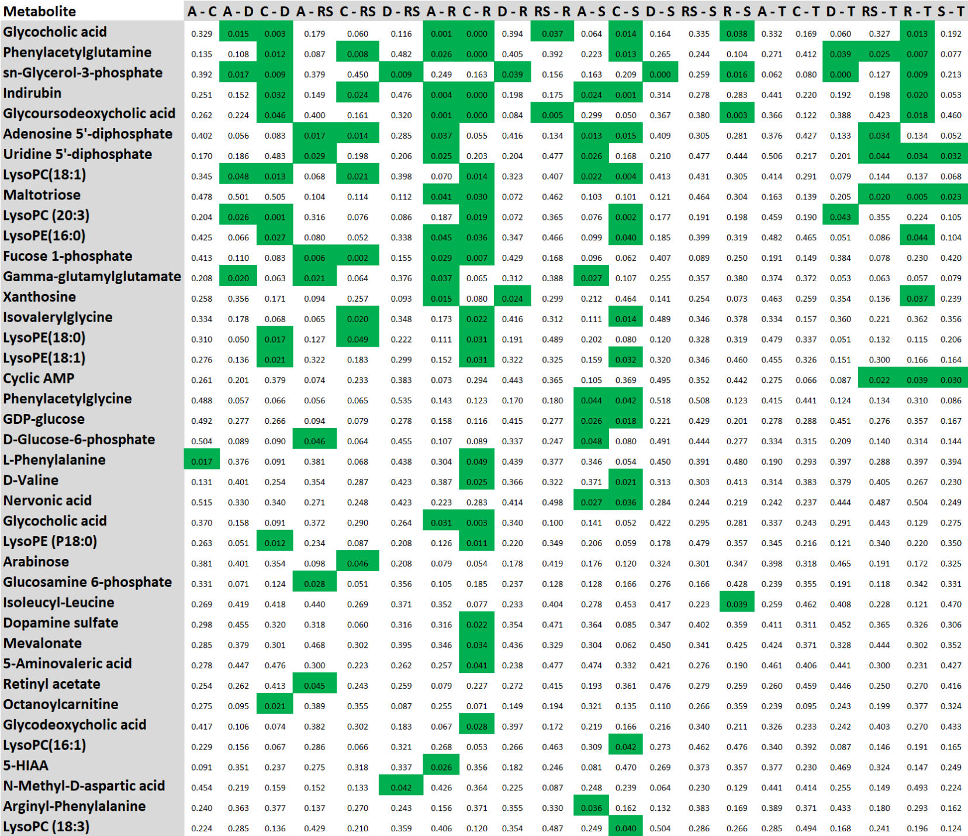
Table S8: Metabolic heterogeneity among colorectum tumors of seven subsites. Kruskal-Wallis ANOVA with Dunn’s post hoc test was applied and abundances for metabolites statistically significant (FDR<0.05) in at least one pairwise comparison between colorectum subsites are shown across seven colorectum subsites in tumors (39 metabolites). Statistically significant FDR-corrected p-values are highlighted in green. C-Cecum, A-Ascending, T-Transverse, D-Descending, S-Sigmoid, RS-Rectosigmoid, R-Rectum

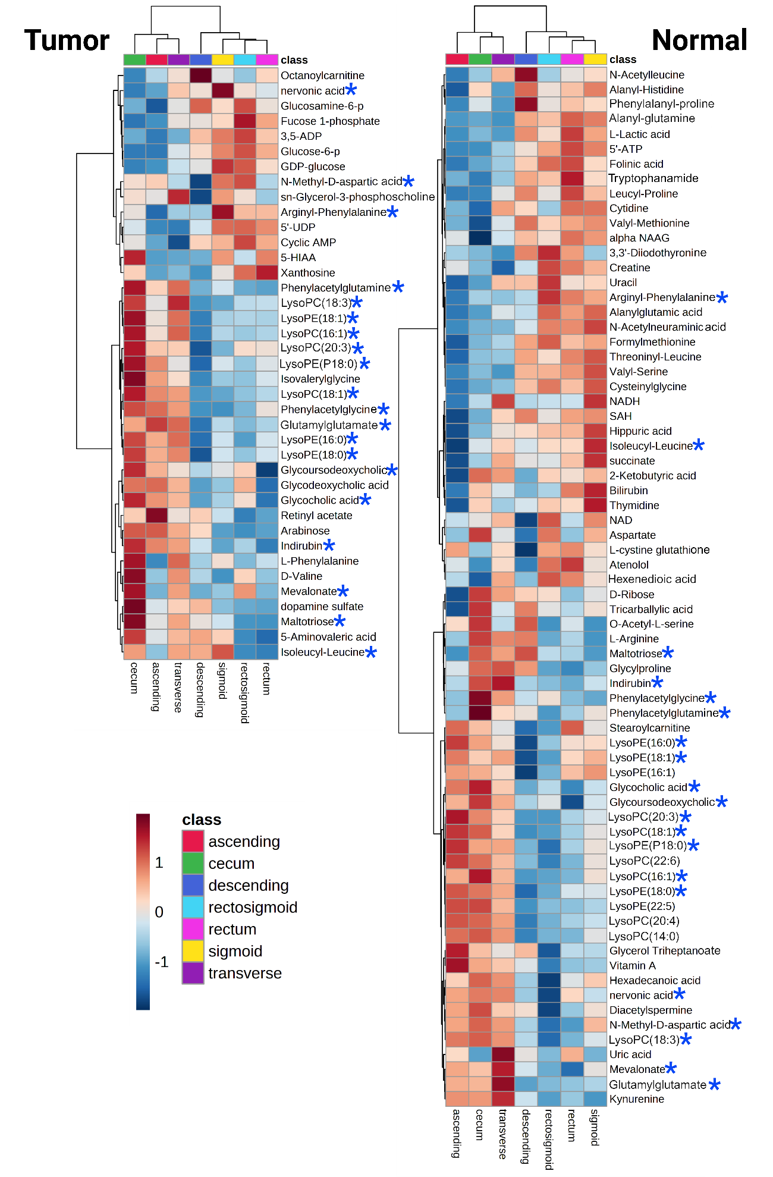
Figure S6: Hierarchical clustering analysis of metabolite abundances from colorectum tissue samples. Abundances for metabolites significantly differentiating in at least one pairwise comparison between colorectum subsites are shown across seven colorectum subsites in tumors (39 metabolites) and normal tissues (70 metabolites). Abundances were averaged from each subsite. Metabolites highlighted with blue asterisk (19 metabolites) were commonly altered in both normal and tumor tissues.
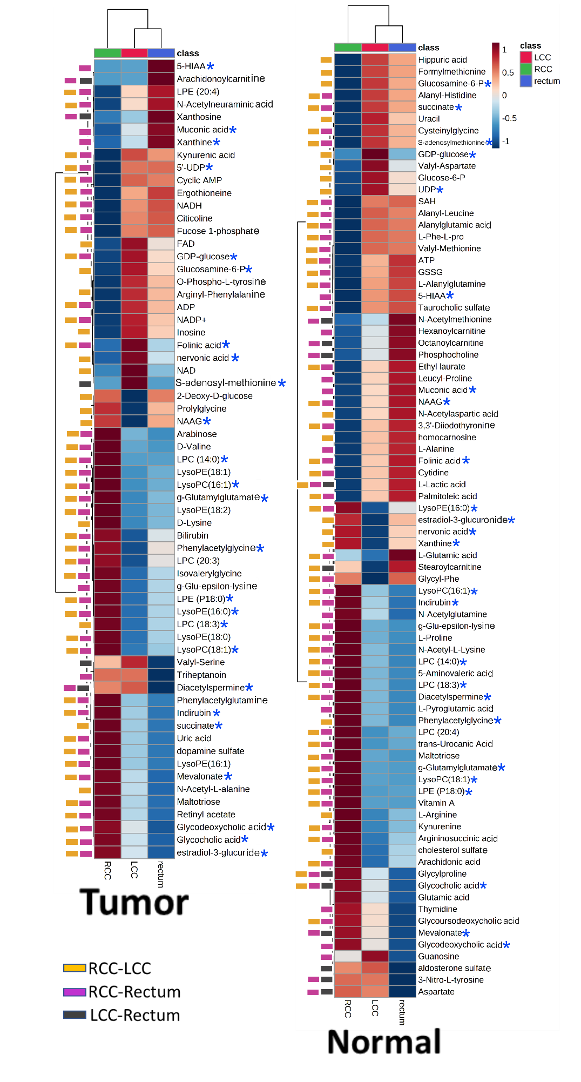
Figure S7: Hierarchical clustering analysis of metabolite abundances from colorectum tissue samples. Abundances for metabolites significantly differentiating in at least one pairwise comparison between three major regions are shown across left side colon, right side colon and rectum in tumors and normal tissues. Abundances were averaged from each subsite. Metabolites highlighted with blue asterisk (25 metabolites) were commonly altered in both normal and tumor tissues.

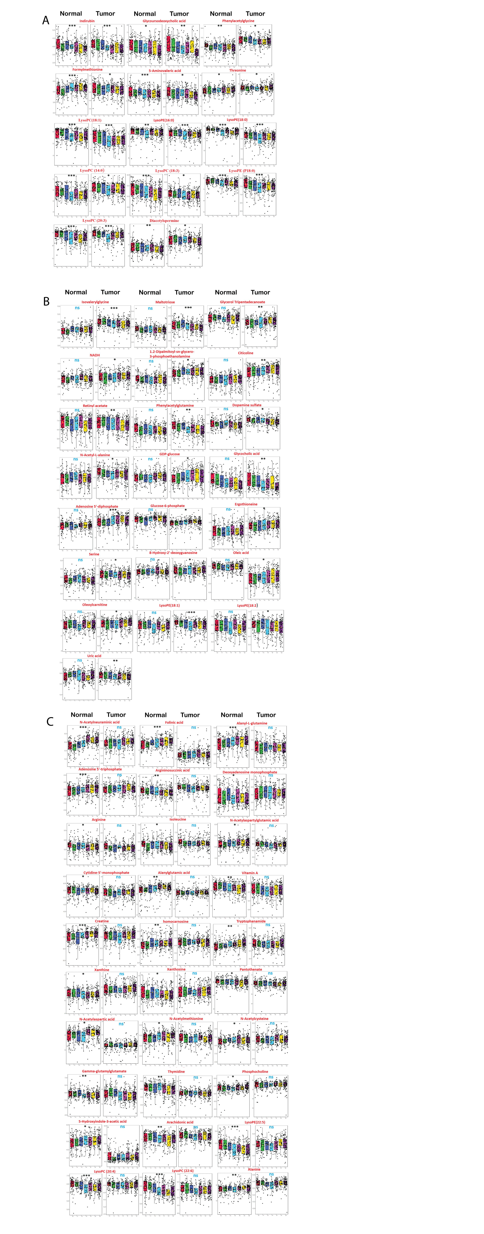

Figure S8: Distribution of metabolite abundances showing concentration gradient exist from cecum to rectum in both tumors and normal mucosa. Linear regression analysis was performed between metabolites abundances and seven subsites. Metabolites showing significant linear trend (P_{linear}<.05) from cecum to rectum in (A) both tumor and normal muocsa, (B) tumor only (C) normal mucosa only. Each subsite is presented in a unique color. Red-cecum, green- ascending, blue- transverse, cyan- descending, light violet- sigmoid, yellow-rectosigmoid and dark violet-rectum. NS = not significant

Table S9: List of metabolites showing signifcaintly lienar trend from cecum to rectum in normal mucosa and tumor tissues
 | Control |  | Tumor
 | slope | p-value | slope | p-value
Significant linear heterogeneity in normal tissue
Folinic acid | .206 | <.001 | .069 | .189
L-Alanyl-L-glutamine | .188 | <.001 | -.078 | .137
N-Acetylneuraminic acid | .349 | <.001 | .088 | .091
Adenosine 5'-triphosphate | .173 | .001 | .063 | .227
Glycylproline | -.172 | .001 | -.054 | .303
Alanylglutamic acid | .145 | .005 | .052 | .322
Ethyl laurate | .144 | .005 | -.016 | .762
Nervonic acid | -.145 | .005 | .078 | .134
Valyl-Serine | .145 | .005 | -.003 | .959
Argininosuccinic acid | -.137 | .008 | -.046 | .38
Glycyl-glycyl-glycine | -.131 | .011 | -.047 | .366
Threoninyl-Leucine | .131 | .011 | .029 | .585
Palmitoleic acid | .127 | .014 | .031 | .557
N-Acetyl-L-cysteine | .125 | .015 | .048 | .36
Deoxyadenosine monophosphate | -.124 | .016 | -.03 | .561
Mevalonate | -.124 | .017 | -.074 | .153
Pyroglutamic acid | -.122 | .018 | .044 | .401
S-Lactoylglutathione | -.123 | .018 | -.006 | .912
N-Acetyl-L-methionine | .122 | .019 | -.037 | .484
N-Acetylaspartylglutamic acid | .12 | .021 | -.01 | .85
Glutathione oxidized | .112 | .031 | .071 | .173
Valyl-Methionine | .11 | .033 | .059 | .259
L-Arginine | -.107 | .04 | -.016 | .759
L-Isoleucine | -.107 | .04 | -.054 | .304
Cholesterol sulfate | -.103 | .047 | -.071 | .175
N-Acetyl-L-aspartic acid | .103 | .048 | .023 | .666
Vitamin A | -.160 | .002 | -.101 | .051
Xanthine | -.104 | .045 | .026 | .618
Xanthosine | -.114 | .027 | -.012 | .824
Pantothenate | -.113 | .028 | -.081 | .118
Thymidine | -.141 | .006 | -.013 | .809
Phosphocholine | .115 | .027 | .068 | .187
N-Methyl-D-aspartic acid | -.190 | <.001 | -.018 | .727
LysoPE (22:5) | -.263 | <.001 | .047 | .367
LysoPC (22:6) | -.272 | <.001 | -.097 | .062
LysoPC (20:4) | -.240 | <.001 | -.020 | .698
Alanine | .133 | .01 | .070 | .178
Homocarnosine | .112 | 0.03 | .058 | .267
Gamma-glutamylglutamate | -.140 | .007 | -.087 | .093
Cytidine-5'-monophosphate | -.108 | .036 | .059 | 0253
Creatine | .188 | <.001 | .028 | .588
Aldosterone sulfate | -.113 | .029 | -.032 | .537
N-Acetylaspartylglutamic acid | .104 | .044 | .023 | .658
Arachidonic acid | -.134 | .009 | -.063 | .221
5-Hydroxyindole-3-acetic acid | .114 | .028 | -.087 | .092
Trptophanamide | .149 | .004 | .061 | .242
Significant linear heterogeneity in tumor tissue
Maltotriose | -.03 | .558 | -.174 | .001
Adenosine 5'-diphosphate | -.005 | .916 | .187 | <0.001
LysoPE (18:1) | -.091 | .078 | -.197 | <.001
LysoPE (18:2) | -.049 | .343 | -.122 | .019
Uric acid | .050 | .334 | -.136 | .008
Oleic acid | -.017 | .749 | .107 | .038
Oleoylcarnitine | .075 | .147 | .109 | .035
Isovalerylglycine | .077 | .136 | -.173 | .001
Glycerol tripentadecanoate | .013 | .807 | .159 | .002
Citicoline | .085 | .102 | .164 | .002
Retinyl acetate | -.101 | .051 | -.153 | .003
Glycocholic acid | -.056 | .285 | -.144 | .005
Phenylacetylglutamine | -.08 | .122 | -.143 | .006
Ergothioneine | .037 | .472 | .132 | .011
Dopamine sulfate | -.092 | .077 | -.13 | .013
Glucose-6-phosphate | .091 | .079 | .127 | .015
NADH | -.018 | .728 | .125 | .016
D-Serine | .017 | .747 | -.123 | .017
Hydrocinnamic acid | .005 | .926 | -.121 | .02
N-Acetyl-L-alanine | -.05 | .34 | -.115 | .028
1,2-Dipalmitoyl-sn-glycero-3-phosphoethanolamine | -.086 | .098 | .11 | .035
GDP-glucose | -.007 | .896 | .11 | .035
4-Hydroxy-3-methoxyphenylacetic acid | .015 | .767 | .121 | .019
8-Hydroxy-2'-deoxyguanosine | .077 | .136 | -.173 | .001
LysoPC (16:1) | -.085 | .120 | -.174 | .001
Significant linear heterogeneity in oth tumor and normal tissue
Indiruin | -.182 | .001 | -.167 | .001
Glycoursodeoxycholic acid | -.11 | .034 | -.153 | .003
Phenylacetylglycine | -.117 | .023 | -.134 | .01
Formylmethionine | .22 | <0.001 | -.12 | .021
5-Aminovaleric acid | -.189 | <0.001 | -.117 | .025
Threonine | .107 | .039 | .124 | .017
Diacetylspermine | -.133 | 0.01 | -.108 | .036
LysoPC (18:1) | -.255 | <.001 | -.220 | <.001
LysoPE (16:0) | -.154 | .003 | -.229 | <.001
LysoPE (18:0) | -.320 | <.001 | -.185 | <.001
LysoPC (14:0) | -.180 | <.001 | -.103 | .048
LysoPC (18:3) | -.216 | <.001 | -.130 | .012
LysoPE (P18:0) | -.203 | <.001 | -.213 | <.001
LysoPC (20:3) | -.288 | <.001 | -.166 | .001

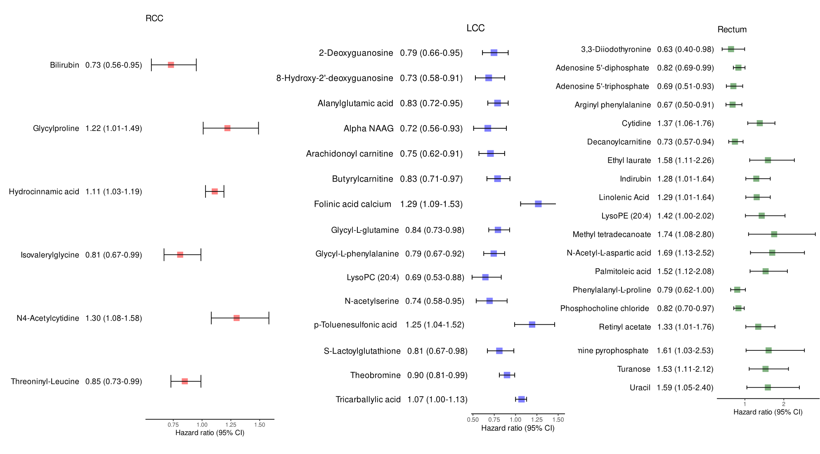
Figure S9: Region specific unique metabolite markers significantly (p <0.05) associated with CRC prognosis in right sided colorectal cancer (RCC), left sided colorectar cancer (LCC) and rectum. Hazard ratio (HR) for each metabolite (log₂-transformed abundance) was calculated by Cox proportional hazard regression analysis between log₂ abundances of individual metabolites and 5-year overall survival in each region, adjusting for age, sex, chemotherapy and stage. Error bars represent 95% confidence intervals (CIs). The unique survival metabolites for each region are color coded differently. RCC-red, LCC-blue, Rectum-green.

