Supplementary Table S1. Candidate list of cell surface molecule screening

GSE65194 (Breast Cancer vs Normal)
Gene Title | Gene symbol
ATP-binding cassette, sub-family A (ABC1), member 1 | ABCA1
ADAM metallopeptidase domain 9 | ADAM9
Annexin A9 | ANKA9
Biglycan | BGN
Calreticulin | CALR
Chemokine (C-C motif) receptor 7 | CCR7
CD24 molecule | CD24
CD274 molecule | CD274
CD 46 molecule, complement regulatory protein | CD46
CD 58 molecule | CD58
CD 74 molecule, major histocompatibility complex, class II invariant chain | CD74
CD 86 molecule | CD86
Cadherin 1, type 1, E-cadherin (epithelial) | CDH1
C-type lectin domain family 7, member A | CLEC7A
Chloride intracellular channel 4 | CLIC4
Cleft lip and palate associated transmembrane protein 1 | CLPTM1
Chemokine (C-X-C motif) ligand 10 | CXCL10
Chemokine (C-X-C motif) ligand 9 | CXCL9
Chemokine (C-X-C motif) receptor 4 | CXCR4
Endoplasmic reticulum protein 27 | ERP27
Fc fragment of IgE, high affinity I, receptor for; gamma polypeptide | FCER1G
Fc fragment of IgG, low affinity IIIa, receptor (CD16a) /// Fc fragment of IgG, low affinity IIIb, receptor (CD16b) | FCGR3A /// FCGR3B
Fibrinogen beta chain | FGB
Fibroblast growth factor receptor 3 | FGFR3
Fibrinogen gamma chain | FGG
GDP dissociation inhibitor 2 | GDI2
Glypican 4 | GPC4
Gremlin 1, DAN family BMP antagonist | GREM1
Major histocompatibility complex, class II, DP alpha 1 | HLA-DPA1
Histocompatibility (minor) 13 | HM13
Hyaluronan-mediated motility receptor (RHAMM) | HMMR
Hepsin | HPN
Heat shock protein 90kDa alpha (cytosolic), class B member 1 | HSP90AB1
Heat shock 60kDa protein 1 (chaperonin) | HSPD1
Intercellular adhesion molecule 1 | ICAM1
Insulin-degrading enzyme | IDE
Insulin-like growth factor 2 receptor | IGF2R
Immunoglobulin heavy locus | IGH
Integrin, beta 2 (complement component 3 receptor 3 and 4 subunit) | ITGB2
Integrin, beta 4 | ITGB4
Lysosomal-associated membrane protein 1 | LAMP1
Lipopolysaccharide binding protein | LBP
Low density lipoprotein receptor | LDLR
Lymphocyte antigen 6 complex, locus D | LY6D
Mannose-6-phosphate receptor (cation dependent) | M6PR
Mucin 1 cell surface associated | MUC1
Prolyl 4-hydroxylase, beta polypeptide | P4HB
Progesterone receptor membrane component 1 | PGRMC1
Plasminogen Activator, urokinase | PLAU
Plasminogen Activator, urokinase receptor | PLAUR
Presenilin 1 | PSEN1
Poliovirus receptor-related 2 (herpesvirus entry mediator B) | PVRL2
Ribosomal protein S6 kinase, 70kDa, polypeptide 1 | RPS6KB1
Selectin L | SELL
Septin 2 | septin 2
Sulfatase 1 | SULF1
Sulfatase 2 | SULF2
Transforming growth factor, beta 1 | TGFB1
Thrombospondin 1 | THBS1
Thy-1 cell surface antigen | THY1
Tumor necrosis factor receptor superfamily, member 12A | TNFRSF12A
TNFSF12-TNFSF13 readthrough /// tumor necrosis factor (ligand superfamily, member 13 | TNFSF13
UL16 binding protein 2 | ULBP2
Vesicle-associated membrane protein 4 | VAMP4
Vascular endothelial growth factor A | VEGFA

GSE45827 (Breast Cancer vs Normal)
Gene Title | Gene symbol
ATP-binding cassette, sub-family A (ABC1), member 1 | ABCA1
ADAM metallopeptidase domain 9 | ADAM9
Annexin A9 | ANKA9
Biglycan | BGN
Calreticulin | CALR
Chemokine (C-C motif) receptor 7 | CCR7
CD24 molecule | CD24
CD274 molecule | CD274
CD 46 molecule, complement regulatory protein | CD46
CD 58 molecule | CD58
CD 74 molecule, major histocompatibility complex, class II invariant chain | CD74
CD 86 molecule | CD86
Cadherin 1, type 1, E-cadherin (epithelial) | CDH1
C-type lectin domain family 7, member A | CLEC7A
Chloride intracellular channel 4 | CLIC4
Cleft lip and palate associated transmembrane protein 1 | CLPTM1
Chemokine (C-X-C motif) ligand 10 | CXCL10
Chemokine (C-X-C motif) ligand 9 | CXCL9
Chemokine (C-X-C motif) receptor 4 | CXCR4
Endoplasmic reticulum protein 27 | ERP27
Fc fragment of IgE, high affinity I, receptor for; gamma polypeptide | FCER1G
Fc fragment of IgG, low affinity IIIa, receptor (CD16a) /// Fc fragment of IgG, low affinity IIIb, receptor (CD16b) | FCGR3A /// FCGR3B
Fibroblast growth factor receptor 3 | FGFR3
GDP dissociation inhibitor 2 | GDI2
GDNF family receptor alpha 1 | GFRA1
Glypican 4 | GPC4
Gremlin 1, DAN family BMP antagonist | GREM1
Major histocompatibility complex, class II, DP alpha 1 | HLA-DPA1
Histocompatibility (minor) 13 | HM13
Hyaluronan-mediated motility receptor (RHAMM) | HMMR
Hepsin | HPN
Heat shock protein 90kDa alpha (cytosolic), class B member 1 | HSP90AB1
Heat shock 60kDa protein 1 (chaperonin) | HSPD1
Intercellular adhesion molecule 1 | ICAM1
Insulin-degrading enzyme | IDE
Insulin-like growth factor 2 receptor | IGF2R
Immunoglobulin heavy locus | IGH
Integrin, alpha L (antigen CD11A (p180), lymphocyte function-associated antigen 1; alpha polypeptide) | ITGAL
Integrin, beta 2 (complement component 3 receptor 3 and 4 subunit) | ITGB2
Integrin, beta 4 | ITGB4
Lysosomal-associated membrane protein 1 | LAMP1
Lipopolysaccharide binding protein | LBP
Low density lipoprotein receptor | LDLR
Lymphocyte antigen 6 complex, locus D | LY6D
Mannose-6-phosphate receptor (cation dependent) | M6PR
Mucin 1 cell surface associated | MUC1
Prolyl 4-hydroxylase, beta polypeptide | P4HB
Progesterone receptor membrane component 1 | PGRMC1
Plasminogen Activator, urokinase | PLAU
Plasminogen Activator, urokinase receptor | PLAUR
Presenilin 1 | PSEN1
Poliovirus receptor-related 2 (herpesvirus entry mediator B) | PVRL2
Ribosomal protein S6 kinase, 70kDa, polypeptide 1 | RPS6KB1
Selectin L | SELL
Septin 2 | septin 2
Sulfatase 1 | SULF1
Sulfatase 2 | SULF2
Transforming growth factor, beta 1 | TGFB1
Thrombospondin 1 | THBS1
Thy-1 cell surface antigen | THY1
Tumor necrosis factor receptor superfamily, member 12A | TNFRSF12A
TNFSF12-TNFSF13 readthrough /// tumor necrosis factor (ligand superfamily, member 13 | TNFSF13
UL16 binding protein 2 | ULBP2
Vesicle-associated membrane protein 4 | VAMP4
Vascular endothelial growth factor A | VEGFA

GSE22358 (Basal type vs Other Breast Cancer)
Gene Title | Gene symbol
Aquaporin 4 | AQP4
Chromosome 12 open reading frame 46 | C12orf46
Caspase recruitment domain family, member 15 | CARD15
CD2 molecule | CD2
CD24 molecule | CD24
CD38 molecule | CD38
CD44 molecule (Indian blood group) | CD44
CD5 molecule | CD5
CD69 molecule | CD69
CD83 molecule | CD83
Cystic fibrosis transmembrane conductance regulator, ATP-binding cassette (sub-family C, member 7) | CFTR
C-type lectin domain family 5, member A | CLEC5A
C-type lectin domain family 7, member A | CLEC7A
Chloride intracellular channel 4 | CLIC4
Chondroitin sulfate proteoglycan 4 (melanoma-associated) | CSPG4
Cathepsin L2 | CTSL2
Chemokine (C-X3-C motif) ligand 1 | CX3CL1
Chemokine (C-X-C motif) receptor 4 | CXCR4
Discoidin, CUB and LCCL domain containing 2 | DCBLD2
Dystrophin (muscular dystrophy, Duchenne and Becker types) | DMD
Epidermal growth factor receptor (erythroblastic leukemia viral (v-erb-b) oncogene homolog, avian) | EGFR
Glutamyl aminopeptidase (aminopeptidase A) | ENPEP
Fas (TNF receptor superfamily, member 6) | FAS
Fas ligand (TNF superfamily, member 6) | FASLG
Fibroblast growth factor binding protein 1 | FGFBP1
Fibroblast growth factor receptor 2 | FGFR2
Frizzled homolog 9 (Drosophila) | FZD9
GDP dissociation inhibitor 2 | GDI2
G protein-coupled receptor 125 | GPR125
G protein-coupled receptor, family C, group 5, member B | GPRC5B
Hyaluronan-mediated motility receptor (RHAMM) | HMMR
Intercellular adhesion molecule 1 (CD54), human rhinovirus receptor | ICAM1
Interferon, gamma | IFNG
Interleukin 12 receptor, beta 2 | IL12RB2
Interleukin 15 | IL15
Interleukin 2 receptor, alpha | IL2RA
Interleukin 6 (interferon, beta 2) | IL6
Integrin, alpha 6 | ITGA6
Potassium voltage-gated channel, subfamily H (eag-related), member 2 | KCNH2
v-kit Hardy-Zuckerman 4 feline sarcoma viral oncogene homolog | KIT
Kelch domain containing 3 | KLHDC3
Lymphocyte-activation gene 3 | LAG3
Lymphocyte antigen 6 complex, locus D | LY6D
Mild fat globule-EGF factor 8 protein | MFGE8
Antigen p97 (melanoma associated) identified by monoclonal antibodies, 133.2 and 96.5 | MF12
Membrane-spanning 4-domains, subfamily A, member 1 | MS4A1
Mesothelin | MSLN
Mucin 16, cell surface associated | MUC16
Notch homolog 1 translocation-associated (Drosophila) | NOTCH1
Notch homolog 2 (Drosophila) | NOTCH2
Proprotein convertase subtilisin/kexin type 9 | PCSK9
Progesterone receptor membrane component 1 | PGRMC1
Plasminogen activator, urokinase receptor | PLAUR
Prominin 1 | PROM1
Protein tyrosine phosphatase, receptor type C | PTPRC
Protein tyrosine phosphatase, receptor type K | PTPRK
Poliovirus receptor | PVR
RGM domain family, member A | RGMA
Reticulon 4 receptor | RTN4R
Scavenger receptor class B, member1 | SCARB1
Selectin L (lymphocyte adhesion molecule 1) | SELL
Secreted frizzled-related protein 1 | SFRP1
Signaling lymphocytic activation molecule family member 1 | SLAMP1
SLAM family member 7 | SLAMF7
Solute carrier family 26, member 9 | SLC26A9
Tumor-associated calcium signal transducer 1 | TACSTD1
Transforming growth factor, alpha | TGFA
Transmembrane protein 123 | TMEM123
Tumor necrosis factor (TNF superfamily, member 2) | TNF
Vascular cell adhesion molecule 1 | VCAM1
Vascular endothelial growth factor | VEGF
V-set and immunoglobulin domain containing 9 | VSIG9
Wingless-type MMTV integration site family, member 5B | WNT5B
Wingless-type MMTV integration site family, member 6 | WNT6

GSE45827 (Basal type vs Other Breast Cancer)
Gene Title | Gene symbol
Intercellular adhesion molecule 1 | ICAM1
Interferon, gamma | IFNG
Interleukin 12 receptor, beta 2 | IL12RB2
Lymphocyte-activation gene 3 | LAG3
Lymphocyte antigen 6 complex, locus D | LY6D
Mesothelin | MSLN
Mucin 16, cell surface associated | MUC16
Prominin 1 | PROM1
Repulsive guidance molecule family member A | RGMA
Secrete frizzled-related protein 1 | SFRP1
Transferrin | TF

Supplementary Table S2. Primer list for plasmid construction in this study
Primer Name | Primer Sequence (5′ to 3′)
Primer 1 | GAG AGA GAA TTC CCC TCA AAA GTC ATC CTG CCC CGG GGA
Primer 2 | TA TAT A GC GGC CGC TCA AGC GTA ATC TGG AAC ATC GTA TGG GTA GGG AGG CGT GGC TTG TGT GTT CGG TTT
Primer A_ΔD1 – fwd | GAG AGA GAA TTC CCC TCA AAA GTC ATC CTG CCC CGG AAA ACC TTC CTC ACC
Primer B_ΔD2 – fwd | TCT TGG CAG CCA GTG CCC CAA GGG CTG GAG
Primer C_ΔD2 – rev | CTC CAG CCC TTG GGG CAC TGG CTG CCA AGA
Primer D_ΔD3 – fwd | CGG GTC CTA GAG GTG AGC CAG GAG ACA CTG
Primer E_ΔD3 – rev | CAG TGT CTC CTG GCT CAC CTC TAG GAC CCG
Primer F_ΔD4 – fwd | CCA GAG GTC TCA GAA GGC CAG CTT ATA CAC
Primer G_ΔD4 – rev | GTG TAT AAG CTG GCC TTC TGA GAC CTC TGG
Primer H_ΔD5 – fwd | TGG ACG TGG CCA GAA GAG GTC ACC CGC GAG
Primer I_ΔD5 – rev | CTC GCG GGT GAC CTC TTC TGG CCA CGT CCA
Primer J_ΔECD – fwd | GAG AGA GAA TTC TCC CCC CGG TAT GAG ATT GTC ATC ATC ACT
Primer K_ΔICD – rev | TA TAT AGC GGC CGC TCA AGC GTA ATC TGG AAC ATC GTA TGG GTA ATA GAG GTA CGT GCT
Primer L_sICAM1 - rev | TA TAT AGC GGC CGC TCA AGC GTA ATC TGG AAC ATC GTA TGG GTA CTC ATA CCG GGG GGA

Supplementary Figures
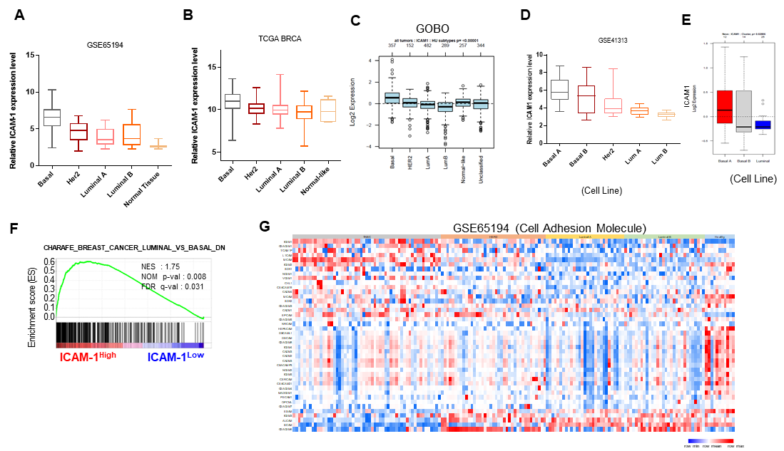
Figure S1. ICAM-1 is highly expressed in basal type breast cancer. (A-C) ICAM-1 expression levels in breast cancer patients from GEO dataset (GSE65194, A), TCGA (B), and GOBO (p<0.00001, provided by GOBO website) (C). (D, E) ICAM-1 expression levels in breast cancer cell lines from GEO dataset (GSE41313, D), and Gene expression-based outcome for breast cancer online (GOBO; p=0.02806, provided by GOBO website) (E). (F) GSEA plots for correlation between ICAM-1 expression and basal-type breast cancer signature genes. (G) Heatmap of breast cancer patients divided by subtype, showing expression levels of cell adhesion molecules. Data are presented as mean ± SD and analyzed by one-way ANOVA (* p < 0.05; **p < 0.01; ***p < 0.001). The GOBO website provide a summary of p-value.

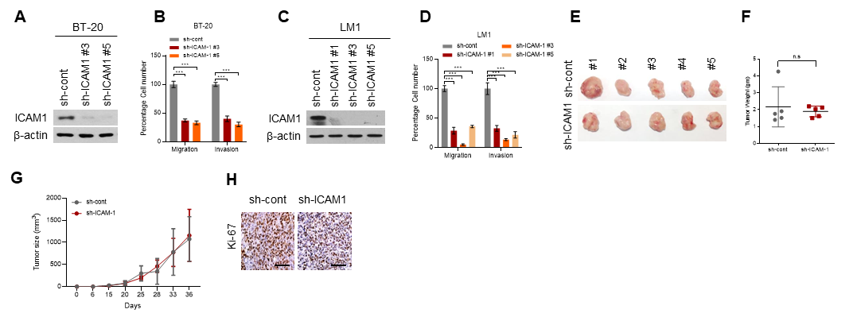
Figure S2. ICAM-1 is associated with promoting metastasis of breast cancer cells both in in vitro and in vivo.
(A, B) Western blot (A) and transwell migration and invasion assay (B) of BT-20 cells transduced with ICAM-1 shRNA. (C, D) Western blot (C) and transwell migration and invasion assay (D) of LM-1 cells transduced with ICAM-1 shRNA. (E-G) Tumor images (E), weight (F), and growth (G) of LM-1^{sh-cont} or LM-1^{sh-ICAM-1} orthotopic xenograft tumors. (H) IHC of Ki-67 in LM-1^{sh-cont} or LM-1^{sh-ICAM-1} orthotopic xenograft tumors. Scale bar = 100 μm. Data are presented as mean ± SD and analyzed by one-way ANOVA or Student’s t-tests. n.s, non-significant; *, p < 0.05; **, p < 0.01; ***, p < 0.001.

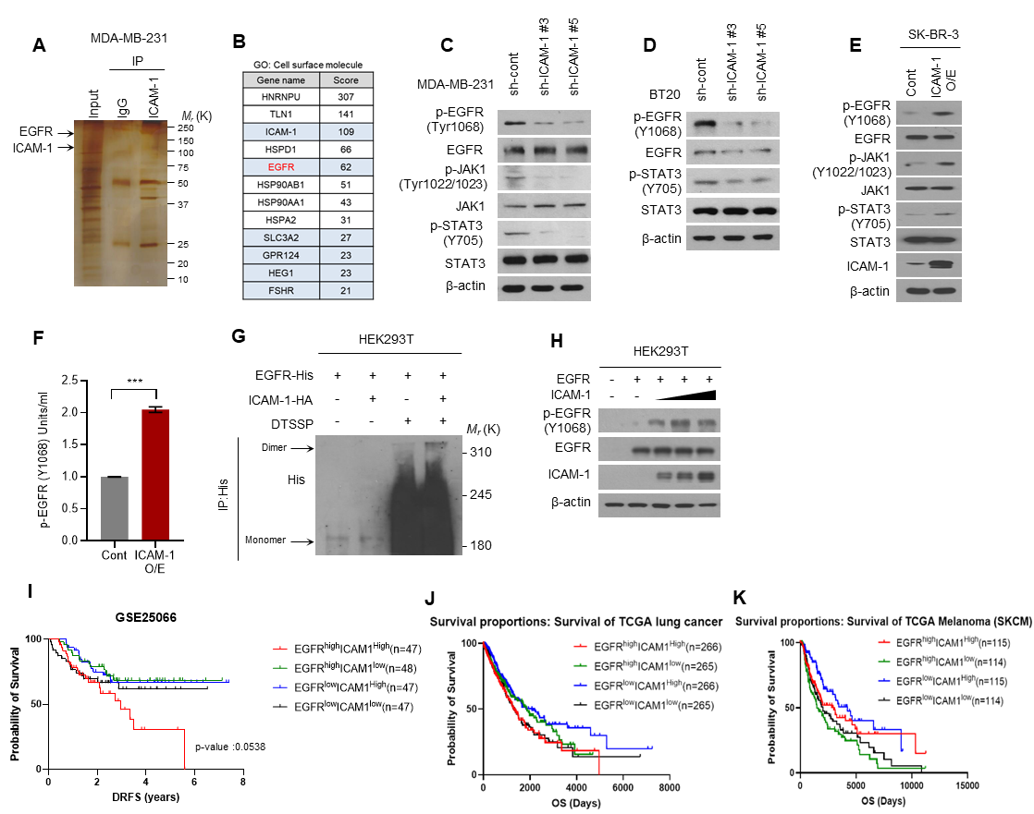
Figure S3. ICAM-1 promotes EGFR activity in breast cancer.
(A) Silver staining of ICAM-1 interactor protein. Total cell lysates are extracted from MDA-MB-231 cells. Co-IP with ICAM-1 antibody and purified proteins were resolved on SDS-PAGE. (B) Target candidate gene list from MALDI-TOF Cell surface molecule screening (C) Western blot for EGFR, JAK1, and STAT3 phosphorylation in MDA-MB-231 cells transduced with ICAM-1 shRNA. (D) Western blot for EGFR, and STAT3 activation in BT-20 cells transduced with ICAM-1 shRNA. (E) Western blot for EGFR, JAK1, and STAT3 activation in SK-BR-3 cells transfected with ICAM-1^{WT} or control empty vector. (F) p-EGFR elisa in SK-BR-3 cells transfected with ICAM-1^{WT} or control empty vector. (G) Dimerization assay to evaluate EGFR dimerization in HEK293T cells transfected EGFR or co-transfected with ICAM-1 vector. (H) Western blot of p-EGFR in HEK293T cells transfected with EGFR or co-transfected with ICAM-1 vector. (I) Kaplan-Meier survival analysis of basal subtype patients with breast cancer (p=0.0538). Breast cancer patients with basal subtypes (n=189) were retrieved from GSE25066 dataset (n=508). (J-K) Kaplan-Meier survival analysis of patients with lung cancer (n=531) and patients with melanoma (n=229) from TCGA database; ICAM-1^{High} EGFR^{High} vs. ICAM-1^{High} EGFR^{Low} vs. ICAM-1^{Low} EGFR^{High} vs. ICAM-1^{Low} EGFR^{Low}. Data are presented as mean ± SD and analyzed by Student’s t-tests. n.s, non-significant; *, p < 0.05; **, p < 0.01; ***, p < 0.001.
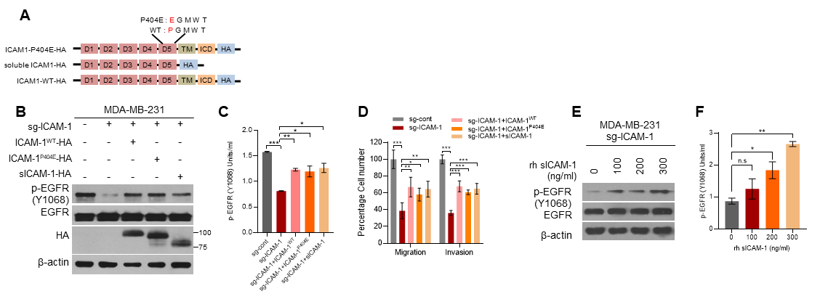
Figure S4. Both soluble and membrane-bound form of ICAM-1 can regulate EGFR activity.
(A) Schematic diagram of expression constructs encoding ICAM-1^{WT}, soluble ICAM-1, and ICAM-1^{P404E}. (b-d) Western blot (B), p-EGFR elisa (C), and transwell invasion, migration assay (D) in MDA-MB-231 sg-cont cells and MDA-MB-231 sg-ICAM-1 cells transfected with either ICAM-1^{WT} or soluble ICAM-1 or ICAM-1^{P404E} vector. (E, F) Western blot (E) and p-EGFR elisa (F) of MDA-MB-231 sg-ICAM-1 cells treated with rh-sICAM-1 in a dose-dependent manner. Data are presented as mean ± SD and analyzed by one-way ANOVA. n.s, non-significant; *, p < 0.05; **, p < 0.01; ***, p < 0.001.

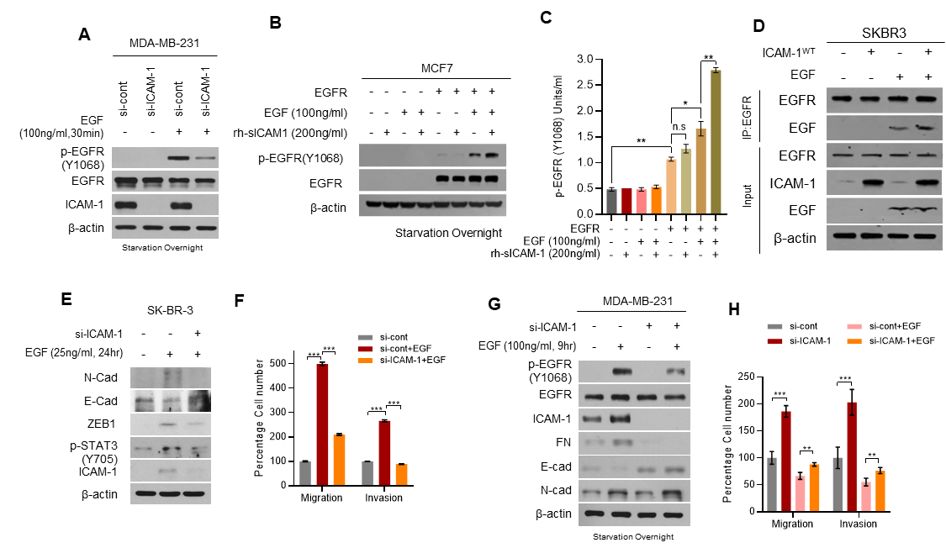
Figure S5. ICAM-1 enhances ligand binding of EGFR.
(A) Western blot of p-EGFR in MDA-MB-231 cells transfected with si-control or si-ICAM-1. Cells are starved overnight and treated with EGF for 30 min. (B, C) Western blot (B), and p-EGFR elisa (C) in MCF7 cells transfected with EGFR or empty control vector. Cells are starved overnight and treated with either EGF or rh-sICAM-1 or co-treated as indicated. (D) Co-IP with EGFR antibody to evaluate the interaction between EGFR and EGF in SK-BR-3 cells transfected with ICAM-1 or control empty vector. EGF was added in total cell lysates. (E, F) Western blot (E), and transwell migration, invasion assay (F) in SK-BR-3 cells transfected with si-control or si-ICAM-1. Cells were starved overnight and treated with EGF for 24 hr. (G, H) Western blot (G), and transwell migration, invasion assay (H) in MDA-MB-231 cells transfected with si-control or si-ICAM-1. Cells were starved overnight and treated with EGF for 9 hr. Data are presented as mean ± SD and analyzed by one-way ANOVA. n.s, non-significant; *, p < 0.05; **, p < 0.01; ***, p < 0.001.

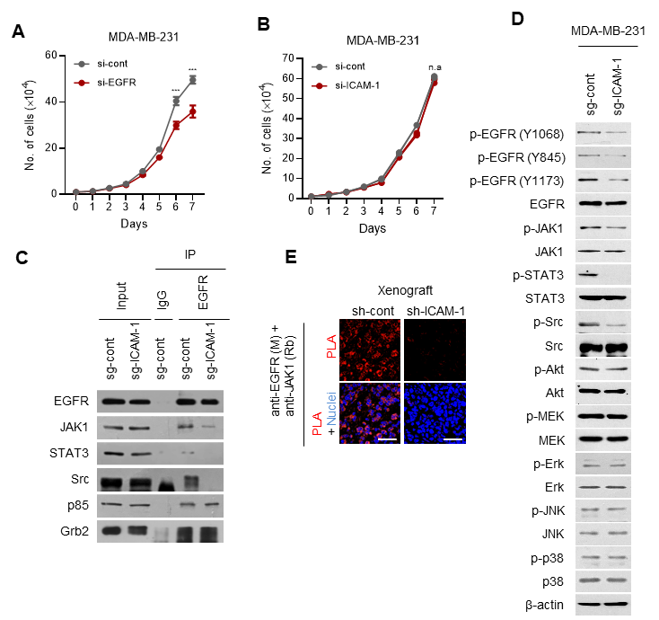
Figure S6. ICAM-1 mediates biased-signaling of EGFR.
(A) Cell growth analysis of MDA-MB-231 cells transfected with si-control or si-EGFR. (B) Cell growth analysis of MDA-MB-231 cells transfected with si-control or si-ICAM-1. (C) Co-IP with EGFR antibody and western blot to evaluate the interaction between EGFR and downstream kinases in MDA-MB-231 sg-cont and MDA-MB-231 sg-ICAM-1 cells. (D) Western blot of EGFR and downstream signaling kinases phosphorylation in MDA-MB-231 sg-cont and MDA-MB-231 sg-ICAM-1 cells. (E) in situ PLA to evaluate the interaction between EGFR and JAK1 in LM-1 sh-cont or LM-1 sh-ICAM-1 orthotopic xenograft tumors. Scale bar = 100 μm. Data are presented as mean ± SD and analyzed by one-way ANOVA. n.s, non-significant; *, p < 0.05; **, p < 0.01; ***, p < 0.001.

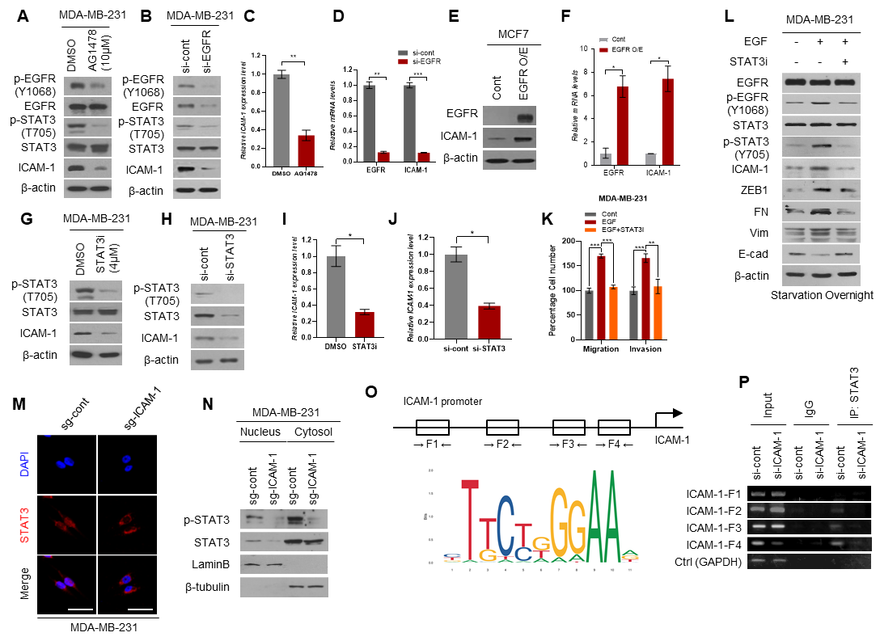
Figure S7. ICAM-1 is induced via EGFR/STAT3 positive feedback regulation.
(A, B) Western blot of p-EGFR, p-STAT3, and ICAM-1 in MDA-MB-231 cells treated with EGFR inhibitor (AG1478, 10μM) for 24hr (A) or transfected with EGFR siRNA (B). (C, D) RT-qPCR of ICAM-1 expression in MDA-MB-231 cells treated with EGFR inhibitor (AG1478, 10μM) for 24hr (C) or transfected with EGFR siRNA (D). (E, F) Western blot (E), and RT-qPCR (F) of EGFR and ICAM-1 in SK-BR-3 cells transfected with ICAM-1 or empty control vector. (G, H) Western blot of p-STAT3, and ICAM-1 in MDA-MB-231 cells treated with STAT3 inhibitor (WP1066, 4μM) for 24hr (G) or transfected with STAT3 siRNA (H). (I, J) RT-qPCR of ICAM-1 expression in MDA-MB-231 cells treated with STAT3 inhibitor (WP1066, 4μM) for 24hr (I) or transfected with STAT3 siRNA (J). (K, L) Transwell migration, invasion assay (K), and western blot (L) of MDA-MB-231 cells. Cells were starved overnight and treated with EGF or co-treated with STAT3 inhibitor. (M) ICC of STAT3 in MDA-MB-231 sg-cont and MDA-MB-231 sg-ICAM-1 cells to evaluate the localization of STAT3. Scale bar = 20 μm. (N) Nucleus/cytosolic faction analysis to evaluate STAT3 and p-STAT3 in MDA-MB-231 sg-cont and MDA-MB-231 sg-ICAM-1 cells. (O) Schematic diagram of ICAM-1 promoter and STAT3 binding motif. F1 to F4 are predicted STAT3 binding sites of the ICAM-1 promoter. (P) Chip assay with STAT3 antibody to evaluate the direct binding between STAT3 and ICAM-1 promoter sites in MDA-MB-231 cells transfected with si-control or si-ICAM-1. Data are presented as mean ± SD and analyzed by one-way ANOVA or Student’s t-tests. n.s, non-significant; *, p < 0.05; **, p < 0.01; ***, p < 0.001.
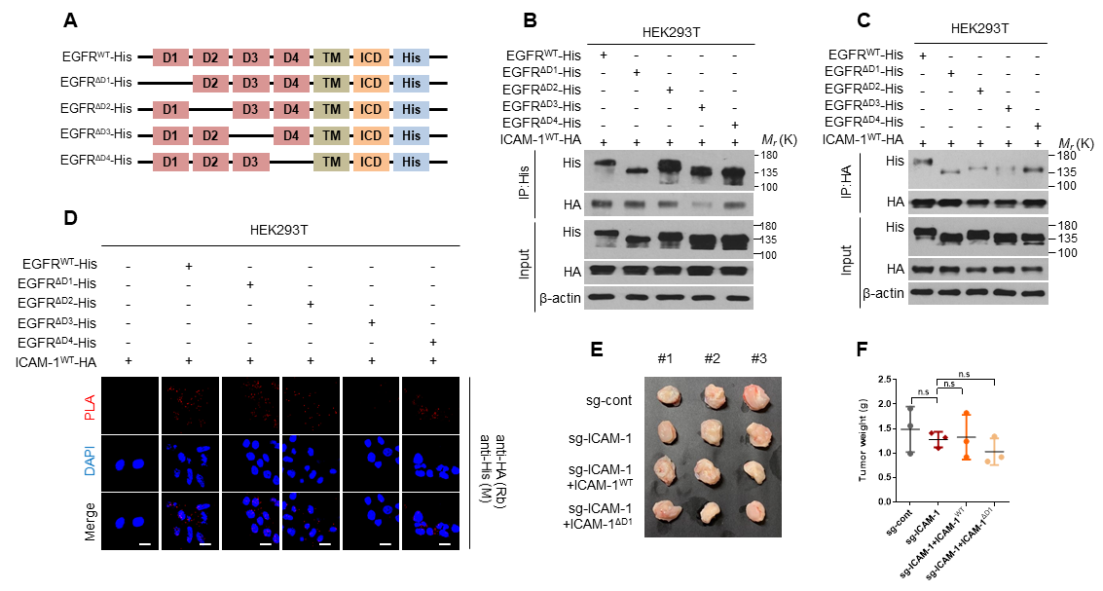
Figure S8. D3 domain of EGFR is necessary for ICAM-1 binding.
(A) Schematic diagram of expression constructs encoding EGFR^{WT}, EGFR^{ΔD1}, EGFR^{ΔD2}, EGFR^{ΔD3}, and EGFR^{ΔD4}. (B-D) Co-IP with His antibody (B) or HA antibody (C), and in situ PLA (D) to evaluate interaction domain between EGFR and ICAM-1 in HEK293T cells co-transfected with ICAM-1^{WT} and either EGFR^{WT} or EGFR^{ΔD1} or EGFR^{ΔD2} or EGFR^{ΔD3} or EGFR^{ΔD4}. Scale bar = 20 μm. (E, F) Xenograft tumors (E) and weight (F) of MDA-MB-231 sg-cont cells or MDA-MB-231 sg-ICAM-1 cells transfected with either ICAM-1^{WT} or ICAM-1^{ΔD1} or control empty vector after orthotopic injection into female NSG mice. Data are presented as mean ± SD and analyzed by Student’s t-tests. n.s, non-significant; *, p < 0.05; **, p < 0.01; ***, p < 0.001.

Figure S9. Blocking ICAM-1 using a neutralizing antibody does not alter primary tumor growth. (A-C) Xenograft tumors (A), weight (B), and growth (C) of LM-1 cells after orthotopic injection into female NSG mice following treatment with isotype IgG or ICAM-1 neutralizing antibody. Data are presented as mean ± SD and analyzed by Student’s t-tests. n.s, non-significant; *, p < 0.05; **, p < 0.01; ***, p < 0.001.

