Supplementary information for the manuscript

A multidimensional recommendation framework for identifying biological targets to aid the diagnosis and treatment of liver metastasis in patients with colorectal cancer

Feng Qi, Na Gao, Jia Li, Chenfei Zhou, Jinling Jiang, Bin Zhou, Liting Guo, Xiaohui Feng, Jun Ji, Qu Cai, Liu Yang, Rongjia Zhu, Xinyi Que, Junwei Wu, Wenqi Xi, Wenxing Qin, Jun Zhang
Correspondence: Jun Zhang, junzhang10977@sjtu.edu.cn; Feng Qi, qf12486@rjh.com.cn; Wenxing Qin, qinwenxingqwx@163.com; Wenqi Xi, xwqi1972@rjh.com.cn.

Supplementary Figures
Supplementary Figure 1. Protein Expression Levels and Construction of the Prediction Model for 25 Optimal Genes. (A) The 25 optimal genes exhibit significant differences in protein expression. (B) Their protein expression levels show a significant positive correlation with gene expression. (C-E) Performance of the prediction model constructed using machine learning methods, from single-fold cross-validation to five-fold cross-validation, demonstrating the best performance at five-fold cross-validation with the highest AUC reaching 0.92.

Supplementary Figure 2. Analysis of Mutation-Related Parameters. (A) The correlation between TMB and MSIsensor Score with the five key genes. (B) MSIsensor Score is significantly increased in CRLM patients. (C) In the comparison between mutation and wild-type patients, patients with high MSI are significantly enriched in the mutation group. (D) The correlation of mutation-related parameters—Fraction genome Altered, Aneuploidy score, MSIsensor Score, MSI MANTIS Score, and TMB—with the five key genes. (E-I) Fraction genome Altered and Aneuploidy score are significantly higher in wild-type patients; MSI MANTIS Score and TMB are significantly higher in mutation-type patients.

Supplementary Figure 3. RNA-Level Analysis of Coding and Non-Coding RNAs. (A) ceRNA regulatory network constructed by differentially expressed mRNAs and non-coding RNAs. (B-D) Heatmaps of differentially expressed mRNAs, lncRNAs, and circRNAs. (E) GO functional enrichment analysis of differentially expressed mRNAs, lncRNAs, and circRNAs. (F) KEGG functional enrichment analysis of differentially expressed mRNAs, lncRNAs, and circRNAs. (G-I) Venn diagrams of the four types of RNA modification sites in differentially expressed mRNAs, lncRNAs, and circRNAs.

Supplementary Figure 4. Enrichment Pathways and Genomic Locations of Four Types of Methylation Modifications in Differentially Expressed RNAs. (A) The situation of four types of methylation modification sites in GO enrichment pathways. (B) The situation of four types of methylation modification sites in KEGG enrichment pathways. (C) The percentage of four types of methylation modifications at different genomic locations in primary and liver metastasis patients. (D) Peaks density graphs of four types of methylation modifications at different genomic locations in primary and liver metastasis patients.

Figure S5. GNB1 influence CRC progression. (A) Expression levels of GNB1 in CRC patients without or with metastasis. (B) Representative specimen of mouse models established using GNB1 overexpression lines and the change of tumor counts. (C) Representative specimen of mouse models established using GNB1 knockdown lines and the change of tumor counts. (D-E) Hematoxylin-eosin (H&E) staining of tumor nodules in mouse models established using GNB1 overexpression and knockdown lines. scale bar, 100μm. (F-G) IHC staining of METTL1, GNB1 and Ki67 in mouse specimens established using GNB1 overexpression and knockdown lines. (H-M) Quantified scoring differences of IHC staining on METTL1, GNB1 and Ki67 in mouse specimens established using GNB1 overexpression and knockdown lines. All qRT-PCR data are presented as ± SEM; n = 3. *p < 0.05. **p < 0.01. ***p < 0.001.

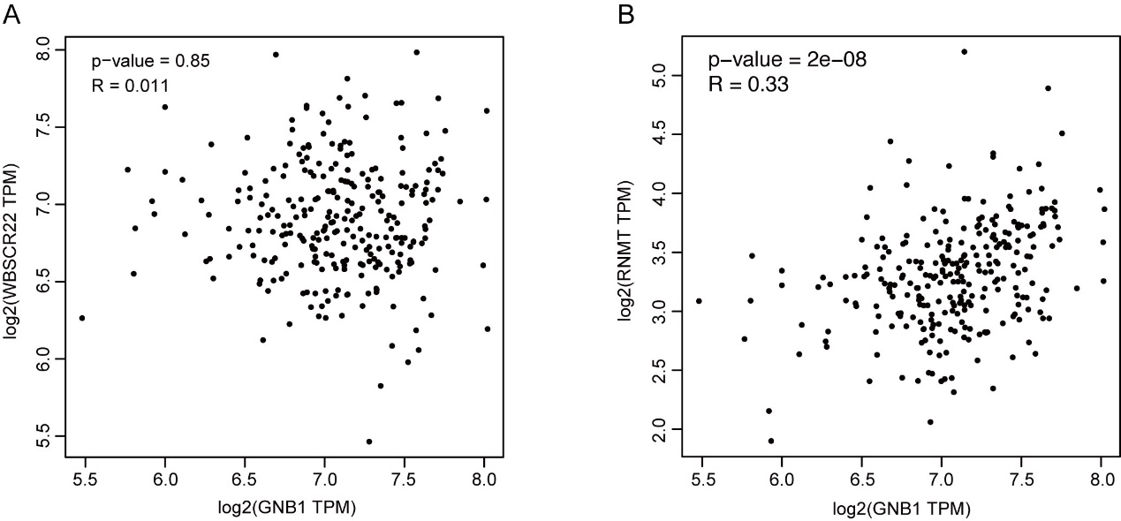
Figure S6. The correlation analysis of m7G methylation "writer" genes with GNB1. (A) WBSCR22 did not show a significant correlation with GNB1. (B) RNMT exhibited a significant positive correlation with GNB1.
Figure S7. Characters of m7G modification in METTL1-KO cells. (A) Global profiling of meRIP seq in SW480 cells: sequence motif identified from the top m7G peaks and distribution of m7G peak reads across all mRNAs. (B) Integrative genomics viewer (IGV) plots of m7G peaks at individual mRNAs. (C-D) qRT-PCR analysis of a-m7G IP in SW480 cells on DVL2 and PHF1.

Figure S8. The spatial transcriptome in CRC patients with liver metastasis. (A) GNB1 expression in different cell subsets. (B) UMAP plot showing the annotation and color codes for T/NK cell subtypes. (C) Boxplot showing the changes of relative proportions on T/NK cell subtypes between primary and metastasis group. (D) UMAP plot showing the annotation and color codes for B/Plasma cell subtypes. (E) Boxplot showing the changes of relative proportions on B/Plasma cell subtypes between primary and metastasis group. (F) The representative HE stained sections of the spatial transcriptome. (G-H) Bar charts and spatial feature plots showing the percentage of different GNB1 expression among the selected tissue sections. (I-J) Bar charts and spatial feature plots showing the differences in the percentages of CD8_CCL5 cells among the selected tissue sections. (K-L) Bar charts and spatial feature plots showing the differences in the percentages of B_memory cells among the selected tissue sections. (M) Scatter plots showing the relationships between SELL and PODXL. *p < 0.05. **p < 0.01. ***p < 0.001.

Figure S9. Fluorescence expression of GNB1 and CT images in metastatic and non-metastatic groups. (A) Different fluorescence expression of GNB1 in CRC without metastasis, colon tumor in CRCLM or liver metastasis in CRCLM. (B) Representative CT imaging pictures of liver in CRC without liver metastasis and with liver metastasis.

