Supplementary figures and legends.
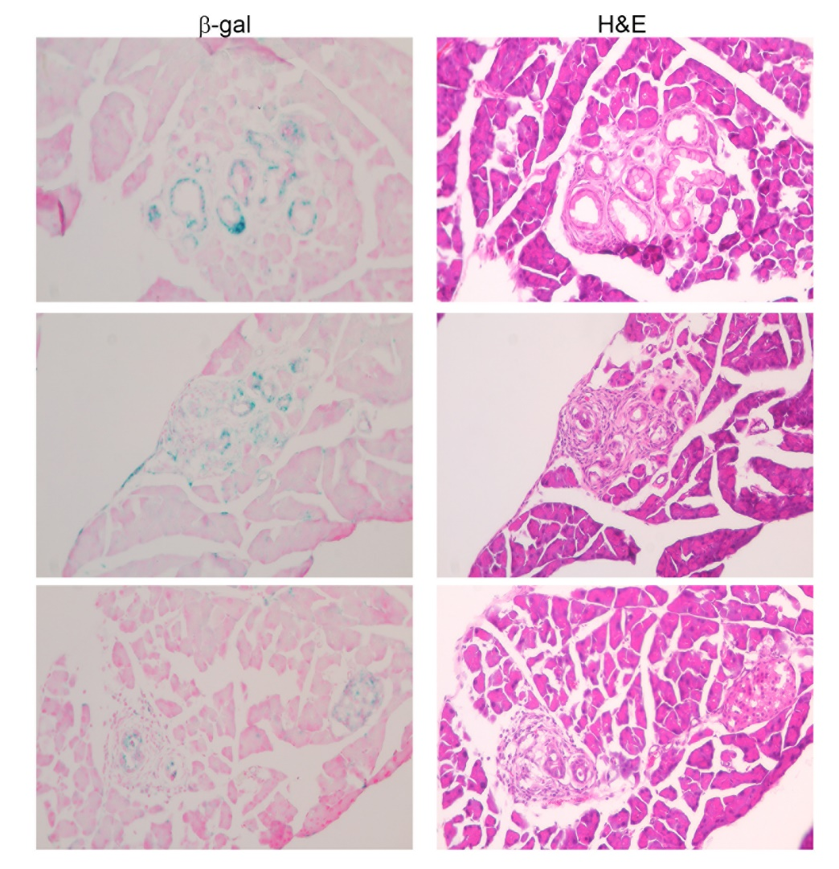
Supplementary figure 1. The expression of SA-β-Gal, which is present only in senescent cells, was detected in KC pancreas. SA-β-Gal staining and histology (H&E) was performed on two consecutive sections of the tissue sample.

Supplementary figure 2. (A) Uniform Manifold Approximation and Projection (UMAP) plot of the normal, early/late lesion pancreas (Kras^{LSL−G12D/+}, Ink4a^{fl/fl}, Ptf1a^{Cre/+}, KIC), and PDAC (Kras^{LSL−G12D/+}, Trp53^{LSL-R172H/+}, Ptf1a^{Cre/+}, KPC; Kras^{LSL−G12D/+}, Trp53 ^{fl/fl}, Pdx1^{Cre/+}, KPfC) composing 13 distinct cell populations. (B) The proportion of 13 distinct cell subsets in different stages of the pancreas. (C)
The differentiation of cellular states predicted by Monocle in different stage of mouse pancreas. (D) Expression level of candidate genes Amy1, Amy2a2, Kras, Krt18, Krt19, and Krt8 in the branched trajectory.

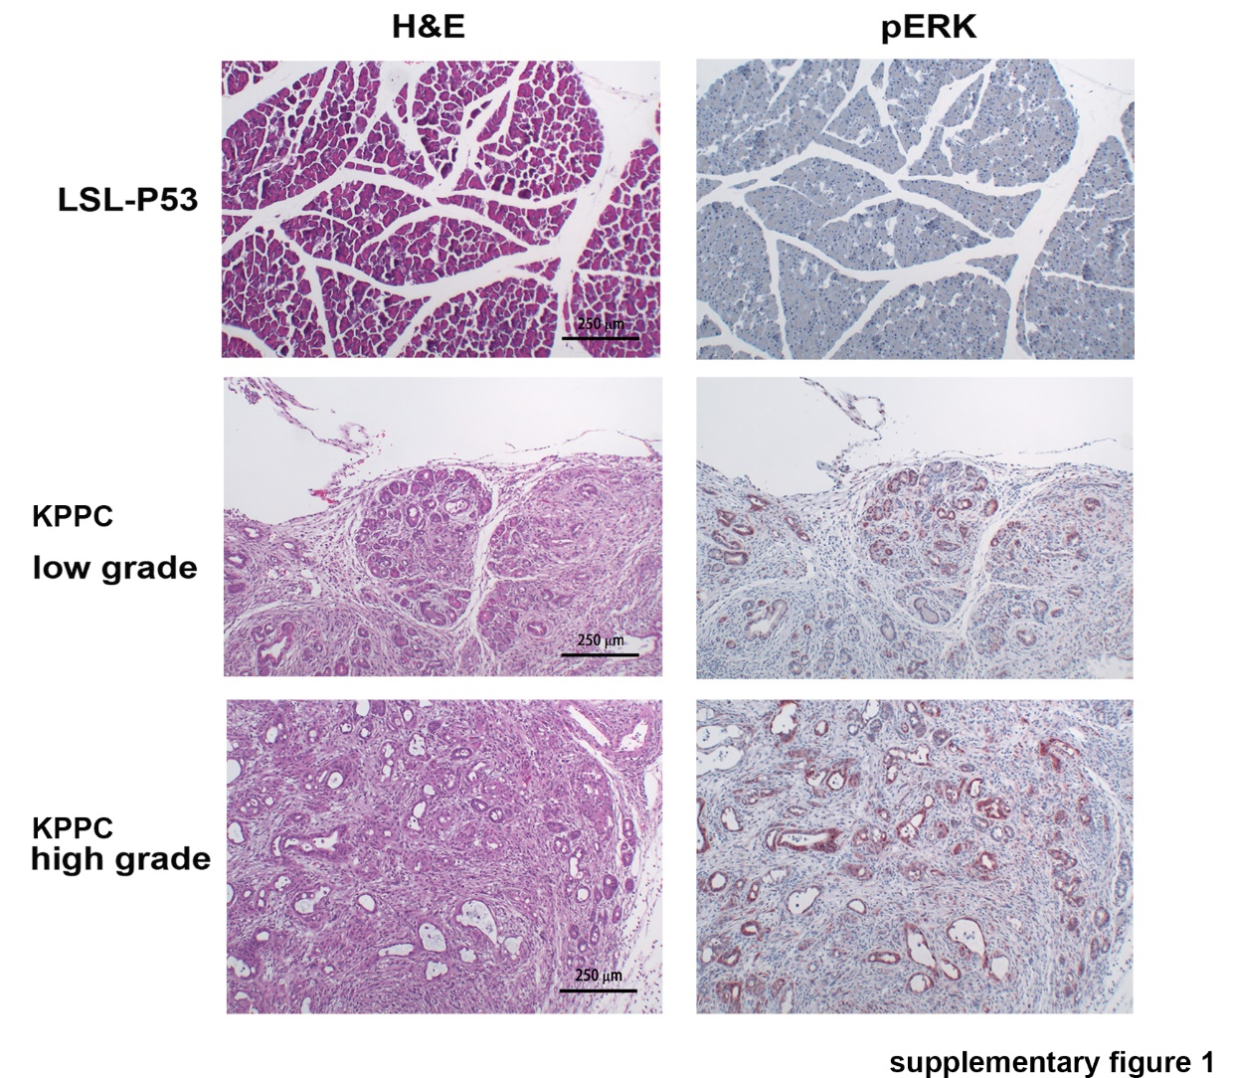
Supplementary figure 3. Expression of phosphor-ERK1/2 in mouse pancreatic tumors. Pancreatic tissues from normal (Trp53^{LSL-R172H/ LSL-R172H}) and KPPC (Kras^{LSL−G12D/+}, Trp53^{LSL-R172H/ LSL-R172H}, Pdx1^{Cre/+}) mice were subjected from immunohistochemistry staining.
Supplementary figure 4. (A) Heatmap depicting the top significantly overexpressed genes in each cluster (C1 to C20). Each column represents an individual cell, and each row is the gene expression value for a single gene. (B) A dot plot showing the relative expression of marker genes used to define each cluster. (C) Hallmark pathway enrichment analysis of DEGs in three epithelial subsets (C1-Epi, C14-Epi, and C15-Epi) detected in a Stage III PDAC tumor. (D) A dot plot showing the relative expression of selected genes in the epithelial cells (E0-E7) in mouse pancreatic tissue.

Supplementary figure 5. (A) Quantification results of ERK1/2 phosphorylation (pERK) and DUSP2 in PANC-1 cells treated with control medium (Ctrl) or conditioned medium (CM) from human pancreatic stellate cells (PSC), U937 (undifferentiated naïve monocyte Mo), and macrophages (Mac) for 48 hours. (B) Quantification results of ERK1/2 phosphorylation (pERK) and DUSP2 in PANC-1 cells co-cultured with different ratio of monocytes (U937) by Transwell for 72 hours. (C) Western blot result shows the expression levels of pERK1/2 and tERK1/2 in AsPC-1 and MIA PaCa-2 cells co-cultured with monocytes (U937) in a 1 to 5 ratio. P: PDAC; U:U937. (D) Co-culture with PANC-1 cells induced monocyte (U937) attachment (upper left). RT-qPCR was performed for the detection of CD86 and CD163 in U937 alone or co-cultured with PANC-1 cells (upper right). IL1B and IL10 in U937 alone or co-cultured with PANC-1 cells (bottom). (E) Western blot result shows the expression levels of pERK1/2, tERK1/2, and DUSP2 in PANC-1, AsPC-1, and MIA PaCa-2 cells alone or co-cultured with macrophages. Monocytes were first differentiated into macrophages and then co-cultured with pancreatic cancer cells. (F) Correlation analysis of immunohistochemistry staining intensity for F4.80 and pERK in the lesion of KC (Kras^{LSL−G12D/+}, Pdx1^{Cre/+}) and KDC (Kras^{LSL−G12D/+}, Dusp2^{fl/fl}, Pdx1^{Cre/+}). (G)Immunofluorescence staining for CD68 (red) and pERK (white) in the lesion of KDC (Kras^{LSL−G12D/+}, Dusp2^{fl/fl}, Pdx1^{Cre/+}) and KC (Kras^{LSL−G12D/+}, Pdx1^{Cre/+}).

Supplementary figure 6. DUSP2 knockdown recapitulates MCM-treated phenotypes in PANC-1 cells.
- Morphology of PANC-1 cells treated with CM from U937 (UCM) and macrophages (MCM) after 24 and 48 hours. (B) Representative Western blot results show the expression of pERK1/2 and tERK in HPDE and MIA-PaCa2 cells treated with MCM. (C) Transwell migration assay was performed in MIA PaCa-2 cells treated with control and MCM. Representative pictures (middle) and quantification of migrated cell numbers (right, n=3) as indicated. (D) RT-qPCR for the expression of CDH1 in PANC-1 cells treated with CM from monocyte (U), macrophage (M), or co-treated with ERK inhibitor (SCH772984). (E) Chromatin immunoprecipitation for the binding of CtBP to E-cadherin promoter in control and MCM-treated PANC-1 cells. (F) AsPC-1 cells were pre-treated with ERK inhibitor (SCH772984) for 15 mins and then treated with MCM or co-cultured with macrophages for 48 hours (left). AsPC-1 cells were pre-treated with HDAC1/2 inhibitor (B390) for 15 mins and then treated with MCM for 24 hours. Representative western blot results show the expression of pERK, E-cadherin, ERK and GAPDH. (G) Control and DUSP2-KD PANC-1 cells were plated in petri dish and recorded by live cell imaging (JuLiBr) for 24 hours. The track of sequence image was measured and quantified by ImageJ. (H) RT-qPCR for the expression of CDH1 in control and DUSP2-KD cells. CYCLOPHILIN B (PPIB) was used as internal control. (I) Immunofluorescence staining of E-cadherin in control and DUSP2-KD PANC-1 cells. F-actin stains for cytoskeleton and Hoechst stains for cell nucleus. (J) Immunohistochemistry staining for E-cadherin in control and DUSP2-KD PANC-1 tumors. Tumors were developed via orthotopic injection of control and DUSP2-KD PANC-1 cells in pancreas of mice.

Supplementary figure 7. (A) CellChat analysis for the number of interactions and interaction strength in early and late KIC mouse pancreas. (B) CellChat analysis for VEGF signaling among 13 distinct cell populations in early and late KIC pancreas. Circle plot was served as visualization outputs and different colors represent different cell groups. (C) A dot plot showing the relative expression of a subset of T-cell marker genes to distinguish the potential function of T-cells (left). Proportion of T cells (CD8+ and other T cells) in early and advanced PDAC tumors (right).
Supplementary figure 8. (A) A dot plot showing the average expression of macrophage marker genes in all clusters. (B) Percentage frequency of macrophage populations in early and advanced PDAC tumors. (C) Hallmark pathway enrichment analysis of DEGs in three macrophage subsets (C4-Mac and C12-Mac) in early and advanced PDAC tumor. (D) The expression of pERK, E-cadherin, and β-actin in PANC-1 cells treated with MCM and different inhibitors. (E) Monocytes (Mon) or macrophages (Mac) were co-cultured with different pancreatic cancer cells (PANC-1, MIA PaCa-2, AsPC-1, and KPPC) for 48 hours. The expression of TIMP-1 and GAPDH was determined by Western blotting. (F) The expression of pERK and tERK in control and CD63-KD cells treated with different doses of MCM for 24 hours. MCM was diluted by RPMI medium containing 10% FBS.

Supplementary figure 9. The regulation by MCM in PANC-1 is reversible. (A) PANC-1 cells treated with MCM for 48 hours were cultured back to medium without MCM for another 48 hours. Western blotting was performed to detect the expression of DUSP2, pERK, tERK, E-cadherin and β-actin.

