Supplementary Materials
CircAKT3 promotes Prostate Cancer Proliferation and Metastasis by enhancing the Binding of RPS27A and RPL11

Supplementary figures and legends

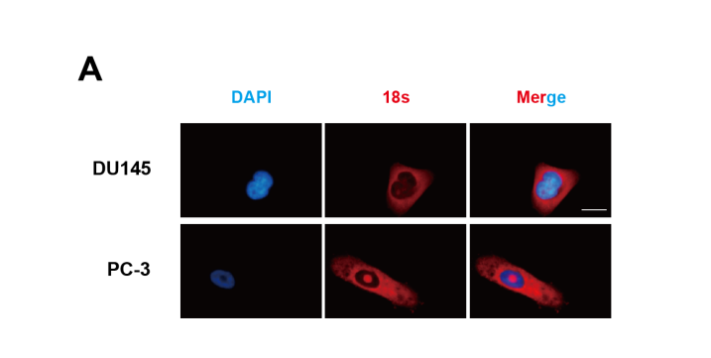
Fig. S1 Characteristics of the novel circular RNA circAKT3 in prostate cancer. A The subcellular localization of 18S rRNA was detected using the RNA-FISH assay (red) as a positive control. Nuclei were stained with DAPI (blue). Scale bar, 20 μm.
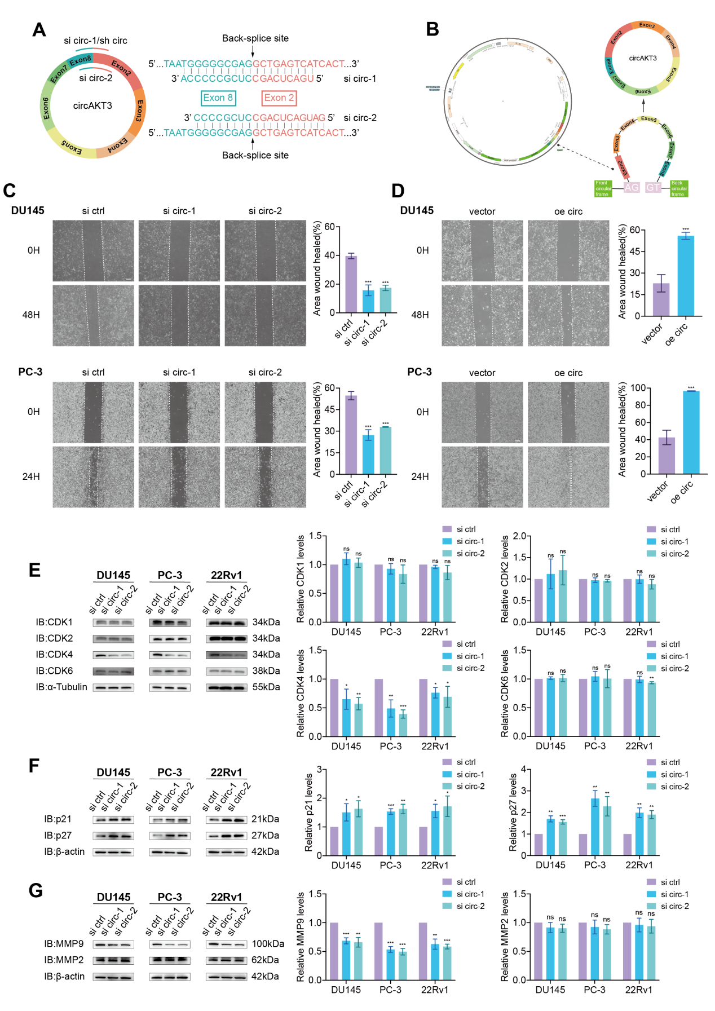
Fig. S2 CircAKT3 enhances PCa cells migration in vitro. A Schematic illustration of two specific siRNAs targeting the circAKT3 back-splice site. circ, circAKT3. B Diagram depicting the circAKT3 overexpression plasmid. C-D Wound-healing assays showed that circAKT3 increased the migratory ability of DU145 and PC-3 cells. Scale bar, 200 μm. Data are presented as mean ± SD. ***P < 0.001, Student’s t-test, n = 3. E Protein levels of CDK1, CDK2, CDK4, and CDK6 following downregulation of circAKT3 expression. α-Tubulin was used as the loading control. Data are expressed as mean ± SD. ***P < 0.001, **P < 0.01, *P < 0.05, ns, not significant, Student’s t-test, n = 3 independent experiments. F Protein level of p21 and p27 following downregulation of circAKT3 expression. β-actin was used as the loading control. Data are expressed as mean ± SD. ***P < 0.001, **P < 0.01, *P < 0.05, Student’s t-test, n = 3 independent experiments. G Protein level of MMP9 and MMP2 after downregulation of circAKT3 expression. β-actin was used as the loading control. Data are expressed as mean ± SD. ***P < 0.001, **P < 0.01, ns, not significant, Student’s t-test, n = 3 independent experiments.
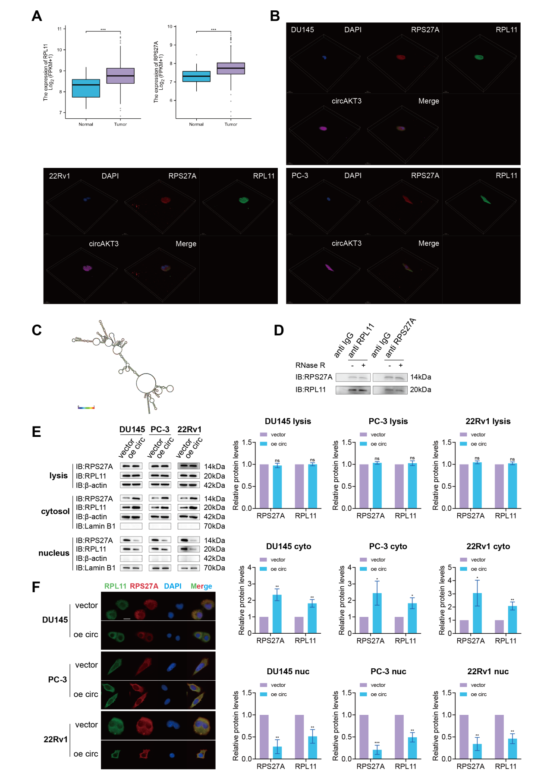
Fig. S3 CircAKT3 interacts with RPS27A and RPL11 to form a ternary complex, modulating the subcellular localization of both proteins. A Upregulation of RPS27A and RPL11 in PCa was observed based on the TCGA database. Data are presented as mean ± SD. ***P < 0.001, Welch's t-test, n = 52 vs. 501. B Representative 3D image from the FISH and IF assays (width: 184.52 μm, height: 184.52 μm, depth: 10.81 μm; scale bar = 20 μm). C The secondary structure of circAKT3 was predicted using the RNAfold website (http://rna.tbi.univie.ac.at/cgi-bin/RNAWebSuite/RNAfold.cgi). D The binding between RPS27A and RPL11 remained unchanged after RNase R treatment. E Western blotting was performed on lysates from PCa cells transfected with vector or circAKT3, analyzing RPS27A and RPL11. β-actin was used as the loading control for the cytosol and lysis, and Lamin B1 for the nucleus. Data are presented as mean ± SD. ns, not significant; ***P < 0.001, **P < 0.01, *P < 0.05, Student’s t-test, n = 3 independent experiments. F IF assays indicated a significant decrease in nuclear levels of RPS27A and RPL11 when circAKT3 was upregulated. Nuclei were counterstained with DAPI. Scale bar, 20 μm.
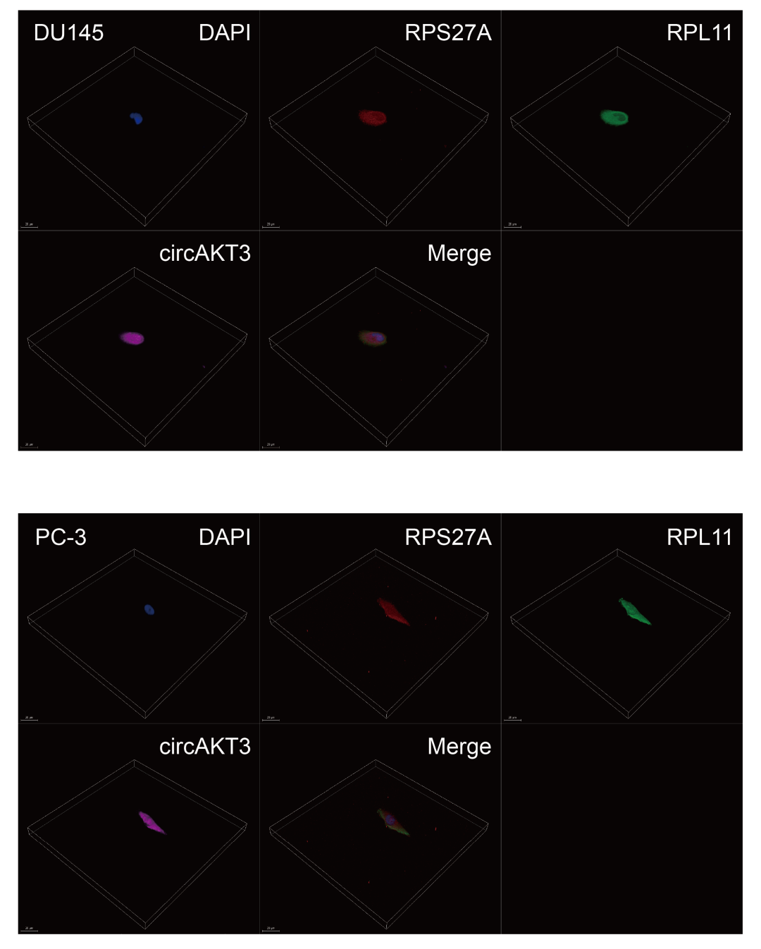
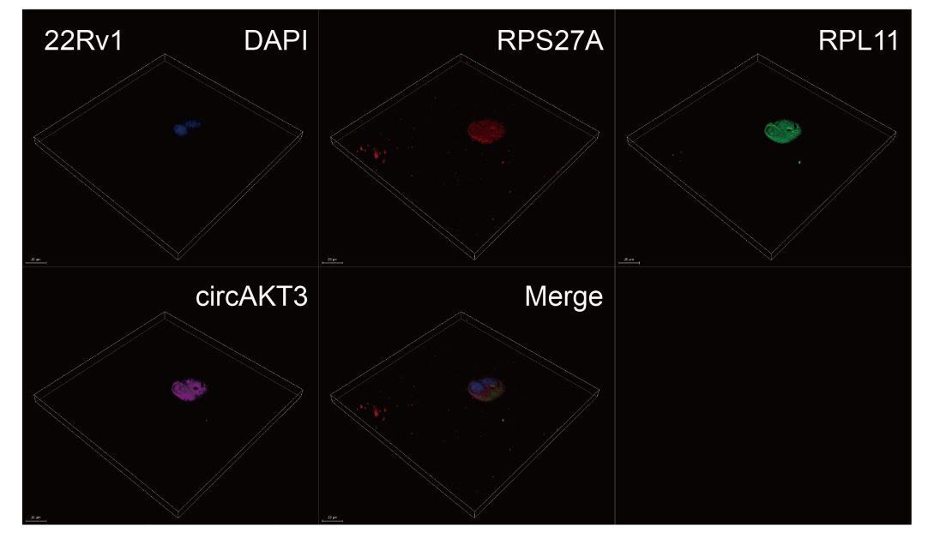
Enlarged version of Figure S3B
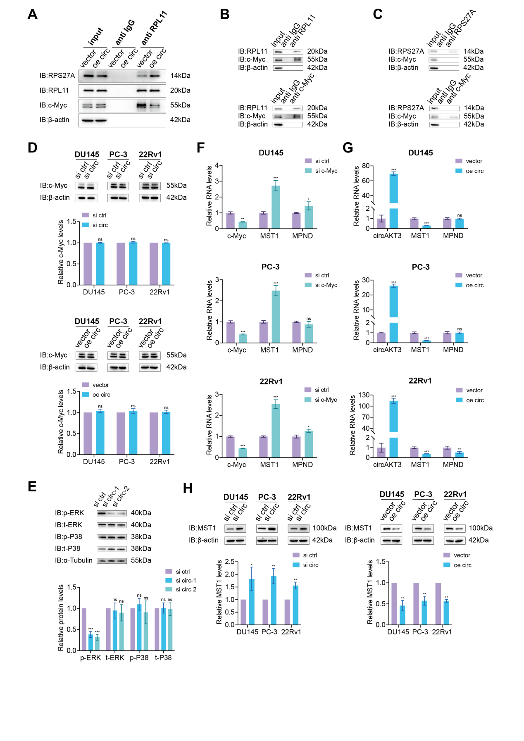
Fig. S4 CircAKT3 modulates MST1 expression by influencing the interaction between RPL11 and c-Myc. A Co-IP analysis revealed that the interaction between RPL11 and c-Myc was suppressed when the binding between RPL11 and RPS27A was enhanced due to circAKT3 upregulation. B-C Co-IP experiments revealed interactions between RPL11 and c-Myc, whereas no interaction was detected between RPS27A and c-Myc. D The protein level of c-Myc following alterations in circAKT3 expression. β-actin was used as the loading control. Data are expressed as mean ± SD. ns, not significant, Student’s t-test, n = 3 independent experiments. E Protein level of p-ERK, t-ERK, p-P38, and t-P38 following downregulation of circAKT3 expression. α-Tubulin was used as the loading control. Data are expressed as mean ± SD. ***P < 0.001, ns, not significant, Student’s t-test, n = 3 independent experiments. F-G MST1 RNA levels were specifically regulated by both c-Myc and circAKT3 in DU145, PC-3, and 22Rv1 cells. Data are expressed as mean ± SD. ***P < 0.001, **P < 0.01, *P < 0.05, ns, not significant, Student’s t-test, n = 3. H MST1 protein levels increased following circAKT3 downregulation (left).MST1 protein levels were reduced following the upregulation of circAKT3 (right). β-actin served as the loading control. Data are presented as mean ± SD. **P < 0.01, *P < 0.05, Student’s t-test, n = 3 independent experiments.
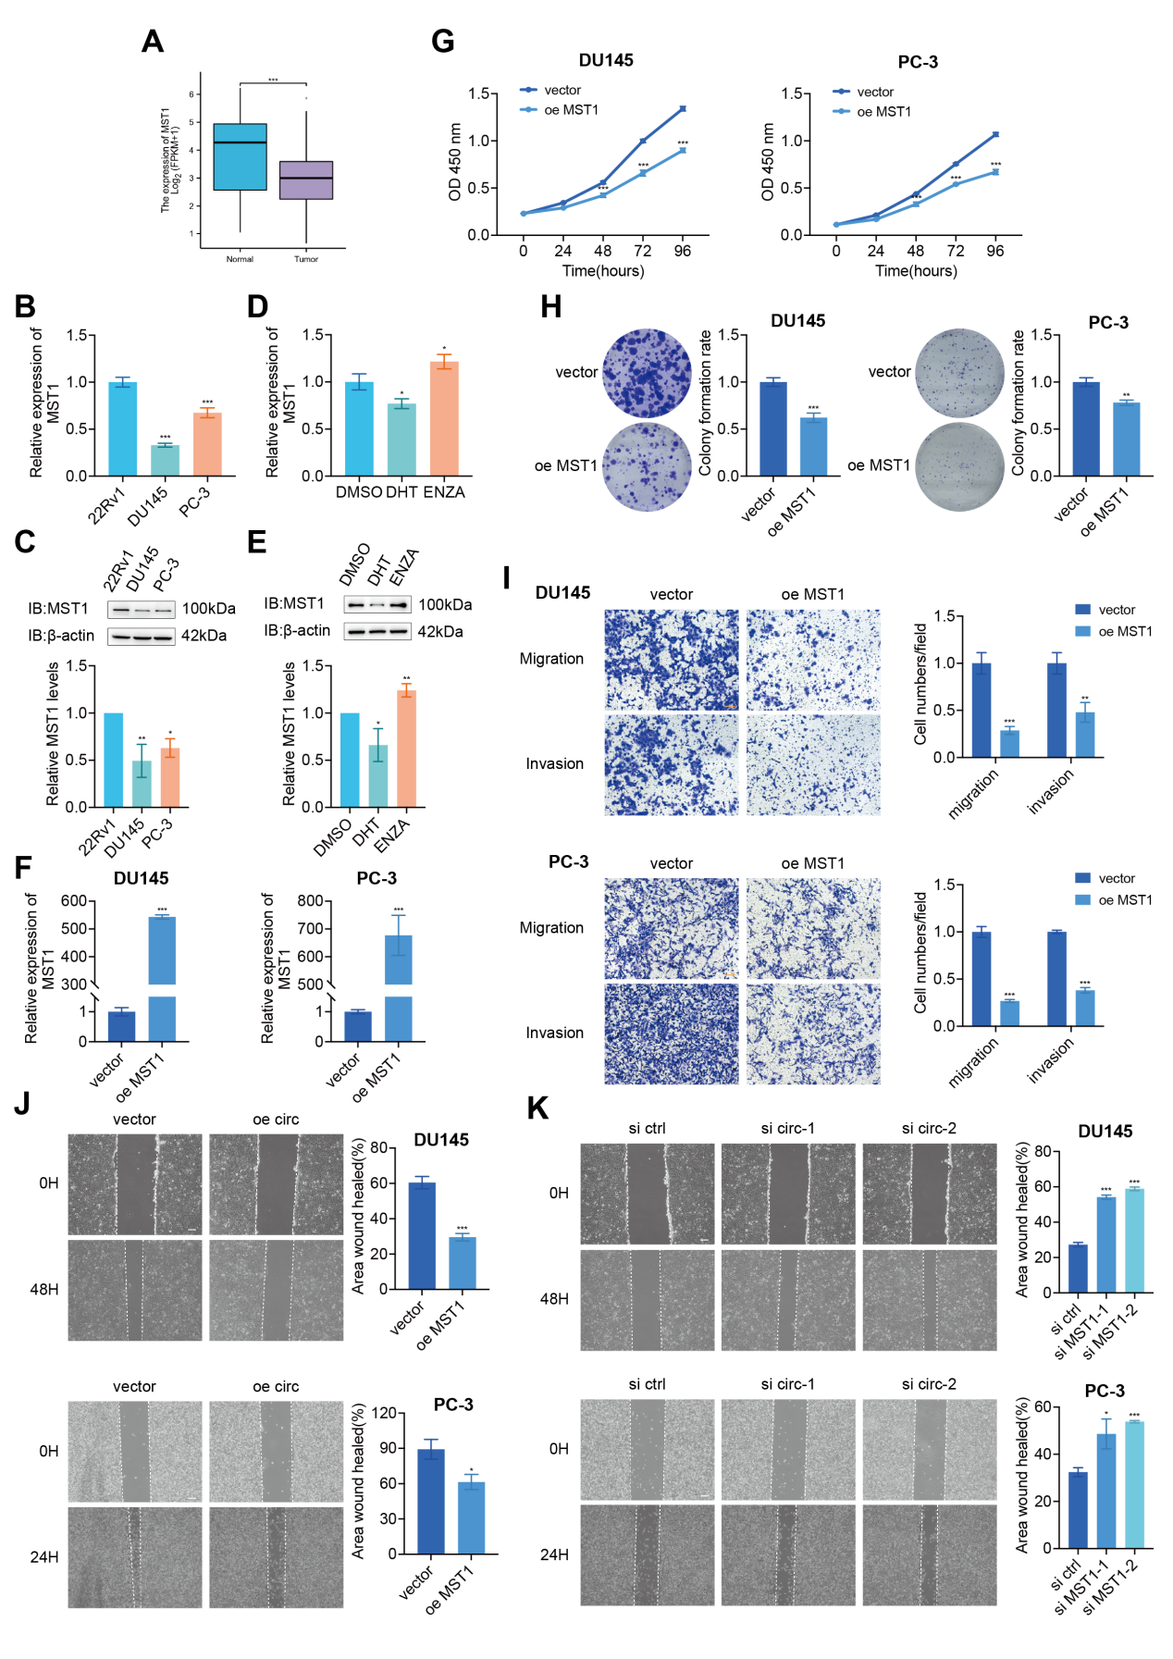
Fig. S5 MST1 inhibits PCa cells proliferation, migration, and invasion. A MST1 expression was found to be downregulated in PCa based on the TCGA database analysis. Data are presented as mean ± SD. ***P < 0.001, Welch t' test, n = 152 vs. 496. B-C RNA and protein levels of MST1 in DU145, PC-3, and 22Rv1 cells. Data are expressed as mean ± SD. **P < 0.01, *P < 0.05, Student’s t-test, n = 3 independent experiments. D-E RNA and protein levels of MST1 in 22Rv1 cells treated with DHT or ENZA. Data are expressed as mean ± SD. **P < 0.01, *P < 0.05, Student’s t-test, n = 3 independent experiments. F MST1 was overexpressed in PCa cells following plasmid transfection. Data are expressed as mean ± SD. ***P < 0.001, Student’s t-test, n = 3. G-H CCK-8 and colony formation assays showed that overexpression of MST1 inhibited the proliferation of DU145 and PC-3 cells. Data are presented as mean ± SD. ***P < 0.001, **P < 0.01, Student’s t-test, n = 3. I Transwell assays showed that MST1 overexpression decreased the migratory and invasive abilities of DU145 and PC-3 cells. Scale bar, 100 μm. Data are presented as mean ± SD. ***P < 0.001, **P < 0.01, Student’s t-test, n = 3. J Wound-healing assays revealed that MST1 reduced the migratory ability of DU145 and PC-3 cells. Scale bar, 200 μm. Data are presented as mean ± SD. ***P < 0.001, *P < 0.05, Student’s t-test, n = 3. K. Wound-healing assays indicated that MST1 knockdown enhanced the migratory ability of DU145 and PC-3 cells. Scale bar, 200 μm. Data are presented as mean ± SD. ***P < 0.001, *P < 0.05, Student’s t-test, n = 3.
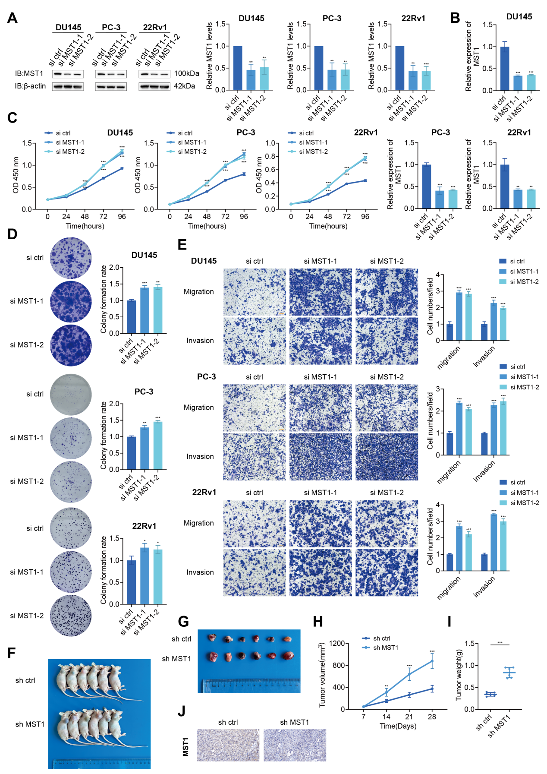
Fig. S6 Downregulation of MST1 enhances PCa cells proliferation, migration, and invasion both in vitro and in vivo. A MST1 protein levels were reduced following MST1 siRNA treatment. Data are expressed as mean ± SD. ***P < 0.001, **P < 0.01, Student’s t-test, n = 3. B RT-qPCR analysis of MST1 mRNA in PCa cells with siRNA. Data are expressed as mean ± SD. ***P < 0.001, **P < 0.01, Student’s t-test, n = 3. C CCK-8 assay revealed that MST1 knockdown promoted the proliferation of PCa cells. Data are presented as mean ± SD. ***P < 0.001, Student’s t-test, n = 3. D Colony formation assay revealed that MST1 knockdown increased the proliferative potential of DU145, PC-3, and 22Rv1 cells. Data are presented as mean ± SD. ***P < 0.001, **P < 0.01, *P < 0.05, Student’s t-test, n = 3. E Transwell assays demonstrated that MST1 knockdown increased the migratory and invasive abilities of DU145, PC-3, and 22Rv1 cells. Scale bar, 100 μm. Data are presented as mean ± SD. ***P < 0.001, Student’s t-test, n = 3. F-G Xenograft tumor models showed that tumors in the sh MST1 group were larger compared to those in the sh control group. H-I Tumor volume changes over time and tumor weight post-dissection. Data are presented as mean ± SD. ***P < 0.001, Student’s t-test, n = 6. J Representative IHC staining images of MST1 in tumor xenografts. Scale bar = 100 μm.

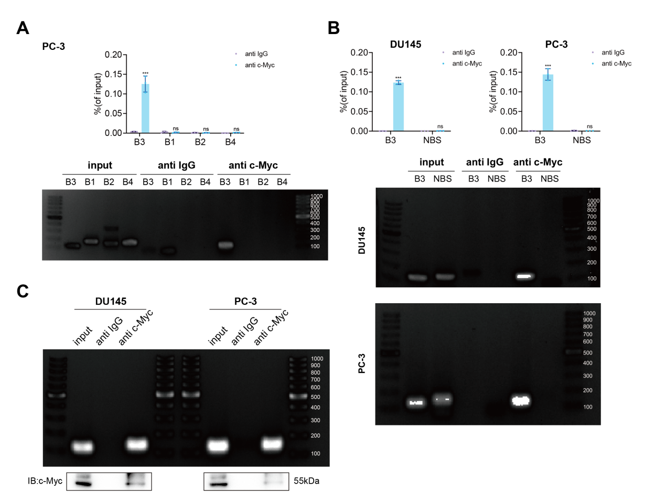
Fig. S7 Potential c-Myc binding sites on the MST1 promoters. A,B,C Gel electrophoresis was conducted to confirm the specificity of the RT-qPCR products. NBS, non-binding site. Data are presented as mean ± SD. ***P < 0.001, ns, not significant, Student’s t-test, n = 3.

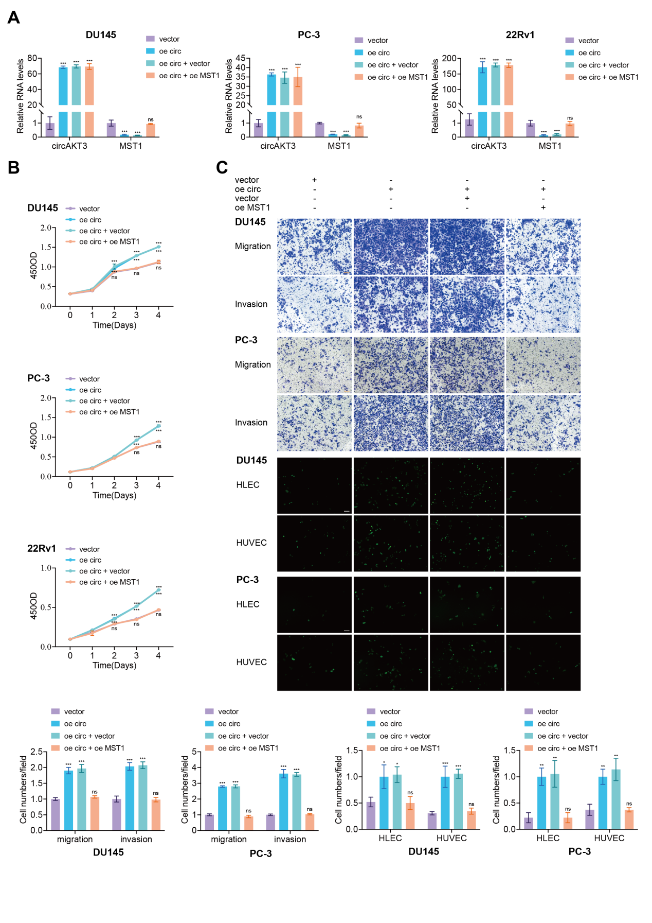
Fig. S8 MST1 upregulation reverses the proliferative, migratory, and metastatic characteristics induced by circAKT3. A RT-qPCR analysis of circAKT3 and MST1 RNA expression in DU145, PC-3, and 22Rv1 cells. Data are presented as mean ± SD. ***P < 0.001, ns, not significant, Student’s t-test, n = 3. B Cell viability was assessed by CCK-8 assays in cells expressing the different vectors. Data are presented as mean ± SD. ***P < 0.001, ns, not significant, Student’s t-test, n = 3. C Representative images and quantification of cell migration and invasion in DU145 and PC-3 cells were assessed using transwell assays (B; top; scale bar, 100 μm) and TEM assays (B; bottom; scale bar, 100 μm). Data are presented as mean ± SD. ***P < 0.001, **P < 0.01, *P < 0.05, ns, not significant, Student’s t-test, n = 3.

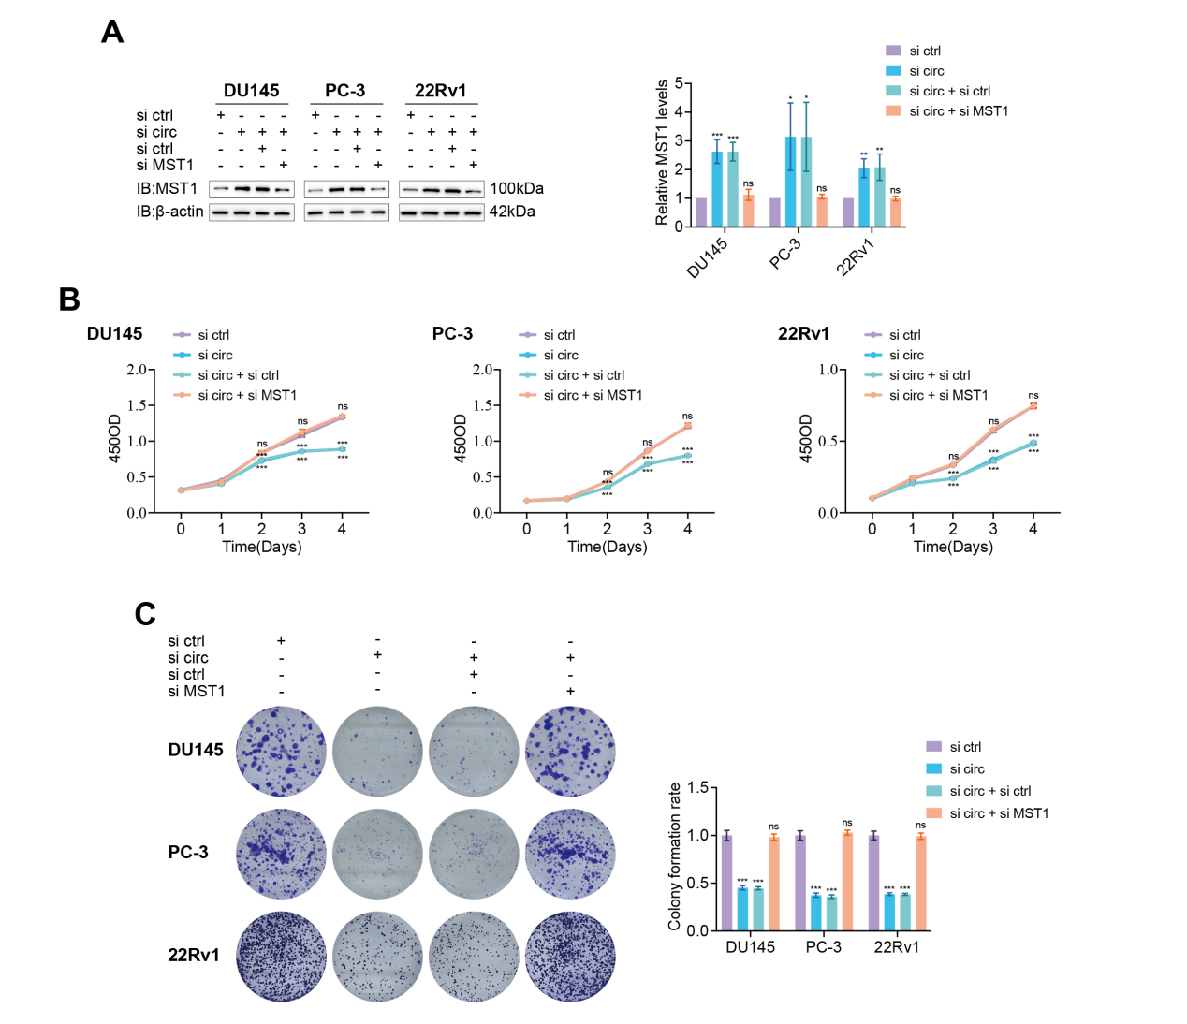
Fig. S9 MST1 knockdown in circAKT3-downregulated PCa cells reverses the inhibitory effects of circAKT3 downregulation on cell proliferation. A Western blot analysis of MST1 expression in DU145, PC-3, and 22Rv1 cells transfected with different constructs. Data are presented as mean ± SD. ***P < 0.001, ns, not significant, Student’s t-test, n = 3. B-C Cell proliferation was assessed using the CCK-8 assay (B) and colony formation assay (C). Data are presented as mean ± SD. ***P < 0.001, ns, not significant, Student’s t-test, n = 3.

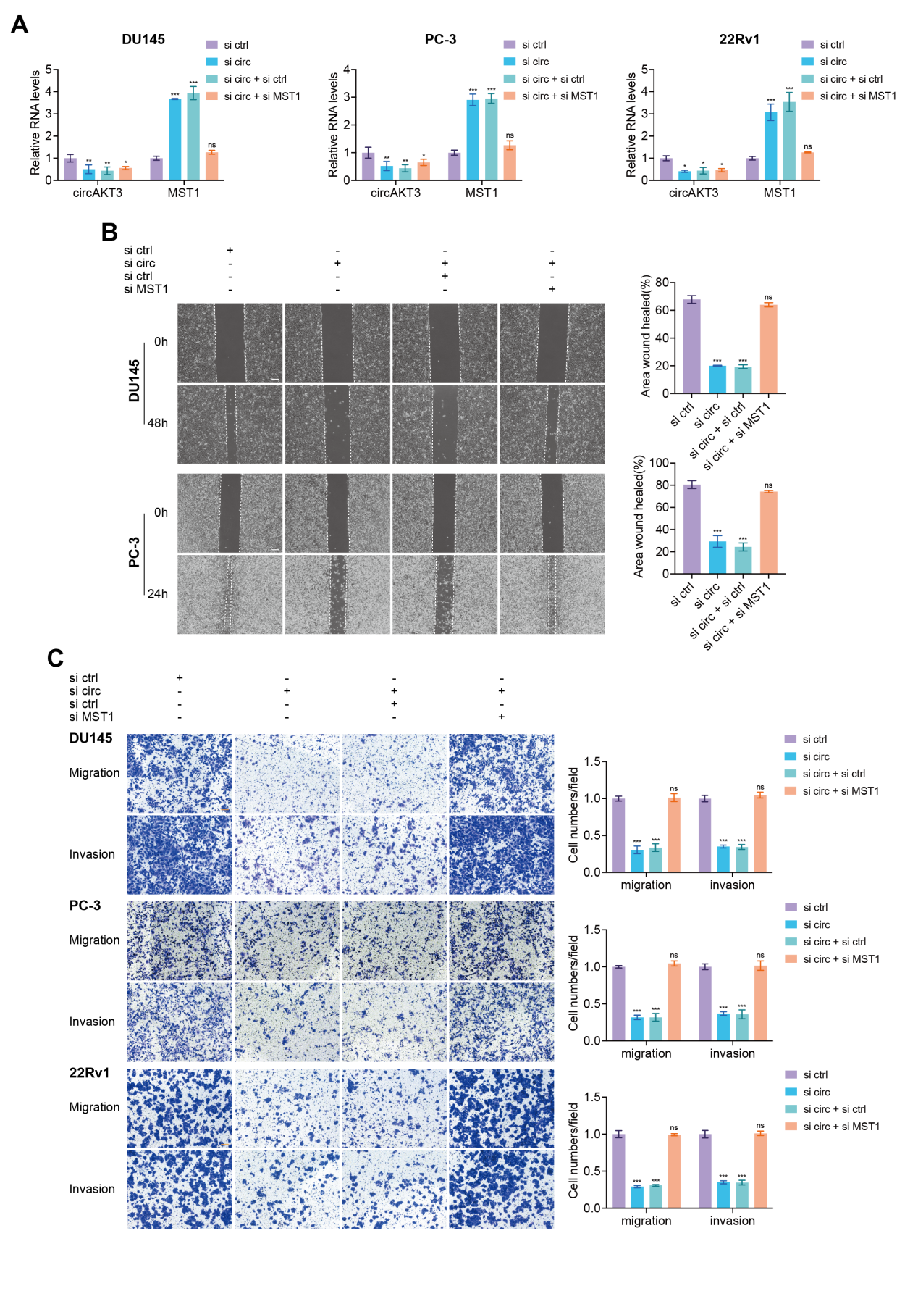
Fig. S10 MST1 knockdown in circAKT3-downregulated PCa cells reverses the inhibitory effects of circAKT3 downregulation on migration and invasion. A RT-qPCR analysis of circAKT3 and MST1 RNA expression in DU145, PC-3, and 22Rv1 cells. Data are presented as mean ± SD. ***P < 0.001, **P < 0.01, *P < 0.05, ns, not significant, Student’s t-test, n = 3. B-C Wound-healing assays (B; scale bar, 200 μm) and transwell assays (C; scale bar, 100 μm) were used to assess the migration and invasion abilities of PCa cells. Data are presented as mean ± SD. ***P < 0.001, ns, not significant, Student’s t-test, n = 3.

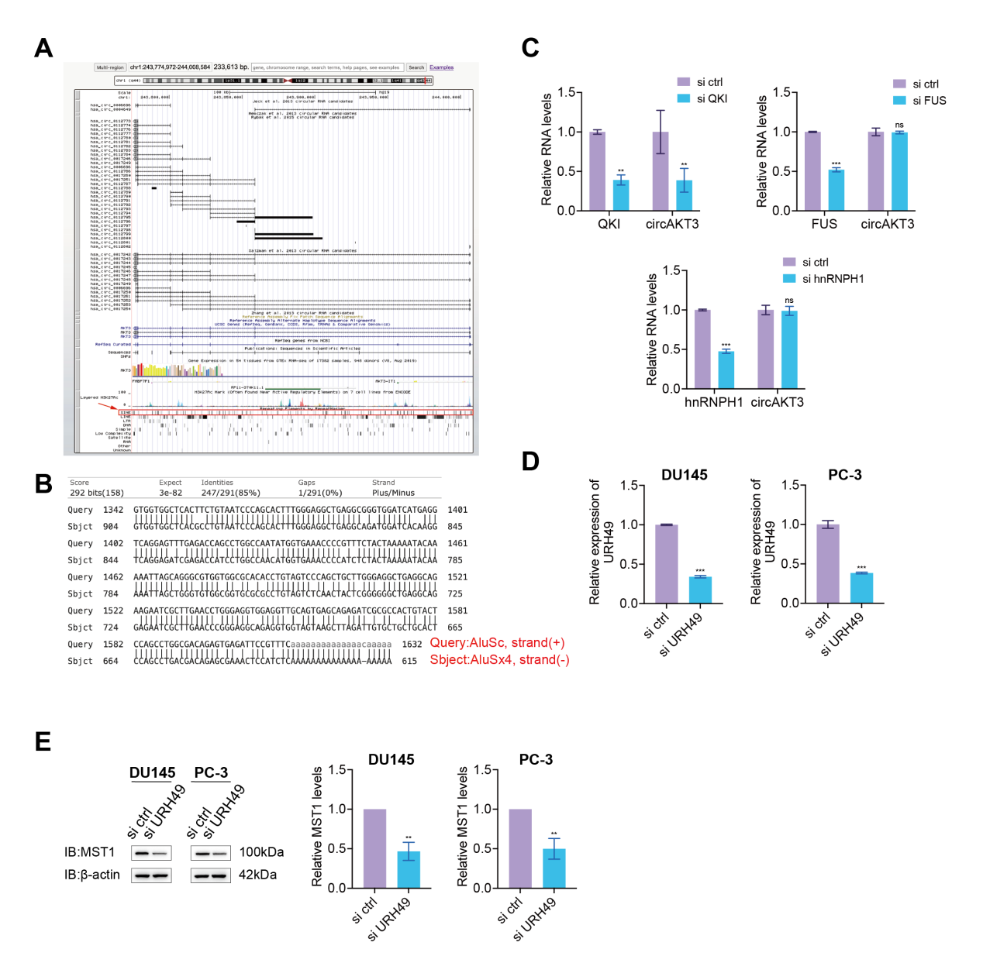
Fig. S11 The circularization and nuclear export of circAKT3. A-B Alignment of AluSc and AluSx4 sequences located in the flanking introns of circAKT3 using UCSC Genome Browser (http://genome.ucsc.edu/) and BLAST (https://blast.ncbi.nlm.nih.gov/Blast.cgi). C RT-qPCR analysis of QKI, FUS, hnRNPH1, and circAKT3 expression in cells transfected with different siRNA. Data are presented as mean ± SD. ***P < 0.001, **P < 0.01, Student’s t-test, n = 3. D RT-qPCR analysis of URH49 expression in cells transfected with URH49-specific siRNA or negative control siRNA. Data are presented as mean ± SD. ***P < 0.001, Student’s t-test, n = 3. E Western blot analysis of MST1 expression in DU145 and PC-3 cells transfected with negative control or URH49-specific siRNA. Data are presented as mean ± SD. **P < 0.01, Student’s t-test, n = 3.

