Table of Contents

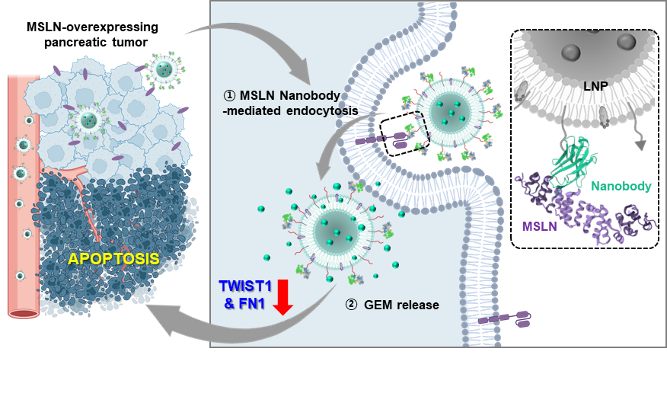
MSLN-specific D3 nanobody with high binding affinity (K_{D} = 2.2 nM) conjugated to gemcitabine-loaded liposomes enhances tumor targeting and gemcitabine efficacy, significantly inhibiting MSLN-positive pancreatic cancer growth.

