Title: Systemic immunosuppression limits NK cell therapy efficacy in pancreatic cancer

Supplemental material: Methods (including reference) and supplemental figures S1-S7.
Materials and Methods
Cell lines
B16F10 and YAC-1 cells were obtained from the American Type Culture Collection (ATCC, Rockville, MD). Murine pancreatic cancer cell line KPC1245 and KPC8069 were kindly provided by Dr. David Tuveson (Cold Spring Harbor Laboratory, KPC1245) and Dr. Michael A. Hollingsworth (University of Nebraska Medical Center, KPC8069). Both KPC1245 and KPC8069 tumor cells were derived from murine pancreatic tumors in LSL-Kras^{LSL.G12D/+}; LSL-p53^{R172H/+}; Pdx1-Cre (KPC) mice. All murine cancer cells were cultured in RPMI 1640 medium (ThermoFisher, Cat# 22400089) supplemented with 10% fetal bovine serum (FBS, Gibco, CA, USA), 1% penicillin-streptomycin (Gibco, CA, USA). Cells were incubated at 37°C in a humidified incubator with 5% CO2.
Animals and Orthotopic Tumor Models
Eight- to ten-week-old Apoe knock-out C57BL/6 (strain# 002052) and wild type C57BL/6 mice were obtained from The Jackson Laboratory. The animal experiments were conducted in accordance with protocols approved by the Institutional Animal Care and Use Committee (IACUC) of the University of Nebraska Medical Center (UNMC) and the University of Oklahoma Health Sciences Center (OUHSC). Mice were housed in a temperature- and humidity-controlled and specific-pathogen-free environment with 12-hour light–dark cycle conditions. Mice were provided with standard rodent chow (Teklad LM-485 Mouse/Rat Sterilizable 7012 Diet) and had ad libitum access to drinking water.
Orthotopic implantation of 3,000 KPC tumor cells (KPC1245/KPC8069 cells) was performed as previously describe¹. Treatments with trimetazidine (Cayman Chemical, Cat# 18165, 10 mg/kg/day, oral gavage), orlistat (Cayman Chemical, Cat# 10005426, 50 mg/kg/day, oral gavage), vitamin E (Sigma, Cat# T3634, 10 mg/kg/day, subcutaneous injections), or BMX-001 (0.5 mg/kg/day subcutaneous injections) commenced onday 10 post-implantation of KPC cells. Mice were euthanized for sample collection on day 24 post-implantation.
For adoptive NK cell transfer studies, 5 x 10⁸ NK cells (isolated from the spleen of healthy mice and labeled with Cell Tracer, Thermo Fisher Scientific, cat# C34572, cat# C34557) were infused intravenously via the tail vein. Recombinant murine IL-15 (Peprotech, cat# 210-15, 2 μg/mouse, intraperitoneal injections) was used to stimulate NK cells.
Isolation of splenic NK cells and Gr-1+ myeloid cells (MDSCs)
Splenic NK cells and Gr-1+ myeloid cells were isolated from murine spleens using the autoMACS system (Miltenyi Biotec) according to the manufacturer's protocol. Single-cell suspensions were prepared from spleens as previously described². NK cells were isolated using the NK cell isolation kit (Miltenyi Biotec, Cat# 130-115-818), while MDSCs were isolated using the mouse MDSC isolation kit (Miltenyi Biotec, Cat# 130-094-538). Purity of isolated NK cells was confirmed by flow cytometry using anti-CD3 and anti-NK1.1 antibodies (CD3-, NK1.1+). Gr-1+ cell purity was confirmed by flow cytometry using anti-CD11b and anti-Gr-1 antibodies (CD11b+, Gr-1+). For long-term culture (longer than 48 hour), primary NK cells were cultured in RPMI with 10% FBS plus 1 ng/mL recombinant mouse IL-2 (PeproTech, Cat# 212-12). Primary MDSCs were cultured in RPMI with 10% FBS plus 1 ng/mL recombinant mouse GM-CSF (PeproTech, Cat# 315-03).
In vitro co-culture assays
Gr-1+ myeloid cells were cultured at 1x10⁶ cells/well in 12-well plates. Hydrophilic PTFE cell culture inserts with a pore size of 0.4 µm (Millipore, PICM03050) were placed in each well seeded with Gr-1+ myeloid cells. NK cells were then added to the inserts at a density of 5x10⁵ cells/well for the designated time points. Following co-culture, NK cells were harvested and subjected to the following analyses: ROS measurement (DCFDA assay), lipid staining (BODIPY 493/503, Thermo Fisher Scientific, Inc., Cat# D3922), lipid peroxidation measurement (C11-BODIPY 581/591, Thermo Fisher Scientific, Inc., Cat# D3861), and GPX4 staining. For proliferation assay, NK cells were labeled with carboxyfluorescein diacetate succinimidyl ester (CFSE, Thermo Fisher Scientific, Inc., Cat# C34554) and co-cultured with with Gr-1+ myeloid cells for 96 hours. Proliferation rates were determined using flow cytometry.
For NK Cell Cytotoxicity measurement in vitro, NK cell killing activity against target cells was assessed using propidium iodide staining method as previously described³. Briefly, target cells were pre-labeled with CellTrace Violet (Thermo Fisher Scientific, Inc., Cat# C34557) and co-cultured with NK cells for 20 hours. The NK cell activation status was further determined by examining the expression of IFNγ, Granzyme B (GZMB), and CD107a in NK cells after stimulation with target cell. Following co-culture, NK cells were incubated with anti-NK1.1 (BioLegend Inc, Cat# 108720, Alexa Fluor 647, 10 µg/mL) and anti-mouse CD107a (BioLegend Inc, Cat# 121608 Alexa Fluor 488, 10 µg/mL) for 30 minutes. GolgiPlug Protein Transport Inhibitor (Fisher Scientific, Inc., Cat# BDB555029, 2 µL/mL) was then added to inhibit intracellular protein transport and secretion, thereby increasing intracellular cytokine levels. Cells were subsequently collected, washed, and fixed in 1X PBS solution containing 2% paraformaldehyde. Permeabilization was achieved using a permeabilization buffer (BioLegend, Inc., Cat# 421002). Finally, cells were resuspended in 50 µL FACS Buffer (1X PBS with 0.5% BSA and 0.1% sodium azide) and stained with anti-IFNγ (BioLegend, Inc., Cat# 505839) and anti-GZMB (BioLegend, Inc., Cat# 396414) antibodies. Flow cytometric data acquisition was performed using a flow cytometer and analyzed using FlowJo V10 software (TreeStar).
Generation of bone marrow-derived mononuclear cells (BMMCs)
BMMCs were isolated from the bone marrow of ApoE-/- or C57BL/6 mice (5- to 6-week-old) using a previously established protocol⁴. Briefly, femurs and tibias were harvested under aseptic conditions and the bone marrow cavity flushed with sterile RPMI-1640 containing 1 mM EDTA. Red blood cells were lysed, and the remaining cells were washed with RPMI-1640. Bone marrow cells were then seeded at a density of of 2×10⁶ cells per dish in 100 mm culture dishes containing RPMI-1640 supplemented with 10% fetal bovine serum (FBS), 10 ng/mL recombinant murine granulocyte-macrophage colony-stimulating factor (GM-CSF; PeproTech, Inc., cat# 315-03), and 10 ng/mL recombinant murine granulocyte colony-stimulating factor (G-CSF; PeproTech, Inc., cat# 250-05). Cells were cultured for 6 days.
Antibody depletion studies
To deplete regulatory T cells (Tregs), macrophages, and Gr-1+ myeloid cells (MDSCs), mice received intraperitoneal injections of specific antibodies five days after orthotopic tumor cell implantation, and antibody treatment continued three times per week until the end of the study. For Treg depletion, mice were administered 400 µg of anti-mouse CD25 (IL-2Rα) antibody (clone: PC-61.5.3; BioXcell, Cat# BE0012). Control mice received an equivalent dose of rat IgG1 isotype control (clone: HRPN; BioXcell, Cat# BE0088). For macrophage depletion, mice were administered 500 µg of anti-mouse CSF1R (CD115) antibody (clone: AFS98; BioXcell, Cat# BP0213). Control mice received an equivalent dose of rat IgG2a isotype control (clone: 2A3; BioXcell, Cat# BP0089). For Gr-1+ myeloid depletion, mice were administered 300 µg of anti-mouse Ly6G/Ly6C (Gr-1) antibody (clone: RB6-8C5; BioXcell, Cat# BP0075). Control mice received an equivalent dose of rat IgG2b isotype control (clone: LTF-2; BioXcell, Cat# BP0090). The depletion efficacy was evaluated by flow cytometry analysis. For NK cell depletion in Figure S7H, mice received intraperitoneal injections of 200 ug of anti-NK1.1 antibody (clone:PK136, BioXcell, Catalog #BE0036) per mouse, started from day 7 post orthotopic tumor cell implantation and continued 3 times a week until the end of the study.
RNA sequencing and RT-qPCR
Splenic Gr-1+ myeloid cells and NK cells were isolated from three groups of mice: healthy wild-type, KPC tumor-bearing, and Apoe knockout KPC tumor-bearing. Cells were homogenized in TRIzol reagent (Thermo Fisher) and total RNA was extracted using the RNeasy Mini Kit (QIAGEN, cat# 74104) following the manufacturer's protocol.
For RNA Sequencing and Bioinformatics Analysis, RNA-seq and primary bioinformatic analysis were performed at the Novogene Corporation Inc. (Sacramento, CA). DEGs (differentially expressed genes) between samples were further analyzed using GESA and heatmap analysis. This analysis aimed to identify the top affected genes and altered signaling pathways associated with each animal cohort.
For RT-qPCR, cDNA was synthesized from 1 µg of total RNA using the High-Capacity cDNA Reverse Transcription Kit (Thermo Fisher Scientific, Inc., Cat # 4368814). The expression of Apoe and its receptors ApoEr2, Lpr1, and Ldlr was detected using the primers: ApoE, Forward 5’-CTGACAGGATGCCTAGCCG-3’, Reverse 5’-CGCAGGTAATCCCAGAAGC-3’; LDLR, Forward 5’-TGACTCAGACGAACAAGGCTG-3’, Reverse 5’-ATCTAGGCAATCTCGGTCTCC-3’; LRP1, Forward 5’-ACTATGGATGCCCCTAAAACTTG-3’, Reverse 5’-GCAATCTCTTTCACCGTCACA-3’; ApoER2, Forward 5’-CCAATGGAATCACCCTGGACT-3’, Reverse 5’-CTTTGGCTCGTTCAGCTCG-3’. PowerUpTM SYBRTM Green Master Mix (ThermoFisher, Cat # A25742) was utilized to prepare the PCR reaction system. The PCR reaction was performed on QuantStudio5 Real-Time PCR System (Thermo Fisher Scientific, Inc.).
Single-cell RNA sequencing data analysis of PBMC and PDAC tumors
The single-cell RNA-seq (scRNA-seq) data of human PDAC tumors, normal control, and PBMCs were collected from previous studies^{5, 6, 7} and 10x Genomics Single-Cell Gene Expression Datasets. Figure 4A scRNA-seq data from PDAC tumors was obtained from the study by Junya Peng, et al.⁶. UMAP analysis plots of Figure 4A for cell types and metabolic signaling pathway enrichment signature were generated using tools from Tumor Immune Single-cell Hub (TISCH) at http://tisch.comp-genomics.org/home/⁷. Figure 4B scRNA-seq data from PDAC tumors was obtained from the study by Nina G. Steele et al⁵. Comparations of the gene signature scores for metabolic signaling pathways in Figure 4B were generated using tools from the Tumor Immunotherapy Gene Expression Resource (TIGER) at http://tiger.canceromics.org⁸. . The fold change of mRNA expression data in Figure 4C were download from TIGER. The raw data of the expression profiles for APOE, GPX1, A2M, and G0S2 in 12 main cell types in human PDAC tumors were obtained from the study by Junya Peng, et al⁶. The expression graphs were generated using TISCH. The average expression data for lipid metabolic genes in myeloid cells in Figure 5J &6B were obtained from the study by Sun et al. and 10x Genomics Single-Cell Gene Expression Datasets⁷. The raw data can be obtained from The Genome Sequence Archive (GSA) with Accession number CRA001160, the NIH Gene Expression Omnibus database under the accession number GSE155698, and 10x Genomics Single-Cell Gene Expression Datasets. The analysis code and marker genes collected and curated for major-lineage level of cell-type annotation can be obtained from the studies of Sun, et al. and Chen et al. at https://github.com/DongqingSun96/TISCH/tree, https://tiger.canceromics.org and http://tisch.comp-genomics.org/home/^{7, 8}.
Flow cytometry analysis
Splenic cell preparation and staining, all samples from individual mice were processed simultaneously. On the endpoint day of the study, mice (both healthy and tumor-bearing) received an intraperitoneal injection of 250 µl Brefeldin A (1 mg/mL). Six hours post-injection, mice were euthanized, and blood, spleens, and tumors were harvested for single-cell suspension. Prior to antibody staining, cells were incubated with LIVE/DEAD Fixable Aqua dye (ThermoFisher Scientific, Cat# L34966) in the dark for 20 minutes on ice. After wash, cells were then blocked with anti-CD16/32 (TruStain FcX, BioLegend, Cat # 101320) for 10 minutes. Subsequently, cells were stained with fluorochrome-conjugated antibodies targeting cell surface and intracellular markers for T cell and myeloid cell populations. , The markers included CD4, CD3, IFN-G, GATA3, RORγt, Foxp3, and CD19, CD8, LAG3, PD-1, TIGIT, IFN-γ, NK1.1; CD11b, CD11c, CD80, CD86, EPCAM, PDL-1, CD163, CD206, CD86, IL10, IA/IE, iNOS2, GR1, ARG1, IL10, Ly6C and Ly6G. Flow cytometry was performed on an LSRII‐Yellow/Green Flow Cytometer (BD Biosciences) and data were analyzed using FlowJo V10 (TreeStar).
ROS, lipid content, and lipid peroxidation measurements
Intracellular ROS levels in NK and myeloid cells were determined using 2, 7-dichlorofluorescein diacetate (DCFDA, Sigma-Aldrich, Cat# D6883) assay. For staining, NK or myeloid cells are seeded in a 96-well round-bottom plate at 1x10⁵ cells/well and stained with DCFDA (50 μM) for 30 min at 37°C in the dark. The intracellular signal intensity was analyzed using flow cytometer. Lipid content in MDSCs and NK cells was detected by BODIPY (BODIPY 493/503, Cayman Chemical, Item No. 25892) staining assay as described previously⁹. Lipid peroxidation status in NK cells was detected by C11-BODIPY 581/591(Cayman Chemical, Item No. 27086) fluorescent indicator. Briefly, cells were seeded in a 96-well round-bottom plate at 1x10⁵ cells/well and stained with C11-BODIPY 581/591 (2 µM) for 2 minutes (plate set on shaker) at room temperature in the dark with gentle shaking. After staining, cells were incubated at 37°C for 30 min in the dark. Subsequently, cells were washed with HBSS and resuspended in FACS buffer and analyzed by flow cytometry.
LC-MS/MS analysis of polar metabolites and non-polar lipids
The measurements of targeted polar and non-polar metabolites were quantified using ausing Waters Acquity UPLC coupled to a Xevo TQ-S mass spectrometer. The system operated in positive and negative switching mode with scheduled selected reaction monitoring (SRM) methods¹⁰. Peak areas of targeted metabolites were integrated using Skyline (MacCoss Lab Software) and normalized to the respective cell numbers. Further analysis of the relative quantification of the resulting peak areas and principal component analysis, heatmap analysis, and pathway enrichment analysis was performed using Metaboanalyst 5.0 software (www.metaboanalyst.ca)¹¹.
Knockdown of Ldlr in Gr-1+ cells
BMMCs were isolated from the bone marrow of six to eight-weeks C57BL/6 mice following the protocol as described above. BMMCs were cultured in RPMI medium containing 10% FBS, recombinant murine GM-CSF (PeproTech, Inc., cat# 315-03, 10 ng/mL) and, G-CSF (PeproTech, Inc., cat# 250-05, 10 ng/mL) for 4 days, then the cells were transfected by 25 nM siRNA of Ldlr (Horizon Discovery, Accell siRNA SMARTpool, Cat#: E-048572-00-0005) or non-targeting Control (Horizon Discovery, Cat#: D-001910-10-05). Transfection was performed in Opti-MEM™ Reduced-Serum Medium (Thermo Fisher, Cat #: 31985070) with DharmaFECT transfection reagent (Horizon Discovery, Cat#:T-2001-02, 2 μL/mL), GM-CSF(10 ng/mL), and G-CSF (10 ng/mL) for 12 hours. Cells were then incubated for 48 hours for RNA analysis and co-culture experiments, or 72 hours for protein analysis and lipid mass spectrometry analysis.
Immunofluorescent staining
Blood was collected from both healthy control and PDAC mice through cardiac puncture following anesthesia. Then a 27G needle, connected to a perfusion system,, was inserted into in the left ventricle of the heart. Once the flow begins, the right atrium was immediately opened to allow drainage. The animals were first perfused with 30 ml phosphate buffered saline (PBS) to flush blood, and then perfused with 4% paraformaldehyde (PFA) with 0.5% Methanol in PBS for 15 minutes. Following perfusion, tissues were collected and stored in 4% PFA at 4°C for an additional 48 hours. Tissues were then transferred to PBS containing 25% sucrose (Fisher Scientific, Cat #: S53) for 24 hours or until they sank to the bottom of the solution. The tissues were the embedded in Tissue-Tek OCT (Sakura Finetek, Cat #: 4583) and sectioned at 8 μm thickness. The anti-APOE (Proteintech, cat #: 66830, 1:75 dilution), anti-LDLR (Proteintech, cat #:10785, 1:150 dilution), nti-Gr-1 (BioLegend, Cat #: 108401, 1:100 dilution), and anti-CD45 (BioLegend, Cat #: 157602, 1:75 dilution) antibodies were used to detect the target proteins in the spleens. The immunofluorescent staining was following the protocol as earlier report¹.
Statistical analysis
Unpaired Student’s t-test (two-tailed) was used to assess statistically significant differences between two groups. One-way ANOVA with Tukey’s multiple comparisons test was utilized for comparing multiple groups. In specific instances, two-way ANOVA with Tukey's test was employed for analyzing data with two or more independent variables. The basic analysis of RNA-seq data was provided by Novogene. Gene expression levels were quantified using FPKM (Fragments Per Kilobase of transcript sequence per Millions base pairs sequenced). A statistically significant difference in gene expression was defined as a |fold change|>2 with adjust p-value<0.05 for the FPKM of a gene. Gene Set Enrichment Analysis (GSEA) was conducted using GSEA_4.0.2 with KEGG and GO pathway datasets. Mouse survival data were visualized using a Kaplan-Meier curve. The Mantel–Cox log-rank test were used to compare survival differences between animal cohorts. The statistical analysis and graphs generation were conducted using GraphPad Prism software (GraphPad Software Inc., San Diego, USA). ***denotes p value < 0.001, **denotes p value < 0.01, *denotes p value < 0.05. p and adjusted p < 0.05 were considered significant.
References
1. King, R.J. et al. CD73 induces GM-CSF/MDSC-mediated suppression of T cells to accelerate pancreatic cancer pathogenesis. Oncogene 41, 971-982 (2022).
2. Burrack, A.L. et al. CD40 Agonist Overcomes T Cell Exhaustion Induced by Chronic Myeloid Cell IL-27 Production in a Pancreatic Cancer Preclinical Model. J Immunol 206, 1372-1384 (2021).
3. Kim, J. et al. A Flow Cytometry-Based Whole Blood Natural Killer Cell Cytotoxicity Assay Using Overnight Cytokine Activation. Front Immunol 11, 1851 (2020).
4. Attri, K.S., Mehla, K. & Singh, P.K. Evaluation of Macrophage Polarization in Pancreatic Cancer Microenvironment Under Hypoxia. Methods Mol Biol 1742, 265-276 (2018).
5. Steele, N.G. et al. Multimodal Mapping of the Tumor and Peripheral Blood Immune Landscape in Human Pancreatic Cancer. Nat Cancer 1, 1097-1112 (2020).
6. Peng, J. et al. Single-cell RNA-seq highlights intra-tumoral heterogeneity and malignant progression in pancreatic ductal adenocarcinoma. Cell Res 29, 725-738 (2019).
7. Sun, D. et al. TISCH: a comprehensive web resource enabling interactive single-cell transcriptome visualization of tumor microenvironment. Nucleic Acids Res 49, D1420-D1430 (2021).
8. Chen, Z. et al. TIGER: A Web Portal of Tumor Immunotherapy Gene Expression Resource. Genomics Proteomics Bioinformatics (2022).
9. Al-Khami, A.A. et al. Exogenous lipid uptake induces metabolic and functional reprogramming of tumor-associated myeloid-derived suppressor cells. Oncoimmunology 6, e1344804 (2017).
10. Shukla, S.K. et al. MUC1 and HIF-1alpha Signaling Crosstalk Induces Anabolic Glucose Metabolism to Impart Gemcitabine Resistance to Pancreatic Cancer. Cancer Cell 32, 71-87 e77 (2017).
11. Pang, Z. et al. Using MetaboAnalyst 5.0 for LC-HRMS spectra processing, multi-omics integration and covariate adjustment of global metabolomics data. Nat Protoc 17, 1735-1761 (2022).

Figure S1. Pancreatic Tumor Burden Systemically Alters the Splenic Immune Landscape and Impairs NK Cell Function. A. Estimated proportions of CD4+ T, CD8+ T, and NK/NKT cells in blood, pancreas, and pancreatic ductal adenocarcinoma (PDAC) from healthy individuals and PDAC patients, based on single-cell RNA sequencing data (scRNA-seq data from Steele, N.G. et al., 2020). B. Representative images of spleens from healthy mice and mice bearing KPC1245 pancreatic tumor (PDAC mice) after 24 days. C& D. Percentage of dying cells in KPC1245, KPC8069, YAC-1, and B16F10 cell lines after co-culture with or without splenic NK cells from healthy, KPC1245, or KPC8096 PDAC mice. E. Expression of IFNγ, GZMB, and CD107a in splenic NK cells isolated from the spleen of healthy or KPC1245 tumor-bearing mice after 20-hour stimulation with B16F10 cells. F. Heatmap analysis illustrating the relative average mRNA expression of genes linked to cytotoxic effector functions in NK cells derived from blood, pancreas, PDAC tumors in both healthy individuals and PDAC patients, utilizing single-cell RNA sequencing data (scRNA-seq data from Steele, N.G. et al., 2020). G. Proportion of PDCD1- and TIGIT-expressing NK cells in circulating NK populations from healthy individuals and PDAC patients, based on single-cell RNA sequencing data (scRNA-seq data from Steele, N.G. et al., 2020). H& I. Percentage of macrophages (CD11b+,F4/80+,CD11c-) and dendritic cells (CD11b+,CD11c+,F4/80-) in the spleen from healthy and KPC1245 PDAC mice. J. Representative images of immunofluorescent staining for CD45 and Gr-1 in the spleens of healthy and KPC1245 PDAC mice. WP: white pulp; RP: Red pulp. K-M. Percentage of G-MDSCs (CD11b+,Ly6G+), M-MDSCs (CD11b+,Ly6C+), dendritic cells (CD11b+,CD11c+,F4/80-), CD4+ T cells, CD8+ T cells, (CD25+FOXP3+) Tregs and NK (CD3-,NK1.1+) cells in the spleen of healthy and KPC1245 PDAC mice. Data were represented as mean ± SEM. One-way ANOVA with Tukey’s multiple comparisons test was used for panel C& D, Two-way ANOVA with Tukey-Kramer test was used for panel E. Unpaired Student’s t-test (two-tailed) was used for panel H, I and K-M. p < 0.05, ** p < 0.01, and *** p < 0.001. The stars without bars represent the comparison between the first column and the column marked with stars.

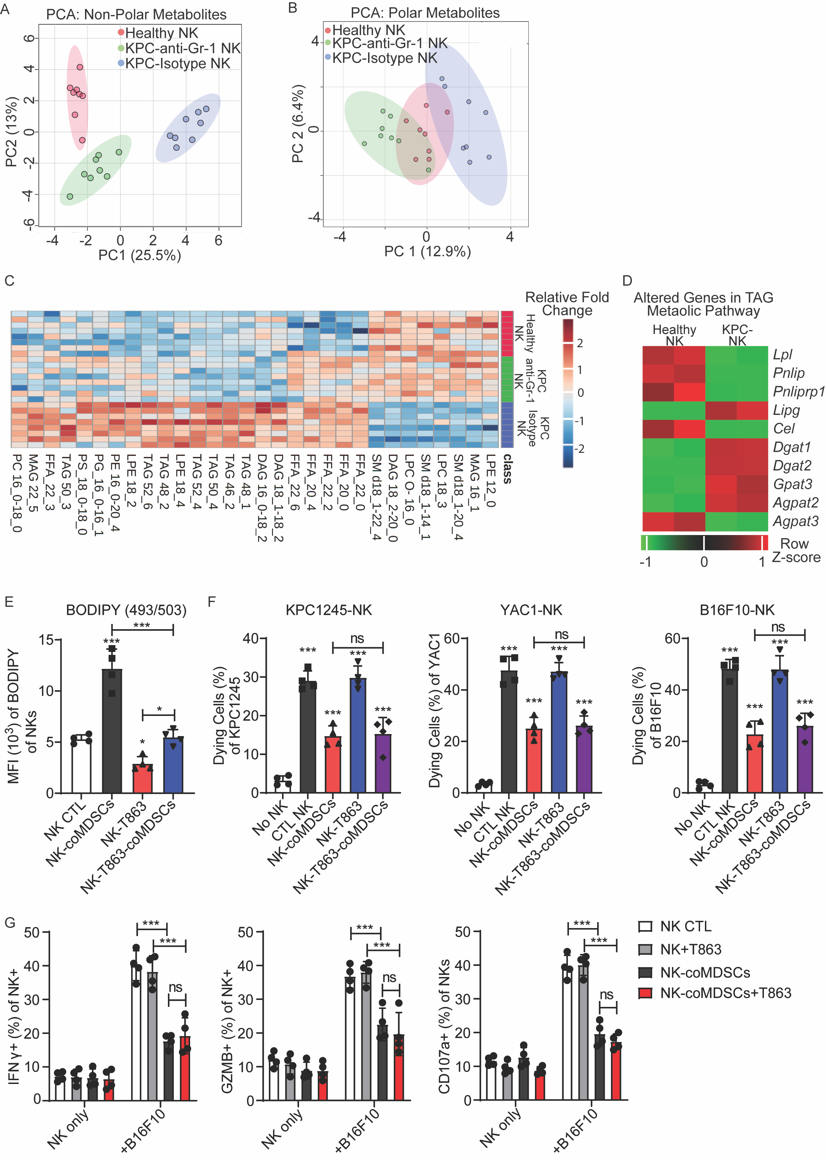Figure S2. Splenic Gr-1+ myeloid cells (MDSCs) from PDAC mice induce lipid metabolic dysregulation in NK cells. A & B. Principal component analysis (PCA) plots depicting the separation of non-polar (A) and polar (B) metabolites detected in murine splenic NK cells from healthy control mice and KPC1245 tumor-bearing mice (PDAC mice) treated with anti-Gr1 antibody or isotype control. Circles represent the 95% confidence interval. C. Heatmap analysis showcasing the top 30 lipid metabolites significantly altered in NK cells isolated from the spleen of healthy control mice and PDAC mice treated with isotype control or anti-Gr1 antibody. D. Heatmap analysis showing the mRNA expression of genes (significantly altered) associated with triacylglycerol synthesis in NK cells from the spleen of healthy mice and PDAC mice. E. Mean fluorescent intensity (MFI) of BODIPY staining in NK cells after treatment with T863 (DAGT inhibitor) and co-incubation (for 48 hours) without or with splenic MDSCs isolated from PDAC mice. F. Percentage of dying KPC1245, YAC-1, and B16F10 cells after co-culture with NK cells from different sources (E:T = 20:1, for 20 hrs). CTL NK: Healthy splenic NK cells; NK-coMDSCs: Healthy NK cells pre-incubated with splenic MDSCs (from PDAC mice) for 48 hours; NK-T863: NK cells pre-treated with T863 for 48 hours; NK-T863-coMDSCs: NK cells pre-incubated with MDSCs plus T863 treatment for 48 hours. G. Expression of IFNγ, GZMB, and CD107a in splenic NKs from different sources (as showed in panel H) after stimulation with B16F10 for 20 hours. Data are represented as mean ± SEM. One-way ANOVA with Tukey’s multiple comparisons test was performed for panels E& F; Two-way ANOVA with Tukey-Kramer test was utilized for panel G. * p < 0.05, and *** p < 0.001. The stars without bars represent the comparison between the first column and the column marked with stars.

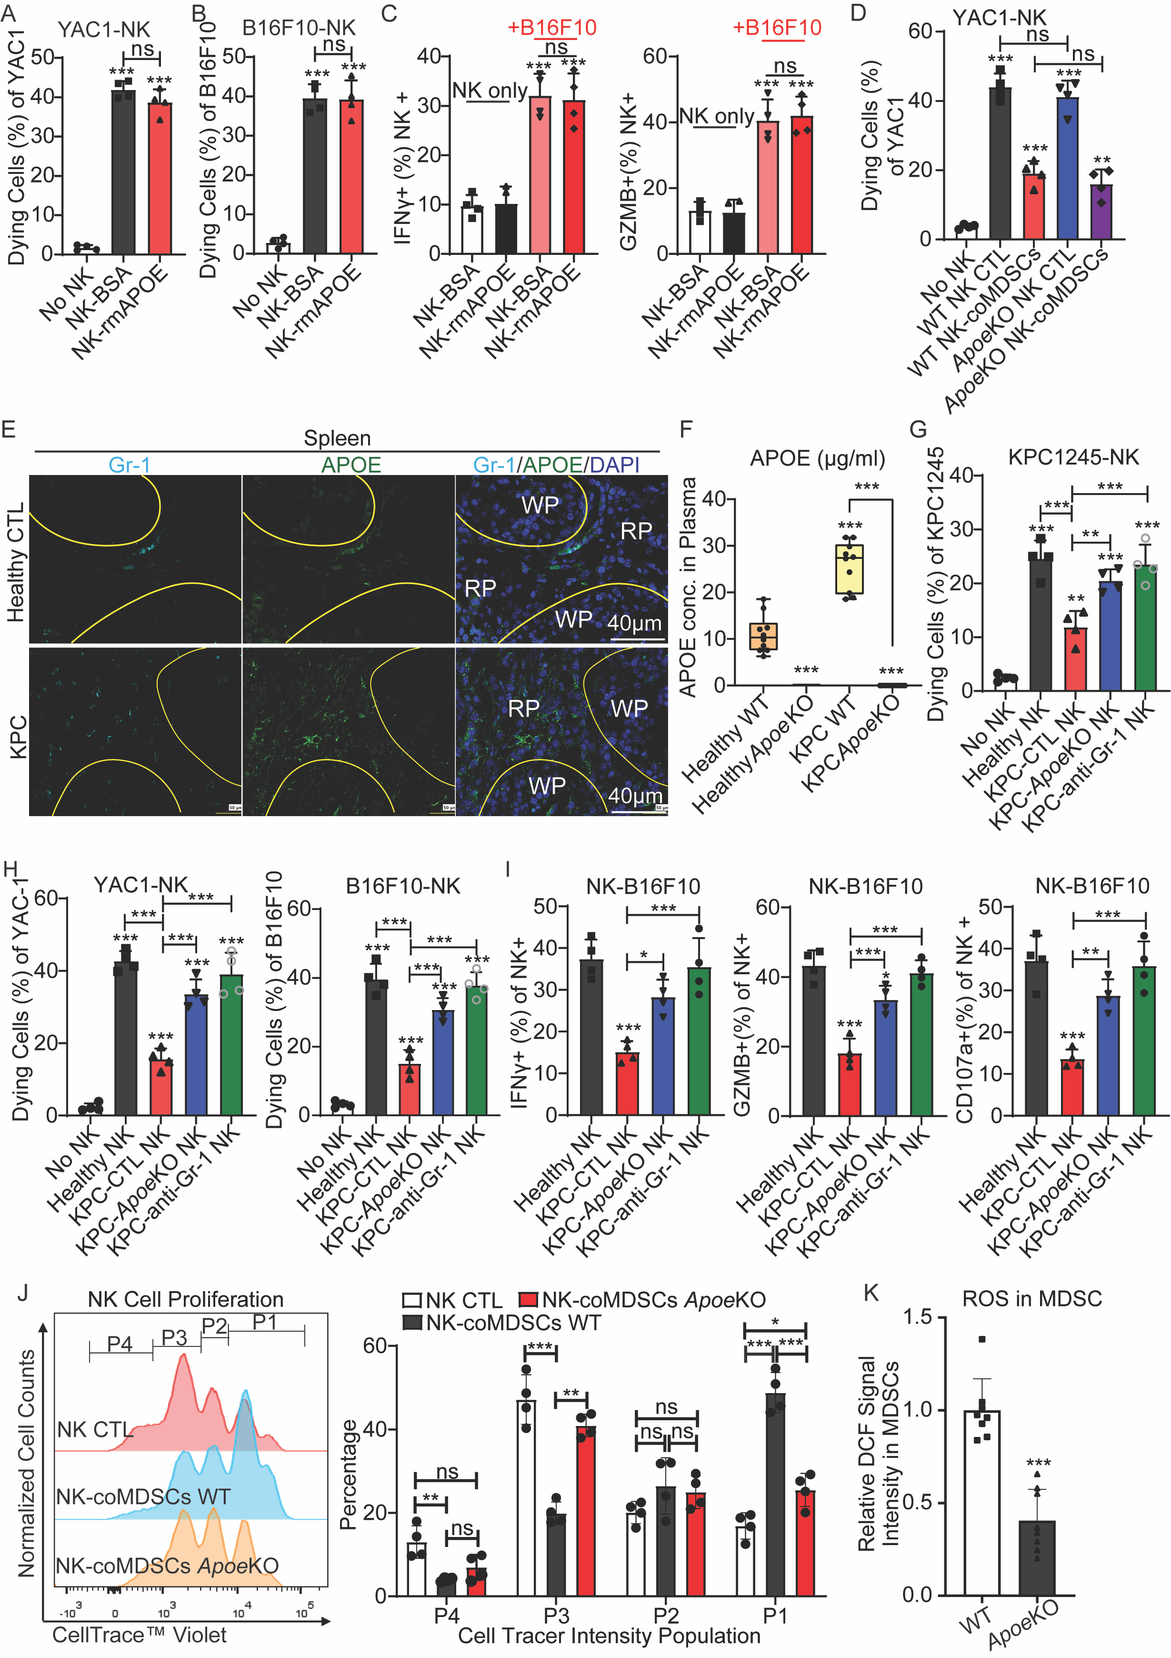Figure S3. Apoe knocking out rescues splenic NK cell function in PDAC mice by reducing ROS production in Gr-1+ myeloid cells. A. Immunofluorescence staining of Gr-1 and APOE in spleens from healthy and KPC1245 pancreatic tumor-bearing mice (PDAC mice). WP: white pulp; RP: red pulp. B. Plasma APOE concentration in wild-type and Apoe-/- mice with or without PDAC tumors. C &D. Percentage of dying KPC1245, YAC-1, and B16F10 cells after co-culture with splenic NK cells (E:T = 20:1, for 20 hrs) from different mouse cohorts. Healthy NKs: splenic NKs from healthy mice; KPC-CTL NK: splenic NKs from wild-type mice with PDAC tumors; KPC-ApoeKO NK: splenic NKs from Apoe-/- mice with PDAC tumors; KPC-anti-Gr-1 NK: splenic NKs from wild-type mice with PDAC tumors treated with anti-Gr-1 antibody. E. Expression of IFNγ, GZMB, and CD107a in splenic NKs from different cohorts (as described in panel H) after stimulation with B16F10 for 20 hours. F &G. Percentage of dying YAC-1 and B16F10 cells after co-culture with NK cells (E:T=20:1, for 20 hrs) from different treatment cohorts. H. Expression of IFNγ, GZMB, and CD107a in splenic NKs from different treatment cohorts after stimulation with or without B16F10 for 20 hours. NK-BSA: healthy splenic NKs pre-treated with BSA; NK-rmAPOE: healthy splenic NKs pre-treated with BSA plus recombinant mouse APOE. I. Percentage of dying YAC-1 cells after co-culture with splenic NK cells (E:T=20:1, for 20 hr) from different experimental cohorts. NK CTL: splenic NK cells from healthy wild-type (WT) mice; NK-coMDSCs: WT splenic NKs pre-incubated with splenic MDSCs isolated from KPC1245 pancreatic tumor-bearing (PDAC) WT mice for 48 hours; ApoeKO NK CTL: Apoe-knockout splenic NKs from healthy Apoe-knockout mice. ApoeKO NK-coMDSCs: Apoe-knockout healthy splenic NKs pre-incubated with splenic MDSCs isolated from wild-type PDAC mice for 48 hours. J. Signal intensity and population distribution of cell-tracer (CellTrace Violet) in splenic NKs when cultured with or without WT or Apoe-knockout splenic Gr-1+ cells isolated from PDAC mice for 96hrs. K. Relative DCF intensity in splenic MDSCs derived from wild-type or Apoe-knockout PDAC mice. Data are shown as the mean ± SEM. Unpaired Student’s t-test (two-tailed) was used for panel N; One-way ANOVA with Tukey’s multiple comparisons test was used for panel A-D, and F-I; Two-way ANOVA with Tukey-Kramer test was used for panel J, and M. * p < 0.05, ** p < 0.01, and *** p < 0.001. The stars without bars represent the comparison between the first column and the column marked with stars.
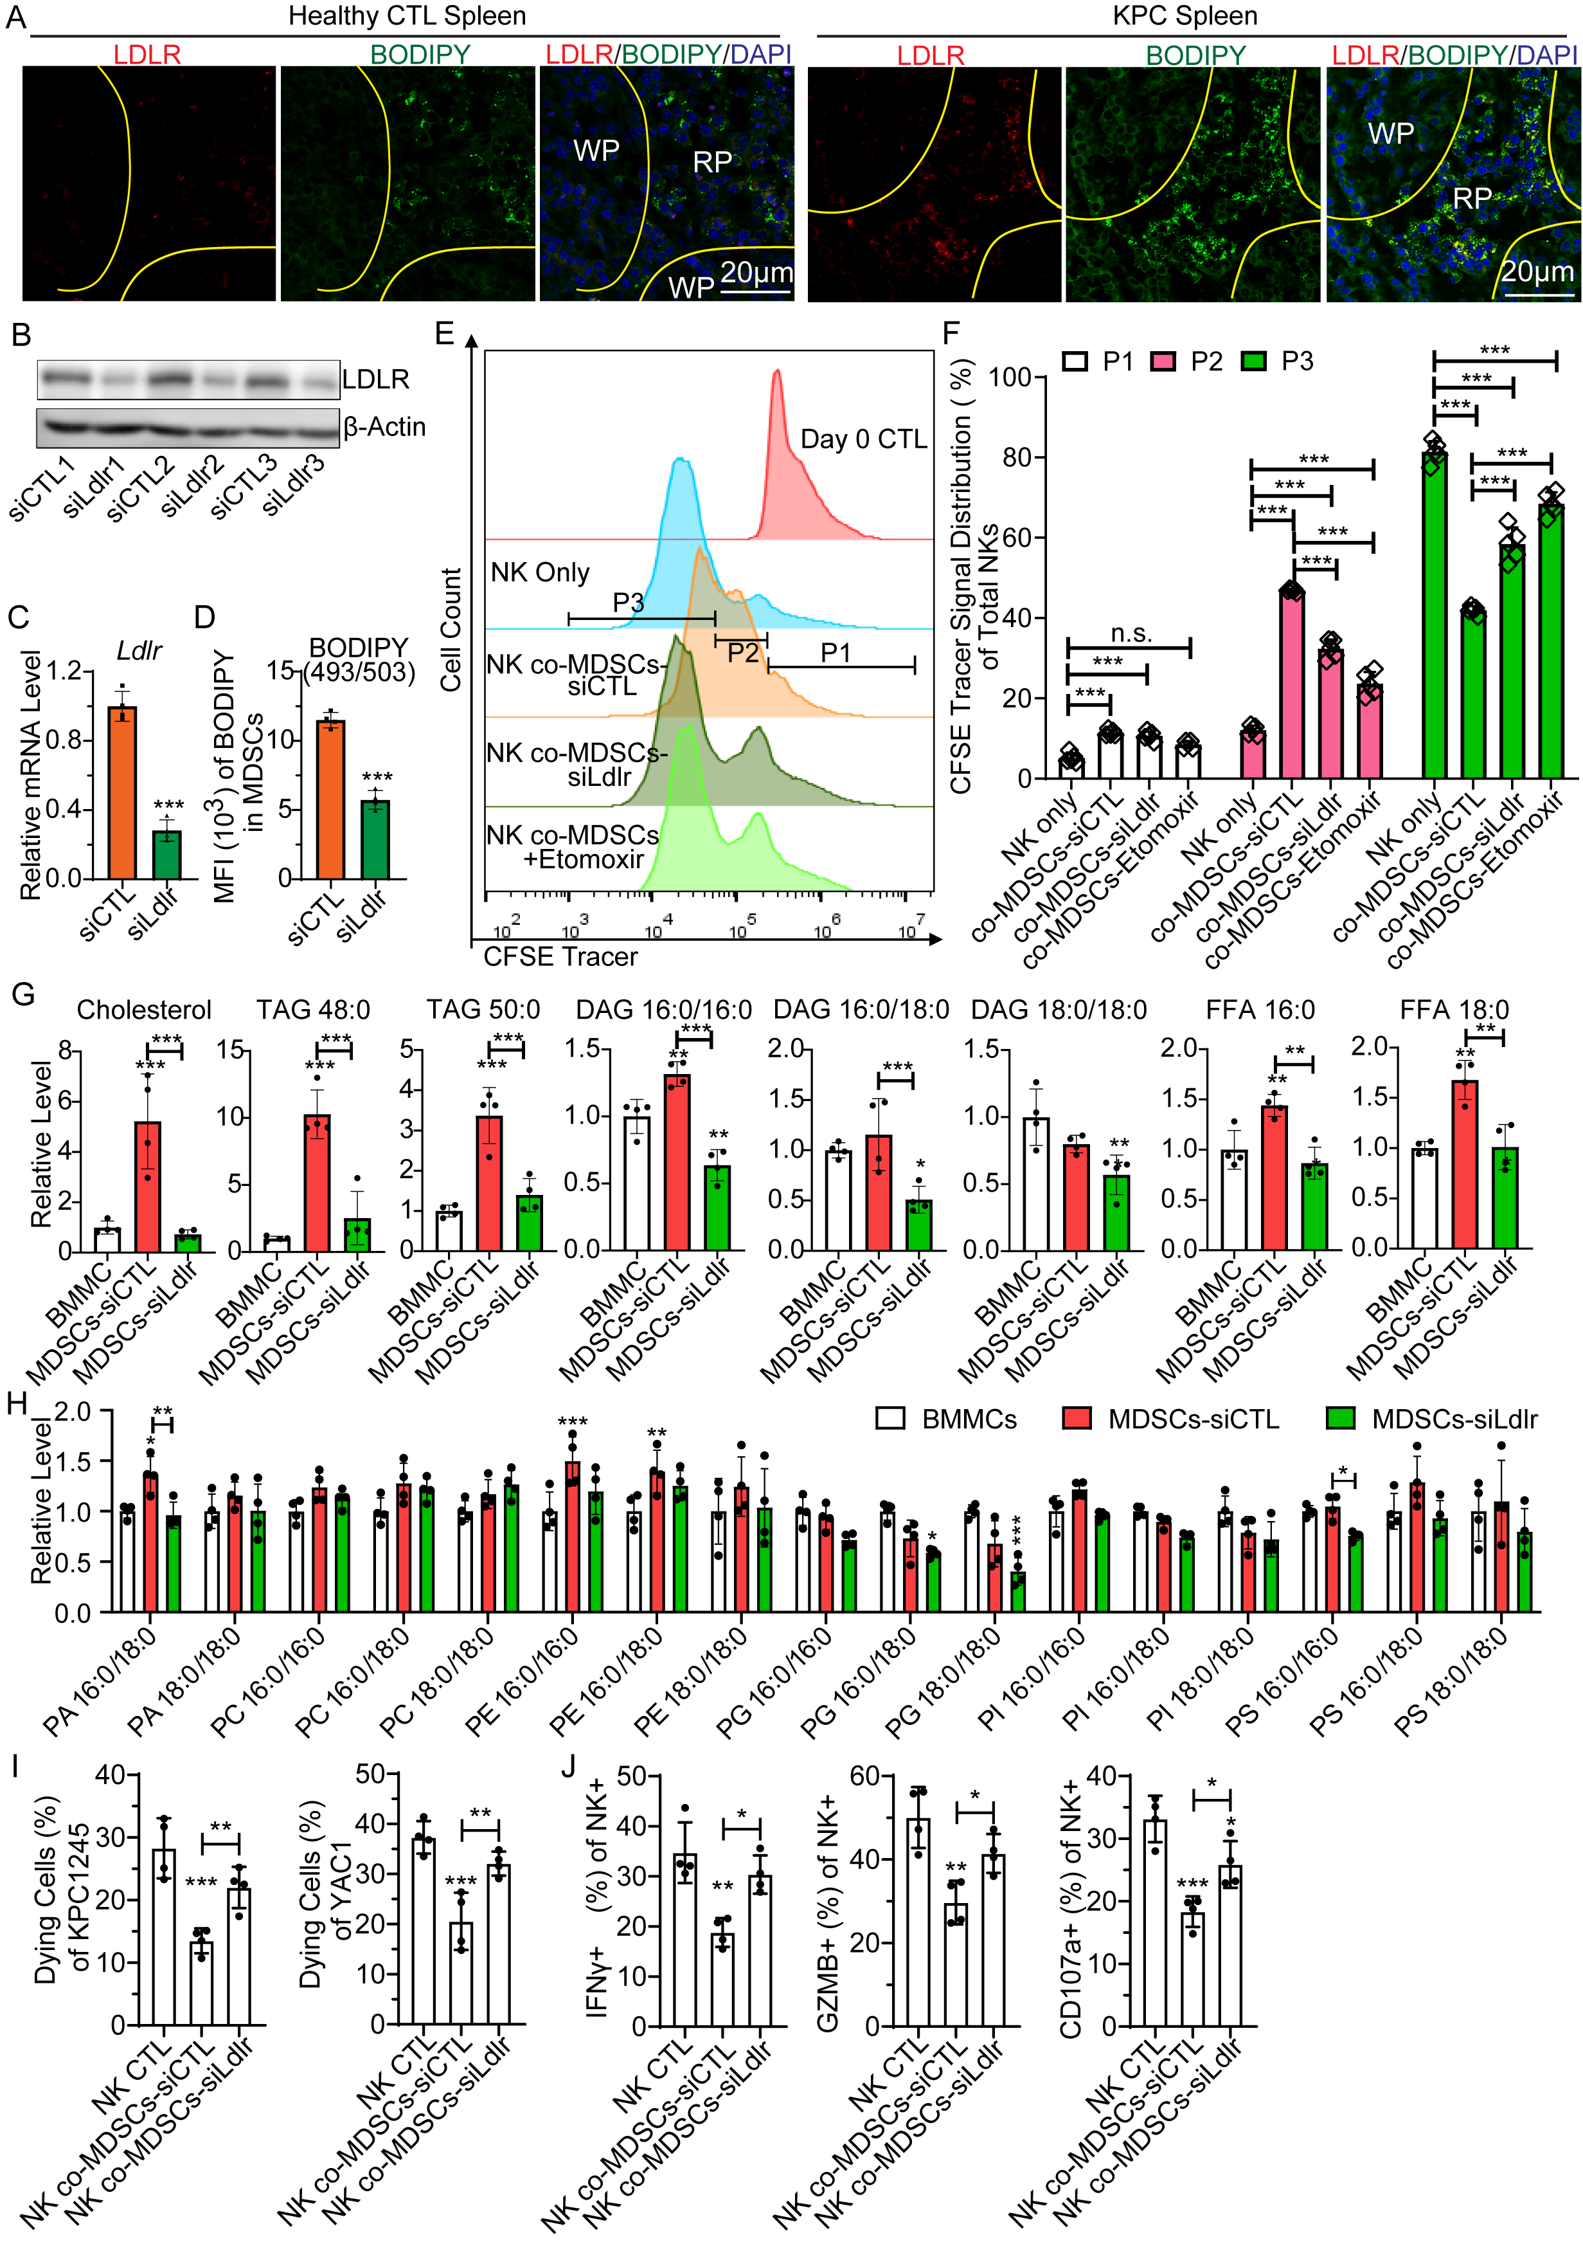
Figure S4. Loss of LDLR in MDSCs impairs their immunosuppressive effects on NK cells. A. Representative immunofluorescent images of LDLR and Lipid (BODIPY 493/503) staining in the spleens of healthy and KPC1245 pancreatic tumor-bearing mice (PDAC mice). WP: white pulp; RP: Red pulp. B. Representative Western blot images showing LDLR protein levels in MDSCs treated with or without siRNA targeting Ldlr. C. Relative mRNA level of Ldlr in MDSCs treated with or without siRNA targeting Ldlr. D. Mean fluorescence intensity (MFI) of BODIPY in GM-CSF and G-CSF-induced MDSCs treated with or without siRNA targeting Ldlr. E &F. Signal intensity and population distribution of cell tracer labeled NK cells after co-incubating with control or Ldlr-knockdown MDSCs pretreated with or without Etomoxir for 24 hours. G &H. Relative levels of common lipids in BMMC and MDSCs treated with or without siRNA targeting Ldlr. I. Percentage of dying YAC-1 and KPC1245 cells after co-culturing with NKs (E:T= 20:1, for 20 hrs) that were pre-co-incubated with or without control or Ldlr-knockdown MDSCs. J. Expression of IFNγ, GZMB, and CD107a in NKs from different pre-cultured cohorts (pre-co-incubated with or without control or Ldlr-knockdown MDSCs) post-stimulation with KPC1245 for 20 hours. Data are shown as the mean ± SEM. Unpaired Student’s t-test (two-tailed) was used for panel C-D; One-way ANOVA with Tukey’s multiple comparisons test was used for panel G-J; Two-way ANOVA with Tukey’s multiple comparisons test was used for panel F. * p < 0.05, ** p < 0.01, and *** p < 0.001. The stars without bars represent the comparison between the first column and the column marked with stars.

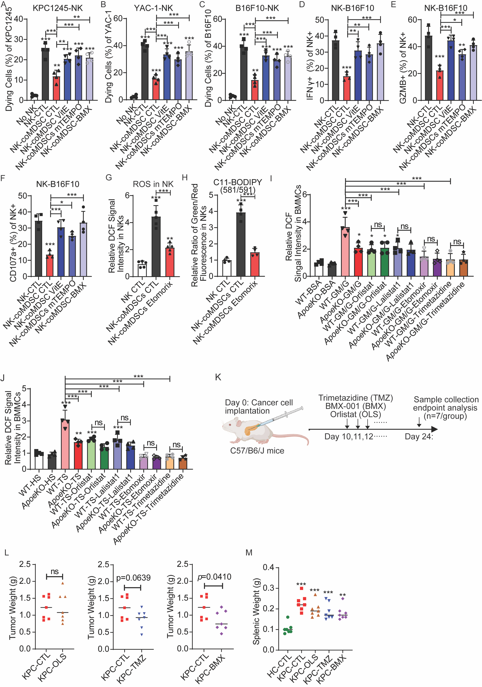
Figure S5. Blockage of lipid oxidation impairs MDSCs-mediated immunosuppressive effects on NKs. A-C. Percentage of dying KPC1245, YAC-1, and B16F10 cells after co-culture (E:T = 20:I, for 20 hr) with NK cells that were pre-cultured for 48 hours with splenic with splenic MDSCs from KPC1245 tumor-bearing mice (PDAC mice) and treated with or without VitE (Vitamin E), mito-TEMPO, and BMX (BMX-001). D-F. Expression of IFNγ, GZMB, and CD107a in splenic NK cells from different pre-treatments (as described in panel A-C) after stimulation with B16F10 for 20 hours. G & H. Relative value of DCF (G) and relative ratio of C11-BODIPY MFI (H) in NK cells after co-incubation with PDAC splenic MDSCs for 48 hours (MDSCs CTL: control MDSCs; MDSCs Etomorix: MDSCs pre-treated with Etomoxir for 24 hours). I. Relative DCF fluorescence in bone morrow derived monocytes (BMMCs) from wild-type (WT) or Apoe-knockout (ApoeKO) mice after 96-hour stimulation with GM-CSF (GM, 10ng/ml) /G-CSF (G, 10ng/ml) and treatmeant with indicated drugs. J. Relative DCF fluorescence in BMMCs from WT and ApoeKO mice after stimulation with serum (10%) from health mice (HS) or PDAC mice (TS). K. Experimental design for determining the impact of targeting lipolysis, FAO, and ROS on systemic MDSCs and NK cells in vivo. L & M. Tumor and spleen weight in healthy and PDAC mice treated with vehicle control (CTL), Orlistat (OLS), Trimetazidine (TMZ), and BMX-001 (BMX). Please note the same control group was used in tumor weight comparison with different treatment cohort in panel L. Data are shown as the mean ± SEM. Unpaired Student’s t-test (two-tailed) was used for panel L, One-way ANOVA with Tukey’s multiple comparisons test was used for panel A-J, and M. * p < 0.05, ** p < 0.01, and *** p < 0.001. The stars without bars represent the comparison between the first column and the column marked with stars.
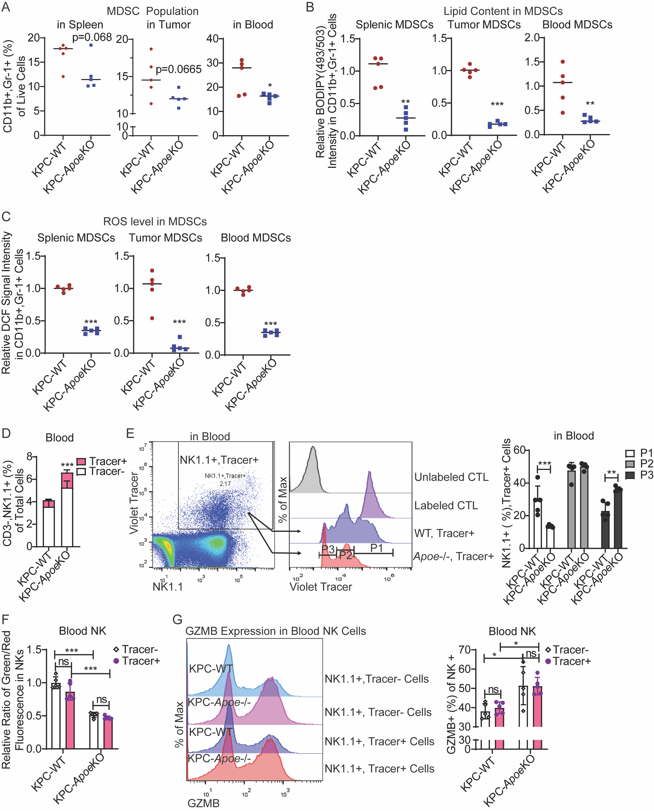
Figure S6. Loss of APOE impairs the immunosuppressive effects of Gr-1+ myeloid cells (MDSCs) on adoptively transferred NK cells. A. Percentage of MDSCs in the spleens, tumors, and blood of wild-type (WT) and Apoe-Konckout (ApoeKO) tumor-bearing mice (as described in Figure 7A). B. Relative mean fluorescence intensity (MFI) of BODIPY(493/503) staining in MDSCs from the WT and ApoeKO tumor-bearing mice described in Figure 7A. C. Relative DCF intensity in MDSCs from WT and ApoeKO tumor-bearing mice described in Figure 7A. D. Percentage of cell tracer-labeled and unlabeled NK cells in the blood of WT and ApoeKO tumor-bearing mice described in Figure 7A. E. Signal intensity and population distribution of cell tracer in labeled NK cells from the blood of WT and ApoeKO mice described in Figure 7A. F. Relative ratio of Green/Red MFI in cell-tracer labeled and unlabeled NK cells (from the blood of WT and ApoeKO tumor-bearing mice described in Figure 7A) after incubation with C11-BODIPY (581/591) for 1 hour. G. Signal intensity and population distribution of GZMB expression in cell-tracer labeled and unlabeled NK cells from the blood of WT and ApoeKO tumor-bearing mice as described in Figure 7A. Data are shown as the mean ± SEM. Unpaired Student’s t-test (two-tailed) was used for panel A-D, Two-way ANOVA with Tukey’s multiple comparisons test was used for panel E-G. * p < 0.05, ** p < 0.01, and *** p < 0.001. The stars without bars represent the comparison between the first column and the column marked with stars.
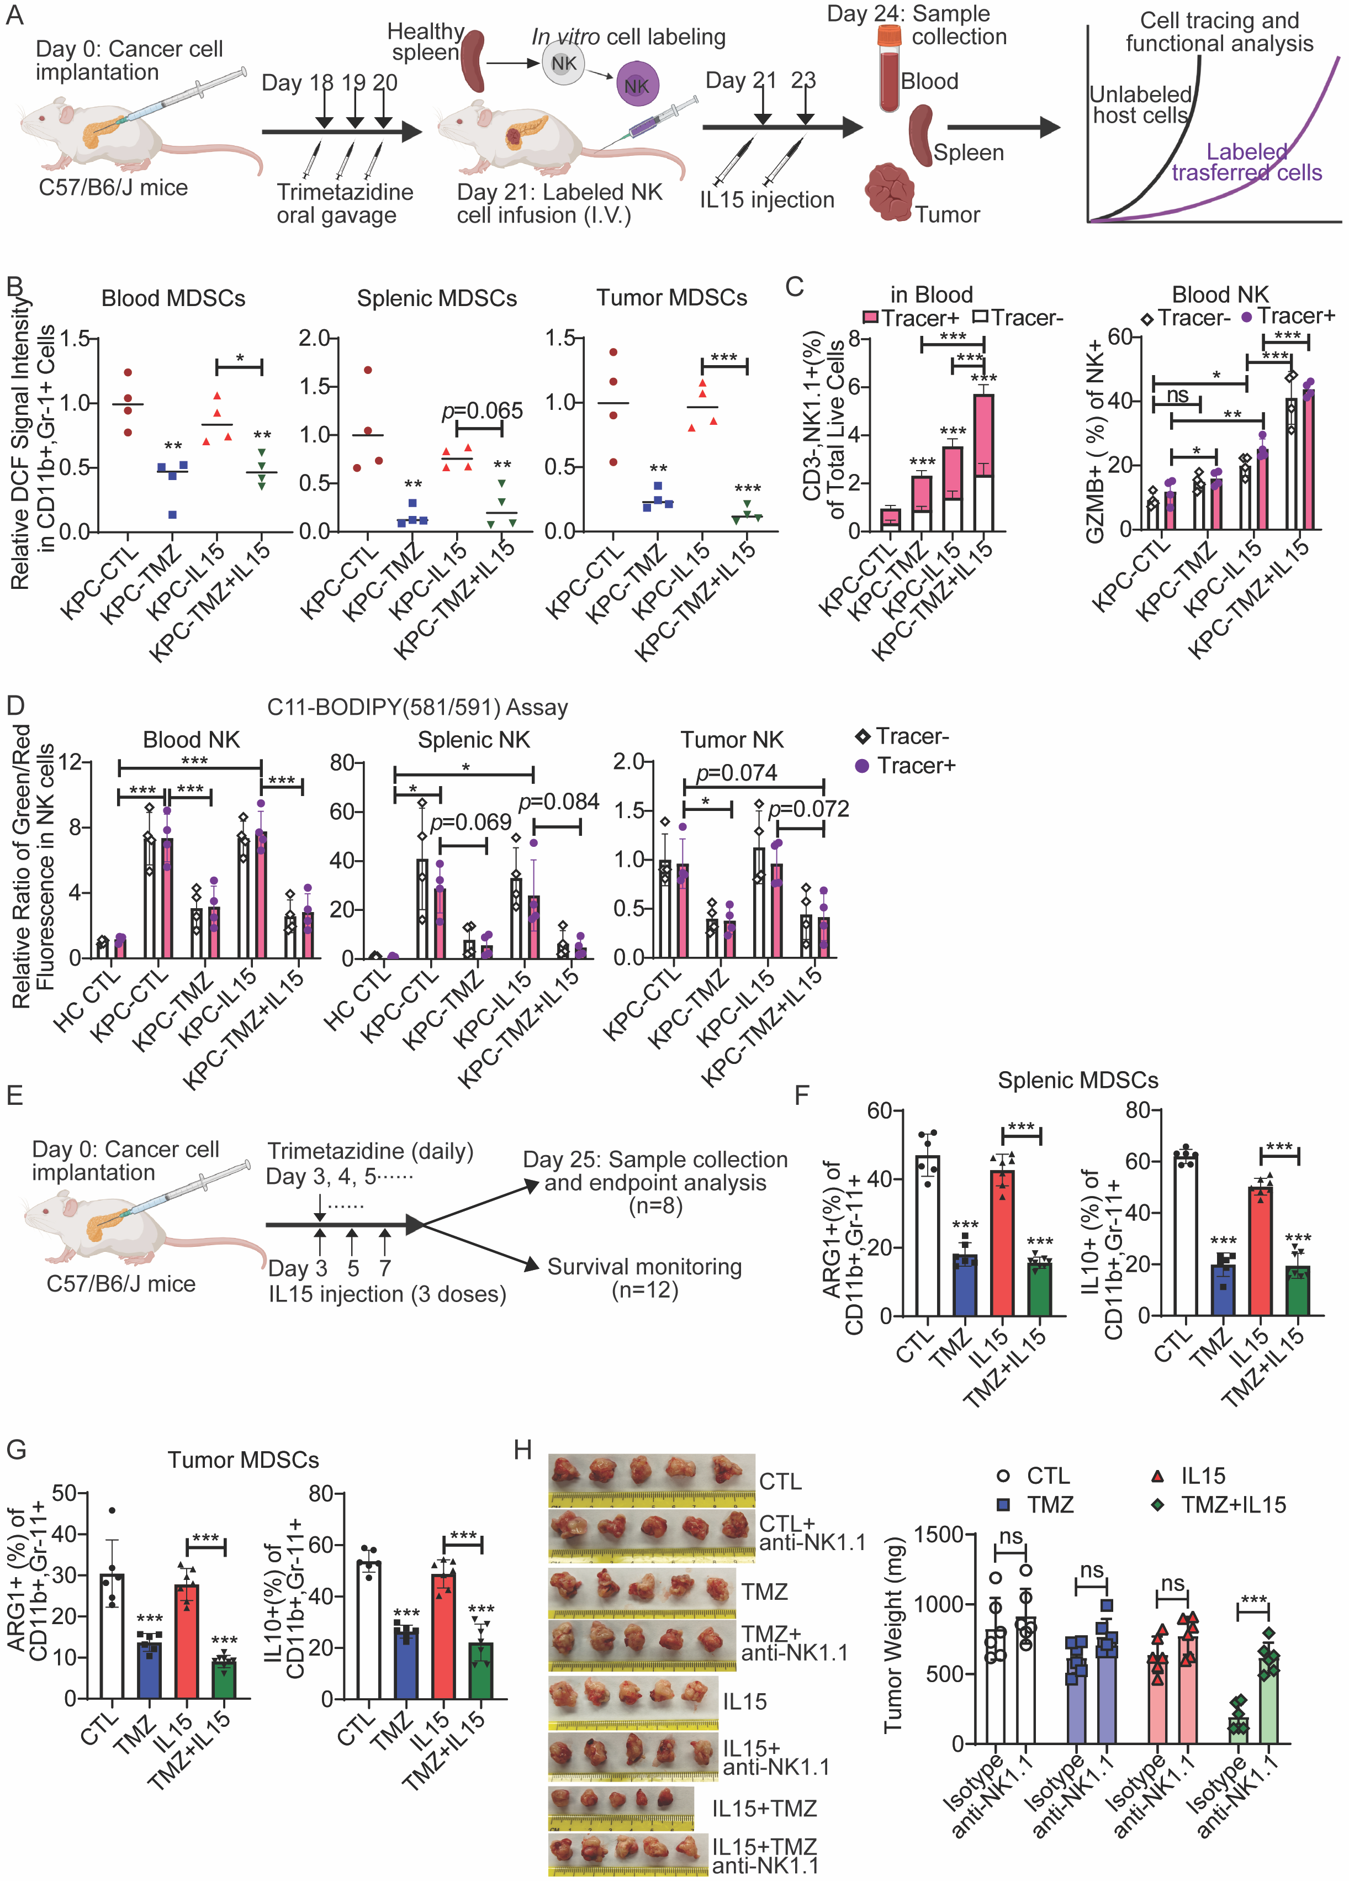
Figure S7. Blockage of lipid oxidation impairs systemic immunosuppressive effects of Gr-1+ myeloid cells (MDSCs) and enhance NK cell therapy. A. Experimental design of NK cell in vivo tracing for determining the effects of Trimetazidine (TMZ) on adoptive transferred NK cells. NK cells isolated from healthy mice were labeled with a violet cell tracer dye and adoptively transferred into tumor-bearing mice. Treatment groups received five doses of Trimetazidine (TMZ) to block lipid oxidation and two doses of IL-15 to induce NK cell proliferation and activation. B. Relative DCF signal intensity in MDSCs from the spleens, tumors, and blood of tumor-bearing mice treated with or without TMZ and IL15 (as described in Figure S7A). C. Left: Percentage of cell tracer-labeled and unlabeled NK cells in blood of tumor-bearing mice treated with or without TMZ and IL15; Right: percentage of GZMB positive cells within the total population of cell tracer-labeled and unlabeled NK cells in the blood of tumor-bearing mice treated with or without TMZ and IL15 (as described in Figure S7A). D. Relative ratio of Green/Red fluorescent signal intensity in cell tracer-labeled and unlabeled NK cells (isolated from the blood, spleens, and tumors as described in Figure S7A) after incubation with C11-BODIPY (581/591) for 1 hour. HC CTL: untreated healthy control. E. Experimental design for determining the impact of combined IL15 (to stimulate NKs) and TMZ (to inhibit FAO) therapy on NK cell activation and PDAC tumor burden. F &G. Percentage of ARG1 and IL10 positive MDSCs in spleens (F) and tumor (G) from mice treated with or without TMZ and IL15 (as described in Figure S7E). H. Representative images and statistical analyses illustrating the tumor size and weight of KPC1245 following NK cell depletion and treatment with TMZ and IL15. Data are shown as the mean ± SEM. One-way ANOVA with Tukey’s multiple comparisons test was used for panel B, C, F, &G. Two-way ANOVA with Tukey’s multiple comparisons test was used for panel C, D, &H. * p < 0.05, ** p < 0.01, and *** p < 0.001. The stars without bars represent the comparison between the first column and the column marked with stars.

