Supplementary Materials

GUIDE: A prospective cohort study for blood-based early detection of gastrointestinal cancers using targeted DNA methylation and fragmentomics sequencing

TABLE OF CONTENTS

Supplementary Methods
- Research center and participants
- Sample size determination
- Measurements for the markers
- Synthetic cfDNA samples
- Detection ratio and false discovery rate for evaluating the technical variation
- LoD for differentiating cancer from healthy samples
- LoD for identifying the TOO
- Tumor fraction estimation
- GutSeer submodels
- WGS data processing
- WGS-based fragmentomics feature generation and modeling

Supplementary Figures
- Supplementary Figure S1. Overview of the GutSeer model building process.
- Supplementary Figure S2. Workflow for the head-to-head comparison between GutSeer and WGS-based approach.
- Supplementary Figure S3. Technical evaluation of GutSeer.
- Supplementary Figure S4. Pipeline for the quantification of the methylation encoding score.
- Supplementary Figure S5. Cross-validation of GutSeer for differentiating cancer from non-cancer samples.
- Supplementary Figure S6. Sensitivity of GutSeer at the cut-off with a specificity of 100% in the training set.
- Supplementary Figure S7. Sensitivity based on methylation/fragmentomics-only.
- Supplementary Figure S8. TOO based on methylation/fragmentomics-only.
- Supplementary Figure S9. Sensitivity of 63 patients diagnosed with advanced precancerous lesions.
- Supplementary Figure S10. Comparison of GutSeer and conventional tumor markers.
- Supplementary Figure S11. Consistency of fragmentomics signatures between GutSeer and WGS data.
- Supplementary Figure S12. Impact of covariates on the GutSeer’s performance.
- Supplementary Figure S13. Low dependence of GutSeer on the sequencing depth.

Supplementary Tables
- Supplementary Table S1. Categorization of Participants.
- Supplementary Table S2. Preanalytical procedures from blood collection to cfDNA extraction.
- Supplementary Table S3. Sample QC metrics.
- Supplementary Table S4. In-house RRBS data utilized for the GutSeer panel development.
- Supplementary Table S5. Number of samples by cancer type and stage.
- Supplementary Table S6. Number of tissue samples used to evaluate the effectiveness of the panel.
- Supplementary Table S7. Accuracy of GutSeer at a specificity of 95.8%/95.8%/94.4%.
- Supplementary Table S8. Accuracy of GutSeer at a specificity of 100%/99.0%/100%.
- Supplementary Table S9. Sensitivity across different cancer types by stage at the specificity of 95.8%/95.8%/94.4% for training/validation/test set.
- Supplementary Table S10. The comparison of integrated vs. single feature.
- Supplementary Table S11. Comparison of the sensitivity between the integrated and the methylation/fragmentomics-only models based on the training dataset.
- Supplementary Table S12. Comparison of the sensitivity between the integrated and the methylation/fragmentomics-only models based on the validation dataset.
- Supplementary Table S13. Comparison of the TOO precision between the integrated and the methylation/fragmentomics-only models.
- Supplementary Table S14. Pathological characteristics of patients diagnosed with advanced precancerous lesions.
- Supplementary Table S15. Comparison between GutSeer and conventional cancer markers for distinguishing between cancer and non-cancer.
- Supplementary Table S16. Samples used for the comparison between GutSeer and the WGS-based approach.
- Supplementary Table S17. Multivariate analysis to assess the independence of GutSeer.
- Supplementary Table S18. Accuracy and sensitivity based on a lower sequencing depth by down-sampling.
- Supplementary Table 19. Comparison of GutSeer with recently published MCED assays.

Supplementary References

Supplementary Methods

Research center and participants
Participants in the GUIDE study were prospectively recruited from inpatient and outpatient care in 5 medical centers, including Zhongshan Hospital of Fudan University (Shanghai), Changhai Hospital (Shanghai), Xuhui Central Hospital (Shanghai), Qingpu Branch of Zhongshan Hospital affiliated to Fudan University (Shanghai), and Hubei Cancer Hospital, Tongji Medical College, Huazhong University of Science and Technology (Wuhan). All these centers were qualified for the clinical research with good clinical practice (GCP) guidelines. The enrollment period spanned from November 15, 2020, to July 31, 2023. Informed consent was obtained from all participants before the study.

For every participant, demographics, general clinical information, medical history, as well as cancer diagnosis data (endoscopy, CT, MRI, ultrasonography, etc., when available) were collected. The clinical stages of cancers were defined according to the American Joint Committee on Cancer (AJCC) 8th edition, except for liver cancer, which was staged with reference to the China liver cancer staging system (CNLC). The choice of staging systems was based on their widespread clinical applicability and alignment with the current guidelines for cancer staging in China. We believe these stage systems allow for comparability with other studies and clinical practices.

Inclusion criteria include:
- Age over 18 years old.
- Participants were able to provide a written informed consent form and blood samples for the GutSeer test.
- Participants who were pathologically or radiologically diagnosed as one of any stage (I-IV) of the five cancers: colorectal cancer, esophageal cancer, gastric (stomach) cancer, hepatocellular carcinoma, or pancreatic cancer.
- Participants who were suspected of colorectal cancer, esophageal cancer, gastric cancer, hepatocellular carcinoma, or pancreatic cancer seeking for further diagnosis.
- Participants presenting to outpatient care settings with gastrointestinal symptoms seeking further diagnostic evaluation.

Exclusion criteria include:
- Participants who were pregnant or lactating.
- Participants who had received anticoagulant agents (e.g., warfarin, aspirin) for ≥1 week preceding phlebotomy or were administered low-molecular-weight heparin on the blood collection day.
- Patients with multiple cancers were excluded.
- Cancer patients having already received surgery, radiotherapy, chemotherapy, targeted therapy, or other anti-tumor intervention previously.
- Recipients with organ, bone marrow, or stem cell transplant.
- Patients with hemorrhagic.
- Patients with systemic inflammatory response syndrome.
- Patients having a history of severe cardiovascular diseases (e.g., previous myocardial infarction, coronary artery bypass grafting, coronary stenting, congestive heart failure, or myocardial infarction within last 6 months, or uncontrolled severe hypertension, etc.).
- Individuals participated in an “interventional” clinical trial within the past 30 days and had taken experimental drug(s).
- Individuals unsuitable for this trial as determined by the investigators. Individuals were considered unsuitable if they withdrew consent, developed health issues prior to blood collection, or were assessed by investigators as have complex medical conditions that posed potential safety risks.
- Individuals failed to collect blood on time according to plan or the blood sample did not meet the requirements: (1) must be delivered to the central laboratory within 72 hours after being collected; (2) must be collected in Streck tubes; (3) volume must be at least 10 mL; (4) has no visible hemolysis or contamination; (5) must be properly labeled and promptly processed or stored according to standard operating protocol.
- Participants who were diagnosed by pathological or radiological tests as advanced precancerous lesions as described in Supplementary Table 1 (only for Model Building Cohort).

Sample size determination
The sample sizes for both the model training and validation cohorts were pre-specified based on empirical experience, with approximately 500 cases or controls allocated to each cohort. For the independent test cohort, sample size was determined based on achieving ±5% precision for 95% confidence intervals of the assay performance metrics. Using the standard formula for proportion estimation (n = Z²α/2 × p × (1-p)/d²), we calculated that a minimum of 246 cancer cases were required for sensitivity assessment (80% expected) and 73 non-cancer controls for specificity evaluation (95% expected). TOO prediction accuracy (85% expected) necessitated approximately 245 cancer cases when accounting for the expected sensitivity. Additional case and control patients were incorporated into the study due to their availability.

Measurements for the markers
For each genomic region of each sample, the methylation level was quantified by measurements including the average methylation fraction (AMF) and the methylation haplotype fraction (MHF). The AMF was calculated by the fraction of all the methylated CpGs compared to the total CpGs across all the reads from the marker region in the sample (as in the following formula), to quantify the overall average methylation level for the marker region:
$${AMF}_{i}=\frac{M_{i}}{N_{i}}$$
Where i is the index of the marker region and N_{i} and M_{i} are the numbers of all and methylated CpGs across all the reads detected in the region.

The MHF was quantified as the fraction of fully methylated and fully unmethylated haplotypes (per the following formula), to evaluate the concentrative level of methylation in the region.
$${MHF}_{i,h}=\frac{N_{i,h}}{N_{i}}$$
Where i is the index of certain consecutive CpG combinations within a marker region; h is the index of the haplotype with fully methylated/unmethylated CpGs; N_{i,h} is the number of reads of haplotype h in the consecutive CpG combination i; and N_{i} is the total number of reads covering the consecutive CpG combination i.

In addition to methylation, fragmentomics patterns, such as the end motif and tFPKM (targeted FPKM) were also quantified. The tFPKM was quantified by the coverage depth of the cfDNA corresponding to the targeted genomic locations for each marker in each sample (formula below). Please note that to remove the bias related to the sequencing depth and marker region size, the samples were normalized to the marker region size and the count of reads mapped on the markers.
$$cov= \frac{N_{i}}{L_{i}×N}$$
Where i is the index of the marker region; N_{i} is the number of reads mapped to region i; L_{i} is the length of region i; and N is the count of reads mapped on the markers.

For the end motif, instead of assessing each marker separately, the value was computed based on the reads across all of the marker regions, by the fraction of every 6-bp motif at the ends of the cfDNA fragments (per the following formula), since it was reported that cancer-induced cfDNA fragmentation changes would affect the enrichment of the motifs at the ends of cfDNA fragments [1].
$$F_{m}= \frac{N_{m}}{4096}$$
Where m is the index of the 6-bp motif; F_{m} is the fraction of motif m; N_{m} is the number of motif m; and 4,096 (4⁶) is the total number of motifs.

Synthetic cfDNA samples
To simulate cfDNA samples from healthy donors, DNA from the GM12878, a lymphoblastoid cell line derived from peripheral blood mononuclear cells were segmented using the EpiScope Nucleosome Preparation Kit (TAKARA) according to the manufacturer’s instructions. Briefly, GM12878 cells were collected by centrifugation and washed in PBS. Approximately 10⁶ cells were digested in cytoplasmic lysis buffer for 10 min. The cell lysate was centrifuged and resuspended in micrococcal nuclease buffer. Micrococcal nuclease, RNaseA and protease inhibitor were added into the slurry and incubated at 37℃ for 30 min. For DNA cleanup, digestions were halted with EDTA and Proteinase K for 30 min at 37 °C. Nucleosome DNA was then purified using XP beads and analyzed on agarose gel to confirm an average size of ~160 bp. For the synthetic cancer cfDNA samples, 5 commonly used gastrointestinal cancer cell lines (liver cancer: PLC; pancreatic cancer: PANC1; gastric cancer: HGC27; esophageal cancer: KYSE150; colorectal cancer: SW480) were selected and their DNA samples were segmented as described above.

Detection of false discovery rate (FDR) to evaluate technical variations
To assess the technical variation, we processed 8 technical replicates of 20 ng mixed cfDNA samples, 20 technical replicates of 20 ng fragmented GM12878 DNA (representing healthy samples) across four independent batches. Additionally, 12 technical replicates were generated with low-input DNA (2 ng, 5 ng, 10 ng) to examine the minimal required DNA input. The pairwise comparisons of technical replicates demonstrated high correlations (Supplementary Figure 3A and B). The FDR was determined through the following steps:

Step 1. Constructing the baseline distribution of methylation levels for each marker. The 32 replicates of GM12878 DNA described above were used to establish a baseline distribution of the average methylation fraction (AMF). This provided the mean and standard deviation (sd) values of AMF for each marker in the GutSeer panel.

Step 2. Identifying anomalous markers. An anomalous marker was defined as one whose AMF falls within the extreme tails of the baseline distribution (2.5% in each tail, α=0.05), corresponding to a cutoff of 2*sd from the mean value. These anomalous markers were classified as cancer-associated positive markers. The ratio of such positive markers in each sample was then calculated using the following formulas:
$${BaselineL}_{i}=mean({AMF}_{i,j})-2*sd({AMF}_{i,j})$$
$${BaselineH}_{i}=mean({AMF}_{i,j})+2*sd({AMF}_{i,j})$$
$${Detect}_{i,j}=\left\{\begin{aligned}1, &{AMF}_{i,j}<{BaselineL}_{i} or {AMF}_{i,j}>{BaselineH}_{i} \\ 0, &{BaselineL}_{i}≤{AMF}_{i,j} ≤ {BaselineH}_{i}\end{aligned}\right.$$
$${DetectRatio}_{j}={\sum_{i=1}^{Markers}{{Detect}_{i,j}}}/{Markers}$$

Step 3. Detecting the FDR associated with DNA input. The 32 replicated healthy samples with multiple DNA input amounts (2 ng, 5 ng, 10 ng and 20 ng) were compared to the baseline distribution to examine the ratio of the anomalous markers for each sample. Given the healthy nature of these samples, the ratio of anomalous markers is also considered as FDR. We observed that FDR decreased with increasing DNA input (Supplementary Figure 3C). Thus, a minimal 10 ng input DNA was required for GutSeer panel to guarantee an FDR below 5%.

Determination of the limit of detection (LoD) for cancer detection
To examine LoD, synthetic cancer cfDNA samples were generated by diluting cancerous DNA derived from PLC, PANC1, HGC27, KYSE150, or SW480 cell line into GM12878 DNA at 5 predefined concentrations (0.01%, 0.05%, 0.1%, 0.5% and 1%). Five technical replicates were prepared for each dilution concentration. Additionally, five replicates of GM12878 DNA were included as reference controls.

The ratio of anomalous markers for each sample was calculated based on the established baseline distribution for each marker. The ratios of anomalous markers for cancer samples at different dilution concentrations were then compared to those of the reference controls using a two-sided t-test. The LoD for cancer detection was referred to as the minimal dilution concentration at which the t-test results were statistically significant. Consequently, the LoD was determined to be 0.01% for liver (PLC), gastric (HGC-27), esophageal (KYSE-150), and colorectal (SW480) cancer, while the LoD was for pancreatic cancer (PANC1) was found to be 0.05% (Supplementary Figure 3D).

LoD for identifying the TOO
In the in silico LoD test for TOO detection, simulated data were generated (Supplementary Figure 3E) and randomly split into training and test datasets for each of the five gastrointestinal cancers. Subsequently, the data for the same cancer type were merged within the training and test groups. For each predefined dilution ratio (0.005%, 0.01%, 0.05%, 0.1%, 0.5%, and 1%), we down-sampled the training/test data and mixed it with plasma data for the corresponding concentration. The process was repeated 50 times to generate a total of 250 training samples (50 per cancer type) and 250 test samples (50 per cancer type) for each dilution concentration.

Then, the methylation features (AMF and MHF) of each marker region in each sample were quantified, and based on that, stacked machine-learning models were built for TOO identification at each dilution concentration mixing ratio. The stacked model consisted of four sub-models: Support vector machines (SVM), Gradient Boosting Machine (GBM), Random Forest (RF), and Logistic Regression (LR). The outputs of these sub-models were then stacked using a multi-class LR classifier. After the stacked models were constructed, they were run on the test samples with the corresponding dilution concentration for the TOO prediction in the simulated test samples. The minimum concentration at which the accuracy is greater than 95% was determined as the LOD for TOO prediction (0.01% to 0.05%) (Supplementary Figure 3F-G).

Tumor fraction estimation
Again, synthetic cancer cfDNA samples were generated with multiple dilutions of cancer cell DNA into gradient concentrations. Tumor fractions were compared between the actual concentration of cancer DNA and the estimated concentration (as described in the following formula) measured by GutSeer:
$$F_{i,j}={({AMF}_{i,j} - μ_{i}^{Normal})}/{(μ_{i}^{Cancer}-μ_{i}^{Normal})}$$
$$μ_{i}^{Normal}={\sum_{j=1}^{N^{Normal}}{{AMF}_{i,j}}}/{N^{Normal}}$$
$$μ_{i}^{Cancer}={\sum_{j=1}^{N^{Cancer}}{{AMF}_{i,j}}}/{N^{Cancer}}$$
Where i and j are the index of the marker and sample, respectively; $F_{i,j}$ represented the estimated tumor fraction of marker i in sample j, the $μ_{i}^{Normal}$ represented the average AMFs of marker i across the synthetic healthy cfDNA samples (NA12878), and the $μ_{i}^{Cancer}$ represented the average AMFs of marker i across the cancer cell line samples. The median with a 95% confidence interval for all of the $F_{i,j}$ values (with all markers across all samples) was taken as the result of the estimated tumor fraction. The estimated tumor fractions closely aligned with expected values (R²=0.99) (Supplementary Figure 3H).

GutSeer submodels
Four submodels were trained separately from the AMF/MHF, end motif, tFPKM, and methylation encoding score (MES), for the first layer of the GutSeer model.

The AMF/MHF submodel was trained using the following pipeline. Step 1: For each target region, AMF/MHF markers were selected comparing either between each type of cancer and non-cancer samples (cancer markers), or among different cancer types (TOO markers) with Mann-Whitney U-test. Cutoff for cancer markers was set at Bonferroni adjusted p≤0.05 and FDR p≤0.05 for TOO markers. Missing values were imputed using k-nearest neighbour algorithms. Step 2: For each respective marker region, a support vector machine (SVM) model was trained using the AMF value and multiple MHF values corresponding to the markers in this marker region. The SVM model was trained using labels indicating both the cancer/non-cancer status and cancer type. The predictions from this SVM model were used to integrate the AMF information and multiple MHFs for each marker region, providing predictions for the cancer/non-cancer status (binary value) or TOO (probability values). Step 3: Based on the predictions from the SVM model, a stacked model consisting of logistic regression, random forest, SVM, and gradient boosting was trained. This model generated the second round of prediction for cancer/non-cancer or TOO as the final result of the AMF/MHF submodel.

tFPKM, and end motif submodels were trained in similar way. For cancer model, tFPKM/end motif markers separating each cancer from non-cancer samples with AUC ≥0.6 or ≤0.4 were selected. Logistic regression model was trained with the selected markers. For TOO model, tFPKM/end motif markers separating each a cancer type from other cancer types with AUC ≥0.6 or ≤0.4 were selected. Multi-classes logistic regression model was trained with the selected markers against corresponding label.

MES submodel
The MES model, incorporating both methylation and fragmentomics information, was calculated for each of the marker regions, as described below (Supplementary Figure 4):
Step 1: Regional methylation reads encoding. Reads covering GutSeer target areas were converted into fixed-length 1D sequences with a length equal to twice the number of CpGs in the region. The first part of the sequence encodes the methylation status, where 0 represents non-methylated or undetected CpGs, and 1 represents methylated CpGs. The second part indicates whether each CpG's methylation status was definitively determined via sequencing, with 1 representing confidently identified CpGs and 0 representing unidentified ones.

Step 2: Read-level models. Ten models were trained for reads in each region: five for cancer/noncancer classification and five for cancer/other-cancer differentiation. These models utilized fully connected, feed-forward neural networks for read classification. During training, reads in tumor samples were labeled as 1, while noncancer samples or other cancer samples were labeled as 0. To avoid a severe imbalance between 'positive' (labeled as 1) and 'negative' (labeled as 0) reads, no more than 2000 reads were randomly selected from tumor samples in each region, and no more than 1000 reads were randomly picked from noncancer or other cancer samples. Each network, except for the input and output layers, consisted of five fully connected layers with 512, 128, 32, 16, and 8 neurons, respectively. The activation function used in all layers, except the final layer, was the rectified linear unit (ReLU). The final layer employed the sigmoid function. The output of each model was a continuous value between 0 and 1, which can be interpreted as the probability of a read belonging to a specific type of cancer compared to noncancer samples, as well as the probability of it belonging to a specific type of cancer compared to other cancers.

Step 3: Region-level Models. Within each region, reads are allocated into 14 distinct intervals ([0.99,1), [0.9,0.99), [0.8,0.9), [0.7,0.8), [0.6,7), [0.55,6), [0.5,0.55), (0.45,0.5), (0.4,0.45], (0.3,0.4], (0.2,0.3], (0.1,0.2], (0.01,0.1], (0,0.01]) based on their estimated probabilities from the read-level models. The number of reads and their respective proportions within these intervals were calculated. These statistics, along with the overall reads count within the region, were used to generate a set of 29 features for training region-level models. Ten region-level logistic regression models have been trained, corresponding to ten categories of read-level models. The output of each model was also a continuous value between 0 and 1, which can be interpreted as the probability of a region belonging to a specific type of cancer compared to noncancer samples, or it belonging to a specific type of cancer compared to other cancers.

Step 4: Sample-level model. Using region-level models, each region obtains 10 scores. The predictions from all regions are utilized as new features, and two neural network models were trained using 10-fold cross-validation. One model predicted the probability of cancer, while the other model predicted the TOO. The cancer model consisted of an input layer, a batch normalization layer, five fully connected layers with 128, 64, 32, 16, and 8 neurons, respectively, and a sigmoid output layer. The TOO model consisted of an input layer, a batch normalization layer, a fully connected layer with 16 neurons, and a softmax layer. It produced four scores, where gastric and esophageal tumors were treated as a combined class. The model training employed the Adam optimizer and cross-entropy loss function. Finally, each sample obtained five scores as the final methylation encoding score (MES).

WGS data processing
Whole-genome paired-end sequencing data was processed using an standard pipeline. In brief, reads were trimmed by fastp [2] (version 0.20.1), after that, the trimmed reads were aligned to the human reference genome (hg19), using BWA (version 0.7.5a-r405). UMI-based duplicates were removed by UMI-tools [3] (version 1.1.1). In addition, a down-sampling step was performed using sambamba (version 0.8.0) for each sample among the aligned reads with a mapping quality of at least 30 and a fragment size ranging from 35bp to 1000bp. This resulted in an approximate coverage of 100 million reads (~5x) for each sample.

WGS-based fragmentomics feature generation and modeling
To make a head-to-head comparison with the performance reported in the previous study [4] (referred as FragD), the corresponding fragmentomics feature was generated according to the original descriptions, using the WGS data:

Fragment profile. The fragment profile characterized the features of short fragments (100-150bp) and long fragments (151-220bp), and also incorporated the chromosome-arm copy number and mitochondrial-derived fragment fraction (http://github.com/Cancer-Genomics/delfi_scripts). We then generated the full fragment profile for each sequenced sample using the down-sampled reads.

As described in the previous study [4], the features in the training data that exhibited high correlation (correlation coefficient > 0.9) or with near-zero variance were removed, then the remaining features were used as inputs for training a stochastic Gradient Boosting Model (GBM) to detect cancer, as well as to distinguish among different cancer types [4].
Supplementary Figures

Figure 1
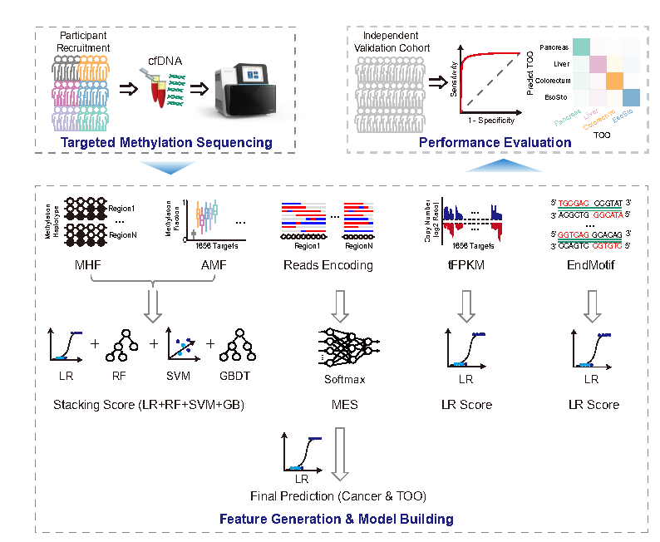
Figure 1. Overview of the GutSeer pipeline
The model was trained to distinguish cancer versus non-cancer samples and identify the tissue of origin (TOO). The model consisted of two layers. In the first layer, four submodels were trained separately from the AMF/MHF, MES, end motif, and tFPKM. The AMF/MHF submodel was trained using the following pipeline. Step 1: For each marker region, a support vector machine (SVM) model was trained using the AMF value and multiple MHF values corresponding to the haplotypes in this marker region. The SVM model was trained using labels indicating both the cancer/non-cancer status and cancer type. The predictions from this SVM model were used to integrate the AMF information and multiple MHFs for each marker region, providing predictions for the cancer/non-cancer status (binary value) or TOO (probability values). Step 2: Based on the predictions from the SVM model, a stacked model consisting of logistic regression, random forest, SVM, and gradient boosting was trained. This model generated the second round of prediction for cancer/non-cancer (binary value) or TOO (probability values) as the final result of the AMF/MHF sub-model. Before each step, a marker pre-selection process was conducted by comparing either between each type of cancer and non-cancer samples, or among different cancer types. The markers were filtered based on thresholds of the Mann-Whitney U-test to ensure their relevance and significance. The MES, tFPKM, and end motif submodels were trained using logistic regression with input data from the MES values of the marker regions, tFPKM values of the marker regions, and the profile spectrum of 4,096 motifs, respectively. These submodels were trained against the corresponding labels (cancer/non-cancer and cancer type) across the samples. Probability values for cancer/non-cancer and TOO prediction were obtained from the models. After training the first layer submodels, the second layer was constructed by stacking the outputs from these submodels. This information from methylation (AMF/MHF and MES) and fragmentomics (end motif and tFPKM) features was integrated to generate the final prediction, which gave a probability of cancer/non-cancer and TOO localization.

Figure 2
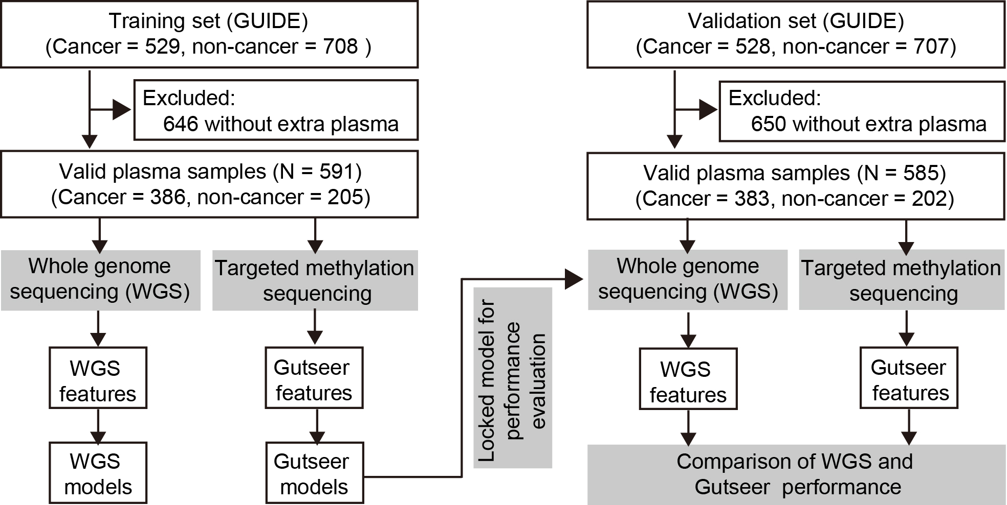
Figure 2. Workflow for the head-to-head comparison between GutSeer and WGS-based approach.

Figure 3
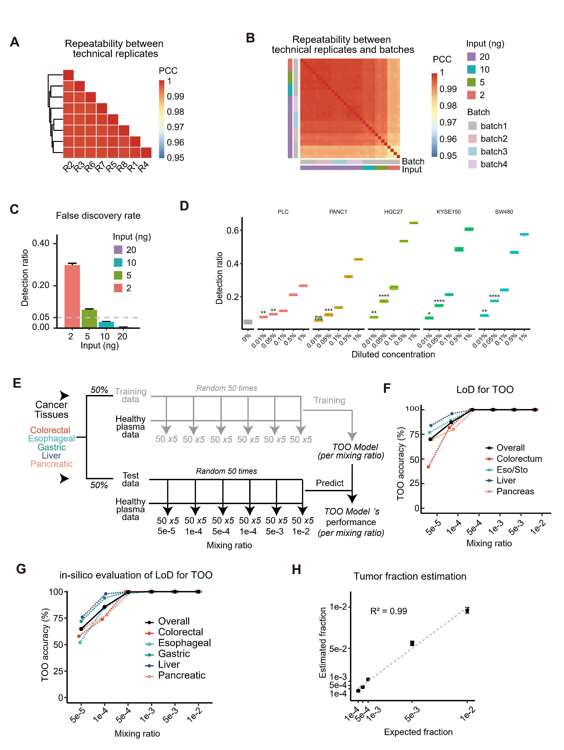
Figure 3. Technical evaluation of GutSeer.
(A) Repeatability between technical replicates. The repeatability was evaluated based on the consistency of methylation levels, measured by the average methylation fraction (AMF), across markers among eight mixed cfDNA technical replicates. Samples were clustered by Euclidean distance, and the filled color represents the Pearson correlation coefficient (PCC).
(B) Repeatability between batches. Heatmap of pairwise PCCs of the AMF among 32 synthetic healthy cfDNA samples (NA12878) with different DNA input amounts from 4 independent batches.
(C) Detection ratio of false positive markers across different DNA input amounts. The synthetic healthy cfDNA samples with multiple DNA input amounts were compared to the baseline group, consisting of healthy cfDNA samples, to detect anomalous markers with extremely low/high methylation levels, defining as false positive markers. Hence, an input of 10 ng cfDNA guarantees a false discovery rate (FDR) below 5%.
(D) Experimental evaluation of the limit of detection (LoD) for cancer detection. The genomic DNA of cancer cell lines (liver cancer: PLC, pancreatic cancer: PANC1, gastric cancer: HGC27, esophageal cancer: KYSE150, and colorectal cancer: SW480) was diluted with synthetic healthy cfDNA (GM12878) into multiple concentrations, each of which had five replicates. For each dilution concentration, the detection ratio (Y-axis) of anomalous markers against the distribution of the baseline group was quantified. The statistical test was performed by a two-sided t-test. Ns, no significance; *, p < 0.05; **, p ≤ 0.01; ***, p ≤ 0.001; and ****, p ≤ 0.0001.
(E-G) The insilico evaluation of the LoD for TOO localization. (E) The pipeline of LoD evaluation for TOO localization. Briefly, the data for every cancer type were randomly split into training and test datasets. The cancer data was diluted using synthetic healthy cfDNA data into multiple concentrations for training and test datasets, generating 250 training and 250 test samples. The TOO model was built with training samples, and tested to predict the cancer type with test samples. (F-G) The LoD of the TOO. The percentage of accurately predicted TOO (Y-axis) under the corresponding dilution concentration (X-axis) of the in silico synthetic cancer cfDNA samples. The solid line represents the overall TOO accuracy; the dotted lines with various colors represent the cancer-type specific TOO accuracy.
(H) Accuracy quantified by the tumor fraction estimation. The PANC1 cancer cell line was spiked into samples at multiple dilutions. The X and Y coordinates represent the actual and estimated tumor fractions.

Figure 4

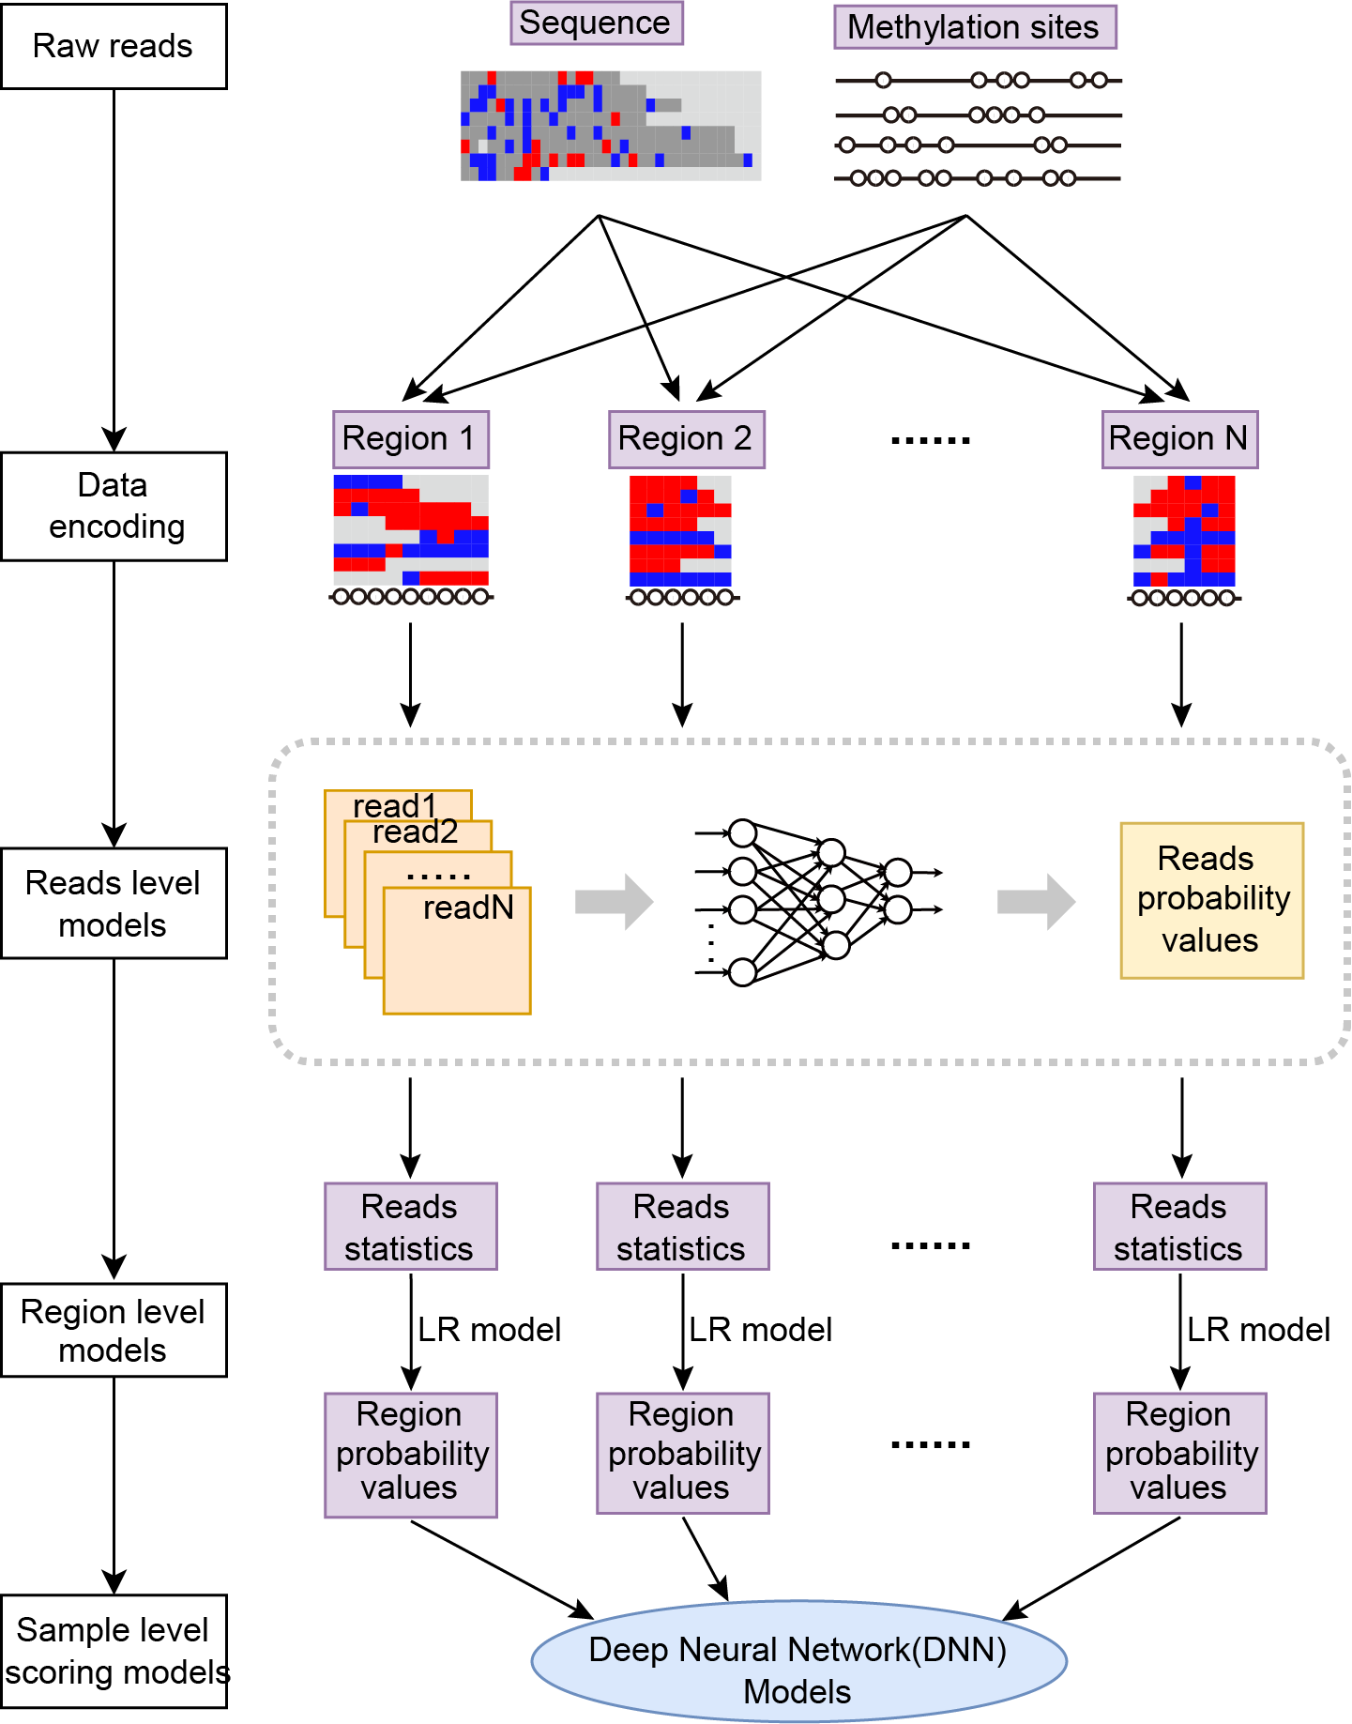

Figure 4. Pipeline for the quantification of the methylation encoding score.

The schematic pipeline of methylation encoding score (MES) modeling. Briefly, sequencing reads are encoded into vectors with both methylation status and sequencing depth. Discrimination models respectively for cancer and tissue of origin prediction are then built for every read-encoded vector, every targeted region, and every sample, gradually.

Figure 5
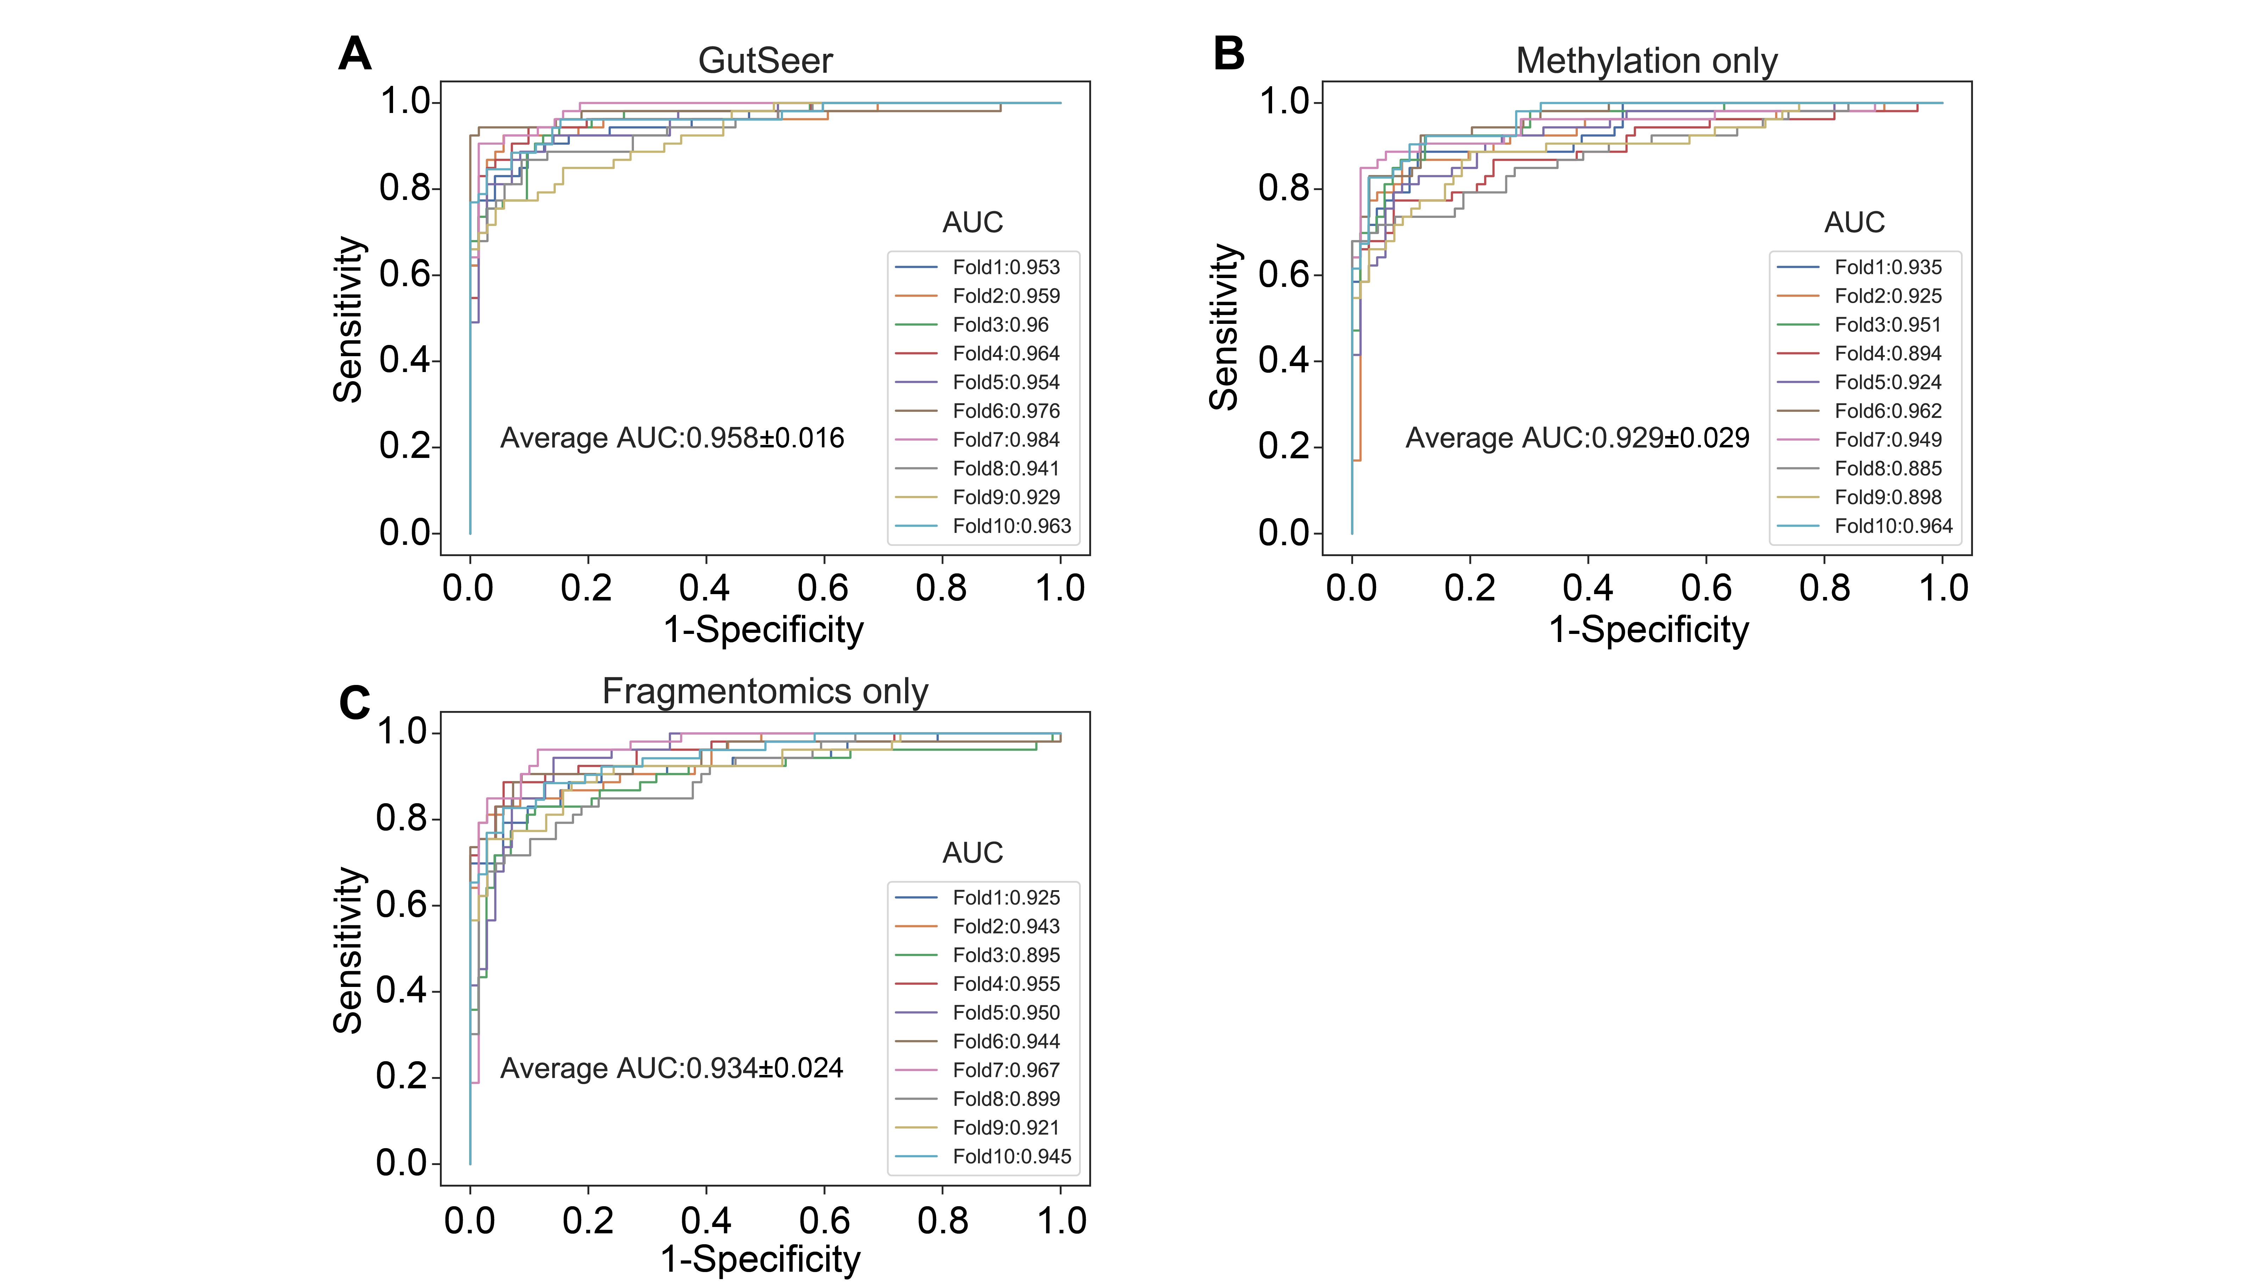
Figure 5. Cross-validation of the GutSeer for differentiating cancer from non-cancer samples.
ROC curves for the 10-fold cross-validation based on the (A) integration of methylation and fragmentomics features, (B) only methylation feature, and (C) only fragmentomics feature. AUC of each fold and the average AUC with standard deviation are given in the plot.

Figure 6

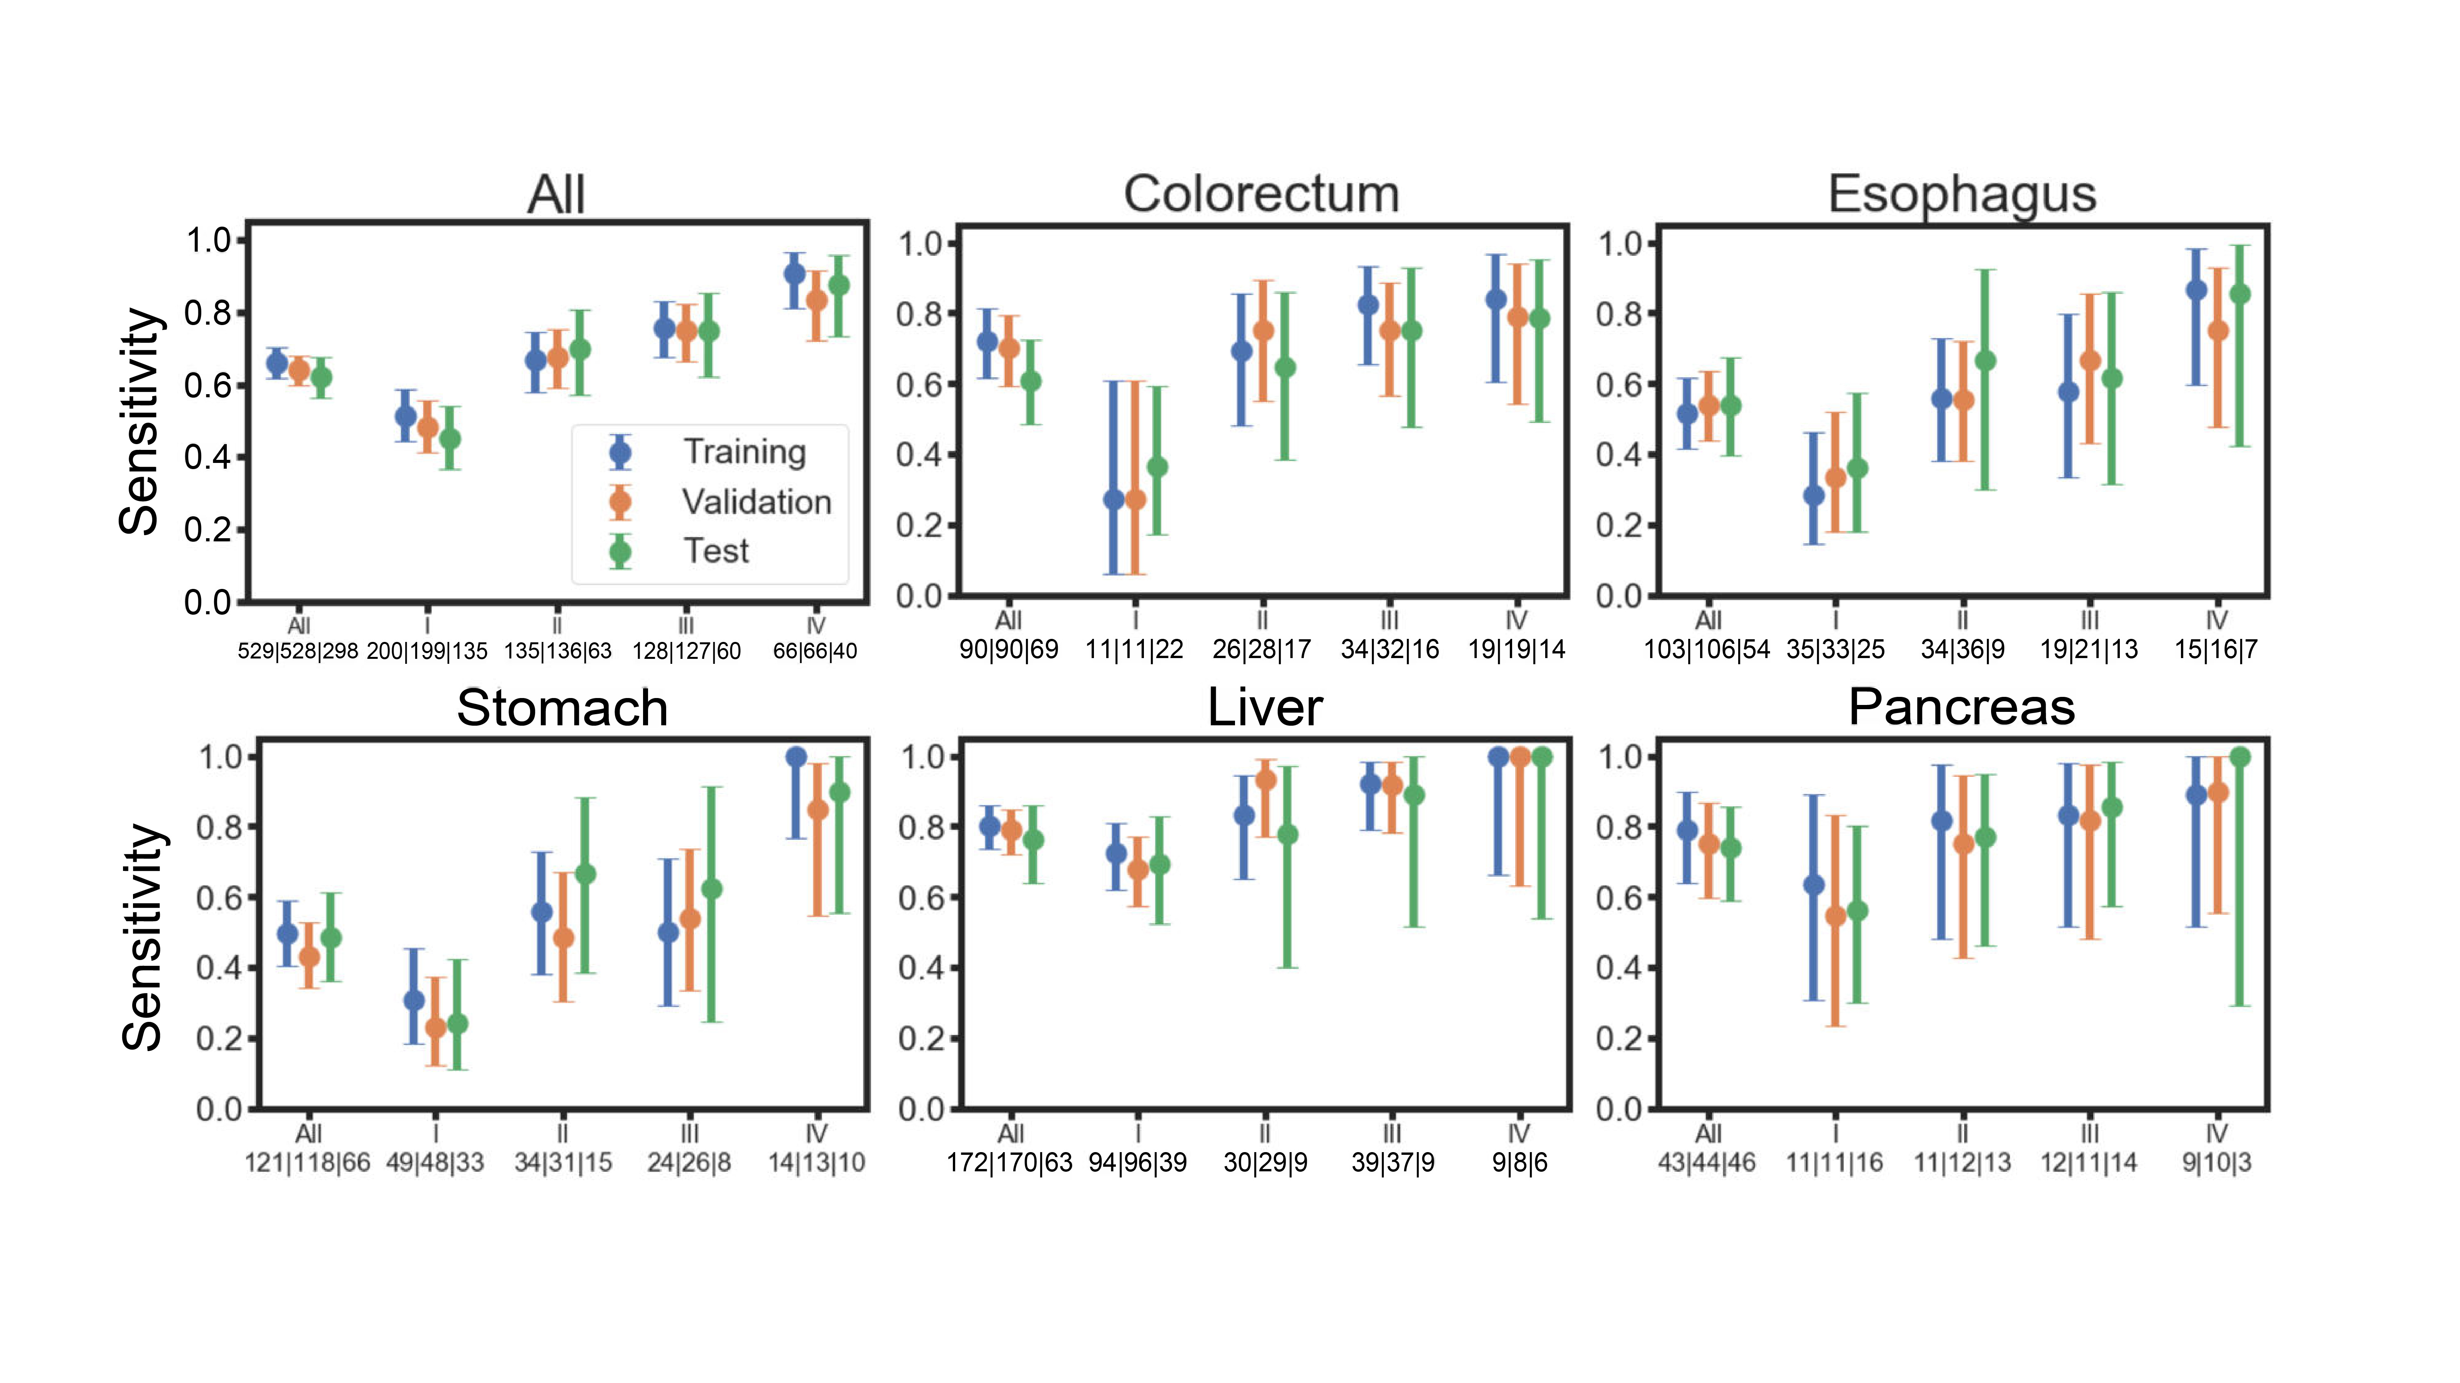
Figure 6. Sensitivity of GutSeer at the cut-off with a specificity of 100% in the training set. The overall sensitivity, and the sensitivity by cancer type and stage are shown for training cohort, validation cohort, and independent cohort at specificity of 100%, 99.0%, and 100%, respectively. 95% confidence interval is depicted for the sensitivity. Numbers below the stage indicate the sample size of “training|validation|test” corresponding to the stage of the test cancer.

Figure 7

Figure 7. Sensitivity based on only methylation/fragmentomics feature.
(A) Sensitivity based on the model constructed with only the methylation feature. The overall sensitivity is shown, along with the sensitivity by cancer type and stage. 95% confidence interval is depicted for the sensitivity. The evaluation of the training dataset was based on 10-fold cross-validation. The specificity was 95.8% and 96.2% in the training and validation datasets, respectively.
(B) Sensitivity based on the model constructed with only the fragmentomics feature. The overall sensitivity is shown, along with the sensitivity by cancer type and stage. The evaluation of the training dataset was based on 10-fold cross-validation. The specificity was 95.8% and 95.2% for the training and validation datasets, respectively.

Figure 8

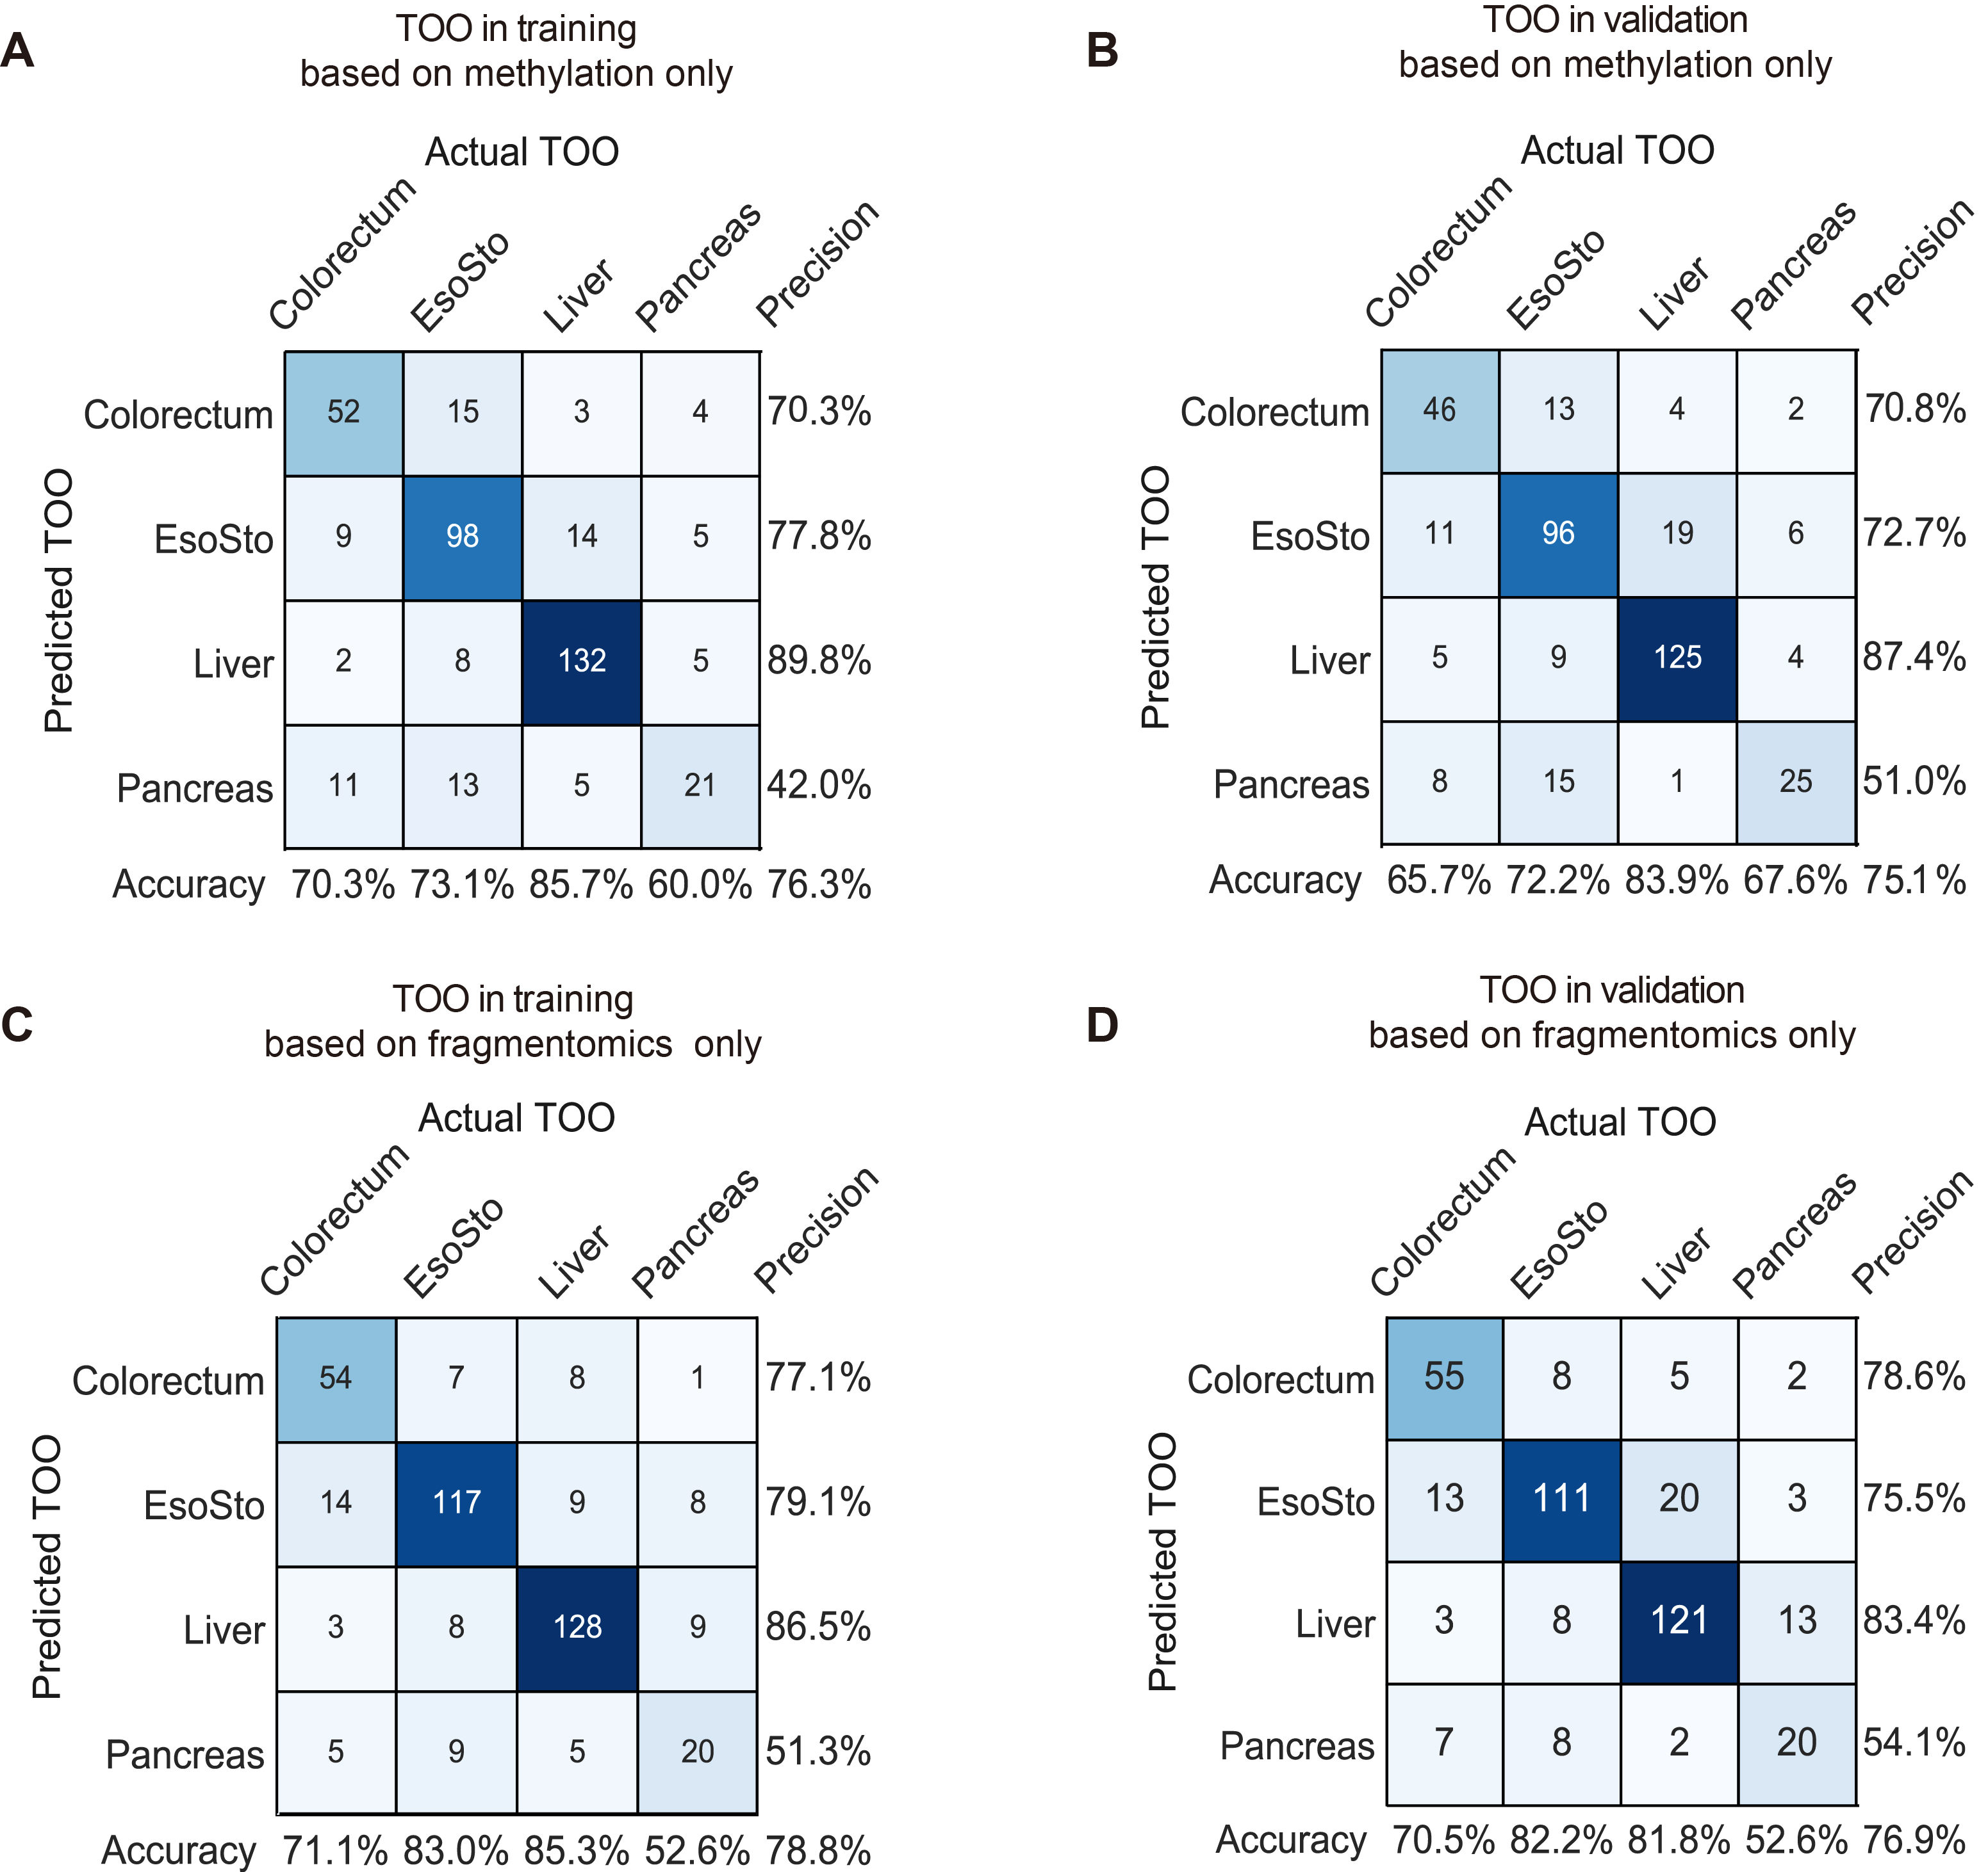
Figure 8. TOO based on only methylation/fragmentomics feature.
(A-B) Confusion matrices of the TOO identification based on the model constructed with only the methylation feature. The TOO in the training dataset (A) was evaluated by ten-fold cross-validation, which was further validated in the validation dataset (B).
(C-D) The same as in (A-B), but for the fragmentomics feature.
The accuracy (column rates) represents the percentage of correct localization within each actual TOO; the precision (row rates) represents the percentage of correct localization within each predicted TOO. EsoSto represents esophageal and/or gastric cancers.

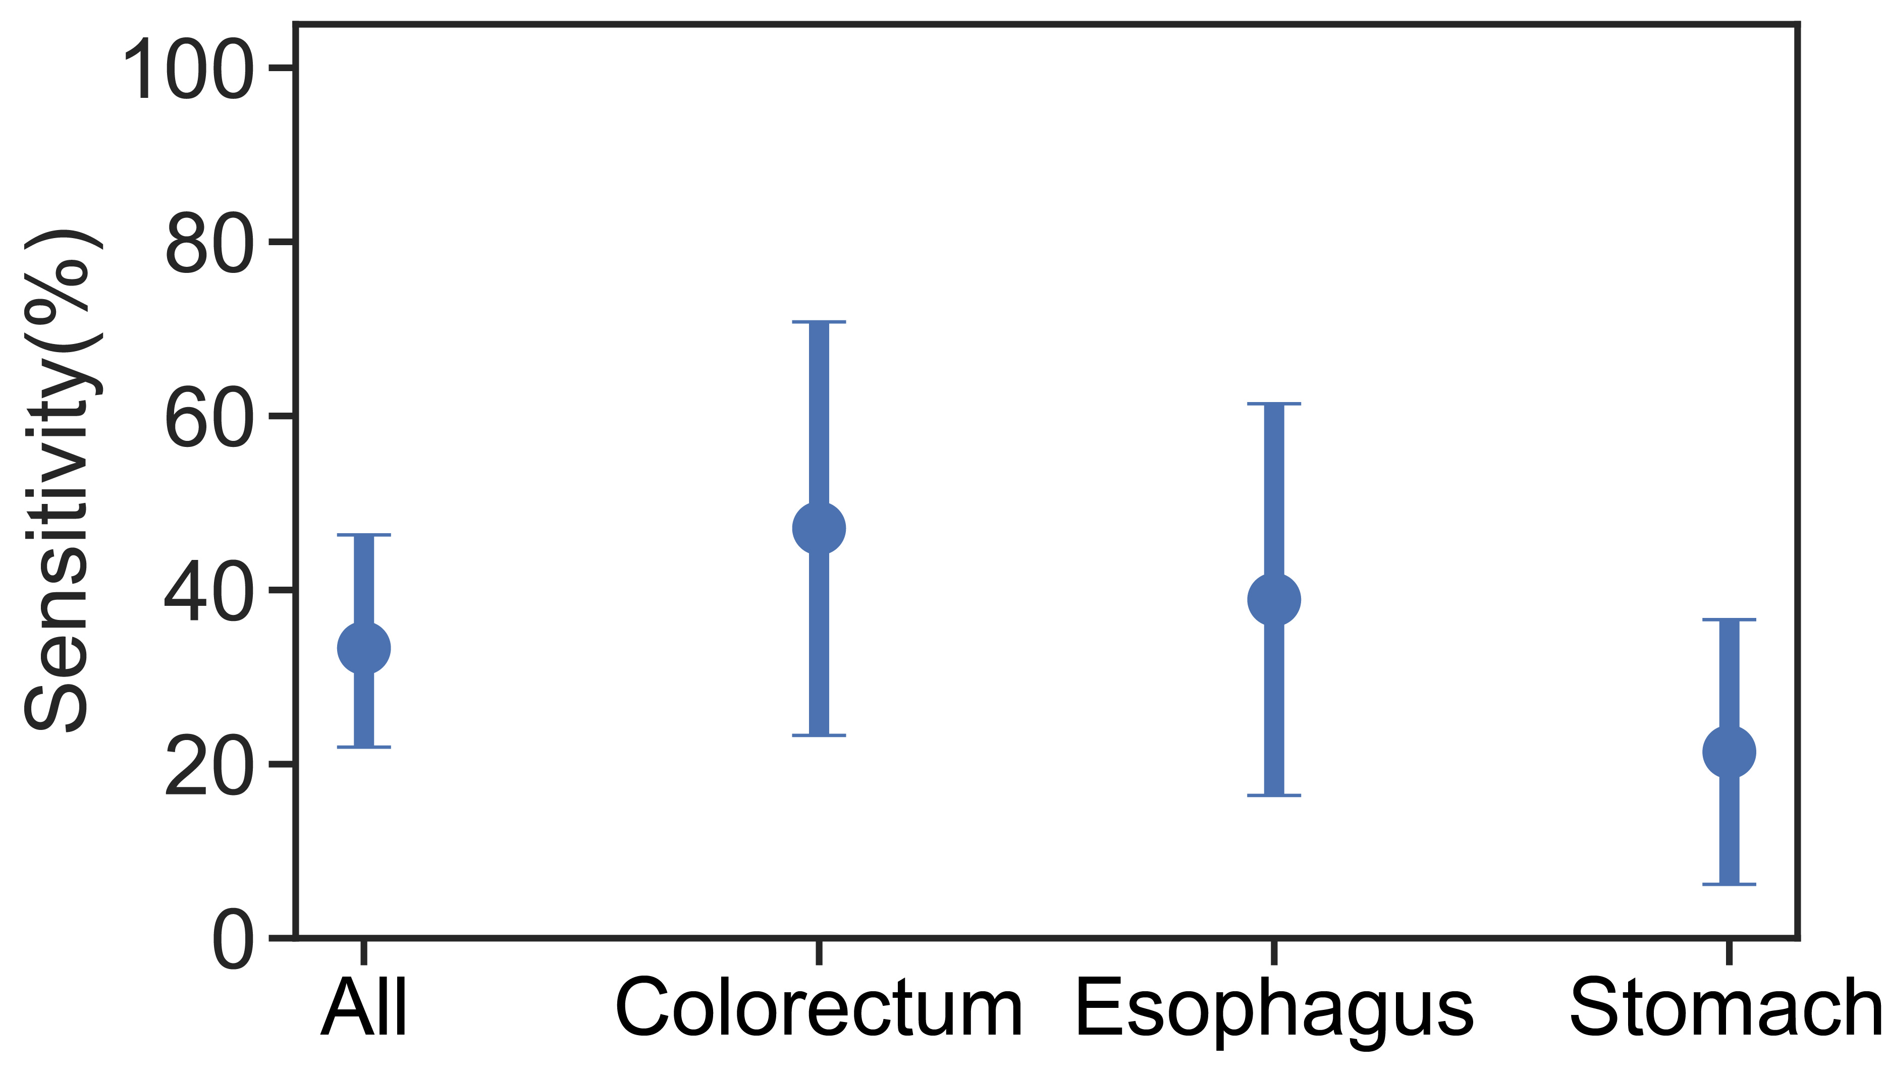
Figure 9

Figure 9. Sensitivity of 63 patients diagnosed with advanced precancerous lesions. The sensitivities of all 63 patients and each cancer type were plotted with 95% confidence interval.

Figure 10

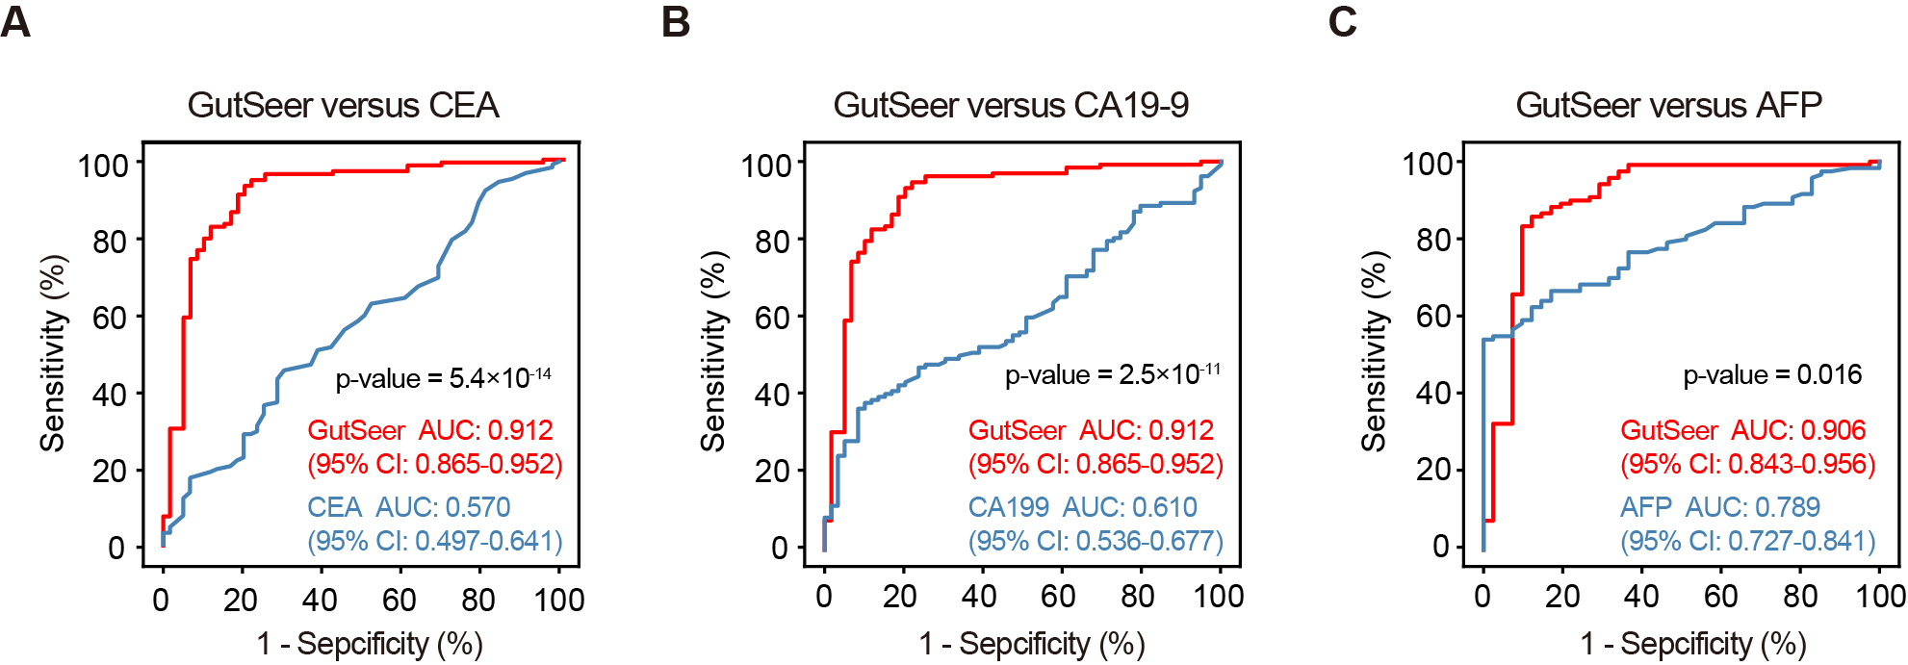

Figure 10. Comparison of GutSeer and conventional tumor serum markers.
Comparison of the AUC values between GutSeer and conventional tumor serum markers. P-values were calculated by Delong test.

Figure 11
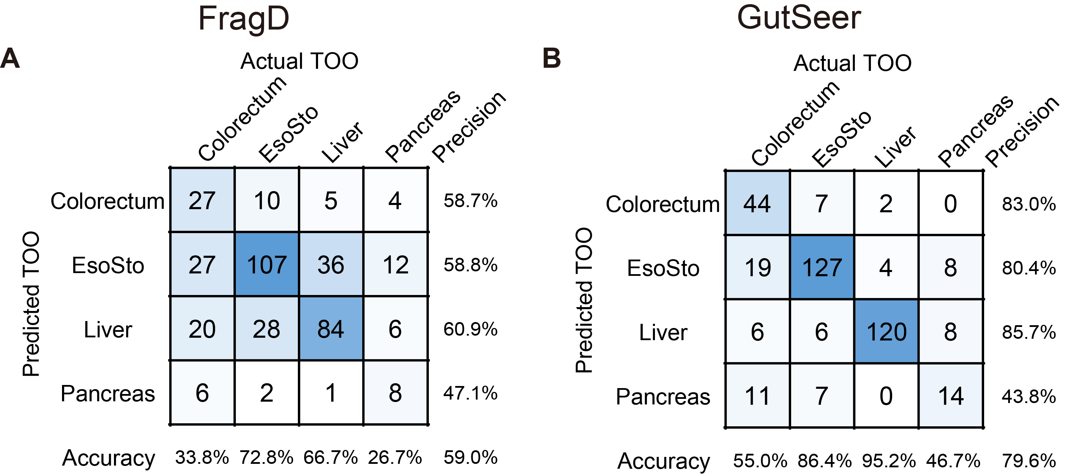
Figure 11. Consistency of fragmentomics signatures between the GutSeer and WGS data. Confusion matrices showing the TOO identification in the test dataset determined by using FragD (A) and GutSeer (B), respectively. EsoSto indicates esophageal and/or stomach cancer.

Figure 12

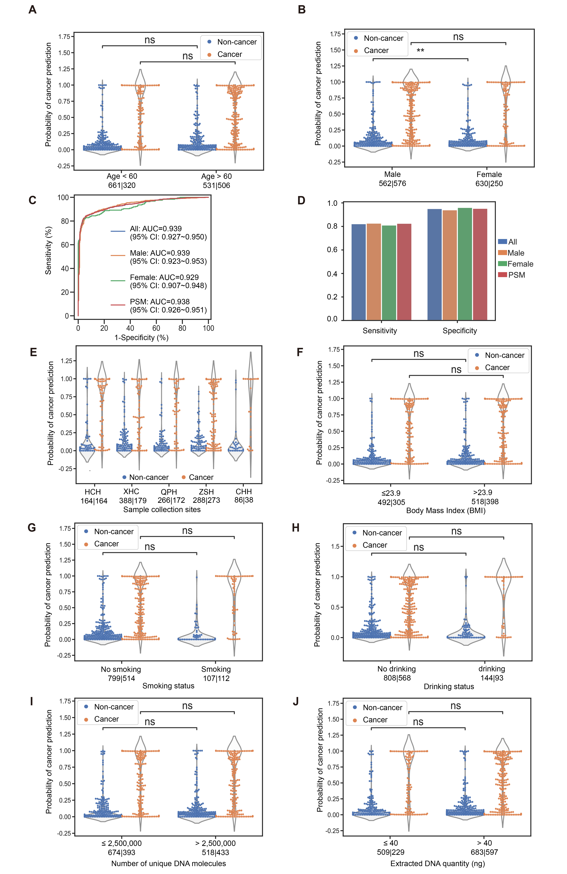
Figure 12. Impact of covariates on the GutSeer performance.
(A-B) Distribution of probability of cancer prediction for different ages (A) and genders (B). No significant difference was obtained among non-cancer groups, or among cancer groups, except a small difference between male and female non-cancer samples (p-value = 0.0049 by Mann-Whitney U-test, further adjusted by Bonferroni procedure).
(A) The p-value was 1 by comparison between the two groups (<60 versus ≥60) cancer samples; the p-value was 0.56 in non-cancer samples. (B) The p-value was 1 between male and female cancer samples. The Mann-Whitney U-test was used for the analyses, and data were further adjusted by Bonferroni procedure.
(C-D) Comparison among four sample sets in the test cohort: all samples, male samples, female samples, and the PSM (propensity score matched: balancing the age and sex between cancer and non-cancer) samples. (C) Comparison of the AUC: No significant difference was noted by Delong test. The p-values were 0.97 (all versus male samples), 0.45 (all versus female samples), and 0.98 (all versus the PSM subset). (D) Comparison of the sensitivity/specificity. The sensitivity was 82.3% (all samples), 82.8% (male samples), 81.2% (female samples), and 83.1% (PSM); the specificity was 95.2% (all samples), 94.1% (male samples), 96.2% (female samples), and 94.6% (PSM). No significant difference was noted by the Chi-squared test. The p-values were 0.40 (all versus male samples), 0.40 (all versus female samples), and 0.61 (all versus PSM subset) for the comparison of sensitivity; the p-values were 0.87 (all versus male samples), 0.76 (all versus female samples), and 0.73 (all versus PSM subset) for the comparison of specificity.
(E-J) Covariate analysis of the (E) collection site, (F) BMI, (G) smoking status, (H) drinking status, (I) number of unique DNA molecules observed and (J) total DNA quantity (ng) extracted. No significant difference was noted among the non-cancer groups or among the cancer groups. The Mann-Whitney U-test was implemented, with data further adjusted by the Bonferroni procedure.
(E) Pairwise comparisons were conducted within non-cancer groups and cancer groups, respectively. All p-values were 1 except for QPH vs. ZSH (p-value = 0.21) and HCH vs. ZSH (p-value = 0.33) in the cancer groups, and XHC vs. ZSH (p-value = 0.58) in the non-cancer groups.
(F) The p-value was 0.54 between non-cancer groups and 1 between cancer groups.
(G) The p-value was 0.31 between non-cancer groups and 1 between cancer groups.
(H) The p-value was 0.32 between non-cancer groups and 1 between cancer groups.
(I) The p-value was 0.39 between non-cancer groups and 0.42 between cancer groups.
(J) The p-value was 0.38 between non-cancer groups and 1 between cancer groups.

Figure 13

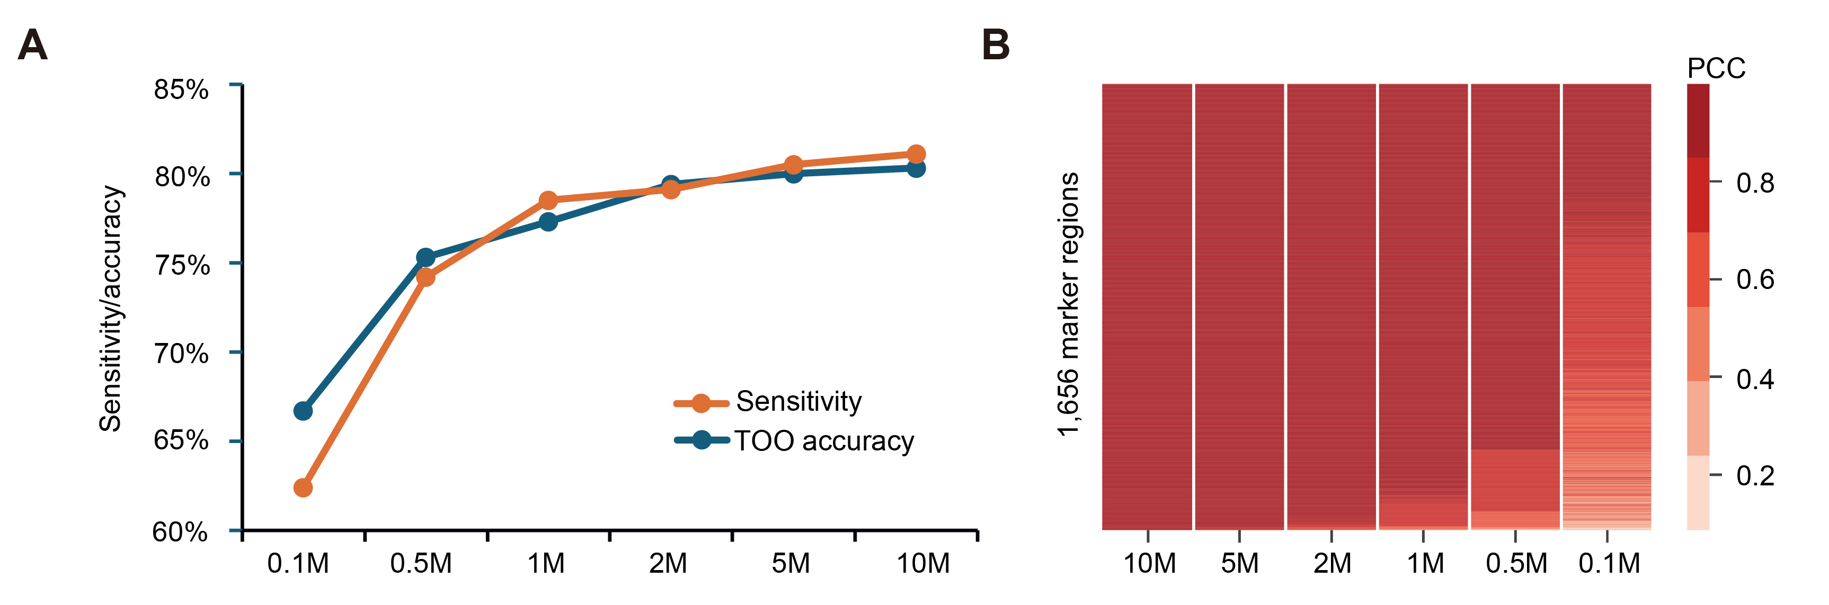
Figure 13. Low dependence of GutSeer on the sequencing depth.
(A) The sensitivity of the differentiation between cancer and non-cancer samples (orange line) and accuracy in tissue of origin (TOO) prediction (blue line) were evaluated by down-sampling the mapped read pairs to 10M, 5M, 2M, 1M, 0.5M, and 0.1M, respectively.
(B) Correlation of the average methylation fraction (AMF) values across all of the samples between those with a high sequencing depth (20M) and a low sequencing depth (by down-sampling the mapped reads to 10M, 5M, 2M, 1M, 0.5M, 0.1M, and 0.01M) for each of the 1,656 marker regions. Each row is a marker region; each column is the sequencing depth after down-sampling; each cell is the cross-sample Pearson correlation coefficient (represented by the filled color) of the AMF between the high sequencing depth and the corresponding down-sampled low sequencing depth.

Supplementary Tables

Table 1. Categorization of Participants

Colorectum*
Category | Description
1 | Adenocarcinoma of colorectum, stages I to IV
2 | Advanced precancerous lesions, including the following subcategories:
2.1 | Adenoma with high-grade dysplasia/carcinoma in situ, any size
2.2 | Adenoma with villous growth pattern (≥25%), any size
2.3 | Adenoma ≥10 mm in size
2.4 | SSL≥10 mm (SSA, SSP,** traditional serrated adenoma) and hyperplastic polyps ≥10 mm
3 | Benign lesions, including the following subcategories:
3.1 | Adenoma(s) including SSA, SSP, nonadvanced, >5 mm in size, <10 mm in size, 1 or 2 adenomas
3.2 | Adenoma(s) including SSA, SSP, nonadvanced, <10 mm in size, ≥3 adenomas
3.3 | Adenoma(s) including SSA, SSP, nonadvanced, ≤5 mm in size, 1 or 2 adenomas
3.4 | Intestinal lipoma
3.5 | Chronic intestinal mucositis
3.6 | Other hyperplastic polyp without high-grade dysplasia lesions
4 | no evidence of diseases
* Imperiale TF, et al. Next-Generation Multitarget Stool DNA Test for Colorectal Cancer Screening. N Engl J Med 2024, 390:984-993.
**SSA denotes sessile serrated adenoma, SSP sessile serrated polyp, SSL sessile serrated lesion
Liver*
Category | Description
1 | Primary liver cancer (HCC), intrahepatic cholangiocarcinoma (ICC), and combined hepatocellular-cholangiocarcinoma (cHCC), stages I to IV
2 | Advanced precancerous lesions, including the following subcategories:
2.1 | High-grade dysplastic nodules (HGDN)
3 | Benign lesions, including the following subcategories:
3.1 | Hepatitis: hepatitis B virus (HBV), hepatitis C virus (HCV), alcoholic hepatitis, and metabolic associated steatohepatitis (MAST)
3.2 | Liver fibrosis
3.3 | Liver cirrhosis
3.4 | Focal nodular hyperplasia (FNH) or low-grade dysplastic nodules (LGDN)
3.5 | Hepatic cyst, hepatic hemangioma, hepatocellular adenoma, hepatic angiomyolipoma or other benign lesions
4 | no evidence of diseases
* HE J, et al. China guideline for liver cancer screening (2022, Beijing). J Clin Hepatol, 2022, 38(8): 1739-1758. DOI: 10.3969/j.issn.1001-5256.2022.08.007
Esophagus*
Category | Description
1 | Esophageal squamous cell carcinoma (ESCC) and esophageal adenocarcinoma (EAC), stages I to IV
2 | Advanced precancerous lesions, including the following subcategories:
2.1 | High-grade intraepithelial neoplasia (HGIN)/carcinoma in situ, any size
3 | Benign lesions, including the following subcategories:
3.1 | Esophagitis
3.2 | Hyperplasia polyps without high-grade intraepithelial neoplasia
3.3 | Leiomyoma, esophageal granular cell tumor, neurilemmoma, esophageal lipoma, esophageal papilloma, and other benign lesions
3.4 | Hiatal hernia
3.5 | Barrett's esophagus
3.6 | Esophageal varices
4 | no evidence of diseases
* He J, et al. China guideline for the screening, early detection and early treatment of esophageal cancer (2022, Beijing). Zhonghua Zhong Liu Za Zhi 2022, 44:491-522.
Stomach*
Category | Description
1 | Papillary adenocarcinoma, poorly cohesive carcinoma (including signet-ring cell carcinoma and non-signet-ring cell carcinoma), tubular adenocarcinoma, mucinous adenocarcinoma, stages I to IV
2 | Advanced precancerous lesions, including the following subcategories:
2.1 | High-grade intraepithelial neoplasia (HGIN)/carcinoma in situ, any size
3 | Benign lesions, including the following subcategories:
3.1 | Chronic atrophic gastritis, hypertrophic gastritis
3.2 | Gastric ulcer
3.3 | Neuroendocrine tumor G1
3.4 | Intestinal metaplasia
3.5 | Nonmalignant gastrointestinal stromal tumor
3.6 | Gastric hyperplastic polyps without high-grade intraepithelial neoplasia
3.7 | Leiomyoma, calcifying fibrous tumor and other benign lesions
4 | no evidence of diseases
* He J, et al: China guideline for the screening, early detection and early treatment of gastric cancer (2022, Beijing). Zhonghua Zhong Liu Za Zhi 2022, 44:634-666.
Pancreas*
Category | Description
1 | Pancreatic adenocarcinoma, stages I to IV
2 | Advanced precancerous lesions, including the following subcategories:
2.1 | High-grade pancreatic intraepithelial neoplasia (HG-PanIN)
2.2 | Pancreatic cystic neoplasm (PCN)** with jaundice associated with tumor, or enhancing mural nodules ≥5mm, or main pancreatic duct (MPD) diameter ≥10mm, or presence of solid components
2.3 | Solid lesions ≥10mm in size or MPD diameter ≥10mm
3 | Benign lesions, including the following subcategories:
3.1 | Chronic pancreatitis: idiopathic, non-alcoholic, hereditary
3.2 | PCN with enhancing mural nodules <5mm, or MPD diameter <10mm
3.3 | Solid lesions <10mm in size or MPD diameter <10mm
4 | no evidence of diseases
* Pancreatic Disease Collaborative Group, Chinese Society of Digestive Endoscopy. Chinese consensus on the early screening and surveillance for pancreatic cancer in high-risk individuals (2021, Nanjing). J Clin Hepatol, 2022, 38(5): 1016-1022.
** Pancreatic cystic neoplasm (PCN): Solid pseudopapillary neoplasm (SPN), Cystic neuroendocrine tumors (cNETs), Intraductal papillary mucinous neoplasm (IPMN)
ªDefinition of each category: Cancer: category 1; advanced precancerous lesions: category 2; benign lesions: category 3; healthy: category 4; non-cancer: category 3 and category 4.

Table 2. Preanalytical procedures from blood collection to cfDNA extraction

Preanalytical Factor | Condition
Collection tube | cfDNA BCT tubes (Streck)
Maximum delivery time | 72 hours
Maximum time interval between sample receipt and processing | 12 hours, usually 4 hours
Temperature control during delivery | 6 ℃ to 37 ℃  (Heating pads were used when the ambient temperature was below 4 °C, and ice packs were used when the temperature exceeded 37 °C)
Centrifugation | Step 1: 1,600 g for 10 mins at 4 °C  Step 2: 16,000 g for 10 min at 4 °C
Plasma storage temperature | - 80 °C
Maximum plasma storage duration | 12 months
Maximum number of freeze-thaw cycles (Plasma) | 1 cycle
cfDNA storage temperature | -20 °C
Maximum storage duration of isolated cfDNA | 24 months
cfDNA quantification | Qubit Fluorometers
cfDNA quality control | LabChip GX Touch Nucleic Acid Analyzer

Table 3. Sample QC metrics

sample type | QC metrics
Blood sample | Collection volume: ≥10 mL typically required
Blood sample | Clotting: No visible clots in the tube
plasma sample | Volume: typically ≥2–4 mL for cfDNA extraction
plasma sample | Hemolysis: evaluated by visually inspecting plasma samples for abnormal red or pink coloration
cfDNA sample | Size distribution: Electropherogram showing expected peak ~170 bp, no genomic DNA contamination (strong high-molecular-weight smear or peaks at >1,000 bp)
cfDNA sample | Yield: Depends on plasma volume and condition; expected cfDNA yield is approximately 2–30 ng/mL of plasma, with a total cfDNA mass of more than 10 ng.

Table 4. In-house RRBS data utilized for the GutSeer panel development
 | Cancer tissue | Para-carcinoma tissue | Healthy
Colorectum | 51 | 65 | NA
Esophagus | 34 | 38 | NA
Stomach | 32 | 33 | NA
Liver | 37 | 26 | NA
Pancreas | 36 | 28 | NA
Plasma | NA | NA | 114
White blood cells | NA | NA | 20
Total | 190 | 190 | 134

Table 5. Number of samples by cancer type and stage

Cohort and Stage | Training |  |  |  | Validation |  |  |  | Test
Cohort and Stage | I | II | III | IV | I | II | III | IV | I | II | III | IV
All cancers | 200 | 135 | 128 | 66 | 199 | 136 | 127 | 66 | 135 | 63 | 60 | 40
Colorectum | 11 | 26 | 34 | 19 | 11 | 28 | 32 | 19 | 22 | 17 | 16 | 14
Esophagus | 35 | 34 | 19 | 15 | 33 | 36 | 21 | 16 | 25 | 9 | 13 | 7
Stomach | 49 | 34 | 24 | 14 | 48 | 31 | 26 | 13 | 33 | 15 | 8 | 10
Liver | 94 | 30 | 39 | 9 | 96 | 29 | 37 | 8 | 39 | 9 | 9 | 6
Pancreas | 11 | 11 | 12 | 9 | 11 | 12 | 11 | 10 | 16 | 13 | 14 | 3

Note: Colorectal, esophageal, gastric, and pancreatic cancers are listed by TNM stage; liver cancers are listed by CLNC stage.

Table 6. Number of tissue samples used to evaluate the effectiveness of the panel

 | Total number | Cancer | Para-carcinoma
All cancers | 175 | 85 | 90
Colorectum | 34 | 16 | 18
Esophagus | 38 | 18 | 20
Stomach | 38 | 21 | 17
Liver | 32 | 17 | 15
Pancreas | 33 | 13 | 20

Table 7. Accuracy of GutSeer at the specificity of 95.8%/95.8%/94.4%

Category | Training set |  |  |  | Validation set |  |  |  | Test set
Category | N | Specificity | Sensitivity | TOO ACC | N | Specificity | Sensitivity | TOO ACC | N | Specificity | Sensitivity | TOO ACC
Non-cancer | 708 | 95.8% |  |  | 707 | 95.8% |  |  | 485 | 94.4%
Cancer | 529 |  | 83.7% | 83.7% | 528 |  | 82.8% | 82.4% | 298 |  | 81.5% | 80.7%
Colorectum | 90 |  | 92.2% | 74.7% | 90 |  | 92.2% | 74.7% | 69 |  | 91.3% | 76.2%
Esophagus | 103 |  | 75.7% | 87.7% | 106 |  | 75.5% | 86.0% | 54 |  | 74.1% | 84.3%
Stomach | 121 |  | 69.4% | 87.7% | 118 |  | 65.3% | 86.0% | 66 |  | 65.2% | 84.3%
Liver | 172 |  | 94.2% | 87.7% | 170 |  | 92.9% | 87.3% | 63 |  | 90.5% | 91.2%
Pancreas | 43 |  | 83.7% | 69.4% | 44 |  | 88.6% | 64.1% | 46 |  | 87.0% | 65.0%

Note: TOO ACC is the percentage of accurate calls for tissue-of-origin localization. The specificity of 95.8%/95.8%/94.4% in the training/validation/test set was used to evaluate the performance.

Table 8. Accuracy of GutSeer at the specificity of 100%/99.0%/100%

Category | Training set |  |  |  | Validation set |  |  |  | Test set
Category | N | Specificity | Sensitivity | TOO ACC | N | Specificity | Sensitivity | TOO ACC | N | Specificity | Sensitivity | TOO ACC
Non-cancer | 708 | 100% |  |  | 707 | 99.0% |  |  | 485 | 100.%
Cancer | 529 |  | 66.2% | 84.6% | 528 |  | 64.0% | 82.8% | 298 |  | 63.1% | 81.4%
Colorectum | 90 |  | 72.2% | 73.8% | 90 |  | 70.0% | 77.8% | 69 |  | 65.2% | 75.5%
Esophagus | 103 |  | 51.5% | 86.7% | 106 |  | 53.8% | 82.4% | 54 |  | 53.7% | 80.3%
Stomach | 121 |  | 49.6% | 86.7% | 118 |  | 43.2% | 82.4% | 66 |  | 48.5% | 80.3%
Liver | 172 |  | 80.2% | 91.3% | 170 |  | 78.8% | 88.8% | 63 |  | 76.2% | 97.9%
Pancreas | 43 |  | 79.1% | 70.6% | 44 |  | 75.0% | 69.7% | 46 |  | 73.9% | 67.6%
Note: TOO is the percentage of accurate calls for tissue-of-origin localization. A specificity of 100%/99.0%/100% in the training/validation/test set was set to evaluate the performance.

Table 9. Sensitivity across different cancer types by stage at the specificity of 95.8%/95.8%/94.4% for training/validation/test set.
 | Training set | Validation set | Test set
Colorectum (95% confidence interval) | 92.2% (86.7%-97.8%) | 92.2% (86.7%-97.8%) | 91.3% (84.7%-98.0%)
Stage I | 81.8% (59.0%-100%) | 72.7% (46.4%-99.0%) | 81.8% (65.7%-97.9%)
Stage II | 88.5% (76.2%-100%) | 92.9% (83.3%-100%) | 88.2% (72.9%-100%)
Stage III | 94.1% (86.2%-100%) | 93.8% (85.4%-100%) | 87.5% (71.3%-100%)
Stage IV | 100% (100%-100%) | 100% (100%-100%) | 100% (100%-100%)
Esophagus | 75.7% (67.4%-84.0%) | 75.5% (67.3%-83.7%) | 74.1% (62.4%-85.8%)
Stage I | 57.1% (40.7%-73.5%) | 60.6% (43.9%-77.3%) | 56.0% (36.5%-75.5%)
Stage II | 82.4% (69.5%-95.2%) | 69.4% (54.4%-84.5%) | 77.8% (50.6%-100%)
Stage III | 84.2% (67.8%-100%) | 95.2% (86.1%-100%) | 92.3% (77.8%-100%)
Stage IV | 93.3% (80.7%-100%) | 93.8% (81.9%-100%) | 100% (100%-100%)
Stomach | 69.4% (61.2%-77.6%) | 65.3% (56.7%-73.8%) | 65.2% (53.7%-76.6%)
Stage I | 55.1% (41.2%-69.0%) | 39.6% (25.7%-53.4%) | 42.4% (25.6%-59.3%)
Stage II | 76.5% (62.2%-90.7%) | 77.4% (62.7%-92.1%) | 80.0% (59.8%-100%)
Stage III | 70.8% (52.6%-89.0%) | 80.8% (65.6%-95.9%) | 87.5% (64.6%-100%)
Stage IV | 100% (100%-100%) | 100% (100%-100%) | 100% (100%-100%)
Liver | 94.2% (90.7%-97.7%) | 92.9% (89.1%-96.8%) | 90.5% (83.2%-97.7%)
Stage I | 93.6% (88.7%-98.6%) | 88.5% (82.2%-94.9%) | 87.2% (76.7%-97.7%)
Stage II | 90.0% (79.3%-100%) | 96.6% (89.9%-100%) | 88.9% (68.4%-100%)
Stage III | 97.4% (92.5%-100%) | 100% (100%-100%) | 100% (100%-100%)
Stage IV | 100% (100%-100%) | 100% (100%-100%) | 100% (100%-100%)
Pancreas | 83.7% (72.7%-94.8%) | 88.6% (79.3%-98.0%) | 87.0% (77.2%-96.7%)
Stage I | 72.7% (46.4%-99.0%) | 72.7% (46.4%-99.0%) | 75.0% (53.8%-96.2%)
Stage II | 81.8% (59.0%-100%) | 91.7% (76.0%-100%) | 84.6% (65.0%-100%)
Stage III | 91.7% (76.0%-100%) | 90.9% (73.9%-100%) | 92.9% (79.4%-100%)
Stage IV | 88.9% (68.4%-100%) | 100% (100%-100%) | 100% (100%-100%)

Table 10. The comparison of integrated vs. single feature

Detection | Dataset | Models
Detection | Dataset | Integrated | Methylation^{b} | Fragmentomics^{b}
Cancer vs. Non-cancer | Training | AUC = 0.958 | AUC = 0.929 | AUC = 0.934
Cancer vs. Non-cancer | Training | AUC = 0.958 | (p-value = 4×10⁻¹⁰) | (p-value = 2×10⁻⁶)
Cancer vs. Non-cancer | Validation | AUC = 0.950 | AUC = 0.926 | AUC = 0.936
Cancer vs. Non-cancer | Validation | AUC = 0.950 | (p-value = 4×10⁻⁸) | (p-value = 0.004)
Cancer vs. Non-cancer | Training | Sensitivity = 83.7% | Sensitivity = 75.0% | Sensitivity = 76.6%
Cancer vs. Non-cancer | Training | Specificity = 95.8% | Specificity = 95.8% | Specificity = 95.8%
Cancer vs. Non-cancer | Training |  | (p-value = 0.002) | (p-value = 0.007)
Cancer vs. Non-cancer | Validation | Sensitivity = 82.8% | Sensitivity = 73.3% | Sensitivity = 75.6%
Cancer vs. Non-cancer | Validation | Specificity = 95.8% | Specificity = 96.2% | Specificity =95.2%
Cancer vs. Non-cancer | Validation |  | (p-value = 0.002) | (p-value = 0.004)
TOOª | Training | Accuracy = 83.7% | Accuracy = 76.3% | Accuracy = 78.8%
TOOª | Training | Accuracy = 83.7% | (p-value = 0.003) | (p-value = 0.03)
TOOª | Validation | Accuracy = 82.4% | Accuracy = 75.1% | Accuracy = 76.9%
TOOª | Validation | Accuracy = 82.4% | (p-value = 0.006) | (p-value = 0.03)

Note: ªThe TOO ACC represents the accuracy in tissue-of-origin localization. The statistical tests were performed comparing the integration model with the corresponding single feature. ^{b}All evaluations (AUC, sensitivity, specificity, and TOO accuracy) in the training set were based on 10-fold cross-validation. The p-values for the comparison of AUC between integration model and single feature model were obtained from Delong test. The p-values for the comparison of accuracy (cancer vs non-cancer accuracy and TOO accuracy) between integration model and single feature model were obtained from χ² test.

Table 11. Comparison of the sensitivity between the integrated and the methylation/fragmentomics-only models based on the training dataset

Cancer | Sensitivity |  |  | p-value by χ2 test
Cancer | Integrated | Meth | Frag | Integrated vs. Meth | Integrated vs. Frag
Colorectum | 92.2% | 82.2% | 84.4% | 0.02 | 0.05
Esophagus | 75.7% | 66.0% | 68.0% | 0.06 | 0.11
Stomach | 69.4% | 54.5% | 58.7% | 0.009 | 0.04
Liver | 94.2% | 89.5% | 87.2% | 0.06 | 0.01
Pancreas | 83.7% | 81.4% | 88.4% | 0.39 | 0.27
All | 83.7% | 75.0% | 76.6% | 2×10⁻⁴ | 0.002

Note: The specificity was 95.8% for the three models based on integrated, methylation (Meth), and fragmentomics (Frag), respectively. The evaluation was performed by 10-fold cross-validation in the training set.
Table 12. Comparison of the sensitivity between the integrated and the methylation/fragmentomics-only models based on the validation dataset

Cancer | Sensitivity |  |  | p-value by χ2 test
Cancer | Integrated | Meth | Frag | Integrated vs. Meth | Integrated vs. Frag
Colorectum | 92.2% | 75.6% | 86.7% | 0.001 | 0.11
Esophagus | 75.5% | 67.0% | 66.0% | 0.09 | 0.07
Stomach | 65.3% | 52.5% | 55.1% | 0.02 | 0.06
Liver | 92.9% | 87.6% | 87.1% | 0.05 | 0.04
Pancreas | 88.6% | 84.1% | 86.4% | 0.27 | 0.37
All | 82.8% | 73.3% | 75.6% | 1×10⁻⁴ | 0.002

Note: The specificity was 95.8% for the integrated model, 96.2% for the model based on methylation (Meth) and 95.2% for the model based on fragmentomics (Frag).

Table 13. Comparison of the TOO precision between the integrated and the methylation/fragmentomics-only models

 | Training |  | Validation
 | Integrated vs. Methy | Integrated vs. Frag | Integrated vs. Methy | Integrated vs. Frag
All cancers | 0.003 | 0.03 | 0.004 | 0.03
Colorectum | 0.27 | 0.3 | 0.09 | 0.28
EsoSto | 7×10⁻⁴ | 0.12 | 0.002 | 0.19
Liver | 0.31 | 0.27 | 0.19 | 0.09
Pancreas | 0.2 | 0.07 | 0.38 | 0.15

Note: The p-value determined by χ2 test was used to evaluate the performance of the integrated in comparison with single methylation (Meth) /fragmentomics (Frag) -based models. EsoSto represents esophageal and/or gastric cancers.

Table 14. Pathological characteristics of patients diagnosed with advanced precancerous lesions

Sample ID | Age | Gender | Organ | Pathological diagnosis
SGI03026 | 65 | Male | Esophageal | High-grade squamous intraepithelial lesion
SGI03317 | 69 | Female | Esophageal | High-grade squamous intraepithelial lesion
SGI03205 | 51 | Male | Esophageal | High-grade squamous intraepithelial lesion
SGI02833 | 66 | Male | Gastric | High-grade dysplasia/intraepithelial
SGI02960 | 50 | Female | Gastric | High-grade dysplasia/intraepithelial
SGI02697 | 66 | Male | Esophageal | High-grade squamous intraepithelial lesion
SGI03282 | 71 | Male | Esophageal | High-grade squamous intraepithelial lesion
SGI02732 | 53 | Male | Gastric | High-grade dysplasia/intraepithelial
SGI03071 | 53 | Female | Gastric | High-grade dysplasia/intraepithelial
SGI02705 | 74 | Male | Esophageal | High-grade squamous intraepithelial lesion
SGI02560 | 50 | Female | Colorectal | Tubular adenoma with high-grade intraepithelial neoplasia
SGI02770 | 60 | Male | Colorectal | Tubular adenoma with high-grade intraepithelial neoplasia
SGI02859 | 63 | Male | Esophageal | High-grade squamous intraepithelial lesion
SGI02816 | 60 | Male | Esophageal | High-grade squamous intraepithelial lesion
SGI03345 | 70 | Female | Colorectal | Tubular adenoma with high-grade intraepithelial neoplasia
SGI02909 | 74 | Female | Esophageal | High-grade squamous intraepithelial lesion
SGI02899 | 67 | Male | Gastric | High-grade dysplasia/intraepithelial
SGI02699 | 60 | Male | Gastric | High-grade dysplasia/intraepithelial
SGI03088 | 70 | Male | Colorectal | Sessile serrated adenoma with high-grade intraepithelial neoplasia
SGI03123 | 69 | Male | Gastric | High-grade dysplasia/intraepithelial
SGI02881 | 67 | Male | Esophageal | High-grade squamous intraepithelial lesion
SGI02611 | 51 | Female | Colorectal | Tubulovillous adenoma with high-grade intraepithelial neoplasia
SGI02727 | 67 | Female | Gastric | High-grade dysplasia/intraepithelial
SGI03279 | 69 | Male | Esophageal | High-grade squamous intraepithelial lesion
SGI02972 | 65 | Male | Gastric | High-grade dysplasia/intraepithelial
SGI03289 | 66 | Male | Esophageal | High-grade squamous intraepithelial lesion
SGI02640 | 74 | Male | Gastric | High-grade dysplasia/intraepithelial
SGI03189 | 66 | Male | Gastric | High-grade dysplasia/intraepithelial
SGI03271 | 57 | Male | Gastric | High-grade dysplasia/intraepithelial
SGI03136 | 62 | Female | Colorectal | Tubular adenoma with high-grade intraepithelial neoplasia
SGI03346 | 68 | Female | Esophageal | High-grade squamous intraepithelial lesion
SGI02942 | 62 | Male | Gastric | High-grade dysplasia/intraepithelial
SGI03361 | 64 | Female | Gastric | High-grade dysplasia/intraepithelial
SGI02548 | 63 | Male | Colorectal | Tubular adenoma with high-grade intraepithelial neoplasia
SGI02775 | 54 | Male | Gastric | High-grade dysplasia/intraepithelial
SGI03264 | 67 | Male | Gastric | High-grade dysplasia/intraepithelial
SGI02827 | 65 | Female | Colorectal | Tubular adenoma with high-grade intraepithelial neoplasia
SGI02930 | 67 | Female | Esophageal | High-grade squamous intraepithelial lesion
SGI02731 | 64 | Male | Gastric | High-grade dysplasia/intraepithelial
SGI03320 | 68 | Male | Gastric | High-grade dysplasia/intraepithelial
SGI02837 | 71 | Male | Gastric | High-grade dysplasia/intraepithelial
SGI03086 | 71 | Male | Gastric | High-grade dysplasia/intraepithelial
SGI02879 | 72 | Male | Gastric | High-grade dysplasia/intraepithelial
SGI03297 | 68 | Male | Colorectal | Tubulovillous adenoma with high-grade intraepithelial neoplasia
SGI02802 | 64 | Male | Colorectal | Tubular adenoma with high-grade intraepithelial neoplasia
SGI02793 | 70 | Female | Colorectal | Tubular adenoma with high-grade intraepithelial neoplasia
SGI02707 | 68 | Female | Esophageal | High-grade squamous intraepithelial lesion
SGI02527 | 58 | Male | Colorectal | Tubular adenoma with high-grade intraepithelial neoplasia
SGI02588 | 61 | Male | Colorectal | Sessile serrated adenoma with high-grade intraepithelial neoplasia
SGI02566 | 46 | Male | Gastric | High-grade dysplasia/intraepithelial
SGI03299 | 64 | Male | Gastric | High-grade dysplasia/intraepithelial
SGI03344 | 63 | Male | Esophageal | High-grade squamous intraepithelial lesion
SGI03009 | 59 | Male | Colorectal | Tubular adenoma with high-grade intraepithelial neoplasia
SGI02952 | 53 | Male | Gastric | High-grade dysplasia/intraepithelial
SGI03044 | 58 | Female | Colorectal | Tubular adenoma with high-grade intraepithelial neoplasia
SGI02605 | 67 | Male | Gastric | High-grade dysplasia/intraepithelial
SGI03326 | 56 | Male | Esophageal | High-grade squamous intraepithelial lesion
SGI02574 | 70 | Male | Gastric | High-grade dysplasia/intraepithelial
SGI03101 | 52 | Female | Gastric | High-grade dysplasia/intraepithelial
SGI03108 | 72 | Male | Colorectal | Sessile serrated adenoma with high-grade intraepithelial neoplasia
SGI03379 | 66 | Female | Colorectal | Tubular adenoma with high-grade intraepithelial neoplasia
SGI02600 | 55 | Male | Gastric | High-grade dysplasia/intraepithelial
SGI03236 | 63 | Male | Esophageal | High-grade squamous intraepithelial lesion

Table 15. Comparison between GutSeer and conventional cancer markers for distinguishing between benign and malignant disease

Marker | Sensitivity |  | Specificity
Marker | Cancer marker | GutSeer | Cancer marker | GutSeer
CEA | 9.1% (12/132) | 82.6% (109/132) | 94.9% (56/59) | 88.1% (52/59)
CA199 | 14.4% (19/132) | 82.6% (109/132) | 96.6% (57/59) | 88.1% (52/59)
AFP | 53.3% (64/120) | 90.0% (108/120) | 100.0% (41/41) | 78.0% (32/41)

Table 16. Samples used for the comparison between GutSeer and the WGS-based approach

Cancer (by stage) and non-cancer samples | Training | Test
Total | 591 | 585
Colorectal cancer | 69 | 80
Stage I | 7 | 11
Stage II | 18 | 26
Stage III | 28 | 27
Stage IV | 16 | 16
Esophageal cancer | 66 | 71
Stage I | 20 | 22
Stage II | 20 | 28
Stage III | 16 | 9
Stage IV | 10 | 12
Gastric cancer | 73 | 76
Stage I | 24 | 30
Stage II | 26 | 20
Stage III | 14 | 17
Stage IV | 9 | 9
Liver cancer | 146 | 126
Stage I | 78 | 69
Stage II | 28 | 23
Stage III | 32 | 29
Stage IV | 8 | 5
Pancreatic cancer | 32 | 30
Stage I | 9 | 7
Stage II | 7 | 8
Stage III | 10 | 7
Stage IV | 6 | 8
Non-cancer | 205 | 202

Note: Liver cancer was staged using the CLNC, all other cancers were staged based on the TNM classification

Table 17. Multivariate analysis to assess the independence of GutSeer

 | Coef. | P>|z|
Intercept | -6.81 | 5.81E-14
GutSeer | 5.92 | 2.05E-88
Age | 0.0556 | 9.17E-11
BMI | 0.0189 | 0.423
N_unique_reads | -1.70E-07 | 0.001
DNA_quantity | 0.00572 | 0.017
Gender_Male | 1.01 | 3.46E-07
Hospital_A | 0.456 | 0.304
Hospital_B | 0.266 | 0.535
Hospital_C | 0.161 | 0.703
Hospital_D | 1.01 | 0.015
Smoke_Yes | 0.0873 | 0.772
Alcohol_Yes | -0.547 | 0.072

Table 18. Accuracy and sensitivity based on a lower sequencing depth by down-sampling

 | 0.1M | 0.5M | 1M | 2M | 5M | 10M
Accuracy of TOO | 66.7% | 75.3% | 77.3% | 79.4% | 80.0% | 80.3%
Sensitivity | 62.4% | 74.2% | 78.5% | 79.1% | 80.5% | 81.1%
Specificity | 93.2% | 94.4% | 95.4% | 95.1% | 95.5% | 95.2%

Table 19. Comparison of GutSeer with recent published MCED studies.

 |  | GutSeer-95 | GutSeer-99 | MCDBT-2 [5] | MCDBT-1 [5] | Galleri (CCGA-3) [6]
Sample size | Non-cancer | 1,900 |  | 1,222 |  | 1,254
Sample size | Cancer | 1,355 |  | 1,173 |  | 2,823
Sample size | Stage I (% of Cancer) | 534 (39.4%) |  | 286 (24.4%) |  | 849 (30.1%)
Sample size | Stage II | 334 (24.6%) |  | 263 (22.4%) |  | 703 (24.9%)
Sample size | Stage III | 315 (23.2%) |  | 346 (29.5%) |  | 566 (20.0%)
Sample size | Stage IV | 172 (12.7%) |  | 278 (23.7%) |  | 618 (21.9%)
Sample size | Others | 63 advanced precancerous lesions |  | - |  | 87
Sample size | Independent test set | 846 |  | 946 |  | 4,077
Panel size | Panel size | 33,032 CpGs across  1,656 marker regions (~400kb) |  | 161,984 CpGs across  7,558 regions (~2.7 Mb) |  | 1,116,720 CpGs across 103,456 regions (17.2 Mb)
Panel size | Sequencing depth | 800X (median) |  | NA |  | 139X (median)
Panel size | Cancer types | colorectum, esophagus, stomach, liver, pancreas |  | colorectum, esophagus, liver, lung, ovarian, pancreas |  | >50 cancer types
Panel size | Features | methylation + fragmentomics |  | methylation |  | methylation
Specificity (sample size) |  | 94.4% (485) | 100.0% (485) | 95.1% (473) | 98.9% (473) | 99.5% (1,254)
Sensitivity - overall |  | 81.5% (298) | 63.1% (298) | 75.1% (473) | 69.1% (473) | 83.7% (GutSeer) | 51.5% (overall) | 76.3% (12-C)
Colorectum | Stage I | 81.8% (22) | 36.4% (22) | 35.7% (14) | 28.6% (14) | 43.3% (30)
Colorectum | Stage II | 88.2% (17) | 70.6% (17) | 78.6% (14) | 71.4% (14) | 85% (40)
Colorectum | Stage III | 87.5% (16) | 81.2% (16) | 88% (25) | 76% (25) | 87.9% (66)
Colorectum | Stage IV | 100.0% (14) | 85.7% (14) | 100.0% (6) | 100% (6) | 95.3% (64)
Colorectum | adv. pre. Lesions | 47.1% (17) | - | - |  | -
Esophagus | Stage I | 56% (25) | 36% (25) | 33.3% (9) | 22.2% (9) | 12.5% (8)
Esophagus | Stage II | 77.8% (9) | 66.7% (9) | 62.5% (16) | 37.5% (16) | 64.7% (17)
Esophagus | Stage III | 92.3% (13) | 61.5% (13) | 90.0% (10) | 80% (10) | 94.1% (34)
Esophagus | Stage IV | 100% (7) | 85.7% (7) | 91.7% (12) | 91.7% (12) | 100% (40)
Esophagus | adv. pre. Lesions | 38.9% (18) | - | - |  | -
Stomach | Stage I | 42.4% (33) | 24.2% (33) | - |  | 16.7% (6)
Stomach | Stage II | 80.0% (15) | 66.7% (15) | - |  | 50% (6)
Stomach | Stage III | 87.5% (8) | 62.5% (8) | - |  | 80% (5)
Stomach | Stage IV | 100.0% (10) | 90.0% (10) | - |  | 100% (12)
Stomach | adv. pre. Lesions | 21.4% (28) | - | - |  | -
Liver | Stage I | 87.2% (39) | 69.2% (39) | 81.8% (22) | 77.3% (22) | 100% (6)
Liver | Stage II | 88.9% (9) | 77.8% (9) | 86.4% (22) | 81.8% (22) | 70% (10)
Liver | Stage III | 100.0% (9) | 88.9% (9) | 100.0% (20) | 95% (20) | 100% (9)
Liver | Stage IV | 100.0% (6) | 100.0% (6) | 100.0% (18) | 100% (18) | 100% (20)
Pancreas | Stage I | 75.0% (16) | 56.2% (16) | 36.0% (25) | 20% (25) | 61.9% (21)
Pancreas | Stage II | 84.6% (13) | 76.9% (13) | 37.5% (24) | 33.3% (24) | 60% (20)
Pancreas | Stage III | 92.9% (14) | 85.7% (14) | 52.9% (17) | 52.9% (17) | 85.7% (21)
Pancreas | Stage IV | 100.0% (3) | 100% (3) | 96.0% (25) | 96% (25) | 95.9% (73)
TOO | TOO | 80.70% | 81.40% | 79.40% | 83.20% | 88.70%
Note: GutSeer-95/99 are two test models from this study, MCDBT-1/2 are two test models from a previous study [5]. The independent validation/test cohorts were used for performance comparison.

Supplementary References

1. Jiang P, Sun K, Peng W, Cheng SH, Ni M, Yeung PC, Heung MMS, Xie T, Shang H, Zhou Z, et al: Plasma DNA End-Motif Profiling as a Fragmentomic Marker in Cancer, Pregnancy, and Transplantation. Cancer Discov 2020, 10:664-673.
2. Chen S, Zhou Y, Chen Y, Gu J: fastp: an ultra-fast all-in-one FASTQ preprocessor. Bioinformatics 2018, 34:i884-i890.
3. Smith T, Heger A, Sudbery I: UMI-tools: modeling sequencing errors in Unique Molecular Identifiers to improve quantification accuracy. Genome Res 2017, 27:491-499.
4. Cristiano S, Leal A, Phallen J, Fiksel J, Adleff V, Bruhm DC, Jensen SO, Medina JE, Hruban C, White JR, et al: Genome-wide cell-free DNA fragmentation in patients with cancer. Nature 2019, 570:385-389.
5. Gao Q, Lin YP, Li BS, Wang GQ, Dong LQ, Shen BY, Lou WH, Wu WC, Ge D, Zhu QL, et al: Unintrusive multi-cancer detection by circulating cell-free DNA methylation sequencing (THUNDER): development and independent validation studies. Ann Oncol 2023, 34:486-495.
6. Klein EA, Richards D, Cohn A, Tummala M, Lapham R, Cosgrove D, Chung G, Clement J, Gao J, Hunkapiller N, et al: Clinical validation of a targeted methylation-based multi-cancer early detection test using an independent validation set. Ann Oncol 2021, 32:1167-1177.

