Supplementary Materials
Table S1. Summary of the datasets
Sequencing type | Series | Sample size
Bulk RNA seq | TGCA-KIRC | 541 RCC tumor tissues and 72 normal tissues
SC-RNA seq | GSE210038 | 7 RCC and 2 NAT
SC-RNA seq | GSE237429 | 4 RCC and 4 NAT
SC-RNA seq | GSE242299 | 8 RCC and 9 NAT
ST-RNA seq | GSE222703 | T3/T4 RCC tumor (a3, b7, b13, c3, c7, c57)
TGCA-KIRC, The Cancer Genome Atlas - Kidney Renal Clear Cell Carcinoma. RCC, Renal Cell Carcinoma. NAT, normal adjacent tissue. SC-RNA seq, Single-Cell RNA sequencing. ST-RNA seq, spatial transcriptomics sequencing. GEO, Gene Expression Omnibus.

Table S2. Correlation between FABP1 expression and clinicopathologic characteristics in RCC patients

Characteristics | Cases | FABP1 expression
Characteristics | Cases | Low | High | p-value†
Gender |  |  |  | 0.191
Male | 48 | 23 | 25
Female | 17 | 10 | 7
Age |  |  |  | 0.455
< 65 | 50 | 26 | 24
≥ 65 | 15 | 7 | 8
T stage |  |  |  | 0.878
T1-2 | 42 | 18 | 24
T3-4 | 23 | 15 | 8
Organ metastasis |  |  |  | 0.008*
Negative | 52 | 22 | 30
Positive | 13 | 11 | 2
Comparison of proportion and correlation analysis was evaluated by Chi-square test.

Table S3. Antibodies used in the experiments
Product | Source | No. of Catalogue
Primary antibody:
Western blot:
anti-β-TUBULIN | Cell Signaling Technology | #2146
anti-FABP1 | Abcam | ab171739
anti-PLG | Proteintech | 66399-1-Ig
anti-PLAT | Proteintech | 10147-1-AP
IHC:
anti-FABP1 | Abcam | ab171739
anti-CD34 | Cell Signaling Technology | #3569
Secondary antibody:
Western blot:
anti-rabbit IgG-HRP | Cell Signaling Technology | 7074
anti-mouse IgG-HRP | Cell Signaling Technology | 7076
IHC:
anti-rabbit IgG-HRP | Proteintech | SA00001-2

Figure S1. Deconvolution result of RCC_a3 by cell2location.

Figure S2. Deconvolution result of RCC_ b7 by cell2location.

Figure S3. Deconvolution result of RCC_ b13 by cell2location.

Figure S4. Deconvolution result of RCC_ c3 by cell2location.

Figure S5. Deconvolution result of RCC_ c7 by cell2location.

Figure S5. Deconvolution result of RCC_ c57 by cell2location.

Figure S6. Knockout of FABP1 expression affects the progression of RCC A) qRT-PCR analysis of FABP1 knockdown efficiency in RCC cell lines. B) Western blot (WB) validation of FABP1 gene knockout in RCC cell lines. C) The orthotopic renal tumor xenograft experiments were conducted to analyze the connection between FABP1 and PLG-PLAT signaling. D) The survival days and metastatic lesion counts were statistically analyzed for each group of mice. All experiments were conducted at least three independently. *, P < 0.05; **, P < 0.01; ***, P<0.001.
Figure S7. Exploration of upstream regulatory mechanisms of FABP1 A) Correlation analysis between HNF4A and FABP1 expression (transcriptome data from GEPIA). B) qRT-PCR examined FABP1 mRNA level in RCC cell lines under hypoxia and normoxia condition. *, P < 0.05; **, P < 0.01; ***, P<0.001.
Figure S8. Interactions between Sunitinib and Orlistat in RCC organoid A) Dose-response matrix for Orlistat and Sunitinib. After 7 days of incubation, viability was calculated as a fraction of the live cells normalized to DMSO-treated controls. B) Dose-response curve for drug Sunitinib and Orlistat. C) Bliss synergy scores heatmaps for drug-drug interactions (mean of independent experiments).
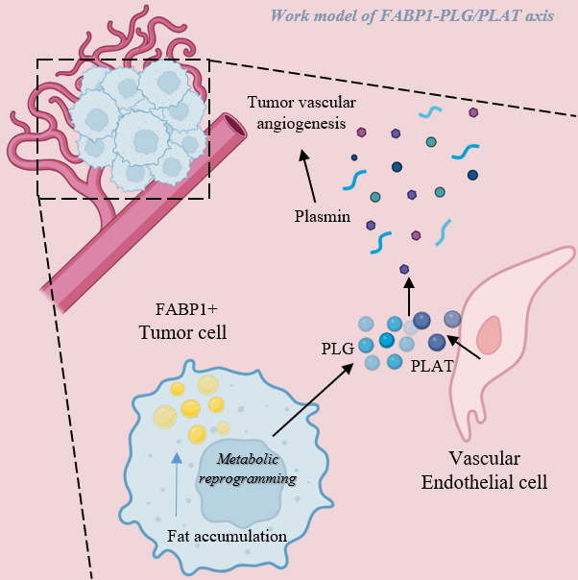
Figure S9. Work model of FABP1-PLG-PLAT axis in RCC

