SUPPLEMENTARY MATERIAL

Novel molecular mechanisms of FLT3 deregulation: from the acute myeloid leukemia experience to therapeutic insights in acute lymphoblastic leukemia

F. Lo Schiavo¹, C. Salvesi^{1*}, M. Jandoubi¹, F. Pirini¹, J. Garbetta¹, G. Martinelli², G. Simonetti¹, A. Ferrari^{1§}

1 Biosciences Laboratory, IRCCS Istituto Romagnolo per lo Studio dei Tumori (IRST) "Dino Amadori", Meldola (FC), Italy
2 University of Bologna, Istituto di Ematologia “Seràgnoli”, Bologna, Italy

* Corresponding author, chiara.salvesi@irst.emr.it
§ Co-corresponding author, anna.ferrari@irst.emr.it

SUPPLEMENTARY TABLE LEGENDS

Table S1. Regulatory effects of canonical and non-canonical FLT3 mutations reported in acute leukemias. * canonical FLT3 mutations; # non-canonical FLT3 mutations.

Table S2. FLT3 main co-mutations in AML and ALL populations.
This table summarizes the co-occurrence of gene mutations in patients with FLT3-mutated AML and ALL across different patient subgroups, including adults, adolescents and young adults (AYA), and pediatric cases. For each gene listed, the table reports the number and percentage of patients who carry both a mutation in FLT3 and a mutation in the indicated gene. These values are shown relative to two populations: FLT3-mutated patients only (column: co-mutated/FLT3-mut) and the total patient cohort (column: co-mutated/total). When available, separate values are provided for each different study. References to the original studies or datasets from which the data were derived are also included.

Table S3. FLT3 inhibitor direct and downstream targets (*) described in the reported literature.

Table S4. Eight FLT3 inhibitor sensitivity data in 43 pediatric/AYA ALL cell lines [70,71].
Sensitivity was quantified using the Selective Drug Sensitivity Score (sDSS), where higher values indicate greater sensitivity. We added a ranking system for: a) cell lines were ranked from 1 to 43 for sensitivity to specific inhibitors (column “Rank into Drug”) and b) FLT3 inhibitors were ranked from 1 to 8 (column “Rank into Cell line”), based on their effectiveness for each cell line. Drug response rules: sDSS ≥ 8: sensitive; 5 ≤ sDSS < 8: intermediate; sensitivity and sDSS < 5: resistant. Data from https://proteomics.se/forall/.
SUPPLEMENTARY FIGURES
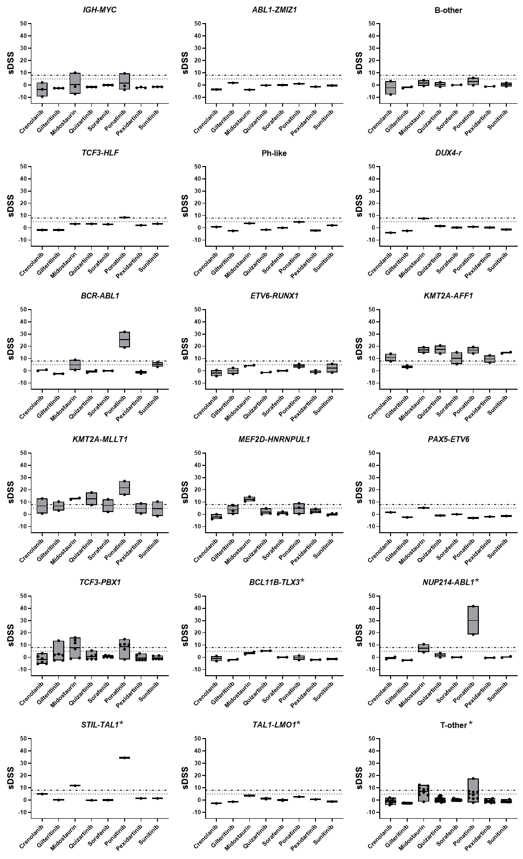
Fig. S1: sDSS to 8 FLT3i for each molecular subgroup of B- and T-cell lines. Each plot shows the sDSS for each FLT3 inhibitor; each dot represents a single cell line. sDSS ≥ 8: high sensitivity; 5 ≤ sDSS < 8: intermediate sensitivity; sDSS < 5: resistance. * T-cell subgroups.
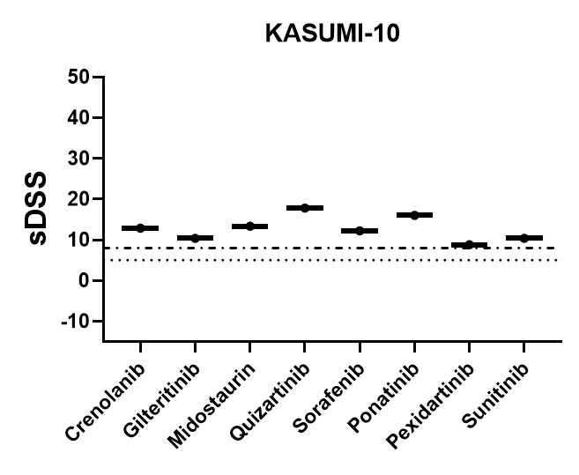

Fig. S2: FLT3-mut KASUMI-10 B-ALL cell line sDSS to 8 FLT3i. sDSS ≥ 8: high sensitivity; 5 ≤ sDSS < 8: intermediate sensitivity; sDSS < 5: resistance.

REFERENCES
1. Cumbo C, Tarantini F, Anelli L, et al. FLT3 mutational analysis in acute myeloid leukemia: Advantages and pitfalls with different approaches. Blood Rev. 2022;54:100928.
2. Fröhling S, Scholl C, Levine RL, et al. Identification of Driver and Passenger Mutations of FLT3 by High-Throughput DNA Sequence Analysis and Functional Assessment of Candidate Alleles. Cancer Cell. 2007;12(6):501-513.
3. Friedman R. The molecular mechanisms behind activation of FLT3 in acute myeloid leukemia and resistance to therapy by selective inhibitors. Biochimica et Biophysica Acta (BBA) - Reviews on Cancer. 2022;1877(1):188666.
4. Marensi V, Keeshan KR, MacEwan DJ. Pharmacological impact of FLT3 mutations on receptor activity and responsiveness to tyrosine kinase inhibitors. Biochem Pharmacol. 2021;183(July 2020):114348.
5. Yamamoto Y, Kiyoi H, Nakano Y, et al. Activating mutation of D835 within the activation loop of FLT3 in human hematologic malignancies. Blood. 2001;97(8):2434-2439.
6. Gutierrez-Camino A, Richer C, Ouimet M, et al. Characterisation of FLT3 alterations in childhood acute lymphoblastic leukaemia. Br J Cancer. 2024;130(2):317-326.
7. Nguyen B, Williams AB, Young DJ, et al. FLT3 activating mutations display differential sensitivity to multiple tyrosine kinase inhibitors. Oncotarget. 2017;8(7):10931-10944.
8. Tiesmeier J, Müller-Tidow C, Westermann A, et al. Evolution of FLT3-ITD and D835 activating point mutations in relapsing acute myeloid leukemia and response to salvage therapy. Leuk Res. 2004;28(10):1069-1074.
9. Mirza Z, Al-Saedi DA, Alganmi N, Karim S. Landscape of FLT3 Variations Associated with Structural and Functional Impact on Acute Myeloid Leukemia: A Computational Study. Int J Mol Sci. 2024;25(6):3419.
10. Clark JJ, Cools J, Curley DP, et al. Variable sensitivity of FLT3 activation loop mutations to the small molecule tyrosine kinase inhibitor MLN518. Blood. 2004;104(9):2867-2872.
11. Grundler R, Thiede C, Miething C, Steudel C, Peschel C, Duyster J. Sensitivity toward tyrosine kinase inhibitors varies between different activating mutations of the FLT3 receptor. Blood. 2003;102(2):646-651.
12. Armstrong SA, Kung AL, Mabon ME, et al. Inhibition of FLT3 in MLL: Validation of a therapeutic target identified by gene expression based classification. Cancer Cell. 2003;3(2):173-183.
13. Armstrong SA, Mabon ME, Silverman LB, et al. FLT3 mutations in childhood acute lymphoblastic leukemia. Blood. 2004;103(9):3544-3546.
14. Schnittger S, Kohl TM, Leopold N, et al. D324N single‐nucleotide polymorphism in the FLT3 gene is associated with higher risk of myeloid leukemias. Genes Chromosomes Cancer. 2006;45(4):332-337.
15. Sandhöfer N, Bauer J, Reiter K, et al. The new and recurrent FLT3 juxtamembrane deletion mutation shows a dominant negative effect on the wild-type FLT3 receptor. Sci Rep. 2016;6(1):28032.
16. Zhang Y, Zhang Y, Wang F, et al. The mutational spectrum of FLT3 gene in acute lymphoblastic leukemia is different from acute myeloid leukemia. Cancer Gene Ther. 2020;27(1-2):81-88.
17. Young DJ, Nguyen B, Zhu R, et al. Deletions in FLT-3 juxtamembrane domain define a new class of pathogenic mutations: case report and systematic analysis. Blood Adv. 2021;5(9):2285-2293.
18. Tarlock K, Hansen ME, Hylkema T, et al. Discovery and Functional Validation of Novel Pediatric Specific FLT3 Activating Mutations in Acute Myeloid Leukemia: Results from the COG/NCI Target Initiative. Blood. 2015;126(23):87-87.
19. Anabtawi N, Nicolet D, Alotaibi N, et al. Prognostic, biological, and structural implications of FLT3-JMD point mutations in acute myeloid leukemia: an analysis of Alliance studies. Leukemia. 2025;39(3):623-631.
20. Janke H, Pastore F, Schumacher D, et al. Activating FLT3 Mutants Show Distinct Gain-of-Function Phenotypes In Vitro and a Characteristic Signaling Pathway Profile Associated with Prognosis in Acute Myeloid Leukemia. Menendez P, ed. PLoS One. 2014;9(3):e89560.
21. Reindl C, Bagrintseva K, Vempati S, et al. Point mutations in the juxtamembrane domain of FLT3 define a new class of activating mutations in AML. Blood. 2006;107(9):3700-3707.
22. Travaglini S, Gurnari C, Antonelli S, et al. Functional characterization and response to FLT3 inhibitors in acute myeloid leukaemia with a non‐canonical FLT3 mutation: A proof of concept. Br J Haematol. 2023;203(2):327-330.
23. Andersson AK, Ma J, Wang J, et al. The landscape of somatic mutations in infant MLL-rearranged acute lymphoblastic leukemias. Nat Genet. 2015;47(4):330-337.
24. Schittenhelm MM, Yee KWH, Tyner JW, et al. FLT3 K663Q is a novel AML-associated oncogenic kinase: determination of biochemical properties and sensitivity to Sunitinib (SU11248). Leukemia. 2006;20(11):2008-2014.
25. Opatz S, Polzer H, Herold T, et al. Exome sequencing identifies recurring FLT3 N676K mutations in core-binding factor leukemia. Blood. 2013;122(10):1761-1769.
26. Smith CC, Lasater EA, Zhu X, et al. Activity of ponatinib against clinically-relevant AC220-resistant kinase domain mutants of FLT3-ITD. Blood. 2013;121(16):3165-3171.
27. Cools J, Mentens N, Furet P, et al. Prediction of resistance to small molecule FLT3 inhibitors: implications for molecularly targeted therapy of acute leukemia. Cancer Res. 2004;64(18):6385-6389.
28. Pauwels D, Sweron B, Cools J. The N676D and G697R mutations in the kinase domain of FLT3 confer resistance to the inhibitor AC220. Haematologica. 2012;97(11):1773-1774.
29. Jiang J, Paez JG, Lee JC, et al. Identifying and characterizing a novel activating mutation of the FLT3 tyrosine kinase in AML. Blood. 2004;104(6):1855-1858.
30. Kindler T. Identification of a novel activating mutation (Y842C) within the activation loop of FLT3 in patients with acute myeloid leukemia (AML). Blood. 2005;105(1):335-340.
31. Smith CC, Chin J, Wang Q, et al. Validation of FLT3-ITD As a Therapeutic Target in Human Acute Myeloid Leukemia. Blood. 2011;118(21):937-937.
32. de Smith AJ, Lavoie G, Walsh KM, et al. Predisposing germline mutations in high hyperdiploid acute lymphoblastic leukemia in children. Genes Chromosomes Cancer. 2019;58(10):723-730.
33. Katayama K, Noguchi K, Sugimoto Y. Heat shock protein 90 inhibitors overcome the resistance to Fms-like tyrosine kinase 3 inhibitors in acute myeloid leukemia. Oncotarget. 2018;9(76):34240-34258.
34. Bagrintseva K, Schwab R, Kohl TM, et al. Mutations in the tyrosine kinase domain of FLT3 define a new molecular mechanism of acquired drug resistance to PTK inhibitors in FLT3-ITD–transformed hematopoietic cells. Blood. 2004;103(6):2266-2275.
35. Serizawa M, Kusuhara M, Ohnami S, et al. Novel Tumor-specific Mutations in Receptor Tyrosine Kinase Subdomain IX Significantly Reduce Extracellular Signal-regulated Kinase Activity. Anticancer Res. 2016;36(6):2733-2744. http://www.ncbi.nlm.nih.gov/pubmed/27272783
36. Jahn N, Jahn E, Saadati M, et al. Genomic landscape of patients with FLT3-mutated acute myeloid leukemia (AML) treated within the CALGB 10603/RATIFY trial. Leukemia. 2022;36(9):2218-2227.
37. Fukushima K, Shibayama H, Chi S, et al. Clinical Significance of FLT3 Mutations in a Comprehensive NGS Multicenter Study of AML: HM-Screen-Japan 01. Blood. 2021;138(Supplement 1):2313-2313.
38. Patel JP, Gönen M, Figueroa ME, et al. Prognostic Relevance of Integrated Genetic Profiling in Acute Myeloid Leukemia. New England Journal of Medicine. 2012;366(12):1079-1089.
39. Borlenghi E, Cattaneo C, Bertoli D, et al. Prognostic Relevance of NPM1 and FLT3 Mutations in Acute Myeloid Leukaemia, Longterm Follow-Up—A Single Center Experience. Cancers (Basel). 2022;14(19):4716.
40. Rivera D, Kim K, Kanagal‐Shamanna R, et al. Implications of RAS mutational status in subsets of patients with newly diagnosed acute myeloid leukemia across therapy subtypes. Am J Hematol. 2022;97(12):1599-1606.
41. Waanders E, Gu Z, Dobson SM, et al. Mutational Landscape and Patterns of Clonal Evolution in Relapsed Pediatric Acute Lymphoblastic Leukemia. Blood Cancer Discov. 2020;1(1):96-111.
42. Brady SW, Roberts KG, Gu Z, et al. The genomic landscape of pediatric acute lymphoblastic leukemia. Nat Genet. 2022;54(9):1376-1389.
43. de Smith AJ, Ojha J, Francis SS, et al. Clonal and microclonal mutational heterogeneity in high hyperdiploid acute lymphoblastic leukemia. Oncotarget. 2016;7(45):72733-72745.
44. Yoo JW, Ahn A, Lee JM, et al. Spectrum of Genetic Mutations in Korean Pediatric Acute Lymphoblastic Leukemia. J Clin Med. 2022;11(21):6298.
45. Gu Z, Churchman ML, Roberts KG, et al. PAX5-driven subtypes of B-progenitor acute lymphoblastic leukemia. Nat Genet. 2019;51(2):296-307.
46. Zhao L, Chen H, Lan F, et al. Distinct FLT3 Pathways Gene Expression Profiles in Pediatric De Novo Acute Lymphoblastic and Myeloid Leukemia with FLT3 Mutations: Implications for Targeted Therapy. Int J Mol Sci. 2024;25(17):9581.
47. Barbosa TC, Andrade FG, Lopes BA, et al. Impact of mutations in FLT3, PTPN11 and RAS genes on the overall survival of pediatric B cell precursor acute lymphoblastic leukemia in Brazil. Leuk Lymphoma. 2014;55(7):1501-1509.
48. Zhang HH, Wang HS, Qian XW, et al. Genetic variants and clinical significance of pediatric acute lymphoblastic leukemia. Ann Transl Med. 2019;7(14):296-296.
49. Zhang J, Mullighan CG, Harvey RC, et al. Key pathways are frequently mutated in high-risk childhood acute lymphoblastic leukemia: a report from the Children’s Oncology Group. Blood. 2011;118(11):3080-3087.
50. Paulsson K, Horvat A, Strömbeck B, et al. Mutations of FLT3 , NRAS , KRAS , and PTPN11 are frequent and possibly mutually exclusive in high hyperdiploid childhood acute lymphoblastic leukemia. Genes Chromosomes Cancer. 2008;47(1):26-33.
51. Messina M, Chiaretti S, Wang J, et al. Prognostic and therapeutic role of targetable lesions in B-lineage acute lymphoblastic leukemia without recurrent fusion genes. Oncotarget. 2016;7(12):13886-13901.
52. Rotta M, Ravandi F, Gandhi M, et al. Covalent-103: A Phase 1, Open-Label, Dose-Escalation, and Dose-Expansion Study of Bmf-500, an Oral Covalent FLT3 Inhibitor, in Adults with Acute Leukemia (AL). Blood. 2023;142(Supplement 1):1546-1546.
53. Galanis A, Ma H, Rajkhowa T, et al. Crenolanib is a potent inhibitor of flt3 with activity against resistance-Conferring point mutants. Blood. 2014;123(1):94-100.
54. Aikawa T, Togashi N, Iwanaga K, et al. Quizartinib, a selective FLT3 inhibitor, maintains antileukemic activity in preclinical models of RAS-mediated midostaurin-resistant acute myeloid leukemia cells. Oncotarget. 2020;11(11):943-955.
55. Mori M, Kaneko N, Ueno Y, et al. Gilteritinib, a FLT3/AXL inhibitor, shows antileukemic activity in mouse models of FLT3 mutated acute myeloid leukemia. Invest New Drugs. 2017;35(5):556-565.
56. Smith BD, Levis M, Beran M, et al. Single-agent CEP-701, a novel FLT3 inhibitor, shows biologic and clinical activity in patients with relapsed or refractory acute myeloid leukemia. Blood. 2004;103(10):3669-3676.
57. Miknyoczki SJ, Chang H, Klein-Szanto A, Dionne CA, Ruggeri BA. The Trk tyrosine kinase inhibitor CEP-701 (KT-5555) exhibits significant antitumor efficacy in preclinical xenograft models of human pancreatic ductal adenocarcinoma. Clin Cancer Res. 1999;5(8):2205-2212. http://www.ncbi.nlm.nih.gov/pubmed/10473107
58. Midostaurin. https://go.drugbank.com/drugs/DB06595
59. Roskoski R. The role of small molecule Flt3 receptor protein-tyrosine kinase inhibitors in the treatment of Flt3-positive acute myelogenous leukemias. Pharmacol Res. 2020;155(February):104725.
60. Stone RM, Manley PW, Larson RA, Capdeville R. Midostaurin: Its odyssey from discovery to approval for treating acute myeloid leukemia and advanced systemic mastocytosis. Blood Adv. 2018;2(4):444-453.
61. DeNardo DG, Brennan DJ, Rexhepaj E, et al. Leukocyte Complexity Predicts Breast Cancer Survival and Functionally Regulates Response to Chemotherapy. Cancer Discov. 2011;1(1):54-67.
62. Smith CC, Zhang C, Lin KC, et al. Characterizing and Overriding the Structural Mechanism of the Quizartinib-Resistant FLT3 “Gatekeeper” F691L Mutation with PLX3397. Cancer Discov. 2015;5(6):668-679.
63. Berman E. How I treat chronic-phase chronic myelogenous leukemia. Blood. 2022;139(21):3138-3147.
64. Ponatinib. https://go.drugbank.com/drugs/DB08901
65. Levis M. Quizartinib for the treatment of FLT3/ITD acute myeloid leukemia. Future Oncology. 2014;10(9):1571–1579.
66. Wilhelm SM, Adnane L, Newell P, Villanueva A, Llovet JM, Lynch M. Preclinical overview of sorafenib, a multikinase inhibitor that targets both Raf and VEGF and PDGF receptor tyrosine kinase signaling. Mol Cancer Ther. 2008;7(10):3129-3140.
67. Papaetis GS, Syrigos KN. Sunitinib. BioDrugs. 2009;23(6):377-389.
68. Sunitinib. https://go.drugbank.com/drugs/DB01268
69. Pratz KW, Kaplan J, Levy M, et al. A phase Ib trial of mivavotinib (TAK-659), a dual SYK/FLT3 inhibitor, in patients with relapsed/refractory acute myeloid leukemia. Haematologica. 2023;108(3):705-716.
70. Leo IR, Aswad L, Stahl M, et al. Integrative multi-omics and drug response profiling of childhood acute lymphoblastic leukemia cell lines. Nat Commun. 2022;13(1):1-19.
71. Aswad L, Jafari R. FORALL: an interactive shiny/R web portal to navigate multi-omics high-throughput data of pediatric acute lymphoblastic leukemia. Bioinformatics Advances. 2023;3(1).

