Supplementary Material 1

Supplementary methods

Samples and cohort
Tissue blocks obtained from resections from patients with small-cell lung cancer (SCLC) were procured from commercial sources in accordance with the principles outlined in the Declaration of Helsinki. All human tissues were obtained with fully informed consent and transferred to AstraZeneca. AstraZeneca has a governance framework and processes to ensure that commercial sources have appropriate patient consent and ethical approval in accordance with the principles outlined in the Declaration of Helsinki in place for collection of the samples for research purposes including use by for-profit companies. The AstraZeneca Biobank in the UK is licensed by the Human Tissue Authority (License No. 12109) and has National Research Ethics Service Committee (NREC) approval as a Research Tissue Bank (RTB) (REC No 17/NW/0207) which covers the use of the samples for this project.

Medical records and archival formalin-fixed paraffin-embedded (FFPE) samples were acquired from the following vendors – Asterand, Avaden, Cureline, NHSB, Proteogenex, Tissue Solutions, TransHit, and Tristar. Inclusion criteria when acquiring patient samples were a diagnosis of SCLC and being age ≥18 years at date of surgery. The samples were initially obtained at surgical resections performed in the years 2001 to 2018; these were diagnostic samples and were thus obtained prior to any treatment.

The medical records of patients were reviewed from the date of surgery until the date of last encounter to obtain information on patient health status (e.g. alive, deceased, disease recurrence) as well as date of death if applicable. For the majority of cases, the date of surgery – when tumor samples were obtained – occurred at approximately the same time as the initial date of diagnosis. The date of surgery was used as the index date for calculation of overall survival (OS) and progression-free survival (PFS). In the absence of date of surgery, date of initial diagnosis was used as the index date.

Immunohistochemistry (IHC), IHC scoring criteria, and digital image analysis
Staining for ASCL1 (achaete-scute homolog; 1:100 dilution, clone 24B72D11.1; BD Bioscience, cat 556604), NEUROD1 (neurogenic differentiation 1; 1:100 dilution, clone EPR20766; Abcam, cat ab213725), POU2F3 (POU domain, class 2, transcription factor 3; 1:500 dilution, clone 6D1; Novus Biologicals, cat H00025833-M02), and major histocompatibility complex (MHC)-I (human leukocyte antigen [HLA]-A, HLA-B, and HLA-C, 1:10,000 dilution, clone EMR8-5; Abcam, cat ab70328) was performed with a BOND RX fully automated stainer (Leica Biosystems). FFPE tissue sections were deparaffinized (BOND Dewax solution; Leica Biosystems) and rehydrated through a series of washes of graded ethanol to deionized water. Antigen retrieval (BOND Epitope retrieval solution 1 or 2; Leica Biosystems) was performed at pH 6.0 (POU2F3) or 9.0 (ASCL1, NEUROD1, MHC-I) for 20 min (ASCL1, NEUROD1), 30 min (MHC-I), or 40 min (POU2F3) at 100ºC. Slides were then stained with primary antibodies for 15 min (ASCL1, NEUROD1, POU2F3) or 30 min (MHC-I). Rabbit anti-mouse immunoglobulin G (IgG; Post primary, BOND Polymer Refine Detection kit; Leica Biosystems) was applied for 8 min, followed by anti-rabbit polymeric horseradish peroxidase (Poly-HRP, BOND Polymer Refine Detection Kit, Leica Biosystems), and slides were counterstained with hematoxylin, dehydrated in graded alcohol and xylene, and mounted with Clearvue. DLL3 (delta-like ligand 3; 1 µg/mL, clone SP347; Roche, cat 790-7016) staining was performed on a Benchmark Ultra (Roche) with CC1 retrieval for 80 min, primary antibody incubation for 32 min, and Optiview DAB (3, 3'-diaminobenzidine) detection kit for 8 min. Counterstaining with haematoxylin II and bluing reagent was performed for 4 min each.

IHC subtyping was manually assessed by a pathologist as % positive tumor cells (1+, 2+, and 3+ as low, medium, and high intensity), and H-score was determined per the formula: H-score = (1 x % 1+ tumor cells) + (2 x % 2+ tumor cells) + (3 x % 3+ tumor cells). To determine the best H-score cut-off, we explored cut-offs of 1, 10, and 30, and selected 1 as it demonstrated the highest concordance with RNA sequencing (RNAseq)-based subtyping. Samples with H-score <1 for all three markers were classified as SCLC-ANP-negative. Subsequently, we compared the H-score to identify the biomarker with the highest value, thereby defining the corresponding subtype. H-score cut-offs for defining samples as MHC-I-low (0–30), MHC-I-medium (31–139), and MHC-I-high (140–300) were per previously published scoring criteria [1]. HALO software (Indica Labs, Albuquerque, NM, USA) was used for automated image quantification of DLL3 on IHC. Using an artificial intelligence (AI)-assisted densenet classifier, non-tumor, necrotic, and pigmented regions were excluded from the tumor region, and multiplex IHC v3.0.4 algorithm was used to calculate percent positive DAB-stained cells as the tumor cell (TC) score. The data were quality checked by a certified pathologist. A TC score of 45% was selected as the cut-off to define DLL3-low (<45% TC) and DLL3-high (≥45% TC) cases based on analysis of the TC score distribution with a Gaussian mixture model (R package mixtools v2.0.0).

RNAseq subtyping
Sectioned FFPE tumor samples were used for total RNA extraction. Total RNA was arrayed on a 96-well PCR plate, and whole transcriptome libraries were generated using KAPA RNA Hyper Prep Kit with RiboErase (HMR) Globin (Roche cat# KK8563) following the manufacturer’s protocol. Whole transcriptome libraries were sequenced with the Illumina NovaSeq 6000 kit v1.5, 300 cycles (150 x 2). The RNAseq pipeline implemented in bcbio-nextgen (version 1.2.7) was used for quality control and gene expression quantification. Reads were aligned to the University of California at Santa Cruz (UCSC) GRCh38 Homo Sapiens genome build, augmented with transcript information from Ensembl release 86 using STAR (v2.6.1) [2]. Alignments were evaluated for evenness of coverage, ribosomal RNA content, genomic context of alignments, and complexity using a combination of FastQC and Qualimap [3]. Samples were removed from downstream analysis if the number of mapped reads was less than 25 million, the number of detected genes was less than 10,000, or the tumor content of the sample was less than 20%. Transcripts per million (TPM) measurements per isoform were quantified from the alignments using Salmon (version 1.4) [4] and used to estimate abundance of genes. SCLC subtyping was performed per the method of Rudin et al [5] based on differential expression of three transcription factor genes (ASCL1, NEUROD1, POU2F3 – respectively, SCLC-A, SCLC-N, and SCLC-P subtypes) and, in those with low/no expression of these genes, an immunologically ‘inflamed’ gene expression pattern (SCLC-I subtype).

Methylomics
The methylome capture technique developed by TWIST Bioscience, which covers approximately 96% of hg38 CpG islands, with approximately 1,100,000 unique probes covering approximately 900K sites, was applied to 158 SCLC FFPE blocks with sufficient DNA. Library construction was conducted from acoustic Shearing, end repair, and ligation with compatible adapters, followed by enzymatic conversion and amplification to complete library preparation. Methylome capture was performed using hybridization capture with methylation-specific reagents afterwards. All the samples were sequenced internally across three batches, and a total of 147 passed the quality check with lambda conversion rate of >99%. Raw sequencing data were processed using the SeqAuto pipeline, with MethylDackle and MethylKit applied for extracting CpG calls and aggregating CpG calls across relevant genomic ranges, respectively.

Multiplex immunofluorescence (mIF) staining and image analysis
Two custom mIF panels detecting different immune cell types were applied to consecutive tissue slides to capture immune contexture and proliferation in SCLC. mIF staining was performed on two 4 µm sections of FFPE SCLC tissue with the Opal 6-plex Detection Kit for Whole Slide Imaging (Akoya Biosciences). Six antibodies were applied to each of the sections. The first panel (1a) consisted of: CD8 (SP239 antibody from Abcam), CD68 (PG-M1 antibody from Agilent/Dako), PD-1 (programmed cell death -1; D4W2J antibody from Cell Signaling), PD-L1 (programmed cell death ligand-1; SP263 antibody from Ventana/Roche), Ki67 (MIB-1 antibody from Agilent/Dako), and PanCK (pan cytokeratin; AE1/AE3 antibody from Agilent/Dako), staining for cytotoxic T-cells, macrophages, the PD-1–PD-L1 protein axis, proliferation status, and cytokeratin, respectively. The second panel (1b) consisted of: FOXP3 (forkhead box P3; SP97 antibody from Abcam), CD20 (L26 antibody from Sigma Aldrich), NKp46 (proprietary antibody from Astrazeneca), ICOS (inducible T-cell costimulatory; D1K2T antibody from Cell Signaling), CD66b (G10F5 antibody from BD Biosciences), and CD1C (OTI2F4 antibody from Abcam), staining for FOXP3+ regulatory immune cells, B cells, natural killer cells, activated cells, neutrophils and eosinophils, and dendritic cells, respectively. In a final step, both sections were stained with DAPI (4′,6-diamidino-2-phenylindole) to facilitate the detection of nuclei in subsequent image analysis pipelines.

mIF images were processed with deep learning image analysis solutions to detect and segment cells and regions of interest across entire tissue sections. An image analysis pipeline was developed to analyze whole slide images stained with the two mIF panels. Firstly, staining intensities were normalized using batch controls from the same tissue block to account for variability of staining between batches. After an initial segmentation of tissue regions suitable for analysis using a deep learning model, pathologists manually annotated a coarse region of the tumor center in all images. In the case of mIF panel 1a, the parenchymal region within the tumor center was segmented using a deep learning model based on PanCK staining. Additional models were applied to detect: i) all nuclei based on DAPI staining, and ii) cells positive for the individual markers from the two panels. Finally, image analysis results in which all cells were classified based on marker positivity and region associations were aggregated to readouts on the region and patient level. The readouts included: densities of all cell types, percentages of multi-positive subgroups within cell types, average minimal distances between different cell types, and spatial proximity scores (fractions of cell types within a given radius to other cell types).

Proteomics
Mass spectrometry (LC-MS/MS)-based proteomic analyses were performed on 84 tumor samples enriched by laser microdissection [6, 7]. Clinical SCLC tissues were sectioned at 10 µm thickness, mounted onto UV-treated polyethylene naphthalate membrane slides (Leica Microsystems) and stained with hematoxylin. As a visual reference for microdissection, an adjacent tissue section at 5 µm thickness was stained with hematoxlyin & eosin (H&E). A pathologist’s markup of the adjacent H&E slide was used to guide laser microdissection (LMD 6500, Leica Microsystems). Microdissected material was collected into a 0.2 mL microcentrifuge tube and stored at –30°C until further processing. Protein extraction and digestion were performed with a modified SP3 protocol on an Agilent BRAVO liquid handling robot [8]. Briefly, the dissected tumor tissue was simultaneously solubilized, denatured, reduced and alkylated in a solution of 4% Sodium dodecyl sulfate, 10 mM Tris(2-carboxyethyl)phosphine hydrochloride, 40 mM chloroacetamide, and 100 mM tris(hydroxymethyl)aminomethane (TRIS) in water at 95°C for 90 min. Proteins were precipitated onto carboxylate-modified magnetic beads (50% GE24152105050250 and 50% GE44152105050250, Cytiva) in 65% acetonitrile. The beads were then washed twice with 80% ethanol and once with 100% acetonitrile. Proteins were finally eluted into 100 mM TRIS and digested overnight with trypsin (V5117, Promega). The digestion was stopped with the addition of trifluoracetic acid to a final concentration of 1%. Protein digest concentrations were measured by microBCA (23235, Thermo) with 10% RIPA (radioimmunoprecipitation assay) buffer as diluent (Pierce; 89900).

Targeted proteomics analysis was performed as previously described [9]. Briefly, a total of 0.5 µg of each protein digest was spiked with 2000 amol of the corresponding stable isotope-labeled synthetic peptide that served as an internal standard. Samples were separated by reverse-phase nano-high performance liquid chromatography (30 SPD, Evosep) and analyzed by parallel reaction monitoring (PRM) on a Thermo Orbitrap Exploris 480 mass spectrometer with a high-field asymmetric waveform ion mobility spectrometry (FAIMS) Pro interface. Each target was quantified by the endogenous peptide intensity divided by the synthetic peptide standard intensity, multiplied by the synthetic peptide standard amount (2000 amol) and divided by the digest loading amount (0.5 µg). For global proteomics analysis, digests were spiked with iRT peptide standards (Ki-3002-2, Biognosys). Then, a total of 0.2 µg of protein digest was separated by reverse-phase nano-high performance liquid chromatography (30 SPD, Evosep) and analyzed by data-independent acquisition parallel accumulation serial fragmentation (DIA-PASEF) on a Bruker TimsTOF Pro 2 mass spectrometer. Additional method settings were as follows: capillary voltage 1500 V, drying temperature 200°C, drying gas 3.0 L/min, ion mobility range 0.70-1.30 V·s/cm², ramp and accumulation times of 100 ms, MS1 range 100–1700 m/z, MS2 range 400–1000 m/z, and 16 Da isolation windows with 1 Da overlap. Raw files were searched using directDIA (library-free) methods by Spectronaut software (Biognosys) with precursor and protein identification thresholds at Qvalue <0.01 (approximately equivalent to a 1% false discovery rate). Data were normalized by median intensity at the precursor level using the automatic row selection option (top 10,000 precursors), and precursors were aggregated to the protein level by the MaxLFQ algorithm, as implemented within Spectronaut. Protein expression was quantified as abundance after peptides assembly, and missing values were imputed by MissForest (R package, v1.5) [6, 7].

Statistical methods
Median OS and PFS were estimated within all groups and subsets using Kaplan‒Meier methodology. In Fig. 4B, C, D, and 5E the comparisons of different cell types between MHC-I and DLL3 groups were performed using the Jonckheere–Terpstra test (corrected for multiple comparisons using the Benjamini–Hochberg method) to specifically test for the direction of the trend. Statistical comparisons between the groups in other figures were performed using the Wilcoxon rank test, student’s t test, or Kruskal–Wallis test, and a significance level of α=0.05 was used to determine statistical significance.

The visualization of global protein abundance involved the utilization of UMAP (uniform manifold approximation and projection) projections (R package, umap_0.2.10.0) for generating lower-dimensional representations and DBSCAN (R package, dbscan_1.1-11) for clustering the samples. Differential expression analysis was carried out using t-test based on log2-transformed protein abundance, with a focus on differentially expressed proteins exhibiting an absolute log2 fold-change >0.5 and Benjamini–Hochberg adjusted p-values<0.05. Furthermore, pathway analyses were conducted utilizing the R package WebGestalt (R_0.4.4).

Supplementary References
1. Mahadevan NR, Knelson EH, Wolff JO, Vajdi A, Saigi M, Campisi M, et al. Intrinsic immunogenicity of small cell lung carcinoma revealed by its cellular plasticity. Cancer Discov. 2021;11:1952-1969.
2. Dobin A, Davis CA, Schlesinger F, Drenkow J, Zaleski C, Jha S, et al. STAR: ultrafast universal RNA-seq aligner. Bioinformatics. 2013;29:15–21.
3. Garcia-Alcalde F, Okonechnikov K, Carbonell J, Cruz LM, Gotz S, Tarazona S, et al. Qualimap: evaluating next-generation sequencing alignment data. Bioinformatics. 2012;28:2678–2679.
4. Patro R, Duggal G, Love MI, Irizarry RA, Kingsford C. Salmon provides fast and bias-aware quantification of transcript expression. Nat Methods. 2017;14:417–419.
5. Rudin CM, Poirier JT, Byers LA, Dive C, Dowlati A, George J, et al. Molecular subtypes of small cell lung cancer: a synthesis of human and mouse model data. Nat Rev Cancer. 2019;19:289-297.
6. Schwanhausser B, Busse D, Li N, Dittmar G, Schuchhardt J, Wolf J, et al. Global quantification of mammalian gene expression control. Nature. 2011;473:337-342.
7. Stekhoven DJ, Buhlmann P. MissForest--non-parametric missing value imputation for mixed-type data. Bioinformatics. 2012;28:112-118.
8. Muller T, Kalxdorf M, Longuespee R, Kazdal DN, Stenzinger A, Krijgsveld J. Automated sample preparation with SP3 for low-input clinical proteomics. Mol Syst Biol. 2020;16:e9111.
9. Sweet S, Chain D, Yu W, Martin P, Rebelatto M, Chambers A, et al. The addition of FAIMS increases targeted proteomics sensitivity from FFPE tumor biopsies. Sci Rep. 2022;12:13876.

Supplementary Table 1 Key patient demographics and disease characteristics
Characteristic | All, N=159
Age
Patients with data / age unknown | 149 / 10
Median, years | 66
Range | (40–89)
Sex
Male | 98 (61.6%)
Female | 58 (36.5%)
Unknown | 3 (1.9%)
Smoking status
Current | 57 (35.8%)
Former | 35 (22.0%)
Never | 3 (1.9%)
Unknown | 64 (40.3%)
Tumor index
Initial | 80 (50.3%)
Recurrent | 9 (5.7%)
Unknown | 70 (44.0%)
Disease stage
I | 20 (12.6%)
II | 14 (8.8%)
III | 28 (17.6%)
IV | 16 (10.1%)
Unknown | 81 (50.9%)
Pathology subtype
Bona-fide SCLC | 95 (59.7%)
Non-classical SCLC | 18 (11.3%)
Poorly differentiated, undefined LCNEC, or NSCLC | 13 (8.2%)
Unknown | 33 (20.7%)
LCNEC, large cell neuroendocrine carcinoma of the lung; NSCLC, non-small-cell lung cancer; SCLC, small-cell lung cancer.

Supplementary Table 2 Protein expression of individual subtype-defining transcription factors in SCLC
Marker | Samples, n* | H-score = 0, n | H-score >0, n | H-score range, n |  |  |  |  | Median H-score (range)
 |  |  |  | >0 – <1 | ≥1 – <10 | ≥10 – <50 | ≥50 – <150 | ≥150 | Median H-score (range)
ASCL1 | 132 | 32 | 100 | 9 | 14 | 31 | 44 | 2 | 22.5 (0–173)
NEUROD1 | 132 | 61 | 71 | 11 | 35 | 20 | 5 | 0 | 0.01 (0–140)
POU2F3 | 132 | 105 | 27 | 5 | 6 | 8 | 6 | 2 | 0 (0–170)
*Two of the 134 samples that were evaluated by immunohistochemistry for subtype-defining transcription factors were missing data for one of the three assays, and subtype could not therefore be definitively determined. SCLC, small-cell lung cancer.

Supplementary Table 3 IHC-based SCLC subtypes and H-scores per transcription factor
Marker |  | SCLC-A  (n=81) | SCLC-N  (n=16) | SCLC-P  (n=21) | SCLC-ANP-negative  (n=14)
ASCL1 | Median | 56 | 2 | 0 | 0
 | Range | (1–173) | (0–30) | (0–9) | (0–0.2)
NEUROD1 | Median | 0.02 | 37.5 | 0 | 0
 | Range | (0–34) | (2–140) | (0–13) | (0–0.02)
POU2F3 | Median | 0 | 0 | 33 | 0
 | Range | (0–2) | (0–0) | (1–170) | (0–0.02)
IHC, immunohistochemistry; SCLC, small-cell lung cancer.

Supplementary Table 4 Co-expression of transcription factors between IHC-based SCLC subtypes
Marker | H-score | SCLC-A  (n=81) | SCLC-N  (n=16) | SCLC-P  (n=21) | SCLC-ANP-negative  (n=14)
ASCL1 | ≥1 | 81 (100%) | 8 (50%) | 2 (9.5%) | 0
NEUROD1 | ≥1 | 39 (48.1%) | 16 (100%) | 5 (23.8%) | 0
POU2F3 | ≥1 | 1 (1.2%) | 0 | 21 (100%) | 0
IHC, immunohistochemistry; SCLC, small-cell lung cancer.
Supplementary Table 5 Median (range) H-scores per transcription factor in IHC-based SCLC subtypes according to MHC-I expression level.
Marker |  | SCLC-A (n=81)* |  |  | SCLC-N (n=16) |  |  | SCLC-P (n=21)† |  |  | SCLC-ANP-negative (n=14)‡
Marker |  | MHC-I high  (n=24) | MHC-I med  (n=21) | MHC-I low  (n=31) | MHC-I high  (n=4) | MHC-I med  (n=5) | MHC-I low  (n=7) | MHC-I high  (n=12) | MHC-I med  (n=5) | MHC-I low  (n=3) | MHC-I high  (n=4) | MHC-I med  (n=4) | MHC-I low  (n=4)
ASCL1 | Median | 54.5 | 65 | 53 | 4.5 | 4 | 0.01 | 0 | 0 | 0 | 0 | 0 | 0
 | Range | (6–155) | (2–148) | (1–173) | (0–29) | (0–30) | (0–20) | (0–9) | (0–5) | (0–0.06) | (0–0.01) | (0–0.01) | (0–0.2)
NEUROD1 | Median | 1 | 0.02 | 1 | 9 | 21 | 75 | 0 | 0 | 0 | 0 | 0 | 0
 | Range | (0–32) | (0–5) | (0–34) | (4–30) | (2–62) | (33–140) | (0–13) | (0–4) | (0–1) | (0–0) | (0–0.02) | (0–0.01)
POU2F3 | Median | 0 | 0 | 0 | 0 | 0 | 0 | 40.5 | 12 | 43 | 0 | 0 | 0
 | Range | (0–2) | (0–0.01) | (0–0.02) | (0–0) | (0–0) | (0–0) | (1–170) | (2–93) | (9–79) | (0–0) | (0–0.02) | (0–0)
*MHC-I not scored in 5 patients. †MHC-I not scored in 5 patients. ‡MHC-I not scored in 2 patients.
IHC, immunohistochemistry; MHC-I, major histocompatibility complex I; SCLC, small-cell lung cancer.

Supplementary Table 6 Spearman correlations between the T-cell inflamed gene signature and key features derived from multiplex immunofluorescence (mIF). Density-based metrics of CD8+ T cells (and their activated/exhausted and proliferating subsets) in the tumor center are strongly correlated, and spatial features – including the average minimum distance and spatial proximity scores between CD8+ T-cells and tumor cells – are robustly associated with the T-cell inflamed gene signature. Metrics reflecting the percentage of CD8+/Ki67+/PD1+ cells out of all CD8+ cells (i.e., compositional measures) showed lower correlation coefficients with the T-cell inflamed gene signature.
Read-out | Target | Region | Samples, n | Spearman correlation
Density | CD8+ | Stroma + parenchyma | 96 | 0.834
Density | CD8+/Ki67+ /PD1+ | Stroma + parenchyma | 95 | 0.827
Density | CD8+/PD1+ | Stroma + parenchyma | 96 | 0.830
Percent | CD8+/Ki67+/PD1+, CD8+ | Stroma + parenchyma | 95 | 0.618
Percent | CD8+/Ki67+/PD1+, CD8+ | Stroma | 95 | 0.608
Percent | CD8+/Ki67+/PD1+, CD8+ | Parenchyma | 95 | 0.667
Average minimum distance, µm | CK+, CD8+/Ki67+/PD1+ | Parenchyma | 92 | -0.741
Spatial proximity score, % | CK+, CD8+/Ki67+/PD1+ | Parenchyma | 95 | 0.788

Supplementary Fig. 1 H-score distribution on IHC for ASCL1, NEUROD1, and POU2F3, and correlation with gene expression.
A. Distribution of H-scores for ASCL1, NEUROD1, and POU2F3 on IHC, with the x-axis of the density plot presented on a log10-transformed scale. B. Correlation of H-score on IHC with ASCL1, NEUROD1, and POU2F3 gene expression, by SCLC subtype.
IHC, immunohistochemistry; SCLC, small-cell lung cancer; TPM, transcript counts per million.

Supplementary Fig. 2 Outcomes according to SCLC subtype by IHC. A. Progression-free survival by IHC SCLC subtype. B. Covariate analysis of progression-free survival. C. Overall survival by IHC SCLC subtype. D. Covariate analysis of overall survival. N-values show numbers of patients evaluable for each endpoint.
A
B
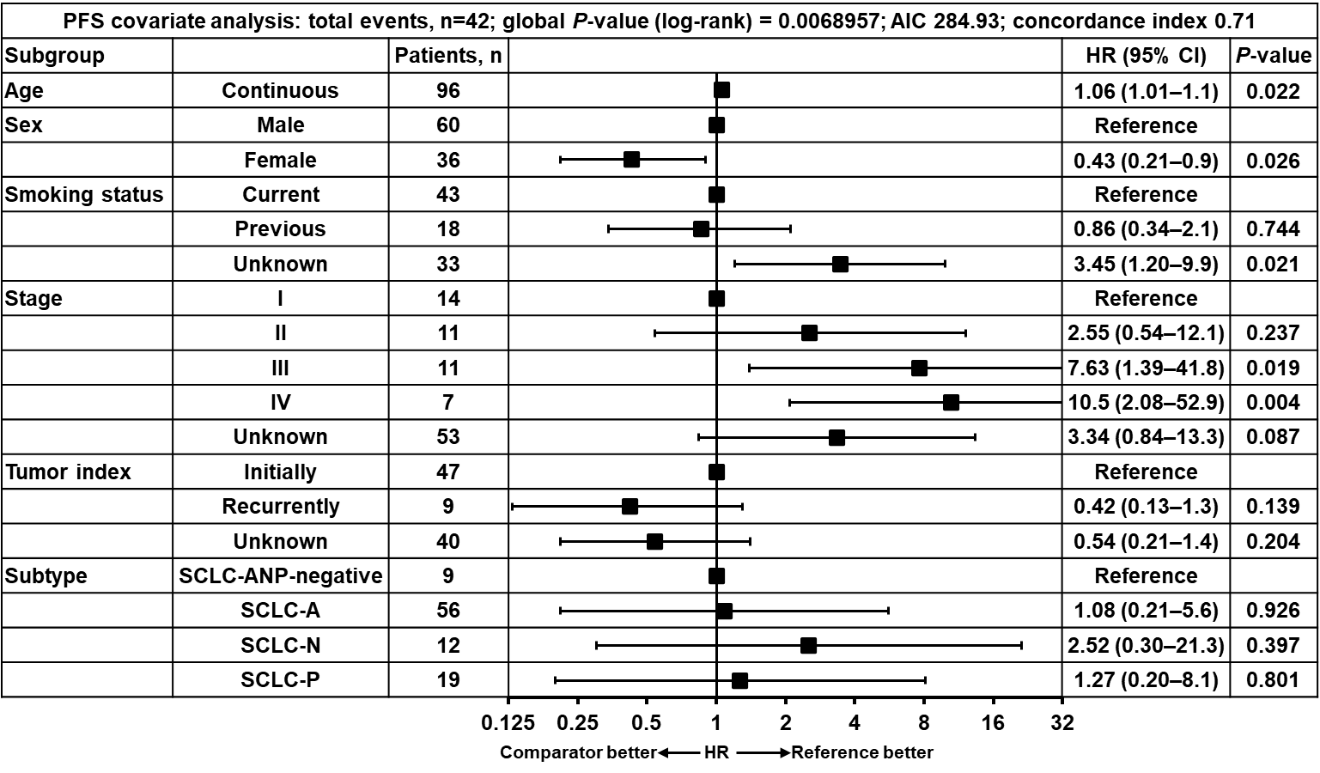
C
D
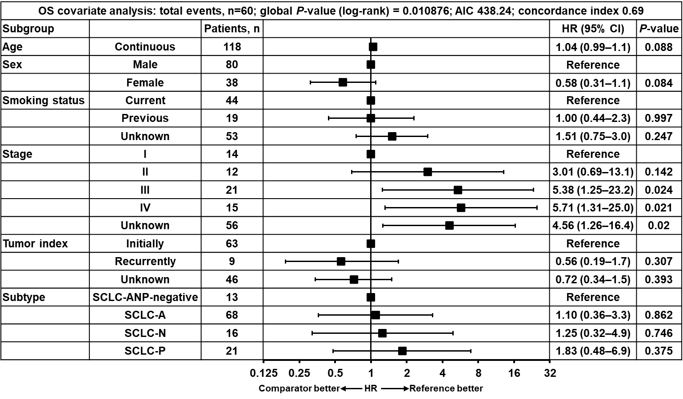
AIC, Akaike information criterion; CI, confidence interval; HR, hazard ratio; IHC, immunohistochemistry; OS, overall survival; PFS, progression-free survival; SCLC, small-cell lung cancer.
Supplementary Fig. 3 Gene expression on RNAseq according to SCLC subtype by IHC. Gene expression of A. NE markers, B. mesenchymal markers, C. epigenetic markers, D. known surface therapeutic targets in SCLC and other indications, E. cell death markers, and F. immune-related markers by SCLC subtype defined by ASCL1 (A), NEUROD1 (N), and POU2F3 (P) expression or lack of expression (ANP–) on IHC. Of the 98 samples in which RNAseq and IHC subtyping data were collected (Supplementary Fig. 1), one sample was missing data for one of the three IHC assays of subtype-defining transcription factors, and subtype could not therefore be determined.
IHC, immunohistochemistry; IO, immunotherapy; NE, neuroendocrine; RNAseq, RNA sequencing; SCLC, small-cell lung cancer; TPM, transcript counts per million.
Supplementary Fig. 4 Methylomic profiling of SCLC reveals additional clusters. A. Hierarchical K-means clustering analysis of the top 5000 promoter methylation regions showed four distinct clusters, C1–4. Of 14 cases with discordance between IHC-based and RNA-based subtyping, 4, 2, 3, and 5 cases were found in clusters C1, C2, C3, and C4, respectively, indicating no evidence for groupings or co-segregation of these cases at the methylome level. B. Correlation between IHC-defined SCLC subtype and methylation-based cluster. C. OS in subgroups defined by methylation-based cluster.
IHC, immunohistochemistry; NA, not available; OS, overall survival; SCLC, small-cell lung cancer.
Supplementary Fig. 5 Global mass spectrometry-based shotgun proteomics analysis by laser microdissection reveals the landscape of protein expression in SCLC. A. Correlation between protein expression of genes and mRNA levels on RNAseq (n=68). B. Heatmap showing differently expressed proteins between NE and NonNE SCLC subtypes, as defined by the IHC assay. C. Levels of proteasome proteins PSMB6 (β1) and PSMB7 (β2) and immunoproteasome proteins PSMB9 (β1i) and PSMB10 (β2i) according to MHC-I expression status.
IHC, immunohistochemistry; MHC-I, major histocompatibility complex I; NE, neuroendocrine; RNAseq, RNA sequencing; SCLC, small-cell lung cancer.

