Supplementary Material

HDAC6 orchestrates metastatic and immunosuppressive programs in small cell lung cancer through S100A2-TGF-β/SMAD and CSF1R signaling
Yantao Jiang¹, Junjie Yu¹, Ting Wang¹, Qingwu Du¹, Jingya Wang¹, Yi Lu¹, Qi Xu¹, Huiyan Liu¹, Xueyang Li¹, Luyao Tong¹, Tingting Qin^{1*}, and Dingzhi Huang^{1*}

Supplementary Figures
Supplementary Figure 1
Supplementary Figure 1. HDAC6 promoted the proliferation and aggressiveness of SCLC cells. a The mRNA expression of HDAC6 across tissue types in GSE116977 dataset. b The mRNA expression of HDAC6 in SCLC with BM and SCLC without BM tissues in GSE161968 dataset. c WB and qRT-PCR validated HDAC6 OE efficiency at protein and mRNA levels. d-e CCK8 (d) and clone formation assay (e) between WT and HDAC6 OE cell lines. f WB experiments of EMT-related key molecules in WT and HDAC6 OE cell lines. g-h Transwell (g) and wound healing assay (h) in WT and HDAC6 OE cell lines. i WB and qRT-PCR validated HDAC6 OE rescue efficiency at protein and mRNA levels. j-m CCK8 (j) and clone formation assay (k), Transwell assay (l) and wound healing assay (n) in HDAC6 KO and HDAC6 KO+OE cell lines. *p < 0.05; **p < 0.01; ***p < 0.001; ****p< 0.0001
Supplementary Figure 2
Supplementary Figure 2. HDAC6 inhibitor Tubastatin A suppressed malignant progression in SCLC. a WB experiments of EMT-related key molecules in HDAC6 KO and KO+OE cell lines. b The 24 h and 48 h IC50 values of Tubastatin A in SBC-2 and H1688 cell lines. c-d CCK8 (c) and clone formation assay (d) between control and drug-treated cell lines. e-g WB and qRT-PCR experiments of apoptotic (e-f) and EMT (g) pathway-related key molecules in control and drug-treated cell lines. h-j Transwell assay (h-i) and wound healing assay (j) in control and drug-treated cell lines. k HBMEC/NHA co-culture model of the BBB. l-m BBB permeability tests: 4h leakage (l) and fluorescein sodium penetration assays (m). n-o The protein (n) and mRNA (o) changes of tight junctions across BBB co-culture phases. *p < 0.05; **p < 0.01; ***p < 0.001; ****p< 0.0001

Supplementary Figure 3
Supplementary Figure 3. a-b Longitudinal monitoring between the two groups was performed via IVIS imaging following intracardiac injection. c Volcano plot of differentially expressed genes between NCI-H1688 HDAC6 WT and KO groups from mRNA-seq. d Pie chart of functional subcellular localization for differential DPs. e Heatmap of EMT-related markers from mRNA-seq data. f Volcano plot of differentially expressed transcription factors from mRNA-seq data. g-h Functional enrichment analysis of differential genes by GO and KEGG based on mRNA-seq data (g) and CUT&TAG data (h), respectively.
Supplementary Figure 4
Supplementary Figure 4. a Heatmap of differentially acetylated proteins between groups. b HDAC6-mediated deacetylation sites. c-d GO (c) and KEGG (d) pathway enrichment analysis. e Differences in S100A2 expression levels between tumor and adjacent normal tissues across various cancer types based on TCGA database. f Impact of S100A2 expression on OS and PFS across multiple cancer types based on GEPIA2.0 database. g WB and qRT-PCR validated S100A2 OE efficiency at protein and mRNA levels, respectively. h WB and qRT-PCR validated S100A2 OE efficiency at protein and mRNA levels in HDAC6 KO cells, respectively. *p < 0.05; **p < 0.01; ***p < 0.001; ****p< 0.0001

Supplementary Figure 5
Supplementary Figure 5. a-b WB and qRT-PCR validated SMAD3 KO efficiency at protein and mRNA levels, respectively in H1688 (a) and SBC-2 (b) cell lines. c WB experiments of EMT markers in WT and SMAD3 KO cell lines. d Correlations between HDAC6 expression and Estimate score, Stroma score and Immune score. e Immune cell composition in SCLC tumor microenvironment (George et al.). f The correlation between HDAC6 and the expression of M1 macrophage-related markers. g The difference in CSF1R mRNA expression between HDAC6 WT and KO groups in H1688 and SBC-2 cell lines.

Supplementary Tables
Supplementary Table 1
Characteristics | Total | HDAC6-Low | HDAC6-High | P
 | N=98 (%) | N=42 (%) | N=56 (%) | P
 | 61.11±8.32  61 (35,77) | 59.60±9.17  59.5 (35,77) | 62.25±7.51  62 (44,76) | 0.40
  Age
  Mean±SD
  Median (min-max)
Gender  Female  Male | 16 (16.33%)  82 (83.67%) | 9 (21.43%)  33 (78.57%) | 7 (12.5%)  49 (87.5%) | 0.36
Smoking history  NO  YES | 13 (13.27%)  85 (86.73%) | 6 (14.29%)  36 (85.71%) | 7 (12.5%)  49 (87.5%) | 0.87
ECOG  0  1  2 | 62 (63.27%)  29 (29.59%)  7 (7.14%) | 27 (64.29%)  12 (28.57%)  3 (7.14%) | 35 (62.5%)  17 (30.36%)  4 (7.14%) | 0.98
T-Stage  I  II  III  IV | 55 (56.12%)  27 (27.55%)  10 (10.20%)  6 (6.12%) | 25 (59.52%)  12 (28.57%)  3 (7.14%)  2 (4.76%) | 30 (53.57%)  15 (26.79%)  7 (12.5%)  4 (7.14%) | 0.78
N-Stage  0  1  2  3 | 57 (58.16%)  11 (11.22%)  29 (29.59%)  1 (1.02%) | 26 (61.9%)  2 (4.76%)  13 (30.95%)  1 (2.38%) | 31 (55.36%)  9 (16.07%)  16 (28.57%)  0 (0.00%) | 0.23
M-Stage  0  1 | 83 (84.69%)  15 (15.31%) | 36 (85.71%)  6 (14.29%) | 47 (83.93%)  9 (16.07%) | 1.00
pTNM-Stage  I  II  III  IV | 39 (39.80%)  16 (16.33%)  30 (30.61%)  13 (13.27%) | 17 (40.48%)  6 (14.29%)  14 (33.33%)  5 (11.90%) | 22 (39.29%)  10 (17.86%)  16 (28.57%)  8 (14.29%) | 0.92
Progress Status  NO  YES | 31 (31.63%)  67 (68.37%) | 18 (42.86%)  24 (57.14%) | 13 (23.21%)  43 (76.79%) | 0.06
OS Status  Live  Dead | 36 (36.73%)  62 (63.27%) | 22 (52.38%)  20 (47.62%) | 14 (25.00%)  42 (75.00%) | 0.01

Supplementary Table 2
Gene | Forward prime | Reverse prime
β-ACTIN | 5'-TGACGTGGACATCCGCAAAG-3' | 5’-CTGGAAGGTGGACAGCGAGG-3'
HDAC6 | 5'-GCCTCAATCACTGAGACCATCC-3' | 5'-GGTGCCTTCTTGGTGACCAACT-3'
S100A2 | 5'-TGCCAAGAGGGCGACAAGTTCA-3' | 5'-AAGTCCACCTGCTGGTCACTGT-3'
CSF1R | 5'-GCTGCCTTACAACGAGAAGTGG-3' | 5'-CATCCTCCTTGCCCAGACCAAA-3'
Bcl-2 | 5'-ATCGCCCTGTGGATGACTGAGT-3' | 5'-GCCAGGAGAAATCAAACAGAGGC-3'
Bax | 5'-TCAGGATGCGTCCACCAAGAAG-3' | 5'-TGTGTCCACGGCGGCAATCATC-3'
Bim | 5'-CAAGAGTTGCGGCGTATTGGAG-3' | 5'-ACACCAGGCGGACAATGTAACG-3'
CD86 | 5'-CCATCAGCTTGTCTGTTTCATTCC-3' | 5'-GCTGTAATCCAAGGAATGTGGTC-3'
CXCL9 | 5'-CTGTTCCTGCATCAGCACCAAC-3' | 5'-TGAACTCCATTCTTCAGTGTAGCA-3'
CXCL10 | 5'-GGTGAGAAGAGATGTCTGAATCC-3' | 5'-GTCCATCCTTGGAAGCACTGCA-3'
TNF-α | 5'-CTCTTCTGCCTGCTGCACTTTG-3' | 5'-ATGGGCTACAGGCTTGTCACTC-3'
NOS2 | 5'-GCTCTACACCTCCAATGTGACC-3' | 5'-CTGCCGAGATTTGAGCCTCATG-3'
CD163 | 5'-CCAGAAGGAACTTGTAGCCACAG-3' | 5'-CAGGCACCAAGCGTTTTGAGCT-3'
CD206 | 5'-AGCCAACACCAGCTCCTCAAGA-3' | 5'-CAAAACGCTCGCGCATTGTCCA-3'
ARG1 | 5'-TCATCTGGGTGGATGCTCACAC-3' | 5'-GAGAATCCTGGCACATCGGGAA-3'
IL-10 | 5'-TCTCCGAGATGCCTTCAGCAGA-3' | 5'-TCAGACAAGGCTTGGCAACCCA-3'
TGF-β | 5'-TACCTGAACCCGTGTTGCTCTC-3' | 5'-GTTGCTGAGGTATCGCCAGGAA-3'
ZO-1 | 5'-GTCCAGAATCTCGGAAAAGGTGCC-3' | 5'-CTTTCAGCGCACCATACCAACC-3'
Claudin-5 | 5'-ATGTGGCAGGTGACCGCCTTC-3' | 5'-CGAGTCGTACACTTTGCACTGC-3'
Occludins | 5'-ATGGCAAAGTGAATGACAAGCGG-3' | 5'-CTGTAACGAGGCTGCCTGAAGT-3'
SNAI2 P1 | 5'-GCTGGGACAGAGTCTTGACAG-3' | 5'-CCACAGGGTCCCTGAGTTTCT-3'
SNAI2 P2 | 5'-TCCCTGGGTGTGTCTGTGTCT-3' | 5'-AGGCACAGGGACAGGAAGAGA-3'
SNAI2 P3 | 5'-GGTGTGGCTGGGAAGTCCT-3' | 5'-CACACACCCACACACACACC-3'
CSF1R P1 | 5'-CTGGTGGGAGGTAAGGCAAG-3' | 5'-AGGTGGCTGGGAGAATCAAT
CSF1R P2 | 5'-AGGAGGATCGAGGGTAAAGG-3' | 5'-GCCAGGGACAGTGATTGAGA-3'
CSF1R P3 | 5'-AGTGAGAAGGGTGAGGAGTT-3' | 5'-TGCCCAGTCTTTTATAGCTG-3'
CSF1R P4 | 5'-AAGGGAACACCAAGACCATC-3' | 5'-GGAAGAAAATCTGCCACCAC-3'
sgRNA Sequences
sgHDAC6#1 | CCGCTCTATCCCCAATCTAG
sgHDAC6#2 | ACCTAATCGTGGGACTGCAA
sgHDAC6#3 | GAAAGGACACGCAGCGATCT
sgSMAD3#1 | TGCGGCTCTACTACATCGGA
sgSMAD3#2 | AATTCGGAGCGCTTCTGCCT
sgSMAD3#3 | GCCATAGCGCTGGTTACAGT
Supplementary Table 3
Uncropped images of the WB

Figure. 1i
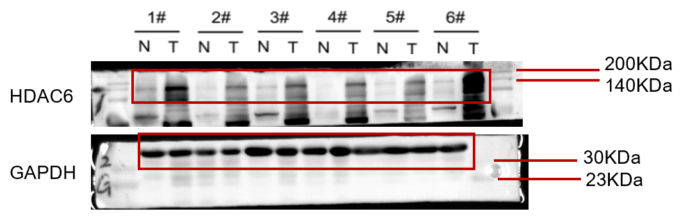
Figure. 2e
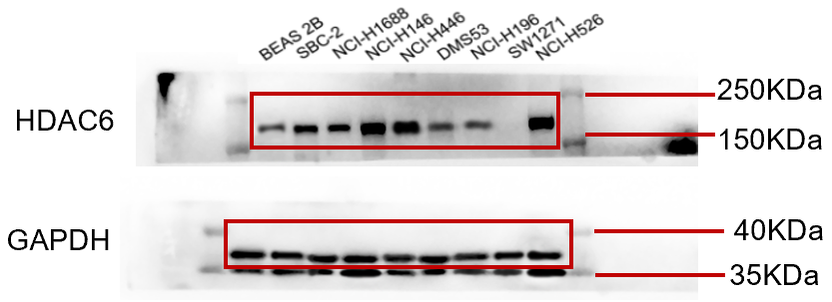
Figure. 2f
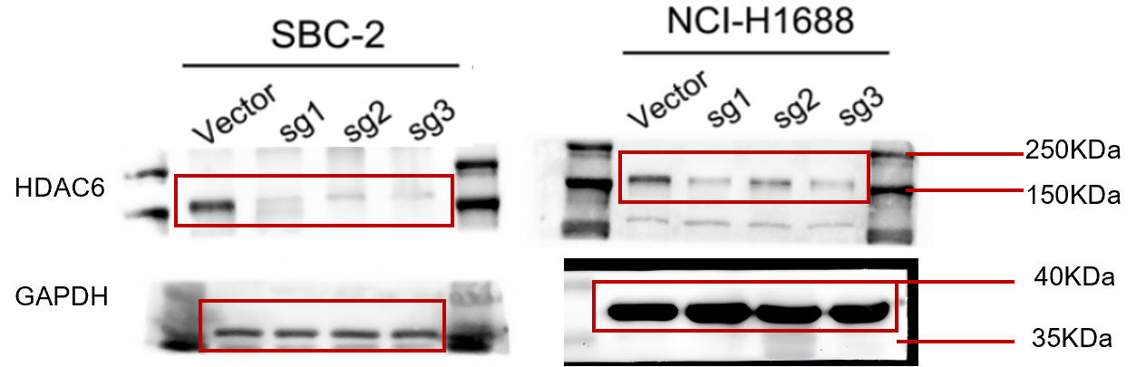
Figure. 2f
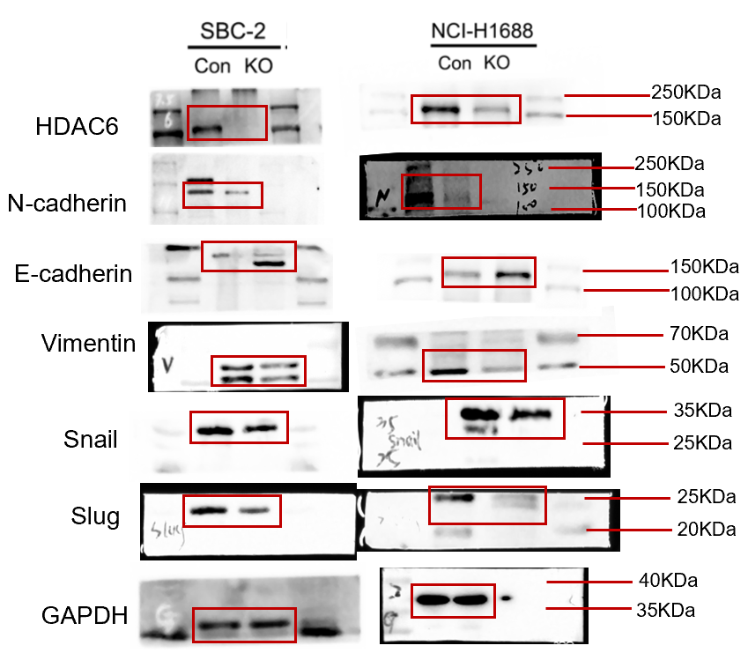
Figure. 2i
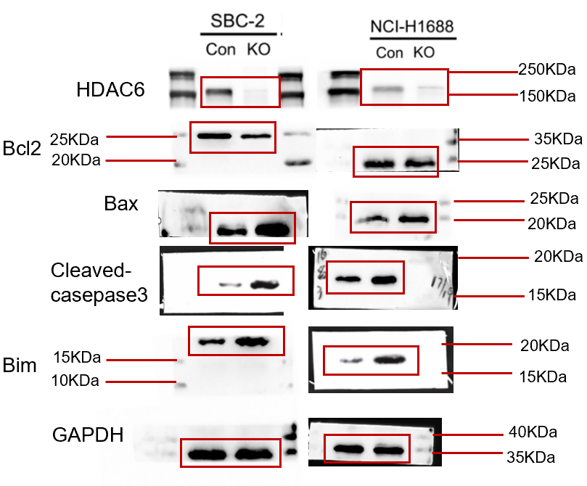
Figure. 5i
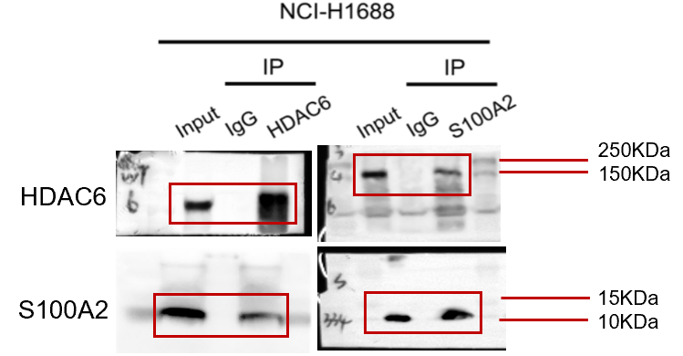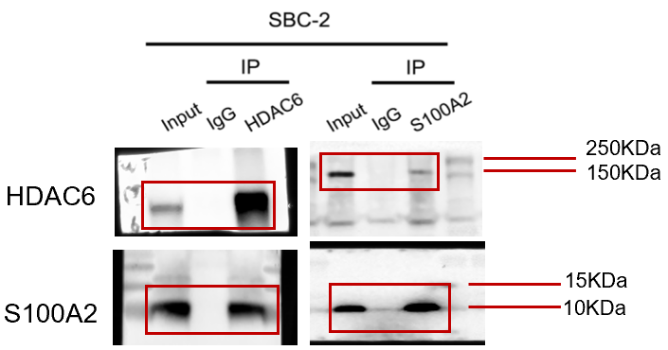

Figure. 5j Figure. 5l
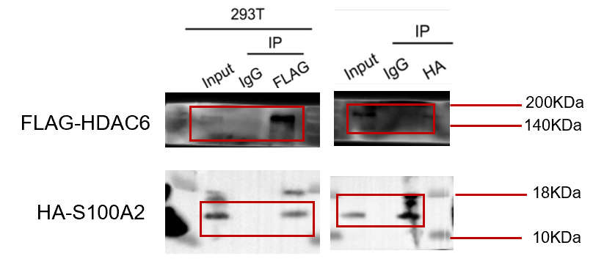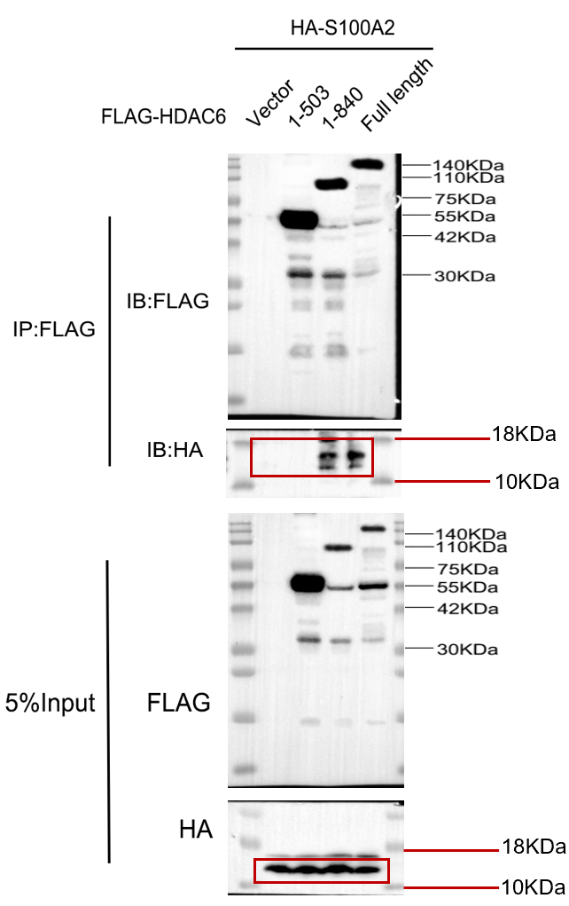
Figure. 5m Figure. 5n
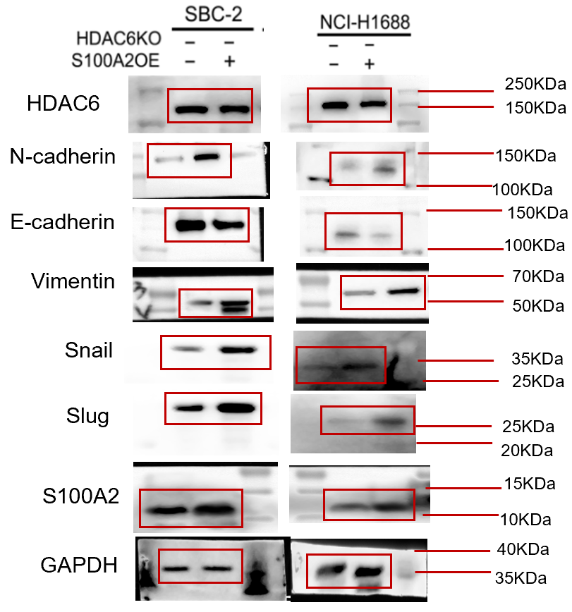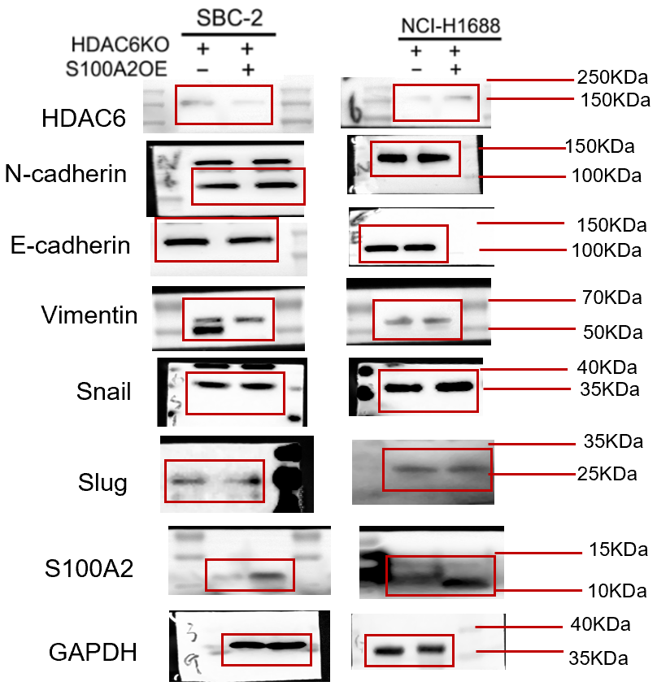
Figure. 5o Figure. 5p
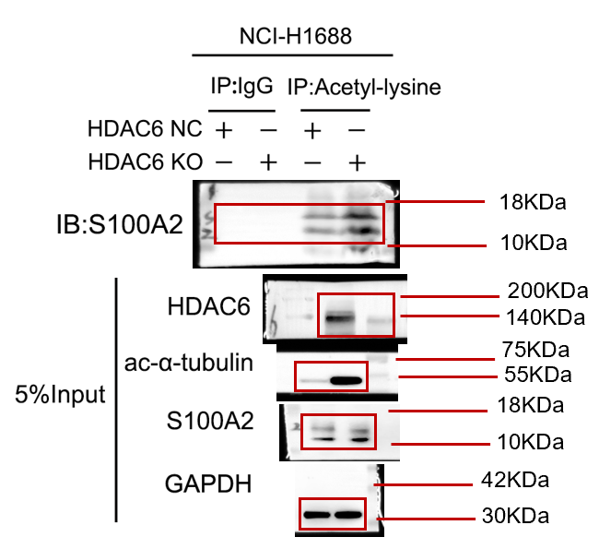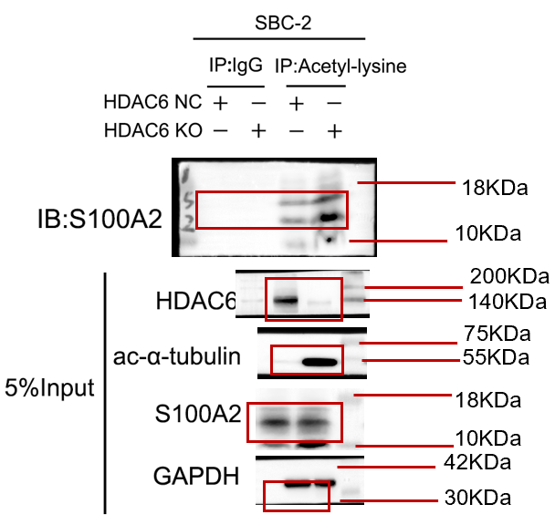
Figure. 5q Figure. 5r

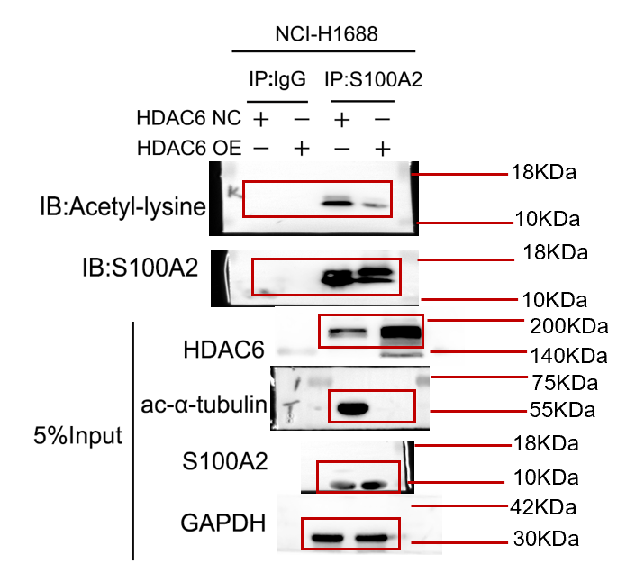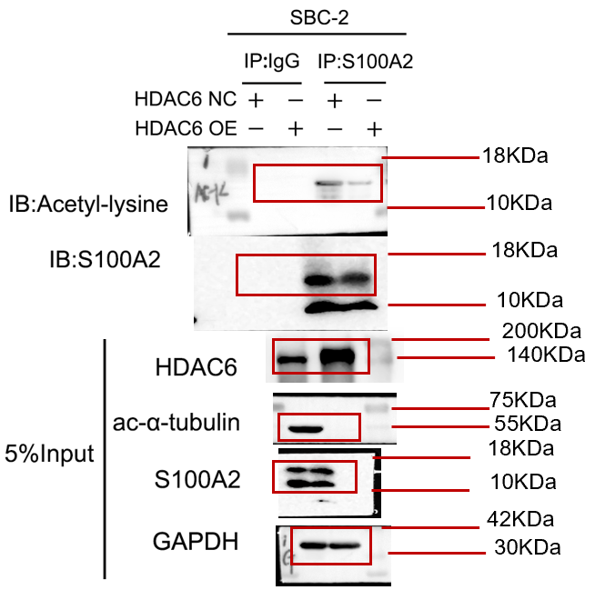
Figure. 5s Figure. 5t
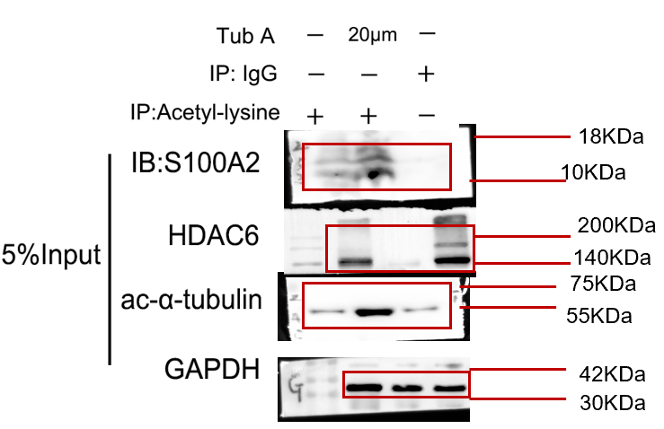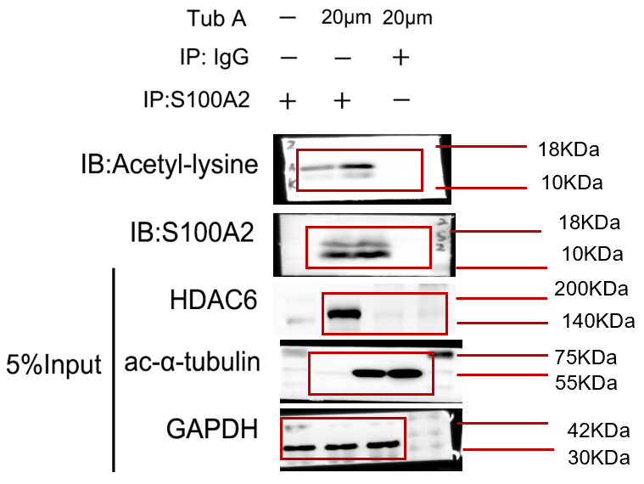

Figure. 6c Figure. 6d
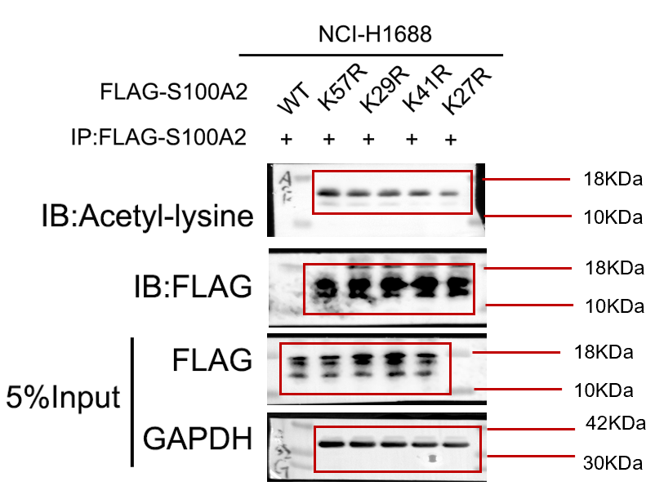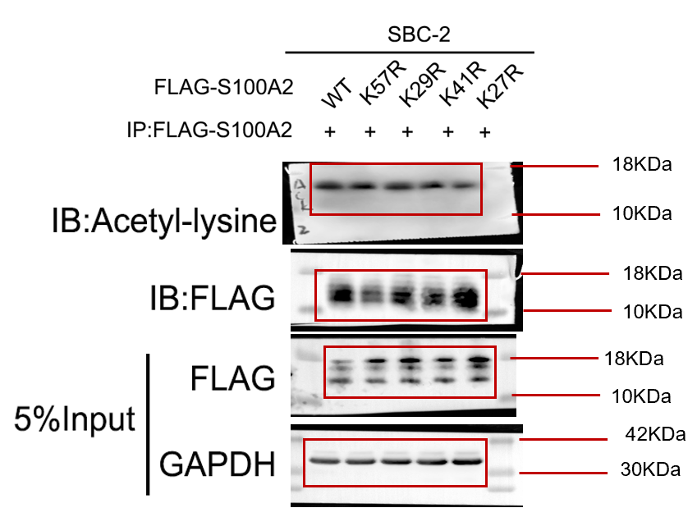

Figure. 6e Figure. 6f
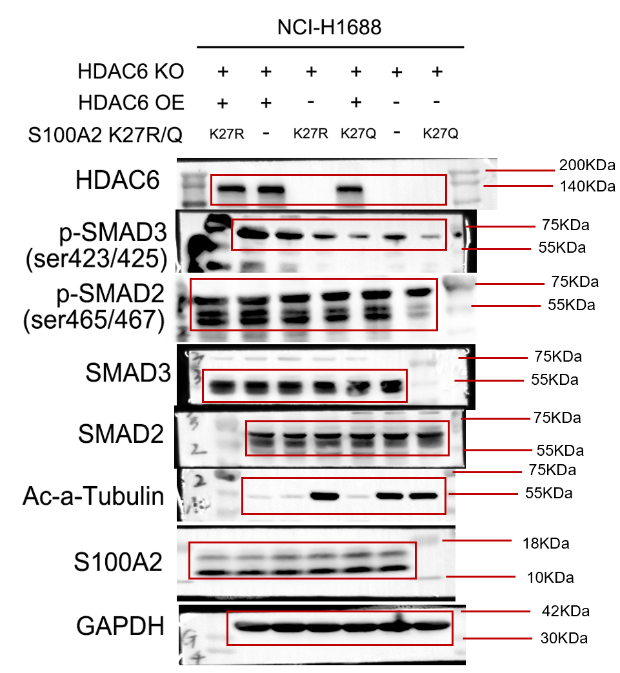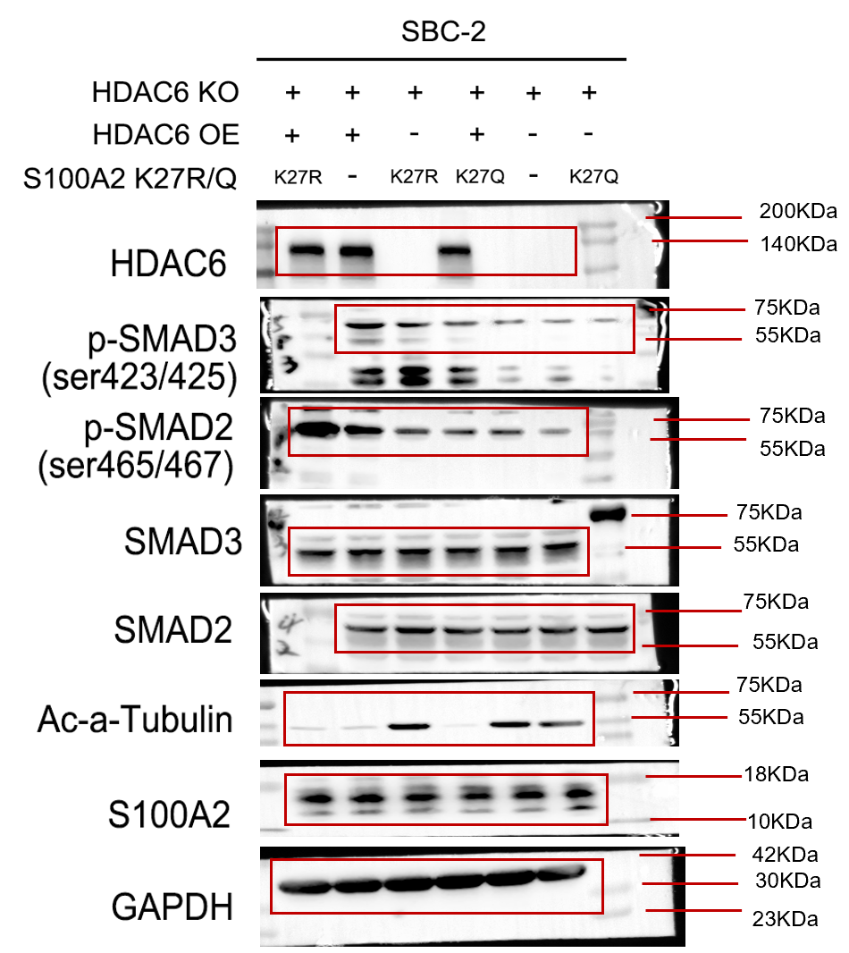

Figure. 6g
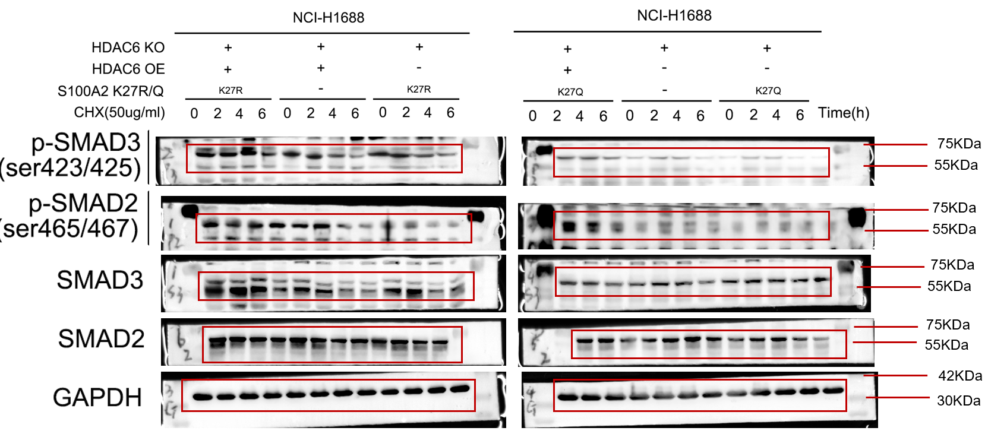
Figure. 6h
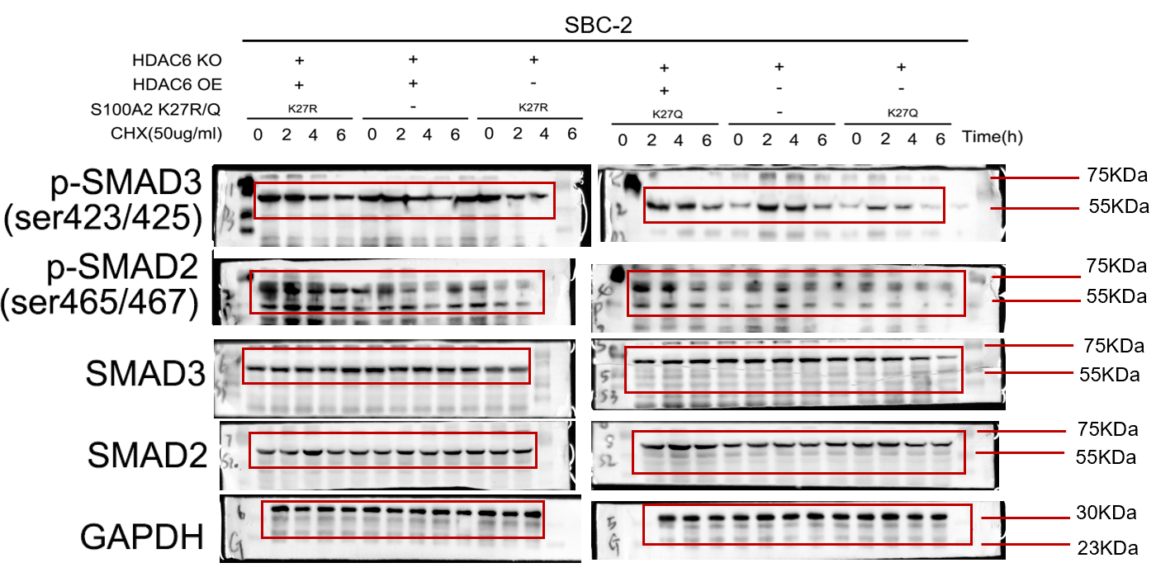
Figure. 6i Figure. 6j
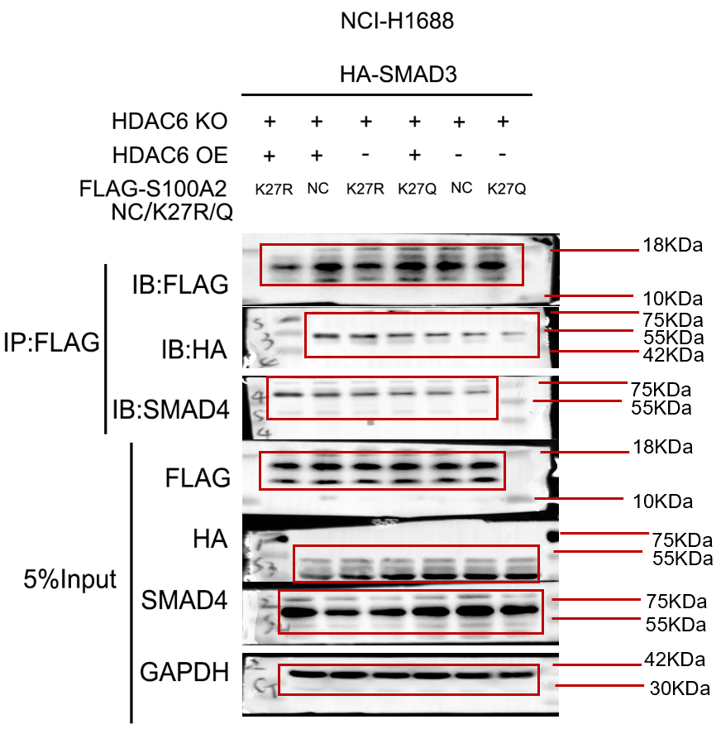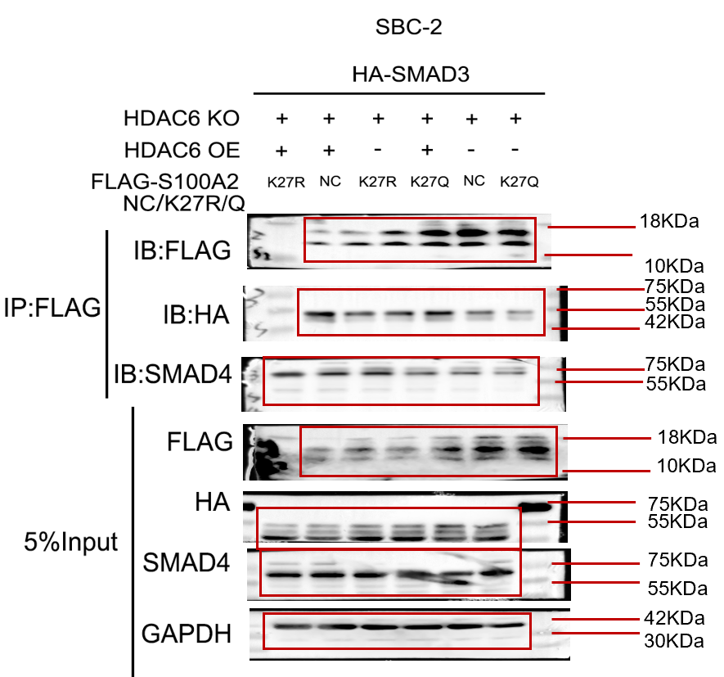

Figure. 6k
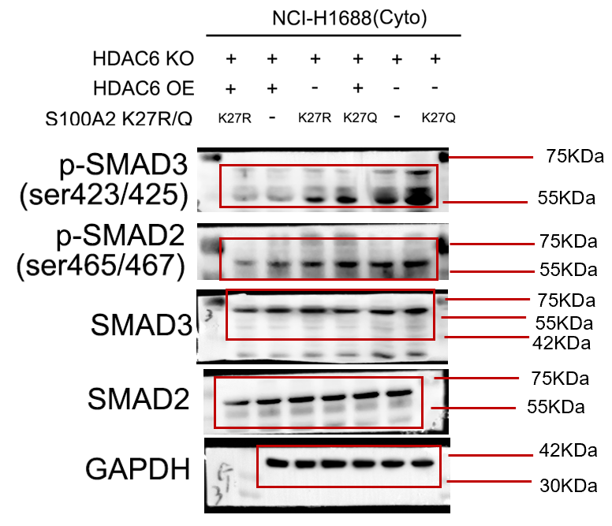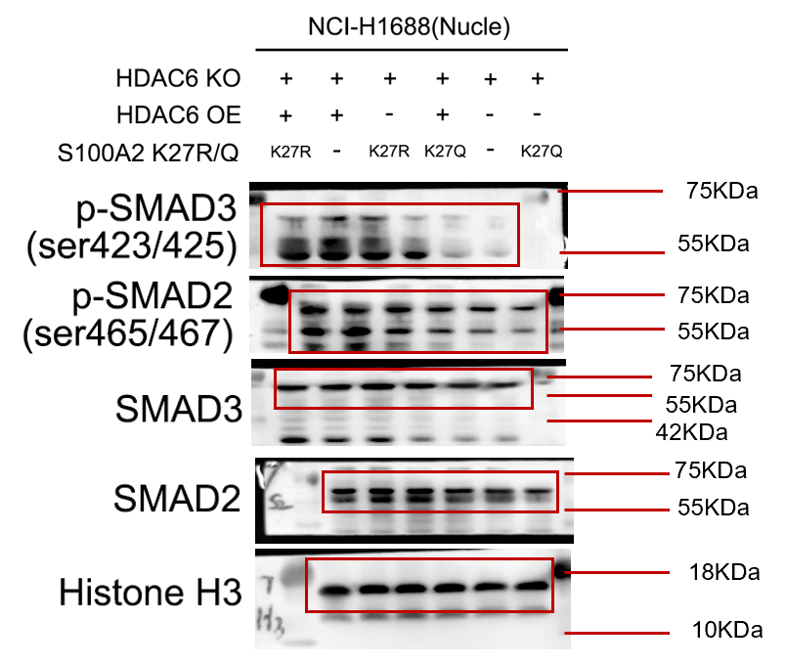
Figure. 6l
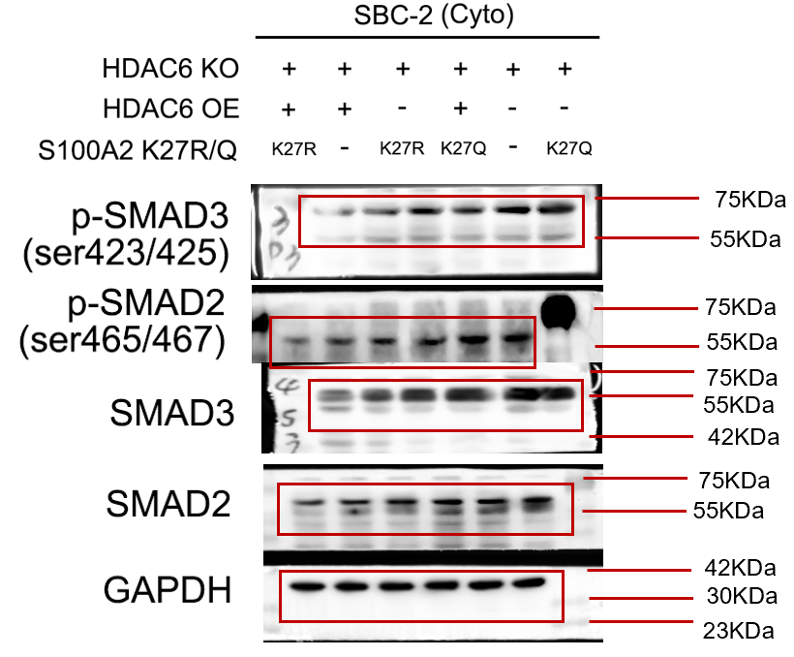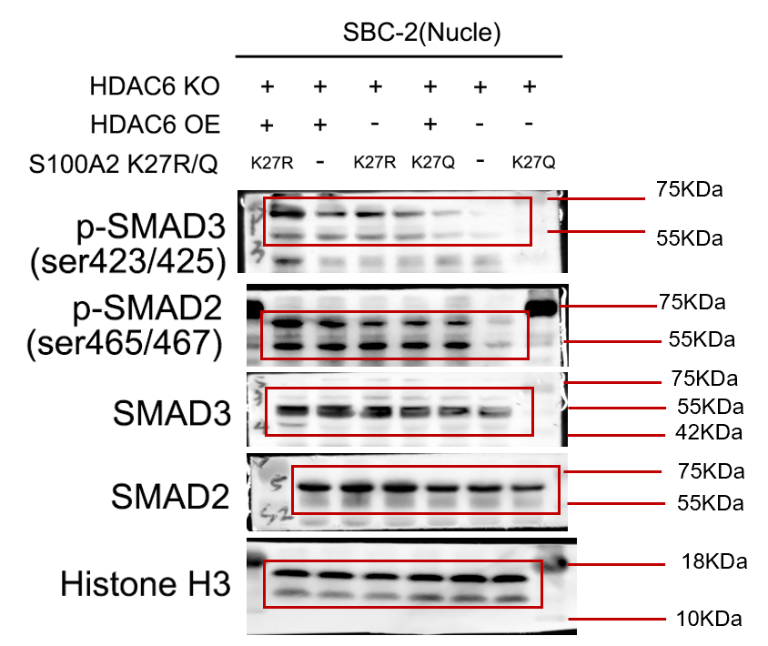

Supplementary Figure. 1c Supplementary Figure. 1f

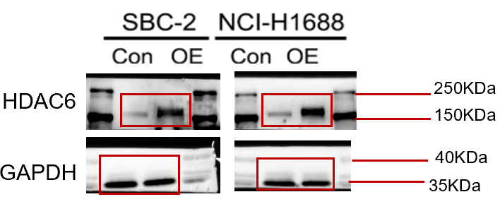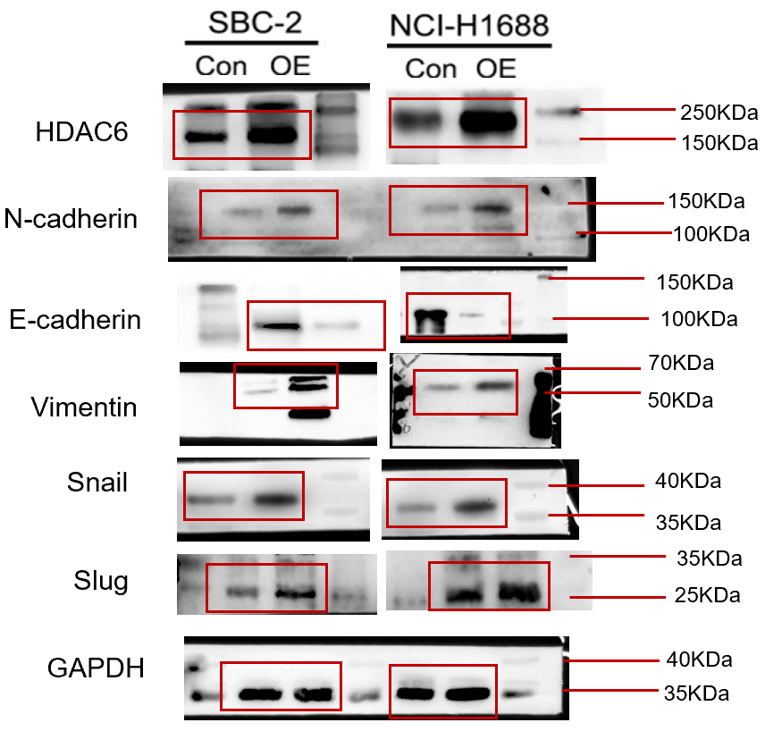
Supplementary Figure. 1i Supplementary Figure. 2a
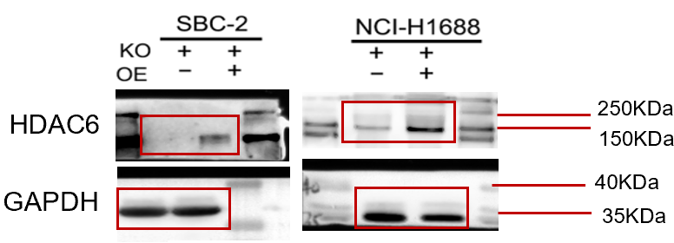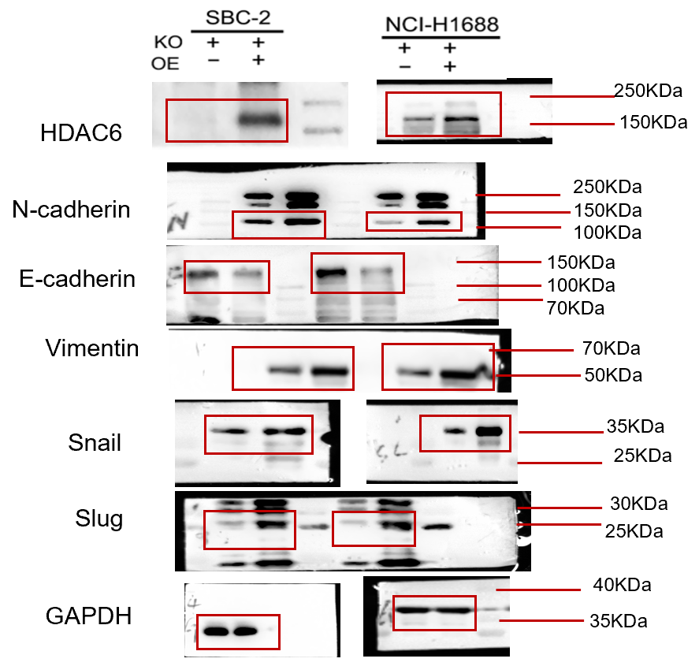

Supplementary Figure. 2e and 2f Supplementary Figure. 2g
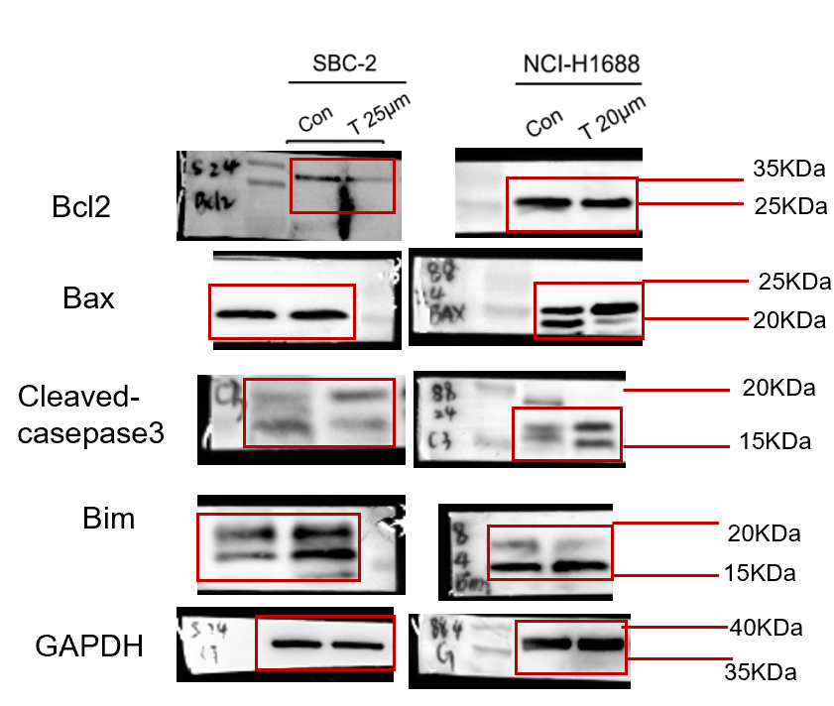 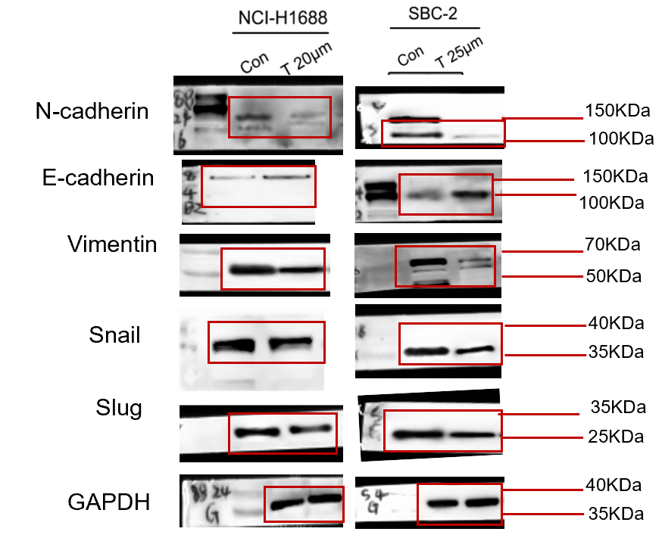

Supplementary Figure. 2n
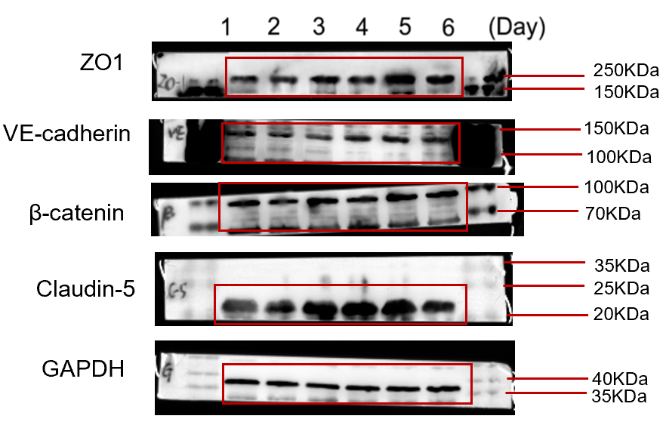
Supplementary Figure. 2n Supplementary Figure. 2h
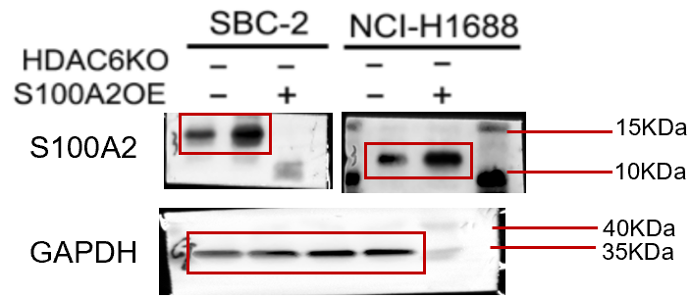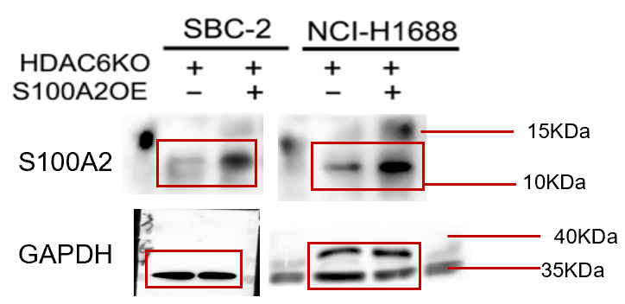

Supplementary Figure. 5a and 5b
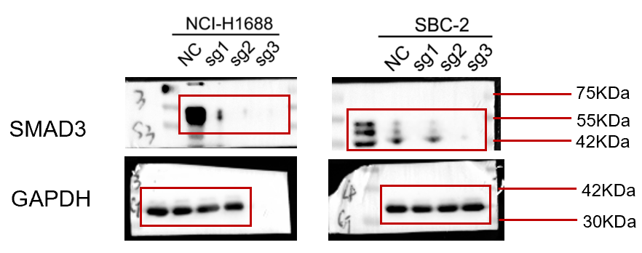

Supplementary Figure. 5c
