Supplementary Materials for

piRNA-1170 drives brain metastasis and immune evasion via WTAP-mediated m6A methylation reprogramming in triple-negative breast cancer
#Yongzhou Luo, #Wenwen Tian, # Xudong Zhu, # Weidong Wei, Feng Ye, Min-Yi Situ, Yuanliang Yan, Xiaofang He, Xuefang Huang, ∗ Jun Tang, ∗Yanan Kong, ∗Hailin Tang

Correspondence to: Hailin Tang (tanghl@sysucc.org.cn), Yanan Kong (kongyn@sysucc.org.cn), Jun Tang (tangjun@sysucc.org.cn).

This PDF file includes:

Supplementary Materials and Methods
Figures. S1 to S6

Supplementary Materials and Methods
Cell lines and cell culture
Cell lines purchased from American Type Culture Collection (ATCC) included MCF-10A(RRID:CVCL_5423), MCF-7(RRID:CVCL_0031), SK-BR-3(RRID:CVCL_0033), T47D(RRID:CVCL_0553), MDA-MB-231(RRID:CVCL_0062), BT-549(RRID:CVCL_1092), MDA-MB-468(RRID:CVCL_0419), and SUM159PT(RRID:CVCL_0063), and all were maintained in culture under standard 5% CO2 and 37°C conditions and they were periodically mycoplasma tested. Cancer cell lines were grown in DMEM with 10% FBS and 1% penicillin-streptomycin, and the MCF-10A(RRID:CVCL_5423) cells were cultured in DMEM/F12 with necessary supplements.

MeRIP experiment and high throughput sequencing and data analysis
MDA-MB-231 were transfected with anta-NC, anta-1170 and then total RNAs were extracted using TRIzol Reagent (Invitrogen, CA, USA). DNA digestion was carried out after RNA extraction by DNaseI. RNA quality was determined by examining A260/A280 with NanodropTM OneCspectrophotometer (Thermo Fisher Scientific Inc). RNA Integrity was confirmed by 1.5% agarose gel electrophoresis. Qualified RNAs were finally quantified by Qubit3.0 with QubitTM RNA Broad Range Assay kit (Q10210, Life Technologies, Carlsbad, CA, USA). 50 μg total RNAs were used for polyadenylated RNA enrichment by VAHTS mRNA Capture Beads (Cat. No. N401-01/02, Vazyme Biotech, Nanjing, China). 20mM ZnCl2 was added to mRNA and incubated at 95℃ for 5min-10min until the RNA fragments were mainly distributed in 100-200 nt. Then 10% RNA fragments was saved as “Input” and the rest was used for m6A immunoprecipitation（IP）.The specific anti-m6A antibody (Synaptic Systems Cat# 202 003, RRID:AB_2279214) was applied for m6A immunoprecipitation. RNA samples of both input and IP were prepared using TRIzol reagent (Invitrogen, CA, USA). The stranded RNA sequencing library was constructed by KC-DigitalTM Stranded mRNA Library Prep Kit for Illumina® (Cat. No. DR08502, Wuhan Seqhealth Co., Ltd., Wuhan, China) following the manufacturer’s instruction. The kit eliminates duplication bias in PCR and sequencing steps, by using unique molecular identifier (UMI) of 8 random bases to label the pre-amplified cDNA molecules. The library products corresponding to 200-500 bps were enriched, quantified and finally sequenced on Novaseq 6000 sequencer (Illumina) with PE150 model.
Raw sequencing data was first filtered by Trimmomatic (version 0.36, RRID:SCR_011848), low-quality reads were discarded and the reads contaminated with adaptor sequences were trimmed. Clean Reads were further treated with in-house scripts to eliminate duplication bias introduced in library preparation and sequencing. In brief, clean reads were first clustered according to the UMI sequences, in which reads with the same UMI sequence were grouped into the same cluster. Reads in the same cluster were compared to each other by pairwise alignment, and then reads with sequence identity over 95% were extracted to a new sub-cluster. After all sub-clusters were generated, multiple sequence alignment was performed to get one consensus sequence for each sub-cluster. After these steps, any errors and biases introduced by PCR amplification or sequencing were eliminated.
The de-duplicated consensus sequences were used for m6A site analysis. They were mapped to the reference genome of Homo sapiens from GRCh38_release107 (https://ftp.ensembl.org/pub/release-107/fasta/homo_sapiens/dna/) using STAR software (version 2.5.3a) with default parameters. The exomePeak (Version 3.8) software was used for peak calling. The m6A peaks were annotated using bedtools (Version 2.25.0). The deepTools (version 2.4.1) was used for peak distribution analysis. The differentially m6A peaks were identified by a python script (RRID:SCR_024202), using fisher test. Sequence motifs enriched in m6A peak regions were identified using Homer (version 4.10).

In Vivo Mouse Studies
Mice were randomly assigned to experimental groups for all the experiments. Mice were anesthetized and injected with breast cancer cells (anta-NC/anta-1170 MDA-MB-231/SUM159PT 2.5×10⁵/mouse) into the left cardiac ventricle as done previously (Palmieri et al., 2009). At the end of each experiment or when mice were moribund, mice were humanely killed, and their brains were fixed in 4% formaldehyde and prepared for histopathology evaluation.

For bioluminescence imaging (BLI), mice were given the substrate D-luciferin (150 mg/kg) by intraperitoneal injection and then subjected to IVIS Spectrum instrument (PerkinElmer) to monitor the systemic dissemination of tumor cells. Metastatic burdens were also measured at the different time points using BLI. BLI images were analyzed using Living Image Software v.2.50. Brain metastatic tumor burden was measured by the photon flux of the BLI signal within a region that corresponds to the brain which was manually drawn to outline. At the end of the experiments, tissues were fixed in 4% formalin and prepared for histopathology evaluation.

For mouse spontaneous metastasis model, MDA-MB-231 cells or SUM159PT cells (5× 10⁵ cells/mouse) in 100 μl PBS and injected into the fourth mammary fat pads. At the experimental endpoint, mice were humanely euthanized in compliance with institutional ethical guidelines, followed by resection of tumor tissues and major organs (lungs, livers, and brains) for subsequent ex vivo BLI and piR-1170 fluorescence in situ hybridization (FISH) analysis.

Extravasation and Metastatic Seeding Assays
For the in vivo brain extravasation and seeding assays, cancer cells labeled with CMFDA (Yeasen, China) were injected intracardially into the nude mice. Cell number and injection procedure were described in “In Vivo Mouse Studies”. At 48 hrs later, the mice were sacrificed. For seeding assay, the mice were perfused with 4% paraformaldehyde (PFA) before the mice were killed. Brains were removed and fixed with 4% PFA for 12-24 hour at 4°C. After that, brains were incubated overnight in 30% sucrose and embedded in Tissue-Tek O.C.T. for cryo-sectioning. Immunofluorescence staining was done on the brain with CD31 antibody (Proteintech Cat# 11265-1-AP, RRID:AB_2299349) for recognition of microvascular endothelial cells. CMFDA positive cancer cells in the sections were detected using a fluorescent microscope and counted.

In vivo intracranial stereotactic implantation
BALB/c nude (RRID:MGI:2683685) female mice (5 to 6 weeks old) were anesthetized by intraperitoneal injection of tribromoethanol (30ul/g) (Meilunbio) and placed in a stereotactic apparatus. A burr hole craniotomy was made 0.1 mm posterior and 2.2 mm lateral to the bregma point.
Five thousand 231-BrM/159-BrM cells in 4ul of PBS were stereotactically injected using a microsyringe at a depth of 3 mm. Tumor development was followed over 11 days by in vivo BLI, and tumor burden was quantified using the Living Image Software v.2.50. At the end point, mice were sacrificed and perfused with 4% PFA before brain resection. Brains were incubated overnight in 30% sucrose and embedded in Tissue-Tek O.C.T. for cryo-sectioning.

Organotypic tumor spheroids (OTS) model
Fresh mouse tumors were obtained from breast cancer metastasis burdened mice. Collagen gel matrices were prepared for transwell inserts by mixing collagen matrix (Cellmatrix type I-A), 10 X concentrated sterile culture medium (Ham’s F-12), and sterile reconstitution buffer (2.2 g NaHCO3 in 100 mL of 0.05 N NaOH and 200 mM HEPES) on ice at a ratio of 8:1:1 until use. 1ml of reconstituted collagen solution is added to a 30 mm, 0.4 μm inner transwell under sterile conditions, serving as a bottom layer gel without tissue. The bottom layer is left to solidify for 30 min either in the hood or in a 37℃ incubator. Tumor metastasis tissues are minced finely on a 109 μm wire mesh and washed twice in F12 (Invitrogen) containing 1X Normocin (InvivoGen), resuspended in 1 mL of pre-reconstructed collagen, and layered on top of 1 mL of pre-reconstructed collagen within the insert. The inner transwell was placed into an outer 60 mm tissue culture dish containing 1.0 mL of growth medium (F12 (Invitrogen), 20% FBS, 1X Normocin and the lid of the outer dish was replaced as previously described.

Supplementary Figure 1. piR-1170 expression profiling in TNBC. (A) RNA-FISH analysis of piR-1170 in TNBC versus adjacent normal tissues. (B) High-throughput sequencing of non-coding RNAs in breast cancer cell lines versus human mammary epithelial cells (HUMECs). (C) RT-qPCR quantification of piR-1170 in TNBC cell lines. (D) Pan-cancer analysis of piR-1170 expression across multiple cancer types. (E) piR-1170 expression distribution in normal human tissues. (F) Knockdown (anta-1170) and overexpression (piR-1170 mimic^{mod}) efficiency validation of piR-1170 by RT-qPCR. (G-H) TNBC cell clonogenic potential was evaluated via colony formation assay (G), and proliferation was assessed by CCK-8 assay (H). The error bars represent the SDs of triplicate experiments.
Supplementary Figure 2. Brain metastasis-derived organoid characterization. (A) 3D immunofluorescence imaging (spinning-disk confocal) of GFAP (red) and pan-CK (green) in brain metastasis-derived organoid. (B) Ki67 (red) and pan-CK (green) co-staining with 3D reconstruction in organoid models from the anta-NC and anta-1170 groups.

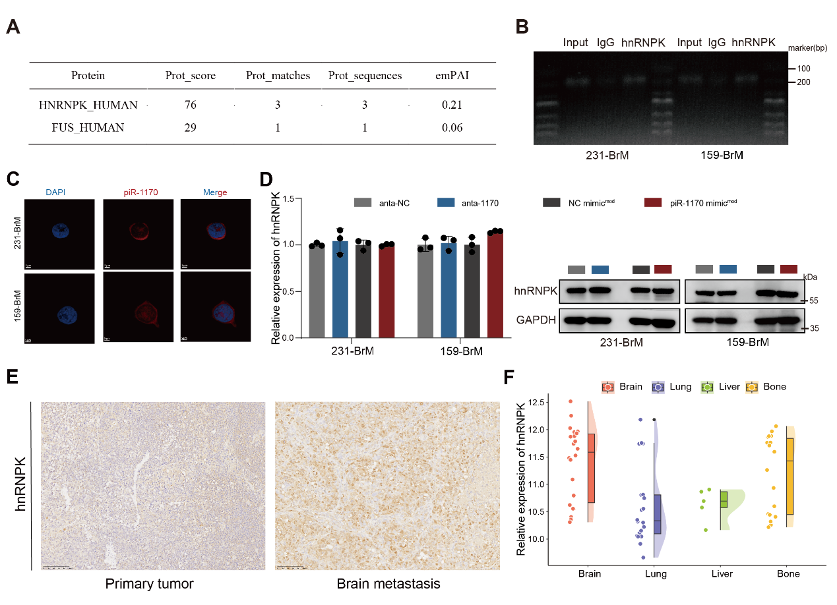
Supplementary Figure 3. piR-1170-hnRNPK interaction analysis. (A) Candidate proteins identified in the 55 kDa band by RNA pull-down assay. (B) Agarose gel electrophoresis validation of RNA fragment size post RIP-qPCR. (C) Subcellular localization of piR-1170 in TNBC cells by RNA-FISH. (D) Relative mRNA levels (left) and protein levels (right) of hnRNPK in TNBC cell lines upon piR-1170 perturbation. The error bars represent the SDs of triplicate experiments. (E) IHC images of hnRNPK expression in primary tumor and matched brain metastases from a TNBC mouse model. (F) Analysis of the GSE14020 dataset showing relative hnRNPK expression levels in breast cancer metastases across different organ sites.

Supplementary Figure 4. piR-1170-mediated regulation of WTAP. (A) Relative mRNA levels of candidate genes in 231-BrM cells after piR-1170 knockdown (anta-1170) or overexpression (piR-1170 mimic^{mod}). (B) Luciferase reporter assays of WTAP 3'-UTR mutants with piR-1170 knockdown or overexpression. (C) Schematic of miR-133a/b binding motifs in WTAP 3'-UTR. (D) Relative luciferase activity of psiCHECK2 vector bearing WTAP 3’UTR in 231-BrM and 159-BrM cells co-transfected with miR-133a/miR-133b inhibitor or mimic. The error bars represent the SDs of triplicate experiments.

Supplementary Figure 5. piR-1170-driven immune evasion via m6A methylation. (A) Metagene plot showing m6A peak distribution on CD274 transcripts upon piR-1170 knockdown (anta-1170). (B-C) RIP-PCR (B) and MeRIP-PCR (C) were used to evaluate the interactions between WTAP and the transcripts of CD274. (D) RT‒qPCR was used to measure the RNA levels of CD274 upon piR-1170 knockdown (anta-1170) or overexpression (piR-1170 mimic^{mod}) in 231-BrM cells. (E) The half-life of CD274 mRNA was evaluated in 231-BrM cells upon piR-1170 knockdown or overexpression. (F) Correlation analysis of m6A readers with DGAT2/CD274 in TCGA-BRCA. (G) Relative mRNA levels of DGAT2 and CD274 in 231-BrM cells upon m6A readers knockdown. (H-I) Relative mRNA levels (H) and protein levels (I) of CD274 in TNBC cells upon piR-1170 knockdown with or without WTAP overexpression. The error bars represent the SDs of triplicate experiments.

Supplementary Figure 6. Restoration of WTAP expression rescues the inhibitory effects of piR-1170 knockdown. (A) Representative fluorescent images of piR-1170 and IHC images of CD274, DGAT2 and genes involved in lipogenesis expression in primary tumor and brain metastases tissues from TNBC patients. (B) Representative images of migrated TNBC cells (left) and quantification of the relative migration cell number (right). (C) Representative images (left) and quantitative analyses (right) of the migration area in the scratch wound assay. The error bars represent the SDs of triplicate experiments.

