Supplementary file for “Integrated Single-cell and Spatial Transcriptomic Profiling Decodes Lineage Plasticity and Immune Microenvironment Remodeling in Prostate Cancer Progression”

Hongyuan Yu^{1*}, Yusong Wang^{2*}, Mingcong He^{3*}, Yiming Chen¹, Jianbin Bi^{1#}, Xuyong Lin^{4#}, Xiaolu Cui^{1#}

- Department of Urology, First Hospital of China Medical University, Shenyang, Liaoning Province 110001, China.
- Department of Breast Surgery, The First Hospital of China Medical University, Shenyang 110001, China
- Department of Cell Biology, Key Laboratory of Medical Cell Biology, Ministry of Education, School of Life Sciences, China Medical University, Shenyang City, Liaoning Province, 110122, China
- Department of Pathology, The First Hospital, College of Basic Medical Sciences, China Medical University, Shenyang, 110122, China.

This file contains:
Supplementary Figure 1-9
Figure legends for Supplementary Figure 1-9

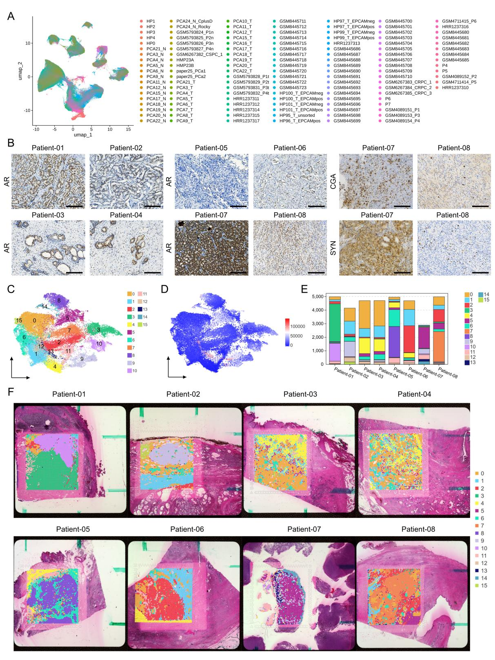
Supplementary Figure 1. Quality control and basic characterization of single-cell and spatial transcriptomic data.
- UMAP visualization showing the distribution of all cells, colored by sample origin. Each distinct color represents cells derived from a different individual sample, demonstrating the integration of multiple datasets. B. Immunohistochemical validation of spatial transcriptomics. Representative images of immunohistochemistry (IHC) staining performed on serial sections of the same prostate samples used for spatial transcriptomics (Patient 01-08). (Left panels) Staining for the androgen receptor (AR) across all eight samples. (Right panels) Staining for neuroendocrine markers Chromogranin A (CGA) and Synaptophysin (SYN) in Patient 07 and Patient 08. Scale bar = 200 µm. C. UMAP visualization displaying the distribution of UMI counts per spot across the 8 spatial transcriptomics samples. Color gradient from blue (low UMI counts) to red (high UMI counts) represents sequencing depth variation across tissue spots. D. UMAP projection showing the clustering results of all spots from the 8 spatial transcriptomics samples, identified as 16 distinct clusters (labeled 0-15). Each cluster is represented by a distinct color. E. Stacked bar plot demonstrating the distribution of spatial clusters across different samples. Each bar represents one spatial transcriptomics sample, with colored segments indicating the proportion of spots belonging to each cluster. F. Spatial mapping of the 16 identified clusters across the 8 samples, paired with corresponding H&E staining of the original tissue sections. Left panels show cluster assignments mapped onto spatial coordinates, right panels display histological morphology of the sequenced regions.

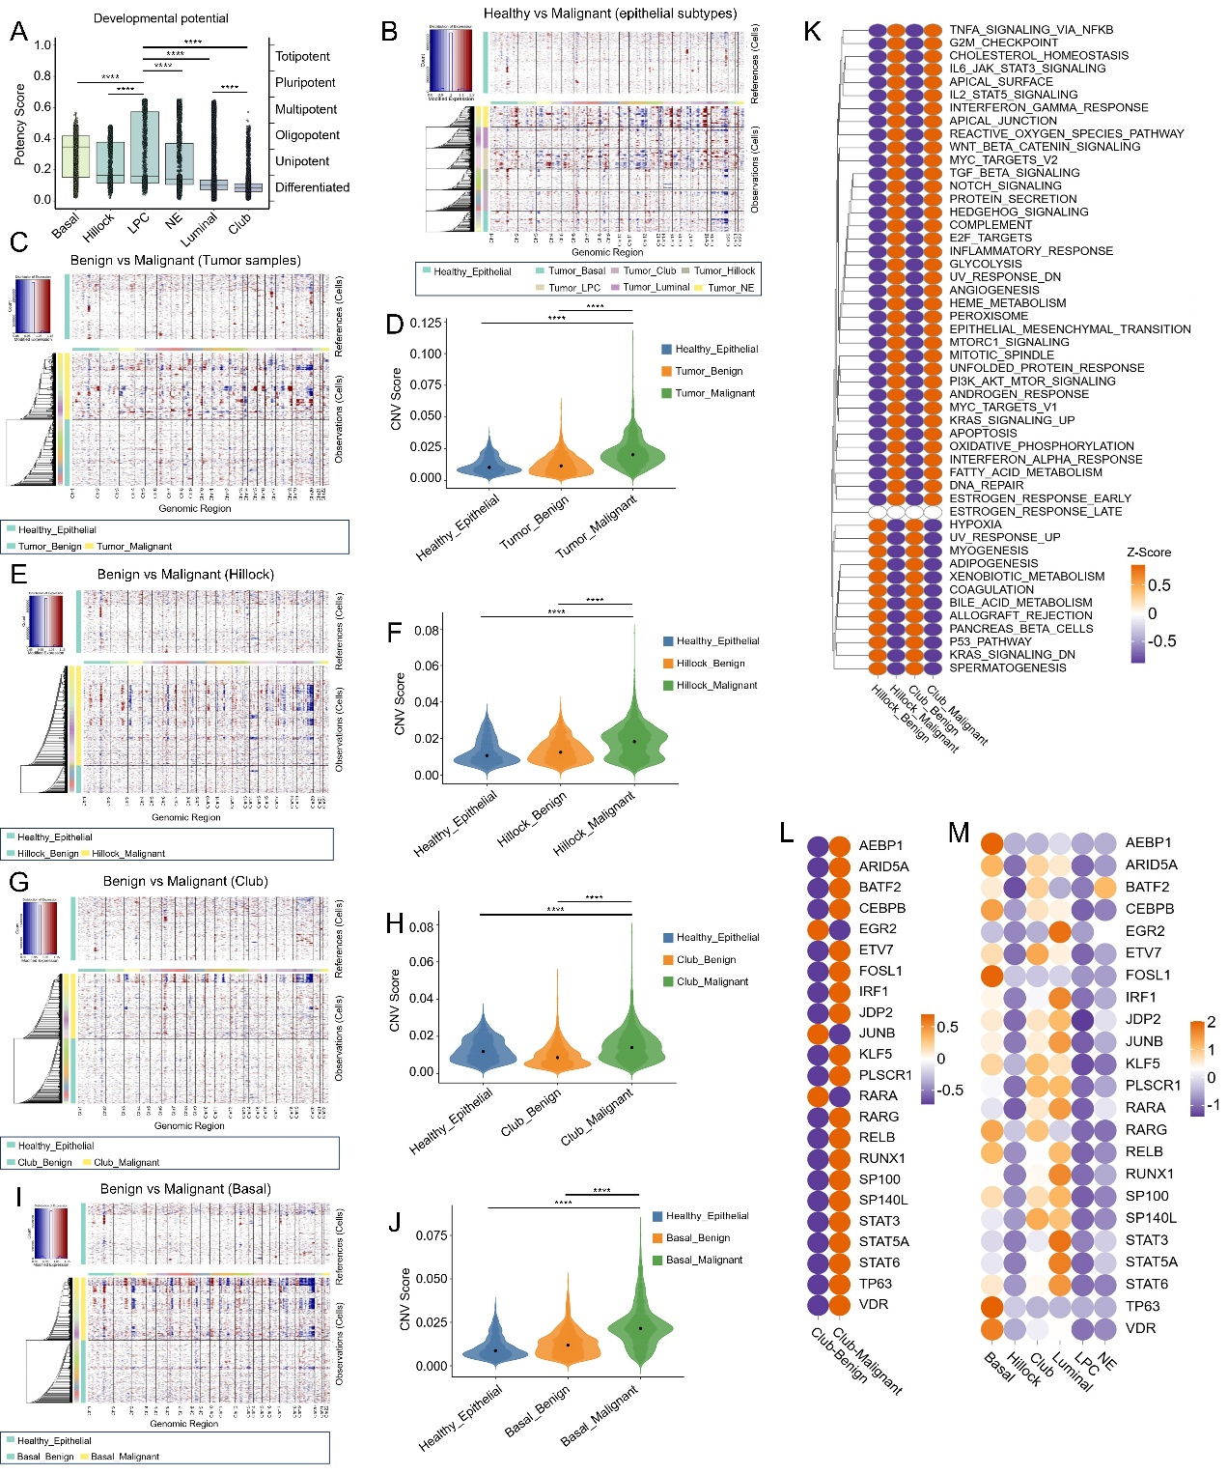
Supplementary Figure 2. Genomic and functional heterogeneity in benign and malignant epithelial cells across subtypes.
A. Differentiation potential of epithelial subtypes. Box plots showing the differentiation potency scores (derived from CytoTRACE analysis) across major epithelial cell types (Basal, Hillock, LPC, NE, Luminal, Club). The y-axis (Cytotrace Score) indicates differentiation potential. Statistical significance was assessed using the Wilcoxon rank-sum test. In this and subsequent panels, significance levels are denoted as follows: ns, not significant; *P < 0.05; **P < 0.01; ***P < 0.001; ****P < 0.0001. B. Copy number variation (CNV) landscape of malignant epithelial subtypes. Heatmap depicting inferred CNV profiles of malignant epithelial cells from each epithelial subtype (columns), using healthy prostate epithelial cells as a reference. Copy number loss is shown in blue and gain in red. The left color bar indicates the corresponding epithelial cell type for each column of cells. C. CNV profiles of benign versus malignant epithelial cells. Heatmap comparing the inferred CNV profiles of benign and malignant epithelial cells, with healthy epithelial cells as the reference. Blue indicates copy number loss, red indicates gain. D. CNV burden comparison (benign vs. malignant). Violin plots comparing the global CNV scores between benign and malignant epithelial cells (as grouped in C). Points are colored by their cell type annotation. E-H. Subtype-specific CNV analysis for Hillock and Club cells. (E, G) CNV heatmaps and (F, H) corresponding violin plots of CNV scores, comparing benign versus malignant cells within the (E, F) Hillock and (G, H) Club epithelial subtypes. Healthy epithelial cells serve as the reference for inference. I-J. CNV analysis for Basal epithelial cells. (I) Heatmap and (J) violin plot comparing the CNV profiles and global scores of benign versus malignant Basal epithelial cells. K. Pathway activity in Hillock and Club cell states. GSVA heatmap showing the enrichment scores of Hallmark pathways in benign Hillock, malignant Hillock, benign Club, and malignant Club epithelial cells. The color scale represents pathway activity from low (blue) to high (red). L. Heatmap displaying the expression levels of the 23 key transcription factors (associated with CRPC plasticity) in benign versus malignant Club epithelial cells. Expression is scaled from low (blue) to high (red). M. Heatmap showing the expression of the 23 key transcription factors across all major benign and malignant epithelial cell types. Expression is scaled from low (blue) to high (red).

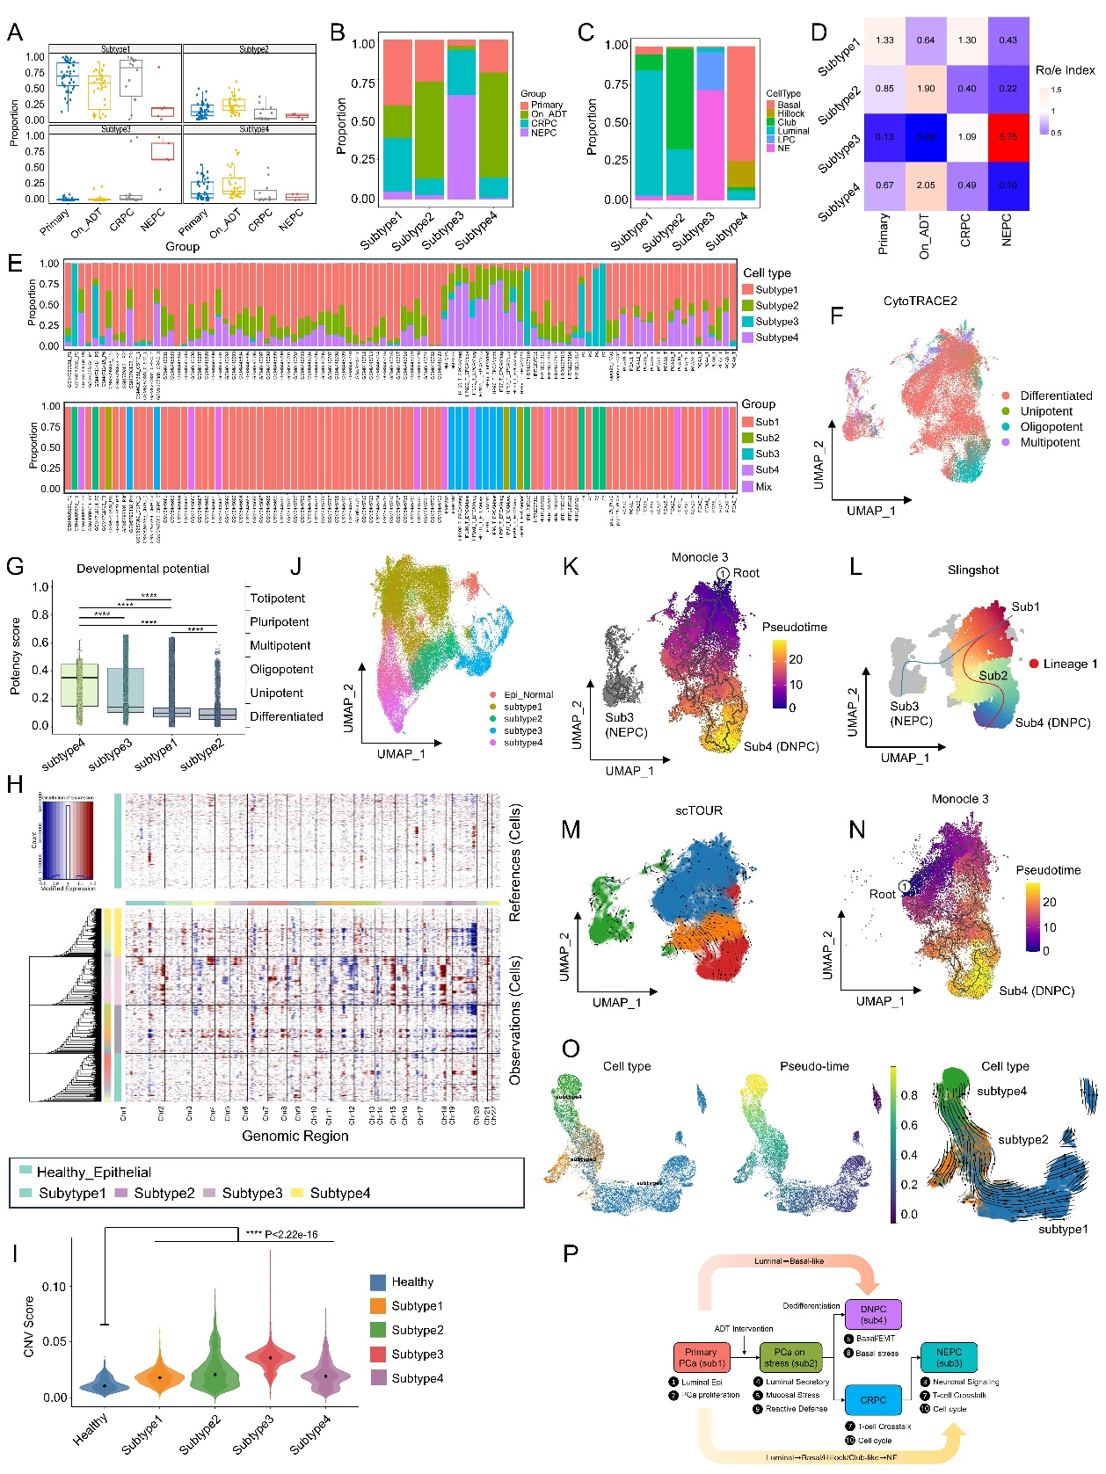
Supplementary Figure 3. Clinical association, genomic landscape, and differentiation trajectories of malignant epithelial subtypes.
A. Clinical origin of cells in each subtype. Box plot showing the distribution of cells derived from different clinical states (Primary PCa, On-ADT, CRPC, NEPC) within each of the four malignant epithelial subtypes (Subtype 1-4). B. Subtype composition across clinical groups. Stacked bar chart illustrating the relative proportion of cells from each clinical group (Primary PCa, On-ADT, CRPC, NEPC) within the four malignant subtypes (Subtype 1-4). C. Epithelial cell type composition across subtypes. Stacked bar chart showing the contribution of major epithelial cell types (e.g., Luminal, Basal, Hillock) to each malignant subtype. D. Enrichment of subtypes in clinical groups. Ro/e index heatmap quantifying the over- (red) or under-representation (blue) of each malignant subtype within the four clinical groups. E. Subtype dominance defines patient groups. (Top) Bar plot showing the percentage of each malignant subtype within individual patient samples. (Bottom) Classification of patient samples into four dominant-subtype groups (Subtype1- to Subtype4-dominant) and a mixed group based on the subtype composition shown above. F-G. Differentiation potential of malignant subtypes. (F) UMAP visualization of all malignant epithelial cells, colored by their CytoTRACE-predicted differentiation potency score. (G) Box plots comparing the CytoTRACE scores among the four malignant subtypes. Statistical significance was assessed using the Wilcoxon rank-sum test. In this and subsequent panels, significance levels are denoted as follows: ns, not significant; *P < 0.05; **P < 0.01; ***P < 0.001; ****P < 0.0001. H-I. Copy number variation (CNV) landscape across subtypes. (H) Heatmap depicting the inferred CNV profiles of cells from the four malignant subtypes, using healthy prostate epithelial cells as a reference. Copy number loss is shown in blue and gain in red. (I) Violin plots comparing the global CNV scores among the four subtypes and reference cells. J. Spatial mapping of subtypes onto epithelial cell landscape. UMAP projection of all epithelial cells (as shown in Figure 2A), with points colored to indicate the re-mapped identity of cells into five distinct categories: normal epithelial cells and the four malignant subtypes (Subtype 1–4). K-M. Differentiation trajectories including all subtypes. Pseudotime trajectories inferred using (K) Monocle3, (L) Slingshot, and (M) scTour analysis on all malignant epithelial cells. In (K) and (M), colors indicate pseudotime from early (purple) to late (yellow). The trajectory curve in (L) is shown in red. The gray shaded area in (K) and (L) highlights that Subtype 3 (NEPC) cells largely fall outside the main differentiation continuum. N-O. Differentiation trajectories for the luminal-basal continuum. Pseudotime analysis focused on Subtype 1, 2, and 4 cells using (N) Monocle3 and (O) scTour. In (O), the left panel shows cells colored by subtype, the middle panel shows pseudotime (purple to yellow), and the right panel shows the inferred trajectory with arrows indicating direction. P. Proposed model of prostate cancer cellular differentiation. Schematic summarizing the inferred differentiation pathways of prostate cancer cells, integrating subtype identities and meta-program (MP) activities. The model posits a starting point in primary disease, with branching differentiation towards Subtype 4 (characterized by DNPC/EMT features) and Subtype 3 (NEPC). Black numbers annotate key transitional states and their associated meta-programs.
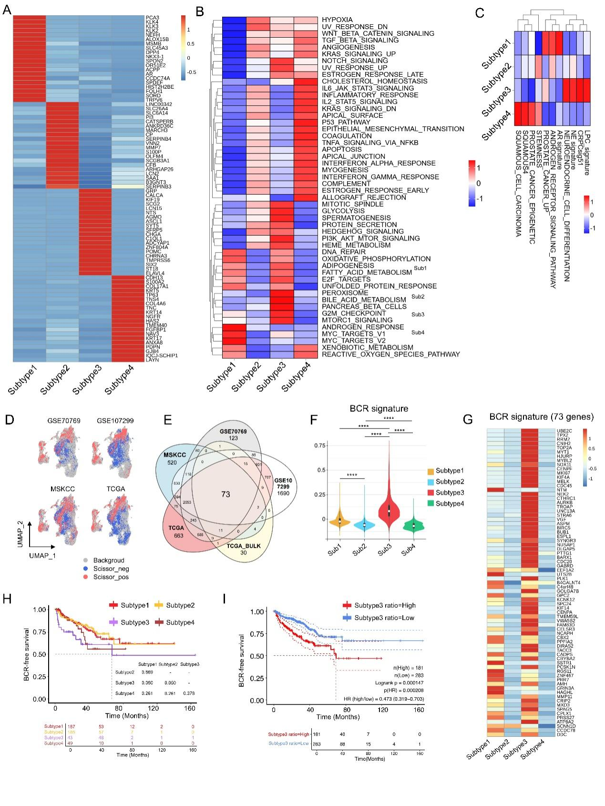
Supplementary Figure 4. Molecular and prognostic characterization of molecular subtypes in prostate cancer.
A. Heatmap displaying expression patterns of the top 20 marker genes for each molecular subtype. Color gradient from blue (low expression) to red (high expression) represents z-score normalized expression levels. B. GSVA heatmap showing Hallmark pathway activities across the four molecular subtypes. Color gradient from blue (low pathway activity) to red (high pathway activity) represents enrichment scores. C. GSVA heatmap displaying prostate cancer-related pathway activities across the four molecular subtypes. Visualization parameters consistent with panel L. D. UMAP projection showing the distribution of Scissors-positive (red), Scissors-negative (blue), and background (gray) cells across four bulk RNA-seq datasets (GSE70769, GSE107299, MSKCC, TCGA). E. Venn diagram displaying the intersection of biochemical recurrence (BCR)-associated genes across five datasets, resulting in 73 consensus genes defined as the BCR signature. F. Violin plots comparing BCR signature scores across the four molecular subtypes. The width of each violin represents the density distribution of signature scores. Statistical significance was assessed using the Wilcoxon rank-sum test. In this and subsequent panels, significance levels are denoted as follows: ns, not significant; *P < 0.05; **P < 0.01; ***P < 0.001; ****P < 0.0001. G. Heatmap showing expression patterns of the 73 BCR signature genes across the four molecular subtypes. Color gradient from blue (low expression) to red (high expression) represents z-score normalized expression levels. H. Kaplan-Meier curve comparing biochemical recurrence-free survival among patients classified into the four molecular subtypes in the TCGA-PRAD dataset. Log-rank test demonstrates significantly worse prognosis for sub3 patients. I. Kaplan-Meier curve comparing biochemical recurrence-free survival between patients with high versus low sub3 signature abundance in the TCGA-PRAD dataset. Patients with high sub3 ratio show significantly poorer outcomes.
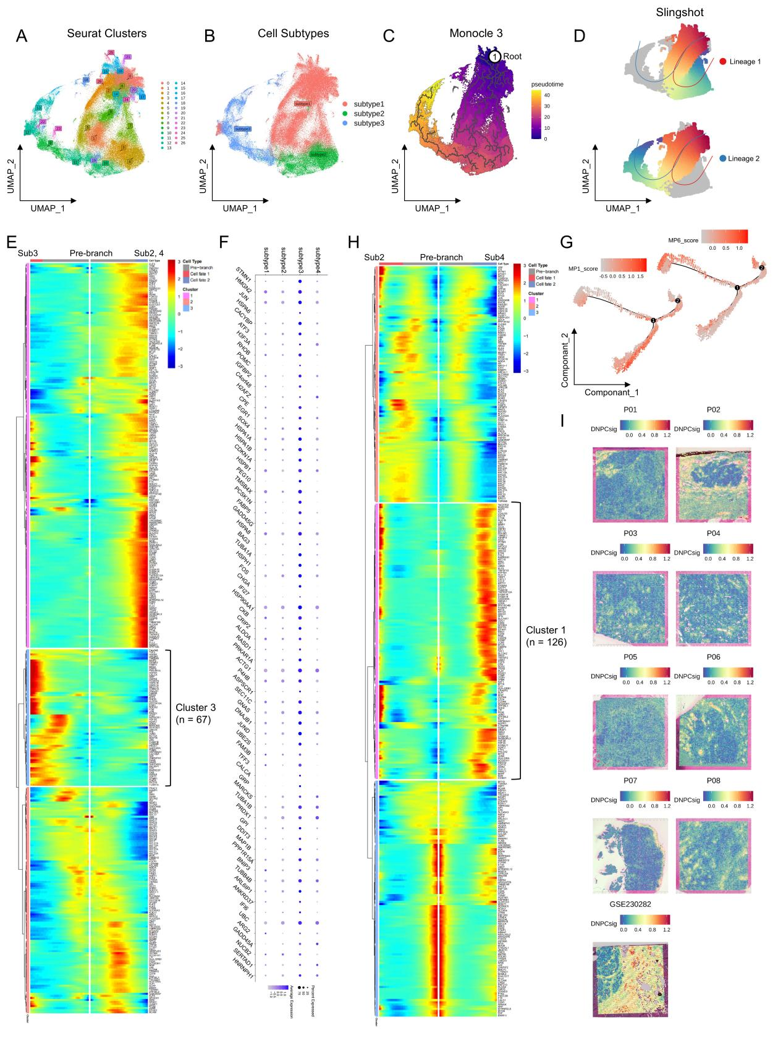
Supplementary Figure 5. Lineage trajectory analysis and molecular dynamics of subtype transitions.
A. Re-clustering of Subtype 1, 2, and 3 cells. UMAP visualization of cells from Subtype 1, 2, and 3 following independent dimensionality reduction and clustering, resulting in 27 transcriptional clusters. B. Re-annotation of Subtype identities. UMAP from panel A, with cells colored by their re-assigned subtype identity (Subtype 1, 2, or 3), confirming the coherence of these populations within the refined clustering. C. Pseudotime trajectory from Subtype 1 to Subtype 3. Monocle3-inferred pseudotime trajectory overlaid on the UMAP, showing a continuous transition from Subtype 1 (early, purple) to Subtype 3 (late, yellow). D. Bifurcating differentiation paths. Slingshot analysis identifies two distinct differentiation lineages overlaid on the UMAP: Lineage 1 (red curve, upper) from Subtype 1 to Subtype 2, and Lineage 2 (blue curve, lower) from Subtype 1 to Subtype 3. E. Heatmap displaying the expression dynamics of all genes that vary significantly along the differentiation trajectory. The central pre-branch region represents the starting point, with genes showing increased expression toward the sub3 differentiation branch (red block) or sub2/sub4 differentiation branch (blue block). F. Dot plot showing expression patterns of all 67 trajectory-associated genes across the four molecular subtypes. Dot size represents the percentage of cells expressing each gene within each subtype, while color intensity indicates average expression level from light yellow (low) to dark red (high). G. Meta-program dynamics along pseudotime. Line plots showing the changes in activity scores for MP1 (Luminal Epithelial, top) and MP6 (Basal/EMT Transition, bottom) along the Monocle2-inferred pseudotime. MP1 activity is highest at the trajectory start (Subtype 1-rich), while MP6 activity increases specifically along the branch leading towards Subtype 4-like states. H. Heatmap displaying the expression dynamics of genes that vary significantly during sub1-sub2-sub4 differentiation. The central pre-branch region represents the starting point, with genes showing increased expression toward the sub2 differentiation branch (red block) or sub4 differentiation branch (blue block). I. Spatial mapping of DNPC signature activity across 9 spatial transcriptomics samples using AddModuleScore. Color gradient from blue (low signature activity) to red (high signature activity) represents the computed signature scores for each spatial spot.

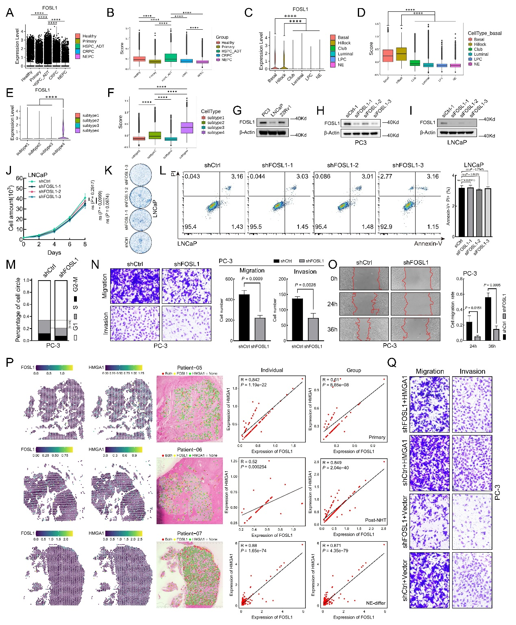
Supplementary Figure 6. Validation of FOSL1 expression patterns and functional analysis in prostate cancer cell lines.
A-B. FOSL1 expression and activity across clinical states. Violin plots (A) and box plots (B) showing the distribution of FOSL1 mRNA expression (left) and SCENIC regulon activity (right) in epithelial cells across clinical cohorts (Healthy, Primary PCa, On-ADT, CRPC, NEPC). Statistical significance was assessed using the Wilcoxon rank-sum test. In this and subsequent panels, significance levels are denoted as follows: ns, not significant; *P < 0.05; **P < 0.01; ***P < 0.001; ****P < 0.0001. C-D. FOSL1 expression and activity across epithelial subtypes. Violin plots (C) and box plots (D) showing FOSL1 mRNA expression (left) and regulon activity (right) in different epithelial cell types (Basal, Hillock, Club, Luminal, LPC, NEPC). E-F. FOSL1 expression and activity across molecular subtypes. Violin plots (E) and box plots (F) showing FOSL1 mRNA expression (left) and regulon activity (right) in the four malignant epithelial subtypes (Subtype 1-4). G. FOSL1 protein expression in prostate cancer cell lines. Western blot analysis of FOSL1 protein levels in PC-3, LNCaP, and 22Rv1 cells. Beta-Actin served as a loading control. H-I. Validation of FOSL1 knockdown efficiency. Western blot confirming FOSL1 protein knockdown after transfection with three independent siRNAs targeting FOSL1 (siFOSL1-1/2/3) compared to control siRNA (siCtrl) in (H) PC-3 and (I) LNCaP cells. J-K. Effect of FOSL1 knockdown on LNCaP cell proliferation. (J) Growth curves (CCK-8 assay) and (K) representative images and quantification of colony formation assays for LNCaP cells transfected with control or FOSL1-targeting siRNAs. Data are mean ± SD; ns = not significant (J: two-way ANOVA). L. Effect of FOSL1 knockdown on LNCaP cell apoptosis. Quantification of total apoptotic cells (Annexin V⁺) by flow cytometry in LNCaP cells transfected as indicated. Data are mean ± SD; ns = not significant (one-way ANOVA). M. Effect of FOSL1 knockdown on PC-3 cell cycle. Cell cycle distribution analysis by flow cytometry in PC-3 cells after FOSL1 knockdown with one siRNA. Data are presented as mean ± SD; ***P < 0.001, **P < 0.01 (two-tailed Student's t-test comparing siFOSL1 vs. siCtrl for each phase). N. Effect of FOSL1 knockdown on PC-3 cell migration and invasion. (Left) Representative images and (Right) quantification of Transwell migration (top) and Matrigel invasion (bottom) assays in PC-3 cells after FOSL1 knockdown. Data are mean ± SD; ***P < 0.001 (two-tailed Student's t-test). O. Effect of FOSL1 knockdown on PC-3 cell migration (wound healing). (Left) Representative images of scratch wounds at 0h and 48h (red lines indicate wound edges). (Right) Quantification of relative wound closure. Data are mean ± SD; ***P < 0.001 (two-tailed Student's t-test). P. Spatial correlation of FOSL1 and HMGA1 expression. (Left panels) Cell2location maps showing the spatial expression patterns of FOSL1 and HMGA1 and their co-localization in Patient 05, 06, and 07 sections. (Middle) Correlation plots for each patient with linear regression line (R and P values indicated). (Right) Correlation analysis of FOSL1 and HMGA1 expression stratified by clinical context. Scatter plots with linear regression lines show the correlation in spots from Primary samples (Patient 01-02), post-NHT samples (Patient 03-06), and NE-differentiated samples (Patient 07-08). Q. Rescue of migratory and invasive phenotypes by HMGA1. Representative images and quantification of Transwell migration (left) and Matrigel invasion (right) assays in PC-3 cells under four conditions: Control, FOSL1 knockdown (siFOSL1), HMGA1 overexpression (oeHMGA1), and FOSL1 knockdown combined with HMGA1 rescue (siFOSL1+oeHMGA1).

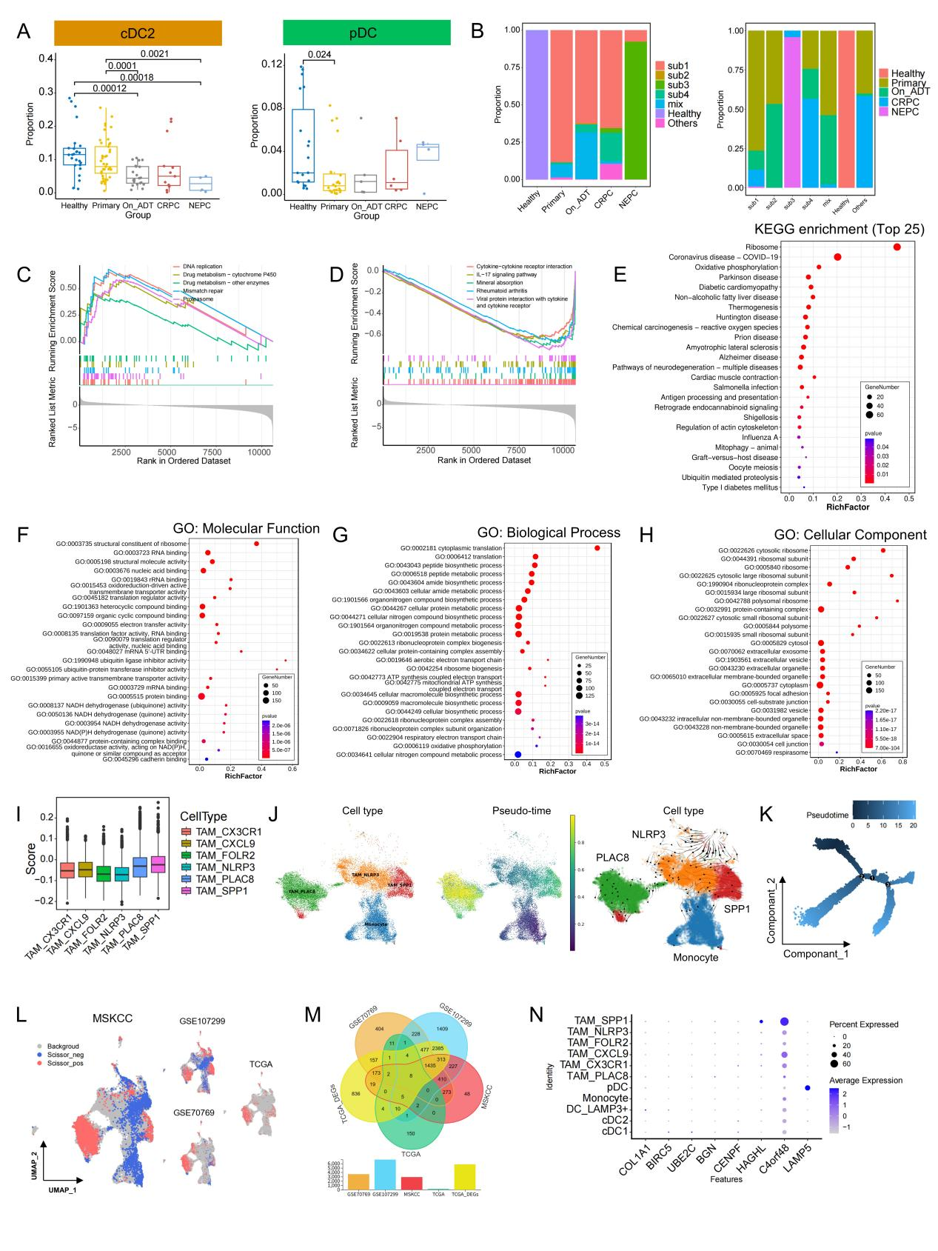
Supplementary Figure 7. Functional characterization of myeloid subsets and their clinical associations
- Box plots showing proportional differences of cDC2 (left) and pDC (right) subsets across clinical groups. Statistical significance was determined using Kruskal-Wallis test with Dunn's post-hoc correction (*p < 0.05, **p < 0.01, ***p < 0.001). Boxes represent interquartile range with center lines indicating median values. B. Stacked bar plots displaying cellular composition within myeloid compartment: (Left) Proportion of cells from different molecular subtypes within myeloid cells of each clinical sample; (Right) Proportion of cells from different clinical groups within myeloid cells of each molecular subtype-dominant sample. C-D. Gene Set Enrichment Analysis (GSEA) of PLAC8+ TAMs: (C) Significantly upregulated pathways and (D) significantly downregulated pathways. Enrichment scores are shown along the vertical axis. E. KEGG pathway enrichment analysis showing the top 20 significantly enriched pathways in PLAC8+ TAMs. Bar color represents -log10(p-value) of pathway enrichment. F-H. Gene Ontology (GO) enrichment analysis of PLAC8+ TAMs: (F) Molecular Function (MF), (G) Biological Process (BP), and (H) Cellular Component (CC) categories. Bar color represents -log10(p-value) of term enrichment. I. P450 gene set scoring across TAM subsets. Box plots show activity levels of cytochrome P450-related genes in different macrophage populations. J. scTOUR trajectory analysis of monocyte-to-TAM differentiation. Left panel: UMAP distribution of four subsets (monocytes, PLAC8+ TAMs, NLRP3+ TAMs, SPP1+ TAMs); Middle panel: pseudotime trajectory from purple (start) to yellow (end); Right panel: vector field analysis showing differentiation directions (small arrows indicate directionality). K. Monocle2 trajectory analysis showing pseudotemporal progression from dark blue (start) to light blue (end). L. UMAP projection showing the distribution of Scissors-positive (red), Scissors-negative (blue), and background (gray) cells from four bulk RNA-seq datasets within macrophage subsets. M. Venn diagram displaying the intersection of biochemical recurrence-associated genes across five datasets, yielding 8 consensus genes significantly associated with BCR. N. Dot plot showing expression patterns of the 8 BCR-associated genes across myeloid subsets. Dot size represents the percentage of cells expressing each gene, while color intensity indicates average expression level from light blue (low) to dark blue (high).

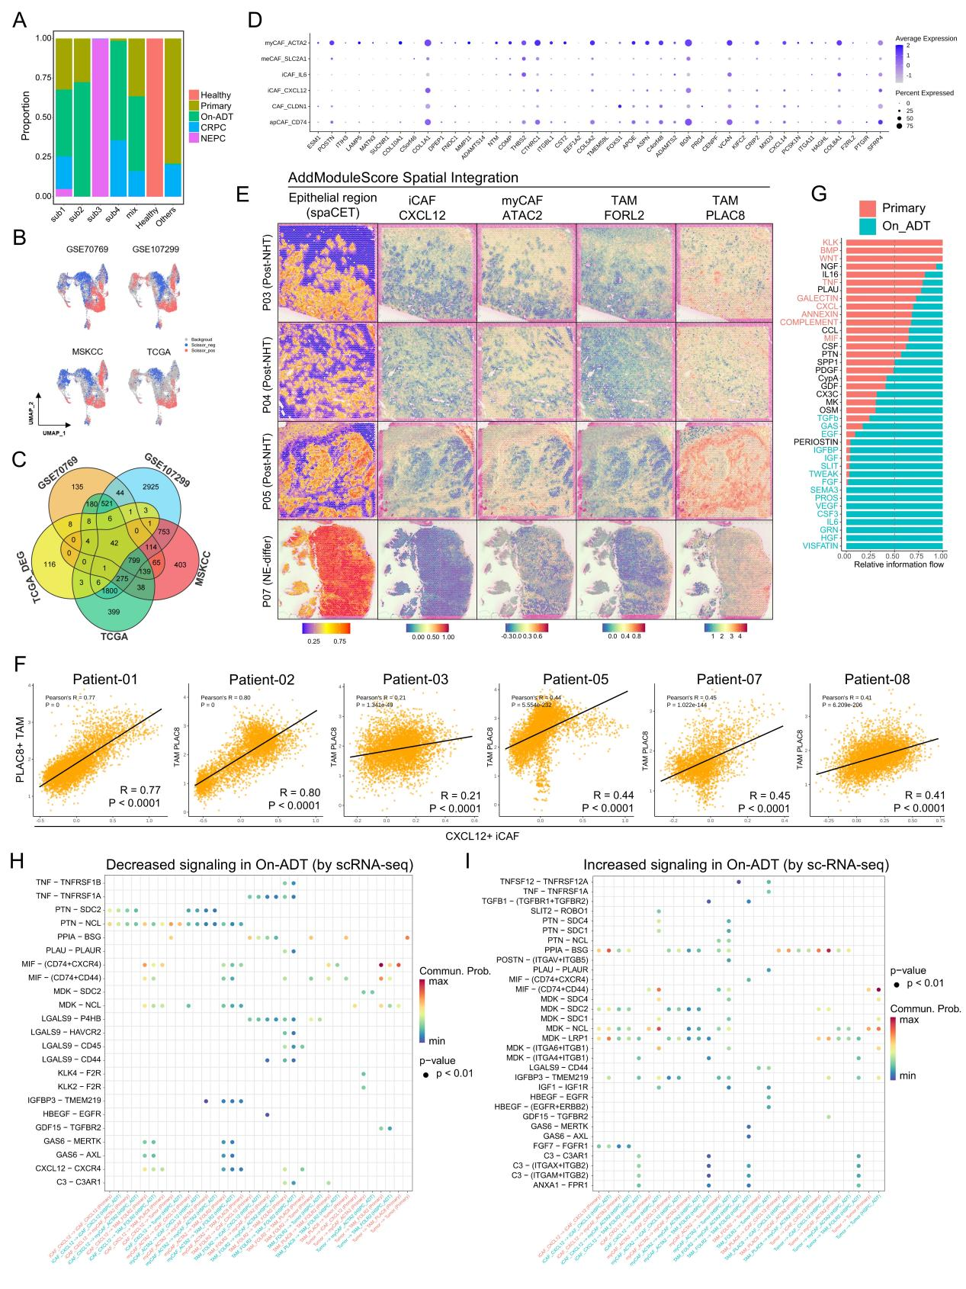
Supplementary Figure 8. CAF heterogeneity, clinical relevance, and spatial interactions
- Stacked bar plot showing the proportional distribution of clinical groups within CAF cells of each molecular subtype. Each bar represents one molecular subtype, with colored segments indicating the percentage of different clinical stages (Healthy, Primary, On-ADT, CRPC, NEPC). B. UMAP projection showing the distribution of Scissors-positive (red), Scissors-negative (blue), and background (gray) cells from four bulk RNA-seq datasets within CAF subsets. C. Venn diagram displaying the intersection of biochemical recurrence-associated genes across five datasets, yielding 42 consensus genes significantly associated with BCR in the CAF compartment. D. Dot plot showing expression patterns of the 42 BCR-associated genes across CAF subsets. Dot size represents the percentage of cells expressing each gene, while color intensity indicates average expression level from light blue (low) to dark blue (high). E. Spatial mapping of CXCL12+ iCAF, ACTA2+ myCAF, FOLR2+ TAM, and PLAC8+ TAM in samples P03, P04, P05, and P07 using AddModuleScore. Each cell type is represented by a distinct color gradient showing relative abundance across tissue spots. F. Correlation heatmap displaying Pearson correlation coefficients between PLAC8+ TAM and CXCL12+ iCAF spatial distributions across different samples. Correlation values are calculated based on cellular proportions within each spot, with color intensity representing the strength of spatial co-localization. G-H. Cell-cell communication network analysis among tumor cells, CXCL12+ iCAF, ACTA2+ myCAF, FOLR2+ TAM, and PLAC8+ TAM: (G) Ligand-receptor pairs significantly downregulated in the post-treatment group; (H) Ligand-receptor pairs significantly upregulated in the post-treatment group. Edge thickness represents communication probability, while node size indicates the number of interactions.
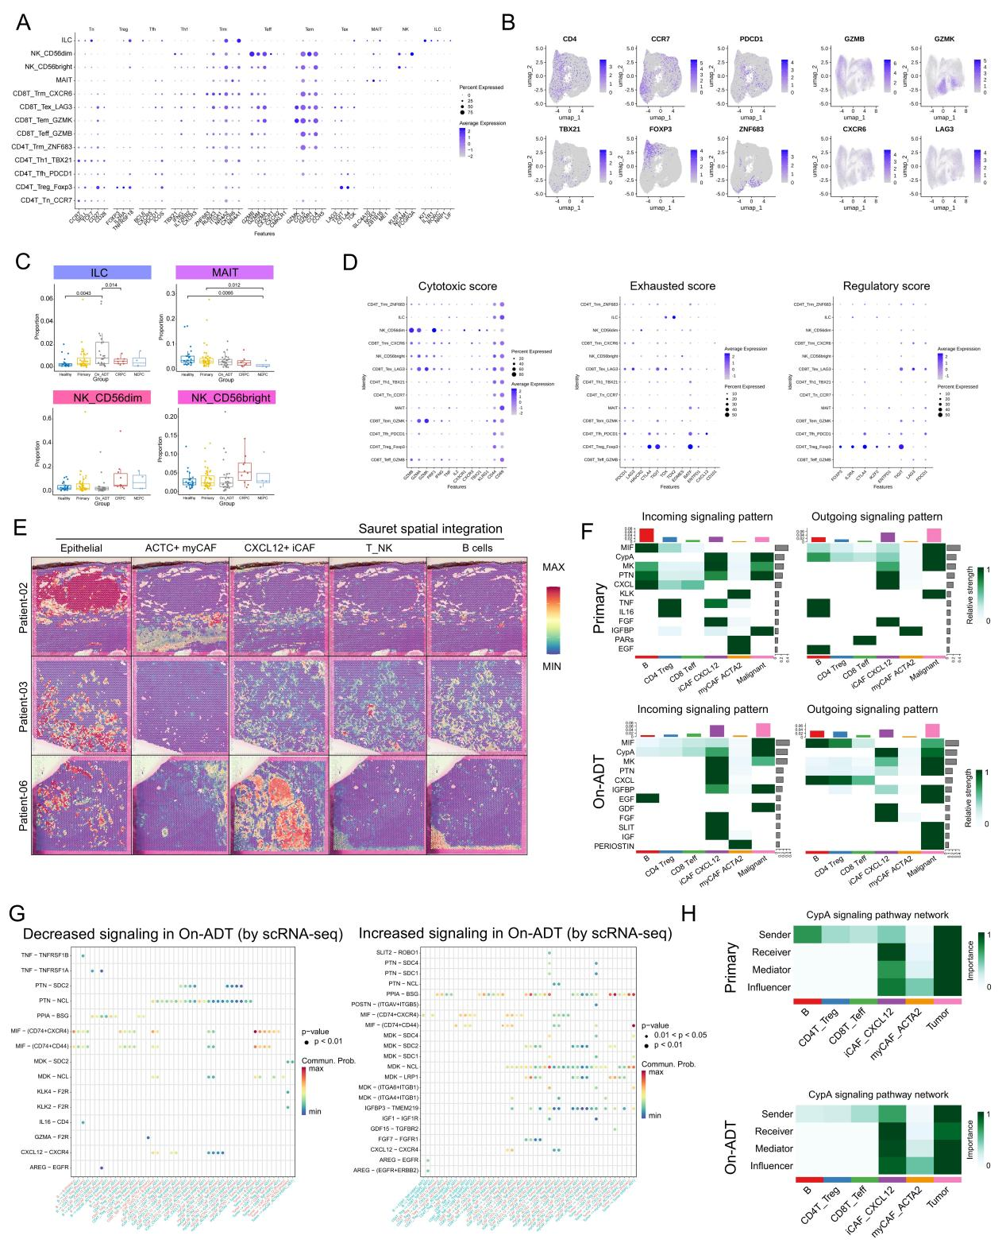
Supplementary Figure 9. Lymphoid cell heterogeneity, spatial organization, and communication networks
- Dot plot displaying expression patterns of marker genes across lymphoid subsets. Dot size represents the percentage of cells expressing each gene, while color intensity indicates average expression level from light blue (low) to dark blue (high). B. UMAP feature plots showing expression distribution of key marker genes across lymphoid subsets. Color gradient from light blue (low expression) to dark blue (high expression) represents expression levels in individual cells. C. Box plots showing proportional differences of ILC, MAIT, NK CD56dim, and NK CD56bright subsets across clinical groups. Statistical significance was determined using Kruskal-Wallis test with Dunn's post-hoc correction (*p < 0.05, **p < 0.01, ***p < 0.001). D. Stacked bar plot illustrating the proportional distribution of lymphoid subsets within each individual sample. Each bar represents one sample, with colored segments indicating the percentage of different lymphoid populations. E. Dot plot displaying gene signature scores across lymphoid subsets for cytotoxicity, exhaustion, and regulation signatures. Dot size represents the percentage of cells with significant signature enrichment, while color intensity indicates the average signature score from light blue (low) to dark blue (high). F. Spatial mapping of ACTA2+ myCAF, CXCL12+ iCAF, T/NK cells, B cells, and epithelial cells in samples P01, P02, and P06 using Seurat. Color gradient from blue (low abundance) to red (high abundance) represents the relative abundance of each cell type across tissue spots. G. CellChat analysis of communication patterns among B cells, CD4+ Treg, CD8+ Teff, ACTA2+ myCAF, CXCL12+ iCAF, and tumor cells. Upper panels: primary group; Lower panels: post-treatment group. Left panels: incoming communication patterns; Right panels: outgoing communication patterns. H. CypA signaling network in primary (upper) and post-treatment (lower) conditions, showing sender, receiver, mediator, and influencer roles in the communication among B cells, CD4+ Treg, CD8+ Teff, ACTA2+ myCAF, CXCL12+ iCAF, and tumor cells. I. Differential ligand-receptor pairs in the communication network among B cells, CD4+ Treg, CD8+ Teff, ACTA2+ myCAF, CXCL12+ iCAF, and tumor cells: Left panel: pairs significantly downregulated in post-treatment group; Right panel: pairs significantly upregulated in post-treatment group.

